Supplementary Material: Functional microbiome shifts are associated with neuroinflammatory outcomes under dietary interventions in multiple sclerosis
Friederike Gutmann^{1,2,3,4,5,7,*}, Lina Samira Bahr^{1,2,3}, Ulrike Brüning⁵, Víctor Hugo Jarquín-Díaz^{1,2,3,4,7}, Lajos Markó^{1,2,3,4}, Martin Weygandt^{1,2,3}, Rebekka Rust^{1,2,3,6}, Judith Bellmann-Strobl^{1,2,3}, Friedemann Paul^{1,2,3}, Sofia K. Forslund-Startceva^{1,2,3,4,7,**} & Jennifer A. Kirwan^{5,8,**}
¹Max Delbrück Center for Molecular Medicine in the Helmholtz Association (MDC), Berlin, Germany
²Charité – Universitätsmedizin Berlin, corporate member of Freie Universität Berlin and Humboldt‐Universität zu Berlin, Berlin, Germany
³Experimental and Clinical Research Center, a cooperation between the Max Delbrück Center for Molecular Medicine in the Helmholtz Association and Charité Universitätsmedizin Berlin (Charité University Hospital Berlin), Germany
⁴German Centre for Cardiovascular Research (DZHK), Partner Site Berlin, Berlin, Germany
⁵Berlin Institute of Health (BIH) at Charité, BIH Metabolomics Platform, Berlin, Germany
⁶Institute for Immunology at Charité Berlin, Berlin, Germany
⁷Cluster of Excellence ImmunoPreCept (EXC 3118), Charité - Universitätsmedizin Berlin, Berlin, Germany
⁸Current address: Veterinary Metabolomics, University of Veterinary Medicine Vienna, Vienna, Austria. Work performed at BIH.

* Corresponding author: friederike.gutmann@mdc-berlin.de

** Co-senior authorship

Supplementary Table 1. Baseline characteristics of the NAMS per-protocol population (primary sample for all main analyses).
Characteristic | Total | CD | FD | KD | p-value
Number of participants, n | 76 | 23 | 33 | 20
Age [years], mean (SD) | 42 (10) | 42 (10) | 41 (9) | 42 (11) | 0.99
Ethnicity [Caucasian], n (%) | 73 (96) | 23 (100) | 32 (97) | 18 (90) | 0.13
Gender [female], n (%) | 62 (78) | 18 (85) | 27 (82) | 17 (85) | 0.85
Disease duration since manifestation [months], median (IQR) | 78 (138) | 63 (128) | 96 (122) | 112 (167) | 0.42
Disease duration since diagnosis [months], median (IQR) | 41 (108) | 24 (40) | 55 (111) | 36 (112) | 0.1
Expanded disability status scale score, median (IQR) | 2.0 (1) | 2.0 (1) | 2.0 (1) | 2.0 (2) | 0.8
Number of T2-lesions, median (IQR) | 36 (38) | 36 (31) | 39 (38) | 26 (40) | 0.67
Participants without DMT, n (%) | 35 (46) | 10 (43) | 15 (45) | 10 (50) | 0.91
Body mass index [kg/m²], median (IQR) | 23.9 (4.0) | 24.7 (4.0) | 23.6 (4.5) | 23.7 (3.5) | 0.62
25-OH-Vitamin D₃ [nmol/L], mean (SD) | 99.1 (37.4) | 107.0 (39.2) | 93.1 (35.0) | 99.6 (39.2) | 0.51
Fatigue severity scale score, median (IQR) | 3.6 (3.2) | 3.6 (3.7) | 3.9 (2.7) | 3.0 (1.9) | 0.28
Beck depression inventory II score, median (IQR) | 7.0 (9.0) | 6.0 (11.5) | 9.0 (8.0) | 5.0 (8.0) | 0.21
Symbol digit modalities test score, median (IQR) | 57 (14) | 56 (11) | 57 (14) | 60 (19) | 0.89
Relapse during study, n (%) | 23 (30) | 5 (22) | 9 (27) | 9 (45) | 0.25
Alemtuzumab, n (%) | 0 | 0 | 0 | 0
Cladribine, n (%) | 1 (1) | 0 | 1 (3) | 0 | 0.52
Daclizumab, n (%) | 0 | 0 | 0 | 0
Dimethyl fumarate, n (%) | 12 (16) | 2 (9) | 5 (15) | 5 (25) | 0.34
Fingolimod, n (%) | 5 (7) | 0 | 5 (15) | 0 | 0.03
Glatiramer acetate, n (%) | 12 (16) | 7 (30) | 3 (9) | 2 (10) | 0.07
Interferon beta-1a, n (%) | 5 (7) | 0 | 3 (9) | 2 (10) | 0.31
Interferon beta-1b, n (%) | 2 (3) | 1 (4) | 0 | 1 (5) | 0.45
Natalizumab, n (%) | 3 (4) | 2 (9) | 1 (3) | 0 | 0.32
Ocrelizumab, n (%) | 0 | 0 | 0 | 0
Rituximab, n (%) | 0 | 0 | 0 | 0
Teriflunomide, n (%) | 1 (1) | 1 (4) | 0 | 0 | 0.31

CD, control diet; DMT, disease modifying therapy; FD, fasting diet; IQR, interquartile range; KD, ketogenic diet; SD, standard deviation.

Supplementary Table 2. Baseline characteristics of the NAMS dropout population (not included in the per-protocol population).
Characteristic |  | Total | CD | FD | KD | p-value
Number of participants, n (% dropout) |  | 29 | 11 (32) | 2 (6) | 16 (44) | 0.0004
Age [years], mean (SD) |  | 42 (9) | 43 (11) | 41 (1) | 41 (8) | 0.5
Ethnicity [Caucasian], n (%) |  | 27 (93) | 11 (100) | 2 (100) | 14 (88) | 0.5
Gender [female], n (%) |  | 26 (90) | 11 (100) | 1 (50) | 14 (86) | 0.11
Disease duration since manifestation [months], median (IQR) |  | 102 (120) | 56 (173) | 134 (2) | 100 (125) | 0.51
Disease duration since diagnosis [months], median (IQR) |  | 56 (108) | 37 (90) | 95 (29) | 66 (103) | 0.55
Expanded disability status scale score, median (IQR) |  | 2.0 (2) | 2.0 (2) | 2.0 (0) | 2.0 (1) | 0.25
Number of T2-lesions, median (IQR) |  | 34 (66) | 35 (62) | 102 (28) | 32 (65) | 0.49
Participants without DMT, n (%) |  | 7 (24) | 2 (18) | 1 (50) | 4 (25) | 0.67
Body mass index [kg/m²], median (IQR) |  | 25.0 (5.0) | 26.2 (3.2) | 23.3 (3.5) | 23.5 (5.4) | 0.81
25-OH-Vitamin D₃ [nmol/L], mean (SD) |  | 106.3 (36.4) | 100.8 (34.5) | 107.0 (2.4) | 109.9 (40.8) | 0.95
Fatigue severity scale score, median (IQR) |  | 4.1 (2.6) | 5.3 (1.3) | 3.2 (0.1) | 3.6 (2.9) | 0.3
Beck depression inventory II score, median (IQR) |  | 8.0 (11.0) | 9.0 (4.5) | 9.5 (4.5) | 7.0 (15.2) | 0.95
Symbol digit modalities test score, median (IQR) |  | 53 (15) | 53 (14) | 57 (0) | 52 (16) | 0.88
Relapse during study, n (%) |  | 6 (21) | 2 (18) | 0 | 4 (25) | 0.69
Alemtuzumab, n (%) |  | 1 (3) | 1 (9) | 0 | 0 | 0.39
 | Cladribine, n (%) | 0 | 0 | 0 | 0
Daclizumab, n (%) |  | 1 (3) | 1 (9) | 0 | 0 | 0.39
Dimethyl fumarate, n (%) |  | 3 (11) | 0 | 0 | 3 (19) | 0.23
Fingolimod, n (%) |  | 6 (21) | 3 (27) | 0 | 3 (19) | 0.79
Glatiramer acetate, n (%) |  | 4 (14) | 2 (18) | 0 | 2 (12) | 0.72
Interferon beta-1a, n (%) |  | 2 (7) | 0 | 0 | 2 (12) | 0.45
Interferon beta-1b, n (%) |  | 1 (3) | 0 | 0 | 1 (6) | 0.68
Natalizumab, n (%) |  | 1 (3) | 0 | 1 (50) | 0 | 0.001
Ocrelizumab, n (%) |  | 1 (3) | 1 (9) | 0 | 0 | 0.39
Rituximab, n (%) |  | 2 (7) | 1 (9) | 0 | 1 (6) | 0.86
Teriflunomide, n (%) |  | 0 | 0 | 0 | 0

CD, control diet; DMT, disease modifying therapy; FD, fasting diet; IQR, interquartile range; KD, ketogenic diet; SD, standard deviation.

Supplementary Table 3. Differences in serum metabolite levels at baseline between patients using DMT (n = 35) and those not using DMT (n = 41). Values are shown as median (IQR) per group, p-values from Wilcoxon rank-sum tests, adjusted for multiple testing using the Benjamini-Hochberg method, and the effect sizes reported as Cliff's delta.
Serum metabolite | p-value | q-value | Median_{NoDMT} (IQR) | Median_{DMT} (IQR) | Effect Size (Cliff’s delta)
Acetoacetic acid | 0.045 | 0.540 | 805.2 (961.3) | 474 (598.9) | 0.268
Hexanoic acid | 0.271 | 0.551 | 814.4 (390.2) | 933 (370.6) | -0.148
Hydroxymethyl butyric acid | 0.395 | 0.551 | 1011.4 (454.7) | 947.3 (529) | -0.115
Kynurenine | 0.183 | 0.551 | 902.1 (300) | 927.9 (367.1) | -0.179
TMAO | 0.828 | 0.903 | 820.9 (844.1) | 668.9 (590) | 0.030
3-Hydroxybutyric acid | 0.413 | 0.551 | 556.6 (557.8) | 381 (483.2) | 0.111
3-Hydroxykynurenine | 0.413 | 0.551 | 1096.9 (445.4) | 1091.4 (432.9) | -0.111
5-Hydroxytryptophan | 0.983 | 0.983 | 916.3 (228.6) | 887.5 (341.1) | 0.003
Indole-3-acetate | 0.126 | 0.551 | 1056.4 (663.1) | 845.3 (501.9) | 0.206
Indole-3-lactate | 0.494 | 0.593 | 862.4 (357.6) | 941.3 (387.3) | -0.093
Serotonin | 0.319 | 0.551 | 920.1 (630.3) | 812.2 (502.1) | 0.134
Tryptophan | 0.334 | 0.551 | 932.7 (218.2) | 958.9 (176.2) | -0.130

DMT, disease modifying therapy; IQR, interquartile range; TMAO, trimethylamine N-oxide.

Supplementary Table 4. Differences in stool metabolite levels at baseline between patients using DMT (n = 35) and those not using DMT (n = 41). Values are shown as median (IQR) per group, p-values from Wilcoxon rank-sum tests, adjusted for multiple testing using the Benjamini-Hochberg method, and the effect sizes reported as Cliff's delta.
Stool metabolite | p-value | q-value | Median_{NoDMT} AUC (IQR) | Median_{DMT} AUC (IQR) | Effect size (Cliff’s delta)
Acetic acid | 0.1890 | 0.591 | 810.4 (246) | 888.7 (338.1) | -0.184
Acetoacetic acid | 0.7080 | 0.974 | 978.2 (857.5) | 1212.2 (815.9) | -0.053
Butyric acid | 0.9160 | 0.981 | 989.9 (447.2) | 970.2 (463) | 0.016
Hexanoic acid | 0.4540 | 0.923 | 533.9 (889.7) | 654.7 (1605.8) | -0.106
Isobutyric acid | 0.1270 | 0.518 | 1127.6 (457.7) | 966.8 (426.1) | 0.214
Isovaleric acid | 0.0795 | 0.398 | 1033.9 (463.6) | 837.8 (458.6) | 0.245
Propanoic acid | 0.5200 | 0.923 | 878 (267.4) | 917.3 (302.6) | -0.091
TMA | 0.9810 | 0.981 | 893 (648.7) | 838.3 (1082.7) | -0.004
Valeric acid | 0.7790 | 0.974 | 934.6 (622.9) | 956.3 (501.8) | 0.040
2-Methylbutyric acid | 0.0595 | 0.372 | 1001.1 (357.2) | 813.5 (523.3) | 0.263
Acetylserotonin | 0.9810 | 0.981 | 417.2 (640.7) | 435.5 (1250) | 0.004
Anthranilate | 0.2460 | 0.683 | 1054.5 (1066.8) | 839.3 (1068.3) | 0.163
Indole-3-carboxaldehyde | 0.0450 | 0.372 | 463.9 (523.7) | 782.6 (988.5) | -0.279
Indole-3-carboxylic acid | 0.5740 | 0.923 | 746.2 (637.7) | 828.7 (1671.6) | -0.079
Indole-3-ethanol | 0.7700 | 0.974 | 1089.4 (883.1) | 987.9 (846.9) | 0.042
Indole-3-propionic acid | 0.3310 | 0.752 | 290.1 (439.4) | 488.3 (881.1) | -0.137
Indole | 0.8240 | 0.978 | 625.3 (791.2) | 829.2 (902.1) | -0.032
Indole-3-acetic acid | 0.5910 | 0.923 | 438.5 (1598.6) | 668.5 (1428.5) | -0.076
Indole-3-lactic acid | 0.1450 | 0.518 | 254.1 (266.1) | 317.8 (526.2) | -0.204
Kynurenic acid | 0.0336 | 0.372 | 227.8 (757.2) | 708.2 (1055.2) | -0.296
Picolinic acid | 0.7170 | 0.974 | 760.5 (541.2) | 837.7 (1210.1) | -0.052
Quinolinic acid | 0.3250 | 0.752 | 1039 (1049.3) | 853.4 (884.2) | 0.138
Serotonin | 0.8610 | 0.978 | 386 (488.7) | 401.4 (1105.9) | 0.025
Tryptamin | 0.0357 | 0.372 | 797.3 (3073.4) | 390.4 (1123.6) | 0.292
Tryptophan | 0.5670 | 0.923 | 697.4 (664.2) | 486.7 (650.4) | 0.081

DMT, disease modifying therapy; IQR, interquartile range; TMA, trimethylamine.

Supplementary Table 5. Analyte-specific LC-MS/MS AUC values of acetoacetic acid, hexanoic acid, hydroxymethylbutyric acid, and 3-hydroxymethylbutyric acid at baseline and after 9 months. ΔAUCs are reported as the median (IQR) of within-patient differences. 95% CIs were computed using the normal approximation. AUCs are processed and corrected peak areas.
Metabolite | Diet | n | AUCbaseline, median (IQR) | AUC9months, median (IQR) | ΔAUC (IQR) | Cohen’s d [95% CI]
AA | CD | 23 | 633.8 (429.9) | 571.8 (755.8) | -4.4 (679.10) | 0.09 [-0.32, 0.50]
AA | KD | 20 | 708.2 (1182.6) | 2897.8 (3498.3) | 1927.7 (4117.61) | 0.84 [0.33, 1.35]
AA | FD | 33 | 642.3 (683.8) | 579.6 (716.7) | 181.2 (757.87) | 0.03 [-0.31, 0.37]
Hexanoic acid | CD | 23 | 753.2 (397.7) | 795.1 (551.8) | -88.7 (633.34) | 0.10 [-0.31, 0.51]
Hexanoic acid | KD | 20 | 982.6 (344.5) | 857.4 (346.6) | -98.4 (606.04) | -0.31 [-0.76, 0.14]
Hexanoic acid | FD | 33 | 903.8 (455.8) | 840.9 (400.4) | -45.8 (577.74) | -0.17 [-0.51, 0.17]
HMB | CD | 23 | 889.2 (476.2) | 956.1 (624.7) | -42.9 (516.81) | 0.08 [-0.33, 0.49]
HMB | KD | 20 | 947.8 (543.7) | 1262.4 (603.0) | 124.5 (1102.61) | 0.37 [-0.08, 0.82]
HMB | FD | 33 | 1058.0 (527.5) | 899.1 (440.4) | -63.9 (768.66) | -0.18 [-0.52, 0.16]
3HB | CD | 23 | 330.0 (380.0) | 271.0 (604.7) | 13.7 (582.88) | 0.12 [-0.29, 0.53]
3HB | KD | 20 | 759.3 (739.1) | 2583.6 (2953.1) | 1210.7 (2917.68) | 0.83 [0.32, 1.34]
3HB | FD | 33 | 434.7 (495.5) | 238.6 (570.0) | -20.9 (721.51) | -0.02 [-0.36, 0.32]

AA, Acetoacetic acid; CD, control diet; CI, confidence interval; FD, fasting diet; HMB, Hydroxymethyl butyric acid; KD, ketogenic diet; SD, standard deviation; 3HB, 3-Hydroxybutyric acid.

Supplementary Table 6. Sensitivity analysis of diet-by-baseline interaction effects. Pairwise group contrasts were re-estimated using absolute AUC change as the outcome, at baseline metabolite levels corresponding to -1 SD, the mean, and +1 SD. AUC changes are not comparable between compounds due to differences in ionization efficiency. Estimates, 95% confidence intervals, and Benjamini-Hochberg-adjusted q-values are shown for each contrast and baseline interval. For readability, significant results are highlighted in grey. For comparison with the primary analysis, contrasts that were also significant when percentage change was used as the outcome are italicized and marked with an asterisk.
Metabolite | Contrast | Interval | Estimate | 2.5 % | 97.5 % | p-value | q-value
AA* | KD vs. CD | - 1 SD | -2,538.3 | -4,415.1 | -661.5 | 8.03E-03 | 2.01E-01
AA* | KD vs. FD | - 1 SD | -3,102.1 | -4,411.4 | -1,792.8 | 3.42E-06 | 1.13E-04
AA* | KD vs. CD | Mean | -2,384.9 | -3,502.9 | -1,266.8 | 2.91E-05 | 9.31E-04
AA* | KD vs. FD | Mean | -2,639.3 | -3,657.7 | -1,621.0 | 3.78E-07 | 1.32E-05
AA | KD vs. CD | + 1 SD | -2,231.4 | -3,867.2 | -595.6 | 7.50E-03 | 1.95E-01
AA | KD vs. FD | + 1 SD | -2,176.6 | -3,583.2 | -769.9 | 2.42E-03 | 6.54E-02
AA | CD vs. FD | - 1 SD | -563.8 | -2,349.3 | 1,221.7 | 5.36E-01 | 1.00E+00
AA | CD vs. FD | Mean | -254.5 | -1,252.2 | 743.2 | 6.17E-01 | 1.00E+00
AA | CD vs. FD | + 1 SD | 54.8 | -1,455.6 | 1,565.3 | 9.43E-01 | 1.00E+00
3HB | KD vs. CD | - 1 SD | -2,462.9 | -3,834.3 | -1,091.4 | 4.32E-04 | 1.25E-02
3HB* | KD vs. FD | - 1 SD | -2,784.0 | -4,118.9 | -1,449.1 | 4.36E-05 | 1.35E-03
3HB | KD vs. CD | Mean | -2,331.6 | -3,258.1 | -1,405.1 | 8.12E-07 | 2.76E-05
3HB | KD vs. FD | Mean | -2,374.7 | -3,229.9 | -1,519.6 | 5.24E-08 | 1.89E-06
3HB | KD vs. CD | + 1 SD | -2,200.4 | -3,438.1 | -962.7 | 4.93E-04 | 1.38E-02
3HB | KD vs. FD | + 1 SD | -1,965.5 | -3,047.0 | -884.1 | 3.68E-04 | 1.10E-02
3HB | CD vs. FD | - 1 SD | -321.1 | -1,358.5 | 716.3 | 5.44E-01 | 1.00E+00
3HB | CD vs. FD | Mean | -43.1 | -839.9 | 753.7 | 9.16E-01 | 1.00E+00
3HB | CD vs. FD | + 1 SD | 234.9 | -977.4 | 1,447.1 | 7.04E-01 | 1.00E+00
Hexanoic acid | KD vs. CD | - 1 SD | -201.1 | -577.1 | 174.9 | 2.95E-01 | 1.00E+00
Hexanoic acid | KD vs. FD | - 1 SD | -182.9 | -565.9 | 200.0 | 3.49E-01 | 1.00E+00
Hexanoic acid | KD vs. CD | Mean | 127.3 | -152.3 | 407.0 | 3.72E-01 | 1.00E+00
Hexanoic acid | KD vs. FD | Mean | 86.6 | -170.1 | 343.3 | 5.08E-01 | 1.00E+00
Hexanoic acid | KD vs. CD | + 1 SD | 455.8 | 70.5 | 841.0 | 2.04E-02 | 4.49E-01
Hexanoic acid | KD vs. FD | + 1 SD | 356.2 | 15.5 | 696.8 | 4.04E-02 | 8.49E-01
Hexanoic acid | CD vs. FD | - 1 SD | 18.1 | -321.6 | 357.8 | 9.17E-01 | 1.00E+00
Hexanoic acid | CD vs. FD | Mean | -40.7 | -288.4 | 206.9 | 7.47E-01 | 1.00E+00
Hexanoic acid | CD vs. FD | + 1 SD | -99.6 | -474.2 | 274.9 | 6.02E-01 | 1.00E+00
HMB | KD vs. CD | - 1 SD | -427.4 | -870.4 | 15.6 | 5.86E-02 | 1.00E+00
HMB* | KD vs. FD | - 1 SD | -557.7 | -1,001.8 | -113.6 | 1.38E-02 | 3.32E-01
HMB | KD vs. CD | Mean | -276.3 | -579.6 | 27.0 | 7.42E-02 | 1.00E+00
HMB | KD vs. FD | Mean | -344.4 | -624.7 | -64.2 | 1.60E-02 | 3.68E-01
HMB | KD vs. CD | + 1 SD | -125.2 | -570.7 | 320.3 | 5.82E-01 | 1.00E+00
HMB | KD vs. FD | + 1 SD | -131.2 | -542.9 | 280.5 | 5.32E-01 | 1.00E+00
HMB | CD vs. FD | - 1 SD | -130.3 | -492.1 | 231.6 | 4.80E-01 | 1.00E+00
HMB | CD vs. FD | Mean | -68.1 | -337.8 | 201.5 | 6.20E-01 | 1.00E+00
HMB | CD vs. FD | + 1 SD | -6.0 | -383.2 | 371.2 | 9.75E-01 | 1.00E+00
AA | Omnibus |  |  |  |  | 5.95E-01 | 6.13E-01
3HB | Omnibus |  |  |  |  | 6.13E-01 | 6.13E-01
Hexanoic acid | Omnibus |  |  |  |  | 3.36E-02 | 1.34E-01
HMB | Omnibus |  |  |  |  | 4.39E-01 | 6.13E-01

AA, Acetoacetic acid; CD, control diet; FD, fasting diet; HMB, Hydroxymethyl butyric acid; KD, ketogenic diet; SD, standard deviation; 3HB, 3-Hydroxybutyric acid.

Supplementary Material 1. Covariates individually considered as potential confounders.
- Ethnicity [Caucasian/Non-Caucasian]
- Gender [Woman/Man]
- Age [years]
- Body mass index (BMI)
- Weight [kg]
- Height [cm]
- Waist circumference [cm]
- Hip circumference [cm]
- Waist-to-hip ratio
- Fat mass [kg]
- Free fat mass [kg]
- Body cell mass [kg]
- Body cell mass [%]
- Extracellular water [L]
- Extracellular water [%]
- Total body water [L]
- Total amount of medication
- Number of dermatologicals
- Number of anti-infectives for systemic use
- Number of antineoplastic and immunomodulating agents
- Number of injectable disease-modifying therapies (DMTs)
- Number of oral DMTs
- Number of antibody DMTs
- Number of musculoskeletal system medications
- Number of nervous system medications
- Number of respiratory system medications
- Number of sensory organs and medication
- Number of genitourinary system medications and sex hormones
- Mental health composite score
- Physical health composite score
- Handgrip strength right [kg]
- Handgrip strength light [kg]
- Multiple sclerosis functional composite (MSFC) z-score
- Paced auditory serial addition test (PASAT) score
- Fatigue severity scale (FSS) score
- Expanded disability status scale (EDSS) score
- Six-minute walking test (6MWT) result
- Beck depression inventory II (BDI-II) score
- Symbol digit modalities test (SDMT) score
- Systolic blood pressure [mmHG]
- Diastolic blood pressure [mmHG]
- Heart rate [bpm]
- Low-density lipoprotein (LDL) cholesterol [mg/dL]
- High-density lipoprotein (HDL) cholesterol [mg/dL]
- Non-HDL cholesterol [mg/dL]
- Total cholesterol [mg/dL]
- Leptin [ng/mL]
- Triglycerides [mg/dL]
- Insulin [mU/L]
- Adiponectin [ng/mL]
- 25-OH-Vitamin D3 [nmol/L]
- Blood protein [g/L]
- Blood glucose [mg/dL]
- R-Homa index
- Insulin-like growth factor 1 (IGF1) [ng/mL]
- Neurofilament light chain (NfL) [ng/mL]
- Relapse during the intervention period [yes/no]
- Number of T2 lesions
- Volume of T2 lesions [mL]
- T2 lesion load based on lesion count [high/low]
- Brain volume change [%]
- Dietary protein consumed [g]
- Dietary tryptophan consumed [g]
- Dietary fiber consumed [g]

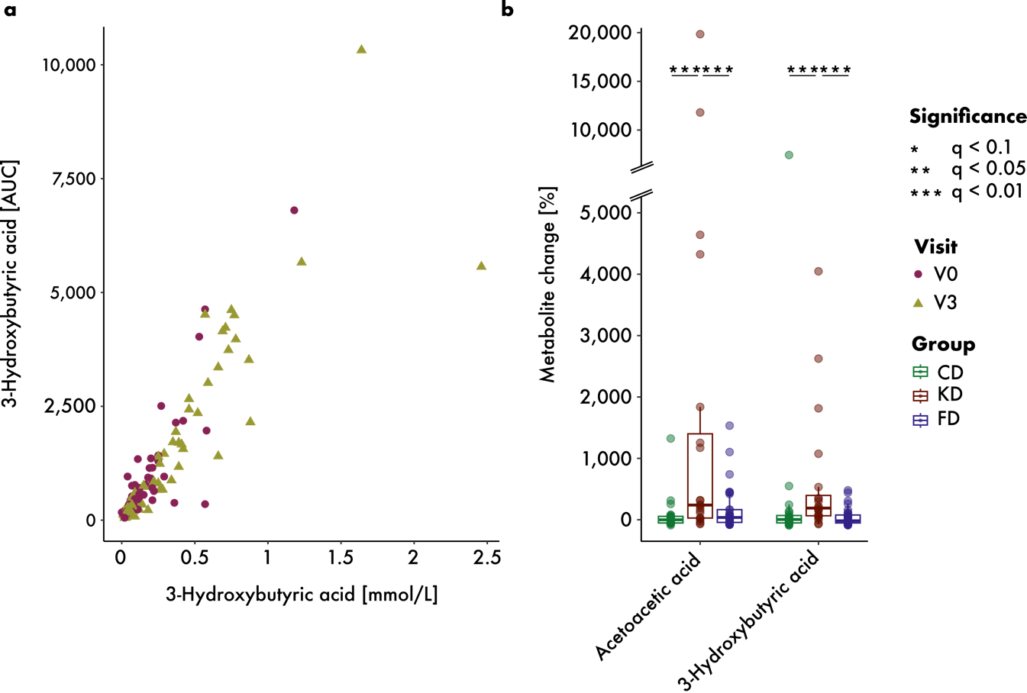

Figure S1. Serum ketone body levels. (a) Correlation between 3-hydroxybutyric acid measurements performed on the same samples in our lab on the y-axis and the contract lab Labor Berlin on the x-axis (p = 2.2e^-16, rho = 0.91). (b) Percent change in AUC from 0 to 9 months of the two measured ketone bodies. KD led to increased acetoacetic acid and 3-hydroxybutyric acid levels, which were significantly greater than those observed in the other diet groups. To accommodate extreme outlier values, the y-axis contains a break marked with diagonal lines between 5,000 and 7,000, with the region above the break compressed to 40% of its original scale relative to the region below.

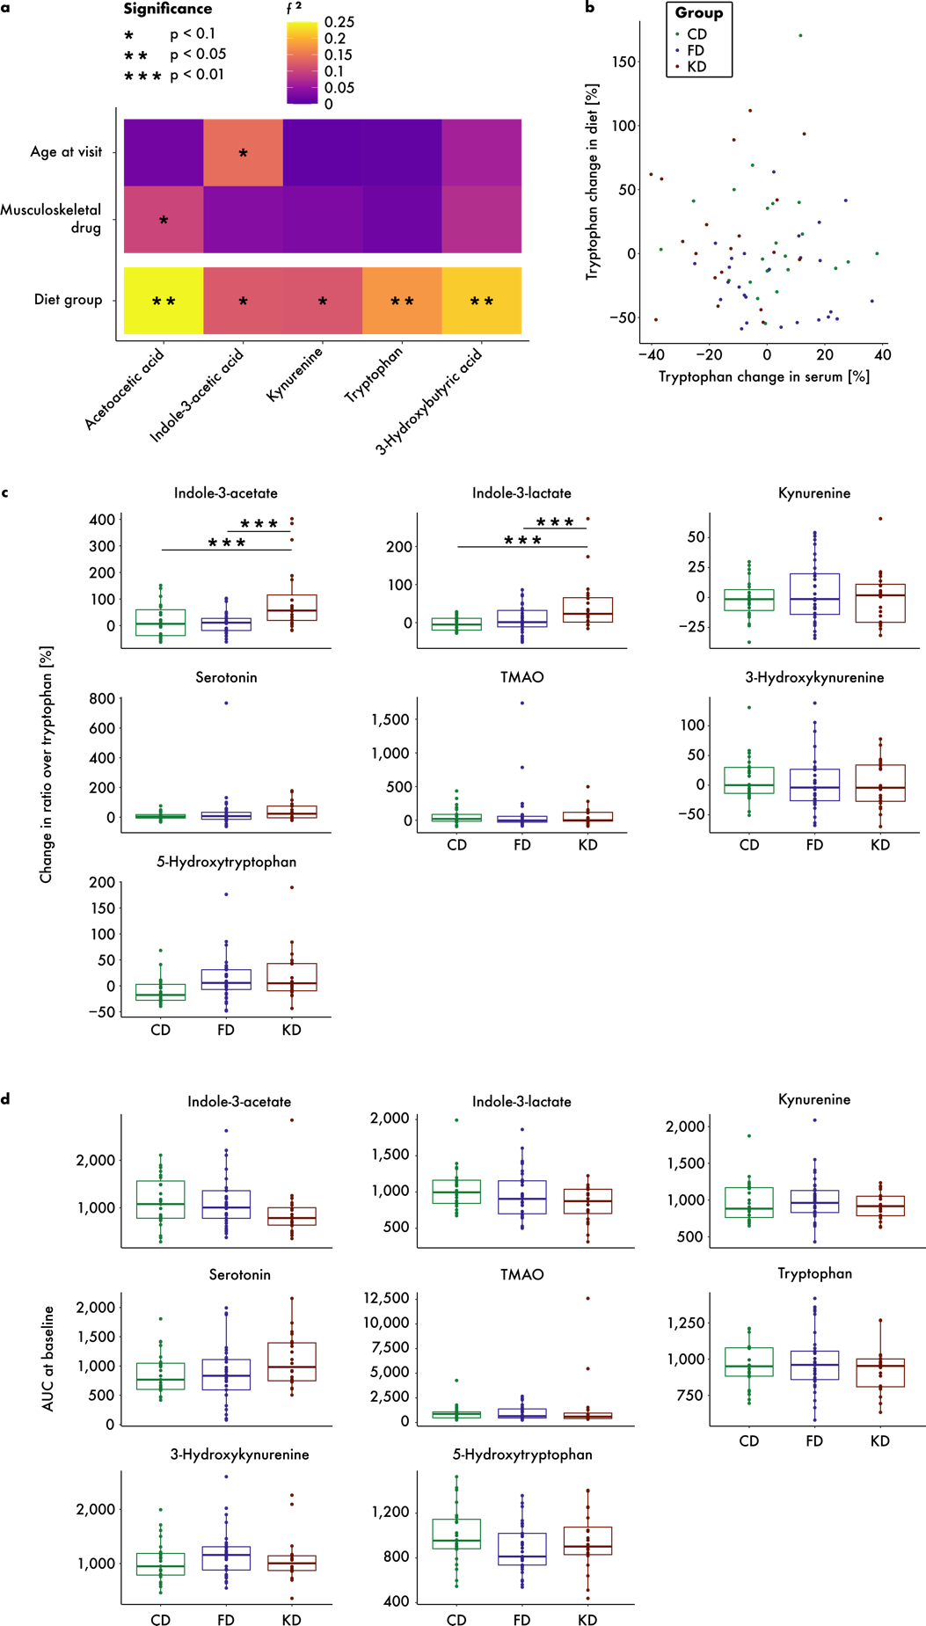

Figure S2. No covariate confounded the diet association with key serum metabolites. (a) Results of confounding analysis. Age and the number of musculoskeletal drugs consumed were co-associated with indole-3-acetate and acetoacetic acid, respectively, but did not confound the group-metabolite association. (b) Tryptophan changes measured in blood and calculated from dietary protocols showed no correlation (p = 0.63, rho = 0.06). (c) Changes in the ratios of each measured tryptophan metabolite to tryptophan in serum were significantly higher in KD than in CD or FD for indole-3-acetic acid and indole-3-lactate. (d) Tryptophan metabolites did not differ between diets at baseline.

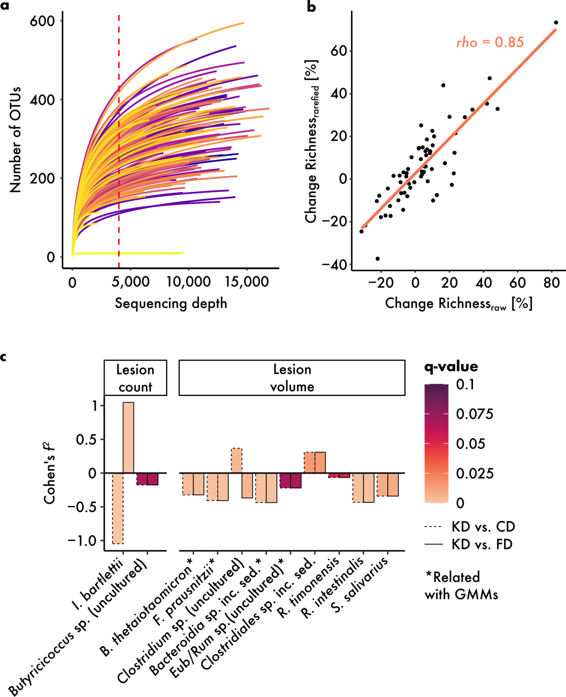

Figure S3. (a) Rarefaction curves showing the relationship between sequencing depth and the number of observed OTUs for each sample. Each line represents an individual sample, subsampled in increments of 20 reads. The dashed red vertical line marks a sequencing depth of 4,000 reads, indicating the rarefaction threshold. (b) Observed richness change over time for each sample, calculated from rarefied and raw, non-rarefied mOTU counts. Rarefied and raw richness changes were strongly correlated (Spearman's rho = 0.85, p = 2.2x10⁻¹⁶, 95% CI [0.78, 0.91]). (c) Bacterial species demonstrating group-dependent associations with lesion volume and lesion count over time. Species that mirror the gut microbial module-outcome relationship are indicated with an asterisk. Bars indicate Cohen’s f², are filled with the respective q-value and outlined according to the diet contrast applied.

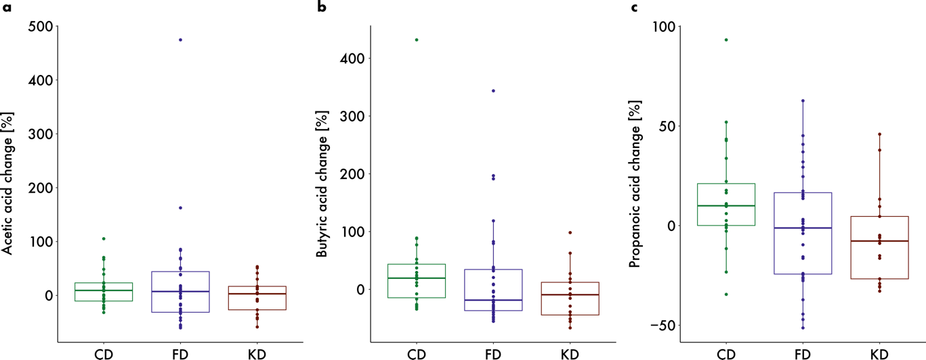

Figure S4. Changes in stool metabolites related to propionate CoA transferase metabolic pathways over 9 months by dietary intervention group showed no significant differences. (a) Acetic acid (p = 0.54, f² = 0.02). (b) Butyric acid (p = 0.11, f² = 0.08). (c) Propanoic acid (p = 0.11, f² = 0.09).

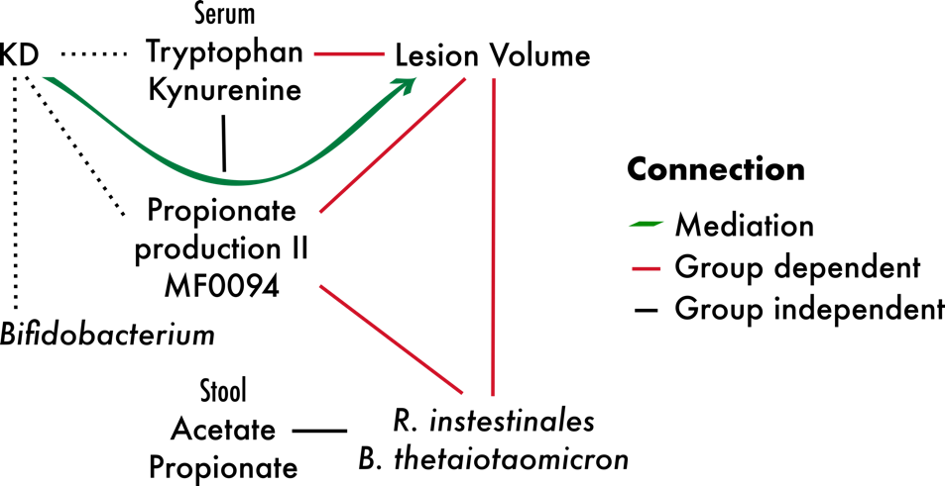

Figure S5. The GMM propionate production II (MF0094) mediated the effect of the diet on lesion volume (p_{KDvs.CD} = 0.06, p_{KDvs.FD} = 0.02, p_{FDvs.CD} = 0.77, proportion mediated_{KDvs.CD} = 0.66, proportion mediated_{KDvs.FD} = 0.71, proportion mediated_{FDvs.CD} = 0.03). In MS patients receiving KD, shifts in microbial function showed stronger associations with changes in serum metabolites, specific microbial species, and lesion outcomes compared to associations with stool metabolite levels or the KD-specific reduction in Bifidobacterium genus abundance. Black lines indicate correlations across diet groups, dashed black lines indicate an association between KD and the feature, while red lines show relationships between features that exhibit a significantly different association with each other in KD than in FD or CD.

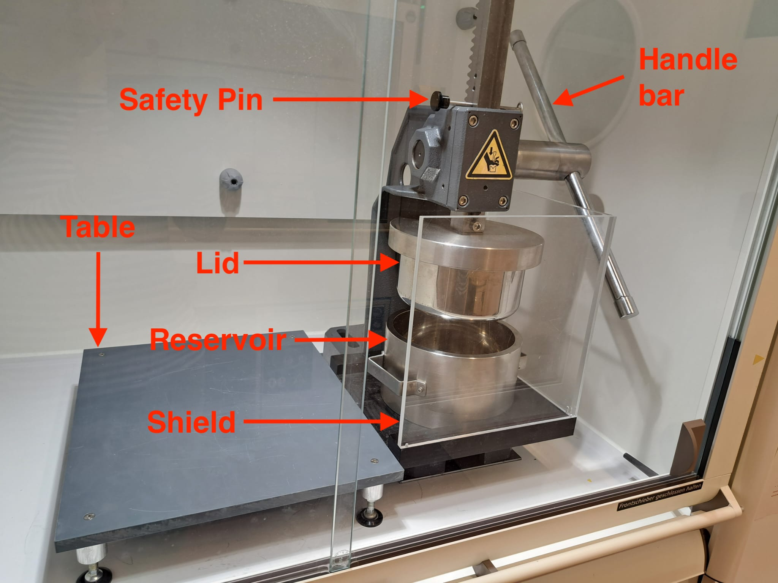

Figure S6. Custom stool homogenization device consisting of a lever with a handle-bar attached to a lid that can be lowered into a reservoir containing frozen stool samples in sterile Whirl-Pak® Standard Sterilized Sampling Bags (Whirl-Pak, Madison, WI, USA) following removal of a safety pin. A protective shield was attached for safety, and a work table was placed adjacent to the device to facilitate the smooth removal of the heavy reservoir. The lid and the reservoir can be frozen at -80 °C to keep the sample frozen at all times.

