Supplementary Information
Validation of a Troponin I-Adapted Modified GRACE Score : A Cohort Study
Dimitrios Delialis, PhD^{1*}, Georgios Georgiopoulos, PhD^{2*}, Christina Chrysochou, PhD³, Luke Spray, PhD⁴, Simon Kraler, MD PhD^{5,6}, Panagiotis Nastatos, MD¹, Polyxeni Manifava, MD¹, Christina Konstantaki, MD¹, Stavros Athanasopoulos, MD¹ , Yannis Skoumas, PhD³, Christos Pitsavos, PhD³, Sofia-Panagiota Giannakopoulou, PhDc⁷, Georgios Mavraganis, MD¹, Kateryna Sopova, PhD^{8,9}, Maria-Angeliki Dimopoulou, MD¹, Dimitrios Papoutsis, PhD¹, Achilleas A. Zacharoulis, MD¹⁰, Konstantinos Stellos, PhD^{8,11}, Ioakim Spyridopoulos, PhD^{4**}, Demosthenes Panagiotakos,PhD^{7 **}, Kimon Stamatelopoulos, PhD^{1**}
¹ Department of Clinical Therapeutics, National and Kapodistrian University of Athens Medical School, Athens, Greece.
² Second Department of Cardiology, School of Medicine, National and Kapodistrian University of Athens, Athens, Greece.
³ First Cardiology Clinic, Medical School, National and Kapodistrian University of Athens, Hippokration Hospital, Athens, Greece
⁴ Translational and Clinical Research Institute, Vascular Biology and Medicine Theme, Faculty of Medical Sciences, Newcastle University, Newcastle upon Tyne, UK.
⁵ Center for Molecular Cardiology, University of Zurich, Zurich, Switzerland.
⁶ Department of Cardiology, University Hospital Zurich, Zurich, Switzerland.
⁷ Department of Nutrition and Dietetics, School of Health Sciences and Education, Harokopio University, Athens, Greece
⁸ European Center for Angioscience (ECAS), Heidelberg University, Mannheim, Germany
⁹ Department of Cardiology, University Hospital Mannheim, Mannheim, Germany
¹⁰ Cardiology Department, Evangelismos Hospital, Athens, Greece
¹¹ Department of Medicine VI (Vascular Medicine and Diabetology), University Hospital Heidelberg - Medical Center Mannheim, Heidelberg University, Mannheim, Germany
¹² German Center for Cardiovascular Research (DZHK), Partner Site Heidelberg/Mannheim, Mannheim, Germany
¹³ Helmholtz-Institute for Translational AngioCardioScience (HI-TAC) of the Max Delbrück Center for Molecular Medicine in the Helmholtz Association (MDC), Heidelberg University, Mannheim, Germany.
*First author equal contribution
**Senior equal contribution

*First author equal contribution
**Senior equal contribution

Supplementary table 1. STROBE checklist
 | Item No | Recommendation | Page  No
Title and abstract | 1 | (a) Indicate the study’s design with a commonly used term in the title or the abstract | 3
Title and abstract | 1 | (b) Provide in the abstract an informative and balanced summary of what was done and what was found | 3-4
Introduction
Background/rationale | 2 | Explain the scientific background and rationale for the investigation being reported | 5
Objectives | 3 | State specific objectives, including any prespecified hypotheses | 5-6
Methods
Study design | 4 | Present key elements of study design early in the paper | 6
Setting | 5 | Describe the setting, locations, and relevant dates, including periods of recruitment, exposure, follow-up, and data collection | 6-7
Participants | 6 | (a) Cohort study—Give the eligibility criteria, and the sources and methods of selection of participants. Describe methods of follow-up  Case-control study—Give the eligibility criteria, and the sources and methods of case ascertainment and control selection. Give the rationale for the choice of cases and controls  Cross-sectional study—Give the eligibility criteria, and the sources and methods of selection of participants | 6-7
Participants | 6 | (b) Cohort study—For matched studies, give matching criteria and number of exposed and unexposed  Case-control study—For matched studies, give matching criteria and the number of controls per case
Variables | 7 | Clearly define all outcomes, exposures, predictors, potential confounders, and effect modifiers. Give diagnostic criteria, if applicable | 6-8
Data sources/ measurement | 8* | For each variable of interest, give sources of data and details of methods of assessment (measurement). Describe comparability of assessment methods if there is more than one group | 6-8
Bias | 9 | Describe any efforts to address potential sources of bias | 6-8
Study size | 10 | Explain how the study size was arrived at | 6-8
Quantitative variables | 11 | Explain how quantitative variables were handled in the analyses. If applicable, describe which groupings were chosen and why | 9
Statistical methods | 12 | (a) Describe all statistical methods, including those used to control for confounding | 9
Statistical methods | 12 | (b) Describe any methods used to examine subgroups and interactions | 9
Statistical methods | 12 | (c) Explain how missing data were addressed | 9
Statistical methods | 12 | (d) Cohort study—If applicable, explain how loss to follow-up was addressed  Case-control study—If applicable, explain how matching of cases and controls was addressed  Cross-sectional study—If applicable, describe analytical methods taking account of sampling strategy | 9
Statistical methods | 12 | (e) Describe any sensitivity analyses

Results
Participants | 13* | (a) Report numbers of individuals at each stage of study—eg numbers potentially eligible, examined for eligibility, confirmed eligible, included in the study, completing follow-up, and analysed | 10
Participants | 13* | (b) Give reasons for non-participation at each stage | 10
Participants | 13* | (c) Consider use of a flow diagram | 10
Descriptive data | 14* | (a) Give characteristics of study participants (eg demographic, clinical, social) and information on exposures and potential confounders | 10
Descriptive data | 14* | (b) Indicate number of participants with missing data for each variable of interest | 10
Descriptive data | 14* | (c) Cohort study—Summarise follow-up time (eg, average and total amount) | 10
Outcome data | 15* | Cohort study—Report numbers of outcome events or summary measures over time
Outcome data | 15* | Case-control study—Report numbers in each exposure category, or summary measures of exposure | 10
Outcome data | 15* | Cross-sectional study—Report numbers of outcome events or summary measures
Main results | 16 | (a) Give unadjusted estimates and, if applicable, confounder-adjusted estimates and their precision (eg, 95% confidence interval). Make clear which confounders were adjusted for and why they were included | 10-11
Main results | 16 | (b) Report category boundaries when continuous variables were categorized
Main results | 16 | (c) If relevant, consider translating estimates of relative risk into absolute risk for a meaningful time period
Other analyses | 17 | Report other analyses done—eg analyses of subgroups and interactions, and sensitivity analyses | 11
Discussion
Key results | 18 | Summarise key results with reference to study objectives | 12
Limitations | 19 | Discuss limitations of the study, taking into account sources of potential bias or imprecision. Discuss both direction and magnitude of any potential bias | 13
Interpretation | 20 | Give a cautious overall interpretation of results considering objectives, limitations, multiplicity of analyses, results from similar studies, and other relevant evidence | 12-14
Generalisability | 21 | Discuss the generalisability (external validity) of the study results | 12-14
Other information
Funding | 22 | Give the source of funding and the role of the funders for the present study and, if applicable, for the original study on which the present article is based | 15

Supplementary Table 2. Formulas and coefficients for the calculation of the short-term (in-hospital and 30-day) ModGRACE risk scores.
Variable | Input / Unit | In-Hospital Coefficient (β) | 30-Day Coefficient (β)
Constant (Intercept) | Base adjustment | -12.05593 | -10.70286
Age | Years | 0.0883206 | 0.0789503
Heart Rate | Beats per minute | 0.0202928 | 0.0206829
Systolic BP | mmHg | -0.0081591 | -0.008848
Creatinine | mg/dL | 0.0523408 | 0.0417948
Killip Class | Class (1, 2, 3, or 4) | 0.4948049 | 0.3902824
Cardiac Arrest | Yes = 1, No = 0 | 1.750323 | 1.639626
ST-segment Deviation | Yes = 1, No = 0 | 0.1789689 | 0.180215
Troponin Ratio | Continuous Fold-Change | 0.025254 | 0.0027154

Supplementary Table 3. Formulas and coefficients for the calculation of the 1-year ModGRACE risk score.
Variable | Transformation / Input | Coefficient (β)
Age | Age / 10 | 0.7167429
 | Age Spline | 0.001264
Systolic BP | Systolic BP / 20 | 0.1560752
 | Systolic BP Spline | 0.0026555
Heart Rate | Heart Rate / 30 | 1.041789
 | Heart Rate Spline 1 | 0.1045914
 | Heart Rate Spline 2 | -0.8098717
Creatinine | Creatinine (mg/dL) | 0.4839132
 | Creatinine Spline ​1 | -0.0954907
 | Creatinine Spline 2 | 0.107697
Killip Class | Class I | 0 (Reference)
 | Class II | 0.7386228
 | Class III | 0.9666557
 | Class IV | 0.5319715
Cardiac Arrest | Yes = 1, No = 0 | 1.006618
ST-segment Deviation | Yes = 1, No = 0 | 0.1973467
Troponin Ratio | Continuous Fold-Change | 0.0017698

Supplementary Table 4. Supplementary Table 2. Baseline characteristics of patients from the GREECS study included (n=1,630) and excluded (n=542).
Variable | Included | Excluded | p-value
Sex (male), % %) | 77.7 | 75.4 | 0.16
Current smoker, % | 66.2 | 66.2 | 0.96
H_{x} of hypertension, % | 57.0 | 54.3 | 0.12
H_{x} of diabetes, % | 33.2 | 31.0 | 0.32
H_{x} of hypercholesterolemia | 45.0 | 47.1 | 0.39
Previous CVD, % | 36.0 | 36.7 | 0.78
Age [years, mean (SD)] | 66.1 (12.9) | 65.9 (12.8) | 0.215
Systolic BP, mmHg  [ mean (SD)] | 135 (25.9) | 136.1 (27.1) | 0.37
Heart rate, bpm  [ mean (SD] | 78.4 (4.1) | 78.1 (4.0) | 0.17
Serum creatinine (mg/dl) [median (IQR)] | 1.0 (0.34) | 1.0 (0.27) | 0.83
ST deviation, % | 33.0 | 34.3 | 0.56
Cardiac Arrest | 1.4 | 0.6 | 0.08
Deaths at 30 days, % | 5.2 | 4.6 | 0.13
CV death 20 years, % | 26.6 | 28.6 | 0.19
MACE 20 yeas, % | 57.6 | 58.8 | 0.49

Supplementary Table 5. Comparison of discrimination performance (AUC and $Δ\text{AUC}$) between the original GRACE framework and ModGRACE risk scores across the GREECS and Freeman cohorts.
 | AUC_{original} _{GRACE} | AUC_{ModGRACE} | ΔAUC_{original GRACE-modGRACE}  P-value
GREECS cohort
30-days mortality | 0.748  (0.673, 0.823) | 0.778  (0.708, 0.847) | 0.029  (-0.011, 0.070)  p=0.156**
MACE 20 years | 0.735*  (0.705, 0.764) | 0.750*  (0.719, 0.779) | 0.015  (-0.011, 0.040)  P=0.26
CV death 20 years | 0.813*  (0.781, 0.847) | 0.856*  (0.826, 0.885) | 0.043  (0.013, 0.073)  P=0.006
FREEMAN cohort
In-hospital mortality | 0.870  (0.837, 0.902) | 0.884  (0.855, 0.914) | 0.015  (-0.001, 0.031)  P=0.066**
30-days mortality | 0.868  (0.837, 0.900) | 0.883  (0.855, 0.912) | 0.015  (-0.001, 0.031)  P=0.06**
1-year mortality | 0.709  (0.683, 0.735) | 0.724  (0.698, 0.751) | 0.015  (0.003, 0.027)  P=0.012
For short-term outcomes (such as in-hospital and 30-day mortality) original GRACE is derived from the original GRACE logistic equations, whereas for long-term outcomes (1-year and 20-year horizons), they derived from using the GRACE 2.0 Cox equation.*Values represent time-dependent (AUCs and absolute differences (ΔAUC) for ModGRACE and GRACE 2.0 predicting 20-year MACE and cv death. Metrics and 95% confidence intervals were derived using time-dependent ROC analysis with marginal weighting for censoring and a 500-replication non-parametric bootstrap procedure. **P-values are derived from DeLong
Abbreviations: AUC, area under the curve; CV, cardiovascular; GRACE, Global Registry of Acute Coronary Events; MACE, major adverse cardiovascular events; modGRACE, modified Global Registry of Acute Coronary Events;

Supplementary Figure 1. Flow chart of the study’s populations.
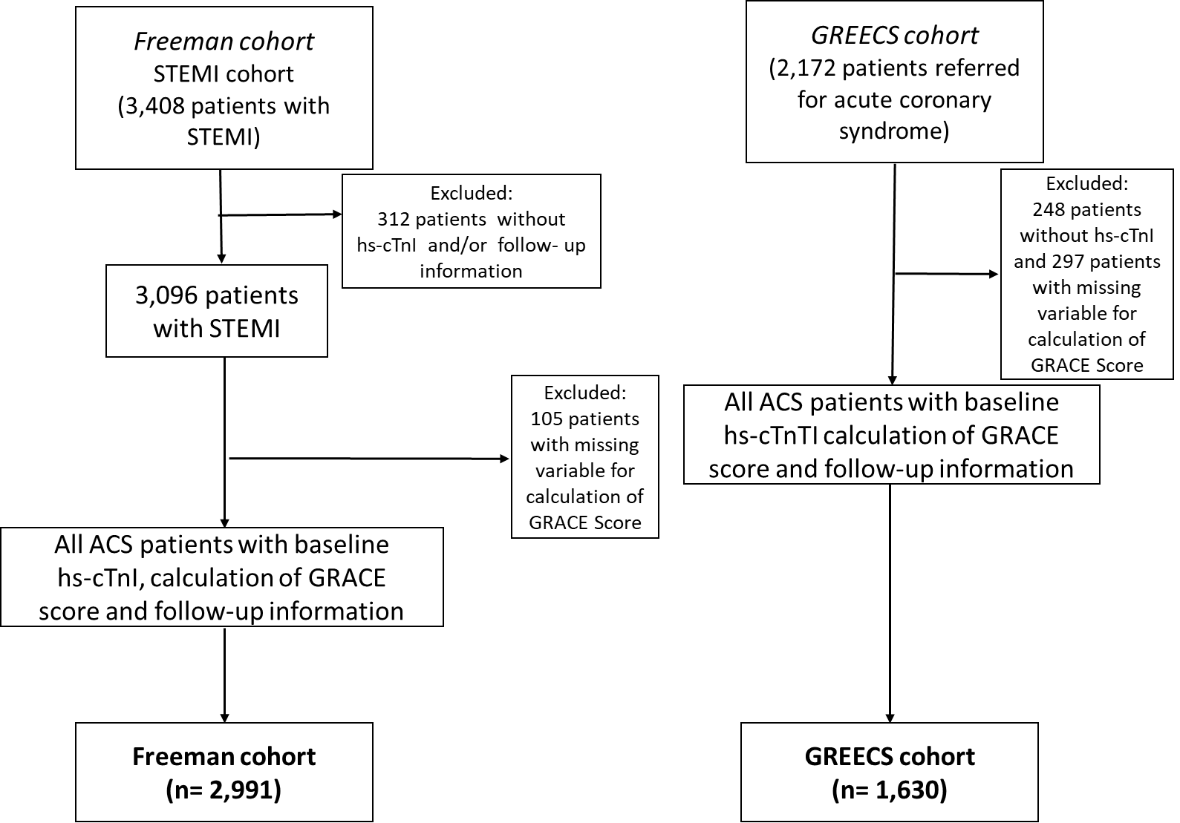
Supplementary Figure 2. Continuous time-dependent receiver operating characteristic (ROC) analysis predicting 20-year MACE and CV death in the GREECS cohort. The left panel illustrates the dynamic area under the curve (AUC) trajectories for ModGRACE (blue line) and GRACE 2.0 (red line) over the follow-up period for (A) MACE and (B) CV death. The right panel displays the absolute difference in AUC ($Δ$AUC, calculated as ModGRACE minus GRACE 2.0) across the same timeframe for (C) MACE and (D) CV death.
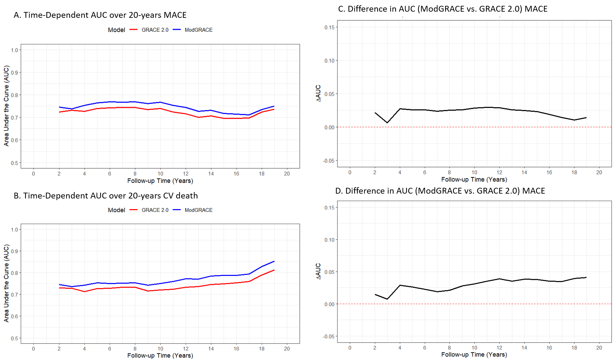

Supplementary Figure 3. Calibration of the modGRACE risk score for short- and long-term cardiovascular outcomes. Plots demonstrate the agreement between predicted (expected) and observed event probabilities in the GREECS (top: 30-day mortality, 20-year CV death, 20-year MACE) and Freeman cohorts (bottom: 30-day, in-hospital, and 1-year mortality). The dashed diagonal line indicates perfect calibration, while the dark solid band represents the actual smoothed relationship. Green circles depict patient risk deciles. Spike (rug) plots along the x-axis show the density of predicted probabilities for events (top) versus non-events (bottom). Key global performance metrics (O:E, CITL, Slope, AUC) are provided for each endpoint.

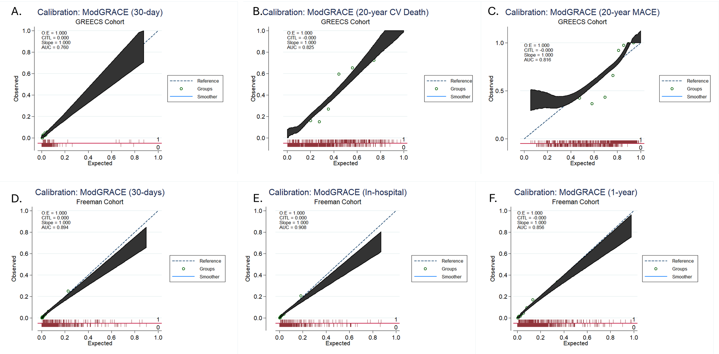

Supplementary Figure 4. Receiver operating characteristic (ROC) curves comparing the predictive performance of the original GRACE framework and ModGRACE risk scores in the GREECS (A-C) and the Freeman cohort (D-F). Formal assessment of discrimination improvement was performed using Harrell’s C-index (reported in Table 2 and Figure 3) to account for censored survival data. Panels (A), (D), and (E) display ordinary binary ROC curves predicting short-term, uncensored outcomes (in-hospital and 30-day mortality), with statistical comparisons performed using the conventional DeLong test. (B) and (C) represent time-dependent AUCs and absolute differences (ΔAUC) evaluated at the fixed 19.9-year follow-up milestone (t=19.9 years) (for predicting MACE and CV death. Metrics and 95% confidence intervals were derived using time-dependent ROC analysis with marginal weighting for censoring and a 500-replication non-parametric bootstrap procedure.

