Microbial Spectrum and Antimicrobial Resistance Are Associated with Outcomes After Endoscopic Ultrasound-Guided Therapy of Pancreatic Fluid Collections

Marcel Razpotnik^{1,*}, Christian Jürgensen¹, Michael Sigal¹, Toni Herta¹, Özlem Çelebi¹, Andreas Adler¹, Silke Leonhardt¹, Federica Branchi², Juliane Buchkremer², Konstantinos Kouladouros¹, Alexander Wree^{1,3}, Jürgen Pilz⁴, Markus M. Heimesaat⁵, Britta Siegmund², Cornelius Engelmann¹, Frank Tacke¹
¹Department of Hepatology and Gastroenterology, Campus Virchow-Klinikum (CVK) and Campus Charité Mitte (CCM), Charité - Universitätsmedizin Berlin, Germany
²Department of Gastroenterology, Infectology and Rheumatology, Campus Benjamin Franklin (CBF), Charité - Universitätsmedizin Berlin, Germany
³Department of Gastroenterology, Vivantes Hospital Friedrichshain Berlin, Berlin, Germany
⁴Department of Statistics, University of Klagenfurt, Klagenfurt, Austria
⁵Institute of Microbiology, Infectious Diseases and Immunology, Charité - Universitätsmedizin Berlin, Corporate Member of Freie Universität Berlin, Humboldt-Universität zu Berlin, and Berlin Institute of Health, Berlin, Germany

Supplementary Material

METHODS
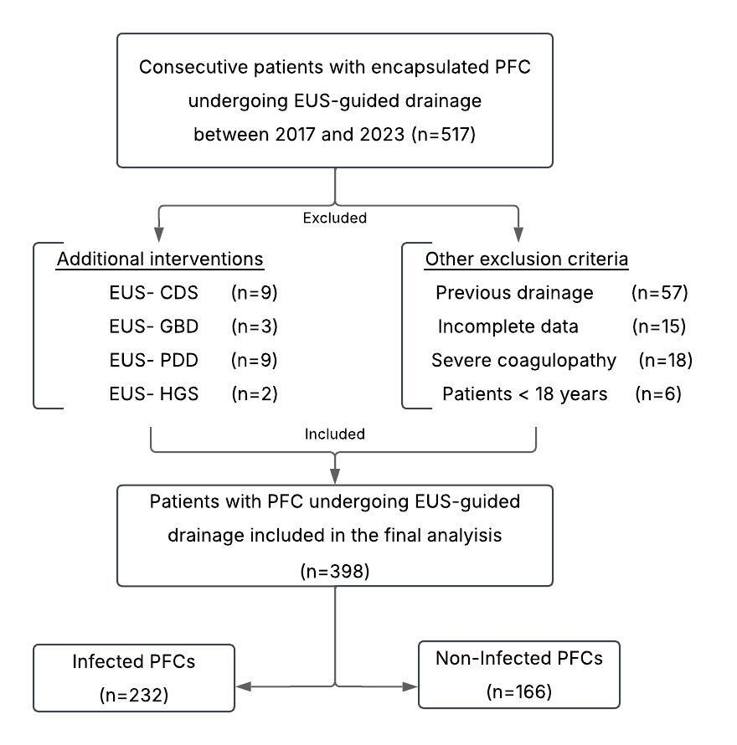
Supplementary Figure 1. Study flow-chart.

Abbreviations: CDS, Choledochoduodenostomy; EUS, Endoscopic Ultrasound; GBD, Gallbladder Drainage; HGS, Hepaticogastrostomy; PDD, Pancreatic Duct Drainage; PFC, Pancreatic Fluid Collection.

Microbiological assessment
Initial evaluation included Gram staining and direct microscopy, followed by aerobic and anaerobic cultures on selective and non-selective media. Bacteria were further classified according to their antibiotic susceptibility profile as defined by the European Committee for Antimicrobial Susceptibility Testing (EUCAST). Multidrug-resistant (MDR) bacteria were defined as having acquired non-susceptibility to ≥1 agent in ≥3 antimicrobial categories; extensively drug-resistant (XDR) bacteria retained susceptibility to ≤2 antimicrobial categories; and pandrug-resistant (PDR) bacteria exhibited resistance to all agents in all antimicrobial categories for which susceptibility testing was performed[15].
RESULTS
Supplementary Table 1. Median number of antimicrobial agents and cumulative duration of therapy during hospitalization.
Antimicrobial Class | Patients | Co-Antibioticsª | Duration^{b}
 | % (N) | N (IQR) | days (IQR)
Aminoglycosides | 2.3 (9) | 8 (5.5-10) | 70 (36.8-87.8)
Carbapenems | 38.2 (152) | 3 (2-5) | 20 (12-39.3)
Caspofungin | 14.8 (59) | 6 (4-7) | 31 (15-45)
Cephalosporins | 20.4 (81) | 3 (2-6) | 15 (10-35.5)
Fluconazole | 4.3 (17) | 5 (4-6) | 24.5 (16-36)
Linezolid | 8.0 (32) | 4.5 (3-6.5) | 35 (15.8-45.8)
Macrolides | 0.8 (3) | 10 (6.3-10) | 93 (55.5-127)
Nitroimidazoles | 12.8 (51) | 3 (2-5) | 13 (9.3-29.3)
Penicillin derivatives | 42.0 (167) | 2 (1-5) | 15 (10-32)
Quinolones | 12.6 (50) | 2 (2-6) | 24 (10-48)
Tigecycline | 4.3 (17) | 6 (3-8) | 56 (28-89.5)
Vancomycin | 21.4 (85) | 4 (2.8-6) | 26.5 (15-48)
Others | 7.3 (29) | 5 (2-8) | 35 (14.8-63.8)

Abbreviations: IQR, interquartile range; N, number. ªMedian number of antibiotics administered during hospitalization, either concurrently or sequentially; ^{b}Median cumulative duration of antibiotic therapy during hospitalization.

Supplementary Table 2. Incidence of the most common microorganisms isolated from infected pancreatic fluid collections.

Gram-positive bacteria | % (N) | Gram-negative bacteria (cont.) | % (N)
Actinomyces spp. | 1.0 (4) | Klebsiella pneumoniae | 7.3 (29)
Enterococcus spp. | 26.9 (107) | Klebsiella oxytoca | 1.5 (6)
Enterococcus faecalis | 8.8 (35) | Pseudomonas spp. | 3.8 (15)
Enterococcus faecium | 18.8 (75) | Pseudomonas aeruginosa | 3.0 (12)
Enterococcus, others | 0.5 (2) | Prevotella spp. | 4.0 (16)
Staphylococcus spp. | 9.8 (39) | Prevotella buccae | 1.8 (7)
Staphylococcus epidermidis | 7.5 (30) | Prevotella melaninogenica | 1.5 (6)
Staphylococcus aureus | 2.5 (10) | Prevotella denticola | 0.8 (3)
Staphylococcus haemolyticus | 2.3 (9) | Proteus spp. | 1.5 (6)
Staphylococcus hominis | 0.5 (2) | Proteus mirabilis | 1.5 (5)
Staphylococcus warneri | 0.5 (2) | Serratia spp. | 2.3 (9)
Streptococcus spp. | 13.1 (52) | Serratia marcescens | 1.8 (7)
Streptococcus mitis/ oralis | 3.3 (13) | Veillonella spp. | 1.5 (5)
Streptococcus parasanguinis | 2.3 (9) | Veillonella atypica | 0.8 (3)
Streptococcus anginosus | 1.8 (7)
Streptococcus salivarius | 1.5 (6) | Candida species | % (N)
Streptococcus constellatus | 1.5 (6) | Candida albicans | 21.9 (87)
Lactobacillus spp. | 2.8 (11) | Candida krusei | 2 (8)
 |  | Candida dubliniensis | 0.8 (3)
Gram-negative bacteria | % (N) | Candida glabrata | 6.3 (25)
Acinetobacter baumannii | 0.5 (2) | Candida tropicalis | 12.6 (5)
Bacteroides spp. | 3.3 (13) | Candida, others | 2.3 (9)
Bacteroides fragilis | 1.8 (7)
Bacteroides vulgatus | 0.5 (2) | Resistant microorganisms | % (N)
Citrobacter spp. | 3.0 (12) | MRSA | 0.8 (3)
Citrobacter freundii | 1.3 (5) | VRE | 6.5 (26)
Citrobacter koseri | 1.0 (4) | 3-MRGN | 3.0 (12)
Escherichia coli | 8.3 (33) | 4-MRGN | 0.8 (3)
Enterobacter cloacae | 4.8 (19) | MDR | 29.6 (118)
Fusobacterium nucleatum | 0.5 (2) | XDR | 1.5 (6)
Klebsiella spp. | 9.0 (36) | PDR | 0.3 (1)

Abbreviations: MDR, multidrug-resistant; MRGN, multiresistant Gram-negative bacteria; MRSA, methicillin-resistant Staphylococcus aureus; N, number; PDR, pandrug-resistant; VRE, Vancomycin-resistant Enterococcus; XDR, extensively drug-resistant.
Only microorganisms identified in at least two cases are presented in the table. The following microorganisms were isolated in a single case: Abiotrophia defective, Actinomyces graevenitzii, Actinomyces israelii, Alloscardovia omicolens, Bacillus cereus, Bacteroides dorei, Bacteroides ovatus, Bacteroides thetaiotaomicron, Bacteroides isolvens, Clostridium clostridioforme, Collinsella aerofaciens, Corynebacterium amycolatum, Cutibacterium acnes, Eikenella corrodens, Enterococcus gallinarum, Enterococcus hirae, Klebsiella aerogenes, Morganella morganii, Neisseria subflava, Ochrobactrum intermedium, Pandoraea sputorum, Parvimonas micra, Proteus vulgaris, Providencia stuartii, Pseudomonas alcaligenes, Pseudomonas oryzihabitans, Pseudomonas stutzeri, Rahnella aquatilis, Raoultella ornithinolytica, Rothia dentocariosa, Serratia liquefaciens, Serratia odorifera, Staphylococcus capitis, Staphylococcus caprae, Streptococcus viridans, Veillonella dispar, Veillonella parvula.

Supplementary Table 3. Sensitivity analysis: Cox regression predictors of incomplete resolution, restricted to patients with infected pancreatic walled-off necrosis (n=118).
Variables | Univariable |  | Multivariableª
Patient | HR (95% CI) | p-value | HR (95% CI) | p-value
Age ≥ 65 years | 0.91 (0.50–1.66) | 0.75
Male | 1.22 (0.71–2.11) | 0.47
BMI ≥ 30 kg/m² | 0.50 (0.25–1.00) | 0.05 | 0.62 (0.29–1.36) | 0.24
Comorbidity | 1.41 (0.85–2.34) | 0.18
ASA ≥ 3 | 1.09 (0.69–1.73) | 0.71
Pre-drainage organ failure | 0.90 (0.50–1.65) | 0.75
Collection
Size > 8 cm | 2.77 (1.68–4.57) | <0.001 | 2.77 (1.54–4.97) | <0.001
Etiology | 1.60 (0.93–2.77) | 0.09 | 1.20 (0.63–2.26) | 0.58
Necrosis extent > 30% | 1.25 (0.77–2.03) | 0.37
Therapy
DPS | 0.45 (0.19–1.03) | 0.06 | 0.58 (0.24–1.38) | 0.22
Multiple stents | 0.99 (0.61–1.61) | 0.98
Percutaneous drainage | 0.97 (0.60–1.56) | 0.90
Immunosuppressive therapy | 1.25 (0.39–3.96) | 0.71
Previous antibiotic therapy | 1.91 (0.95–3.86) | 0.09
IAT | 1.33 (0.79–2.25) | 0.28
Infection
Gram-positive | 2.69 (1.34–5.38) | 0.005 | 2.33 (1.08–5.04) | 0.03
Gram-negative | 0.80 (0.50–1.27) | 0.34
Polymicrobial | 1.10 (0.48–2.54) | 0.82
Enterococcus spp. | 2.34 (1.45–3.77) | <0.001 | 2.24 (1.37–3.67) | 0.001
VRE | 1.25 (0.67–2.32) | 0.49
MDR | 1.18 (0.72–1.94) | 0.51
MDR multiple | 1.63 (0.90–2.98) | 0.11 | 1.62 (0.86–3.05) | 0.13
XDR | 0.69 (0.22–2.17) | 0.53
MRGN | 1.17 (0.50–2.72) | 0.72
Candida albicans | 0.62 (0.38–1.00) | 0.05 | 0.63 (0.38–1.04) | 0.07
Candida, non-albicans | 1.20 (0.72–1.98) | 0.49

Abbreviations: ASA, American Society of Anesthesiologists; BMI, body mass index; DPS, double-pigtail plastic stents; HR, hazard ratio; IAT, inadequate antimicrobial therapy; MDR, multidrug-resistant; MRGN, multi resistant Gram-negative bacteria; PFC, pancreatic fluid collection; VRE, Vancomycin-resistant Enterococcus; XDR, extensively drug-resistant. ªMultivariable model adjusted for the following covariates: age, gender, comorbidity, PFC size, and etiology.
Supplementary Table 4. Multinomial logistic regression identifying risk factors for Enterococcus- and non-Enterococcus-infected PFCs versus sterile controls.
Variables | Enterococcus vs. Control |  | Non-Enterococcus vs. Control
 | RRR (95% CI) | p-value | RRR (95% CI) | p-value
Patient
Age ≥ 65 years | 0.93 (0.54-1.59) | 0.79 | 0.48 (0.27-0.86) | 0.01
Male | 1.91 (1.10-3.32) | 0.02 | 1.48 (0.89-2.45) | 0.13
BMI ≥ 30 kg/m² | 0.94 (0.46-1.94) | 0.88 | 0.86 (0.43-1.71) | 0.67
Comorbidity | 1.92 (1.08-3.42) | 0.03 | 1.16 (0.70-1.92) | 0.57
ASA ≥ 3 | 2.72 (1.64-4.53) | <0.001 | 1.11 (0.70-1.77) | 0.66
Pre-drainage organ failure | 1.35 (0.73-2.50) | 0.34 | 1.00 (0.54-1.85) | 0.99
Collection
Size > 8 cm | 4.39 (2.51-7.68) | <0.001 | 1.58 (0.98-2.56) | 0.06
Etiology | 1.93 (1.16-3.23) | 0.01 | 1.69 (1.04-2.74) | 0.03
Presence of necrosis | 4.98 (2.95-8.45) | <0.001 | 1.62 (0.99-2.66) | 0.05
Necrosis extent > 30% | 2.26 (0.98-5.25) | 0.06 | 0.56 (0.21-1.46) | 0.23
Therapy
DPS | 0.97 (0.50-1.90) | 0.94 | 4.30 (1.60-11.6) | 0.004
Multiple stents | 2.45 (1.45-4.14) | <0.001 | 2.65 (1.60-4.41) | <0.001
Necrosectomy | 5.0 (2.88-8.67) | <0.001 | 2.14 (1.24–3.72) | 0.007
Percutaneous drainage | 4.11 (2.09-8.07) | <0.001 | 1.17 (0.54-2.55) | 0.70
Immunosuppressive therapy | 0.81 (0.33–1.99) | 0.65 | 1.27 (0.59–2.74) | 0.54
Previous antibiotic therapy | 2.02 (1.03-3.97) | 0.04 | 1.30 (0.74-2.29) | 0.37
IAT | 3.49 (1.10-11.0) | 0.03 | 1.10 (0.34-3.59) | 0.88

Abbreviations: ASA, American Society of Anesthesiologists; BMI, body mass index; CI, confidence interval; DPS, double-pigtail plastic stents; IAT, inadequate antimicrobial therapy; PFC, pancreatic fluid collection; RRR, relative risk ratio.

Supplementary Table 5. Clinical characteristics in PFC patients with vs. without direct endoscopic necrosectomy.
Variables | PFCs with Necrosectomy | PFCs without Necrosectomy | p-valueª
 | (n=123) | (n=275)
Patient
Age ≥ 65 years (%) | 26 (21.1) | 74 (26.9) | 0.40
Male (%) | 93 (75.6) | 188 (68.4) | 0.60
BMI ≥ 30 kg/m² (%) | 14 (11.4) | 41 (14.9) | 0.50
Comorbidity (%) | 92 (74.8) | 196 (71.3) | 0.84
ASA ≥ 3 (%) | 58 (47.2) | 142 (51.6) | 0.70
Pre-drainage organ failure | 21 (17.1) | 51 (18.5) | 0.88
Collection
Size > 8 cm (%) | 94 (76.4) | 104 (37.8) | <0.001
Etiology (%) | 105 (85.4) | 145 (52.7) | 0.005
Presence of necrosis (%) | 106 (86.2) | 58 (21.1) | <0.001
Necrosis extent > 30% (%) | 43 (35.0) | 18 (6.5) | <0.001
Therapy
DPS (%) | 102 (82.9) | 241 (87.6) | 0.79
Multiple stents (%) | 87 (70.7) | 55 (20) | <0.001
Percutaneous drainage (%) | 24 (19.5) | 35 (12.7) | 0.18
Immunosuppressive therapy | 7 (5.7) | 30 (10.9) | 0.18
Previous antibiotic therapy (%) | 114 (92.7) | 164 (59.6) | 0.009
IAT (%) | 33 (26.8) | 37 (13.5) | 0.01
Infection
Infection (%) | 94 (76.4) | 138 (50.2) | 0.02
Gram-positive (%) | 81 (65.9) | 100 (36.4) | 0.001
Gram-negative (%) | 50 (40.7) | 73 (26.5) | 0.06
Polymicrobial (%) | 84 (68.3) | 114 (41.5) | 0.007
Enterococcus spp. (%) | 55 (44.7) | 52 (18.9) | <0.001
VRE (%) | 20 (16.3) | 6 (2.2) | <0.001
MDR (%) | 56 (45.5) | 62 (22.5) | 0.001
MDR multiple (%) | 23 (18.7) | 15 (5.5) | <0.001
XDR (%) | 3 (2.4) | 3 (1.1) | 0.58
MRGN (%) | 10 (8.1) | 5 (1.8) | 0.009
Candida albicans (%) | 34 (27.6) | 53 (19.3) | 0.18
Candida, non-albicans (%) | 29 (23.6) | 21 (7.6) | <0.001
Abbreviations: ASA, American Society of Anesthesiologists; BMI, body mass index; DPS, double-pigtail plastic stents; HR, hazard ratio; IAT, inadequate antimicrobial therapy; MDR, multidrug-resistant; MRGN, multi resistant Gram-negative bacteria; PFC, pancreatic fluid collection; VRE, Vancomycin-resistant Enterococcus; XDR, extensively drug-resistant. ªChi-square Test.

