Supplementary Notes
quantmsdiann: a scalable SDRF-driven DIA-NN workflow for reanalysis of single-cell, spatial, and bulk proteomics datasets
Qi-Xuan Yue ¹; Yufei Shen ¹; Chengxin Dai ²; Asier Larrea-Sebal ^{3,4}; Henry Webel ⁵; Jose Nimo ^{6,7,8}; Fabian Coscia ⁶,⁸; Orhun Kok ⁹; Nikolai Slavov ^{9,10}; Juan Antonio Vizcaı́no ³; Timo Sachsenberg ^{11,12}; Mingze Bai ¹; Vadim Demichev ¹³; Yasset Perez-Riverol ^{3,*}
¹ Chongqing Key Laboratory of Big Data for Bio Intelligence, Chongqing University of Posts and Telecommunications, Chongqing, China.
² State Key Laboratory of Proteomics, Beijing Proteome Research Center, National Center for Protein Sciences (Beijing), Beijing Institute of Life Omics, Beijing, China.
³ European Molecular Biology Laboratory, European Bioinformatics Institute (EMBL-EBI), Wellcome Genome Campus, Hinxton, Cambridge, UK.
⁴ Department of Biochemistry and Molecular Biology, Universidad del País Vasco UPV/EHU, Bilbao, 48080, Spain.
⁵ Novo Nordisk Foundation Center for Protein Research, Faculty of Health and Medical Sciences, University of Copenhagen, Copenhagen, Denmark.
⁶ Spatial Proteomics Group, Max-Delbrück-Center for Molecular Medicine in the Helmholtz Association (MDC), Berlin, Germany.
⁷ Charité – Universitätsmedizin Berlin, corporate member of Freie Universität Berlin and Humboldt-Universität zu Berlin, Berlin, Germany.
⁸ German Cancer Consortium (DKTK), Partner Site Berlin, Heidelberg, Germany.
⁹ Department of Bioengineering and Barnett Institute, Northeastern University, Boston, Massachusetts, USA
¹⁰ Parallel Squared Technology Institute, Watertown, Massachusetts, USA.
¹¹ Department of Computer Science, Applied Bioinformatics, University of Tübingen, Tübingen, Germany.
¹² Institute for Bioinformatics and Medical Informatics, University of Tübingen, Tübingen, Germany.
¹³ Quantitative Proteomics Laboratory, Charité – Universitätsmedizin Berlin, Berlin, Germany.

Supplementary Note 1: Building DIA-NN container images 3
Supplementary Note 2: Datasets benchmarked and reanalyzed 3
Supplementary Note 3: Identification filtering and protein counting 5
Supplementary Note 4: Per-process runtime and resource envelopes 6
Supplementary Note 5: ProteoBench protein-group depth across DIA-NN versions 7
Supplementary Note 6: Per-cohort completeness and overlap (cell-line reanalyses) 8
Supplementary Note 7: Software and resources 10

Supplementary Note 1: Building DIA-NN container images
Every quantmsdiann step runs in a versioned container (Docker, Singularity, or Apptainer). Most images are pulled automatically from public registries (BioContainers or ghcr.io/bigbio); DIA-NN is the exception because its license restricts redistribution. Only DIA-NN 1.8.1 may be redistributed, so it is shipped as the default and pulled from BioContainers (docker.io/biocontainers/diann:v1.8.1_cv1). Releases from 1.9 onward (1.9.2 through 2.5.1, including the 2.5.1-enterprise build) cannot be redistributed and are therefore not shipped as images; instead, the companion quantms-containers repository (https://github.com/bigbio/quantms-containers) provides one build recipe per release. A user with a valid DIA-NN download builds the image locally from the matching recipe, for example:
cd diann-2.5.1 && docker build -t ghcr.io/bigbio/diann:2.5.1 .
For quantmsdiann to select a locally built image automatically, it must be tagged with the prefix ghcr.io/bigbio/diann: followed by the release tag (e.g. ghcr.io/bigbio/diann:2.5.1 or ghcr.io/bigbio/diann:2.5.1-enterprise); the workflow then resolves the container for the requested version through the corresponding diann_vX_Y_Z profile selected at runtime.

Supplementary Note 2: Datasets benchmarked and reanalyzed
Table 1 lists every public dataset used in this study. For each dataset, an SDRF was prepared from the original sample metadata; every accession in the table below links to its validated SDRF in the curated bigbio/sdrf-annotated-datasets collection (https://github.com/bigbio/sdrf-annotated-datasets). Raw files were downloaded from PRIDE and MassIVE using pridepy. For each cell-line reanalysis cohort, the original published quantification was downloaded from a public repository (the PRIDE deposition, or an associated repository such as figshare for ProCan) and used as the comparator. The cell-line bulk DIA cohorts were assembled by programmatic search of PRIDE Archive via the PRIDE API, filtering for projects annotated as DIA acquisition on human samples with at least one standardised cell line listed in the Cellosaurus reference, downloadable raw files, and SDRF-compatible sample metadata.
Datasets benchmarked and reanalysed with quantmsdiann. The “Public date” column is the PRIDE/MassIVE public-release year of the deposit, which can predate the associated publication year cited in the main text (e.g. PXD003539 was deposited in 2016 and published as Guo et al. 2019; PXD004701 deposited 2016, published as Sun et al. 2023).
Accession | Instrument | Type | Public date
ProteoBench benchmarks
PXD049412 | Orbitrap Astral | Single-cell (Module 9) | 2024
PXD062685 | timsTOF SCP | diaPASEF (Module 5) | 2025
PXD070049 | ZenoTOF 7600 | Mixed-species (Module 10) | 2025
Module 7 | Orbitrap Astral | Mixed-species (Module 7) | 2025
Bulk cell-line panel
PXD003539 | TripleTOF 5600 | Cell line (NCI-60) | 2016
PXD030304 | TripleTOF 6600 | Cell line (ProCan) | 2022
PXD004701 | TripleTOF 5600 | Cell line (Sun 2023) | 2016
PXD041421 | timsTOF (diaPASEF) | Cell line (Wang 2023) | 2023
PXD017199 | Q Exactive Plus | Cell line (Tognetti 2021) | 2021
Single-cell proteomics
PXD046357 | Orbitrap Astral | Single-cell HeLa (Astral) | 2024
PXD049412 | Orbitrap Astral | Single-cell A549/H460 (Bubis 2025; also, Module 9 benchmark) | 2024
MSV000093870 | Q Exactive | Single-cell oocyte plexDIA (Galatidou 2024) | 2024
Phosphoproteomics
PXD034128 | timsTOF Pro | Phospho diaPASEF (Skowronek 2022) | 2022
PXD034623 | Orbitrap Exploris 480 | Phospho directDIA (Galectin-1) | 2023
PXD049692 | timsTOF HT | Phospho diaPASEF (NK cells) | 2024
Spatial proteomics
PXD064049 | timsTOF SCP | Spatial DVP, diaPASEF (MYCN neuroblastoma) | 2025
Scalability experiment
PXD071075 | Orbitrap Eclipse | Single-cell | 2025

Supplementary Note 3: Identification filtering and protein counting
All quantmsdiann identification counts follow a single rule with exactly one admissible q-value filter per quantity and nothing else (no contaminant/target filter, no positive-quantity filter; zero quantities are counted; decoys are dropped). Per-run numbers (per cell, per run): protein groups at PG.Q.Value $≤0.01$ only; precursors at Q.Value $≤0.01$ only. Global (dataset-total/union) numbers: protein groups at Lib.PG.Q.Value $≤0.01$ only; precursors at Lib.Q.Value $≤0.01$ only. For deposited datasets, the “original” count is the deposited analysis result: the row count of the deposited pg_matrix/pr_matrix where only a count matrix is available (HeLa, spatial), or a protein count recomputed from the deposited search output for the reanalysis-recovery cohorts (NCI-60, ProCan, Sun; see below). In plexDIA mode, the channel is the per-run unit, so per-cell precursors are counted at Channel.Q.Value $≤0.01$ in addition to Q.Value $≤0.01$. plexDIA protein-group identification counts are not compared across DIA-NN versions, because the channel-level PG.Q.Value confidence used here is not defined in pre-2.0 output; for plexDIA, we report quantmsdiann depth on its own and assess reproducibility against the deposited analysis rather than an identification gain. For the reanalysis-recovery figure, each “original” count is recomputed from the deposited or public-repository data rather than transcribed from the paper, so every bar is reproducible: NCI-60 (PXD003539) and Sun (PXD004701) from the deposited PRIDE OpenSWATH analyses (for NCI-60, proteins with $≥2$ distinct peptides in feature_alignment_requant_matrix.tsv, reproducing the published 4,284; for Sun, proteotypic SwissProt proteins at the OpenSWATH peak-group q-value $≤0.01$ in 1R_all_id.txt, 6,183, reproducing the published $∼$6,091), and ProCan (PXD030304) from the authors’ figshare peptide-count matrix (proteins with $≥2$ supporting peptides, 6,698, reproducing the published 6,692). The quantmsdiann count is computed under its own global rule (Lib.PG.Q.Value $≤0.01$, with the $≥2$-peptide refinement where the original reports a $≥2$-peptide headline); no original-study consistency or detection filter is applied to the quantmsdiann side. Three caveats bound the cross-deposit comparisons (main-text Experimental Procedures): differences in FDR calibration across search-engine generations, the use of each original study’s own counting criterion, and possible differences in protein sequence database and search settings between the deposited analysis and the reanalysis (including contaminant databases that are often not deposited, as for the spatial DVP cohort PXD064049). Because quantmsdiann applies one harmonised FASTA and parameter set across all cohorts, residual count differences attributable to such undocumented database or setting choices cannot be fully excluded.

Supplementary Note 4: Per-process runtime and resource envelopes
These figures decompose the end-to-end wall-clock and resource use reported in main-text Fig. 2b by Nextflow process, derived from trace.txt records collected across the ProteoBench benchmark cohorts and the PXD071075 single-cell production sweep.
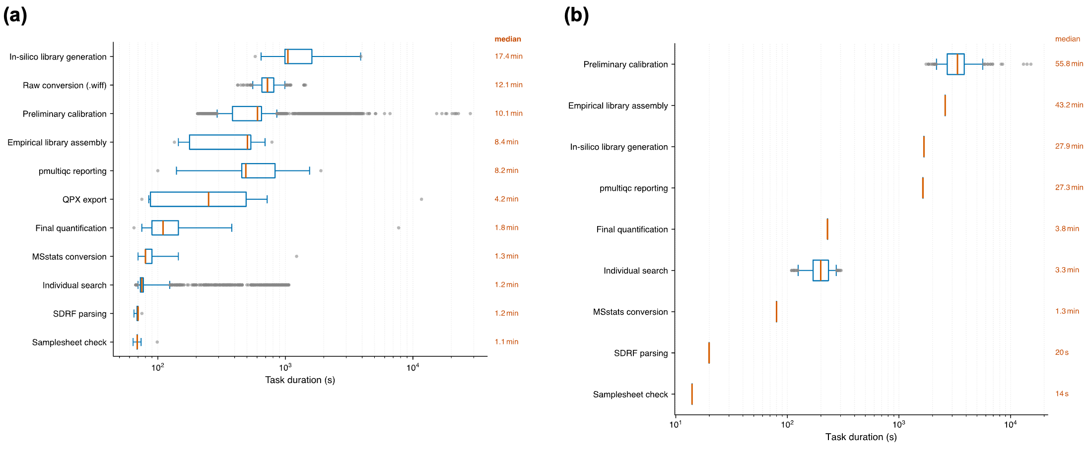
Figure S1: Per-step wall-clock distribution across Nextflow processes on the EBI cluster and an independent third-party cluster. (a) Task wall-clock time (boxplot, median and IQR) for each quantmsdiann process across the ProteoBench cohorts and the PXD071075 cluster-node sweep on the EBI HPC cluster. The per-file parallel stages (file_preparation, preliminary_analysis, individual_analysis) run once per raw file and set the parallelisation envelope. The collective stages (insilico_library_generation, assemble_empirical_library, final_quantification, diann_msstats) run once per cohort and set the wall-clock floor. (b) The same breakdown for a run executed independently by another group on a non-EBI SLURM cluster (Max Delbrück Center, Berlin; 279 raw files, DIA-NN 2.5.0, quantmsdiann v2.1.0, Singularity profile; total wall-clock 7 h 49 m). The process structure holds on third-party infrastructure without modification, showing the workflow's portability.
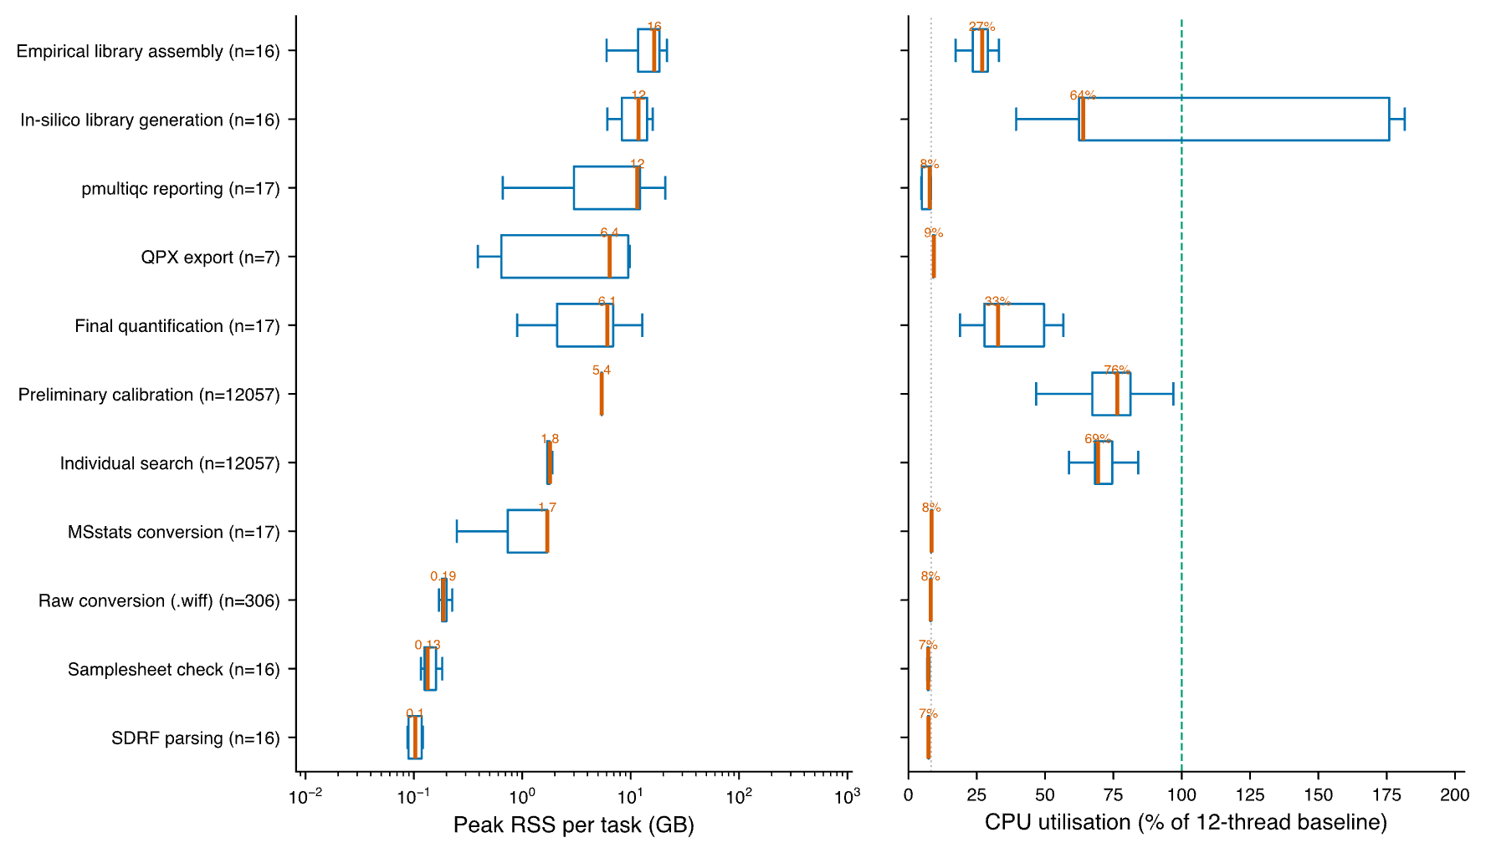
Figure S2: Peak memory and CPU envelope per Nextflow process. Per-task peak resident-set-size memory (left panel) and CPU utilisation (right panel) per quantmsdiann process across the ProteoBench benchmark cohorts and the PXD071075 cluster-node sweep. Box plots show the median (vermillion) and interquartile range; the per-step task count is given in each y-axis label and the median is printed above each box. CPU utilisation is expressed as a percentage of quantmsdiann’s 12-thread DIA-NN allocation, so a step that parallelises beyond its 12 allotted threads exceeds the 100% baseline (green dashed line); the in-silico library-generation step does so, while single-threaded glue steps sit near $1/12≈8\%$ (grey dotted line). The collective FINAL_QUANTIFICATION stage dominates memory use on large cohorts; per-file stages remain well within the commodity 8–16 GB per-task envelope typical of HPC partitions.

Supplementary Note 5: ProteoBench protein-group depth across DIA-NN versions
The main text reports ProteoBench quantification accuracy (Fig. 2c) and the per-run protein-group depth behind the same runs (Fig. 2d); the precursor and complete-profile depth are summarised here. Total precursors (at the global 1% Lib.Q.Value) rise by 9–22% from DIA-NN 1.8.1 to 2.5.1-enterprise on all four modules (largest on timsTOF diaPASEF, 102,528 $→$ 124,756); proteins quantified in every run rise by up to 18% (e.g. single-cell Astral, 6,246 $→$ 7,299, $+17$%). Protein groups are counted from the per-precursor DIA-NN report at a 1% run-specific protein-group q-value (PG.Q.Value); the per-run average is shown in Fig. 2d.

Supplementary Note 6: Per-cohort completeness and overlap (cell-line reanalyses)
These figures complement main-text Fig. 4 with per-protein peptide counts, gene/accession overlap, and per-tissue protein recovery across the reanalysed cohorts.
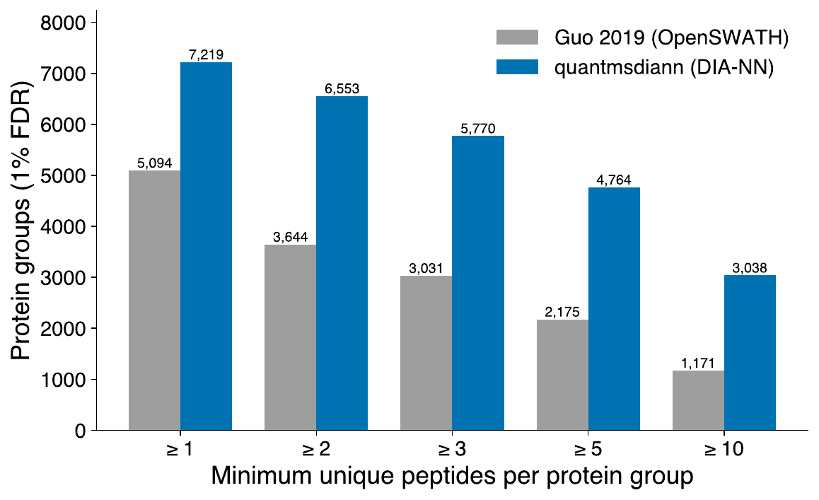
Figure S3: PXD003539 - distribution of peptides per protein group. quantmsdiann (DIA-NN, blue) versus Guo 2019 OpenSWATH (grey) on the same NCI-60 raw data.
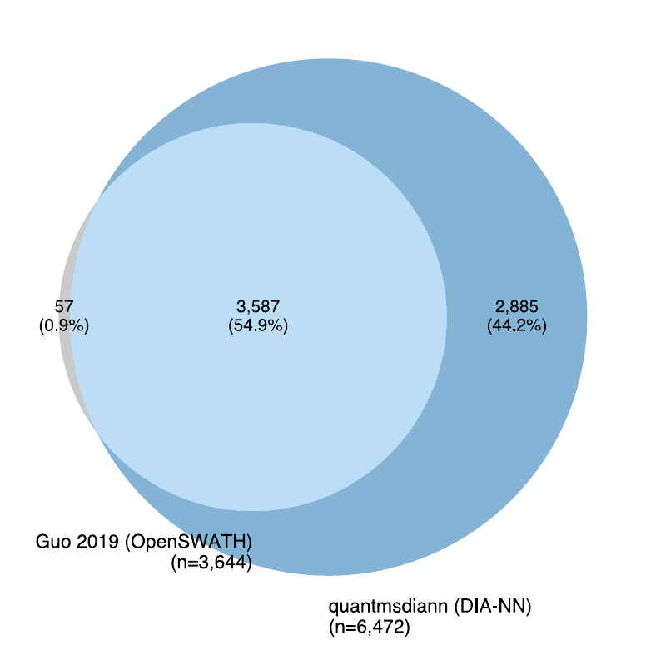
Figure S4: PXD003539 - UniProt-accession overlap between original OpenSWATH analysis and quantmsdiann reanalysis.
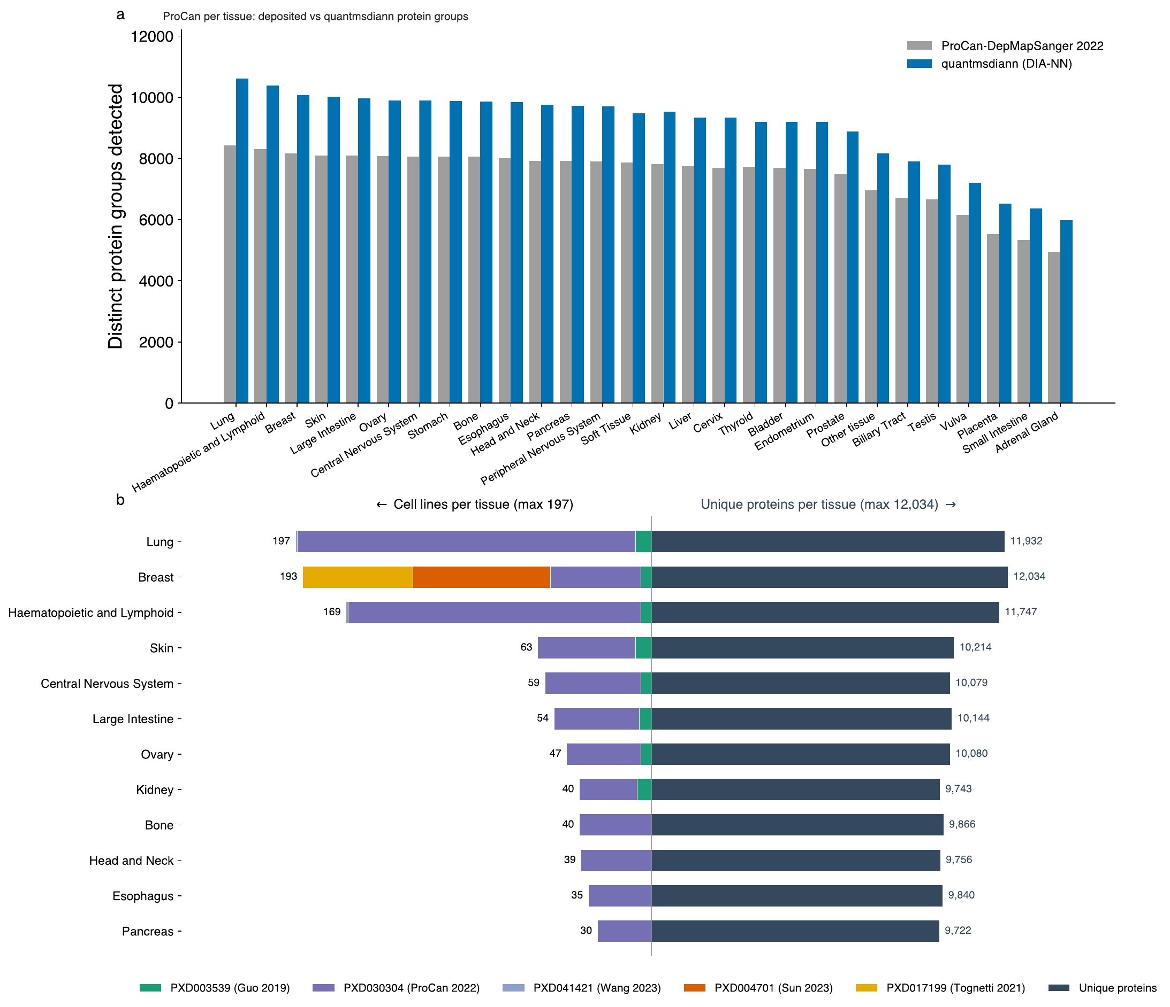
Figure S5: Pan-cohort of five public DIA cell-line reanalyses by quantmsdiann under a single SDRF-driven invocation. Combines PXD003539 (NCI-60, Guo 2019), PXD030304 (ProCan-DepMapSanger, 947 lines), PXD004701 (Sun 2023, 76 breast-cancer lines), PXD041421 (Wang 2023), and PXD017199 (Tognetti 2021, 67 breast-cancer lines). (a) ProCan-DepMapSanger (PXD030304): distinct protein groups detected per tissue of origin, deposited analysis (grey) versus the quantmsdiann reanalysis (blue) on the same raw data. (b) Back-to-back per-tissue summary across the combined panel: cell lines contributing to each tissue, stacked by cohort (left), and the union of unique UniProt proteins detected per tissue (right); the most represented of the 29 tissue categories are shown.

Supplementary Note 7: Software and resources
Table 2 lists the software packages, formats, and public resources used by quantmsdiann and in this study, with their canonical repositories or portals. quantmsdiann and its supporting tools (sdrf-pipelines, pmultiqc, QPX, wiffconverter, container recipes) are released open-source under the bigbio organisation; per-version DIA-NN container images are built from the recipes in quantms-containers (Supplementary Note 1).
Software, formats, and public resources used in this study, with their canonical repositories or portals.
Name | Role in this study | Repository / URL
quantmsdiann | SDRF-driven DIA-NN reanalysis workflow (this work) | https://github.com/bigbio/quantmsdiann
quantms | Sibling SDRF-driven multi-engine quantitative proteomics pipeline | https://github.com/bigbio/quantms
quantms-containers | Per-release DIA-NN container recipes | https://github.com/bigbio/quantms-containers
SDRF-Proteomics | Sample-and-Data-Relationship-Format metadata standard | https://github.com/bigbio/proteomics-sample-metadata
sdrf-pipelines | SDRF validation and DIA-NN configuration generation (convert-diann) | https://github.com/bigbio/sdrf-pipelines
qpx | Quantitative Proteomics eXchange format and qpxc CLI | https://github.com/bigbio/qpx
pmultiqc | Proteomics QC reporting (MultiQC extension) | https://github.com/bigbio/pmultiqc
wiffconverter | SCIEX .wiff to mzML conversion | https://github.com/bigbio/wiffconverter
pridepy | PRIDE/MassIVE raw-file download client | https://github.com/PRIDE-Archive/pridepy
DIA-NN | Data-independent acquisition search and quantification engine | https://github.com/vdemichev/DiaNN
Nextflow | Workflow orchestration engine | https://github.com/nextflow-io/nextflow
nf-core | Community framework and conventions for the workflow | https://nf-co.re
MultiQC | Aggregated analysis-report framework (extended by pmultiqc) | https://github.com/MultiQC/MultiQC
MSstats | Statistical quantification; target output format | https://github.com/Vitek-Lab/MSstats
ProteoBench | Community benchmarking platform for DIA workflows | https://github.com/Proteobench/ProteoBench
ThermoRawFileParser | Thermo .raw to mzML conversion | https://github.com/compomics/ThermoRawFileParser
Docker | Container runtime (workflow profile) | https://www.docker.com
Apptainer (Singularity) | HPC container runtime (workflow profile) | https://apptainer.org
BioContainers | Source of the default DIA-NN 1.8.1 image | https://biocontainers.pro
DuckDB | In-process engine for querying the QPX Parquet archive | https://github.com/duckdb/duckdb
MuData (.h5mu) | Multimodal container for single-cell export | https://github.com/scverse/mudata
scverse | Single-cell analysis ecosystem (downstream of MuData export) | https://scverse.org
PRIDE Archive | Source repository for deposited datasets | https://www.ebi.ac.uk/pride
ProteomeXchange | Data-deposition consortium / dataset search API | https://www.proteomexchange.org
MassIVE | Source repository for the plexDIA cohort | https://massive.ucsd.edu
UniProt | Reference protein sequences (search FASTA) | https://www.uniprot.org
Cellosaurus | Cell-line nomenclature and tissue annotation | https://www.cellosaurus.org

