Supplementary material

Supplementary Table 1 Regions activating during the memory-encoding task.
Region | Hemisphere | Coordinate |  |  | corresponding AAL parcellation
Region | Hemisphere | X | Y | Z | corresponding AAL parcellation
Positive memory contrast
Hippocampus | Left | -21 | -14 | -17.5 | Hippocampus_L
Fusiform cortex/parahippocampus | Left | -24.5 | -42 | -14 | Fusiform_L
Occipital lobe | Left | -31.5 | -80.5 | 28 | Occipital_Mid_L
Precuneus | Left | -7 | -56 | 14 | Precuneus_L
Orbital frontal cortex | Left | -3.5 | 42 | -17.5 | Rectus_L
Inferior frontal gyrus | Left | -31.5 | 31.5 | -14 | Frontal_Inf_Orb_L
Inferior frontal gyrus | Left | -42 | 7 | 28 | Frontal_Inf_Oper_L
Hippocampus | Right | 21 | -14 | -17.5 | ParaHippocampal_R
Fusiform cortex/parahippocampus | Right | 31.5 | -38.5 | -14 | Fusiform_R
Occipital lobe | Right | 35 | -80.5 | 21 | Occipital_Mid_R
Precuneus | Right | 10.5 | -52.5 | 10.5 | Precuneus_R
Orbital frontal cortex | Right | 0 | 49 | -17.5 | Rectus_L
Inferior frontal gyrus | Right | 31.5 | 35 | -10.5 | Frontal_Inf_Orb_R
Inferior frontal gyrus | Right | 38.5 | 7 | 28 | Frontal_Inf_Oper_R
Negative memory contrast
Inferior parietal lobule | Left | -63 | -49 | 28 | SupraMarginal_L
Middle temporal gyrus | Left | -59.5 | -24.5 | -10.5 | Temporal_Mid_L
Precuneus | Left | -7 | -70 | 35 | Precuneus_L
Mid cingulate cortex | Left | 0 | -24.5 | 35 | Cingulum_Mid_L
Anterior cingulate cortex | Left | -3.5 | 31.5 | 17.5 | Cingulum_Ant_L
Middle frontal gyrus | Left | -38.5 | 42 | 21 | Frontal_Mid_L
Rolandic opreculum | Left | -52.5 | 10.5 | 3.5 | Rolandic_Oper_L
Inferior parietal lobule | Right | 56 | -52.5 | 42 | Parietal_Inf_R
Middle temporal gyrus | Right | 63 | -21 | -14 | Temporal_Mid_R
Precuneus | Right | 10.5 | -66.5 | 31.5 | Precuneus_R
Mid cingulate cortex | Right | 0 | -24.5 | 35 | Cingulum_Mid_L
Anterior cingulate cortex | Right | 7 | 38.5 | 17.5 | Cingulum_Ant_R
Middle frontal gyrus | Right | 28 | 52.5 | 21 | Frontal_Mid_R
Inferior frontal gyrus | Right | 52.5 | 14 | 3.4 | Frontal_Inf_Oper_R
Supplementary motor area | Right | 14 | 14 | 63 | Supp_Motor_Area_R
The table provides coordinates of regional activity from memory contrast from 203 CN individuals (p<0.05 FWE, cluster threshold > 10) with the corresponding ROIs in AAL parcellation obtained from the peak coordinate.

Supplementary Table 2 Expected posterior and posterior probability of modulatory connectivity obtained from Bayesian model average.
Connectivity | expected posterior | posterior probability  (|Ep|>0 )
PPA to PPA | -0.96 | 1.00
PPA to HC | 0.09 | 0.50
PPA to PCU | 0.00 | 0.00
HC to PPA | -0.28 | 0.96
HC to HC | 0.00 | 0.00
HC to PCU | 0.00 | 0.00
PCU to PPA | 0.00 | 0.00
PCU to HC | 0.00 | 0.00
PCU to PCU | 0.00 | 0.00

The table presents the expected posterior and posterior probability of the modulatory connectivity of memory encoding derived from Bayesian model average of the healthy individuals. Abbreviations: PPA (parahippocampal place area), HC (hippocampus), and PCU (precuneus), CN (cognitively normal), SCD (subjective cognitive decline), MCI (mild cognitive impairment), and DAT (dementia of Alzheimer's type).

Supplementary Table 3 Mean connectivity and the effects of amyloid-β42/40 (Aβ42/40), phospho-tau-181 (p-tau-181) on connectivity.
Connectivity | mean | Amyloid status | p-tau-181 level | A status x p-tau-181 interaction
Intrinsic
PPA to PPA | 0.20 (1.00)* | 0.00 (0.00) | 0.00 (0.00) | 0.00 (0.00)
PPA to HC | 0.26 (1.00)* | 0.00 (0.00) | -0.00 (0.00) | 0.00 (0.00)
PPA to PCU | -0.19 (1.00)* | 0.00 (0.00) | 0.00 (0.00) | 0.03 (0.51)
HC to PPA | -0.28 (1.00)* | 0.00 (0.00) | 0.00 (0.00) | 0.00 (0.00)
HC to HC | 0.03 (0.54) | -0.00 (0.00) | -0.00 (0.00) | -0.00 (0.00)
HC to PCU | 0.24 (1.00)* | -0.00 (0.00) | 0.05 (0.60) | -0.11 (1.00)*
PCU to PPA | 0.21 (1.00)* | 0.00 (0.00) | -0.10 (1.00)* | 0.09 (0.80)
PCU to HC | 0.04 (0.68) | 0.00 (0.00) | 0.00 (0.00) | 0.00 (0.00)
PCU to PCU | -0.04 (0.55) | -0.00 (0.00) | 0.00 (0.00) | -0.00 (0.00)
Modulation
PPA to PPA | -0.76 (1.00)* | -0.02 (0.00) | -0.00 (0.00) | -0.01 (0.12)
HC to PPA | -0.52 (1.00)* | -0.04 (0.21) | -0.01 (0.00) | -0.02 (0.17)
Input
PPA | 0.41 (1.00)* | 0.01 (0.07) | -0.01 (0.07) | -0.02 (0.08)
The table presents the effects of Alzheimer's pathology (amyloid-β42/40 and phospho-tau181) on effective connectivity. The results are displayed in coefficient and posterior probability. Statistical significance is denoted by * for Pp>0.95. Abbreviations: PPA (parahippocampal place area), HC (hippocampus), PCU (precuneus), Aβ42/40 (amyloid-β42/40), p-tau-181 (phospho-tau181).

Supplementary Table 4 Mean connectivity and the effects of amyloid-β42/40 (Aβ42/40), phospho-tau-181 (p-tau-181) on connectivity, with site as covariates.
Connectivity | mean | Amyloid status | p-tau-181 level | A status x p-tau-181 interaction
Intrinsic
PPA to PPA | 0.20 (1.00) * | 0.00 (0.00) | 0.00 (0.00) | 0.00 (0.00)
PPA to HC | 0.26 (1.00) * | 0.00 (0.00) | -0.00 (0.00) | 0.00 (0.00)
PPA to PCU | -0.19 (1.00) * | 0.00 (0.00) | 0.00 (0.00) | 0.03 (0.52)
HC to PPA | -0.28 (1.00) * | 0.00 (0.00) | 0.00 (0.00) | 0.03 (0.50)
HC to HC | 0.03 (0.52) | -0.00 (0.00) | 0.00 (0.00) | 0.00 (0.00)
HC to PCU | 0.24 (1.00) * | 0.00 (0.00) | 0.05 (0.60) | -0.11 (1.00) *
PCU to PPA | 0.21 (1.00) * | 0.00 (0.00) | -0.12 (1.00) * | 0.12 (1.00) *
PCU to HC | 0.06 (1.00) * | 0.00 (0.00) | 0.00 (0.00) | 0.00 (0.00)
PCU to PCU | -0.04 (0.56) | -0.00 (0.00) | 0.00 (0.00) | -0.00 (0.00)
Modulation
PPA to PPA | -0.75 (1.00) * | -0.03 (0.00) | -0.00 (0.00) | -0.01 (0.00)
HC to PPA | -0.52 (1.00) * | -0.04 (0.00) | -0.00 (0.00) | -0.02 (0.00)
Input
PPA | 0.41 (1.00) * | -0.00 (0.00) | -0.02 (0.07) | -0.01 (0.08)
The table presents the effects of Alzheimer's pathology (amyloid-β42/40 and phospho-tau181) on effective connectivity. The results are displayed in coefficient and posterior probability. Statistical significance is denoted by * for Pp>0.95. Abbreviations: PPA (parahippocampal place area), HC (hippocampus), PCU (precuneus), Aβ42/40 (amyloid-β42/40), p-tau-181 (phospho-tau181).

Supplementary Table 5 Spearman's rank correlation of effective connectivity and memory performance.
Connectivity | Memory performance | PACC5
Intrinsic
PPA to PPA | 0.06 (0.31) | 0.05 (0.31)
PPA to HC | 0.18 (4.09x10⁻⁴)* | 0.19 (2.61x10⁻⁴)*
PPA to PCU | -0.21 (1.56x10⁻⁵)* | -0.16 (1.26x10⁻³)*
HC to PPA | -0.16 (1.22x10⁻³)* | -0.10 (0.06)
HC to HC | -0.05 (0.36) | -0.08 (0.11)
HC to PCU | 0.10 (0.06) | 0.01 (0.87)
PCU to PPA | 0.14 (5.02x10⁻³)* | 0.09 (0.11)
PCU to HC | -0.01 (0.80) | -0.02 (0.67)
PCU to PCU | 0.08 (0.14) | -0.02 (0.67)
Modulation
PPA to PPA | -0.22 (7.35x10⁻⁶)* | -0.10 (0.07)
HC to PPA | -0.22 (7.35x10⁻⁶)* | -0.04 (0.51)
Input
PPA | 0.25 (3.00x10⁻⁷)* | 0.16 (1.26x10⁻³)*
The table presents the Spearman's correlation coefficients (ρ) and p-values for each connection's relationship with memory performance and PACC5 test, with age, sex, and education as covariates. To indicate the amplitude of the effect, the significance column uses the following symbols: '*' for p < 0.05. P-values were adjusted for false discovery rate (FDR) using the Benjamini-Hochberg procedure. Abbreviations: PPA (parahippocampal place area), HC (hippocampus), and PCU (precuneus).

Supplementary Figure 1 Distribution of cognitive measurements

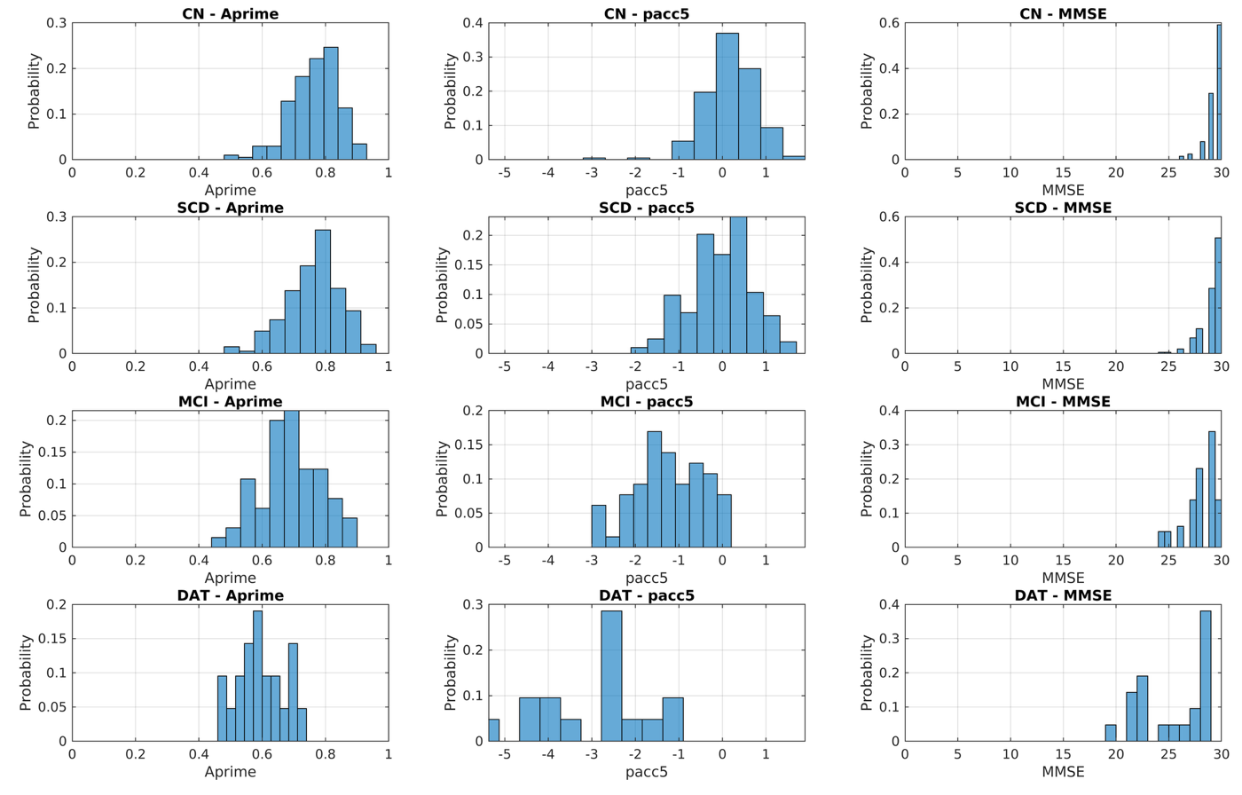
The histograms show the distribution of memory performance(A'), PACC5, and MMSE by diagnoses. Unlike MMSE, A′ and PACC5 show no ceiling effect across diagnostic groups.

