SUPPLEMENTARY MATERIAL

Figure 1. The cumulative incidence of malignancy (green) according to the RCTs (blue), respectively
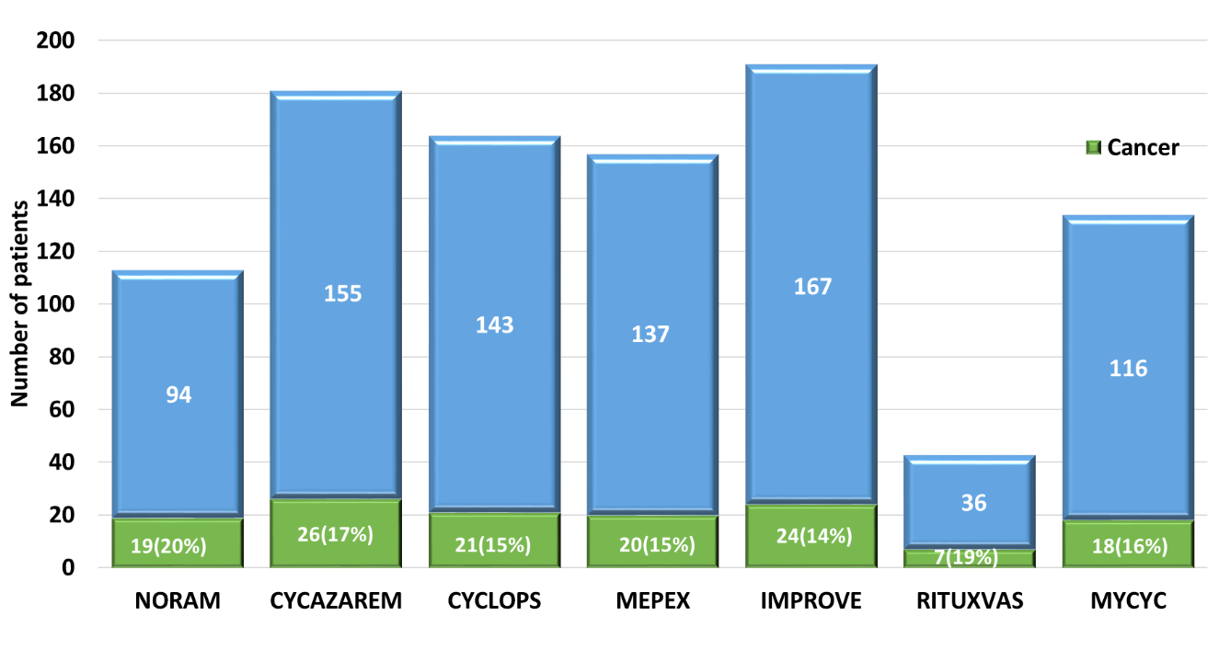

Figure 2. Forest plot of SIR of malignancy in AAV in previous studies

Figure 3. Forest plot of SIR of malignancy: All sites excluding NMSC in previous studies

Figure 4. Forest plot of the SIR of NMSC in previous studies

