Table S1. Comprehensive 75K-baseline vs 118K Scope B comparison. All metrics evaluated on each version's held-out test split (75K: n = 11,340; v3: n = 28,274). Bold indicates 118K Scope B improvements. pp = percentage points.

Metric | the 75K baseline (75K) | 118K (this work) | Δ
Sample count (train) | 63,777 | 118,263 | +85%
Sample count (test) | 11,340 | 28,274 | +149%
UBERON tissue categories | 43 | 42 | —
Cell lines included | Yes | No (curated) | —
Class balancing | None | Stratified 10K cap | —
Training time (RTX 4060) | ~3 h | ~5 h | —
Peak RAM (data loading) | 50+ GB CSV | 25 GB HDF5 | −50%
Balanced accuracy (Standard) | 90.7% | 94.9% | +4.2 pp
Weighted F1 (Standard) | 93.7% | 96.2% | +2.5 pp
Per-gene ρ (Standard) | 0.914 | 0.935 | +1.8%
Per-gene ρ (Denoising) | 0.919 | 0.934 | +1.5%
Per-sample ρ (Standard) | 0.766 | 0.829 | +6.3 pp
Per-sample ρ (Denoising) | 0.773 | 0.830 | +5.7 pp
Imputation @ 10% (Denoising) | 0.852 | 0.880 | +2.8 pp
Imputation @ 20% (Denoising) | 0.853 | 0.879 | +2.6 pp
Imputation @ 30% (Denoising) | 0.855 | 0.879 | +2.4 pp
LISI / max | 1.09 / 4.0 | 1.02 / 3.0 | purer
kNN source mixing (k=20) | 0.047 | 0.012 | −74%
TARGET overall accuracy (n=734) | 86.6% | 84.6% | −2.0 pp
AML (n=196) | 97% | 99% | +2 pp
ALL (n=194) | 65% | 96% | +31 pp
AML Induction Failure (n=32) | 94% | 100% | +6 pp
Neuroblastoma (n=162) | 99% | 72% | −27 pp
Wilms Tumor (n=132) | 95% | 65% | −30 pp
Rhabdoid Tumor (n=5) | 80% | 100% | +20 pp
scGPT zero-shot (frozen) | 61.0% | 61.0% | —
All genes + kNN baseline | 89.6% | 92.6% | +3.0 pp
Top-2000 HVG + kNN baseline | 89.0% | 93.4% | +4.3 pp
All genes + PCA(121) + kNN baseline | 87.4% | 92.0% | +4.6 pp
Supervised VAE advantage (vs all-kNN) | +1.1 pp | +2.3 pp | wider
Table S2. Developmental-origin rubric used to score TARGET tissue-of-origin transfer. For each paediatric cancer type, the expected adult UBERON tissue categories were defined a priori from its established developmental lineage, with the supporting reference. A prediction was scored correct if the assigned tissue fell within the expected set. The mappings reflect canonical developmental biology rather than post-hoc selection; alternative groupings at the germ-layer level (e.g. collapsing all intermediate-mesoderm derivatives) yield the same qualitative conclusions.
Cancer type | Developmental origin | Expected adult tissue categories | Reference
Acute myeloid leukaemia | Haematopoietic / myeloid progenitors (bone marrow) | blood, bone marrow, lymphoid | Bonnet & Dick, Nat Med 1997
Acute lymphoblastic leukaemia | Haematopoietic / lymphoid progenitors | blood, bone marrow, lymphoid | Bonnet & Dick, Nat Med 1997
AML, induction-failure subtype | Haematopoietic / myeloid progenitors | blood, bone marrow, lymphoid | Bonnet & Dick, Nat Med 1997
Neuroblastoma | Developing sympathetic nervous system (neural crest) | brain, nerve, adrenal gland | Maris, N Engl J Med 2010
Wilms tumour | Intermediate mesoderm (precursors of kidney, uterus, ovary, testis) | kidney, ovary, uterus, testis | Hohenstein et al., Genes Dev 2015
Kidney, rhabdoid tumour | Renal / metanephric mesenchyme | kidney | Hohenstein et al., Genes Dev 2015
Clear cell sarcoma of the kidney | Renal mesenchyme (no well-defined adult correlate) | kidney | Hohenstein et al., Genes Dev 2015
References: Bonnet D, Dick JE. Nat Med 1997;3:730-7. Maris JM. N Engl J Med 2010;362:2202-11. Hohenstein P, Pritchard-Jones K, Charlton J. Genes Dev 2015;29:467-82.

Table S3. Per-category tissue-of-origin accuracy on the TARGET cohort: supervised VAE versus BulkFormer. Both models were evaluated out of the box on 734 TARGET paediatric tumours using the same k-nearest-neighbour protocol and developmental-expectation rubric (Table S2; Figure 6). Accuracy is the fraction of samples assigned to the expected adult tissue(s) of origin. BulkFormer was pretrained on GEO/ARCHS4 and may have encountered TARGET, so the transfer is out-of-distribution only for the supervised VAE.
TARGET cancer category | Expected tissue of origin (developmental) | Supervised VAE | BulkFormer
Haematopoietic (AML, ALL) | Blood, bone marrow, lymphoid | >97% | >97%
Neuroblastoma | Brain, nerve, adrenal gland | 72.2% | 75.9%
Wilms tumour | Intermediate mesoderm (kidney, ovary, uterus) | 65.2% | 13.6%
Clear cell sarcoma of the kidney | Kidney (no clear adult correlate) | 0% | 0%
Overall (734 samples) | — | 84.6% | 76.8%

Supplementary Figures
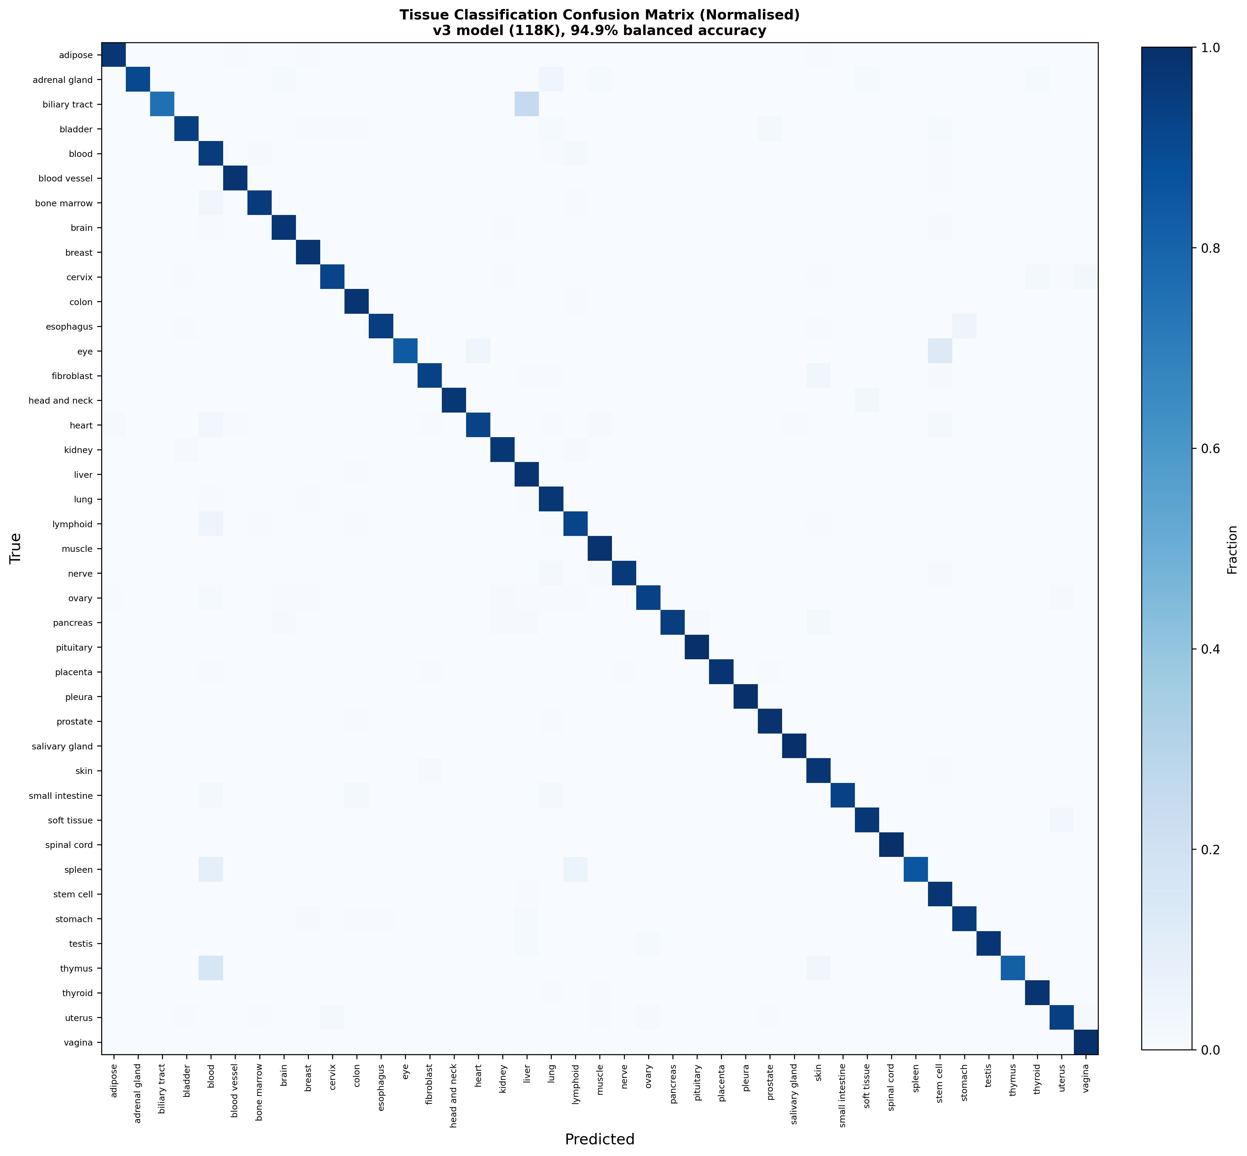
Figure S1. Normalized confusion matrix for the 118K supervised VAE classifier. Row-normalized confusion matrix across the 42 UBERON tissue categories on the held-out 118K test split (n = 28,274). Rows are true tissue labels, columns are predicted labels; diagonal values are per-class recall (matching the per-tissue accuracies in Figure 2). Off-diagonal entries highlight the few biologically plausible confusions remaining after class balancing.

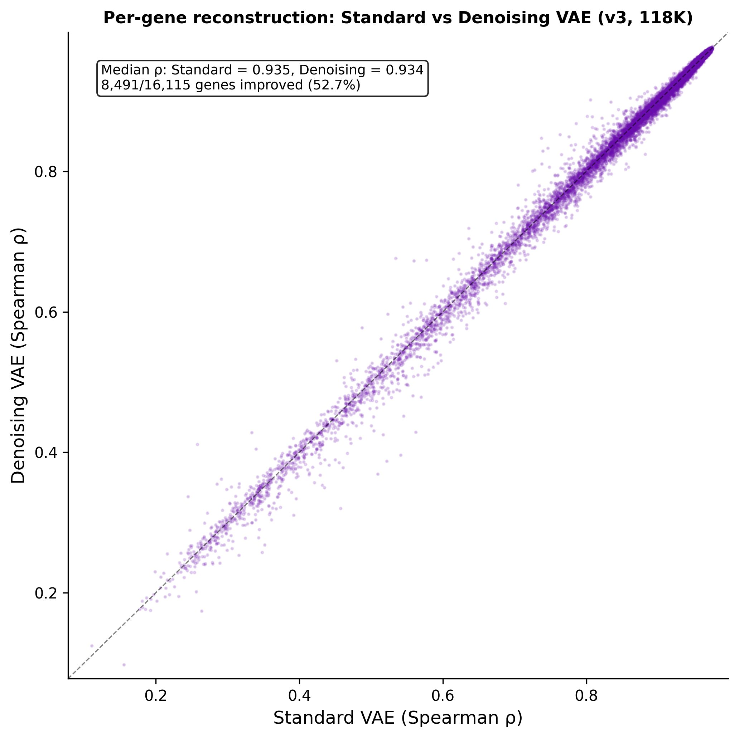
Figure S2. Per-gene reconstruction performance scatter. Scatter of original versus reconstructed expression values, aggregated across all genes and samples in the held-out 118K test split, for the Standard VAE variant. Density coloring shows the high-density diagonal consistent with the median per-gene Spearman ρ = 0.935 reported in Figure 3a.

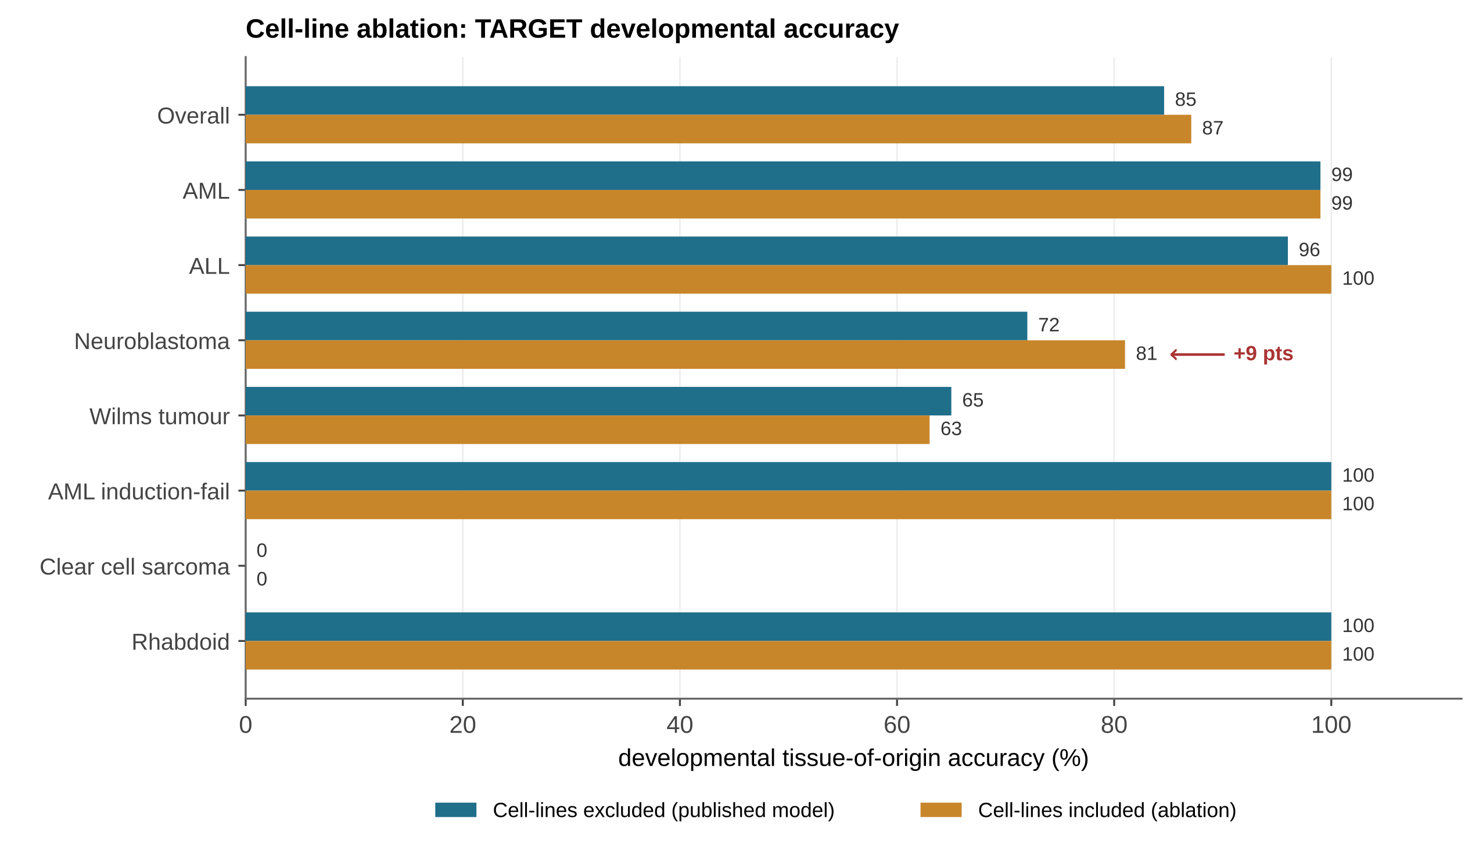
Figure S3. Cell-line removal has a small, localized effect on TARGET developmental transfer. Per-cancer and overall accuracy for the published model (cell lines excluded, teal) versus a matched control in which ARCHS4 cell lines were retained under the same per-tissue capping policy and random seed (cell lines included, ochre); the two models differ only in cell-line inclusion. Excluding cell lines changes overall accuracy by 2.5 percentage points (87.1% with cell lines, 84.6% without), an effect confined almost entirely to neuroblastoma (72% versus 81%), the one cancer whose neural-crest lineage cell lines most directly represent. All other cancer types are unchanged, and Wilms tumour differs by under two points (65% versus 63%). Cell-line removal therefore carries only a minor, lineage-specific cost on developmental transfer, consistent with its role in producing a latent space less anchored to cell-line transcriptomes (Table 2).

