Safety and efficacy of a sandwich total neoadjuvant therapy strategy for low-risk distal locally advanced rectal cancer: results from the TESS phase II trial

Shuang Liu^{1-4,#}, GuangZhao Lv^{2,5,#}, GeYu Xu^{2,6,#}, XiaoZhong Wang^{7,#}, YeZhong Zhuang^{8,#}, ShouMin Bai⁹ , HaiNa Yu^{1,2,10}, XiaoJun Wu^{2,5}, YiJing Ye¹¹, HuiLong Luo^{1,2}, ShuoYu Xu¹², QiaoXuan Wang^{1,2}, Hui Chang^{1,2}, PeiQiang Cai^{2,6}, ZhiZhong Pan^{2,5}, YuanHong Gao^{1,2,}*, Gong Chen^{2,5,}*, WeiWei Xiao^{1,2,13}*

Affiliations
¹ Department of Radiation Oncology, Sun Yat-sen University Cancer Center, Guangzhou, China
² Sun Yat-sen University Cancer Center, State Key Laboratory of Oncology in South China, Collaborative Innovation Center for Cancer Medicine, Guangzhou, China
³ Department of Hematology, Oncology, and Tumor Immunology and Berlin Institute of Health, Charité-Universitätsmedizin Berlin, Germany
⁴ Berlin Institute for Medical Systems Biology (BIMSB), Max Delbrück Center for Molecular Medicine, Berlin, Germany
⁵ Department of Colorectal Surgery, Sun Yat-sen University Cancer Center, Guangzhou, China
⁶ Department of Medical Imaging and Interventional Radiology, Sun Yat-sen University Cancer Center, Guangzhou, China
⁷ Department of General Surgery, Shantou Central Hospital, Shantou, China
⁸ Department of Abdominal Surgery, Cancer Hospital of Shantou University Medical College, Shantou, China
⁹ Department of Radiation Oncology, Sun Yat-sen Memorial Hospital, Sun Yat-sen University, Guangzhou, China
¹⁰ Department of Medical Oncology, Jinjiang Municipal Hospital (Shanghai Sixth People's Hospital Fujian), Jinjiang, China
¹¹ Department of Radiation Oncology, Zhongshan People's Hospital, Zhongshan, China
¹² Bio-totem Pte Ltd, Suzhou, China
¹³ United Laboratory of Frontier Radiotherapy Technology of Sun Yat-sen University & Chinese Academy of Sciences Ion Medical Technology Co., Ltd, Guangzhou, China

#These authors contributed equally to this work.
*Corresponding authors:
YuanHong Gao, MD
Department of Radiation Oncology, Sun Yat-sen University Cancer Center, Guangzhou 510060, China Tel: +86-20-87343385
Fax: +86-20-87343385
Email: gaohy@sysucc.org.cn
Gong Chen, MD
Department of Colorectal Surgery, Sun Yat-sen University Cancer Center, Guangzhou 510060, China
Tel: +86-20-87343584
Fax: +86-20-87343584
Email: chengong@sysucc.org.cn
WeiWei Xiao, MD, PhD (Lead Corresponding Author)
Department of Radiation Oncology, Sun Yat-sen University Cancer Center, Guangzhou 510060, China Tel: +86-20-87343491
Fax: +86-20-87343491
Email: xiaoww@sysucc.org.cn

Supplementary Information
Supplementary Tables
Table S1. Comparison of baseline clinical characteristics and treatment between CR and non-CR patients in the intention-to-treat (ITT) population
Table S2. Comparison of baseline clinical characteristics and treatment between CR and non-CR patients in the observed response population
Table S3. Comparison of baseline clinical characteristics and treatment between CR and non-CR patients in the exploratory histopathological analysis cohort
Table S4. Univariate analysis of pretreatment histopathological features associated with clinical response (CR vs non-CR) in the exploratory histopathological analysis cohort
Table S5. Comparative outcomes of total neoadjuvant therapy (TNT) regimens for locally advanced rectal cancer
Table S6. Clinical complete response (cCR) assessment criteria and representative images

Supplementary Figures
Figure S1. Treatment and outcomes of patients who underwent a second course of radiotherapy
Figure S2. Comparison of immune cell density and proportion between non-CR and CR patients
Figure S3. Spatial distribution analysis of tumor cells and immune cells between non-CR and CR patients
Figure S4. Representative H&E-stained whole-slide images and corresponding tissue classification
Table S1. Comparison of baseline clinical characteristics and treatment between CR and non-CR patients in the intention-to-treat (ITT) population
Variable | No. | Non-CR (%) | CR (%) | P value
All patients | 98 | 41 (42%) | 57 (58%)
Age |  |  |  | 0.97
< 55 | 44 | 19 (43%) | 25 (57%)
≥ 55 | 54 | 22 (41%) | 32 (59%)
Sex |  |  |  | 0.458
Female | 34 | 12 (35%) | 22 (65%)
Male | 64 | 29 (45%) | 35 (55%)
Distance to the anal verge (cm) |  |  |  | 0.561
< 3.5 | 50 | 19 (38%) | 31 (62%)
≥ 3.5 | 48 | 22 (46%) | 26 (54%)
CEA (ng/ml) |  |  |  | 0.463
< 5 | 65 | 25 (39%) | 40 (61%)
≥ 5 | 33 | 16 (49%) | 17 (51%)
CA19-9 (U/ml) |  |  |  | 0.373
< 35 | 88 | 35 (40%) | 53 (60%)
≥ 35 | 10 | 6 (60%) | 4 (40%)
T stage |  |  |  | 0.622
T2 | 6 | 2 (33%) | 4 (67%)
T3 | 81 | 33 (41%) | 48 (59%)
T4a | 11 | 6 (55%) | 5 (45%)
N stage |  |  |  | 0.462
N0 | 28 | 9 (32%) | 19 (68%)
N1 | 43 | 20 (47%) | 23 (53%)
N2 | 27 | 12 (44%) | 15 (56%)
MRF |  |  |  | 0.782
Negative | 53 | 21 (40%) | 32 (60%)
Positive | 45 | 20 (44%) | 25 (56%)
EMVI |  |  |  | 0.672
Negative | 75 | 30 (40%) | 45 (60%)
Positive | 23 | 11 (48%) | 12 (52%)
Cycles of neoadjuvant chemotherapy |  |  |  | 0.133
4 | 4 | 3 (75%) | 1 (25%)
5 | 7 | 5 (71%) | 2 (29%)
6 | 80 | 30 (38%) | 50 (62%)
7 | 5 | 3 (60%) | 2 (40%)
8 | 2 | 0 (0%) | 2 (100%)
Cycles of adjuvant chemotherapy |  |  |  | 0.48
2 | 95 | 39 (41%) | 56 (59%)
3 | 1 | 1 (100%) | 0 (0%)
4 | 2 | 1 (50%) | 1 (50%)
Abbreviations: MRF, mesorectal fascia; EMVI, extramural venous invasion; CEA, carcinoembryonic antigen; CA19-9, carbohydrate antigen 19-9. Values are presented as number (%). Percentages represent the proportion within each row.
Table S2. Comparison of baseline clinical characteristics and treatment between CR and non-CR patients in the observed response population
Variable | No. | Non-CR (%) | CR (%) | P value
All patients | 98 | 38 (39%) | 60 (61%)
Age |  |  |  | 0.855
< 55 | 44 | 18 (41%) | 26 (59%)
≥ 55 | 54 | 20 (37%) | 34 (63%)
Sex |  |  |  | 0.766
Female | 34 | 12 (35%) | 22 (65%)
Male | 64 | 26 (41%) | 38 (59%)
Distance to the anal verge (cm) |  |  |  | 0.434
< 3.5 | 50 | 17 (34%) | 33 (66%)
≥ 3.5 | 48 | 21 (44%) | 27 (56%)
CEA (ng/ml) |  |  |  | 0.455
< 5 | 65 | 23 (35%) | 42 (65%)
≥ 5 | 33 | 15 (46%) | 18 (54%)
CA19-9 (U/ml) |  |  |  | 0.67
< 35 | 88 | 33 (38%) | 55 (62%)
≥ 35 | 10 | 5 (50%) | 5 (50%)
T stage |  |  |  | 0.514
T2 | 6 | 2 (33%) | 4 (67%)
T3 | 81 | 30 (37%) | 51 (63%)
T4a | 11 | 6 (55%) | 5 (45%)
N stage |  |  |  | 0.182
N0 | 28 | 7 (25%) | 21 (75%)
N1 | 43 | 18 (42%) | 25 (58%)
N2 | 27 | 13 (48%) | 14 (52%)
MRF |  |  |  | 0.983
Negative | 53 | 20 (38%) | 33 (62%)
Positive | 45 | 18 (40%) | 27 (60%)
EMVI |  |  |  | 0.776
Negative | 75 | 28 (37%) | 47 (63%)
Positive | 23 | 10 (43%) | 13 (57%)
Cycles of neoadjuvant chemotherapy |  |  |  | 0.321
4 | 4 | 3 (75%) | 1 (25%)
5 | 7 | 4 (57%) | 3 (43%)
6 | 80 | 29 (36%) | 51 (64%)
7 | 5 | 2 (40%) | 3 (60%)
8 | 2 | 0 (0%) | 2 (100%)
Cycles of adjuvant chemotherapy |  |  |  | 0.424
2 | 95 | 36 (38%) | 59 (62%)
3 | 1 | 1 (100%) | 0 (0%)
4 | 2 | 1 (50%) | 1 (50%)
Abbreviations: MRF, mesorectal fascia; EMVI, extramural venous invasion; CEA, carcinoembryonic antigen; CA19-9, carbohydrate antigen 19-9. Values are presented as number (%). Percentages represent the proportion within each row.
Table S3. Comparison of baseline clinical characteristics and treatment between CR and non-CR patients in the exploratory histopathological analysis cohort
Variable | No. | Non-CR (%) | CR (%) | P value
All patients | 50 | 20 (40%) | 30 (60%)
Age |  |  |  | 0.953
< 55 | 21 | 9 (43%) | 12 (57%)
≥ 55 | 29 | 11 (38%) | 18 (62%)
Sex |  |  |  | 0.266
Female | 21 | 6 (29%) | 15 (71%)
Male | 29 | 14 (48%) | 15 (52%)
Distance to the anal verge (cm) |  |  |  | 0.953
< 3.5 | 29 | 11 (38%) | 18 (62%)
≥ 3.5 | 21 | 9 (43%) | 12 (57%)
CEA (ng/ml) |  |  |  | 0.345
< 5 | 35 | 12 (34%) | 23 (66%)
≥ 5 | 15 | 8 (53%) | 7 (47%)
CA19-9 (U/ml) |  |  |  | 0.328
< 35 | 44 | 16 (36%) | 28 (64%)
≥ 35 | 6 | 4 (67%) | 2 (33%)
T stage |  |  |  | 0.336
T2 | 2 | 1 (50%) | 1 (50%)
T3 | 42 | 15 (36%) | 27 (64%)
T4a | 6 | 4 (67%) | 2 (33%)
N stage |  |  |  | 0.328
N0 | 12 | 3 (25%) | 9 (75%)
N1 | 24 | 12 (50%) | 12 (50%)
N2 | 14 | 5 (36%) | 9 (64%)
MRF |  |  |  | 1
Negative | 24 | 10 (42%) | 14 (58%)
Positive | 26 | 10 (39%) | 16 (61%)
EMVI |  |  |  | 0.153
Negative | 41 | 14 (34%) | 27 (66%)
Positive | 9 | 6 (67%) | 3 (33%)
Cycles of neoadjuvant chemotherapy |  |  |  | 0.125
4 | 3 | 3 (100%) | 0 (0%)
5 | 1 | 1 (100%) | 0 (0%)
6 | 43 | 15 (35%) | 28 (65%)
7 | 2 | 1 (50%) | 1 (50%)
8 | 1 | 0 (0%) | 1 (100%)
Cycles of adjuvant chemotherapy |  |  |  | 0.21
2 | 1 | 1 (100%) | 0 (0%)
3 | 48 | 18 (38%) | 30 (62%)
4 | 1 | 1 (100%) | 0 (0%)
Abbreviations: MRF, mesorectal fascia; EMVI, extramural venous invasion; CEA, carcinoembryonic antigen; CA19-9, carbohydrate antigen 19-9. Values are presented as number (%). Percentages represent the proportion within each row.
Table S4. Univariate analysis of pretreatment histopathological features associated with clinical response (CR vs non-CR) in the exploratory histopathological analysis cohort
Variable | Non-CR (N=20) | CR (N=30) | OR [95%CI] | P value
Tumor bulk proportion in total tissue area | 0.44 (0.25) | 0.44 (0.22) | 1.08 [0.09;13.2] | 0.951
Tumor area proportion in total tissue area | 0.23 (0.15) | 0.20 (0.13) | 0.25 [0.00;14.6] | 0.502
Lymphocyte area proportion in total tissue area | 0.05 [0.02;0.08] | 0.06 [0.04;0.09] | 949 [0.00; Inf] | 0.338
Mucus area proportion in total tissue area | 0.02 [0.01;0.05] | 0.03 [0.01;0.05] | 7066 [0.00; Inf] | 0.33
Stromal area proportion in total tissue area | 0.07 [0.02;0.17] | 0.06 [0.03;0.12] | 0.48 [0.00;101] | 0.789
Ratio of stromal area to total stromal and tumor areas | 0.29 [0.09;0.56] | 0.25 [0.14;0.53] | 1.21 [0.17;8.47] | 0.849
Ratio of mucus area to total mucus and tumor areas | 0.12 [0.03;0.25] | 0.13 [0.07;0.23] | 2.05 [0.20;20.6] | 0.541
Stromal area proportion in the tumor bulk | 0.07 [0.03;0.20] | 0.10 [0.05;0.13] | 2.53 [0.02;390] | 0.718
Tumor area proportion in the tumor bulk | 0.54 [0.37;0.58] | 0.42 [0.31;0.54] | 0.07 [0.00;3.49] | 0.18
Lymphocyte area proportion in the tumor bulk | 0.09 [0.04;0.12] | 0.07 [0.05;0.12] | 1.99 [0.00;6825] | 0.869
Mucus area proportion in the tumor bulk | 0.02 [0.01;0.03] | 0.02 [0.01;0.05] | 21.1 [0.00;151536] | 0.501
Cell density in the tumor region of the tumor bulk
Lymphocyte | 6.63 [6.10; 6.88] | 6.83 [6.29; 7.15] | 1.31 [0.61; 2.79] | 0.484
Neutrophil | 3.51 (0.79) | 4.14 (0.94) | 2.34 [1.12; 4.90] | 0.024
Plasma cell | 4.59 (0.79) | 4.91 (0.86) | 1.58 [0.79; 3.17] | 0.195
Stromal cell | 7.40 [7.23; 7.63] | 7.51 [7.26; 7.61] | 0.96 [0.25; 3.65] | 0.953
Cell proportion in the tumor bulk
Lymphocyte | -1.98 (0.49) | -1.71 (0.41) | 4.25 [1.01; 17.9] | 0.049
Neutrophil | -5.09 (0.85) | -4.50 (0.93) | 2.15 [1.04; 4.45] | 0.038
Plasma cell | -3.71 [-4.21; -3.36] | -3.41 [-3.85; -3.04] | 1.85 [0.82; 4.20] | 0.141
Stromal cell | -1.15 (0.33) | -1.03 (0.27) | 4.28 [0.57; 32.3] | 0.158
Cell-to-tumor cell ratio in the tumor bulk
Lymphocyte | -1.21 (0.66) | -0.65 (0.71) | 3.63 [1.30; 10.1] | 0.014
Neutrophil | -4.32 (0.85) | -3.44 (1.08) | 2.63 [1.26; 5.51] | 0.01
Plasma cell | -3.11 (0.77) | -2.51 (0.93) | 2.30 [1.09; 4.86] | 0.029
Stromal cell | -0.38 (0.55) | 0.03 (0.60) | 3.63 [1.16; 11.4] | 0.027
G _{Tumor:Cell} AUC_{0,50μm} quartiles in the tumor bulk
Lymphocyte | 3.24 [3.12; 3.31] | 3.24 [3.13; 3.40] | 1.04 [0.15; 7.33] | 0.968
Neutrophil | 1.02 (0.77) | 1.41 (0.94) | 1.69 [0.86; 3.33] | 0.125
Plasma cell | 2.35 [1.72; 2.49] | 2.40 [1.80; 2.75] | 1.23 [0.54; 2.82] | 0.622
Stromal cell | 3.45 [3.41; 3.48] | 3.43 [3.38; 3.46] | 0.01 [0.00; 18.4] | 0.241
M-H index of cell in the tumor bulk
Lymphocyte | -1.02 (0.31) | -0.89 (0.25) | 5.73 [0.64; 50.9] | 0.117
Neutrophil | -3.26 (0.80) | -2.54 (0.78) | 3.36 [1.37; 8.26] | 0.008
Plasma cell | -2.08 [-2.43; -1.76] | -1.58 [-2.15; -1.36] | 2.03 [0.91; 4.49] | 0.083
Stromal cell | -0.65 (0.18) | -0.71 (0.23) | 0.26 [0.02; 4.44] | 0.352
Tumor infiltrating cell Ab score in the tumor bulk
Lymphocyte | -2.64 (0.88) | -2.05 (0.68) | 2.83 [1.20; 6.67] | 0.017
Neutrophil | -7.44 (1.72) | -6.01 (1.71) | 1.67 [1.12; 2.48] | 0.012
Plasma cell | -5.26 (1.58) | -4.36 (1.74) | 1.39 [0.96; 1.99] | 0.079
Stromal cell | -1.46 (0.58) | -1.16 (0.46) | 3.24 [0.98; 10.8] | 0.055
Cell density in the tissue region
Lymphocyte | 759 (380) | 940 (453) | 1.00 [1.00; 1.00] | 0.15
Neutrophil | 32.9 [6.74; 56.9] | 42.0 [17.5; 107] | 1.01 [1.00; 1.03] | 0.062
Plasma cell | 127 [77.8; 181] | 156 [96.0; 242] | 1.00 [1.00; 1.01] | 0.133
Stromal cell | 1651 [1207; 1938] | 1614 [1338; 2070] | 1.00 [1.00; 1.00] | 0.325
Cell proportion in the tissue region
Lymphocyte | -1.75 (0.34) | -1.61 (0.31) | 4.18 [0.65; 27.1] | 0.133
Neutrophil | -5.13 (0.81) | -4.69 (0.99) | 1.71 [0.89; 3.31] | 0.109
Plasma cell | -3.36 [-3.88; -3.11] | -3.33 [-3.78; -2.86] | 1.52 [0.61; 3.80] | 0.368
Stromal cell | -0.99 (0.35) | -0.94 (0.33) | 1.60 [0.29; 8.89] | 0.588
Cell-to-tumor cell ratio in the tissue region
Lymphocyte | -0.69 (0.69) | -0.33 (0.66) | 2.35 [0.90; 6.11] | 0.08
Neutrophil | -4.07 (0.84) | -3.41 (1.11) | 1.98 [1.04; 3.77] | 0.038
Plasma cell | -2.49 (0.77) | -2.12 (0.76) | 1.97 [0.88; 4.41] | 0.1
Stromal cell | 0.08 (0.77) | 0.34 (0.81) | 1.56 [0.73; 3.34] | 0.254
Cell density in the tumor bulk
Lymphocyte | 786 [642; 1009] | 973 [707; 1474] | 1.00 [1.00; 1.00] | 0.196
Neutrophil | 44.1 [22.4; 65.2] | 68.0 [23.0; 111] | 1.01 [1.00; 1.03] | 0.058
Plasma cell | 156 [78.8; 189] | 189 [92.6; 292] | 1.01 [1.00; 1.01] | 0.071
Stromal cell | 1906 (558) | 2117 (791) | 1.00 [1.00; 1.00] | 0.303
Cell density in the stromal region of the tumor bulk
Lymphocyte | 1502 [945; 2325] | 1919 [1282; 2821] | 1.00 [1.00; 1.00] | 0.634
Neutrophil | 64.1 [40.9; 91.7] | 87.8 [38.3; 159] | 1.01 [1.00; 1.02] | 0.106
Plasma cell | 210 [106; 404] | 351 [161; 521] | 1.00 [1.00; 1.00] | 0.142
Stromal cell | 3099 (630) | 3449 (839) | 1.00 [1.00; 1.00] | 0.123
Cell density in the stromal region
Lymphocyte | 1436 [876; 2523] | 2015 [1292; 2685] | 1.00 [1.00; 1.00] | 0.655
Neutrophil | 59.9 [12.4; 82.6] | 72.9 [26.2; 163] | 1.01 [1.00; 1.01] | 0.109
Plasma cell | 208 [145; 397] | 351 [158; 496] | 1.00 [1.00; 1.00] | 0.173
Stromal cell | 3035 (874) | 3458 (852) | 1.00 [1.00; 1.00] | 0.103
G _{Neutrophil:Lymphocyte} AUC_{0,50μm} quartiles in the tumor bulk | 2.64 [2.16;2.89] | 2.89 [2.42;3.19] | 2.95 [1.02;8.53] | 0.046
Abbreviations:∞: infinity; OR: odds ratio.
Continuous variables are presented as mean (SD) or median (IQR), as appropriate.
Table S5. Comparative outcomes of total neoadjuvant therapy (TNT) regimens for locally advanced rectal cancer
Study | Patients | Primary endpoint | Arm | Treatment strategy details | cCR | pCR | cCR with local regrowth | Grade ≥3 toxicities | LRR | DFS | DMFS | OS
POLISH II | cT4 or fixed cT3 | R0 | TNT | 5×5Gy -> FOLFOX * 3 -> Surgery | / | 16% | / | 24% | 35% | 43% | 64% | 49%
POLISH II | cT4 or fixed cT3 | R0 | Standard | CRT [50.4 Gy + 5-FU/ OXA] -> Surgery | / | 12% | / | 24% | 32% | 41% | 66% | 49%
RAPIDO | cT4a or cT4b, extramural vascular invasion, cN2, involved mesorectal fascia, or enlarged lateral lymph nodes | DrTF | TNT | 5 × 5 Gy -> CapeOx * 6 or FOLFOX * 9 ‐> Surgery | / | 28% | / | 48% | 17% | 23.7% | 67% | 89.1%
RAPIDO |  | DrTF | Standard | CRT [28 × 1.8Gy or 25 × 2Gy + Cape] -> Surgery -> CapeOx * 8 or FOLFOX * 12 | / | 14% | / | 25% | 10% | 30.4% | 81% | 88.8%
PRODIGE-23 | rectal adenocarcinoma within 15 cm of the anal verge, stage cT3 (at risk of LR and for which a multidisciplinary tumor board recommended preoperative CRT) or cT4. | DFS | TNT | mFOLFIRINOX * 6 -> CRT [50.4Gy/25F + Cape] -> Surgery -> mFOLFOX6 * 6 or Cape * 4 | / | 27.8% | / | 45% | 19.5% | 76% | 79% | 91%
PRODIGE-23 |  | DFS | Standard | CRT [50.4Gy/25F + Cape] – TME ‐ mFOLFOX * 12 or Cape * 8 | / | 12.10% | / | 76% | 27% | 69% | 72% | 88%
OPRA | cT3–T4N0, or any T, N1-2 | DFS | INCT-CRT | INCT [mFOLFOX * 8 or CapeOx * 5] -> CRT [54 Gy + 5-FU or Cape] -> Surgery or W&W | 71% | 75% | 40% | 41% | 6% | 76% | 84% | 90.5%
OPRA | cT3–T4N0, or any T, N1-2 | DFS | CRT-CNCT | CRT [54 Gy + 5-FU or Cape] -> CNCT [mFOLFOX * 8 or CapeOx * 5]-> Surgery or W&W | 76% | 78% | 27% | 34% | 6% | 76% | 82% | 92.8%
CAO/ARO/AIO-12 | rectal adenocarcinoma up to 12 cm above the anal verge; cT3 tumor less than 6 cm from the anal verge, cT3 cancer in the middle third of the rectum (≥6–12 cm) with extramural tumor spread into the mesorectum of more than 5 mm (>cT3b), cT4 tumors, or lymph node involvement. | pCR | INCT-CRT | FOLFOX * 3 -> CRT [50.4 Gy + FU/ OXA] -> Surgery | / | 17.00% | / | 37% | 6% | 73% | 82% | 92%
CAO/ARO/AIO-12 |  | pCR | CRT-CNCT | CRT [50.4 Gy + 5-FU/ OXA] -> FOLFOX * 3 -> Surgery | / | 25.00% | / | 27% | 5% | 73% | 84% | 92%
TNTCRT | LARC patients with high risk factors of recurrence: cT4a-b (resectable)  cT3c-d with EMVI+  cN2  MRF+ | DFS | TNT | CapeOx * 1-> CRT [50-50.4 Gy / 25-28 F + CapeOx * 2] -> CapeOx * 3 | 13/232 | 27.51% | / | 28.02% | 2.59% | 77.0% | 83.0% | 90.30%
TNTCRT |  | DFS | Standard | CRT [50-50.4 Gy / 25-28 F + Cape] -> Surgery -> CapeOx or Cape | 2/222 | 9.84% | / | 22.07% | 3.54% | 67.9% | 74.2% | 87.9%
STELLAR | distal or middle-third, clinical primary tumor stage 3-4 and/or regional lymph node–positive rectal cancer | DFS | TNT | 5 × 5Gy -> CapeOx * 4 -> Surgery -> CapeOx * 2 | 11.1% | 17.2% | 7.1% | 26.5% | 8.40% | 64.5% | 77.1% | 86.5%
STELLAR |  | DFS | Standard | CRT [50 Gy / 25 F + Cape] -> Surgery -> CapeOx * 6 | 4.4% | 13.9% | 10.0% | 12.6% | 11.00% | 62.3% | 75.3% | 75.1%
TESS | cT3-4 Nany or cT1-4aN+, tumor located less than 5cm from the anal verge, sphincter-preserving surgery is not applicable or not sure by colorectal surgeon’s evaluation, without lateral lymph node metastasis or distant metastasis | cCR | TNT | CapeOx * 2 -> CRT [50.4Gy/25F + CapeOx * 2] -> CapeOx * 2 -> Surgery or W&W | 46.9% | 46.4% | 9.7% | 27.6% | 0.0% | / | 92.9% | 96.9%
Abbreviations: TNT, total neoadjuvant therapy; CRT, chemoradiotherapy; TME, total mesorectal excision; LARC, locally advanced rectal cancer; pCR, pathological complete response; cCR, clinical complete response; LRR, local relapse rate; DFS, disease-free survival; DMFS, distant metastasis-free survival; OS, overall survival; W&W, watch-and-wait; DrTF, disease-related treatment failure; INCT-CRT, induction chemotherapy followed by CRT; CRT-CNCT, CRT followed by consolidation chemotherapy; Cape, capecitabine; CapeOx, capecitabine plus oxaliplatin; FOLFOX, folinic acid, fluorouracil, and oxaliplatin; 5-FU, fluorouracil; OXA, oxaliplatin; FOLFIRINOX, folinic acid, fluorouracil, irinotecan, and oxaliplatin; MRF, mesorectal fascia; EMVI, extramural venous invasion.

Table S6. Clinical complete response (cCR) assessment criteria and representative images
 | cCR | Near-cCR | Non-cCR
Digital rectal examination (DRE) | Normal | Minor mucosal abnormality | Palpable tumor nodules
Endoscopic criteria | White and flat mucosal scars | Irregular rectal mucosa or other minor mucosal abnormalities, including scarring with mild persistent mucosal erythema, shallow ulcers, or small nodules | Visible tumor
High-resolution MRI criteria | T2WI: Normal appearing rectal wall or homogeneous low-signal fibrosis at the primary tumor site, without intermediate signal intensity.  DWI: No high signal intensity on high b-values* at the primary tumor site.  ADC: No low-signal intensity areas suggestive of residual tumor, with only linear fibrotic signal in the tumor bed.  No suspicious lymph nodes present. | T2WI: Predominantly low-signal fibrotic scar with minimal residual intermediate signal intensity, and partial reduction in lymph node size.  DWI: Mild or equivocal hyperintensity on high b-values*, with significant signal regression from baseline.  ADC: Minimal residual low-signal intensity.  Residual lymph nodes may be present but appear morphologically benign without diffusion restriction. | T2WI: Persistent intermediate or heterogeneous signal intensity at the primary tumor site, with mass-like nodularity.  DWI: Clearly hyperintense signal on high b-value*.  ADC: Persistent low-signal areas present in the area corresponding to the DWI hyperintensity.  Suspicious lymph nodes present.
Representative endoscopic images | Baseline  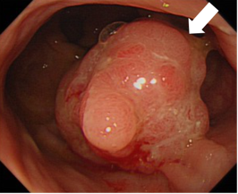  After TNT  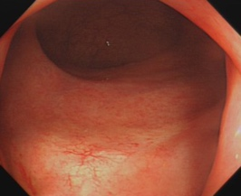  Baseline endoscopy revealed a raised mass occupying the majority of the rectal lumen (white arrow).  After TNT, follow-up endoscopy revealed mild mucosal swelling in the lower rectum with no obvious mass identified. | Baseline  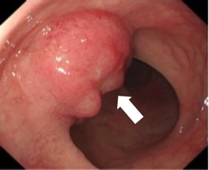  After TNT  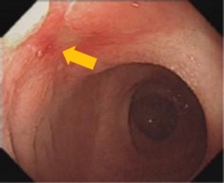  Baseline endoscopy revealed an exophytic, protruding mass located 4–5 cm from the anal verge, growing into the lumen (white arrow).  After TNT, follow-up endoscopy revealed a well-healed ulcer scar located 4-5 cm from the anal verge, with central fibrinous exudate and no evidence of residual mass (yellow arrow). | Baseline  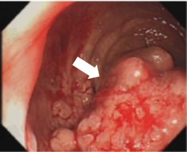  After TNT  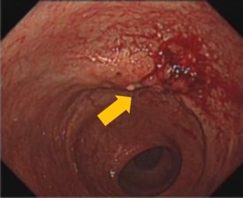  Baseline endoscopy revealed a cauliflower-like mass in the lower rectum, approximately 2–5 cm from the anal verge (white arrow).  After TNT, follow-up endoscopy revealed persistent mucosal congestion with nodular surface elevation in the lower rectum, approximately 3–5 cm from the anal verge (yellow arrow).
MRI T2WI representative images | Baseline  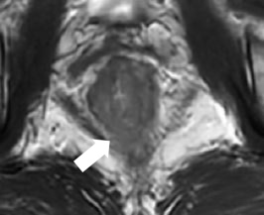  After TNT  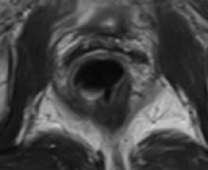  Baseline MRI demonstrated intermediate signal intensity on T2WI (white arrow), with tumor extension beyond the muscularis propria into the perirectal fat.  After TNT, post-therapy MRI demonstrated only fibrotic signal (dark T2 signal) at the primary tumor site, with no residual intermediate signal intensity. | Baseline  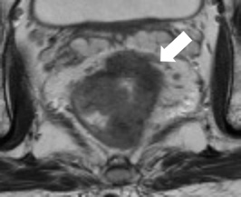  After TNT  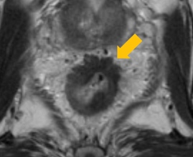  Baseline MRI demonstrated the tumor as an intermediate T2WI lesion, with extramural extension into the perirectal fat (white arrow).  After TNT, post-therapy MRI demonstrated a fibrotic scar with minimal residual intermediate signal intensity at the primary tumor site (yellow arrow). | Baseline  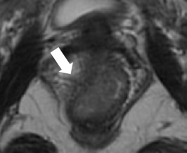  After TNT  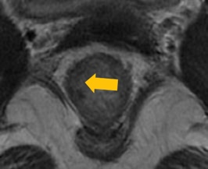  Baseline MRI demonstrated intermediate signal intensity on T2WI, with tumor extension beyond the muscularis propria into the perirectal fat (white arrow).  After TNT, post-therapy MRI demonstrated intermediate signal intensity breaching the inner hypointense layer, with substantial residual intermediate signal intensity (yellow arrow).
MRI DWI representative images | Baseline  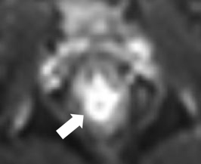  After TNT    Baseline MRI demonstrated high signal intensity on DWI (white arrow).  After TNT, post-therapy MRI demonstrated complete resolution of the previously noted high signal intensity on DWI. | Baseline  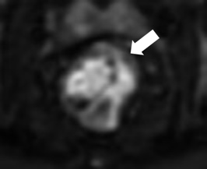  After TNT  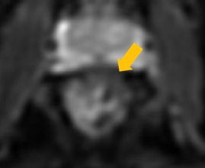  Baseline MRI demonstrated high signal intensity on DWI (white arrow).  After TNT, post-therapy MRI demonstrated few punctate foci of mildly high signal intensity on DWI (yellow arrow). | Baseline  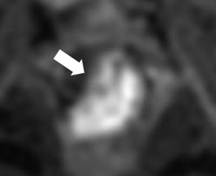  After TNT  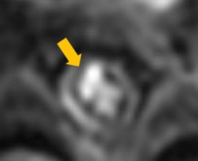  Baseline MRI demonstrated high signal intensity on DWI (white arrow).  After TNT, post-therapy MRI demonstrated persistent focal high signal intensity on DWI (yellow arrow).
MRI ADC representative images | Baseline  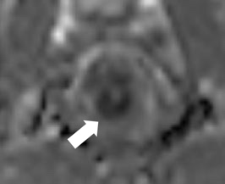  After TNT  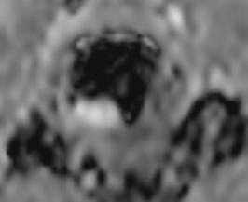  Baseline MRI demonstrated low signal intensity on ADC map (white arrow).  After TNT, post-therapy MRI demonstrated complete resolution of the previously noted high signal intensity on ADC map. | Baseline  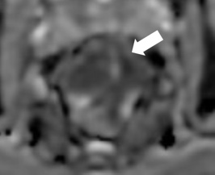  After TNT  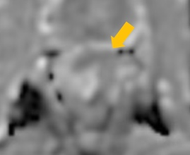  Baseline MRI demonstrated low signal intensity on ADC (white arrow).  After TNT, post-therapy MRI demonstrated persistently mild low signal intensity on the corresponding ADC map (yellow arrow). | Baseline  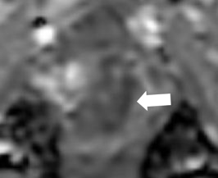  After TNT  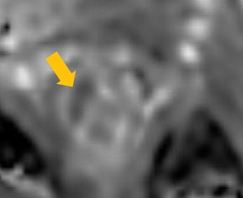  Baseline MRI demonstrated low signal intensity on ADC (white arrow).  After TNT, post-therapy MRI demonstrated persistent focal low signal intensity on the corresponding ADC map (yellow arrow).
*: b ≥ 800 sec/mm².
Abbreviations: TNT, total neoadjuvant treatment; T2WI, T2-weighted imaging; DWI, diffusion-weighted imaging; ADC, apparent diffusion coefficient.
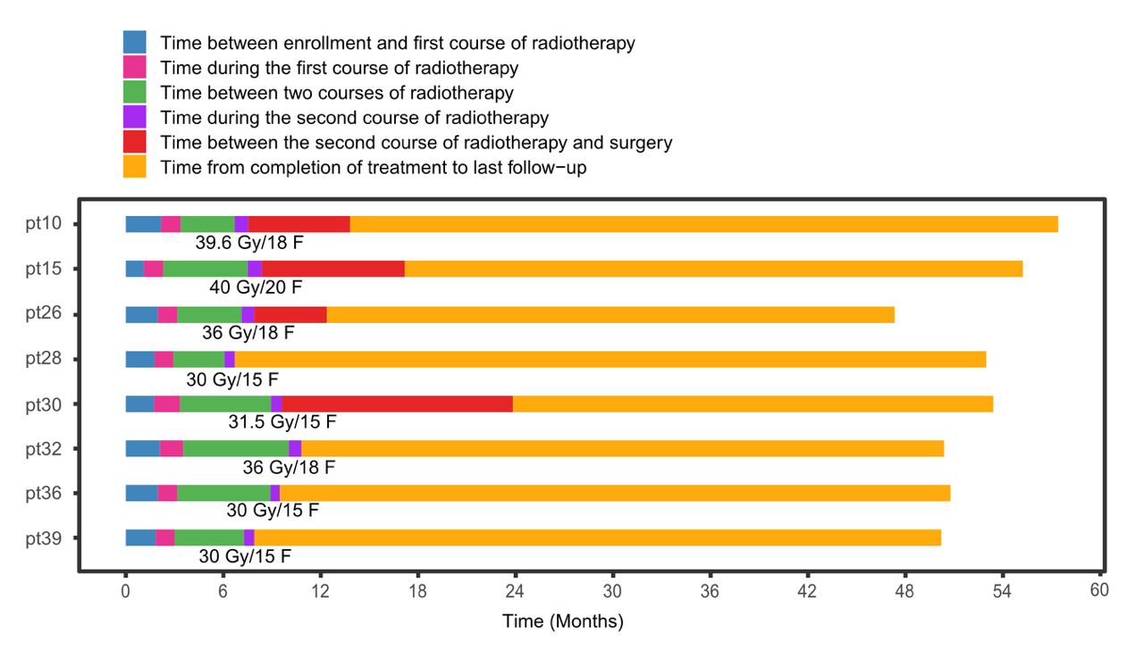
Figure S1. Treatment and outcomes of patients who underwent a second course of radiotherapy. One patient (pt36) was evaluated as near-cCR, and the other seven patients were evaluated as non-cCR at the first assessment. Four patients (pt28, pt30, pt32, and pt39) received a second course of radiotherapy and subsequently achieved cCR. One patient (pt30) underwent sphincter-preserving surgery (SPS). Three patients (pt10, pt15, pt26) underwent non-sphincter-preserving surgery. One patient (pt26) achieved pCR, while three patients (pt10, pt15, and pt30) did not achieve pCR. Abbreviations: near-cCR, near-complete clinical response; non-cCR, non-complete clinical response; pCR, pathological complete response; SPS, sphincter-preserving surgery.

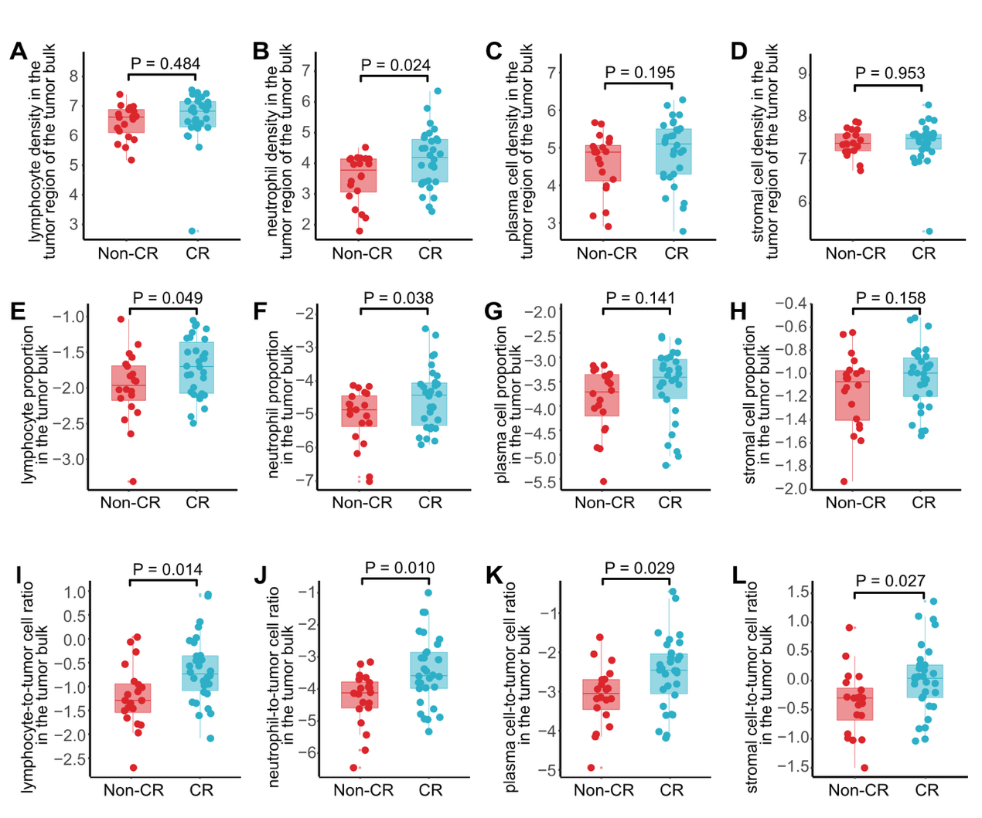
Figure S2. Comparison of immune cell density and proportion between non-CR and CR patients.
(A-D) Boxplots showing the density of lymphocytes (A), neutrophils (B), plasma cells (C), and stromal cells (D) in the tumor region of the tumor bulk.
(E-H) Boxplots showing the proportion of lymphocytes (E), neutrophils (F), plasma cells (G), and stromal cells (H) in the tumor bulk.
(I-L) Boxplots showing the cell-to-tumor cell ratios for lymphocytes (I), neutrophils (J), plasma cells (K), and stromal cells (L) in the tumor bulk.
Data were log-transformed prior to analysis to improve normality.

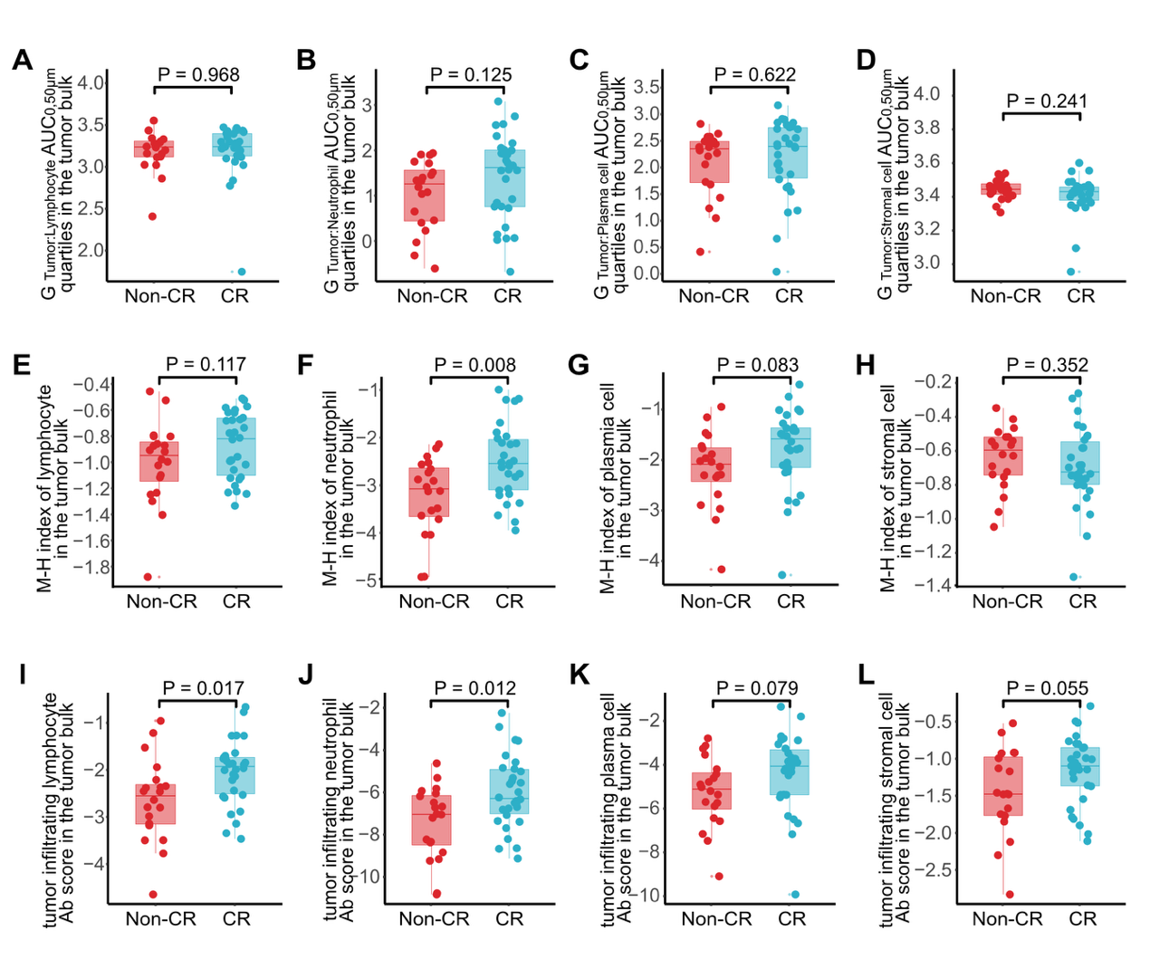
Figure S3. Spatial distribution analysis of tumor cells and immune cells between non-CR and CR patients.
(A–D) Boxplots showing G_{Tumor:lymphocyte} (A), neutrophil (B), plasma cell (C), and stromal cell (D) AUC_{0, 50 μm} quartiles in the tumor bulk.
(E–H) Boxplots showing the Morisita-Horn index (M-H index) for lymphocytes (E), neutrophils (F), plasma cells (G), and stromal cells (H) in the tumor bulk.
(I-L) Boxplots showing the tumor-infiltrating cell abundance (Ab) score for lymphocytes (I), neutrophils (J), plasma cells (K), and stromal cells (L) in the tumor bulk.
G _{Tumor: specific cell} AUC_{0, 50 μm}, estimates the probability that a tumor cell has at least one neighboring cell of the specified type within a 50 μm radius.
Data were log-transformed prior to analysis to improve normality.

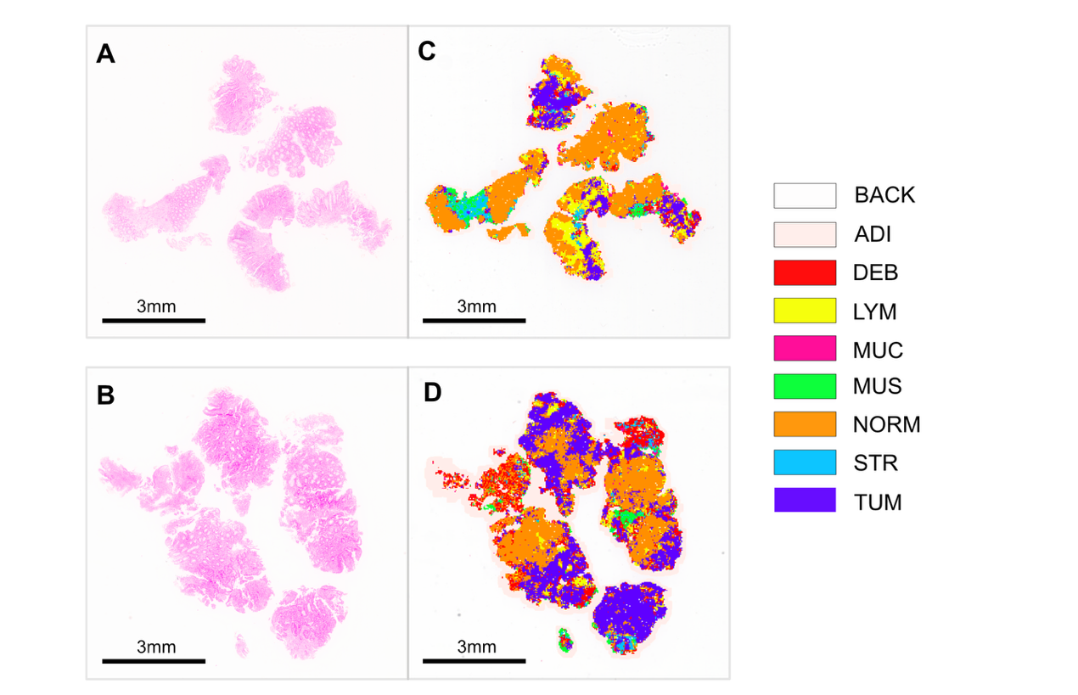
Figure S4. Representative H&E-stained whole-slide images and corresponding tissue classification. Panels A and B show representative H&E-stained whole-slide images. Panels C and D show the corresponding tissue classification into nine tissue types, with each tissue type annotated in distinct colors: BACK, background; ADI, adipose tissue; DEB, debris/necrosis; LYM, aggregated lymphocytes; MUC, mucus; MUS, smooth muscle; NORM, normal colon mucosa; STR, tumor-associated stroma; and
TUM, adenocarcinoma epithelium. Scale bars indicate 3 mm.

