Supplement

High resolution, isotropic late gadolinium enhanced imaging for the quantification of left atrial fibrosis and post-ablation scarring

Methods

Integration of bipolar Electroanatomic mapping with 3D Dixon Late Gadolinium Enhancement Image segmentation shell
Electroanatomic mapping (EAM) data was exported from the workstation and converted to an open-source format¹ using custom software based on a modified version of Hohmann et al.² written in Python 3.11 with the NumPy 1.26, VTK 9.31 and PyVista 0.45.2 libraries^{1,3,4}. 3D Late Gadolinium Enhancement (LGE) segmentations were converted to meshes in the segmentation software⁵ (Appendix Figure 1 A) and co-registered rigidly with the electroanatomic mapping mesh using the iterative closest point (ICP) algorithm (Appendix Figure 1 B). ICP was initialized using the meshes’ centres of mass⁴. Rigid alignment alone left residual misalignment, particularly in the atrial roof (Appendix Figure 1 B, yellow arrows). To address this, non-rigid registration was performed using as-rigid-as-possible surface (ARAP) deformation⁶ with correspondence pairs based on closest points between the two meshes (Appendix Figure 1 C). Only corresponding vertices within a distance of <5mm⁷ were included in the registration. Following registration, LGE-Image Intensity Ratio (IIR) samples within a radius of 5mm of EAM samples were combined linearly using weights determined by a Wendland weighting function⁸ to analyse the correspondence between LGE and EAM. To evaluate registration quality, average surface distance (ASD) was calculated after both the rigid and non-rigid registration steps for the total left atrial surface and posterior wall. Quantitative assessment of the image registration pipeline demonstrated average surface distances in the range of 1–2 voxels for both the total left atrial surface and posterior wall, supporting adequate spatial alignment between LGE and electroanatomical mapping datasets.

Supplement Figure 1
A left: Reconstruction of 3D Late Gadolinium Enhancement (LGE) surface shell. Image Intesity Ratio (IIR) values >1.34 indicating fibrosis on LGE marked in red. A Right: export of bipolar Electroanatomic mapping (EAM), Voltages <0.5mV marked in red. Red dots denote ablation sites.
B: Residual misalignment between the meshes after initial rigid registration using the iterative closest points algorithm (ICP) indicated by yellow arrows. C: N-rigid registration using as-rigid-as-possible surface deformation addressed this, indicated by green arrows.
Electro-anatomical mapping settings
Bipolar endocardial LA voltage maps (mean 1032 ± 562 sites) were acquired in sinus rhythm prior to catheter ablation using either a Lasso-Nav in 18 patients or a Pentaray diagnostic mapping catheter (Biosense Webster, Diamond Bar, CA) in 10 patients in combination with the endocardial mapping system CARTO-3. Patients presenting in AF were cardioverted into sinus rhythm if necessary. We aimed to acquire a point density of min. 700 points evenly covering the entire LA (posterior, anterior, septal, lateral walls, pulmonary vein ostia, LA appendage ostium, inferior wall/“LA floor”). The following settings were used:
Mapping Catheter:
- Lasso® 2515, NAV eco, 12 electrodes, electrode spacing: 8mm (Biosense Webster, Diamond Bar, CA)
OR
- Pentaray™ NAV eco, 20 electrode, electrode spacing: 2-6-2mm (Biosense Webster, Diamond Bar, CA)

CARTO Settings:
Tissue Proximity Index (TPI): "ON" (Measures impedance difference between the blood pool and myocardium, a point is registered for the map only after a certain impedance difference is detected), Cycle Length: 700-1300 ms (Only electrograms within this cycle length range are registered, prevents registration of premature atrial contractions (which have shorter cycle lengths), Position Stability: 6mm, Local Activity Time: 6ms, Density: "Maximum density" = 0.25mm (No additional point is registered within a 0.25mm distance), Color: 10mm (An area is only filled with color if the distance between the mapped point and the next point is ≤ 10mm, Point Filtering: 6mm.

Results
Intra-reader comparison

Supplement Figure 2 Intra Reader Comparison for left atrial LGE assessment

Registration accuracy between EAM and LGE
The average surface distance values of the two main registration steps, assessed for both the total left atrial surface and the posterior wall, were generally in the range of 1–2 voxels at 1.3 mm³ isotropic resolution after the second step of the registration pipeline.

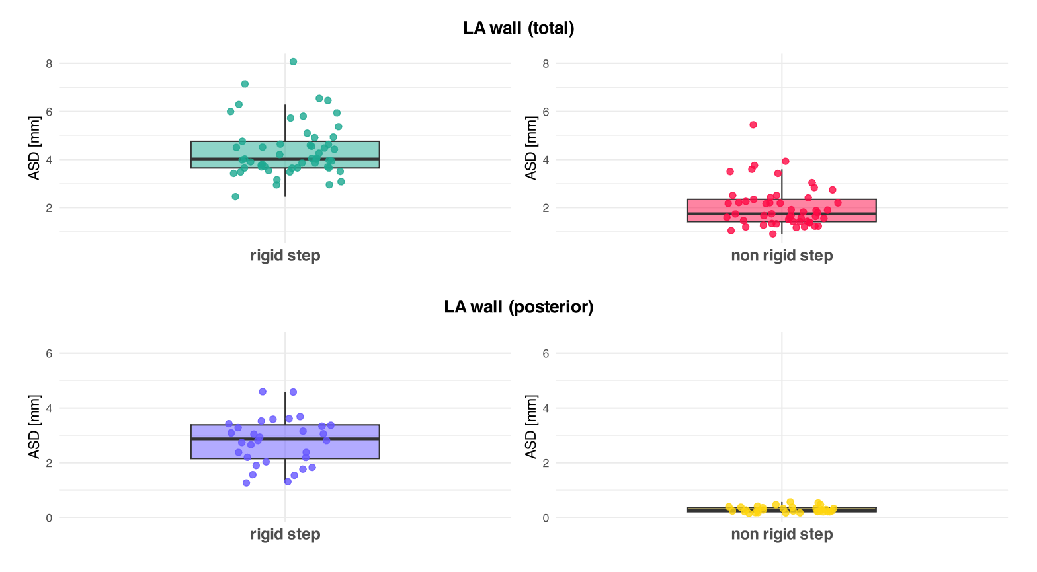
Supplement Figure 3 Average Surface Distance (ASD) of the two main registration steps assessed for the total Left-Atrial surface and the posterior wall. Overall, the pipeline achieved ASD-values in the range of 1-2 Voxels at 1.3mm³ isotropic resolution.

Image Intensity ratio values distribution in the healthy volunteer cohort
We performed a visual analysis of the IIR-distribution within the healthy volunteer cohort using Q-Q-plots (see Supplement Figure 4 and 5). According to a Shapiro-Wilk-Test for normality, the volunteer’s IIR values not normally distributed (Test Statistic=.9445, p<.001.). The healthy cohort’s normalized IIR data was also not distributed according to a Rice-Distribution (Kolmogorov-Smirnov Test, K-S-Test-Statistic= .0958, p<.0001). We then calculated the Kolmogorov-Smirnov-Statistic for different possible distributions yielding a similar K-S statistic for Gaussian and Rice-Distributions. We used scipy: 1.14.1 for calculation of the test statistics.

Distribution | K-S Statistic | p-Value
---------------------------------------------
norm | 0.0958 | 0.0000
rice | 0.0958 | 0.0000
rayleigh | 0.3380 | 0.0000
nakagami | 0.0975 | 0.0000
lognorm | 0.0963 | 0.0000
weibull_min | 0.0782 | 0.0000
gamma | 0.1136 | 0.0000

Fitting a Rice Distribution to the Volunteer cohort’s data to determine the IIR cutoff value based on the 97.72nd percentile (equivalent to mean + 2SD in Gaussian distribution), yields an IIR-cutoff of 1.3363$≈$1.34, similar to the Cutoff derived from the mean + 2SD approach: 1.3354$≈$1.34.
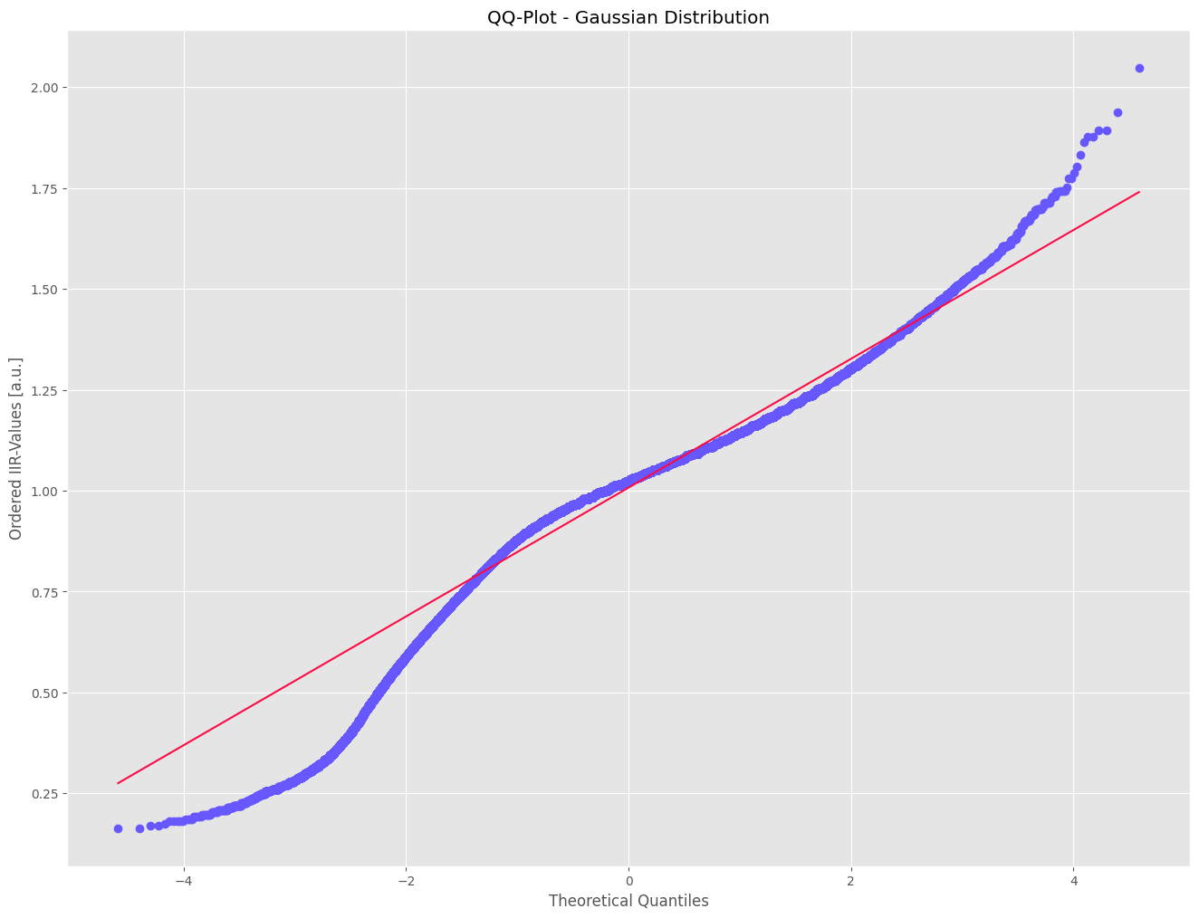
Supplement Figure 5 QQ-Plot for a Gaussian Distribution
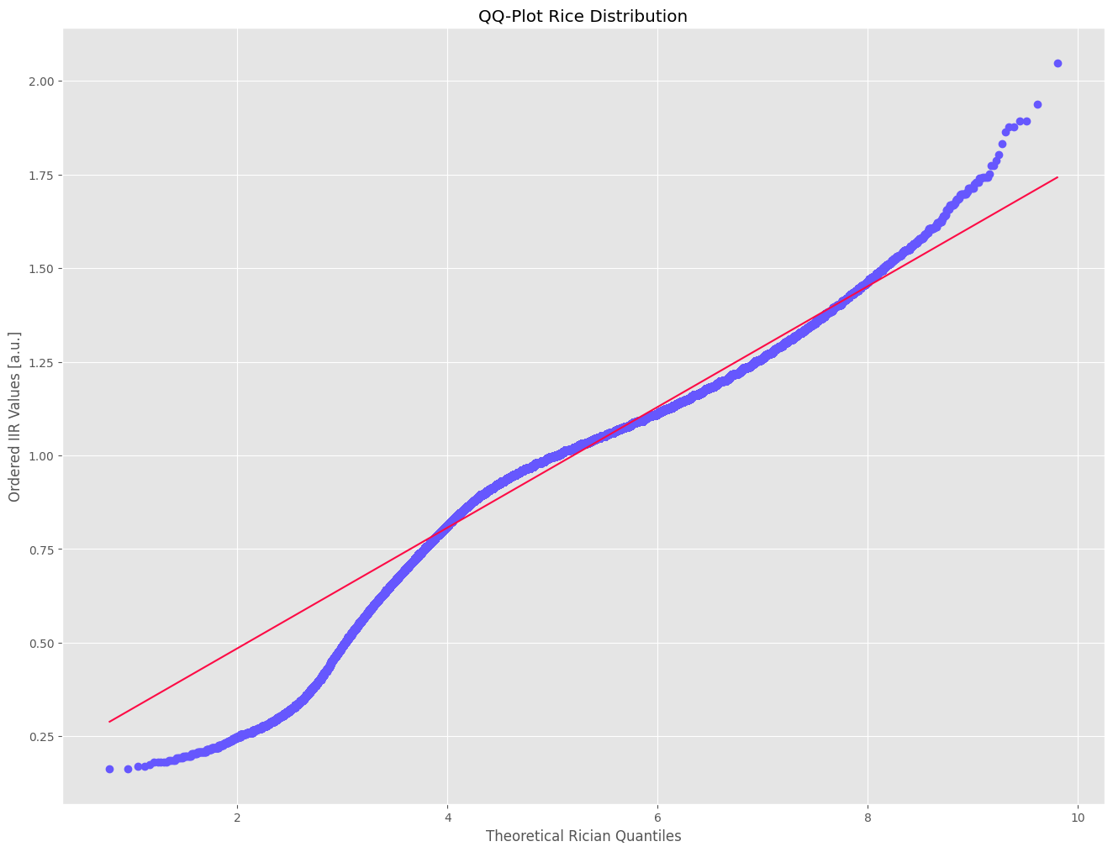
Supplement Figure 6 QQ-Plot for a Rician Distribution

Supplement References
1. Schroeder W, Martin K, Lorensen B. The Visualization Toolkit (4th ed.). Kitware; 2006.
2. Hohmann S, Henkenberens C, Zormpas C, Christiansen H, Bauersachs J, Duncker D, et al. A novel open-source software-based high-precision workflow for target definition in cardiac radioablation. Journal of Cardiovascular Electrophysiology 2020;31:2689–95.
3. Harris CR, Millman KJ, Walt SJ van der, Gommers R, Virtanen P, Cournapeau D, et al. Array programming with NumPy. Nature Springer Science and Business Media LLC; 2020;585:357–62.
4. Sullivan B, Kaszynski A. PyVista: 3D plotting and mesh analysis through a streamlined interface for the Visualization Toolkit (VTK). Journal of Open Source Software The Open Journal; 2019;4:1450.
5. Razeghi O, Solís-Lemus JA, Lee AWC, Karim R, Corrado C, Roney CH, et al. CemrgApp: An interactive medical imaging application with image processing, computer vision, and machine learning toolkits for cardiovascular research. SoftwareX 2020;12:100570.
6. Sorkine O, Alexa M. As-rigid-as-possible surface modeling. Proceedings of the Fifth Eurographics Symposium on Geometry Processing Goslar, DEU: Eurographics Association; 2007. p. 109–16.
7. Bijvoet GP, Nies HMJM, Holtackers RJ, Linz D, Adriaans BP, Nijveldt R, et al. Correlation between Cardiac MRI and Voltage Mapping in Evaluating Atrial Fibrosis: A Systematic Review. Radiology: Cardiothoracic Imaging Radiological Society of North America; 2022;4:e220061.
8. Wendland H. Local polynomial reproduction and moving least squares approximation. IMA J Numer Anal 2001;21:285–300.

