Prevascularized grafts with spatially organized MSC spheroids to accelerate therapeutic angiogenesis in ischemic disease

Jeonghyun Son^{1,2,†}, Aruzhan Naren^{1,3,†}, Hanan Jamal Mohamed^{1,†}, Minjun Ahn⁴, Won Ha^{1,5}, Min Kyeong Kim¹, Seunggyu Jeon^{1,6}, Byoung Soo Kim^{4,7,8}, Yoon-Kyoung Cho¹, Shoji Takeuchi^{9,10,11,12}, and Hyun-Wook Kang^{1,}*

† These authors contributed equally to this work and should be considered as co-first authors.
* Corresponding author. E-mail: hkang@unist.ac.kr
1. Department of Biomedical Engineering, Ulsan National Institute of Science and Technology, Ulsan 44919, Republic of Korea
2. Department of Bioengineering, Stanford University, Stanford, CA 94305, USA
3. Max Delbrück Center for Molecular Medicine (MDC), Berlin 13125, Germany
4. Medical Research Institute, Pusan National University, Yangsan 50612, Republic of Korea
5. Department of Plastic and Reconstructive Surgery, Ulsan University Hospital University of Ulsan College of Medicine, Ulsan 44033, Republic of Korea
6. Department of Bionic Machinery, Research Institute of AI Robotics, Korea Institute of Machinery & Materials (KIMM), Daejeon 34103, Republic of Korea
7. School of Biomedical Convergence Engineering, Pusan National University, Yangsan 50612, Republic of Korea
8. Research Institute for Convergence of Biomedical Science and Technology, Pusan National University Yangsan Hospital, Yangsan 50612, Republic of Korea
9. Department of Mechano-Informatics, Graduate School of Information Science and Technology, University of Tokyo, Tokyo 113-8656, Japan
10. Department of Mechanical and Biofunctional Systems, Institute of Industrial Science (IIS), The University of Tokyo, Tokyo 153-8505, Japan
11. International Research Center for Neurointelligence (WPI-IRCN), The University of Tokyo Institutes for Advanced Study, The University of Tokyo, Tokyo 113-0033, Japan
12. Artificial Cell Membrane Systems Group, Kanagawa Institute of Industrial Science and Technology, Kanagawa 213-0012, Japan
Supplementary Tables
Table S1. Formulations of matrix inks used for spheroid formation.
Matrix ink | Hyaluronic acid,  (HA; mg/mL) | Gelatin,  (mg/mL) | Alginate,  (mg/mL) | Fibrinogen,  (mg/mL)
A12 | 3 | 30 | 12 | -
A12F10 | 3 | 30 | 12 | 10
A8F10 | 3 | 30 | 8 | 10
A4F10 | 3 | 30 | 4 | 10

Table S2. Formulations of cell-laden bio-inks (MSC and µVP).
Cell-laden  bio-inks | HA (mg/mL) | Gelatin (mg/mL) | Pluronic F-127 (%, v/v) | CaCl₂  (mM) | Fibrinogen  (mg/mL) | Cell concentration (cells/mL)
MSC bio-ink | 3 | 40 | 2 | 5 | - | 1.0×10⁸ (MSC)
µVP bio-ink | 3 | 40 | - | - | 10 | 5.0×10⁶ (EC) /  5.0×10⁶ (MSC)

Supplementary Figures
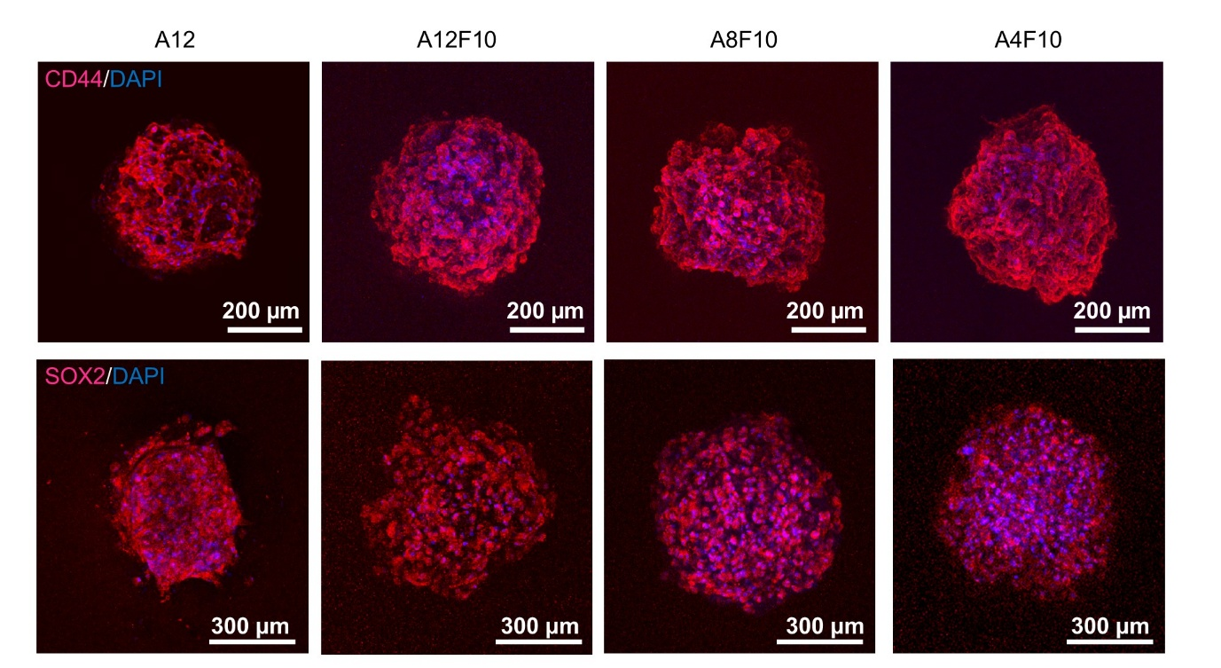
Fig. S1. Immunostaining of stemness-associated markers (CD44 and SOX2) in printed MSC spheroids fabricated with different matrix inks. Confocal Z-stack images are shown (Red: CD44 or SOX2; Blue: DAPI).

Fig. S2. Viability of MSC spheroids under varying dispensing time. (A) Quantification of dead cell count per spheroid area for different dispensing times (n=4). (B) Quantification of the ATP luminescent cell viability assessment: raw luminescence values (RLU; relative value) were normalized to dispensing time and presented as relative ATP levels (n=4). NS, not significant. *p<0.05, **p<0.01, and ****p<0.0001.

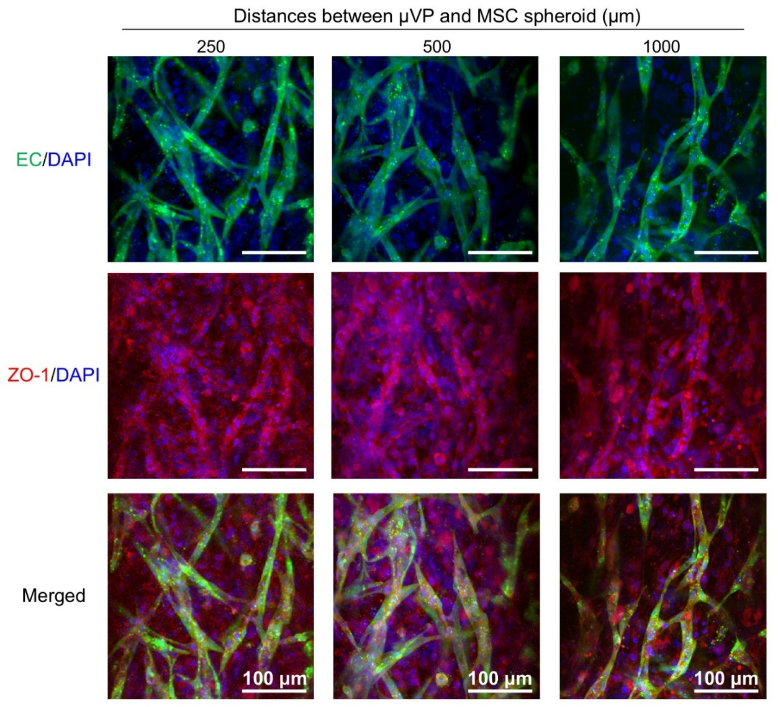
Fig. S3. Immunostaining tight junction markers relative to the distance between the µVP and MSC spheroids. Confocal Z-stacked images of capillaries within µVPs stained with anti-zonula occludens-1 (ZO-1) antibody (Green: GFP-expressing EC; Red: ZO-1; Blue: DAPI).

Fig. S4. Immunostaining mural cell markers relative to the µVP after 6 days of culture. Confocal Z-stack images of capillary structures stained for α-SMA (A, B) and NG2 (C, D) at low and high magnification. GFP-expressing ECs (green), α-SMA (red), NG2 (magenta), and nuclei (DAPI, blue).

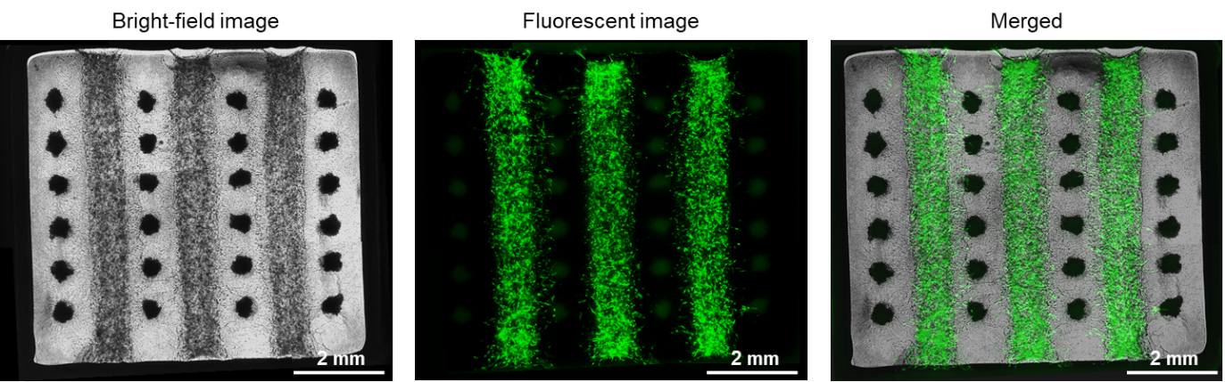
Fig. S5. Microscopic images of bioprinted prevascularized grafts. Bright-field image (left) shows a graft containing three µVP lines and 24 MSC spheroids. Fluorescent image (middle) shows capillary formation within µVPs after 6 days of culture (GFP-ECs, green).

Fig. S6. Storage modulus (G') and loss modulus (G'') of matrix ink and µVP bioink after crosslinking. Frequency sweep (0.05–100 Hz) was performed at room temperature (n = 3). Data are presented as mean ± SD.

Fig. S7. Immunostaining of GFP and DAPI with or without quenching to visualize implanted vessel structures within µVP regions of harvested grafts. Quenching treatment reduces autofluorescence, enabling clearer identification of GFP-positive vessels with lumens (Green: GFP-expressing ECs; Blue: DAPI).

Fig. S8. Picrosirius red (PSR)-stained images showing collagen fiber deposition in harvested skin tissues from a cutaneous wound model at day 9. Images were acquired under polarized light.

Fig. S9. Pilot hindlimb ischemia study to determine the implantation endpoint. Two groups were tested: Only Gel (negative control) and Spheroid Only (experimental group). (A) Limb outcomes after surgery (n = 7). Most outcomes were consistent between weeks 2 and 4, except for a few cases of mild toe necrosis at week 2 that later recovered to limb salvage. (B) Representative images of three Only Gel mice showing changes in ischemic limbs at weeks 2 and 4.

Fig. S10. Vascular integration of implanted and host capillaries in the µVP region. (A) Schematic illustration showing the integration between implanted capillaries (green) and host capillaries (red), forming a chimeric vessel. (B) Confocal z-stack images at depths of 0, 2, and 4 µm showing anastomotic morphologies between implanted capillaries (green, anti-GFP antibody) and host capillaries (red, anti-mouse CD31 antibody).
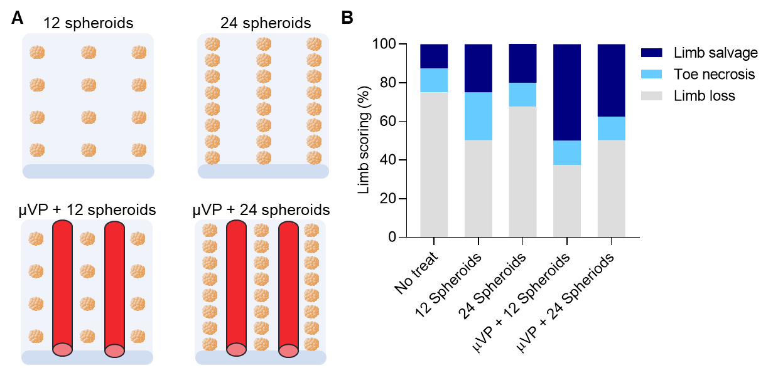
Fig. S11. Evaluation of the synergistic effects of µVP and MSC spheroids in prevascularized grafts using a critical limb ischemia model. (A) Schematic of graft designs with varying compositions. (B) Quantitative assessment of the ischemic limb status at 14 days post-transplantation (n=8).

Fig. S12. Fabrication of large-scale constructs to demonstrate feasibility for clinical applications. (A) Printed construct on a petri dish before crosslinking, with a magnified view showing µVP (white dashed lines) and MSC spheroid regions (yellow circles). The matrix ink and MSC bioink were labeled with red and blue dyes, respectively. (B) Crosslinked constructs demonstrating sufficient mechanical integrity for handling.

