Supplementary Materials

Supplementary Table S1. Landmark analysis of ECG-derived age acceleration and all-cause mortality in MIMIC-IV-ECG.

Landmark (days) | n patients | n events | HR per year | 95% CI | p-value | C-index
0 | 160,493 | 26,902 | 1.005 | 1.004–1.006 | 1.88×10⁻¹⁷ | 0.746
30 | 156,477 | 22,886 | 1.007 | 1.006–1.008 | 2.02×10⁻²⁸ | 0.744
90 | 153,725 | 20,134 | 1.009 | 1.007–1.010 | 3.18×10⁻³⁶ | 0.741
180 | 151,428 | 17,837 | 1.010 | 1.009–1.011 | 6.78×10⁻⁴² | 0.739

Supplementary Table S2. Concordance index comparison across nested Cox regression models.
Model | C-index
Age acceleration only | 0.510
Chronological age only | 0.743
Age + sex | 0.745
Full (accel + age + sex) | 0.746 (95% CI: 0.744–0.748)

Supplementary Table S3. SCP-ECG code descriptions. SCP-ECG diagnostic code abbreviations and descriptions used in the PTB-XL analysis. All codes and descriptions are from the PTB-XL dataset's official SCP-ECG annotation standard.
SCP Code | SCP-ECG Statement Description
NORM | Normal ECG
DIG | Digitalis-effect
ISCAL | Ischemic in anterolateral leads
LNGQT | Long QT-interval
ISC_ | Ischemic ST-T changes (non-specific)
ISCLA | Ischemic in lateral leads
NDT | Non-diagnostic T abnormalities
NST_ | Non-specific ST changes
IMI | Inferior myocardial infarction
LVH | Left ventricular hypertrophy
INJAL | Subendocardial injury in anterolateral leads
CLBBB | Complete left bundle branch block
CRBBB | Complete right bundle branch block
IRBBB | Incomplete right bundle branch block
1AVB | First degree AV block
LAFB | Left anterior fascicular block
LPFB | Left posterior fascicular block
IVCD | Non-specific intraventricular conduction disturbance
AFIB | Atrial fibrillation
PVC | Ventricular premature complex
PACE | Normal functioning artificial pacemaker
RVH | Right ventricular hypertrophy

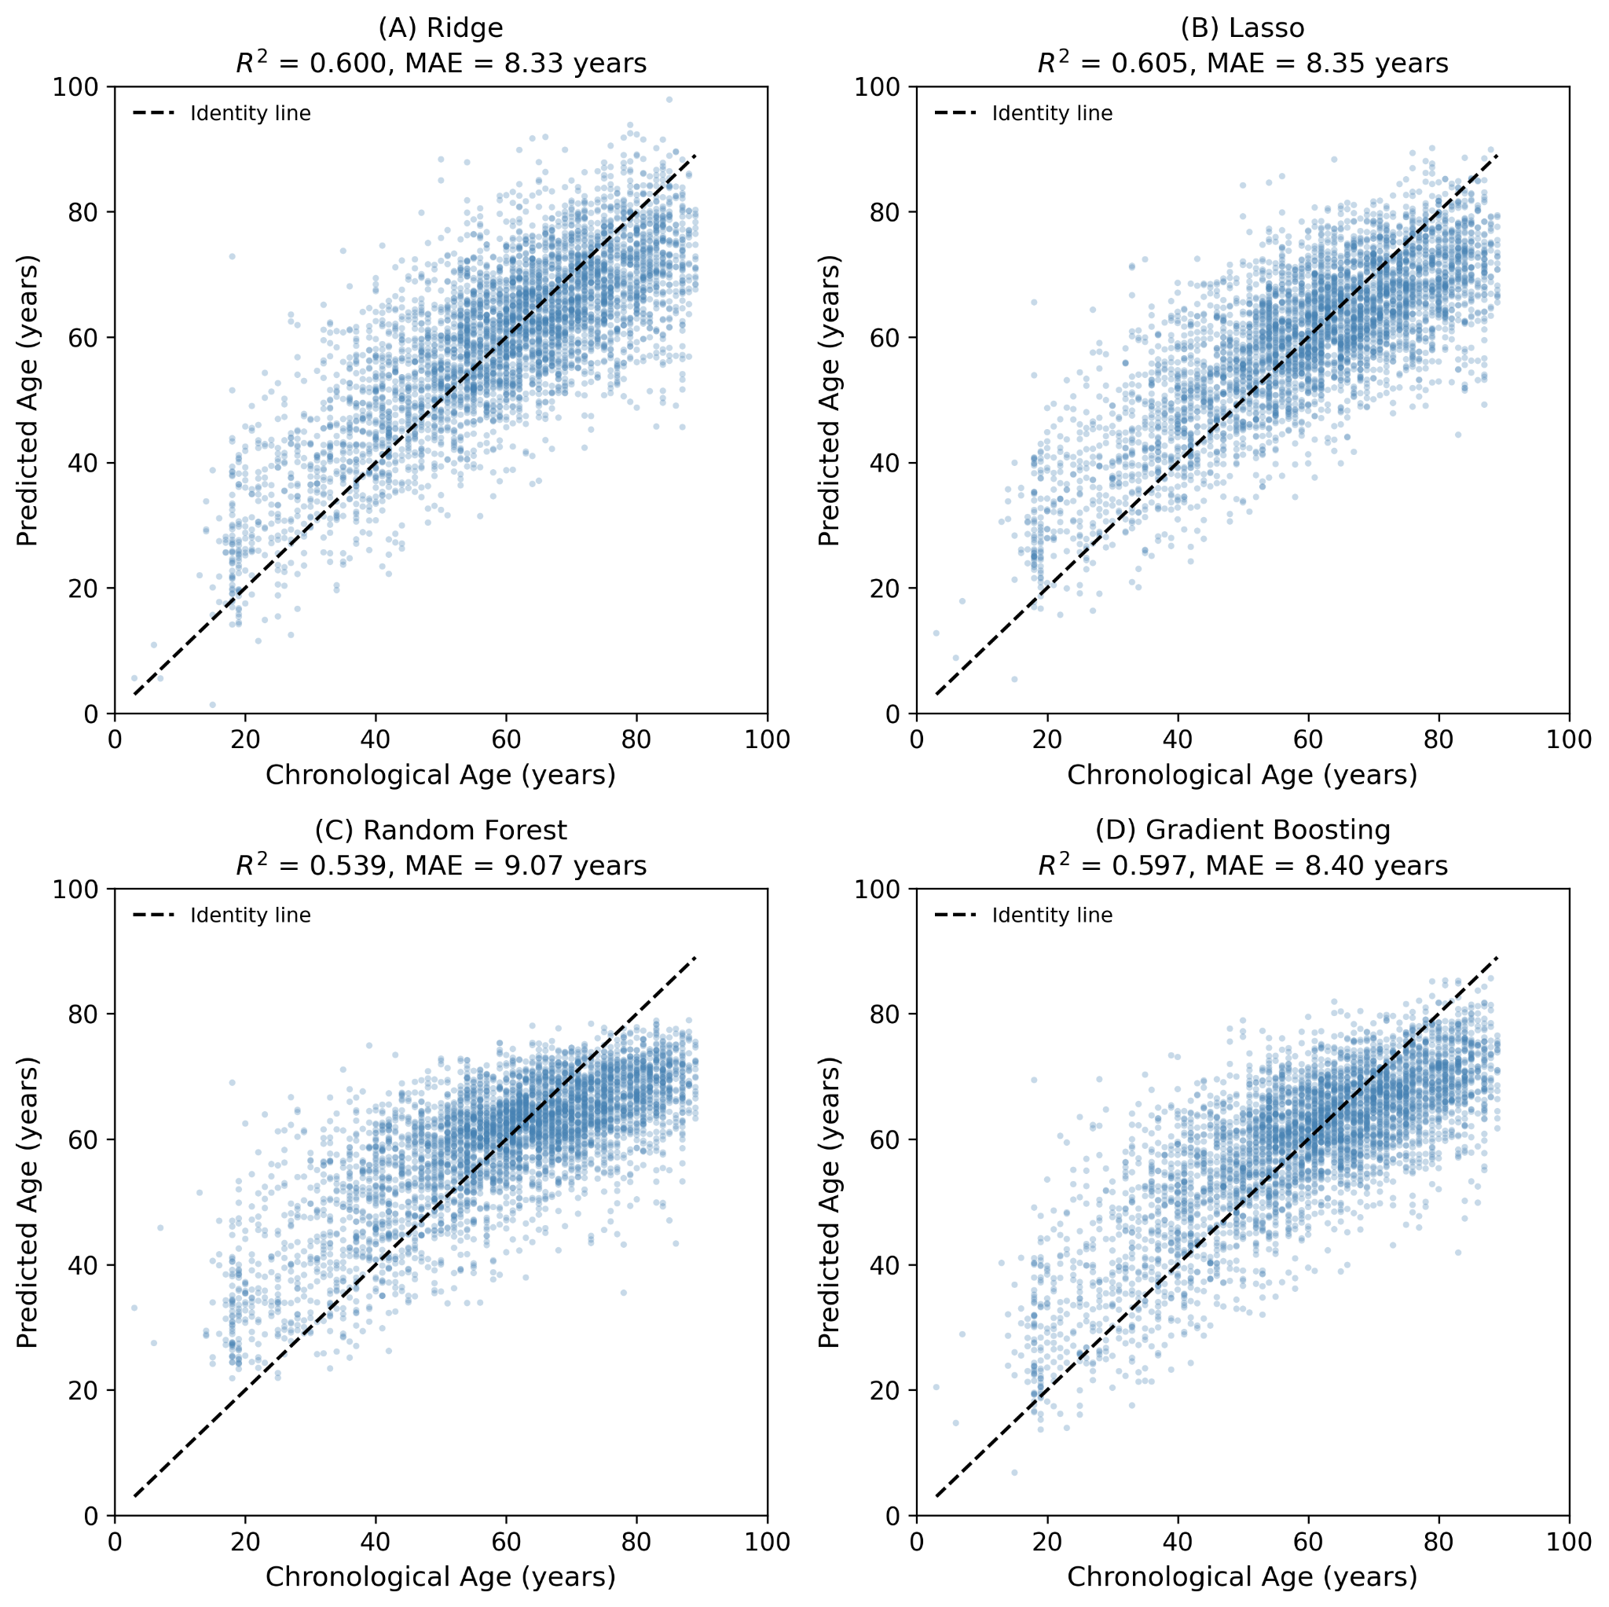

Fig. S1: Model comparison (Ridge/Lasso/GB/RF)Age prediction performance across four regression models on the full PTB-XL dataset. Scatter plots of predicted versus chronological age for (A) Ridge regression (R²=0.600, MAE=8.33 years), (B) Lasso regression (R²=0.605, MAE=8.35 years), (C) Random Forest (R²=0.539, MAE=9.07 years), and (D) Gradient Boosting (R²=0.597, MAE=8.40 years). Dashed lines represent perfect prediction (y=x). All models were trained on the full dataset (healthy + diseased) for model selection purposes; the primary analysis used ElasticNetCV trained on healthy subjects only (R²=0.611, MAE=8.31 years). Linear models performed comparably to ensemble methods, supporting the use of ElasticNetCV for subsequent analyses.

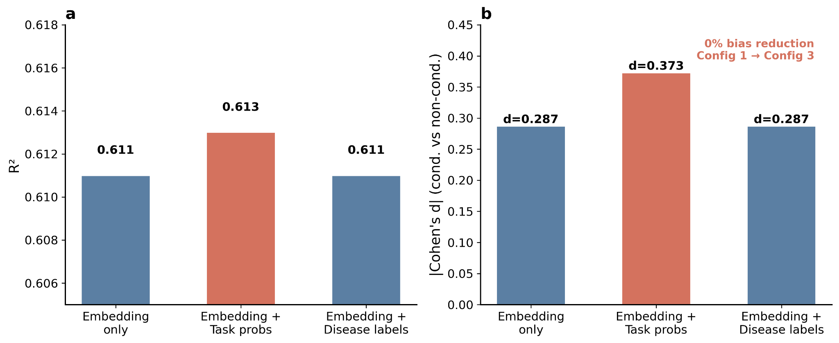

Fig. S2: Conduction 3-config sensitivity. Three feature configurations tested to determine whether the conduction bias is correctable: Configuration 1 (embedding only, d=−0.287), Configuration 2 (embedding + 150 task probabilities, d=−0.373), and Configuration 3 (embedding + 30 disease one-hot labels, d=−0.287). The 0% bias reduction from Configuration 1 to 3 indicates that the conduction bias is intrinsic to the ECGFounder embedding space. Configuration 2 amplified the bias, suggesting task probability outputs encode conduction-specific information that further separates conduction from aging signals.

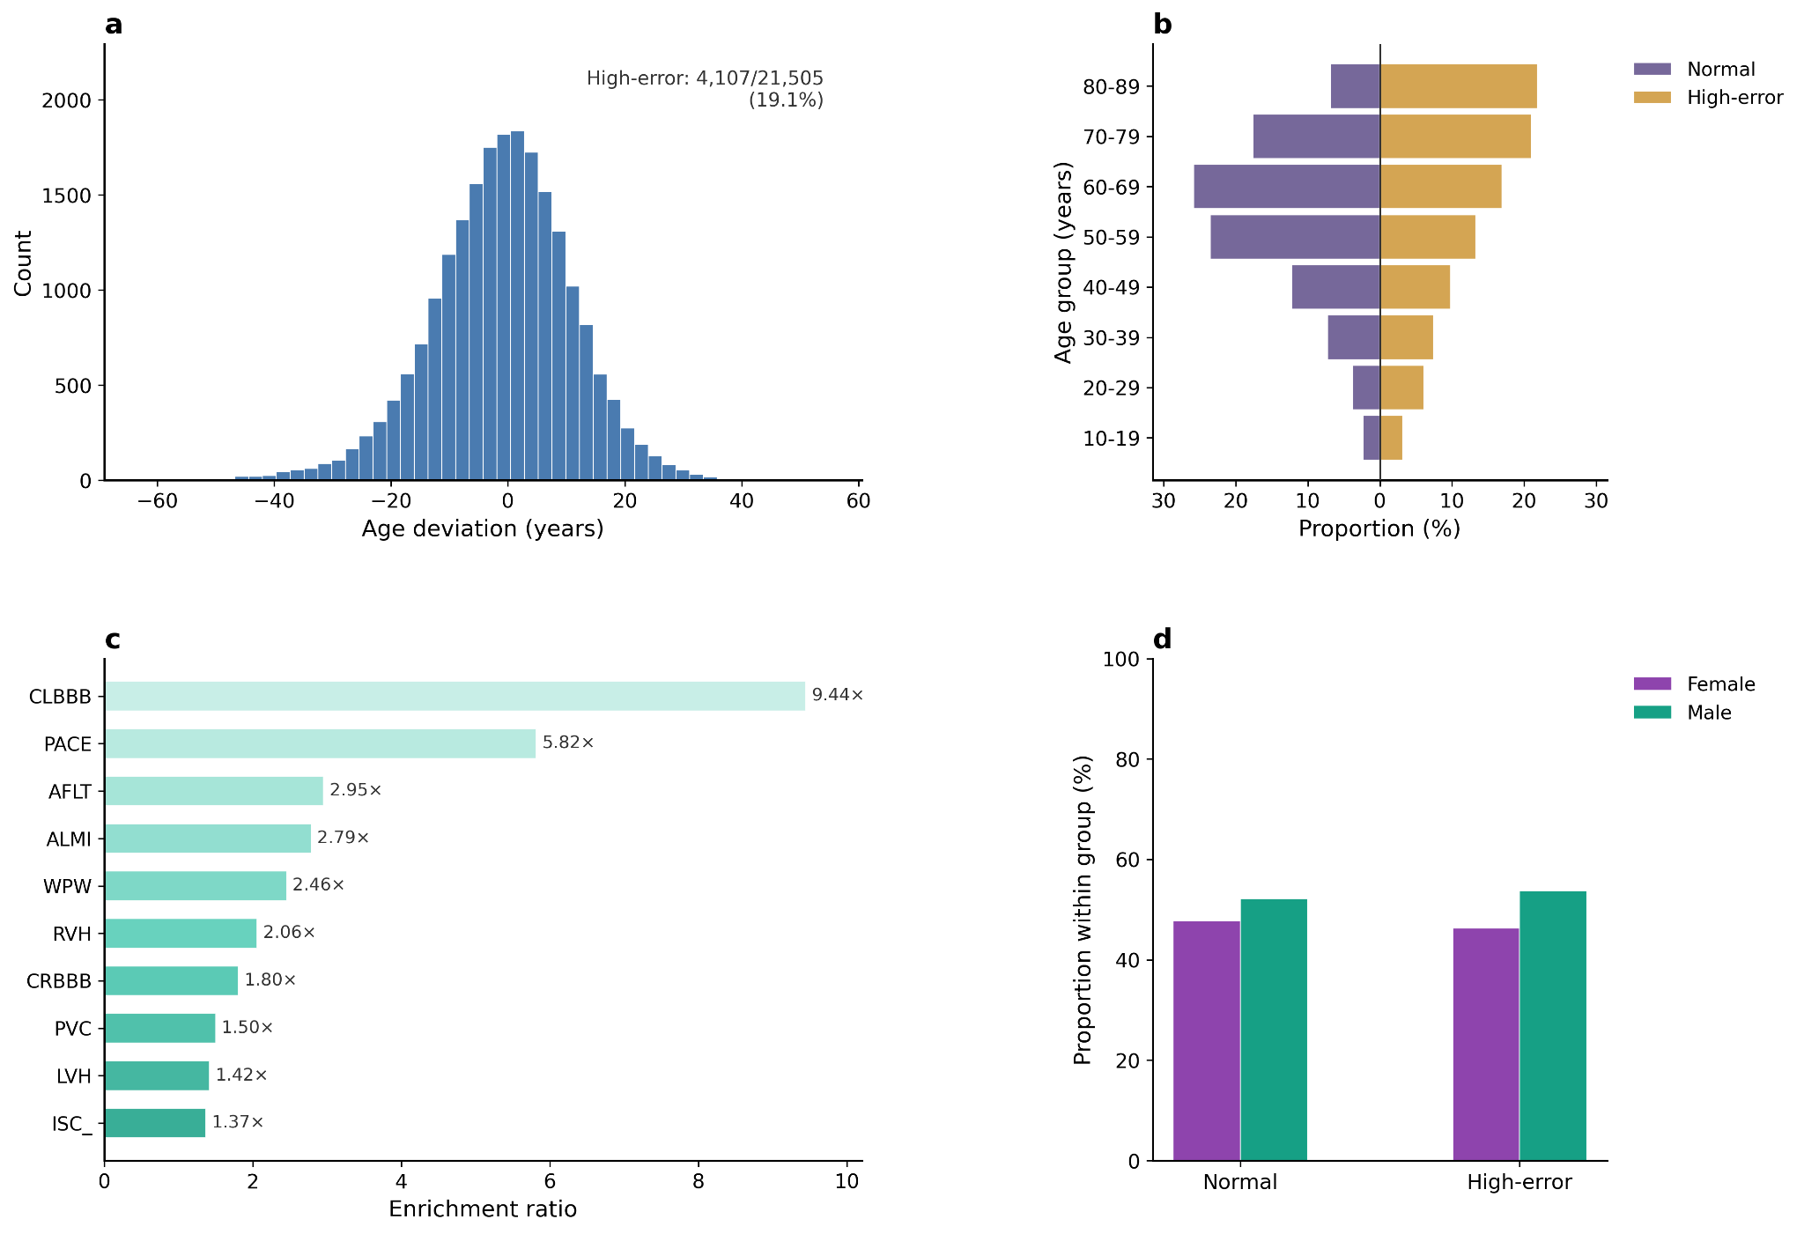

Figure S3. High-error patient analysis in the PTB-XL cohort High-error patient analysis in PTB-XL. (a) Distribution of age deviation across all recordings. (b) Age distribution comparison between normal-error and high-error patients. (c) Disease enrichment ratios in the high-error group relative to normal-error, showing that complete left bundle branch block (CLBBB, 9.44×) and pacemaker rhythm (PACE, 5.82×) are the most over-represented conditions. (d) Sex distribution comparison between normal-error and high-error groups.

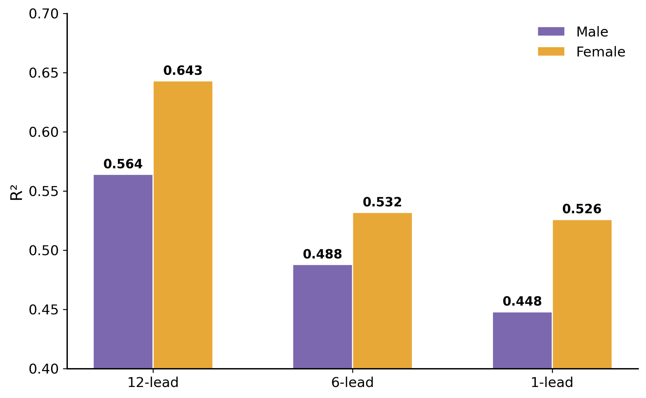

Fig. S4: Sex-stratified lead comparison. Age prediction performance stratified by sex across all three lead configurations. Females consistently showed higher R² (12-lead: 0.643 vs 0.564; 6-lead: 0.532 vs 0.488; 1-lead: 0.526 vs 0.448), suggesting a more consistent aging signal in female ECG embeddings.
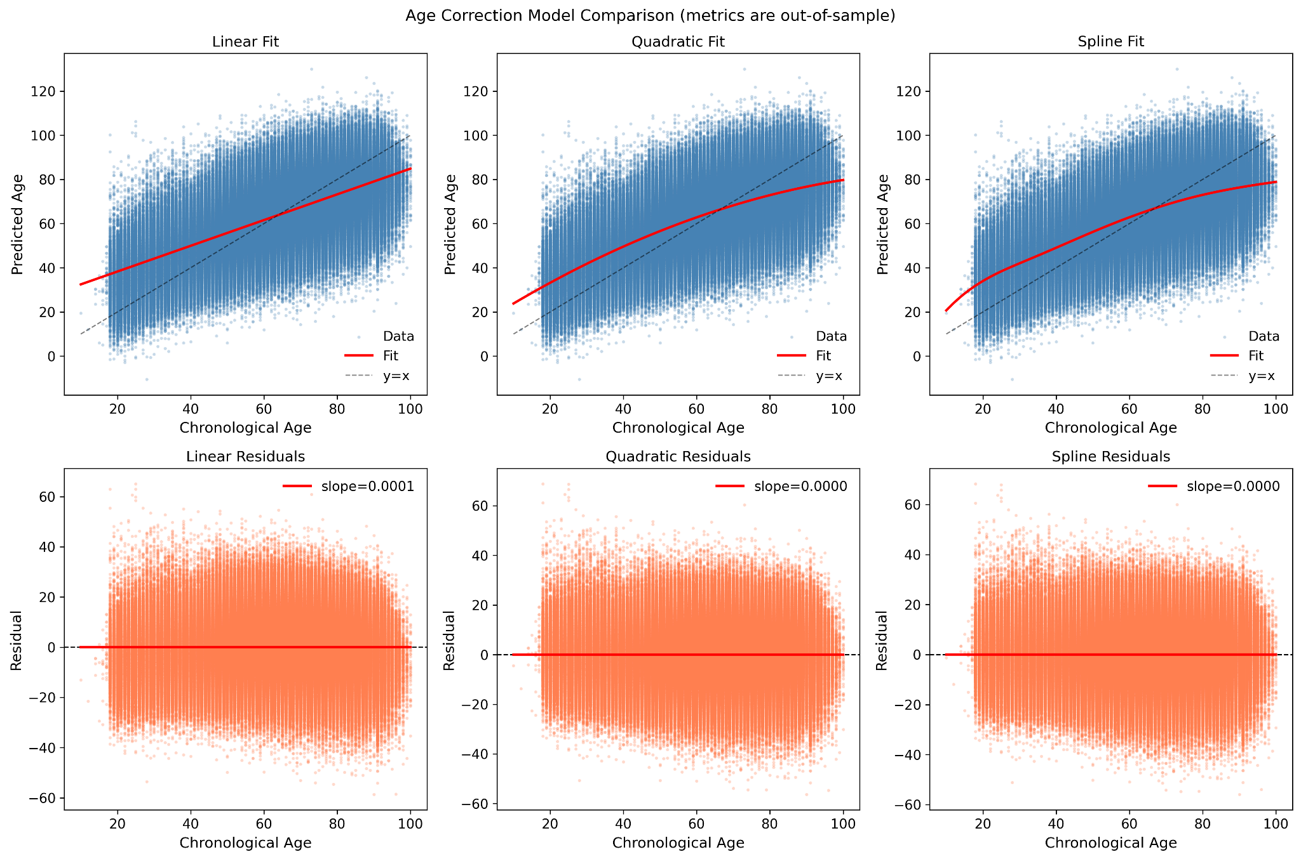
Figure S5. Comparison of linear, quadratic, and spline age correction models in MIMIC-IV-ECG. Top row: predicted versus chronological age with fitted correction curves. Bottom row: residual plots after correction, showing near-zero slopes across all three methods (linear: 0.0001, quadratic: 0.0000, spline: 0.0000), confirming the sufficiency of linear OLS correction.

