Supplementary Materials for

Walking on the Moon: Hypogravity drives the emergence of a proprioception-dependent locomotor state

Alessandro Santuz*, Francesco Luciano, Valentina Natalucci, Adama Mbaye, Nini Ma, Dario Cazzola, Steffi Colyer, James Cowburn, Kirsten Albracht, Bjoern Braunstein, Jörn Rittweger, Nolan Herssens, Tobias Weber, David A. Green, Joriene de Nooij, Alberto E. Minetti, Gaspare Pavei*, Niccolò Zampieri*.

*Corresponding authors: alessandro.santuz@mdc-berlin.de; gaspare.pavei@unimi.it; niccolo.zampier@mdc-berlin.de

The PDF file includes:

Materials and Methods
Figs. S1 to S6
Tables S1 and S2
References

Other Supplementary Materials for this manuscript include the following:

Movies S1 to S6

Materials and Methods – Human Experiments
This study was reviewed and approved by the Ethics Committees of the University of Bath (ID: EP 18/19 018) and the University of Milan (ID: 12/22). In accordance with the Declaration of Helsinki, all participants provided written informed consent prior to the study after receiving all necessary explanations.

Apollo 17 extravehicular activity (EVA) tracking and 3D pose reconstruction
To analyze the Eugene Cernan’s gait, we used the video clip from the Apollo Lunar Surface Journal of Geology Station 5 at Camelot Crater during EVA 2. This clip corresponds to the segment from mission time 146:50:03 to 146:50:53. During this time, Eugene Cernan spontaneously switches to a skipping gait while returning to the Lunar Roving Vehicle. We first used DeepLabCut v2.3.9 (24) for markerless body part tracking and labeled 17 body landmarks on 40 frames taken from the original video, assigning 95% of the images to the training set without cropping. Specifically, we labeled the pelvis, right hip, right knee, right ankle, left hip, left knee, left ankle, spine, thorax, nose, head, left shoulder, left elbow, left wrist, right shoulder, right elbow, and right wrist. We trained the model using a ResNet-50-based neural network (34, 35) with default parameters for 500,000 training iterations. We validated with one shuffle and found a test error of 6.36 pixels and a train error of 1.98 pixels. We then analyzed the video with this model to get 2D landmark coordinates. Because the original footage from 1972 was monocular and not purely sagittal, the resulting 2D trajectories could not be directly interpreted as sagittal-plane kinematics. Therefore, we fed the DeepLabCut output to FMPose3D (36) to lift the 2D joint trajectories into a frame-by-frame 3D pose sequence from the single video view. We then postprocessed the inferred 3D coordinates in R (v4.5.3; The R Foundation for Statistical Computing, Vienna, Austria) and projected them onto the sagittal plane to generate the stick diagrams shown in Fig. 1A.

Locomotion On Other Planets facility and body weight suspension system
The Locomotion On Other Planets (L.O.O.P.) laboratory is an European Space Agency ground-based facility located in the Human Physiology Building at the University of Milan (37). L.O.O.P. simulates low gravity by means of body weight suspension inside a 3 x 3 m, 17-meter-tall cavaedium (light shaft) (12). The body suspension system consists of 4-meter-long bungee cords (Diagoline S.r.l., Ponderano, BI, Italy) with a stiffness of 92.7 N/m. The bungee cords are linked in series with a short, inextensible 4 mm diameter, 1.2 m long Dyneema SK78 rope (Gottifredi Maffioli S.r.l., Novara, NO, Italy), that slides inside a low-friction upper pulley. One bungee cord is fixed to the wall and the other is connected to a force transducer (TS 300 kg, AEP Transducers, Modena, MO, Italy), which is placed in series with a body-suspension harness. The upper pulley can be raised or lowered by a suspension cable connected to a 2.20 kW motorized winch (Officine Iori S.r.l., Albinea, RE, Italy), which allows unloading the body to the desired gravity level (12).

Experimental protocol
Twelve participants (five females; age: 31.1 ± 5.7 years; height: 1.77 ± 0.07 m; body mass: 69.8 ± 14.1 kg; mean ± SD) were asked to walk, skip, and run at 1.1, 1.4, and 3.1 m/s on a double split-belt instrumented treadmill (FIT, Bertec Corporation, Columbus, OH, United States) at 1.00 g (Earth gravity) and at two simulated gravities: 0.38 g (Martian gravity), and 0.17 g (lunar gravity). Each acquisition lasted 60 s. The order of gaits and gravity levels was randomized. Participants rested for five minutes when the gravity level changed and whenever they requested it. At least 24 hours prior to the experiments, each participant underwent a dedicated familiarization session in which they became accustomed to the setup, gaits, and gravities.

Electromyographic (EMG) recordings
The muscle activity of the following 6 muscles was recorded bilaterally, for a total of 12 muscles, using a 16-channel wireless EMG system (Trigno, Delsys, Natick, MA, United States), with a frequency of 2000 Hz: vastus medialis (vm), semitendinosus (st), biceps femoris (long head, bf), tibialis anterior (ta), gastrocnemius medialis (gm), and soleus (so). Prior to electrode placement each recording area was shaved, abraded, and cleaned with an alcohol wipe/swab (38). Electrodes were positioned according to SENIAM guidelines (39).

Gait cycle breakdown
Vertical ground reaction forces were recorded at 2 kHz from the instrumented treadmill, synchronously with EMG. These forces were used to detect the touchdown and takeoff of each foot with a vertical threshold of 20 N.

Muscle synergies extraction
Muscle synergies were extracted through custom scripts (R v4.5.3) using the default parameters of our R package musclesyneRgies (40) v1.2.5.9009 using the classical Gaussian non-negative matrix factorization (NMF) algorithm (41). The raw EMG signals were band-pass filtered within the acquisition device (cut-off frequencies 10 and 500 Hz). Then the signals were high-pass filtered, full-wave rectified and lastly low-pass filtered using a 4th order IIR Butterworth zero-phase filter with cut-off frequencies 50 Hz (high-pass) and 20 Hz (low-pass for creating the linear envelope of the signal). After subtracting the minimum, the amplitude of the EMG recordings was normalized to the maximum activation recorded for each trial for every individual muscle (i.e. every EMG channel was normalized to its maximum in every trial) (18). Each gait cycle was then time-normalized to 200 points. Synergies were then extracted through NMF. For the analysis, we considered the 12 muscles described above. The m = 12 time-dependent muscle activity vectors were grouped in a matrix V with dimensions m × n (m rows and n columns). The dimension n represented the number of normalized time points (i.e. 200*number of gait cycles). The matrix V was factorized using NMF so that V ≈ V_{R} = WP. The new matrix V_{R}, reconstructed multiplying the two matrices W and P, approximates the original matrix V. The matrix P contained the time-dependent coefficients of the factorization (activation patterns) with dimensions r × n, where the number of rows r represents the minimum number of synergies necessary to satisfactorily reconstruct the original set of signals V. The matrix W, with dimensions m × r, contained the time-invariant muscle weights, which describe the relative contribution of single muscles within a specific synergy (a weight was assigned to each muscle for every synergy). W and P described the synergies necessary to accomplish the required task (i.e. walking, skipping or running). The update rules for W and P are:

$$\left\{\begin{aligned}P_{i+1}=P_{i}\frac{{W_{i}}^{T}V}{{W_{i}}^{T}W_{i}P_{i}} \\ W_{i+1}=W_{i}\frac{V{{(P}_{i+1})}^{T}}{W_{i}P_{i+1}{{(P}_{i+1})}^{T}}\end{aligned}\right.$$
The quality of reconstruction was assessed by measuring the coefficient of determination R² (38) between the original and the reconstructed data (V and V_{R}, respectively), defined as the ratio between the residuals and total sum of squares:

$$R^{2}=\frac{{\left(V-V_{R}\right)}^{2}}{{\left(V-\overline{V}\right)}^{2}}$$

The limit of convergence for each synergy was reached when a change in the calculated R² was smaller than the 0.01% in the last 20 iterations (38) meaning that, with that amount of synergies, the signal could not be reconstructed any better. This operation was first completed by setting the number of synergies to 1. Then, it was repeated by increasing the number of synergies each time, until a maximum of 9 synergies. The number 9 was chosen to be lower than the number of muscles, since extracting a number of synergies equal to the number of measured EMG activities would not reduce the dimensionality of the data. Specifically, 9 is the 75% of 12, which is the number of considered muscles (38). For each synergy, the factorization was repeated 10 times, each time creating new randomized initial matrices W and P, in order to avoid local minima (42). The solution with the highest R² was then selected for each of the 9 synergies. To choose the minimum number of synergies required to represent the original signals, the curve of R² values versus synergies was fitted using a simple linear regression model, using all 9 synergies. The mean squared error (43) between the curve and the linear interpolation was then calculated. Afterwards, the first point in the R²-vs.-synergies curve was removed and the error between this new curve and its new linear interpolation was calculated. The operation was repeated until only two points were left on the curve or until the mean squared error fell below 10⁻⁴. This was done to search for the most linear part of the R²-versus-synergies curve, assuming that in this section the reconstruction quality could not increase considerably when adding more synergies to the model.

Muscle synergies analysis
We quantified the temporal structure of muscle synergy activation patterns using full width at half maximum (FWHM) and center of activity (CoA) measurements. We calculated the FWHM for each gait cycle by subtracting the minimum, normalizing to the peak, and defining it as the number of time-normalized points at which the activation pattern exceeded half of its maximum. The mean FWHM across cycles was used for analysis. The CoA was computed using circular statistics. For an activation pattern P sampled at p equally spaced points with phases θ ∈ [0, 2π]:

$$A=\sum_{1}^{p}{P\cos{θ}}, B=\sum_{1}^{p}{P\sin{θ}}$$
$$CoA=\arctan\left(\frac{B}{A}\right)$$

The angle was mapped to the normalized gait cycle (0–100%). To quantify the dispersion of activation timing, we calculated the circular standard deviation:

$$R=\sqrt{{\left(\frac{1}{\sum{P}}\sum{P\cos{θ}}\right)}^{2}+{\left(\frac{1}{\sum{P}}\sum{P\sin{θ}}\right)}^{2}}, cSD=\sqrt{-2\ln{R}}$$

Cross-reconstruction and permutation analysis
To evaluate how similar muscle synergy structures are across different locomotion conditions, we performed a cross-reconstruction analysis of EMG signals. This analysis used time-independent muscle synergy weights and time-dependent activation patterns. For each subject and gravity level, we reconstructed EMG signals from a reference condition (running) using either the same synergy weights (within-condition reconstruction) or weights from a comparison condition (skipping), combined with the reference condition’s activation patterns. Synergies were treated as four functionally labeled modules functionally classified as explained above. When a labeled synergy was absent in a given trial, its corresponding weight vector was set to zero so that missing synergies would not contribute to the reconstruction. This ensured that all reconstructions were performed in a fixed canonical synergy space, without remapping or interpolation of missing modules. Reconstruction quality between the original data V and the reconstructed data V_{R} was quantified using the variance accounted for (VAF) defined as

$$VAF=1-\frac{{\left(V-V_{R}\right)}^{2}}{V^{2}}$$

To assess the specificity of synergy ordering, reconstruction was repeated for all 24 possible permutations of the four synergy labels by reordering the weight matrices while keeping the activation patterns unchanged. Permutation selection was performed only on Earth-gravity trials: for each reference comparison, all 24 possible orders of the four comparison-gait weight vectors were tested against the reference-gait activation patterns under Earth gravity. The order that maximized reconstruction quality was then applied, without re-optimization, to simulated Martian and lunar trials. This prevented the ordering of modules from being defined by locomotor patterns produced in newly experienced hypogravity conditions, which may not have reflected the habitual locomotor repertoire of the participants. It also allowed the hypogravity analyses to test the generalization of an Earth-derived reference architecture. For each gravity level, the quality of the reconstruction was compared across three types: within-condition reconstruction using the original ordering; cross-reconstruction using the same ordering; and cross-reconstruction using a reordered synergy set.

Statistics
The statistical analyses of the human experiments were performed in R v4.5.3 using linear mixed-effects models. Unless otherwise stated, participants were included as random intercepts to account for repeated measurements within individuals. For outcomes measured repeatedly across synergy, identity, or reconstructed objects, the corresponding term was included as an additional random intercept when required by the analysis. Fixed effects were selected according to the design of each analysis. For outcomes measured across gait and gravity, such as interlimb step-time asymmetry, the number of extracted synergies, and electromyography (EMG) reconstruction quality, models included gait, gravity, and their interaction as fixed effects. The interlimb asymmetry analysis was restricted to the gait-speed combinations shown in Fig. 1E: walking at 1.1 m/s, skipping at 1.4 m/s, and running at 3.1 m/s. For the short-term maximum Lyapunov exponent of activation-pattern dynamics, models were fitted separately at each gravity level, with gait as the fixed effect and participant as the random intercept. For the full width at half maximum (FWHM) of activation patterns, models were fitted separately for each gait-speed condition. These models included gravity, synergy identity, and their interaction as fixed effects and participant and synergy object as random intercepts. Reconstruction quality in the cross-reconstruction analyses was compared among reconstruction types using mixed-effects models with participants as random intercepts
Fixed effects were evaluated using Type III tests. The Kenward-Roger degrees-of-freedom approximation was used for analyses implemented with Kenward-Roger mixed-model inference. Type III Wald tests were used for models fitted with Wald inference. Post hoc comparisons were performed on estimated marginal means. Tukey adjustment was used for all-pair comparisons within a single contrast family. Holm adjustment was used for targeted families of contrasts, such as gait comparisons within each gravity level or gravity comparisons within each gait level. Compact letter display (44) was used as graphical summaries of adjusted post hoc comparisons. For each comparison family, the estimated marginal means were ordered from lowest to highest before letters were assigned, with "a" denoting the lowest estimated value and subsequent letters denoting progressively higher values. Conditions that shared at least one letter were not statistically distinguishable at the 0.05 level of significance, whereas conditions that had no letters in common differed significantly. Thus, the letters indicate the ordinal direction of the effect under this ordering convention but not its magnitude.

Materials and Methods – Mouse Experiments
All animal procedures were performed in accordance with European Research Council directives and were approved by the Regional Office for Health and Social Affairs Berlin (LAGeSo) under experimental license number G 0091/22. In all our experiments, both male and female mice were used. Animals were fed ad libitum and maintained under standard conditions on a 12-hour light/dark cycle.

Body weight suspension system
Hypogravity was simulated with a vertical elastic suspension system that used a solid, round silicone cord (HokoFLEX®, nominal diameter 1.0 mm ± 0.35 mm, 60 ± 5 Shore A, axial stiffness ~1.7 N/m; HOKOSIL® Elastomertechnik GmbH, Bredenbek, Germany) connected to the animal with a commercially available soft Velcro mouse harness (Butterfly Mouse Harness, Lomir Biomedical Inc., Notre-Dame-de-l’Île-Perrot, QC, Canada). This harness consists of a single piece of back-to-back Velcro with separate neck and thoracic closures, which allow for an adjustable fit while leaving the forelimbs free and the mouth and neck unobstructed. To maintain the line of pull near the anteroposterior location of the mouse center of mass, an additional Velcro strip was placed between the dorsal harness and the base of the tail. The suspension was designed to provide a constant upward force that corresponds to the desired reduction in effective gravity. To achieve this, the cord rest length was chosen based on the installed vertical span and the mass of the mouse. For the body mass range used in this study and a fixed installed span of 1.50 m, the resulting mean cord extension was approximately 80 to 115 mm under lunar conditions. Kinematic recordings showed a maximum vertical excursion of the center of mass of about 20 mm. Under these conditions, the expected variation in step-to-step force remained moderate and was primarily determined by the ratio of vertical body oscillation to mean cord extension. Material nonlinearities and hysteresis were neglected at the design stage because force variability was dominated by geometry.
To evaluate the potential impact of the harness on spontaneous locomotion, we conducted a one-hour open-field test (ActiMot, TSE Systems GmbH, Berlin, Germany) with a group of seven littermates (three females). We recorded their behavior with and without the harness on two different days, 72 hours apart. We quantified volitional activity in consecutive 10-minute bins using the manufacturer’s analysis software.

Estimation of the anteroposterior location of the center of mass from passive suspension
The experiment was conducted on 4 young adult littermates (2 females; age 152 days; mass 27.9 ± 1.4 g) and 4 older adult littermates (2 females; age 70 days; mass 22.2 ± 0.7 g) mice. After euthanasia, the mice were positioned in a standardized trotting posture, with one diagonal limb pair extended and the other flexed. They were then allowed to undergo rigor mortis in this configuration before being stored at -80 °C. Suspension experiments were conducted at 4 °C. Each frozen specimen was suspended from a fixed overhead point via the tail-base strap of the harness in a dorsal position. The specimens were suspended at successive positions spaced 5 mm apart along the full anteroposterior extent of the dorsal strap. At each position, a photograph was taken once the animal reached stable equilibrium. The images were analyzed using the ImageJ2 distribution Fiji v2.17.0 (45). A reference segment was drawn from the external auditory meatus to the ventral surface of the tail base. A perpendicular projection from the suspension point onto this segment defined the normalized suspension position. The equilibrium angle relative to horizontal was recorded at each position. The anteroposterior center-of-mass location was estimated as the zero crossing of a linear regression of body angle on normalized suspension position.

Mouse lines and experimental protocol
We generated PV^{cre};Rx3^{flpo};Mapt^{dsDTR};Ai65D transgenic mice using the following lines. PV^{cre}: Jackson Laboratories, Bar Harbor, ME, USA; RRID:IMSR_JAX:008069 (46). Rx3^{flpo}: courtesy of Dr Joriene De Nooij at Columbia University, New York, NY, USA (26); Ai65D: Jackson Laboratories, Bar Harbor, ME, USA; RRID:IMSR_JAX:021875 (47). Recordings were conducted on 23 adult (13 females; age 73 ± 8 days; mass 23.2 ± 4.7 g) mice.
Before treadmill recordings, animals were briefly anesthetized with isoflurane (3% in oxygen, 1 L/min delivered by inhalation). The right hindlimb was shaved and anatomical landmarks were highlighted using a water-based white marker placed over the hip joint and iliac crest to facilitate kinematic tracking. For hypogravity experiments, the body weight support harness was fitted during the same anesthesia period. Animals were then transferred to the treadmill and allowed to fully recover before data acquisition. Recordings only started once animals resumed spontaneous exploratory behavior and completed at least one full grooming sequence, indicating recovery from anesthesia and reacclimatization to the experimental environment.
For baseline treadmill locomotion and line characterization, animals were tested at 0.1, 0.3, 0.5, 0.7, and 0.9 m/s, presented in ascending order. For each speed, we aimed to record at least 100 gait cycles of the right hind leg. This was done in one or any number of trials necessary to reach a total of 100 cycles. After each trial, animals were given a two-minute recovery period before proceeding further. If an animal failed to maintain locomotion at a given speed, the condition was repeated a total of three times. Speeds that could not be successfully maintained after three attempts were classified as not achieved, and no further higher speed conditions were tested for that animal. The animals were tested in the morning.
For simulated hypogravity experiments, the protocol was identical except that recordings were performed only at 0.3 m/s. The body weight support harness was applied during the initial anesthesia period. The harness was carefully positioned around the thorax and neck while ensuring unrestricted movement of the forelimbs and head. The animals were tested in the morning.
Open field testing was performed using an ActiMot infrared beam activity monitor (TSE Systems, Berlin, Germany). The mice were tested individually in 60x60 cm acrylic glass arenas. Each animal was placed in an arena and allowed to explore freely for 60 minutes. The ActiMot system recorded horizontal and vertical beam breaks, and the manufacturer’s software extracted locomotor variables in 10-minute intervals. The animals were tested in the morning.

Diphtheria toxin delivery
Each adult PV^{cre};Rx3^{flpo};Mapt^{dsDTR};Ai65D mouse received an intraperitoneal injection of diphtheria toxin (D0654 lyophilized; Sigma-Aldrich, St. Louis, MO, USA), diluted in ultrapure water at a concentration of 100 μg/kg (31, 48). The final solution contained 10 μg/ml of toxin. For example, a 32-g mouse would receive 320 μl of the solution.

Immunohistochemistry
For immunohistochemistry analysis, each PV^{cre};Rx3^{flpo};Mapt^{dsDTR};Ai65D mouse was perfused after deep anesthesia was achieved using a diluted cocktail of xylazine and ketamine in 1X phosphate buffered saline (PBS). For every 10 g of mouse body mass, the cocktail was prepared with 20 µl of 10% ketamine (Ketabel®, 100 mg/ml), 16 µl of 2% xylazine (Rompun®, 20 mg/ml), and 64 µl of 1X PBS. After thoracotomy, the mice were perfused with 20 ml of 1X PBS followed by 10 ml of 4% paraformaldehyde (PFA) solution through the left cardiac ventricle. The tissue of interest was dissected and post-fixed in 4% PFA at 4 °C overnight. Then, it was cryoprotected by immersion in a 30% sucrose-1X PBS solution for at least 24 hours or until it sank. After cryoprotection, the tissue was embedded in an optimal cutting temperature (OCT) mounting medium, flash frozen on dry ice, and stored at -80 °C. The tissue was sectioned using a cryostat (Leica CM3050 S, Leica Biosystems AG, Muttenz, Switzerland) and placed on microscope slides to dry for at least one hour. The muscle, brainstem, and brain samples were sectioned at 50 µm, the dorsal root ganglia at 25 µm, and the spinal cord at 20 µm. For all types of tissue, we initially washed the slides three times in 1X PBS for 10 minutes each to remove OCT. Then, the slides were incubated overnight at 4 °C in a primary antibody solution diluted in 1X PBS + 0.1% Triton X-100 (PBT). The next day, the slides were washed three more times in 1X PBT for five minutes each. Then, the slides were incubated for one hour at room temperature with a secondary antibody solution in PBT. After three more 5-minute washes in 1X PBS, the slides were mounted with Mowiol mounting medium and coverslipped. Primary antibodies: guinea pig anti-parvalbumin (1:3000, Swant, GP72), guinea pig anti-VGLUT1 (1:2000, Sigma-Aldrich, AB5905), and rabbit anti-DsRed (1:1000, Takara, 632496). Secondary antibodies: Alexa Fluor 488 donkey anti-guinea pig IgG (H+L) (1:500, Jackson ImmunoResearch, 706-545-148) and Cy3 donkey anti-rabbit IgG (H+L) (1:500, Jackson ImmunoResearch, 711-165-152). NeuroTrace 435 (1:500, Invitrogen, N21479) was used as a fluorescent Nissl stain.

Motion capture
The kinematics data were recorded through one high-speed camera (boA1936-400cc, Basler AG, Ahrensburg, Germany) operating at 250 Hz. For markerless body part tracking we used DeepLabCut, v2.3.9 (24). We labelled 57 body landmarks and 6 calibration markers on 96 frames taken from 12 videos of 8 different animals, assigning 95% of those images to the training set without cropping. Namely, we labelled six calibration markers from the sagittal view and additionally:
- From the sagittal view: snout, right eye and ear; ankle and metatarsal joints, toe tip of all paws; the right hindlimb iliac crest and hip; scapula, most dorsal point of the trunk, most ventral part on the spine between the previous and the tail base; five equidistant points on the tail from the tail base to the tail tip.
- From the bottom mirror (ventral) view: snout, mouth, ears; the middle and each finger of every paw; five equidistant points on the tail from the tail base to the tail tip.
Iliac crest and hip were highlighted by two white-marker dots as described above. We used a ResNet-50-based neural network (34, 35) with default parameters for 1,100,000 training iterations including two refinements. We validated with one shuffle and found the test error was 4.51 pixels and the train error 2.47 pixels.

Gait cycle breakdown
Gait events were identified from the filtered kinematic trajectories of the distal limb markers. Specifically, the detection of touchdown and lift-off of each paw relied on the horizontal and vertical motion of the toe tip and metatarsal landmarks from all four limbs. The marker trajectories were low-pass filtered using a fourth-order, zero-phase Butterworth filter with a cut-off frequency of 20 Hz. Trials containing prolonged halts, direction changes, tracking failures, or sustained contact of the tail with the back wall of the treadmill were excluded prior to gait event detection.
For each limb, normalized horizontal toe tip displacement was differentiated to obtain velocity and acceleration profiles. Candidate stride events were first identified from periodic changes in horizontal toe tip motion. Specifically, we detected peaks corresponding to transitions between forward and backward horizontal toe-tip velocity from a more strongly smoothed version of the horizontal displacement signal (8 Hz low-pass filter), with minimum peak spacing adapted to the expected stride frequency. Then, touchdown timing was refined within a narrow temporal window (-5, +20 ms) around each candidate event (18). The algorithm searched for the earliest peak in vertical acceleration between the metatarsal and toe tip markers. This accounted for variability in foot strike patterns across steps and animals (49). Additionally, tracking likelihood values from DeepLabCut were used to avoid touchdown assignments during periods of poor marker confidence. Lift-off was identified as the instant of minimum horizontal toe-tip displacement between two consecutive touchdown events, corresponding to the onset of forward paw progression during swing. Touchdown and lift-off timings were calculated independently for all four limbs. To improve cycle consistency and minimize misassignments, gait cycles were aligned relative to the timing of the right hind limb cycle.

Statistics
Statistical analyses of the mouse experiments were performed in R v4.5.3 using mixed-effects models. Mouse identity was included as a random intercept unless stated otherwise. For analyses of left-right limb asymmetry, asymmetry values were bounded between 0 and 1. These values were squeezed away from the exact boundaries and logit-transformed before statistical modeling. For intact mice, asymmetry was analyzed with gravity condition, limb pair, and their interaction as fixed effects. For proprioceptor ablation experiments, day after diphtheria toxin injection was included as an additional fixed effect, together with its interactions with gravity condition and limb pair. Pairwise contrasts between gravity conditions were computed within limb pair and day using estimated marginal means and Holm correction for multiple testing. Compact letter displays were used to summarize the adjusted post hoc comparisons at α = 0.05.
Principal component analyses of mouse kinematics were performed using separate linear mixed-effects models for scores on PC1 and PC2. The fixed effect was the experimental factor represented in the corresponding figure: either the gravity condition or the day after diphtheria toxin injection. Mouse identity was included as a random intercept. Pairwise contrasts among days were adjusted using the Holm method. When testing PC1 and PC2 together, the resulting families of p-values were adjusted using Holm correction across principal components. For the effect-size analysis of lunar-gravity-induced hindlimb asymmetry, the condition contrasts were standardized using the residual standard deviation from the corresponding mixed-effects model. They were then reported as Cohen’s d on the transformed scale. Confidence intervals were obtained from the estimated marginal contrasts.
For the harness-control experiment, distance traveled and average moving speed were analyzed with harness condition as the fixed effect and mouse identity as the random intercept. Histological quantification of proprioceptor ablation was analyzed with the number of days since diphtheria toxin injection as a fixed effect. When cell-level measurements were used, mouse identity was included as a random intercept to account for the nesting of cells within animals. Model assumptions were evaluated by inspecting residual distributions and fitted versus residual plots.

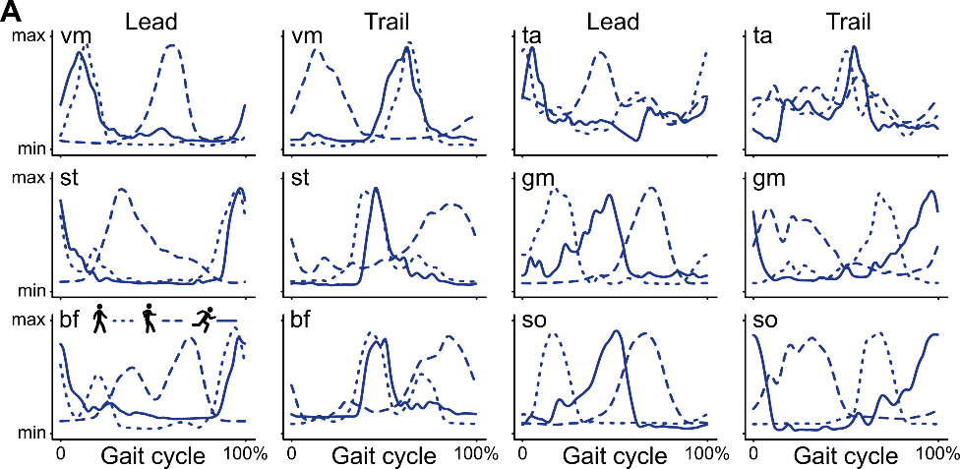

Fig. S1. Lower-limb muscle activity across gait modes under Earth gravity. (A) Average electromyographic activity profiles for individual muscles during walking at 1.1 m/s, skipping at 1.4 m/s, and running at 3.1 m/s under Earth gravity (N = 12 participants). Signals are shown separately for the leading and trailing legs, time-normalized to the gait cycle, and amplitude-normalized between minimum and maximum activation. Line type indicates gait mode, as shown by the icons. Abbreviations: vm = vastus medialis; st = semitendinosus; bf = biceps femoris; ta = tibialis anterior; gm = gastrocnemius medialis; so = soleus.

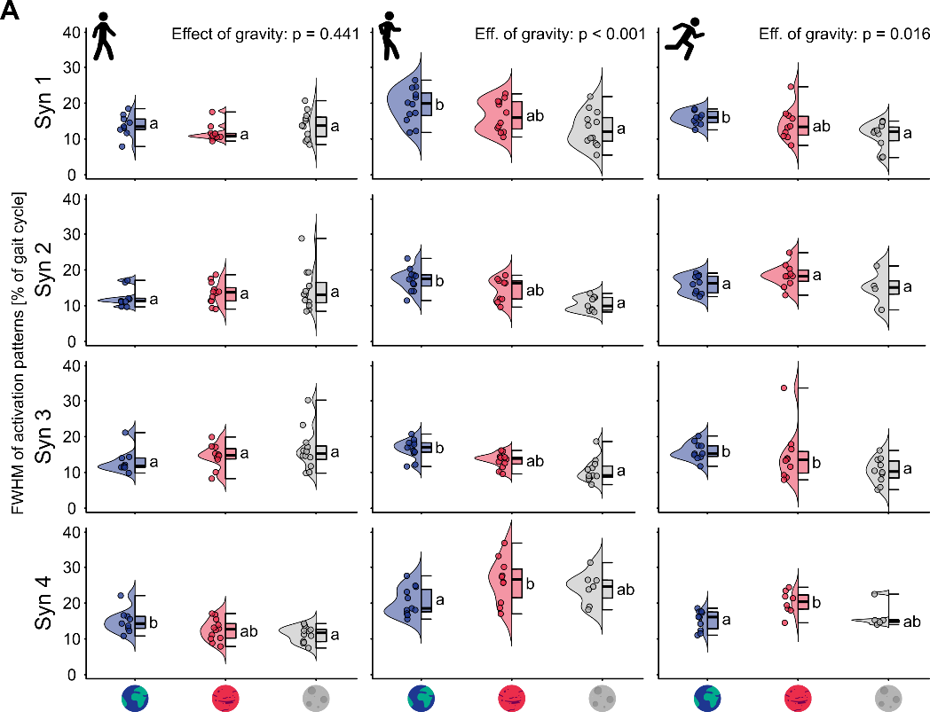

Fig. S2. Temporal width of muscle-synergy activation patterns across gaits and gravity levels. (A) Full width at half maximum (FWHM) of synergy activation patterns for walking at 1.1 m/s, skipping at 1.4 m/s, and running at 3.1 m/s under Earth, Martian, and lunar gravity. Rows show individual synergies (Syn1 to Syn4), and columns show gait modes. Within each panel, distributions across gravity conditions are shown as violin plots, with overlaid boxplots and individual trial estimates. FWHM values are expressed as percentage of the gait cycle. Different letters indicate significant post-hoc differences (N = 12 participants).

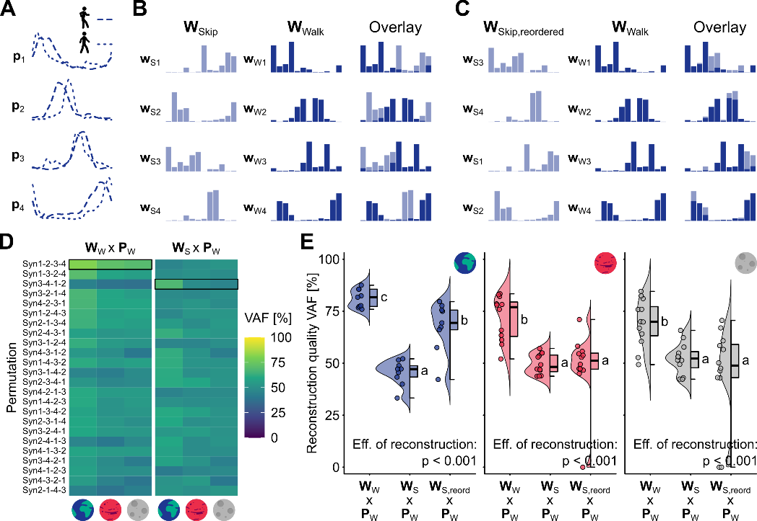

Fig. S3. Skipping does not share a walking-like modular architecture. (A) Average synergy activation patterns P for walking and skipping under Earth gravity. (B) Synergy muscle weights W for walking and skipping under Earth gravity. (C) Reordered skipping muscle weights overlaid on walking weights. (D) Cross-reconstruction analysis of running EMG using walking activation patterns combined with walking weights or with skipping weights. Reconstruction quality was quantified for all possible weight-order permutations. (E) Reconstruction quality of walking across gravity conditions using i) walking weights and activations, ii) skipping weights and walking activations, or iii) reordered skipping weights and walking activations. Different letters indicate significant post-hoc differences (N = 12 participants).

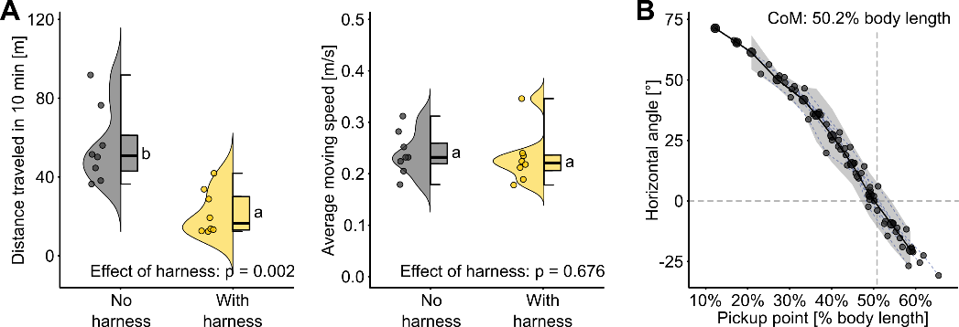

Fig. S4. Effects of the body-weight support harness on mouse locomotion. (A) Distance traveled and average moving speed of mice in open field test with or without the body-weight support harness (N = 8 mice). Different letters denote significant post-hoc differences. (B) Estimation of the anteroposterior position center of mass of the mouse from passive suspension tests (N = 8 mice; n = 4 young adults; n = 4 older adults). Frozen mice were positioned in a standardized trotting posture and suspended from successive pickup points along the dorsal harness strap. The horizontal body angle was plotted as a function of pickup-point distance from the tail base, expressed as a percentage of body length. The thin lines and small dots show the data for individual mice, the thick line and big dots show the mean across mice, and the shaded ribbon indicates ±1 standard deviation. The horizontal dashed line marks zero body angle, and the vertical dotted line indicates the interpolated zero crossing used to estimate the anteroposterior center-of-mass position. Different letters indicate significant post-hoc differences.

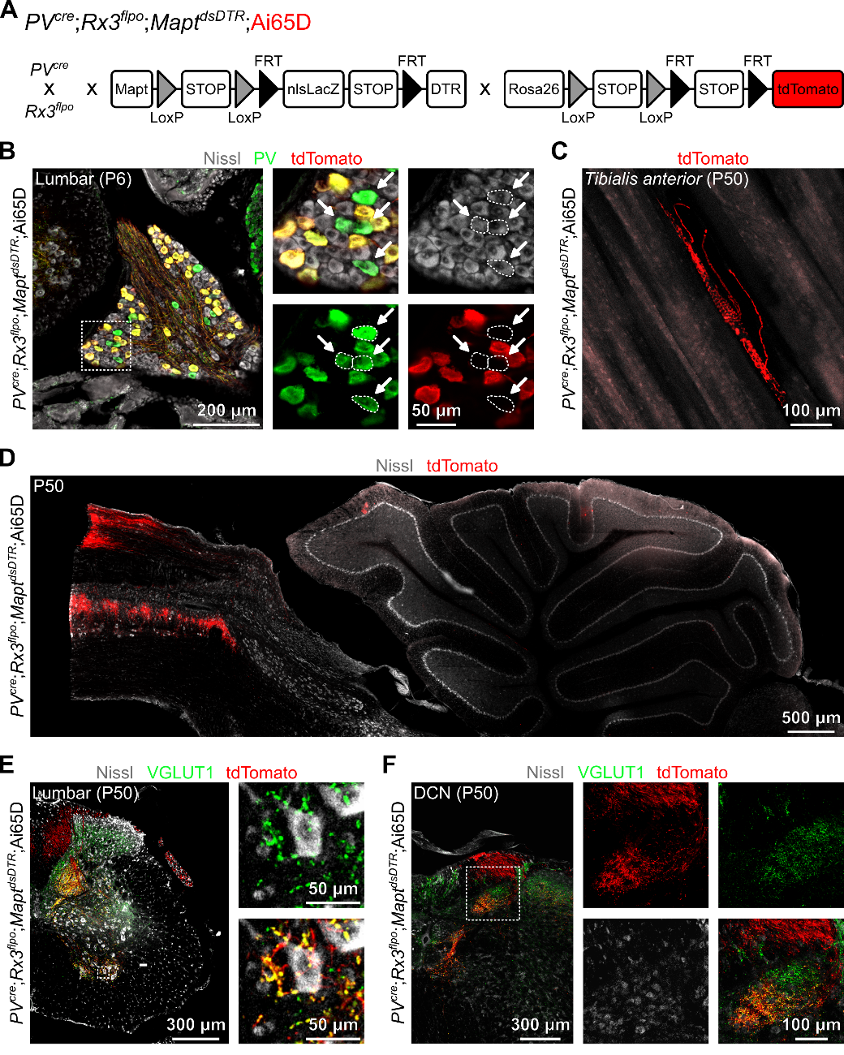

Fig. S5. Genetic strategy and anatomical validation of proprioceptor targeting. (A) Intersectional genetic strategy used to selectively target proprioceptive sensory neurons with diphtheria toxin receptor (DTR) and tdTomato. (B) A lumbar dorsal root ganglion at P6 showing Nissl staining, parvalbumin (PV) immunolabeling, and tdTomato expression. The insets show the overlap between PV and tdTomato in sensory neurons. As expected, not all PV-positive neurons express tdTomato (26, 50). (C) tdTomato-labeled muscle spindle in the tibialis anterior muscle at P50. (D) Sagittal view of tdTomato-labeled proprioceptive afferents in the cervical spinal cord and hindbrain at P50. (E) Coronal section of lumbar spinal cord at P50 shows tdTomato-labeled proprioceptive afferents and co-localization with VGLUT1-positive presynaptic puncta on motor neurons. (F) Coronal view of the hindbrain at P50 show tdTomato-labeled proprioceptive afferents projections to the dorsal column nuclei (DCN).

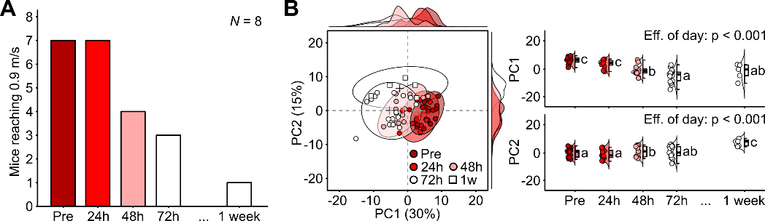

Fig. S6. Progressive loss of locomotor performance after proprioceptor ablation. (A) Number of mice able to reach 0.9 m/s before (Pre) and after proprioceptor ablation (N = 8 mice). (B) Principal component analysis of kinematic variables before and after diphtheria toxin injection (n = 17 for Pre and 72h; n = 12 for 24h and 48h; n = 5 for 1 week). Different letters indicate significant post-hoc differences.

Table S1. Function of muscle synergies during walking, skipping, and running.
Muscle synergies extracted from EMG activity in the lower limbs during walking, skipping and running were determined based on the timing of their activation patterns within the gait cycle and the relative contribution of individual muscles to the corresponding muscle weights.

Gait | Synergy | Function | Muscle contributions
Walking | 1 | Body weight acceptance of the leading leg | Knee extensors and ankle plantarflexors
Walking | 2 | Propulsion of the leading leg and swing of the trailing leg | Ankle plantarflexors and hip flexors
Walking | 3 | Body weight acceptance of the trailing leg | Knee extensors and ankle plantarflexors
Walking | 4 | Propulsion of the trailing leg and swing the leading leg | Ankle plantarflexors and hip flexors
Skipping | 1 | Body weight acceptance and propulsion of the trailing leg | Knee extensors and ankle plantarflexors
Skipping | 2 | Body weight acceptance and swing of the leading leg | Knee extensors
Skipping | 3 | Propulsion of the leading leg | Ankle plantarflexors
Skipping | 4 | Swing of the trailing leg | Hip flexors and ankle dorsiflexors
Running | 1 | Body weight acceptance and propulsion of the leading leg | Knee extensors and ankle plantarflexors
Running | 2 | Swing of the trailing leg | Hip flexors and ankle dorsiflexors
Running | 3 | Body weight acceptance and propulsion of the trailing leg | Knee extensors and ankle plantarflexors
Running | 4 | Swing of the leading leg | Hip flexors and ankle dorsiflexors

Table S2. Kinematic parameters included in the principal component analysis of mouse locomotion.
Parameters were extracted from markerless motion tracking during treadmill locomotion under both Earth’s and simulated lunar gravity. The table below lists parameter, unit, and operational definition for each variable included in the principal component analysis (PCA). The variables describe body mass, temporal gait structure, left-right airtime asymmetry, limb endpoint trajectories, paw drag, cycle-to-cycle variability, Poincaré-map descriptors, base of support, joint and trunk kinematics, and low-dimensional axial-body kinematic structure. Units refer to the variables before PCA.

# | Parameter | Unit | Definition
1 | Body mass | g | Body mass of the mouse at the corresponding experimental day.
2 | Cadence, left forelimb | cycles/min | Mean value of cadence for the left forelimb, computed as 60 divided by the stride duration between consecutive touchdowns.
3 | Cadence, right forelimb | cycles/min | Mean value of cadence for the right forelimb, computed as 60 divided by the stride duration between consecutive touchdowns.
4 | Cadence, left hindlimb | cycles/min | Mean value of cadence for the left hindlimb, computed as 60 divided by the stride duration between consecutive touchdowns.
5 | Cadence, right hindlimb | cycles/min | Mean value of cadence for the right hindlimb, computed as 60 divided by the stride duration between consecutive touchdowns.
6 | Stance duration, left forelimb | s | Mean value of stance duration for the left forelimb, measured from paw touchdown to subsequent lift-off.
7 | Stance duration, right forelimb | s | Mean value of stance duration for the right forelimb, measured from paw touchdown to subsequent lift-off.
8 | Stance duration, left hindlimb | s | Mean value of stance duration for the left hindlimb, measured from paw touchdown to subsequent lift-off.
9 | Stance duration, right hindlimb | s | Mean value of stance duration for the right hindlimb, measured from paw touchdown to subsequent lift-off.
10 | Swing duration, left forelimb | s | Mean value of swing duration for the left forelimb, measured from paw lift-off to the next touchdown of the same paw.
11 | Swing duration, right forelimb | s | Mean value of swing duration for the right forelimb, measured from paw lift-off to the next touchdown of the same paw.
12 | Swing duration, left hindlimb | s | Mean value of swing duration for the left hindlimb, measured from paw lift-off to the next touchdown of the same paw.
13 | Swing duration, right hindlimb | s | Mean value of swing duration for the right hindlimb, measured from paw lift-off to the next touchdown of the same paw.
14 | Cadence, left forelimb (standard deviation) | cycles/min | Standard deviation across gait cycles of cadence for the left forelimb, computed as 60 divided by the stride duration between consecutive touchdowns.
15 | Cadence, right forelimb (standard deviation) | cycles/min | Standard deviation across gait cycles of cadence for the right forelimb, computed as 60 divided by the stride duration between consecutive touchdowns.
16 | Cadence, left hindlimb (standard deviation) | cycles/min | Standard deviation across gait cycles of cadence for the left hindlimb, computed as 60 divided by the stride duration between consecutive touchdowns.
17 | Cadence, right hindlimb (standard deviation) | cycles/min | Standard deviation across gait cycles of cadence for the right hindlimb, computed as 60 divided by the stride duration between consecutive touchdowns.
18 | Stance duration, left forelimb (standard deviation) | s | Standard deviation across gait cycles of stance duration for the left forelimb, measured from paw touchdown to subsequent lift-off.
19 | Stance duration, right forelimb (standard deviation) | s | Standard deviation across gait cycles of stance duration for the right forelimb, measured from paw touchdown to subsequent lift-off.
20 | Stance duration, left hindlimb (standard deviation) | s | Standard deviation across gait cycles of stance duration for the left hindlimb, measured from paw touchdown to subsequent lift-off.
21 | Stance duration, right hindlimb (standard deviation) | s | Standard deviation across gait cycles of stance duration for the right hindlimb, measured from paw touchdown to subsequent lift-off.
22 | Swing duration, left forelimb (standard deviation) | s | Standard deviation across gait cycles of swing duration for the left forelimb, measured from paw lift-off to the next touchdown of the same paw.
23 | Swing duration, right forelimb (standard deviation) | s | Standard deviation across gait cycles of swing duration for the right forelimb, measured from paw lift-off to the next touchdown of the same paw.
24 | Swing duration, left hindlimb (standard deviation) | s | Standard deviation across gait cycles of swing duration for the left hindlimb, measured from paw lift-off to the next touchdown of the same paw.
25 | Swing duration, right hindlimb (standard deviation) | s | Standard deviation across gait cycles of swing duration for the right hindlimb, measured from paw lift-off to the next touchdown of the same paw.
26 | Duty factor, left forelimb | dimensionless | Fraction of the gait cycle spent in stance for the left forelimb, computed as stance duration divided by stride duration.
27 | Duty factor, right forelimb | dimensionless | Fraction of the gait cycle spent in stance for the right forelimb, computed as stance duration divided by stride duration.
28 | Duty factor, left hindlimb | dimensionless | Fraction of the gait cycle spent in stance for the left hindlimb, computed as stance duration divided by stride duration.
29 | Duty factor, right hindlimb | dimensionless | Fraction of the gait cycle spent in stance for the right hindlimb, computed as stance duration divided by stride duration.
30 | Touchdown phase, left forelimb | gait-cycle fraction | Touchdown timing of the left forelimb relative to right-hindlimb touchdown, divided by right-hindlimb stride duration.
31 | Touchdown phase, right forelimb | gait-cycle fraction | Touchdown timing of the right forelimb relative to right-hindlimb touchdown, divided by right-hindlimb stride duration.
32 | Touchdown phase, left hindlimb | gait-cycle fraction | Touchdown timing of the left hindlimb relative to right-hindlimb touchdown, divided by right-hindlimb stride duration.
33 | Forelimb left-right airtime asymmetry | dimensionless | Absolute difference between left and right forelimb airtime fractions. Airtime was estimated as the proportion of frames above a limb-specific vertical threshold.
34 | Hindlimb left-right airtime asymmetry | dimensionless | Absolute difference between left and right hindlimb airtime fractions. Airtime was estimated as the proportion of frames above a limb-specific vertical threshold.
35 | Stride length, left forelimb | mm | Mean value of the anteroposterior range of the toe-tip trajectory over one gait cycle for the left forelimb.
36 | Stride length, right forelimb | mm | Mean value of the anteroposterior range of the toe-tip trajectory over one gait cycle for the right forelimb.
37 | Stride length, left hindlimb | mm | Mean value of the anteroposterior range of the toe-tip trajectory over one gait cycle for the left hindlimb.
38 | Stride length, right hindlimb | mm | Mean value of the anteroposterior range of the toe-tip trajectory over one gait cycle for the right hindlimb.
39 | Step height, left forelimb | mm | Mean value of the vertical range of the toe-tip trajectory over one gait cycle for the left forelimb.
40 | Step height, right forelimb | mm | Mean value of the vertical range of the toe-tip trajectory over one gait cycle for the right forelimb.
41 | Step height, left hindlimb | mm | Mean value of the vertical range of the toe-tip trajectory over one gait cycle for the left hindlimb.
42 | Step height, right hindlimb | mm | Mean value of the vertical range of the toe-tip trajectory over one gait cycle for the right hindlimb.
43 | Tail-base height, right hindlimb | mm | Mean value of tail-base height during right-hindlimb gait cycles, computed relative to the lowest vertical limb landmark in the same cycle.
44 | Stride length, left forelimb (standard deviation) | mm | Standard deviation across gait cycles of the anteroposterior range of the toe-tip trajectory over one gait cycle for the left forelimb.
45 | Stride length, right forelimb (standard deviation) | mm | Standard deviation across gait cycles of the anteroposterior range of the toe-tip trajectory over one gait cycle for the right forelimb.
46 | Stride length, left hindlimb (standard deviation) | mm | Standard deviation across gait cycles of the anteroposterior range of the toe-tip trajectory over one gait cycle for the left hindlimb.
47 | Stride length, right hindlimb (standard deviation) | mm | Standard deviation across gait cycles of the anteroposterior range of the toe-tip trajectory over one gait cycle for the right hindlimb.
48 | Step height, left forelimb (standard deviation) | mm | Standard deviation across gait cycles of the vertical range of the toe-tip trajectory over one gait cycle for the left forelimb.
49 | Step height, right forelimb (standard deviation) | mm | Standard deviation across gait cycles of the vertical range of the toe-tip trajectory over one gait cycle for the right forelimb.
50 | Step height, left hindlimb (standard deviation) | mm | Standard deviation across gait cycles of the vertical range of the toe-tip trajectory over one gait cycle for the left hindlimb.
51 | Step height, right hindlimb (standard deviation) | mm | Standard deviation across gait cycles of the vertical range of the toe-tip trajectory over one gait cycle for the right hindlimb.
52 | Tail-base height, right hindlimb (standard deviation) | mm | Standard deviation across gait cycles of tail-base height during right-hindlimb gait cycles, computed relative to the lowest vertical limb landmark in the same cycle.
53 | Paw drag, left forelimb | a.u. | Mean value of the area under the vertical toe-tip trajectory during swing for the left forelimb, after subtraction of local minimum paw height and normalization by femur plus tibia length.
54 | Paw drag, right forelimb | a.u. | Mean value of the area under the vertical toe-tip trajectory during swing for the right forelimb, after subtraction of local minimum paw height and normalization by femur plus tibia length.
55 | Paw drag, left hindlimb | a.u. | Mean value of the area under the vertical toe-tip trajectory during swing for the left hindlimb, after subtraction of local minimum paw height and normalization by femur plus tibia length.
56 | Paw drag, right hindlimb | a.u. | Mean value of the area under the vertical toe-tip trajectory during swing for the right hindlimb, after subtraction of local minimum paw height and normalization by femur plus tibia length.
57 | Paw drag, left forelimb (standard deviation) | a.u. | Standard deviation across gait cycles of the area under the vertical toe-tip trajectory during swing for the left forelimb, after subtraction of local minimum paw height and normalization by femur plus tibia length.
58 | Paw drag, right forelimb (standard deviation) | a.u. | Standard deviation across gait cycles of the area under the vertical toe-tip trajectory during swing for the right forelimb, after subtraction of local minimum paw height and normalization by femur plus tibia length.
59 | Paw drag, left hindlimb (standard deviation) | a.u. | Standard deviation across gait cycles of the area under the vertical toe-tip trajectory during swing for the left hindlimb, after subtraction of local minimum paw height and normalization by femur plus tibia length.
60 | Paw drag, right hindlimb (standard deviation) | a.u. | Standard deviation across gait cycles of the area under the vertical toe-tip trajectory during swing for the right hindlimb, after subtraction of local minimum paw height and normalization by femur plus tibia length.
61 | Ataxia coefficient, left forelimb | dimensionless | Cycle-to-cycle stride-length variability for the left forelimb, computed as the stride-length range divided by mean stride length.
62 | Ataxia coefficient, right forelimb | dimensionless | Cycle-to-cycle stride-length variability for the right forelimb, computed as the stride-length range divided by mean stride length.
63 | Ataxia coefficient, left hindlimb | dimensionless | Cycle-to-cycle stride-length variability for the left hindlimb, computed as the stride-length range divided by mean stride length.
64 | Ataxia coefficient, right hindlimb | dimensionless | Cycle-to-cycle stride-length variability for the right hindlimb, computed as the stride-length range divided by mean stride length.
65 | Poincare hip section | dimensionless | Width of the Poincare cloud for the amplitude-normalized hip angle sampled at right-hindlimb touchdown.
66 | Poincare hip section | dimensionless | Length of the Poincare cloud for the amplitude-normalized hip angle sampled at right-hindlimb touchdown.
67 | Poincare hip section (Current-cycle section value) | dimensionless | Centroid coordinate of the amplitude-normalized hip angle section in the current gait cycle, x(n).
68 | Poincare hip section (Next-cycle section value) | dimensionless | Centroid coordinate of the amplitude-normalized hip angle section in the following gait cycle, x(n + 1).
69 | Poincare knee section | dimensionless | Width of the Poincare cloud for the amplitude-normalized knee angle sampled at right-hindlimb touchdown.
70 | Poincare knee section | dimensionless | Length of the Poincare cloud for the amplitude-normalized knee angle sampled at right-hindlimb touchdown.
71 | Poincare knee section (Current-cycle section value) | dimensionless | Centroid coordinate of the amplitude-normalized knee angle section in the current gait cycle, x(n).
72 | Poincare knee section (Next-cycle section value) | dimensionless | Centroid coordinate of the amplitude-normalized knee angle section in the following gait cycle, x(n + 1).
73 | Poincare ankle section | dimensionless | Width of the Poincare cloud for the amplitude-normalized ankle angle sampled at right-hindlimb touchdown.
74 | Poincare ankle section | dimensionless | Length of the Poincare cloud for the amplitude-normalized ankle angle sampled at right-hindlimb touchdown.
75 | Poincare ankle section (Current-cycle section value) | dimensionless | Centroid coordinate of the amplitude-normalized ankle angle section in the current gait cycle, x(n).
76 | Poincare ankle section (Next-cycle section value) | dimensionless | Centroid coordinate of the amplitude-normalized ankle angle section in the following gait cycle, x(n + 1).
77 | Poincare metatarsophalangeal joint section | dimensionless | Width of the Poincare cloud for the amplitude-normalized metatarsophalangeal joint angle sampled at right-hindlimb touchdown.
78 | Poincare metatarsophalangeal joint section | dimensionless | Length of the Poincare cloud for the amplitude-normalized metatarsophalangeal joint angle sampled at right-hindlimb touchdown.
79 | Poincare metatarsophalangeal joint section (Current-cycle section value) | dimensionless | Centroid coordinate of the amplitude-normalized metatarsophalangeal joint angle section in the current gait cycle, x(n).
80 | Poincare metatarsophalangeal joint section (Next-cycle section value) | dimensionless | Centroid coordinate of the amplitude-normalized metatarsophalangeal joint angle section in the following gait cycle, x(n + 1).
81 | Base of support (maximum) | mm | Maximum value of the convex-hull area defined by stance paw landmarks, divided by femur plus tibia length, over the right-hindlimb gait cycle.
82 | Base of support (minimum) | mm | Minimum value of the convex-hull area defined by stance paw landmarks, divided by femur plus tibia length, over the right-hindlimb gait cycle.
83 | Base of support (range of motion) | mm | Maximum minus minimum value of the convex-hull area defined by stance paw landmarks, divided by femur plus tibia length, over the right-hindlimb gait cycle.
84 | Hip angle, hip (maximum) | deg | Maximum value of the time-normalized hip angle profile over the right-hindlimb gait cycle.
85 | Knee angle, knee (maximum) | deg | Maximum value of the time-normalized knee angle profile over the right-hindlimb gait cycle.
86 | Ankle angle, ankle (maximum) | deg | Maximum value of the time-normalized ankle angle profile over the right-hindlimb gait cycle.
87 | Metatarsophalangeal angle, metatarsophalangeal joint (maximum) | deg | Maximum value of the time-normalized metatarsophalangeal angle profile over the right-hindlimb gait cycle.
88 | Sagittal trunk angle (maximum) | deg | Maximum value of the time-normalized sagittal trunk angle profile over the right-hindlimb gait cycle.
89 | Hip angle, hip (minimum) | deg | Minimum value of the time-normalized hip angle profile over the right-hindlimb gait cycle.
90 | Knee angle, knee (minimum) | deg | Minimum value of the time-normalized knee angle profile over the right-hindlimb gait cycle.
91 | Ankle angle, ankle (minimum) | deg | Minimum value of the time-normalized ankle angle profile over the right-hindlimb gait cycle.
92 | Metatarsophalangeal angle, metatarsophalangeal joint (minimum) | deg | Minimum value of the time-normalized metatarsophalangeal angle profile over the right-hindlimb gait cycle.
93 | Sagittal trunk angle (minimum) | deg | Minimum value of the time-normalized sagittal trunk angle profile over the right-hindlimb gait cycle.
94 | Hip angle, hip (range of motion) | deg | Maximum minus minimum value of the time-normalized hip angle profile over the right-hindlimb gait cycle.
95 | Knee angle, knee (range of motion) | deg | Maximum minus minimum value of the time-normalized knee angle profile over the right-hindlimb gait cycle.
96 | Ankle angle, ankle (range of motion) | deg | Maximum minus minimum value of the time-normalized ankle angle profile over the right-hindlimb gait cycle.
97 | Metatarsophalangeal angle, metatarsophalangeal joint (range of motion) | deg | Maximum minus minimum value of the time-normalized metatarsophalangeal angle profile over the right-hindlimb gait cycle.
98 | Sagittal trunk angle (range of motion) | deg | Maximum minus minimum value of the time-normalized sagittal trunk angle profile over the right-hindlimb gait cycle.
99 | Kinematic-synergy local complexity | dimensionless | Mean Higuchi fractal dimension of retained axial-kinematic PC score trajectories, used as an index of local complexity.
100 | Kinematic-synergy global complexity | dimensionless | Mean Hurst exponent of retained axial-kinematic PC score trajectories, used as an index of global complexity or cycle-to-cycle persistence.
101 | Kinematic-synergy PC1 variance | proportion | Fraction of total variance explained by PC1 in the axial-kinematic PCA.
102 | Kinematic-synergy PC2 variance | proportion | Fraction of total variance explained by PC2 in the axial-kinematic PCA.
103 | Kinematic-synergy PC3 variance | proportion | Fraction of total variance explained by PC3 in the axial-kinematic PCA.

Movie S1. Eugene Cernan’s locomotion on the lunar surface.
Original NASA Apollo 17 video footage showing Eugene Cernan moving on the lunar surface. The sequence illustrates naturally occurring locomotor strategies in lunar gravity, including transitions between running, skipping, and hopping-like patterns. The MPEG video was obtained from the Apollo 17 Lunar Surface Journal.

Movie S2. Human walking, skipping and running in simulated lunar gravity.
Representative participant walking, skipping, and running on a treadmill under simulated lunar gravity. Walking is shown on the left at 1.1 m/s, skipping in the middle at 1.4 m/s, and running on the right at 3.1 m/s. Footprint schematics indicate the corresponding footfall sequence and follow the convention used in Fig. 1C.

Movie S3. Mouse treadmill locomotion under Earth and simulated lunar gravity.
Representative mouse locomoting on a treadmill at 0.3 m/s under Earth gravity, left, and simulated lunar gravity, right. Videos are shown at 20% real speed.

Movie S4. Mouse treadmill locomotion 72 h after proprioceptor ablation.
Representative mouse locomoting on a treadmill at 0.3 m/s 72 h after proprioceptor ablation under Earth gravity, left, and simulated lunar gravity, right. Videos are shown at 20% real speed.

Movie S5. Mouse treadmill locomotion before and 48h after proprioceptor ablation under Earth gravity.
Representative mouse treadmill locomotion under Earth gravity at 0.3 m/s before ablation, left, and 48 h after proprioceptor ablation, right. Videos are shown at 20% real speed.

Movie S6. Mouse treadmill locomotion before and 48h after proprioceptor ablation under simulated lunar gravity.
Representative mouse treadmill locomotion under simulated lunar gravity at 0.3 m/s before ablation, left, and 48 h after proprioceptor ablation, right. Videos are shown at 20% real speed.

