Supplementary Material S1

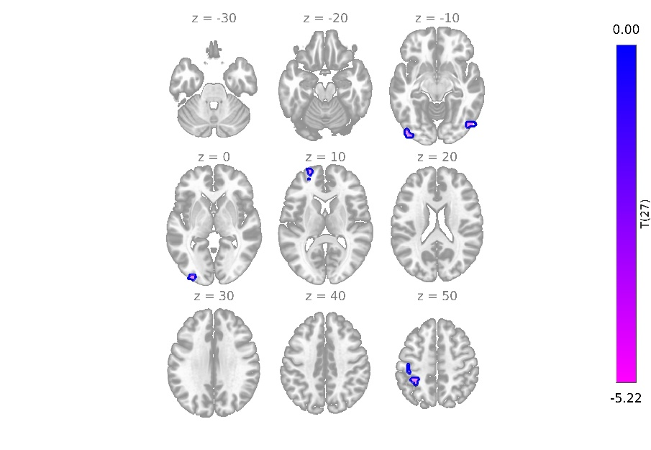
Figure S1 (Sensitivity analysis): Thalamic functional connectivity in ME/CFS patients pre-vs-post-treatment (Threshold: voxel-wise p < 0.001; cluster-level p < 0.05, FDR-corrected).
Patients longitudinal (pre-vs-post-treatment), seed: left thalamic sensorimotor cluster. Post-treatment reductions in thalamic connectivity were observed with left sensorimotor regions (precentral and postcentral gyri), and bilateral visuo-occipital regions (lateral occipital cortex, occipital pole).

