Supplemental Materials
- Supplementary Methods.
- Supplementary Table 1. Burden of cardiotropic viruses other than parvovirus B19
- Supplementary Table 2. Details of each endpoint event.
- Supplementary Table 3. Association of parvovirus B19 with the combined endpoint of cardiac death, heart failure hospitalization, and life-threatening arrhythmia
- Supplementary Table 4. Parvovirus B19 viral load characteristics
- Supplementary Table 5. Comparison of clinical characteristics of patients included in single nuclear RNA sequencing analysis based on spare biopsy availability.
- Supplementary Figure 1: Single nuclear RNA sequencing data processing and filtering.
- Supplementary Figure 2: IVIg induced alteration of myeloid-fibroblast interaction and transcriptional state.
- Supplementary Figure 3: Placebo treated cardiomyocyte shift to a disease associated transcriptional state.
- References of the supplementary methods section

Supplementary Methods

Single nuclear RNA sequencing
Endomyocardial biopsies (EMB) were taken from the right ventricular septum and collected via the internal jugular vein using a transcatheter bioptome (Cordis, Miami, FL., USA) at baseline before the IVIg treatment and at the standardized six-months follow-up timepoint of the original study (i.e., median 6.4 [5.9-7.3] months). EMB were evaluated regarding viral persistent and immunohistology markers of inflammation and fibrosis. Spare cardiac biopsies were stored at -80°C until preparation of snRNA sequencing.
The isolation of cardiac nuclei and the 10x library preparation were performed at the Max Delbrück Center for Molecular Medicine following a published protocol (1) with adaptations to low-sized tissue pieces (2). In brief, 1–4-mg-sized flash-frozen cardiac biopsies were placed in a pre-cooled dish and an equally sized droplet of homogenization buffer (250 mM sucrose, 25 mM KCl, 5 mM MgCl₂, 10 mM Tris-HCl, 1 μM DTT, 1× protease inhibitor, 0.4 U μl⁻¹ RNaseIn, 0.2 U μl⁻¹ SUPERaseIn and 0.1% Triton X-100 in nuclease-free water) was added. Buffer-encapsulated tissue pieces were sliced with a scalpel. The tissue pieces were then transferred to a 7-ml glass Dounce tissue grinder (Merck), and nuclei were isolated and stained with NucBlue Live ReadyProbes Reagent (Thermo Fisher Scientific). Hoechst⁺ single nuclei were sorted via fluorescence-activated cell sorting (FACS) (BD Biosciences, FACSAria Fusion). Purity and integrity of nuclei were confirmed microscopically, and nuclei numbers were counted using a Countess II (Life Technologies) before processing with the Chromium Controller (10x Genomics) per the manufacturer’s protocol. Single-nucleus 3′ gene expression libraries were created using version 3.1 Chromium Single Cell Reagent Kits (10x Genomics) following the manufacturerʼs instructions. cDNA library quality control was performed using Bioanalyzer High Sensitivity DNA Analysis (Agilent Technologies) and a KAPA Library Quantification Kit. cDNA libraries were sequenced on an Illumina NovaSeq with a targeted read number of 30,000–50,000 reads per nucleus.

snRNA data processing
Fastq files with sequencing results were processed using cellranger version 6.1.2 with the GRCh38-2020-A reference provided by 10x Genomics. All further processing and analysis of the snRNA data was performed in R (version 4.1.2) using Rstudio (version 2023.12.1+402) and mostly based on functions provided by the Seurat package (PMID: 29608179). The filtered feature count matrix was used to create a seurat object for each sample with the gene inclusion criteria of being expressed in at least 3 cells and the cell inclusion criteria of minimum 200 genes detected.
To assess the quality of each sample, the samples were first processed individually by running the following Seurat functions with default settings: NormalizeData, FindVariableFeatures, ScaleData, RunPCA, RunUMAP, FindNeighbors and FindClusters (resolution set to 0.1). A schematic representation of the filtering steps is depicted in supplementary figure 1. The SoupX package (3) was used with default parameters to correct the raw count matrix for unspecific background signal of ambient RNA contamination. One sample failed in the SoupX analysis and was excluded due to poor data quality. The scDblFinder package (4) was used with default parameters to detect doublets. Cells with a feature count below 500 were labeled as Low_nFeature and above 6000 as high_Feature. Cells with more than 5% counts mapping to the mitochondrial genome were labeled high_MT. After quality assessment per sample, all samples were merged into one single Seurat object. The merged sample was processed by default seurat functions for normalization, detection of highly variable genes, scaling and PCA.
To correct for individual batch effects, the harmony package (5) was used with default parameters while running the RunHarmony function. After investigating the ElbowPlot of 50 harmony dimensions, the first 20 harmony dimensions were selected as input for the RunUMAP and FindNeighors function, followed by FindClusters with resolution set to 1. The resulting clusters included clusters highly enriched for cells marked as doublets, as well as Low_nFeature labeled cells. These clusters were removed from the data for all subsequent steps. Also, all cells labeled at high_MT were removed. The processing steps variable feature selection, scaling, PCA and harmony batch correction were run again on the filtered data and the cells clustered with FindClusters at the resolution 0.1.
Major cardiac cell type clusters were annotated based on canonical marker gene expression including, cardiomyocytes (RYR2), endothelial cells (VWF), fibroblast (DCN), mural cells (RGS5), myeloid and lymphoid cells (PTPRC), endocardial endothelial cells (NRG3), neuronal (NRXN1), lymphatic endothelial cells (MMRN1) and adipocytes (GPAM). To further identify and filter remaining cells with a high potential to be doublets or low-quality cells, each of the major cell type clusters was processed separately. The subset per cell type was processed again by the default seurat functions to find variable feature, scale, run PCA, followed by harmony batch correction. After clustering at different resolutions, clusters of doublets or low-quality cells were identified and removed from the subset, as well as the overall dataset containing all cell types. In addition, biological relevant subclusters of the cell types were annotated according to previous cell type definitions for cardiac cells(6-8).
Using the filtered overall dataset, pseudobulk PCA was performed which led to the identification of one overall bad quality sample, which needed to be removed for all subsequent analysis. An additional sample was removed as a mismatch of sex between the meta data and the X/Y-chromosomal gene expression likely indicated a sample swap. Later in-depth analysis of certain cell types revealed minor cell numbers of remaining cells with a high likelihood to be doublets or low quality. Those cells were removed from all analysis.

Pseudobulk based principal component analysis
Pseudobulk data was generated from the snRNA data by summing counts per gene for all cells of an individual sample. This included a control step where a pseudobulk sample was only generated if at least 20 cells were available since not all samples had at least 20 cells when generating pseudobulks based on a single cell type. The resulting count matrix of pseudobulk samples was stored in a seurat object together with sample level aggregated meta data. Low coverage genes were removed by excluding all genes that are expressed in less than 5 pseudobulk samples. Pseudobulk counts were normalized by DESeq2 (9) and stored in the data slot of the seurat object.
To reduce the patient-to-patient variance, the normalized counts were scaled by variance stabilizing transformation and afterward the individual patient bias regressed using the removeBatchEffect function of the limma package (10) with the patients as batch effect, while conversing 3 groups including baseline (all pre samples), placebo (post) and IVIg (post) group in the model design. In addition, the average percentage of mitochondrial read fraction was added to the model as fixed effect. Principal components were calculated based on the complete scaled expression matrix using the stats package and added as dimensional reduction to the seurat object. PCA plots were generated from the seurat object using the CellDimPlot function of the SCP package(11).

Composition analysis
Composition analysis was performed with two different approaches. First, following the concept proposed by Phipson et al. (12)using normalization of cell type frequencies, followed by logit transformation and linear regression based on limma. As the coverage of nuclei differs between samples, total nuclei count per sample was added as fixed effect to the model. For the second approach, the log fold change of normalized cell type frequencies from paired biopsies were calculated. The distribution of logFC of the two conditions was tested for significant differences using Wilcoxon test with Benjamini-Hochberg correction.

Marker gene identification
Marker genes of clusters were identified using two different approaches. Directly based on the snRNA data using the FindAllMarker function of Seurat with the following parameters altered from default: min.pct = 0.3, logfc.threshold = 0.3, test.use = "MAST". A second approach was performed based on pseudobulking per sample and cluster, as described in the PCA method section. To find robust marker genes, the pesudobulk data was filtered using a stringent filter setting were genes expressed in less than 50 % of the pseudobulk samples were removed from the analysis. Differential expression analysis based on limma was used to compare pseudobulk samples of a single cell type to all other cell types combined. Significant marker genes were selected with an adjusted p-value < 0.05.

Differential gene expression analysis
Differential gene expression analysis was performed based on the R package dreamlet(13), following the suggested steps of the methods. Counts of the snRNA data were summarized into pseudobulk samples where each major cell type was tested separately. The formular of the linear model was based on grouping the conditions in 3 groups (pre, IVIG_post, Placebo_post), adding the patient as random effect and percentage of mitochondrial genes as fixed effect. To find differential expressed genes due to the IVIG treatment, the IVIG_post and Placebo_post were contrasted. Using a stringent cut-off for the adjusted p-value of < 0.05 it was not possible to find differential expressed genes, therefore all further analysis was carried out using the differential expression result of all genes and based only on the ranks ordered by t-value.

Gene set enrichment analysis
Gene set enrichment analysis was either based on the multivariate linear model approach implemented in the decoupler package (14) or using classic GSEA implemented in fGSEA(15). The ranking of genes was based on multiple different methods. Loadings of principal component 1 were used to rank genes and used as input for fGSEA with the KEGG term database as reference. Resulting plots display significant enriched terms (adjusted p-value < 0.05). As input for the multivariate linear model approach genes were either ranked by t-value, a matrix of t-values was used based on the marker genes expression analysis or the scaled pseudobulk expression matrix after correction for the patient bias (as described in PCA on pseudobulk section). Different gene set reference were used in the analysis including the pathway reference of PROGENy(16), the KEGG term database, and marker genes identified in different studies for cardiomyocyte subtypes (6-8).

Gene set expression score
Gene set expression scores based on the snRNA data were generated used the AddModuleScore function of seurat with default parameters.

Gene set centric expression analysis
A gene set centric expression analysis approach was based on calculation of a gene set expression score for selected relevant gene sets for each sample. The expression score was calculated using multivariate linear model as implement in decoupler based on the scaled pseudobulk expression matrix after correction for the patient bias (as described in PCA on pseudobulk section). For paired biopsy samples of the same patient, the difference of the gene set expression score was calculated, resulting for each gene set in a set of score differences for the placebo group and the IVIG group. Based on those score differences the two groups were then tested for significant differences for each gene set using a Wilcox test with Benjamini-Hochberg correction. Terms with a significant difference (p-value < 0.05) were plotted.

Cell-cell communication analysis
MultiNicheNet (17) was used to predict changes in cell-cell communication due to the IVIG treatment. Following the recommended processing for MultiNicheNet, pseudobulk data was generated from the snRNA data and filtered for sufficient cell and gene coverage. The result of differential gene expression from dreamlet were added, while removing genes filtered in the previous step. Ligand activity prediction was run with a threshold for the logFC of 0.5, p-value of 0.05 and number of top target genes of 250. The analysis was focused on upregulated ligand activity; however, it is important to notice that the comparison of IVIG vs placebo group was added with both directions. Therefore, ligands with higher activity per condition were predicted for both conditions.
Results were displayed for the top 25 priority ligand receptor interactions per condition as chord diagramm. Furthermore, plotting function of MultiNicheNet were customized to plot the mean ligand receptor pseudobulk expression product and ligand activity. Based on decouplers univariate linear model differential expression analysis results were used to score the expression of the target genes for each ligand receptor interaction.

Statistical analysis
Variables are displayed as frequencies (percentage), mean ± SD, or median (IQR) as appropriate. Normality was assessed visually by using Q-Q-plots and histograms. The Mann-Whitney U-test was used to compare left ventricle ejection fraction (LVEF) at 10-year (+/- 5 years) follow-up. Kaplan-Meier was used to visualize time-to-event analysis and Log-rank was applied for comparison of Kaplan-Meier curves. Cox proportional-hazard regression analysis was performed to assess association with event-free survival. To test whether the effect of IVIg was independent of B19V status, we incorporated an interaction term between these variables. In the time-to-event analyses of our primary endpoint (i.e., Kaplan-Meier, Cox proportional-hazard regression), death from non-cardiac causes was treated as censoring. The level of significance was p<0.05 and tests were 2-sided. All statistical analyses were performed using RStudio version 2024.04.

Data and code availability
The data underlying this article will be shared on reasonable request to the corresponding author. The code used for the analysis can be accessed anonymously through Zenodo. (https://zenodo.org/records/15425073?preview=1&token=eyJhbGciOiJIUzUxMiJ9.eyJpZCI6IjUwN2NlMGFjLWQyMDUtNGM5ZC1hMDUzLWVjYWFlZjBiZDBhZCIsImRhdGEiOnt9LCJyYW5kb20iOiIzNzQyMDU1Y2UzZGE5NzU2NWJiNWZiNmVmNGMwY2ZlYSJ9.8e8JiZN4hVYqvKCVyt7WyT9NrxQZ1nZbTFP1iKdGW34RLMeUN9k-pURWyI4uIzCfEvOo9LbSbav-oRSBqClNFw).

Supplementary Table 1. Burden of cardiotropic viruses other than parvovirus B19
 | Baseline |  |  | 6-months
 | IVIg  N=26 | Placebo  N=24 | P | IVIg  N=24 | 6 Placebo  N=24 | P
HHV4 (EBV) | 2 | 1 | 1.00 | 0 | 1 | 1.00
HHV6 | 5 | 7 | 0.51 | 5 | 4 | 1.00
CMV | 0 | 0 | 1.00 | 0 | 1 | 1.00
Enterovirus | 0 | 0 | 1.00 | 0 | 0 | 1.00
Abbreviations: IVIg = intravenous immunoglobulin therapy; HHV = human herpes virus; EBV = Ebstein-Barr virus; CMV = cytomegalovirus.

SID | IVIg/  placebo | Endpoint | Endpoint type | Setting | Time from baseline (days) | In or out of hospital | Last LVEF
107 | Placebo | Cardiac death | End-stage heart failure | End-stage heart failure within a palliative setting. Autopsy confirmed end-stage heart failure as cause of death. | 2351 | In | 19%
113 | Placebo | LTA | ICD shock | Shock from S-ICD due to supraventricular or ventricular tachycardia. Later at day 2485 another shock, this time clearly ventricular tachycardia. | 1626 | Out | 34%
117 | Placebo | Cardiac death, LTA | Sudden cardiac death. | Suddenly unwell at home while in bed. Cardiopulmonary resuscitation was unsuccesful. | 491 | Out | 32%
124 | IVIg | HFH | Hospitalization for decompensated heart failure | After hospitalization, patient died at day 2942 due to end-staged heart failure. | 2480 | Out | 14%
125 | Placebo | HFH | Hospitalization for decompensated heart failure | Hospitalized for decompensated heart failure. Trigger of decompensation is unclear. Ventricular tachycardia occurred possibly secondary to decompensatio for which CRT-P was upgraded to CRT-D. | 2318 | In | 40%
126 | Placebo | HFH | Hospitalization for decompensated heart failure | Decompensation possibly due to atrial fibrillation. Recompensation by diuretics and rate control. | 1305 | In | 22%
138 | Placebo | Cardiac death | End-stage heart failure | End-stage heart failure in palliative setting. | 2922 | In | 24%
140 | Placebo | LTA | Out-of-hospital cardiac arrest. | Out-of-hospital cardiac arrest due to ventricular fibrillation. Succesful cardiopulmonary resuscitation. | 1493 | Out | 48%
SID=study identification number; IVIg=intravenous immunoglobulin therapy; LVEF=left ventricle ejection fraction; LTA=life-threatenning arrhythmia; HFH=heart failure hospitalization; ICD=implantable cardiac defibrillator
Supplementary Table 2. Detail of each endpoint event.

Supplementary Table 3. Lack of association of parvovirus B19 with the combined endpoint of cardiac death, heart failure hospitalization, and life-threatening arrhythmia
 | HR | 95%-confidence interval | P
B19V load, per 100 copies/μgDNA | 0.91 | 0.76-1.09 | 0.310
B19V load, ≥500 copies/μgDNA as cut-off | 0.75 | 0.20-2.85 | 0.671
Decrease in B19V between baseline and six months, per 100 copies/μgDNA | 0.98 | 0.92-1.04 | 0.514
Abbreviations: HR = Hazard’s ratio; B19V = parvovirus B19; IQR = interquartile range

Supplementary Table 4. Parvovirus B19 viral load characteristics
 | IVIg (n=26) | Placebo (n=24)  Copies/μgDNA | IVIg vs. placebo  P
B19V load,  copies/μgDNA  [IQR] | 480  [334; 907] | 354  [287; 883] | 0.351
B19V load >500 copies/μgDNA, n | 13 | 10 | 0.89
Decrease in B19V between baseline and six months,  copies/μgDNA  [IQR] | 123  [-96; 329] | 119  [14; 377] | 0.303
Abbreviations: IVIg = intravenous immunoglobulin therapy; B19V = parvovirus B19; IQR = interquartile range

Supplementary Table 5. Comparison of clinical characteristics of patients included in single nuclear RNA sequencing analysis based on spare biopsy availability.

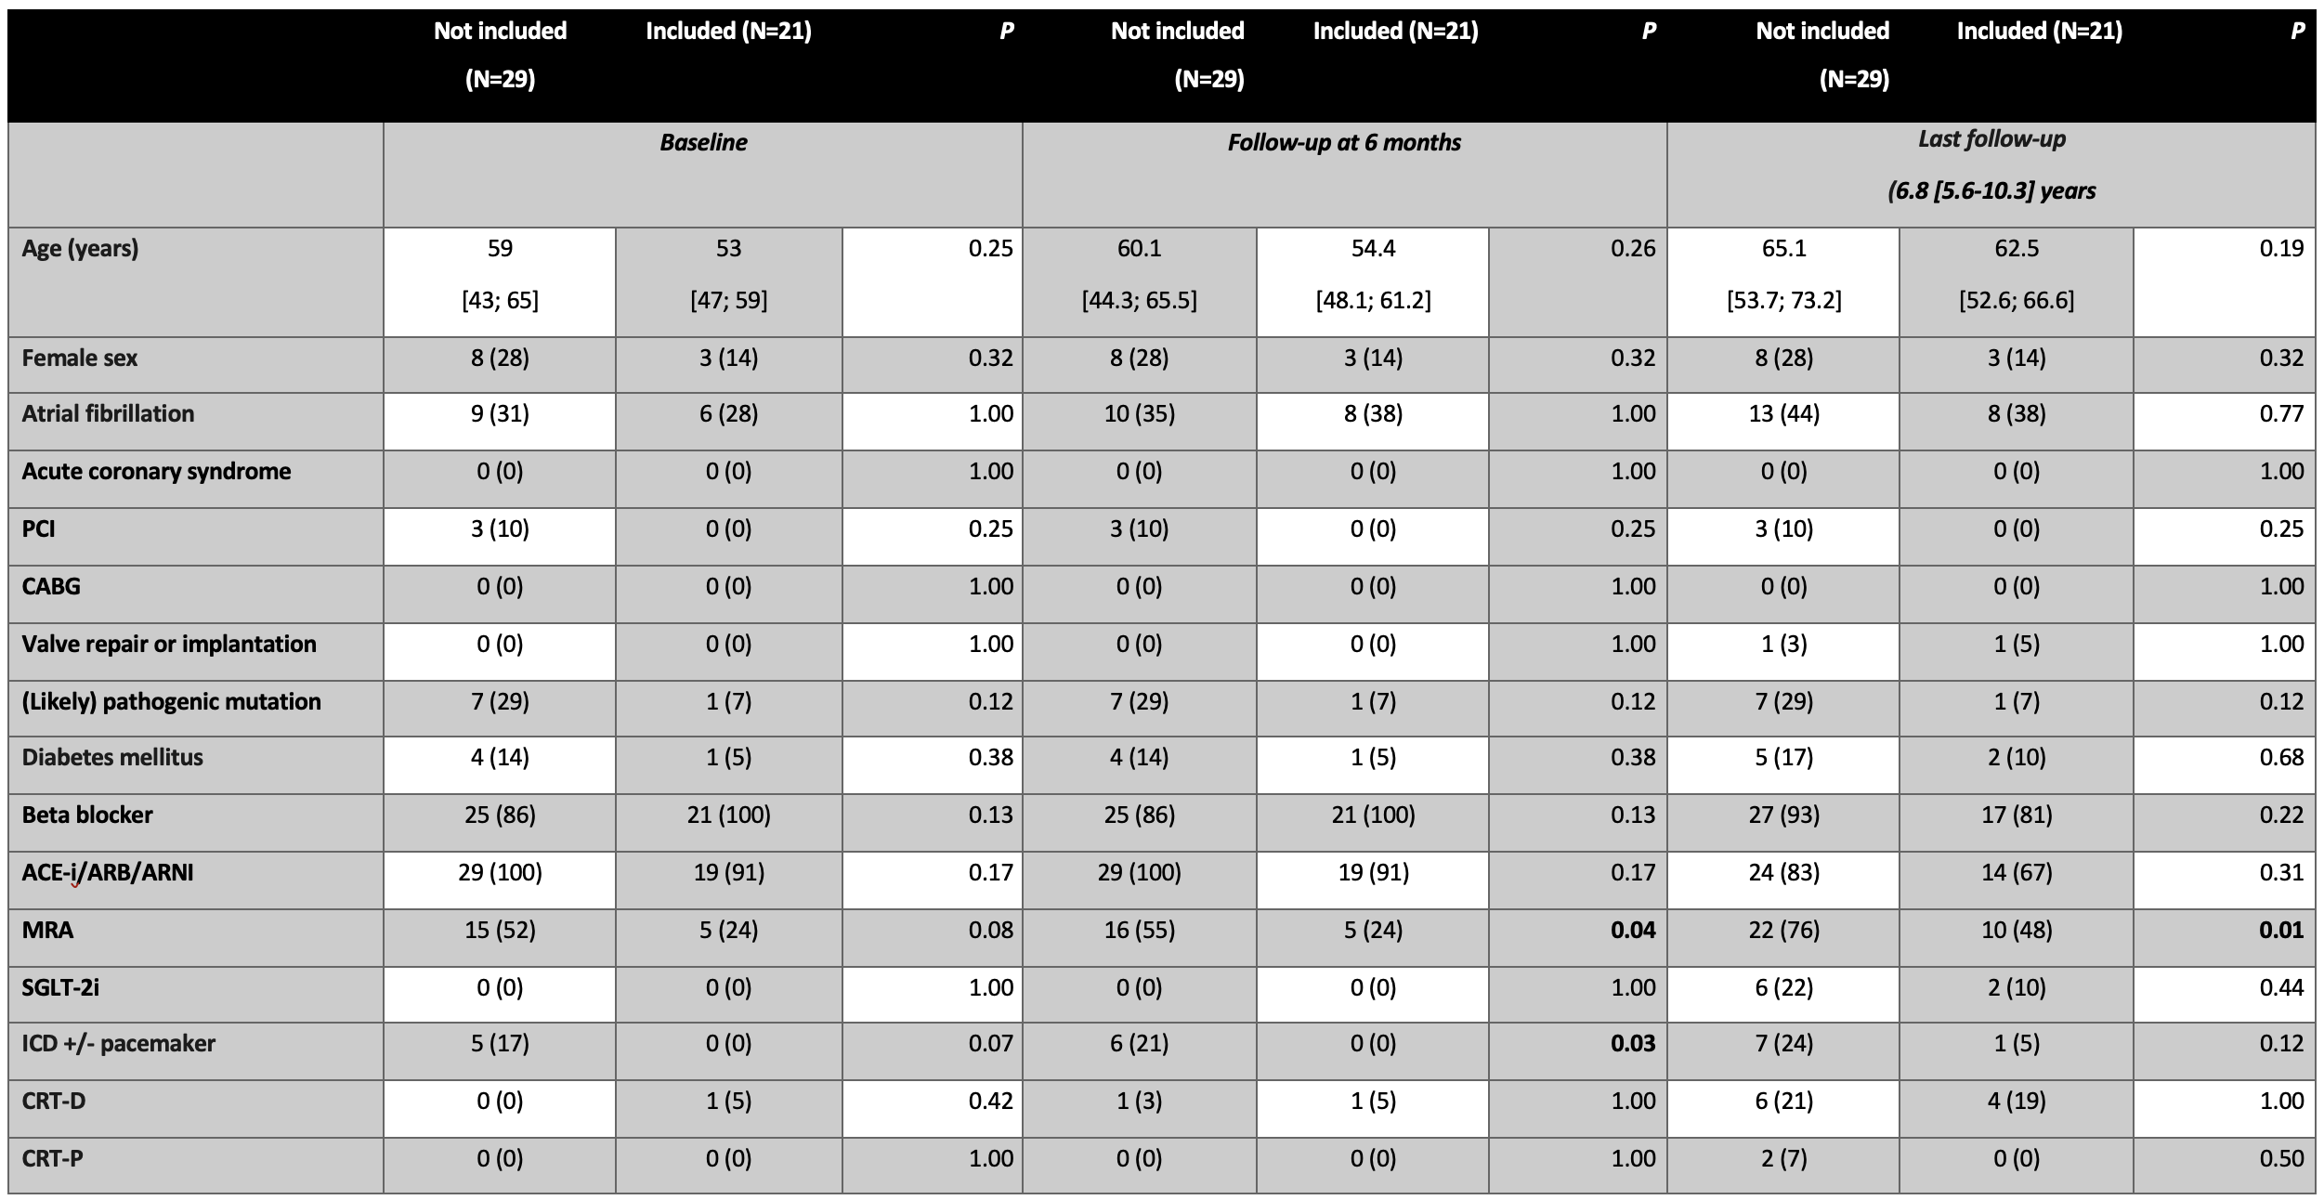
Ordinal variables are presented as numbers (percentages). Non-parametric continuous variables are presented as median [interquartile range].

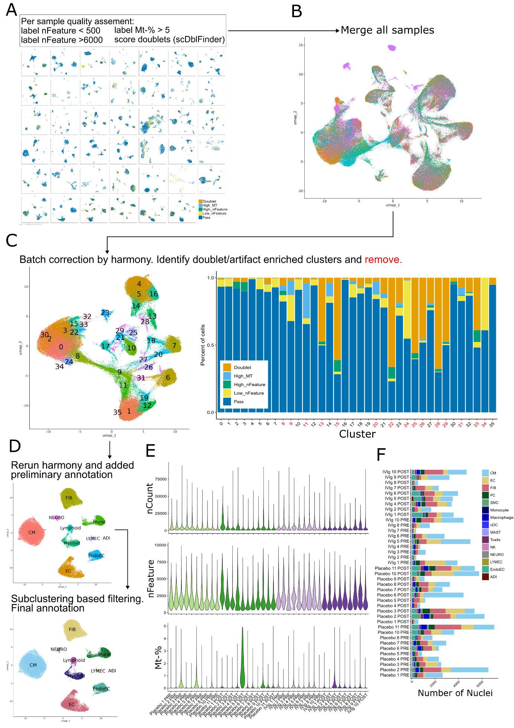
Supplementary Figure 1: Single nuclear RNA sequencing data processing and filtering. (A) Step one of the quality assessments for the snRNA data was performed separate for each sample, where nuclei were classified as either low_nFeature (< 500), high_nFeature (> 6000), high mitochondrial gene read fraction (>5%), as doublet by scDblFinder or pass. (B) UMAP representation of all samples merged into one data object (C) UMAP representation of the merged data object after batch correction by harmony and cluster at a high resolution of 1.0. The stacked bargraph shows the proportion of nuclei by their quality classification as assigned in A per cluster. Clusters with a high proportion of doublets and low quality nuclei were removed from subsequent analysis (number in red). (D) Upper UMAP representation after removal and rerun of the harmony batch correction. Preliminary annotation added for major cardiac cell types. Lower UMAP representation after an additional filtering of each major cell type by separate subclustering and removal of remaining doublets and artifacts that were not captured by the cutoffs in A. (E) Violin plots of data quality measured per sample, colored by condition. Top to bottom: nCount showing the reads per cell/sample, nFeature showing the number of genes detected per cell/sample, Mt-% showing the gene fraction of mitochondrial genes per cell/sample. (F) Stacked bargraph of total nuclei number per sample after filtering. Colors show the absolute proportion of each major cell type. Abbreviations: Mt-% = percent mitochondrial gene fraction, CM = cardiomyocyte, EC = endothelial cell, FIB = fibroblast, PC = pericyte, SMC = smooth muscle cell, cDC = classic dendritical cell, NK = natural killer cell, NEURO = neuronal cell, LYMEC = lymphatic endothelial cell, EndoEC = endocardial endothelial cell, ADI = adipocyte.
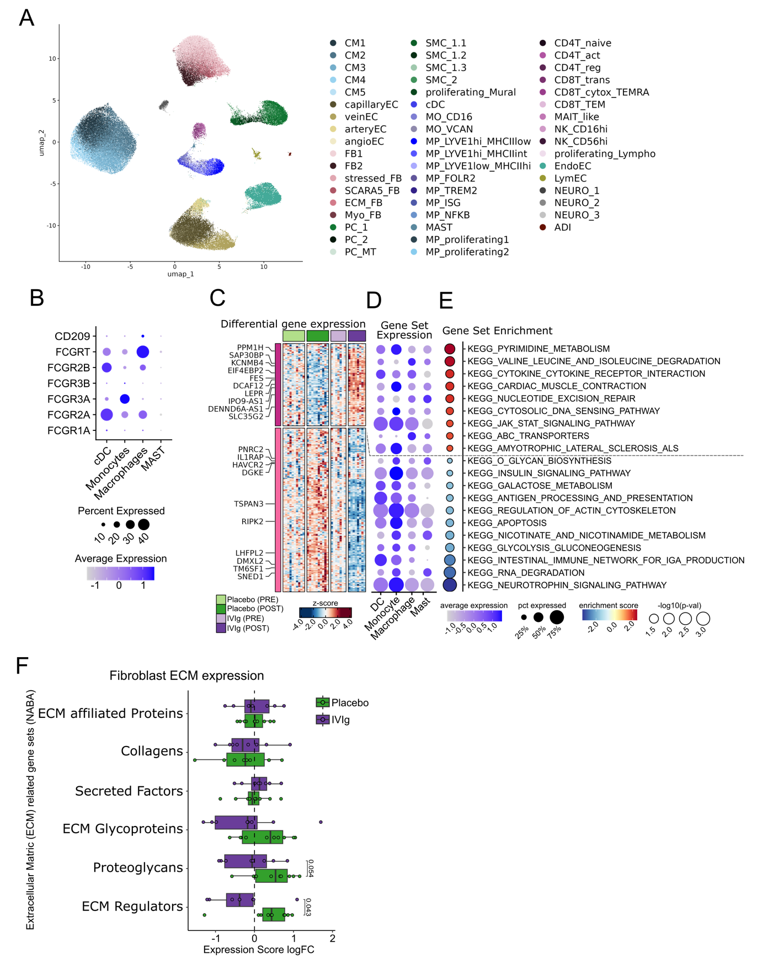Supplementary Figure 2: IVIg induced alteration of myeloid-fibroblast interaction and transcriptional state. (A) UMAP representation of the final dataset with the complete subcluster/subtype annotation. (B) Dotplot of gene expression for all FC-receptor genes shown for all major myeloid cell types. (C) Heatmap of differential gene expression result in myeloid cells, comparing placebo and IVIg samples after the treatment. Gene were selected by a p-value cut off < 0.05 and the top significant gene higher and lower expressed are labeled on the heatmap. (D) Gene expression scores per myeloid cell type for the gene sets found significantly enriched in the result of differential expression. Gene sets are labeled in E. (E) Gene set enrichment analysis based on the differential expression analysis in myeloid cells with KEGG as reference. Significantly enriched gene sets are plotted, and the normalized enrichment scores indicate higher enrichment in IVIg (red) or higher enrichment in placebo (blue). (F) Extra cellular matrix related gene set expression changes in fibroblast. Log fold change (logFC) was calculated for paired biopsy samples per patient. Boxplots indicate median and interquartile range. Significance was tested with paired Wilcoxon test with Benjamini-Hochberg correction, p-values shown. Abbreviations: CM = cardiomyocyte, EC = endothelial cell, FB = fibroblast, ECM = extracellular matrix, Myo_FB = myofibroblast, PC = pericyte, SMC = smooth muscle cell, cDC = classic dendritical cell, MO = monocyte, MP = macrophage, NK = natural killer cell, NEURO = neuronal cell, LYMEC = lymphatic endothelial cell, EndoEC = endocardial endothelial cell, ADI = adipocyte.
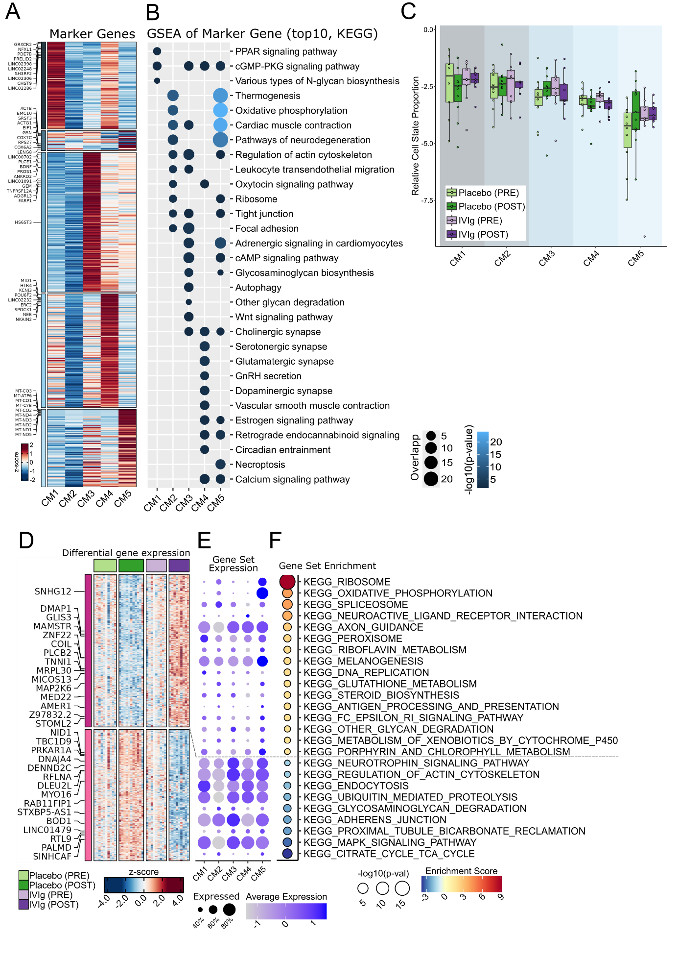
Supplementary Figure 3: Placebo treated cardiomyocyte shift to a disease associated transcriptional state. (A) Boxplots of endomyocardial biopsy cardiomyocyte substate composition analysis after normalization and logit transformation of proportions per sample. Statistical differences were tested by fitting a linear model with Benjamini-Hochberg correction, no significant difference found. Boxplots indicate median and interquartile range. (B) Heatmap of marker genes detected for cardiomyocyte substates using differential expression analysis, most significant genes per state are annotated. (C) Gene set enrichment analysis based on the marker genes shown in B separate for each subtype, with KEGG as reference. (D) Heatmap of differential gene expression result in cardiomyocytes, comparing placebo and IVIg samples after the treatment. Gene were selected by a p-value cut off < 0.05 and the top significant gene higher and lower expressed are labeled on the heatmap. (D) Gene expression scores per cardiomyocyte substate for the gene sets found significantly enriched in the result of differential expression. Gene sets are labeled in E. (E) Gene set enrichment analysis based on the differential expression analysis in cardiomyocyte substates with KEGG as reference. Significantly enriched gene sets are plotted, and the normalized enrichment scores indicate higher enrichment in IVIg (red) or higher enrichment in placebo (blue).

References of the supplementary methods section
1. Nadelmann ER, Gorham JM, Reichart D, Delaughter DM, Wakimoto H, Lindberg EL, et al. Isolation of Nuclei from Mammalian Cells and Tissues for Single-Nucleus Molecular Profiling. Curr Protoc. 2021;1(5):e132.
2. Maatz H, Lindberg EL, Adami E, López-Anguita N, Perdomo-Sabogal A, Cocera Ortega L, et al. The cellular and molecular cardiac tissue responses in human inflammatory cardiomyopathies after SARS-CoV-2 infection and COVID-19 vaccination. Nat Cardiovasc Res. 2025;4(3):330-45.
3. Young MD, Behjati S. SoupX removes ambient RNA contamination from droplet-based single-cell RNA sequencing data. Gigascience. 2020;9(12).
4. Germain PL, Lun A, Garcia Meixide C, Macnair W, Robinson MD. Doublet identification in single-cell sequencing data using scDblFinder. F1000Res. 2021;10:979.
5. Korsunsky I, Millard N, Fan J, Slowikowski K, Zhang F, Wei K, et al. Fast, sensitive and accurate integration of single-cell data with Harmony. Nat Methods. 2019;16(12):1289-96.
6. Reichart D, Lindberg EL, Maatz H, Miranda AMA, Viveiros A, Shvetsov N, et al. Pathogenic variants damage cell composition and single cell transcription in cardiomyopathies. Science. 2022;377(6606):eabo1984.
7. Kanemaru K, Cranley J, Muraro D, Miranda AMA, Ho SY, Wilbrey-Clark A, et al. Spatially resolved multiomics of human cardiac niches. Nature. 2023;619(7971):801-10.
8. Kuppe C, Ramirez Flores RO, Li Z, Hayat S, Levinson RT, Liao X, et al. Spatial multi-omic map of human myocardial infarction. Nature. 2022;608(7924):766-77.
9. Love MI, Huber W, Anders S. Moderated estimation of fold change and dispersion for RNA-seq data with DESeq2. Genome Biol. 2014;15(12):550.
10. Ritchie ME, Phipson B, Wu D, Hu Y, Law CW, Shi W, et al. limma powers differential expression analyses for RNA-sequencing and microarray studies. Nucleic Acids Res. 2015;43(7):e47.
11. Zhang H. SCP: Single Cell Pipeline. 2023.
12. Phipson B, Sim CB, Porrello ER, Hewitt AW, Powell J, Oshlack A. propeller: testing for differences in cell type proportions in single cell data. Bioinformatics. 2022;38(20):4720-6.
13. Hoffman GE, Lee D, Bendl J, Prashant NM, Hong A, Casey C, et al. Efficient differential expression analysis of large-scale single cell transcriptomics data using dreamlet. bioRxiv. 2024.
14. Badia IMP, Vélez Santiago J, Braunger J, Geiss C, Dimitrov D, Müller-Dott S, et al. decoupleR: ensemble of computational methods to infer biological activities from omics data. Bioinform Adv. 2022;2(1):vbac016.
15. Korotkevich G, Sukhov V, Budin N, Shpak B, Artyomov M, Sergushichev A. Fast gene set enrichment analysis.
16. Schubert M, Klinger B, Klünemann M, Sieber A, Uhlitz F, Sauer S, et al. Perturbation-response genes reveal signaling footprints in cancer gene expression. Nat Commun. 2018;9(1):20.
17. Browaeys R, Gilis J, Sang-Aram C, De Bleser P, Hoste L, Tavernier S, et al. MultiNicheNet: a flexible framework for differential cell-cell communication analysis from multi-sample multi-condition single-cell transcriptomics data. 2023.
18. Caforio AL, Angelini A, Blank M, Shani A, Kivity S, Goddard G, et al. Passive transfer of affinity-purified anti-heart autoantibodies (AHA) from sera of patients with myocarditis induces experimental myocarditis in mice. Int J Cardiol. 2015;179:166-77.

