SUPPLEMENTS

SUPPLEMENT 1 Neuropsychology
Table S1. z-scores of subtests respectively subdomains of ECAS (means, standard deviations) of whole patient’s sample
ECAS domain | ALSni | ALSci | ALS-FTD
ECAS total score | -0,10 (0,99) | -2,31 (1,30) | -2,91 (2,01)
ECAS Language | 0,19 (0,74) | -0,86 (1,58) | -0,92 (1,42)
ECAS Verbal Fluency | -0,28 (0,82) | -1,64 (0,99) | -1,70 (1,21)
ECAS Executive | 0,01 (1,01) | -2,22 (1,99) | -2,63 (2,21)
ECAS ALS-specific | -0,12 (0,92) | -2,35 (1,17) | -2,60 (1,84)
ECAS Memory | 0,03 (1,09) | -0,94 (1,40) | -1,72 (1,76)
ECAS Visual-spatial | -0,42 (2,08) | -1,55 (3,22) | -3,78 (6,60)
ECAS ALS-nonspecific | 0,00 (1,10) | -1,06 (1,49) | -2,02 (2,15)
ALSni=ALS without cognitive impairment; ALSci=ALS with cognitive impairment; ALS-FTD=ALS with ALS and additional frontotemporal dementia

Figure S1.1 Proportional distribution of cognitive and behavioral impairments (defined by a <1.5 SD threshold for cognitive impairment)

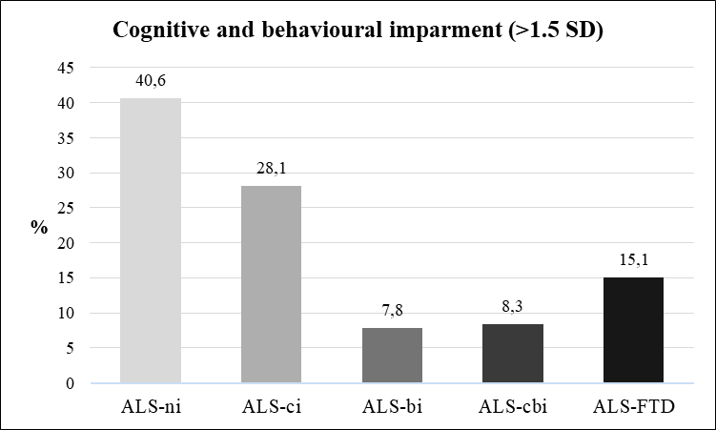

Figure S1.2 Proportion of cognitive impairment per cognitive domain of ECAS (defined by a <=1.5 SD threshold for cognitive impairment)

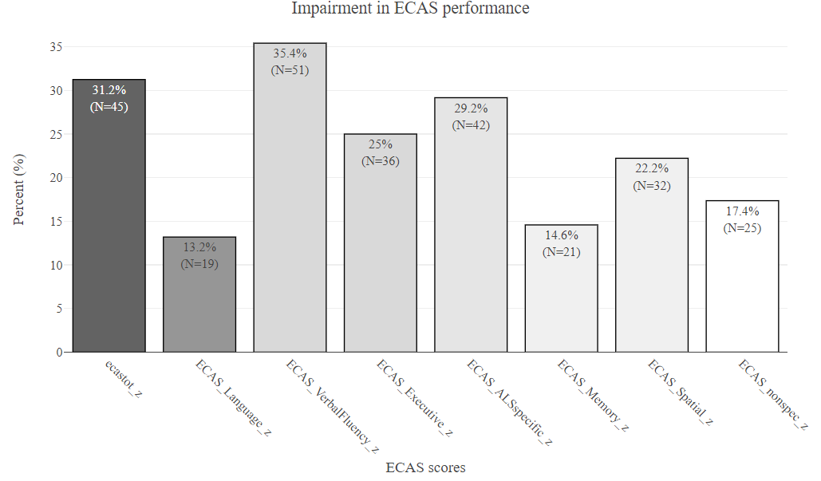

SUPPLEMENT 2 Group comparisons and regression analyses
Table S2.1 Group comparisons of Plasma extracellular vesicle tau and Plasma TDP-43 levels (subsample B), and NfL (subsample C) between cognitive subgroups

 | HC | ALSni | ALSci | ALS-FTD | Significant  post-hoc differences⁺ | Effect sizes of posthoc comparisons  (cohen’s rho)
Plasma extracellular vesicle tau
N (f/m) |  | 56 (26/30) | 56 (22/34) | 23 (8/15)
Age in years (M, SD) |  | 62.3 (12.21) | 66.1 (9.82) | 70.3 (9.42) | ALSni < ALS-FTD  (p= 0.009**)
Education in years (M, SD) |  | 13.8 (2.60) | 12.6 (2.59) | 12.3 (3.72)
ALSFRS-R (M, SD) /  Range |  | 35.9 (7.70) /  10-46 | 35.1 (6.78) /  17-48 | 36.7. (7.87) /  23-48
Disease Duration in month (M, SD) /  Range |  | 32.0 (52.70) /  3-268 | 23.9 (24.01) /  4-100 | 17.3 (14.01) /  6-33
APOE-Status ε (23/33/34/44) |  | 3/30/16/2 | 5/32/14/2 | 3/11/3/2
sEV3R-tau |  | 433.4 (76.80) | 444.5 (97.29) | 428.7 (100.53)
sEV4R-tau (M, SD) |  | 482.2  173.05 | 466.4 (132.55) | 497.7 (170.05)
Ratio sev3R-tau/sev4R-tau (M, SD) |  | 0.95 (0.18) | 1.01 (0.41) | 0.89 (0.12)
mEV3R-tau (M, SD) |  | 563.0 (209.54) | 568.6 (210.84) | 555.5 (127.15)
mEV4R-tau (M, SD) |  | 559.2 (213.77) | 565.3 (197.64) | 589.3 (194.02)
Ratio mev3R-tau/mev4R-tau (M, SD) |  | 1.02 (0.18) | 1.05 (0.42) | 1.05 (0.40)
Plasma TDP-43 levels
plasma sEV TDP-43 level |  | 56.0 (31.33) | 50.4 (30.98) | 49.3 (22.04)
plasma mEV TDP-43 level |  | 43.0 (16.83) | 79.0 (244.22) | 38.9 (20.86)
plasma-TDP-43 level (global) |  | 238.4 (216.62) | 238.4 (216.62) | 181.4 (176.40)
NfL
N (f/m) | 100 (57/43) | 76 (36/40) | 62 (24/38) | 25 (9/16)
Age in years (M, SD) | 62.0 (13.70) | 61.3 (11.98) | 66.6 (11.08) | 71.0 (8.90) | ALSni < ALS-FTD  (p= 0.001***)  HC < ALS-FTD  (p=0.006**),
Education in years (M, SD) | 15.3 (2.73) | 13.7 (2.97) | 12.6 (2.76) | 12.8 (3.14) | HC < ALSni (p=0.008**),  HC < ALSci (p=0.000****),  HC < ALS-FTD (p=0.001**),  ALSni > ALSci (p=0.019*)
ALSFRS-R (M, SD) /  Range | n.a. | 36.4 (7.53) /  10-46 | 34.7 (7.29) /  11-48 | 36.6 (8.00) /  23-48
Disease Duration in month (M, SD)/  Range | n.a. | 30.78 (47.05) /  1-268 | 23.2 (34.73) /  4-100 | 68.5 (112.63) /  3-294
APOE-Status ε (23/33/34/44) | n.a. | 5/44/23/2 | 8/36/14/2 | 3/13/2/3
Mean Concentration NfL | 14.6 (17.01) | 59.3 (42.86) | 76.8 (54.63) | 105.5 (101.63) | HC < ALSni (p=0.000****),  HC < ALSci (p=0.000****),  HC < ALS-FTD (p=0.000****) | HC~ALSni=0.56;  HC~ALSci=0.62;  HC ~ ALS-FTD = 0.45;  ALSni ~ ALSci = 0.09;  ALSni~ALS-FTD = 0.07;  ALSci ~ ALS-FTD = 0.002
+Group differences were tested using Kruskal–Wallis tests with Dunn’s post-hoc comparisons and p-values adjusted for multiple testing (Bonferroni–Holm); sex distribution was analysed using Pearson’s Chi-square test; ++Effect sizes are reported as Cohen’s r for all post-hoc comparisons.
HC=Healthy Controls; ALSni=ALS without cognitive impairment; ALSci=ALS with cognitive impairment; ALS-FTD=ALS with ALS and additional frontotemporal dementia;
ALSFRS-R=ALS-Functional Rating Scale-Revised; sEV 3R-tau=small extracellular vesicle 3R-tau; mEV 3R-tau=medium size extracellular vesicle 3R-Tau; sEV-TDP-43=small extracellular vesicle-TDP-43; mEV-TDP-43= medium extracellular vesicle-TDP-43; NfL=neurofilament light chain; M=mean; SD=standard deviation;

Table S2.2. Piecewise (Spline) regression analysis of AD biomarkers and cognitive performance using pathological thresholds as knots in patients with ALS without FTD (Subsample D)

 | Predictor | β | SE | p | Adj. R²_{model} | p _{model} | % with pathological threshold ALSni/ALSci
p-tau pg/ml; knot = 73.65 |  |  |  |  |  |  | 2.9 / 15.6
ECAS total score | ns (p-tau [pg/ml]) 1 | -3.45 | 1.02 | 0.001* | 0.13 | 0.005
 | ns (p-tau [pg/ml]) 2 | -1.22 | 1.09 | 0.267
ECAS language | ns (p-tau [pg/ml]) 1 | -2.66 | 1.04 | 0.013 * | 0.02 | 0.089
 | ns (p-tau [pg/ml]) 2 | -2.12 | 1.11 | 0.060
ECAS executive functions | ns (p-tau [pg/ml]) 1 | -2.76 | 1.22 | 0.023 * | 0.07 | 0.050
 | ns (p-tau [pg/ml]) 2 | 0.06 | 1.30 | 0.963
ECAS ALS specific functions | ns (p-tau [pg/ml]) 1 | -2.57 | 1.027 | 0.020* | 0.06 | 0.049*
 | ns (p-tau [pg/ml]) 2 | -0.58 | 1.10 | 0.600
ECAS - memory | ns (p-tau [pg/ml]) 1 | -3.09 | 0.87 | 0.001** | 0.16 | 0.002**
 | ns (p-tau [pg/ml]) 2 | -1.88 | 0.93 | 0.047
ECAS ALS non-specific functions | ns (p-tau [pg/ml]) 1 | -3.37 | 0.89 | 0.0003*** | 0.17 | 0.001**
 | ns (p-tau [pg/ml]) 2 | -1.83 | 0.95 | 0.059
Total tau; knot=510.9 |  |  |  |  |  |  | 11.4 / 25.0
ECAS total score | ns (total tau [pg/ml]) 1 | -2.30 | 0.98 | 0.022* | 0.07 | 0.043*
 | ns (total tau [pg/ml]) 2 | -1.28 | 0.89 | 0.157
ECAS language | ns (total tau [pg/ml]) 1 | -2.02 | 0.89 | 0.027* | 0.22 | 0.0001***
 | ns (total tau [pg/ml]) 2 | -3.48 | 0.81 | 0.0000***
ECAS ALS specific functions | ns (total tau [pg/ml]) 1 | -1.94 | 0.95 | 0.050 | 0.06 | 0.048*
 | ns (total tau [pg/ml]) 2 | -1.59 | 0.87 | 0.071
ECAS - Spatial | ns (total tau [pg/ml]) 1 | -3.47 | 1.72 | 0.048* | 0.03 | 0.136
 | ns (total tau [pg/ml]) 2 | -0.23 | 1.57 | 0.884
ECAS ALS non-specific functions | ns (total tau [pg/ml]) 1 | -1.84 | 0.89 | 0.044* | 0.03 | 0.122
 | ns (total tau [pg/ml]) 2 | -0.03 | 0.81 | 0.969
Ratio Aβ42/ Aβ40; knot=0.08 |  |  |  |  |  |  | 11.4 / 21.9
ECAS total score | ns (Aβ42/Aβ40) 1 | 2.85 | 1.28 | 0.030* | 0.04 | 0.088
 | ns (Aβ42/Aβ40) 2 | 0.32 | 0.62 | 0.602
ECAS verbal fluency | ns (Aβ42/Aβ40) 1 | 1.94 | 0.94 | 0.043* | 0.13 | 0.033*
 | ns (Aβ42/Aβ40) 2 | 0.13 | 0.45 | 0.770
ECAS visuo-spatial | ns (Aβ42/Aβ40) 1 | 4.99 | 2.20 | 0.027* | 0.05 | 0.075
 | ns (Aβ42/Aβ40) 2 | 0.75 | 1.06 | 0.481
Ratio Aβ42/p-tau181; knot=9.68 |  |  |  |  |  |  | 8.6 / 9.4
ECAS total score | ns (Aβ42/p-tau181) 1 | 2.73 | 1.18 | 0.024* | 0.05 | 0.076
 | ns (Aβ42/p-tau181) 2 | 0.21 | 1.03 | 0.836
ECAS ALS specific functions | ns (Aβ42/p-tau181) 1 | 2.38 | 1.15 | 0.041* | 0.046 | 0.081
 | ns (Aβ42/p-tau181) 2 | -0.70 | 0.99 | 0.487
ECAS ALS non-specific functions | ns (Aβ42/p-tau181) 1 | 2.01 | 1.05 | 0.060 | 0.07 | 0.036*
 | ns (Aβ42/p-tau181) 2 | 1.85 | 0.910 | 0.047
ECAS visuo-spatial | ns (Aβ42/p-tau181) 1 | 5.03 | 2.02 | 0.015* | 0.06 | 0.046*
 | ns (Aβ42/p-tau181) 2 | 1.40 | 1.76 | 0.427
Piecewise spline regression models were used to assess whether associations between AD biomarkers and cognitive measures differed across pathological and non-pathological ranges. Ns 1 and ns 2 represent the spline segments below and above the respective pathological thresholds. Presented are only models with at least one significant predictor (β, SE, p) are reported, along with overall model fit statistics including adjusted R² and model p-value. Only predictors that reached significance in the final model are listed; SE = standard error; ns = natural spline; *p<0.05; **p<0.01; ***p<0.001;

Table S2.3. Pairwise Binomial Logistic Regression Models for Classification of Cognitive Subtypes (Subsample A and B)
Model | predictor | β | SE | z | p | AUC_{predictor} | AUC_{model}
AD-specific markers
ALSni vs. ALSci | p-tau (pg/ml) | -0.003 | 0.02 | -0.13 | 0.895 | 0.58 | 0.65
ALSni vs. ALSci | total.tau (pg/m | 0.003 | 0.02 | 1.33 | 0.183 | 0.63 | 0.65
ALSni vs. ALSci | Aβ42/Aβ40 | -1.26 | 16.54 | -0.08 | 0.939 | 0.60 | 0.65
ALSni vs. ALSci | Aβ42/p-tau181 | -0.03 | 0.06 | -0.50 | 0.612 | 0.62 | 0.65
ALSni vs. ALS-FTD | p-tau (pg/ml) | -0.13 | 0.05 | -2.57 | 0.010* | 0.52 | 0.65
ALSni vs. ALS-FTD | total.tau (pg/m | 0.01 | 0.004 | 3.13 | 0.002** | 0.76 | 0.65
ALSni vs. ALS-FTD | Aβ42/Aβ40 | -10.99 | 34.30 | -0.32 | 0.749 | 0.70 | 0.65
ALSni vs. ALS-FTD | Aβ42/p-tau181 | -0.02 | 0.11 | -0.16 | 0.870 | 0.71 | 0.65
ALSci vs. ALS-FTD | p-tau (pg/ml) | -0.13 | 0.05 | -2.52 | 0.012* | 0.61 | 0.87
ALSci vs. ALS-FTD | total.tau (pg/m | 0.01 | 0.003 | 2.87 | 0.004** | 0.65 | 0.87
ALSci vs. ALS-FTD | Aβ42/Aβ40 | -22.15 | 26.64 | -0.83 | 0.406 | 0.61 | 0.87
ALSci vs. ALS-FTD | Aβ42/p-tau181 | -0.07 | 0.08 | -0.87 | 0.387 | 0.62 | 0.87
Plasma tau
ALSni vs. ALSci | plasma sEV 3R-tau | 0.001 | 0.002 | 0.63 | 0.531 | 0.54 | 0.55
ALSni vs. ALSci | plasma sEV 3R/4R-tau ratio | 0.88 | 0.90 | 0.99 | 0.324 | 0.52 | 0.55
ALSni vs. ALS-FTD | plasma sEV 3R-tau | -0.001 | 0.003 | -0.30 | 0.768 | 0.54 | 0.67
ALSni vs. ALS-FTD | plasma sEV 3R/4R-tau ratio | -2.31 | 1.62 | -1.43 | 0.153 | 0.65 | 0.67
ALSci vs. ALS-FTD | plasma sEV 3R-tau | -0.002 | 0.003 | -0.74 | 0.460 | 0.57 | 0.70
ALSci vs. ALS-FTD | plasma sEV 3R/4R-tau ratio | -3.94 | 1.93 | -2.05 | 0.040* | 0.67 | 0.70
Plasma TDP-43
ALSni vs. ALSci | plasma sEV TDP-43 levels | -0.01 | 0.01 | -1.55 | 0.121 | 0.57 | 0.62
ALSni vs. ALSci | plasma mEV TDP-43 levels | 0.003 | 0.01 | 0.48 | 0.631 | 0.53 | 0.62
ALSni vs. ALSci | plasma-TDP-43 level (global) | 0.001 | 0.001 | 1.56 | 0.119 | 0.55 | 0.62
ALSni vs. ALS-FTD | plasma sEV TDP-43 levels | -0.006 | 0.01 | -0.60 | 0.549 | 0.60 | 0.61
ALSni vs. ALS-FTD | plasma mEV TDP-43 levels | -0.01 | 0.02 | -0.75 | 0.453 | 0.55 | 0.61
ALSni vs. ALS-FTD | plasma-TDP-43 level (global) | -0.001 | 0.001 | -0.91 | 0.453 | 0.55 | 0.61
ALSci vs. ALS-FTD | plasma sEV TDP-43 levels | 0.003 | 0.01 | 0.27 | 0.786 | 0.52 | 0.62
ALSci vs. ALS-FTD | plasma mEV TDP-43 levels | -0.01 | 0.01 | -0.57 | 0.567 | 0.56 | 0.62
ALSci vs. ALS-FTD | plasma-TDP-43 level (global) | -0.02 | 0.001 | -1.5 | 0.124 | 0.59
NfL
ALSni vs. ALSci | Mean.Concentration.NFL_all | 0.01 | 0.004 | 2.00 | 0.045* | n.a. | 0.61
ALSni vs. ALS-FTD | Mean.Concentration.NFL_all | 0.01 | 0.004 | 2.71 | 0.007** | n.a. | 0.59
ALSci vs. ALS-FTD | Mean.Concentration.NFL_all | 0.01 | 0.003 | 1.63 | 0.103 | n.a. | 0.51

Pairwise logistic regression analyses were conducted to examine whether CSF and plasma biomarkers discriminate between cognitive subgroups (subsample D: ALS-ni, ALS-ci, ALS-FTD). Shown are regression coefficients (β), standard errors (SE), z-values, p-values, and the area under the curve (AUC) for each predictor as well as the overall model performance.

SUPPLEMENT 3 Neuropathological data
Table S3.1. postmortem AD neuropathological change and TDP-43 pathology of autopsy cases
Autopsy Case Nr. | Neuropathological  diagnosis | gene mutation | AD neuropathological change |  | TDP-43 pathology
 |  |  | ABC Score | ABC Score risk | TDP pathology | Sufficient frontal and/or temporal pathology for FTLD-TDP subtyping | Score prefrontal TDP43 burden | Score temporal TDP43 burden | Score hippocampus TDP43 burden
1 | ALS-TDP |  | A0, B0, C0 | not | yes | no | 0 | 0 | 0
2 | ALS-TDP |  | A1, B2, C0 | low | yes | no | 0 | 0 | 1
3 | ALS-TDP |  | A1, B1, C0 | low | yes | no | 0 | 0 | 0
4 | ALS-TDP |  | A1, B1, C0 | low | yes | no | 0 | 0 | 0
5 | ALS-TDP |  | A2, B2, C1 | intermediate | yes | no | 0 | 0 | 0
6 | ALS-TDP |  | A1, B1, C0 | low | yes | no | 1 | 1 | 2
7 | ALS-TDP |  | A0, B1, C0 | not | yes | no | 0 | 0 | 0
8 | ALS-TDP | C9orf72 repeat expansion | A1, B1, C0 | low | yes | no | 1 | 0 | 0
9 | ALS-TDP |  | A0, B1, C0 | not | yes | no | 0 | 0 | 0
10 | ALS-TDP |  | A2, B1, C0 | low | yes | no | 0 | 0 | 0
11 | ALS-TDP |  | A2, B2, C1 | intermediate | yes | no | 0 | 1 | 0
12 | ALS-TDP |  | A1, B1, C0 | low | yes | no | 0 | 0 | 0
13 | ALS-TDP |  | A0, B1, C0 | not | yes | no | 0 | 0 | 0
14 | ALS-TDP |  | A0, B2, C0 | not | yes | no | 0 | 0 | 0
15 | ALS-TDP |  | A1, B1, C0 | low | yes | yes | 2 | 2 | 1
16 | ALS-TDP |  | A1, B1, C0 | low | yes | yes | 1 | 0 | 0
17 | ALS-TDP |  | A2, B2, C2 | intermediate | yes | yes | 0 | 0 | 1
18 | ALS-TDP | TBK1 mutation  (p Glu643del, heterozygous) | A1, B2, C0 | low | yes | no | 1 | 1 | 1
19 | ALS-TDP |  | A1, B2, C0 | low | yes | no | 0 | 0 | 0
20 | ALS-TDP |  | A0, B1, C0 | not | yes | no | 0 | 0 | 1
21 | ALS/FTLD-TDP |  | A0, B0, C0 | not | yes | yes | 2 | 2 | 2
22 | ALS/FTLD-TDP |  | A1, B2, C1 | low | yes | yes | 3 | 2 | 3
23 | ALS/FTLD-TDP |  | A1, B1, C0 | low | yes | yes | 1 | 2 | 3
24 | ALS/FTLD-TDP | C9orf72 repeat expansion | A2, B1, C1 | low | yes | yes | 1 | 1 | 1
25 | ALS/FTLD-TDP |  | A1, B1, C0 | low | yes | yes | 3 | 3 | 3
26 | ALS/FTLD-TDP |  | A3, B1, C1 | low | yes | yes | 1 | 2 | 1
27 | ALS-UPS | CHCHD10 mutation  p.Arg15Leu | A1, B1, C0 | low | no
28 | ALS-SOD1 |  | A1, B1, C0 | low | no
ABC Score risk= overalls coring for AD neuropathological changes by considering Aβ/amyloid deposits phase (A), Neurofibrillary tangles score (B), and neuritic plaque score (C) based on standard NAI-AA criteria; TDP-43 burden in the selected brain regions was semiquantitatively scored as absent (0), mild (1), moderate (2) or severe (3).

Table S3.2. Relationship between postmortem pathology and cognitive performance (ECAS): ABC Score
Predictor | β | SE | 95% CI | Odds Ratio (OR) | 95% CI OR | BF₁₀
ABC Score overall
ECAS total score (z) | -0.27 | 0.40 | -1.07 | 0.50 | 0.77 | 0.34 | 1.65 | 0.493
ECAS language (z) | -0.12 | 0.38 | -0.87 | 0.63 | 0.89 | 0.42 | 1.89 | 0.390
ECAS verbal fluency (z) | -0.01 | 0.38 | -0.74 | 0.74 | 0.99 | 0.48 | 2.10 | 0.380
ECAS executive functions (z) | -0.45 | 0.39 | -1.23 | 0.30 | 0.64 | 0.29 | 1.35 | 0.743
ECAS ALS specific functions (z) | -0.23 | 0.39 | -1.02 | 0.51 | 0.79 | 0.36 | 1.66 | 0.464
ECAS memory (z) | -0.21 | 0.42 | -1.04 | 0.61 | 0.81 | 0.35 | 1.85 | 0.464
ECAS visuo-spatial (z) | -0.13 | 0.36 | -0.84 | 0.58 | 0.88 | 0.43 | 1.79 | 0.389
ECAS ALS non-specific functions (z) | -0.21 | 0.42 | -1.04 | 0.60 | 0.81 | 0.35 | 1.83 | 0.470
ABC Score A
ECAS total score (z) | -0.27 | 0.40 | -1.07 | 0.50 | 0.76 | 0.34 | 1.64 | 0.487
ECAS language (z) | -0.06 | 0.35 | -0.75 | 0.64 | 0.94 | 0.47 | 1.90 | 0.361
ECAS verbal fluency (z) | 0.00 | 0.36 | -0.70 | 0.70 | 1.00 | 0.50 | 2.02 | 0.365
ECAS executive functions (z) | -0.47 | 0.39 | -1.27 | 0.27 | 0.62 | 0.28 | 1.32 | 0.810
ECAS ALS specific functions (z) | -0.24 | 0.38 | -1.00 | 0.52 | 0.79 | 0.37 | 1.67 | 0.459
ECAS memory (z) | -0.26 | 0.39 | -1.03 | 0.49 | 0.77 | 0.36 | 1.64 | 0.491
ECAS visuo-spatial (z) | -0.00 | 0.35 | -0.69 | 0.68 | 1.00 | 0.50 | 1.97 | 0.346
ECAS ALS non-specific functions (z) | -0.25 | 0.40 | -1.03 | 0.53 | 0.78 | 0.36 | 1.69 | 0.483
ABC Score B
ECAS total score (z) | -0.23 | 0.41 | -1.05 | 0.58 | 0.80 | 0.35 | 1.79 | 0.466
ECAS language (z) | 0.20 | 0.39 | -0.56 1.00 | 1.23 | 0.57 | 2.71 | 0.444
ECAS verbal fluency (z) | -0.25 | 0.41 | -1.05 | 0.57 | 0.78 | 0.35 | 1.77 | 0.482
ECAS executive functions (z) | -0.19 | 0.41 | -1.00 | 0.60 | 0.82 | 0.37 | 1.82 | 0.444
ECAS ALS specific functions (z) | -0.17 | 0.39 | -0.97 | 0.60 | 0.84 | 0.38 | 1.82 | 0.443
ECAS memory (z) | -0.17 | 0.42 | -0.99 | 0.64 | 0.84 | 0.37 | 1.89 | 0.444
ECAS visuo-spatial (z) | -0.27 | 0.40 | -1.05 | 0.53 | 0.77 | 0.35 | 1.69 | 0.484
ECAS ALS non-specific functions (z) | -0.23 | 0.42 | -1.07 | 0.56 | 0.79 | 0.34 | 1.75 | 0.477
ABC Score C
ECAS total score (z) | -0.45 | 0.49 | -1.40 | 0.50 | 0.64 | 0.25 | 1.65 | 0.774
ECAS language (z) | 0.37 | 0.52 | -0.58 | 1.46 | 1.44 | 0.56 | 4.29 | 0.627
ECAS verbal fluency (z) | -0.23 | 0.51 | -1.22 | 0.81 | 0.80 | 0.30 | 2.25 | 0.572
ECAS executive functions (z) | -0.71 | 0.49 | -1.67 | 0.24 | 0.49 | 0.19 | 1.27 | 1.422
ECAS ALS specific functions (z) | -0.45 | 0.49 | -1.42 | 0.52 | 0.64 | 0.24 | 1.68 | 0.754
ECAS memory (z) | -0.28 | 0.46 | -1.16 | 0.63 | 0.76 | 0.31 | 1.88 | 0.552
ECAS visuo-spatial (z) | -0.01 | 0.46 | -0.86 | 0.97 | 0.99 | 0.42 | 2.65 | 0.456
ECAS ALS non-specific functions (z) | -0.31 | 0.47 | -1.19 | 0.63 | 0.74 | 0.30 | 1.87 | 0.588
Bayesian cumulative logistic regression examining associations between neuropathological markers (ABC score) and ECAS cognitive domain scores. Values represent posterior means with 95% credible intervals (CI), corresponding odds ratios (OR) with 95% CI, standardized regression coefficients (Std. β), and Bayes factors (BF₁₀) quantifying evidence in favour of an association. All models were adjusted for age at death and estimated using weakly informative priors (normal [0,1] for slopes; normal [0,5] for thresholds). BF₁₀ > 3 reflects moderate evidence, BF₁₀ > 10 strong evidence for an effect.

Table S3.3. Relationship between postmortem pathology and cognitive performance (ECAS): TDP-43 4 Level*
Predictor | β | SE | 95% CI | Odds Ratio (OR) | 95% CI OR | BF₁₀
TDP-43 4 Level
TDP-43 burden prefrontal
ECAS total score (z) | -0.68 | 0.47 | -1.56 | 0.25 | 0.51 | 0.21 | 1.29 | 1.405
ECAS language (z) | -0.93 | 0.46 | -1.87 | -0.05 | 0.39 | 0.15 | 0.95 | 4.041
ECAS verbal fluency (z) | -0.74 | 0.45 | -1.65 | 0.11 | 0.48 | 0.19 | 1.12 | 1.846
ECAS executive functions (z) | -0.55 | 0.40 | -1.34 | 0.22 | 0.58 | 0.26 | 1.25 | 1.058
ECAS ALS specific functions (z) | -0.84 | 0.45 | -1.74 | 0.03 | 0.43 | 0.18 | 1.03 | 2.617
ECAS memory (z) | 0.06 | 0.48 | -0.84 | 1.01 | 1.06 | 0.43 | 2.74 | 0.477
ECAS visuo-spatial (z) | -0.68 | 0.40 | -1.51 | 0.07 | 0.51 | 0.22 | 1.07 | 1.774
ECAS ALS non-specific functions (z) | -0.07 | 0.48 | -1.00 | 0.90 | 0.93 | 0.37 | 2.47 | 0.479
TDP-43-burden temporal
ECAS total score (z) | -1.04 | 0.47 | -1.99 | -0.12 | 0.35 | 0.14 | 0.89 | 5.319
ECAS language (z) | 10 | -1.0.47 | -2.03 | -0.21 | 0.33 | 0.13 | 0.81 | 8.183
ECAS verbal fluency (z) | -0.97 | 0.48 | -1.92 | -0.04 | 0.38 | 0.15 | 0.96 | 4.592
ECAS executive functions (z) | -0.38 | 0.43 | -1.21 | 0.44 | 0.68 | 0.30 | 1.56 | 0.638
ECAS ALS specific functions (z) | -1.04 | 0.46 | -1.97 | -0.16 | 0.35 | 0.14 | 0.85 | 5.959
ECAS memory (z) | -0.39 | 0.44 | -1.25 | 0.47 | 0.68 | 0.29 | 1.61 | 0.647
ECAS visuo-spatial (z) | -0.21 | 0.42 | -1.00 | 0.64 | 0.81 | 0.37 | 1.90 | 0.483
ECAS ALS non-specific functions (z) | -0.48 | 0.44 | -1.36 | 0.40 | 0.62 | 0.26 | 1.49 | 0.79
TDP-43-burden hippocampal
ECAS total score (z) | -0.89 | 0.44 | -1.77 | -0.06 | 0.409 | 0.17 | 0.95 | 3.567
ECAS language (z) | -0.90 | 0.44 | -1.80 | -0.06 | 0.408 | 0.17 | 0.94 | 3.897
ECAS verbal fluency (z) | -1.01 | 0.44 | -1.90 | -0.19 | 0.364 | 0.15 | 0.83 | 6.830
ECAS executive functions (z) | -0.41 | 0.40 | -1.23 | 0.35 | 0.67 | 0.29 | 1.42 | 0.656
ECAS ALS specific functions (z) | -1.00 | 0.44 | -1.91 | -0.15 | 0.37 | 0.15 | 0.86 | 7.402
ECAS memory (z) | -0.12 | 0.44 | -0.98 | 0.75 | 0.89 | 0.38 | 2.11 | 0.461
ECAS visuo-spatial (z) | -0.61 | 0.41 | -1.45 | 0.20 | 0.55 | 0.23 | 1.22 | 1.201
ECAS ALS non-specific functions (z) | -0.90 | 0.44 | -1.80 -0.06 | 0.77 | 0.31 | 1.88 | 0.537
TDP-43 3 Level
TDP-43 burden prefrontal
ECAS total score (z) | -0.60 | 0.45 | -1.52 | 0.29 | 0.55 | 0.21 1.34 | 1.147
ECAS language (z) | -0.96 | 0.47 | -1.92 | -0.07 | 0.38 | 0.15 | 0.93 | 4.535
ECAS verbal fluency (z) | -0.70 | 0.44 | -1.56 | 0.15 | 0.50 | 0.21 | 1.16 | 1.650
ECAS executive functions (z) | -0.54 | 0.41 | -1.34 | 0.24 | 0.58 | 0.26 | 1.27 | 1.007
ECAS ALS specific functions (z) | -0.78 | 0.44 | -1.66 | 0.08 | 0.46 | 0.19 | 1.08 | 2.186
ECAS memory (z) | 0.10 | 0.48 | -0.79 | 1.09 | 1.11 | 0.45 | 2.97 | 0.476
ECAS visuo-spatial (z) | -0.63 | 0.40 | -1.44 | 0.17 | 0.53 | 0.24 | 1.19 | 1.426
ECAS ALS non-specific functions (z) | -0.00 | 0.48 | -0.93 | 0.96 | 1.00 | 0.39 | 2.61 | 0.464
TDP-43-burden temporal
ECAS total score (z) | -0.86 | 0.47 | -1.82 | 0.02 | 0.42 | 0.16 | 1.02 | 2.714
ECAS language (z) | -1.02 | 0.47 | -1.96 | -0.14 | 0.36 | 0.14 | 0.87 | 5.866
ECAS verbal fluency (z) | -0.90 | 0.46 | -1.83 | -0.01 | 0.41 | 0.16 | 0.99 | 3.348
ECAS executive functions (z) | -0.32 | 0.43 | -1.16 | 0.52 | 0.72 | 0.31 | 1.69 | 0.565
ECAS ALS specific functions (z) | -0.90 | 0.45 | -1.82 | -0.07 | 0.41 | 0.16 | 0.93 | 3.422
ECAS memory (z) | -0.30 | 0.42 | -1.10 | 0.55 | 0.74 | 0.33 | 1.73 | 0.547
ECAS visuo-spatial (z) | -0.23 | 0.44 | -1.09 | 0.66 | 0.79 | 0.34 | 1.93 | 0.521
ECAS ALS non-specific functions (z) | -0.37 | 0.42 | -1.20 | 0.48 | 0.69 | 0.30 | 1.61 | 0.624
TDP-43-burden hippocampal
ECAS total score (z) | -0.81 | 0.44 | -1.71 | 0.02 | 0.44 | 0.18 | 1.02 | 2.564
ECAS language (z) | -0.89 | 0.43 | -1.76 | -0.08 | 0.41 | 0.17 | 0.92 | 3.859
ECAS verbal fluency (z) | -0.95 | 0.44 | -1.84 | -0.11 | 0.39 | 0.16 | 0.90 | 4.836
ECAS executive functions (z) | -0.40 | 0.39 | -1.18 | 0.37 | 0.67 | 0.31 | 1.45 | 0.642
ECAS ALS specific functions (z) | -0.96 | 0.44 | -1.83 | -0.13 | 0.38 | 0.16 | 0.87 | 5.610
ECAS memory (z) | -0.04 | 0.44 | -0.91 | 0.82 | 0.96 | 0.40 | 2.28 | 0.442
ECAS visuo-spatial (z) | -0.51 | 0.41 | -1.35 | 0.28 | 0.60 | 0.26 | 1.32 | 0.900
ECAS ALS non-specific functions (z) | -0.18 | 0.44 | -1.05 | 0.69 | 0.84 | 0.35 | 1.99 | 0.482
Bayesian cumulative logistic regression examining associations between neuropathological markers (ABC score) and ECAS cognitive domain scores. Values represent posterior means with 95% credible intervals (CI), corresponding odds ratios (OR) with 95% CI, standardized regression coefficients (Std. β), and Bayes factors (BF₁₀) quantifying evidence in favour of an association. All models were adjusted for age at death and estimated using weakly informative priors (normal [0,1] for slopes; normal [0,5] for thresholds). BF₁₀ > 3 reflects moderate evidence, BF₁₀ > 10 strong evidence for an effect.

Table S3.4. Relationship between postmortem pathology and cognitive performance (ECAS): TDP-43 3 Level*
Predictor | β | SE | 95% CI | Odds Ratio (OR) | 95% CI OR | BF₁₀
TDP 3 Level
TDP-43 burden prefrontal
ECAS total score (z) | -0.60 | 0.45 | -1.52 0.29 | 0.55 | 0.21 1.34 | 1.147
ECAS language (z) |  |  |  |  |  | 4.535
ECAS verbal fluency (z) | -0.70 | 0.44 | -1.56 0.15 | 0.50 | 0.21 1.16 | 1.65
ECAS executive functions (z) | -0.54 | 0.41 | -1.34 0.24 | 0.58 | 0.26 1.27 | 1.007
ECAS ALS specific functions (z) | -0.78 | 0.44 | -1.66 0.08 | 0.46 | 0.19 1.08 | 2.186
ECAS memory (z) | 0.10 | 0.48 | -0.79 1.09 | 1.11 | 0.45 2.97 | 0.476
ECAS visuo-spatial (z) | -0.63 | 0.40 | -1.44 0.17 | 0.53 | 0.24 1.19 | 1.426
ECAS ALS non-specific functions (z) | -0.00 | 0.48 | -0.93 0.96 | 1.00 | 0.39 2.61 | 0.464
TDP-43-burden temporal
ECAS total score (z) | -0.86 | 0.47 | -1.82 0.02 | 0.4242012 | 0.16 1.02 | 2.714
ECAS language (z) | -1.02 | 0.47 | -1.96 -0.14 | 0.3618726 | 0.14 0.87 | 5.866
ECAS verbal fluency (z) | -0.90 | 0.46 | -1.83 -0.01 | 0.4084558 | 0.16 0.99 | 3.348
ECAS executive functions (z) | -0.32 | 0.43 | -1.16 0.52 | 0.7245856 | 0.31 1.69 | 0.565
ECAS ALS specific functions (z) | -0.90 | 0.45 | -1.82 -0.07 | 0.41 | 0.16 0.93 | 3.422
ECAS memory (z) | -0.30 | 0.42 | -1.10 0.55 | 0.74 | 0.33 1.73 | 0.547
ECAS visuo-spatial (z) | -0.23 | 0.44 | -1.09 0.66 | 0.79 | 0.34 1.93 | 0.521
ECAS ALS non-specific functions (z) | -0.37 | 0.42 | -1.20 0.48 | 0.69 | 0.30 1.61 | 0.624
TDP-43-burden hippocampal
ECAS total score (z) | -0.81 | 0.44 | -1.71 0.02 | 0.44 | 0.18 1.02 | 2.564
ECAS language (z) | -0.89 | 0.43 | -1.76 -0.08 | 0.41 | 0.17 0.92 | 3.859
ECAS verbal fluency (z) | -0.95 | 0.44 | -1.84 -0.11 | 0.3877822 | 0.16 0.90 | 4.836
ECAS executive functions (z) | -0.40 | 0.39 | -1.18 0.37 | 0.67 | 0.31 1.45 | 0.642
ECAS ALS specific functions (z) | -0.96 | 0.44 | -1.83 -0.13 | 0.38 | 0.16 0.87 | 5.610
ECAS memory (z) | -0.04 | 0.44 | -0.91 0.82 | 0.96 | 0.40 2.28 | 0.442
ECAS visuo-spatial (z) | -0.51 | 0.41 | -1.35 0.28 | 0.60 | 0.26 1.32 | 0.900
ECAS ALS non-specific functions (z) | -0.18 | 0.44 | -1.05 0.69 | 0.84 | 0.35 1.99 | 0.482
Bayesian cumulative logistic regression examining associations between neuropathological markers (ABC score) and ECAS cognitive domain scores. Values represent posterior means with 95% credible intervals (CI), corresponding odds ratios (OR) with 95% CI, standardized regression coefficients (Std. β), and Bayes factors (BF₁₀) quantifying evidence in favour of an association. All models were adjusted for age at death and estimated using weakly informative priors (normal [0,1] for slopes; normal [0,5] for thresholds). BF₁₀ > 3 reflects moderate evidence, BF₁₀ > 10 strong evidence for an effect.
SUPPLEMENT 4 Analyses of neuropsychological data and AD biomarkers (defined by a 2 SD threshold for cognitive impairment)

Figure S4.1. Proportional distribution of cognitive and behavioral impairments (defined by a ≥2 SD threshold for cognitive impairment)

Figure S4.2. Proportion of cognitive impairment per cognitive domain of ECAS (defined by a ≥2 SD threshold for cognitive impairment)

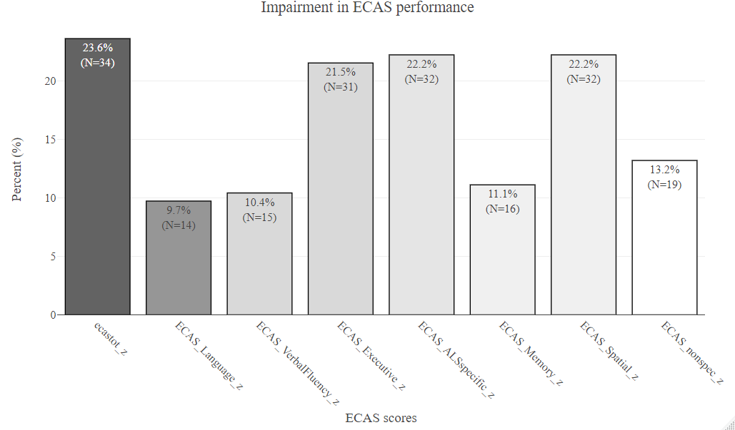

Table S4.1. Comparison of AD-specific CSF biomarkers across cognitive subgroups defined by a 2 SD threshold for cognitive impairment (subsample A)

AD-specific markers (Subsample A) | HC | ALSni | ALSci | ALS-FTD | Significant post-hoc differences⁺
p-tau pg/ml  (M, SD) | 53.9  (14.30) | 45.6  (16.05) | 53.4  (28.12) | 44.5  (16.90)
total-tau pg/ml  (M, SD) | 290.3  (103.93) | 343.4  (157.68) | 436.3  (245.24) | 531.9  (234.28) | HC < ALS-FTD (p=0.007**)
ratio Aβ42/Aβ40  (M, SD) | 0.11  (0.02) | 0.09  (0.03) | 0.09  (0.02) | 0.09  (0.02) | HC > ALSci (p=0.002**),  HC > ALS-FTD (p=0.004**)
ratio Aβ42/p-tau181  (M, SD) | 20.5  (3.94) | 18.9  (6.47) | 16.5  (7.53) | 15.3  (7.48) | HC > ALSci (0.005**),  HC > ALS-FTD (0.001**)
+Group differences were tested using Kruskal–Wallis tests with Dunn’s post-hoc comparisons and p-values adjusted for multiple testing (Bonferroni–Holm); sex distribution was analysed using Pearson’s Chi-square test; ++Effect sizes are reported as Cohen’s r for all post-hoc comparisons.
HC = healthy controls; ALSni = ALS with normal cognition; ALSci = ALS with cognitive impairment; ALS-FTD = ALS with additional frontotemporal dementia; ALSFRS-R = ALS Functional Rating Scale–Revised; M = mean; SD = standard deviation; n.a. = not assigned.

