Supplementary

Results
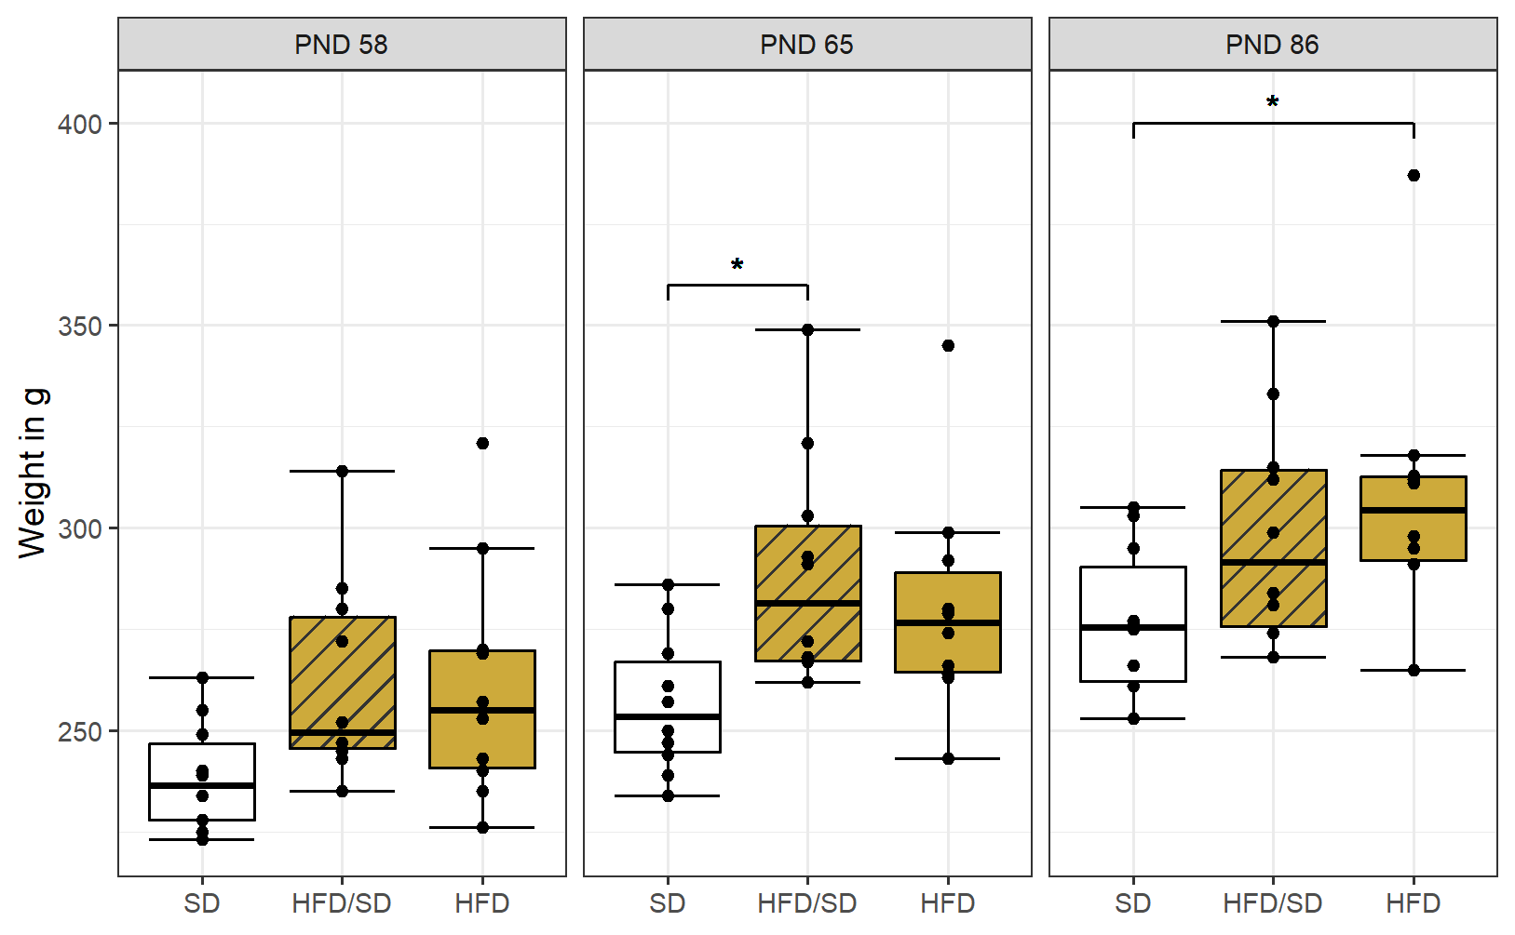
Fig. S1. Weight Development Across Diet Groups. Body weight was measured longitudinally in each diet group (n = 10 per group) and analyzed using repeated-measures ANOVA; * p < 0.05. A significant weight increase was observed following the diet switch at PND 65. By adulthood (PND 86), only the HFD group remained significantly heavier compared to the other groups. Boxplots show medians and interquartile ranges; whiskers represent 1.5× IQR. Individual data points are overlaid. Fill colors represent HFD exposure; striped patterns indicate a dietary switch.
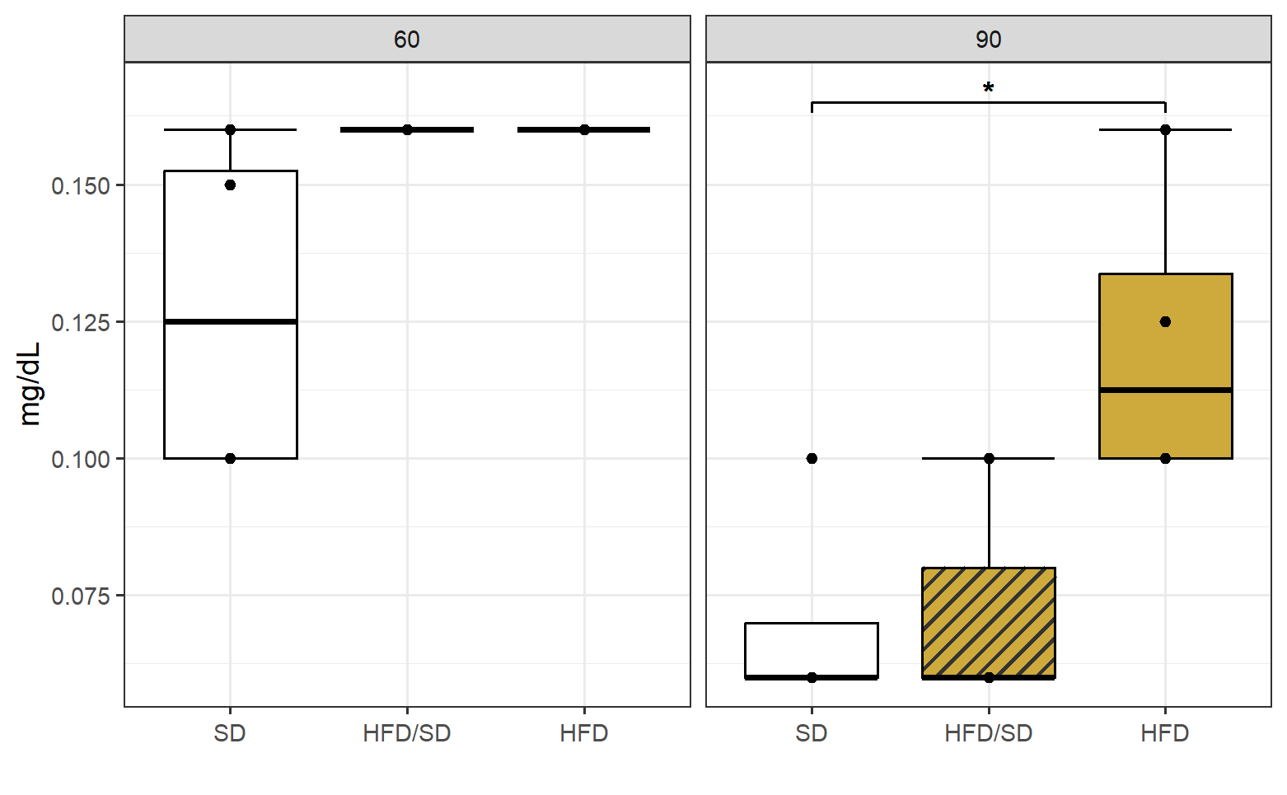
Fig. S2. LDL Serum Levels. LDL levels were significantly elevated in the HFD group at PND 90, but not at PND 60, compared to controls (n = 5 per group). Statistical significance was determined by
One-way ANOVA with Tukey’s post hoc test (*p < 0.05). Boxplots show medians and interquartile ranges (IQR); whiskers extend to 1.5× IQR, with individual data points overlaid. Fill colors represent HFD exposure; striped patterns indicate a dietary switch.

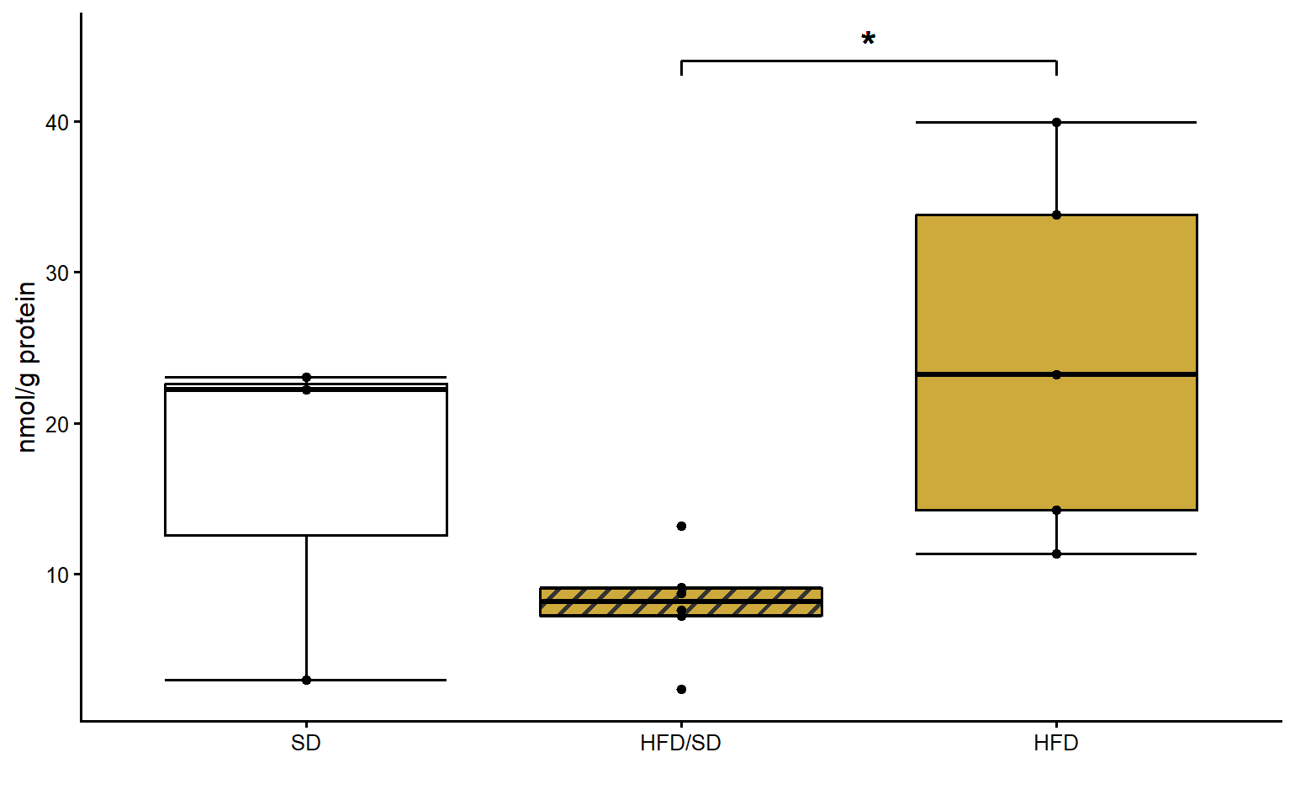

Fig S3. Dopamine concentration in Amygdala. Dopamine was increased in HFD group compared to HFD/SD. (n = 6 per group). Statistical significance was determined by One-way ANOVA with Tukey’s post hoc test (*p < 0.05). Boxplots show medians and interquartile ranges (IQR); whiskers extend to 1.5× IQR, with individual data points overlaid. Fill colors represent HFD exposure; striped patterns indicate a dietary switch.

Variable | Group | Mean (SD) | Levene's p-value | ANOVA F-statistic | ANOVA p-value
Aspartate_Amy | HFD | 18.4 (1.32)µmol/g protein | 0.1992 | F(2, 15) = 0.5953 | 0.5639
 | HFD/SD | 19.9 (3.01)µmol/g protein
 | SD | 20.7 (5.67)µmol/g protein
Glutamate_Amy | HFD | 68.6 (8.99)µmol/g protein | 0.7006 | F(2, 15) = 0.1105 | 0.8962
 | HFD/SD | 68.8 (18.55)µmol/g protein
 | SD | 72.5 (18.51)µmol/g protein
Glutamine_Amy | HFD | 36.7 (2.34)µmol/g protein | 0.3952 | F(2, 15) = 0.4787 | 0.6288
 | HFD/SD | 41.1 (9.09)µmol/g protein
 | SD | 40.2 (11.04)µmol/g protein
Taurine_Amy | HFD | 34.2 (8.48)µmol/g protein | 0.9748 | F(2, 15) = 1.1397 | 0.3461
 | HFD/SD | 37.4 (9.49)µmol/g protein
 | SD | 42.7 (11.4)µmol/g protein
GABA_Amy | HFD | 24.4 (6.05)µmol/g protein | 0.9136 | F(2, 15) = 0.0278 | 0.9726
 | HFD/SD | 23.7 (6.03)µmol/g protein
 | SD | 24.2 (5.42)µmol/g protein
DOPAC_Amy | HFD | 9.81 (4.59)nmol/g protein | 0.6083 | F(2, 11) = 1.1295 | 0.358
 | HFD/SD | 11.4 (9.94)nmol/g protein
 | SD | 19.4 (12.9)nmol/g protein
Dopamine_Amy | HFD | 24.5 (12.3)nmol/g protein | 0.1857 | F(2, 11) = 4.4188 | 0.039
 | HFD/SD | 8.03 (3.5)nmol/g protein
 | SD | 16.1 (11.3)nmol/g protein
HIAA_Amy | HFD | 74.4 (21.0)nmol/g protein | 0.4408 | F(2, 14) = 1.1404 | 0.3477
 | HFD/SD | 83.8 (27.8)nmol/g protein
 | SD | 94.3 (11.5)nmol/g protein
HT_Amy | HFD | 76.3 (34.9)nmol/g protein | 0.4756 | F(2, 12) = 3.1867 | 0.0776
 | HFD/SD | 40.1 (33.7)nmol/g protein
 | SD | 25.3 (16.3)nmol/g protein
HIAA/HT_Amy | HFD | 1.39 (1.34) | 0.02364 | F(2, 12) = 1.5856 | 0.2449
 | HFD/SD | 4.15 (3.39)
 | SD | 2.69 (3.17)
Aspartate_Hipp | HFD | 16.5 (4.06)µmol/g protein | 0.5572 | F(2, 15) = 0.7774 | 0.4773
 | HFD/SD | 14.2 (2.89)µmol/g protein
 | SD | 15.0 (2.75)µmol/g protein
Glutamate_Hipp | HFD | 76.6 (12.2)µmol/g protein | 0.9266 | F(2, 15) = 1.4015 | 0.2767
 | HFD/SD | 65.6 (13.1)µmol/g protein
 | SD | 66.9 (12.2)µmol/g protein
Glutamine_Hipp | HFD | 32.7 (6.37)µmol/g protein | 0.9315 | F(2, 15) = 0.3599 | 0.7036
 | HFD/SD | 31.1 (5.61)µmol/g protein
 | SD | 29.9 (5.33)µmol/g protein
Taurine_Hipp | HFD | 52.1 (7.58)µmol/g protein | 0.9857 | F(2, 15) = 1.4722 | 0.2607
 | HFD/SD | 43.8 (8.24)µmol/g protein
 | SD | 46.4 (9.61)µmol/g protein
GABA_Hipp | HFD | 20.4 (5.2)µmol/g protein | 0.9373 | F(2, 15) = 0.1326 | 0.8769
 | HFD/SD | 18.8 (5.59)µmol/g protein
 | SD | 19.3 (5.38)µmol/g protein
HIAA_Hipp | HFD | 53.2 (4.04)nmol/g protein | 0.2651 | F(2, 10) = 0.7778 | 0.4853
 | HFD/SD | 45.4 (12.3)nmol/g protein
 | SD | 50.8 (7.11)nmol/g protein
HT_Hipp | HFD | 21.4 (8.46)nmol/g protein | 0.4895 | F(2, 12) = 2.2732 | 0.1455
 | HFD/SD | 19.3 (8.17)nmol/g protein
 | SD | 12.6 (4.44)nmol/g protein
HIAA/HT_Hipp | HFD | 3.43 (0.62) | 0.5521 | F(2, 8) = 0.3548 | 0.7118
 | HFD/SD | 2.76 (3.74)
 | SD | 4.17 (1.41)
Aspartate_FC | HFD | 9.07 (0.76)µmol/g protein | 0.1427 | F(2, 15) = 2.1839 | 0.1471
 | HFD/SD | 7.64 (1.11)µmol/g protein
 | SD | 7.86 (1.75)µmol/g protein
Glutamate_FC | HFD | 32.1 (3.47)µmol/g protein | 0.7266 | F(2, 15) = 2.8444 | 0.08967
 | HFD/SD | 26.8 (4.47)µmol/g protein
 | SD | 29.2 (3.47)µmol/g protein
Glutamine_FC | HFD | 14.0 (2.02)µmol/g protein | 0.9388 | F(2, 15) = 0.4992 | 0.6167
 | HFD/SD | 12.9 (1.78)µmol/g protein
 | SD | 13.1 (2.02)µmol/g protein
Taurine_FC | HFD | 16.5 (1.61)µmol/g protein | 0.6242 | F(2, 15) = 2.4909 | 0.1164
 | HFD/SD | 13.7 (2.83)µmol/g protein
 | SD | 15.2 (2.04)µmol/g protein
GABA_FC | HFD | 6.18 (0.73)µmol/g protein | 0.6985 | F(2, 15) = 1.1664 | 0.3382
 | HFD/SD | 5.18 (1.14)µmol/g protein
 | SD | 5.69 (1.43)µmol/g protein
DOPAC_FC | HFD | 1.55 (1.04)nmol/g protein | 0.2088 | F(2, 14) = 0.7995 | 0.4691
 | HFD/SD | 1.28 (0.46)nmol/g protein
 | SD | 0.98 (0.68)nmol/g protein
Dopamine_FC | HFD | 0.88 (0.13)nmol/g protein | 0.5977 | F(2, 14) = 0.0028 | 0.9972
 | HFD/SD | 0.86 (0.26)nmol/g protein
 | SD | 0.87 (0.31)nmol/g protein
HIAA_FC | HFD | 65.8 (11.07)nmol/g protein | 0.3857 | F(2, 15) = 0.2597 | 0.7747
 | HFD/SD | 60.2 (14.34)nmol/g protein
 | SD | 60.8 (17.82)nmol/g protein
HT_FC | HFD | 17.8 (1.94)nmol/g protein | 0.03242 | F(2, 15) = 0.6672 | 0.5277
 | HFD/SD | 18.8 (6.03)nmol/g protein
 | SD | 23.4 (14.09)nmol/g protein
HIAA/HT_FC | HFD | 3.77 (0.99) | 0.04278 | F(2, 15) = 0.0316 | 0.9689
 | HFD/SD | 3.66 (1.87)
 | SD | 3.95 (2.88)

Table S1 HPLC Results. Notably, Dopamine was not detectable in the hippocampus across the groups.

feature | metaVariable | Ps | Qs | Ds | status
Actinobacteriota | SD | 0,000666 | 0,00222 | 1 | OK_nc
Bacteroidota | SD | 0,000666 | 0,00222 | 1 | OK_nc
Desulfobacterota | SD | 0,002664 | 0,005328 | -0,92 | OK_nc
Firmicutes | SD | 0,001332 | 0,00333 | -0,96 | OK_nc
Proteobacteria | SD | 0,055278 | 0,09213 | 0,64 | OK_nc
Verrucomicrobiota | SD | 0,000666 | 0,00222 | -1 | OK_nc
Table S2. Differential Abundance Analysis at the Phylum Level on PND60. Only significant results from MetadeconfoundR are shown.
feature | metaVariable | Ps | Qs | Ds | status
Patescibacteria | SD | 0,008332 | 0,083323 | 0,74 | OK_nc
Bacteroidota | HFD_SD | 0,000666 | 0,00333 | 1 | OK_sd
Firmicutes | HFD_SD | 0,000666 | 0,00333 | -1 | OK_sd
Actinobacteriota | HFD | 0,007 | 0,0175 | 0,9 | OK_nc
Bacteroidota | HFD | 0,000666 | 0,00666 | -1 | OK_sd
Desulfobacterota | HFD | 0,003968 | 0,013225 | 0,96 | OK_nc
Firmicutes | HFD | 0,012654 | 0,025308 | 0,8 | OK_sd
Verrucomicrobiota | HFD | 0,002624 | 0,013119 | 1 | OK_nc
Table S3. Differential Abundance Analysis at the Phylum Level on PND90. Only significant results from MetadeconfoundR are shown.
feature | metaVariable | Ps | Qs | Ds | status
Bacteroidota | SD | 0,031115 | 0,077788 | 0,49 | C: HFD, diet
Desulfobacterota | SD | 0,00113 | 0,005651 | -0,745 | AD
Firmicutes | SD | 0,049031 | 0,098062 | -0,45 | C: HFD, diet
Patescibacteria | SD | 0,026926 | 0,077788 | 0,395 | OK_nc
Verrucomicrobiota | SD | 0,000335 | 0,003349 | -0,82 | C: diet
Bacteroidota | HFD | 0,003258 | 0,010861 | -0,65 | AD
Desulfobacterota | HFD | 0,014608 | 0,036521 | 0,56 | C: SD, diet
Firmicutes | HFD | 0,003258 | 0,010861 | 0,65 | AD
Verrucomicrobiota | HFD | 0,000761 | 0,007608 | 0,77 | C: diet
unknown | Age | 0,011392 | 0,037973 | 0,546667 | OK_nc
Actinobacteriota | Age | 0,003014 | 0,030137 | -0,64 | OK_nc
Bacteroidota | Age | 0,007544 | 0,037718 | 0,564444 | OK_sd
Desulfobacterota | Age | 0,030998 | 0,061996 | -0,46667 | OK_sd
Proteobacteria | Age | 0,020902 | 0,052256 | -0,49333 | OK_nc
Bacteroidota | diet | 0,011796 | 0,034251 | Inf | AD
Desulfobacterota | diet | 0,002949 | 0,014747 | Inf | AD
Firmicutes | diet | 0,013701 | 0,034251 | Inf | AD
Verrucomicrobiota | diet | 0,000279 | 0,002789 | Inf | OK_sd
Table S4. Differential Abundance Analysis at the Phylum Level by Diet and Age. To account for repeated measures (PND60 and PND90), subject ID was included as a random variable. Only significant results from MetadeconfoundR are shown.

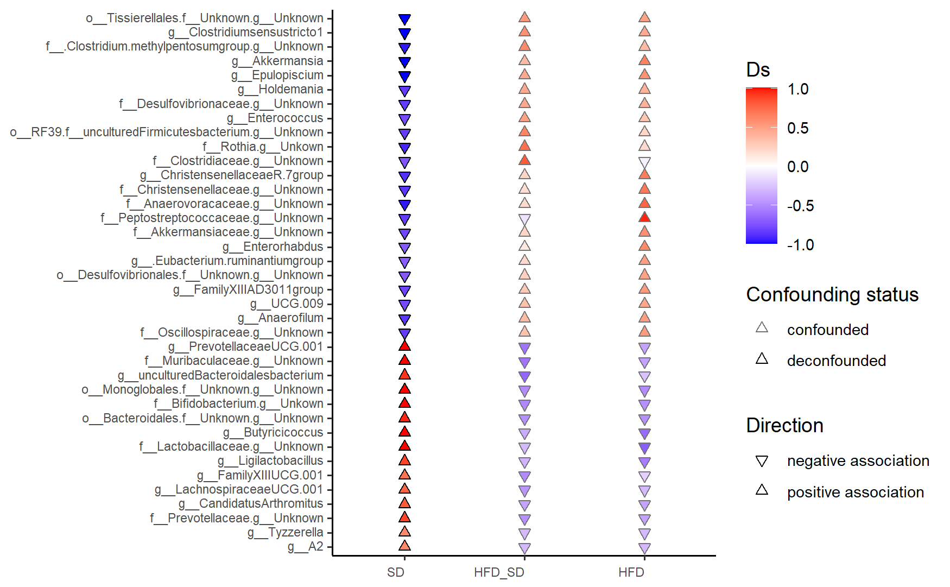
Fig. S4. Differential Abundance Analysis across Diets at the Genus Level on PND60. Genus-level taxa that could not be confidently assigned were labeled by their highest resolved taxonomic rank (e.g. family) followed by 'unknown'. Black-bordered triangles: Two-sided Wilcoxon rank sum test FDR-adjusted p value < 0.1. The direction and coloring of triangles indicate Cliff’s Delta effect size. Statistical significance was assessed using a two-sided Wilcoxon rank-sum test with FDR adjustment (p < 0.1; p < 0.001). Detailed values are provided in Table S4.

feature | metaVariable | Ps | Qs | Ds | status
Bifidobacterium | SD | 0,003 | 0,027 | 1 | OK_nc
Rothia | SD | 0,006 | 0,041 | -0,92 | OK_nc
Enterorhabdus | SD | 0,028 | 0,089 | -0,72 | OK_nc
Bacteroidales_Unknown_Unknown | SD | 0,001 | 0,027 | 0,96 | OK_nc
Muribaculaceae_Unknown | SD | 0,001 | 0,022 | 1 | OK_nc
Muribaculaceae_uncultured Bacteroidalesbacterium | SD | 0,006 | 0,041 | 0,92 | OK_nc
Prevotellaceae_Unknown | SD | 0,008 | 0,046 | 0,88 | OK_nc
Prevotellaceae UCG1 | SD | 0,001 | 0,022 | 1 | OK_nc
Desulfovibrionales_Unknown_Unknown | SD | 0,028 | 0,089 | -0,72 | OK_nc
Desulfovibrionaceae_Unknown | SD | 0,008 | 0,046 | -0,84 | OK_nc
Holdemania | SD | 0,012 | 0,052 | -0,84 | OK_nc
Enterococcus | SD | 0,020 | 0,075 | -0,78 | OK_nc
Lactobacillaceae_Unknown | SD | 0,003 | 0,027 | 1 | OK_nc
Ligilactobacillus | SD | 0,005 | 0,038 | 0,88 | OK_nc
uncultured Firmicutesbacterium_Unknown | SD | 0,010 | 0,049 | -0,84 | OK_nc
Christensenellaceae_Unknown | SD | 0,010 | 0,049 | -0,86 | OK_nc
Christensenellaceae R-7group | SD | 0,008 | 0,046 | -0,88 | OK_nc
Clostridiaceae_Unknown | SD | 0,023 | 0,080 | -0,74 | OK_nc
Candidatus Arthromitus | SD | 0,002 | 0,027 | 0,8 | OK_nc
Clostridium sensustricto1 | SD | 0,003 | 0,027 | -1 | OK_nc
Lachnospiraceae A2 | SD | 0,011 | 0,050 | 0,6 | OK_nc
Epulopiscium | SD | 0,002 | 0,027 | -1 | OK_nc
Lachnospiraceae UCG1 | SD | 0,020 | 0,075 | 0,76 | OK_nc
Tyzzerella | SD | 0,011 | 0,050 | 0,6 | OK_nc
Eubacterium ruminantium group | SD | 0,023 | 0,080 | -0,7 | OK_nc
Unknown | SD | 0,000 | 0,022 | 1 | OK_nc
Butyricicoccus | SD | 0,002 | 0,027 | 1 | OK_nc
Butyricicoccaceae UCG9 | SD | 0,019 | 0,075 | -0,78 | OK_nc
Oscillospiraceae_Unknown | SD | 0,008 | 0,046 | -0,84 | OK_nc
Anaerofilum | SD | 0,009 | 0,049 | -0,86 | OK_nc
Clostridium | SD | 0,004 | 0,033 | -0,96 | OK_nc
Tissierellales_Unknown_Unkown | SD | 0,001 | 0,022 | -1 | OK_nc
Anaerovoracaceae_Unknown | SD | 0,004 | 0,033 | -0,96 | OK_nc
Anaerovoracaceae-FamilyXIIIAD3011group | SD | 0,013 | 0,053 | -0,8 | OK_nc
Anaerovoracaceae-FamilyXIIIUCG1 | SD | 0,024 | 0,080 | 0,7 | OK_nc
Peptostreptococcaceae_Unknown | SD | 0,008 | 0,046 | -0,84 | OK_nc
Akkermansiaceae_Unknown | SD | 0,017 | 0,068 | -0,8 | OK_nc
Akkermansia | SD | 0,002 | 0,027 | -1 | OK_nc
Table S5. Differential Abundance Analysis at the Genus Level on PND 60. Only significant results from MetadeconfoundR are shown. Genus-level taxa that could not be confidently assigned were labeled by their highest resolved taxonomic rank (e.g. family) followed by 'unknown'.

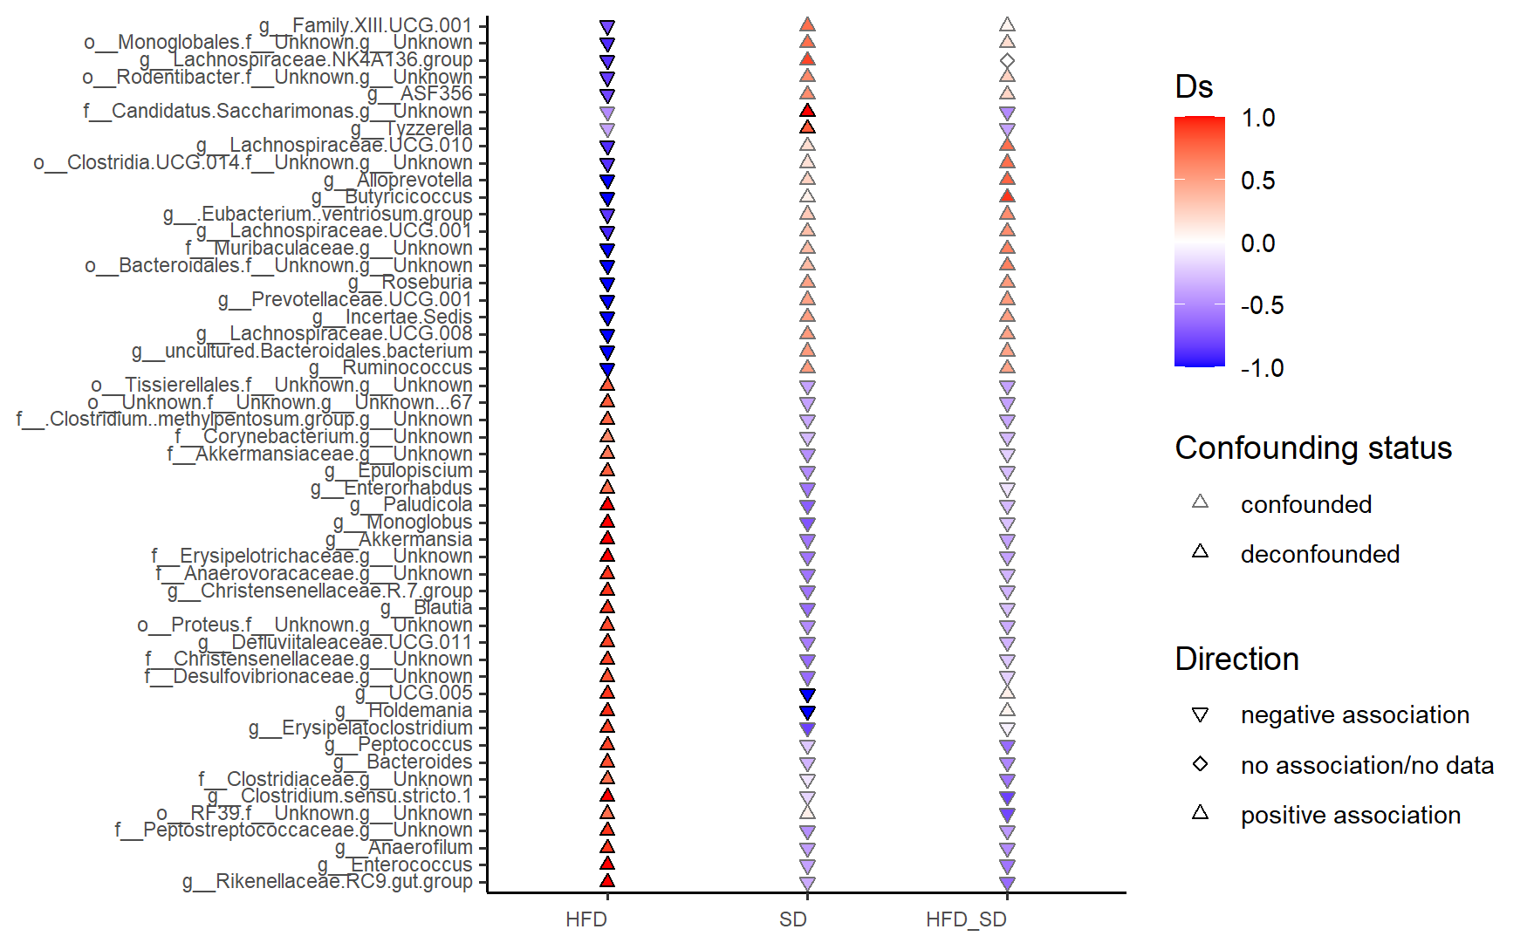
Fig. S5. Differential Abundance Analysis across Diets at the Genus Level on PND90. Genus-level taxa that could not be confidently assigned were labeled by their highest resolved taxonomic rank (e.g. family) followed by 'unknown'. Black-bordered triangles: Two-sided Wilcoxon rank sum test FDR-adjusted p value < 0.1. The direction and coloring of triangles indicate Cliff’s Delta effect size. Statistical significance was assessed using a two-sided Wilcoxon rank-sum test with FDR adjustment (p < 0.1; p < 0.001). Detailed values are provided in Table S5.

feature | metaVariable | Ps | Qs | Ds | status
Holdemania | SD | 0,002 | 0,082 | -1 | OK_sd
Tyzzerella | SD | 0,002 | 0,082 | 0,8 | OK_nc
Oscillospiraceae UCG5 | SD | 0,003 | 0,082 | -1 | OK_sd
Saccharimonas | SD | 0,000 | 0,043 | 1 | OK_nc
Corynebacterium | HFD | 0,011 | 0,034 | 0,6 | OK_nc
Enterorhabdus | HFD | 0,028 | 0,073 | 0,72 | OK_nc
Bacteroidales_Unknown_Unknown | HFD | 0,001 | 0,009 | -1 | OK_nc
Bacteroides | HFD | 0,008 | 0,027 | 0,84 | OK_nc
Muribaculaceae_Unknown | HFD | 0,001 | 0,009 | -1 | OK_nc
Muribaculaceae_uncultured Bacteroidales bacterium | HFD | 0,001 | 0,009 | -1 | OK_nc
Alloprevotella | HFD | 0,001 | 0,009 | -1 | OK_nc
Prevotellaceae UCG1 | HFD | 0,002 | 0,017 | -1 | OK_nc
Rikenellaceae RC9 gut group | HFD | 0,001 | 0,009 | 1 | OK_nc
Desulfovibrionaceae_Unknown | HFD | 0,008 | 0,027 | 0,84 | OK_nc
Erysipelatoclostridium | HFD | 0,008 | 0,027 | 0,88 | OK_nc
Erysipelotrichaceae_Unknown | HFD | 0,001 | 0,009 | 1 | OK_nc
Holdemania | HFD | 0,004 | 0,024 | 0,94 | OK_sd
Enterococcus | HFD | 0,002 | 0,017 | 1 | OK_nc
Bacilli RF39_Unknown_Unknown | HFD | 0,032 | 0,082 | 0,72 | OK_nc
Clostridia_Unknown_Unknown_Unknown | HFD | 0,013 | 0,036 | 0,8 | OK_nc
Christensenellaceae_Unknown | HFD | 0,008 | 0,027 | 0,88 | OK_nc
Christensenellaceae_R7 group | HFD | 0,003 | 0,017 | 0,92 | OK_nc
Clostridia UCG14_Unkown_Unkown | HFD | 0,005 | 0,024 | -0,88 | OK_nc
Clostridiaceae_Unknown | HFD | 0,023 | 0,062 | 0,72 | OK_nc
Clostridium sensu stricto 1 | HFD | 0,002 | 0,017 | 1 | OK_nc
Defluviitaleaceae UCG 11 | HFD | 0,008 | 0,027 | 0,88 | OK_nc
Lachnospiraceae ASF356 | HFD | 0,017 | 0,047 | -0,8 | OK_nc
Blautia | HFD | 0,006 | 0,024 | 0,92 | OK_nc
Epulopiscium | HFD | 0,006 | 0,024 | 0,78 | OK_nc
Lachnospiraceae NK4A136 group | HFD | 0,005 | 0,024 | -0,88 | OK_nc
Lachnospiraceae UCG1 | HFD | 0,006 | 0,024 | -0,92 | OK_nc
Lachnospiraceae UCG 8 | HFD | 0,001 | 0,009 | -1 | OK_nc
Lachnospiraceae UCG 10 | HFD | 0,005 | 0,024 | -0,9 | OK_nc
Roseburia | HFD | 0,001 | 0,009 | -1 | OK_nc
Eubacterium ventriosum group | HFD | 0,009 | 0,030 | -0,86 | OK_nc
Monoglobales_Unkown_Unkown | HFD | 0,005 | 0,024 | -0,9 | OK_nc
Monoglobus | HFD | 0,002 | 0,017 | 1 | OK_nc
Butyricicoccus | HFD | 0,003 | 0,017 | -1 | OK_nc
Oscillospiraceae UCG5 | HFD | 0,006 | 0,024 | 0,92 | OK_sd
Anaerofilum | HFD | 0,003 | 0,017 | 0,92 | OK_nc
Ruminococcaceae Incertae Sedis | HFD | 0,003 | 0,017 | -1 | OK_nc
Paludicola | HFD | 0,002 | 0,017 | 1 | OK_nc
Ruminococcus | HFD | 0,001 | 0,009 | -1 | OK_nc
Clostridium | HFD | 0,010 | 0,033 | 0,76 | OK_nc
Peptococcus | HFD | 0,007 | 0,027 | 0,88 | OK_nc
Tissierellales_Unknown_Unkown | HFD | 0,013 | 0,036 | 0,8 | OK_nc
Anaerovoracaceae_Unkown | HFD | 0,005 | 0,024 | 0,92 | OK_nc
Anaerovoracaceae Family XIII UCG 1 | HFD | 0,018 | 0,048 | -0,78 | OK_nc
Peptostreptococcaceae_Unkown | HFD | 0,003 | 0,017 | 0,92 | OK_nc
Proteus | HFD | 0,007 | 0,027 | 0,86 | OK_nc
Rodentibacter | HFD | 0,012 | 0,035 | -0,84 | OK_nc
Akkermansia | HFD | 0,001 | 0,017 | 1 | OK_nc
Table S6. Differential Abundance Analysis at the Genus Level on PND 90. Only significant results from MetadeconfoundR are shown. Genus-level taxa that could not be confidently assigned were labeled by their highest resolved taxonomic rank (e.g. family) followed by 'unknown'.

