Supplementary Information for

Effects of altered gravity on adrenergic-mediated cAMP signalling in intact cells

Marc Bathe-Peters^{1*}, Iqra Sohail^{2*}, Alexei Sirbu², Katharina Schneider², Tommaso Patriarchi³, Anantha Anilkumar¹, Yannick Lichterfeld⁴, Christian Liemersdorf⁴, Primal de Lanerolle⁵, Paolo Annibale^{1,2,6}

1 School of Physics and Astronomy, University of St Andrews, St Andrews, United Kingdom
2 Max-Delbrück-Center for Molecular Medicine, Berlin, Germany
3 Institute of Pharmacology and Toxicology, University of Zürich and Neuroscience Center Zürich (ZNZ), ETH and University of Zürich, Zürich, Switzerland
4 Institute for Aerospace Medicine, Deutsches Zentrum für Luft- und Raumfahrt, Cologne, Germany
5 Department of Physiology and Biophysics, College of Medicine, University of Illinois at Chicago, United States
6 Correspondence to pa53@st-andrews.ac.uk

This files contains:
Supplementary Figures S1-S10
Supplementary Table 1
Supplementary Figures
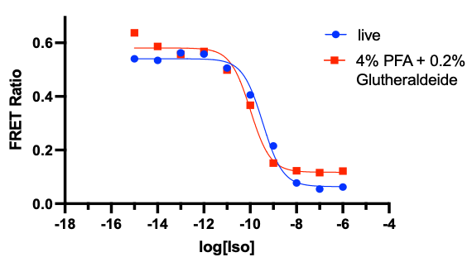
Figure S1. Effect of fixation on FRET readout for HEK293 cells transiently transfected with EPAC-S^{H187}. cAMP concentration as a function of Isoproterenol(Iso) stimulus comparing live vs chemically fixed HEK293 cells using. Fixation was achieved by a combination of 4% Paraformaldehyde and 0.2% Gluteraldehyde, for 10 minutes at room temperature. n=1 replicate.
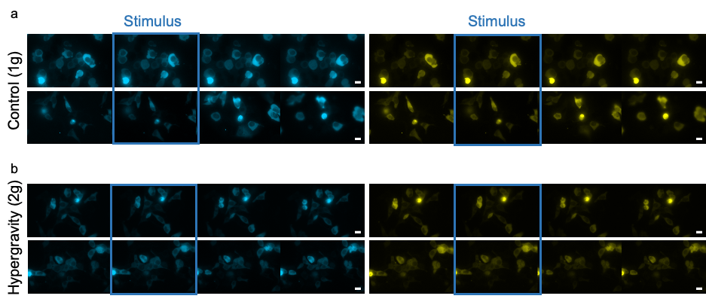
Figure S2: β-adrenergic activation measured by live FRET microscopy of HEK293 transfected the EPAC-SH187 sensor and exposed to 1g or 2g conditions in the Hyperscope. a) donor (mTurquoise2, left)and FRET (mVenus, right) signals from two representative experiments (out of n=5 experiments) where HEK293 cells were stimulated at the indicated time with 1 µM isoproterenol in 1 g conditions. b) donor (left)and FRET (right) signals from two representative experiments (from n=5 experiments) where HEK293 cells were stimulated at the indicated time with 1 µM isoproterenol in 2 g conditions. Each time sequence contains a snapshot stimulus, shortly after (rising phase), at peak response, and after peak. Scale bar is 20 µm throughout.

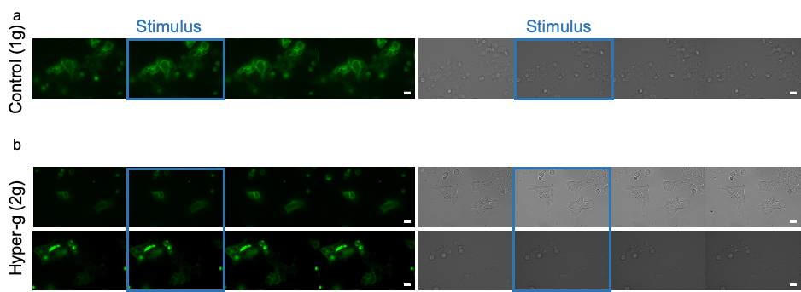
Figure S3: β-adrenergic activation measured by live FRET microscopy of HEK293 transfected the β2-AR-cpGFP sensor and exposed to 1g or 2g conditions in the Hyperscope. a) cpGFP (green, left) and DIC (gray, right) signals from a representative experiments where HEK293 cells were stimulated at the indicated time with 1 µM isoproterenol in 1 g conditions. n=1 experiment. b) signals from n=2 experiments where HEK293 cells were stimulated at the indicated time with 1 µM isoproterenol in 2 g conditions. Each time sequence contains a snapshot stimulus, shortly after (rising phase), at peak response, and after peak. Scale bar is 20 µm.
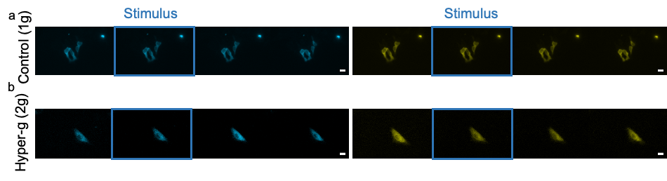
Figure S4: β-adrenergic activation measured by live FRET microscopy of H9c2 transfected the EPAC-SH187 sensor and exposed to 1g or 2g conditions in the Hyperscope. a) representative donor (mTurquoise2, left)and FRET (mVenus, right) signals from n=5 experiments where H9c2 cells were stimulated at the indicated time with 1 µM isoproterenol in 1 g conditions. a) representative donor (left)and FRET (right) signals from n=2 experiments where H9c2 cells were stimulated at the indicated time with 1 µM isoproterenol in 2 g conditions. Each time sequence contains a snapshot stimulus, shortly after (rising phase), at peak response, and after peak. Scale bar is 20 µm. Scale bar is 20 µm throughout.

Figure S5: β-adrenergic activation in retinoic-acid treated H9c2 cells under hyper-g. (a) Representative image series at different time points before stimulus, shortly after (rising phase), at peak, and after peak. Frames indicate the first change in channels fluorescence. Scale bar is 20 µm. (b) Averaged traces represent 2g (green, n=2 experiment, 6 cells) via FRET readout with the EPAC-S^{H187} sensor after 1 µM stimulation with Isoproterenol. Error bands represent sem.

Figure S6: mosaic of HEK293 cells transfected with lifeact-EGFP and exposed to control gravity conditions or simulated microgravity for 24h. Representative images (24 per condition) from two experimental sessions conducted at the Ground Based Facility (GBF).

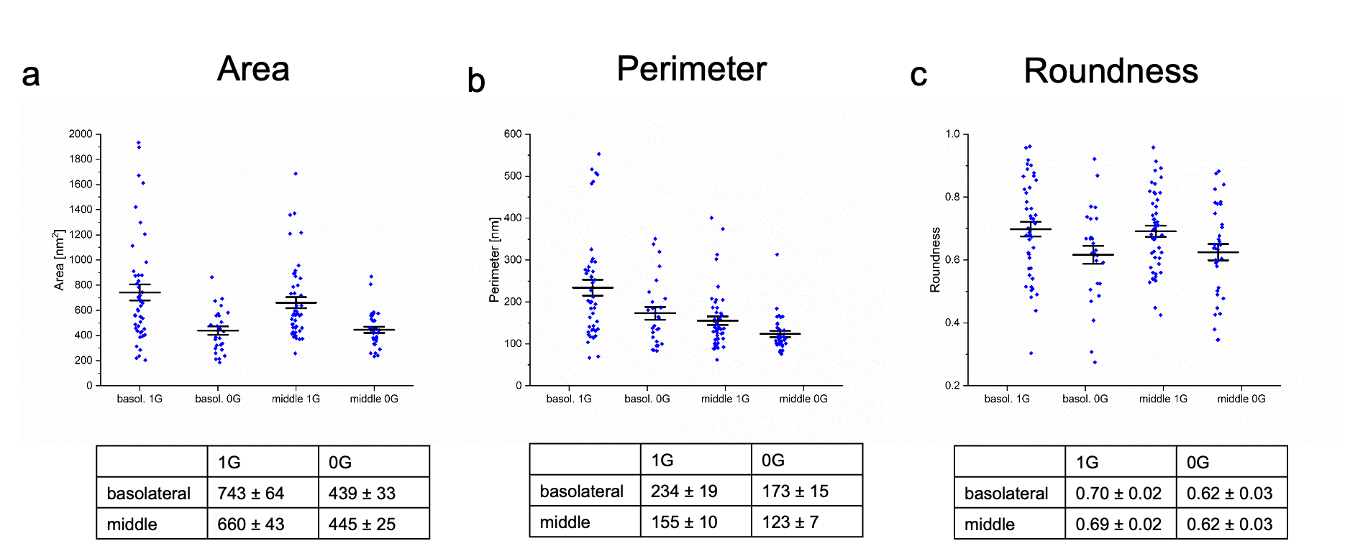
Figure S7: Qualitative morphological changes at HEK293 cells transfected with lifeact-EGFP and exposed to control gravity conditions or simulated microgravity for 24h. Displayed value indicate a) cell area within the confocal section, either at the basolateral membrane or at an intermediate perinuclear section; b) cell perimeter within the confocal section, either at the basolateral membrane or at an intermediate perinuclear section and c) overall cell roundness observed at the confocal section, either at the basolateral membrane or at an intermediate perinuclear section. Number of images acquired for basolateral µg: 27, 1g: 45; for middle µg: 34, 1g 48. The data originate from two experimental sessions conducted at the GBF.

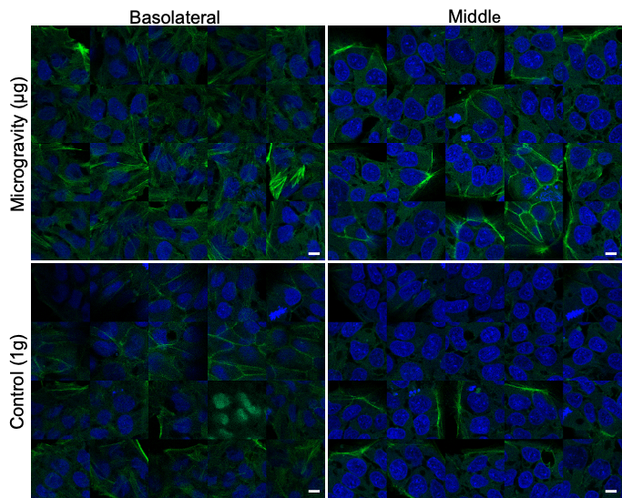
Figure S8: mosaic of hiPSCs cells expressing endogenously tagged EGFP-actin and exposed to control gravity conditions or simulated microgravity for 24h. Basolateral and perinuclear refer to the position where the images were taken in the confocal z-stack. Number of images acquired for each condition is 20. The data originate from one experimental session conducted at the GBF.

Figure S9: Effect of 24h hypergravity on cAMP production in HEK293 cells expressing the melanocortin 4 receptor (MC4R). The MC4R is a Gs-coupled a receptor involved in appetite regulation, upon stimulation with the agonist ⍺MSH. Here, concentration-response curve of FRET ratio to ⍺MSH stimulus does not highlight any significant difference between 2g and 1g control (n=1 biological replicate). FRET ratios are not normalised here, e.g. FRET ratio decreases as more cAMP is present.
Figure S10: Effect of 24h hypergravity on cAMP production in HEK293 cells upon stimulation with salbutamol. Effect of 24h hypergravity (2g) on cAMP production in response to increasing concentration of Salbutamol, conducted in HEK293 cells transfected with Epac-S^{H187} biosensor. EC₅₀^{control}=74 nM (logEC50 95%CI[-7.4 to -6.8]), EC₅₀^{2g}=34 nM (logEC50 95%CI[-7.6 to -7.4]) (n=2).

 | $τ$ [s] |  | 95% confidence interval from fit |  | calculated standard error
 |  |  | lower | upper
HEK 2g (Figure 2) | 9.671 |  | 8.869 | 10.47 | 0.41
H9c2 2g (Figure 4) | 30.42 |  | 24.74 | 36.11 | 2.79
H9c2 retinoic 2g (Figure S5) | 3.294 |  | 2.385 | 4.203 | 0.45
HEK 1g (Figure 2) | 156.9 |  | 144.1 | 169.7 | 6.49
H9c2 1g (Figure 4) | 21.44 |  | 20.01 | 22.88 | 0.72

Supplementary Table 1: result of the fit of kinetic cAMP accumulation traces in Figures 2,4 and S5 and associated confidence intervals for the time constant 𝛕.

