Supplementary Figures:
Supplementary Figure 1. Domain sequence alignment of ACD homologues.
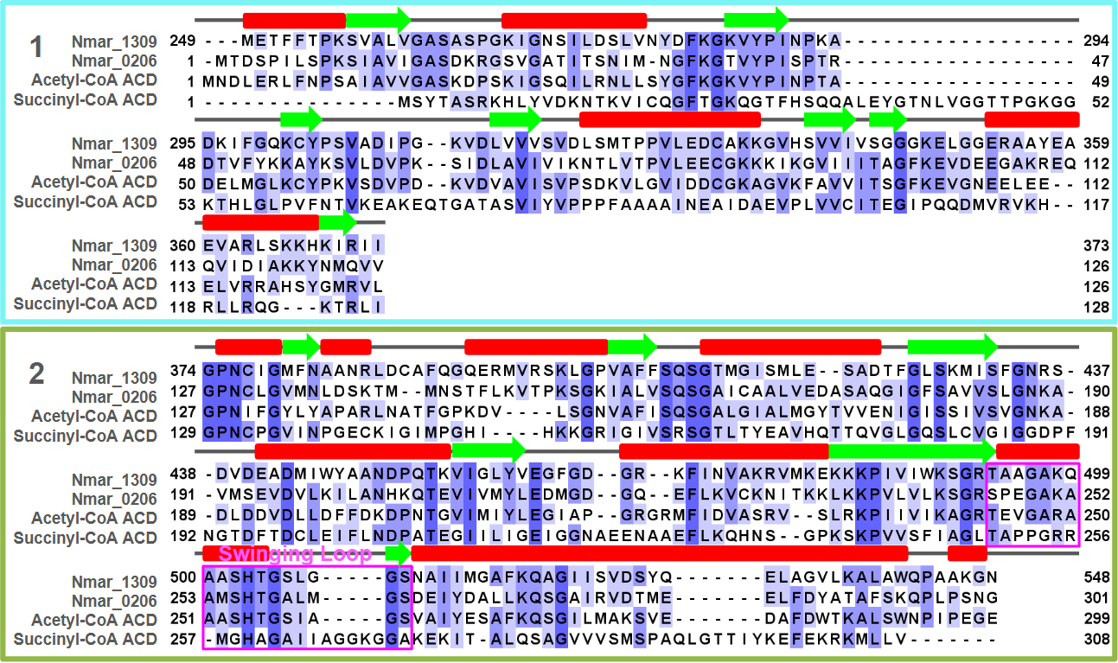
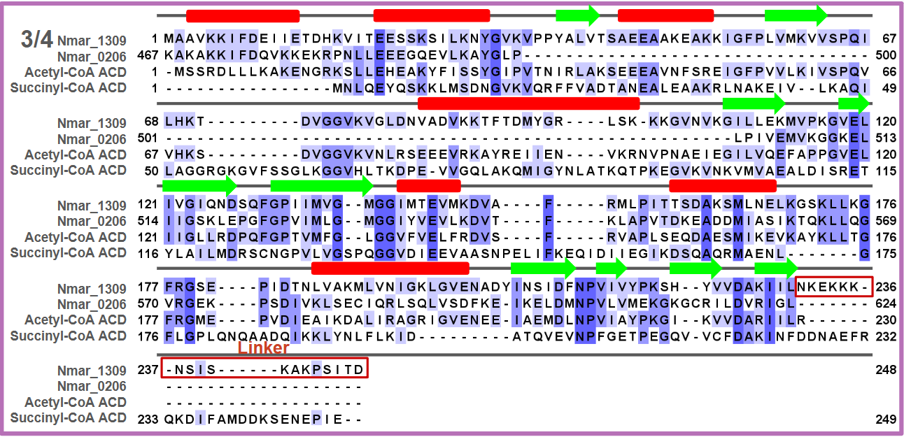
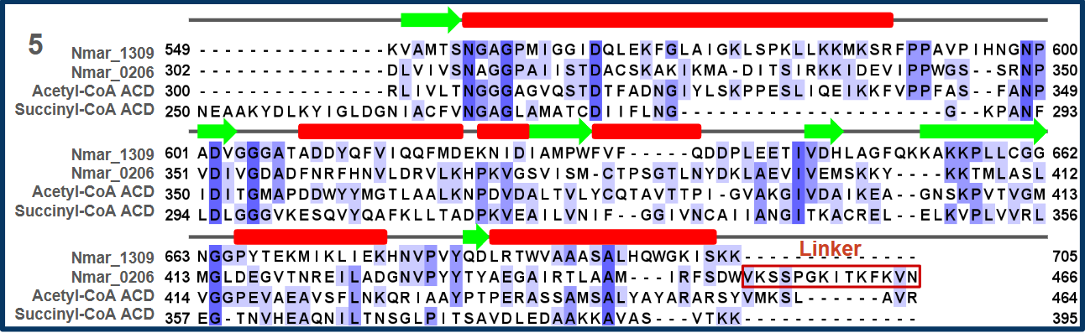
Multiple sequence alignments for subdomains 1-5, showing residue and secondary structure conservation with beta-sheets indicated by green arrows and alpha-helices indicated with red bars.

Supplementary Figure 2. Electron density, residues and interactions of linker loop.
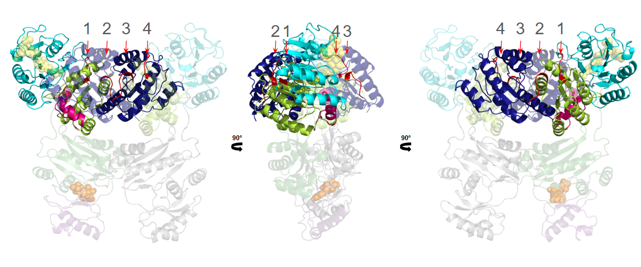
Numbers 1 and 2 indicate connections between subdomains 1-2 and 2-5 on Chain A. Chain B, shown transparent in the figure, contains these same connections labeled numbers 4 and 3.

Supplementary Figure 3. TOPS diagram of Nmar_1309.
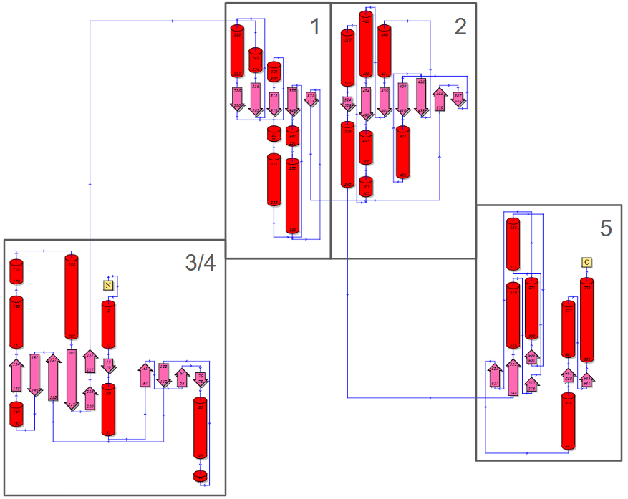
The TOPS diagram of Nmar_1309 shows the internal organization of the individual domains.

Supplementary Figure 4. Interactions of the linker region with subdomains I, II, and IV.
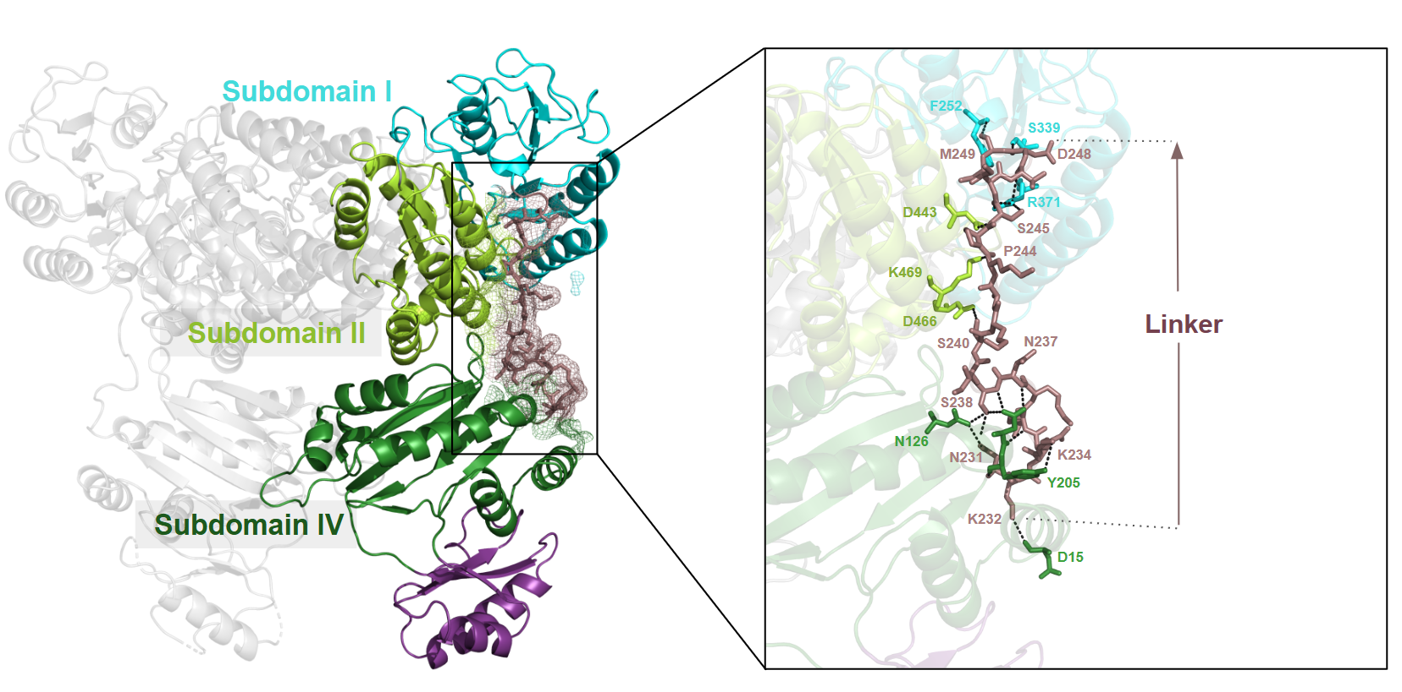
Subdomain I (teal), Subdomain II (lemon), and Subdomain IV (forest), along with the linker region (dirty violet) are shown in Chain A. The residues involved in interactions between the subdomains and the linker region are highlighted.

Supplementary Figure 5. Bound ADPNP and Magnesium and their interactions within the ATP binding domain
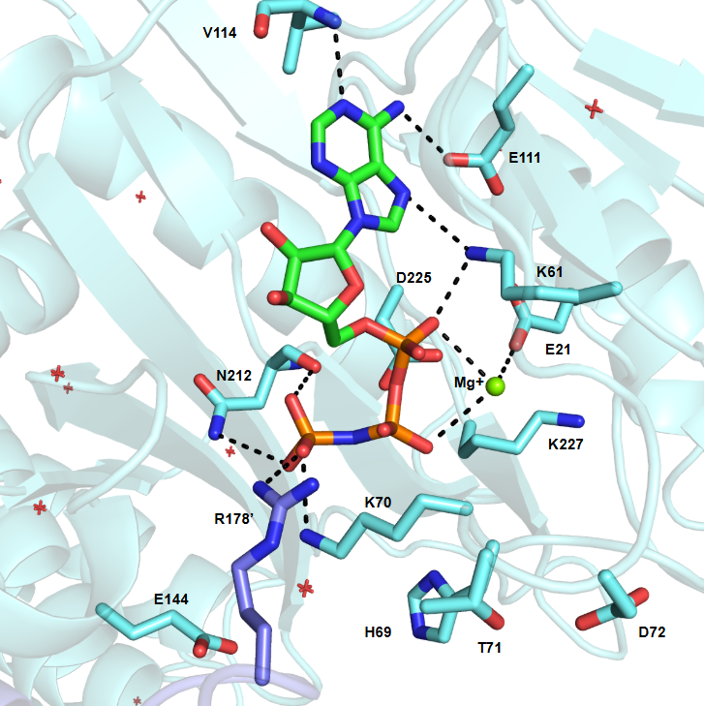
ADPNP with a bound Magnesium ion can be found bound to the ATP binding site of chain A. While the interaction between the gamma phosphate of ADPNP and R178’ is consistent with the expected reaction mechanism (see Fig. 6 panel 1), other interactions are either missing (in the case of interactions between ADPNP and D225 and T71, H69 and D72) or interact differently than expected (K70 and its interaction with the gamma phosphate of ADPNP instead of the bridging oxygen between the alpha and beta phosphates). Additionally, interactions can be seen below the adenyl head include that of K61, E21 and N212. Interactions with the adenyl head (V114, E111 and K61) likely do not play a role in catalysis of the reaction itself, instead stabilizing the structure of ADPNP itself.

Supplementary Figure 6. Calculating the rotation of ADP-grasping domain.
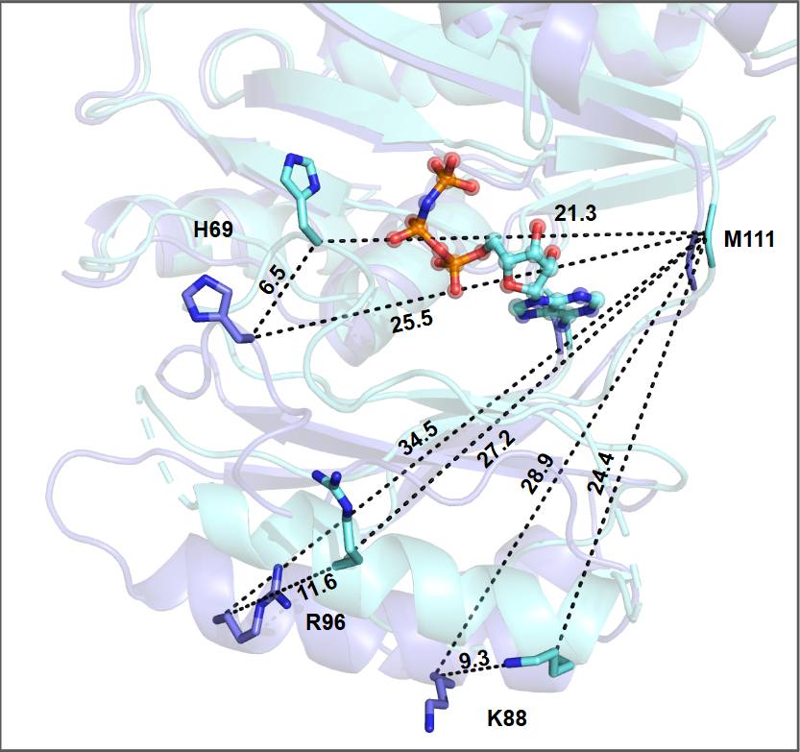
The distances used to calculate ATP-grasping rotation upon ADPNP binding are shown. With M111 used as a reference, the average translation of residues H69, K88 and R96 were used to calculate that angle with respect to M111. These were averaged to achieve a rotation of 15.6°.

Supplementary Figure 7. Occupancies of oppositely oriented 3-hydroxypropionate in a low resolution electron density.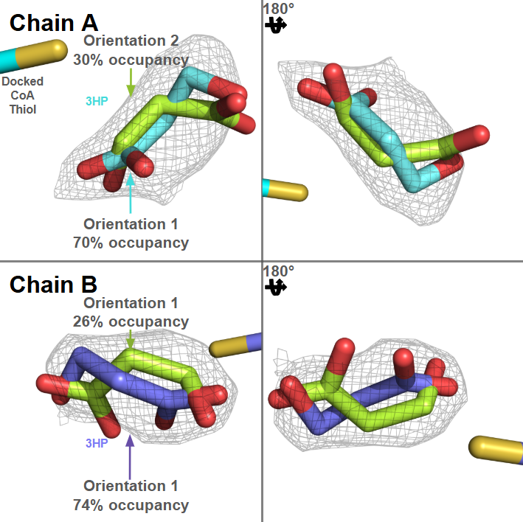
Electron density and occupancy of the two possible orientations of 3HP from chain A and B. The dominant orientation seems to mirror other bound ligands in homologues. This orientation was used for the final figure generation. The thiol tail of Coenzyme-A from PDB-ID 4YAK is shown for orientation.
Supplementary Figure 8. Active site comparisons of ACD homologous structures.
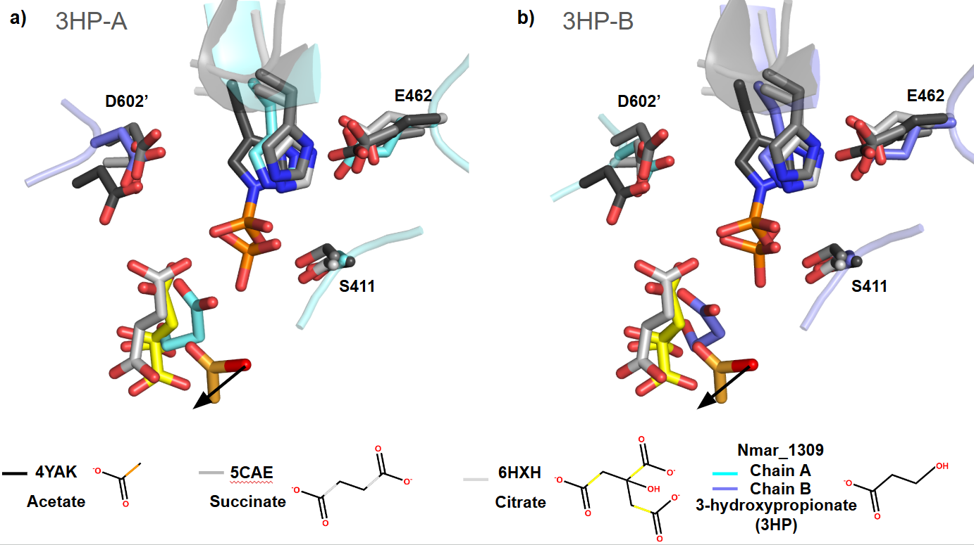
Dominant 3HP occupancy orientations for 3HP within chains A and B can be seen here relative to AC-S, SCS and ATP Citrate Lyase bound ligands and their surrounding residues. The black arrows indicate the direction Coenzyme-A passes from the active site. The shown phosphates are those bound to this Nmar_1309 structure. All homologous ligands are bound to their respective structure with the exception of the acetate, which is found bound to the thiol tail of Coenzyme-A in the pdb structure 4YAK.

