Supporting Information

For

Conservation and specificity in Bacillus biofilm dynamics: on structure and function of B. cereus Camelysins

Anne Diehl, Florian Lindemann, Nils Cremer, Yvette Roske, Matthias Herrera-Glomm, Barth van Rossum, Martina Leidert, Kürşad Turgay, Hartmut Oschkinat

Corresponding author: Hartmut Oschkinat
Email: oschkinat@fmp-berlin.de

This PDF file includes:

A Supporting Text
B Figures S1 to S15
C Tables S1 to S3

A Supporting Text
Protease Assays
The ability to cleave azo-casein was investigated at room temperature for five days. Even though this is an unusually long time for an enzyme, no activity was detected for different CalY1 fusion proteins made for the purpose of purification (Figure S3), indicated by the colorless appearance of the samples. In the contrary, with trypsin as positive control an intense orange color as a sign for the liberation of the azo-dye is obtained (Figure S3). The assay was also performed in the presence of Ca, Cd, Cu, Fe, Mn, Mg, Ni and Zn ions, with negative result. Similar results were obtained for CalY2.
Furthermore, the possible degradation of casein by CalY1-II and CalY2 was monitored via 15 % SDS-PAGE, directly after mixing the components (Figure S4A) and after incubation for 24 h (Figure S4B). The effect of Proteinase K as positive control may be appreciated from a comparison of lanes 1 and 2 in Figures S4A and B. Strongly reduced intensities of casein bands (lanes 1) are observed directly after adding Proteinase K. After 24 h, no bands are detected anymore in lanes 2. In contrast, neither the Camelysins nor TasA show any proteolytic activity after 24 h, as evident when comparing lanes 3, 4, and 5 in Figures S4A and B, respectively. The degradation products from the same samples were also characterized by LC/MS (Figures S4C-E). Casein alone (Figure S5A) showed three characteristic peaks at 23984, 20523 and 11824 Dalton. In the presence of CalY1-II or CalY2 large peaks corresponding to their own molecular weight and to the casein-specific species persist (Figures 4C and D). With Proteinase K (Figure S4E), degradation products appear over a broad molecular weight range with a main peak at 5561 Dalton. Notably, no protease activity was found for TasA (Figure S5B).
With milk powder in an LB agar plate, protease activity in MOLP medium from biofilm formation experiments (21 h) was detected by halo-formation, a differentiated zone surrounding the central sample application position (Figure S6). MOLP medium alone (A1) is free of any protease activity. Protease K (K) shows a halo-ring. As expected, B. subtilis WT secretes proteases into the medium and a distinct protease activity (C1) can be detected as halo. The same size of halo was found for medium from a $∆$tasA strain, indicating no additional proteolytic contribution by TasA. In C3 to C6 and A4 no extension of the halo could be detected, indicating that the addition of TasA, CalY1 or CalY2 does not increase the proteolytic activity.

Material and Methods

Protease activity testing.
Azocasein as substrate. Azocasein (A2765 Sigma-Aldrich) was used according to the instruction of Sigma SSAZOC03, but the applied quantity reduced to 0,1 ml setups instead of 5 ml. Briefly, the reaction in 20 mM phosphate buffer pH 7,0 150 mM NaCl was stopped after 5 days at room temperature with trichloroacetic acid and neutralized with NaOH. The appearance of orange azo dye stands for protease activity and can be measured at 440 nm. Trypsin (Fluka 93630) was used as positive control.
Casein as substrate: The stock solution of Casein (50 mg/ml) was transferred into 100 mM Tris and adjusted to pH 7,5 with HCl. Protease activity was tested in 20 mM Tris HCl buffer, pH 7,0, 150 mM NaCl, 100 µM ZnCl₂, and10 mg/ml (about 400 µM) Casein at 37 °C over 24 h. The solution of the positive control Proteinase K (Invitrogen 52895) with a final concentration of 2,5 µg/ml (about 0,1 µM) contained additionally 5 mM CaCl₂. CalY`s and TasA were applied at a concentration of 10 µM. Samples were analysed by SDS-PAGE and LC/MS.
Milk powder as substrate: 2 % milk powder was dissolved in liquid LB agar. 20µl of sample were applied. Proteinase K as positive control (Invitrogen 52895 1:10 diluted) and medium from biofilm experiments were checked for halo formation as hint for protease activity over 21 h at 30 °C.

B Figures

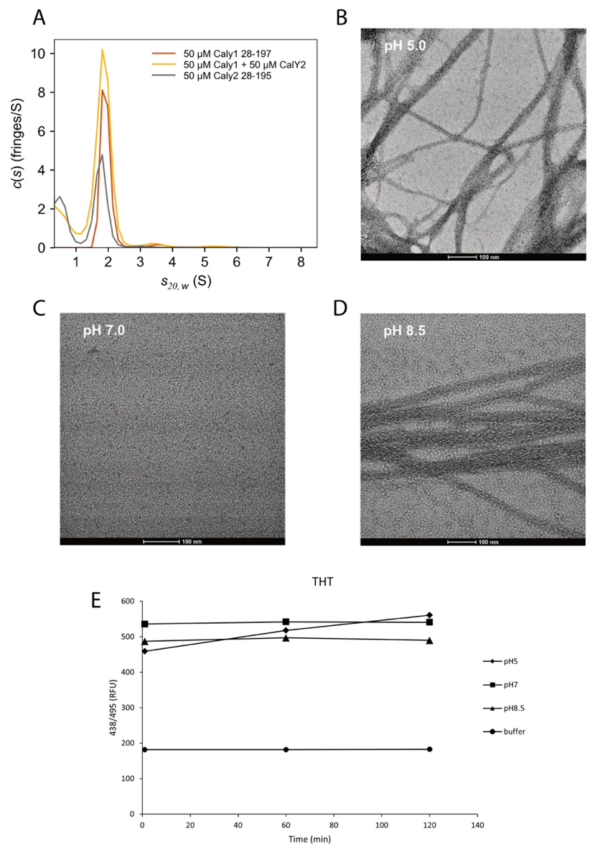
Figure S1. (A) Analytical ultracentrifugation of 50 µM CalY2 (grey), CalY1 (red), and both together (yellow), at 300 mM NaCl, showing solely the presence of monomers except for the polydisperse CalY1. (B-D) Generation of filaments from CalY1 solutions at pH values of 5.0, 8.0, 8.5, respectively. (E) Intensity of Thioflavin T response of the three samples.

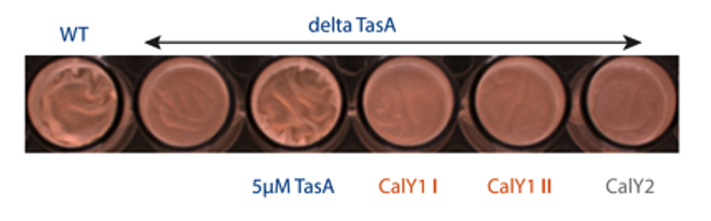
Figure S2. Rescue experiments with B. subtilis $∆$tasA and TasA, CalY1 I & II, Caly2. WT shows typical biofilm with wrinkled surface. $∆$tasA biofilm is compromised, which can be rescued by 5µM TasA but not with any variant of CalY at that concentration.

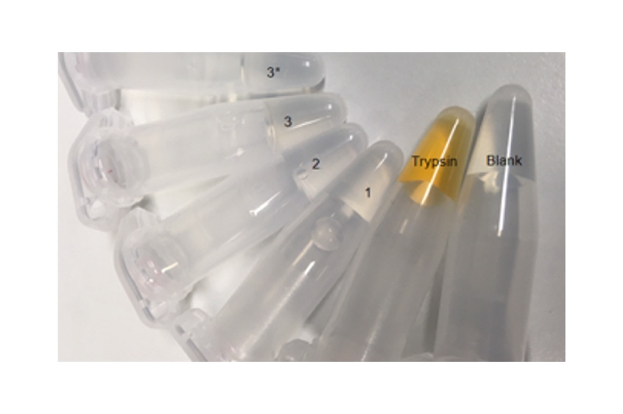
Figure S3. Check for protease activity with Azocasein as substrate for different CalY1 fusions. 1, His_Sumo_CalY1; 2, His_Sumo_TEV_EK_CalY1; 3, His_Sumo_CalY1_3C_GFP; 3+, 1 mM ZnCl2 in comparison to trypsin as positive control. The orange color demonstrating protease activity, as the azo-dye is liberated from the substrate, is observed solely for trypsin.
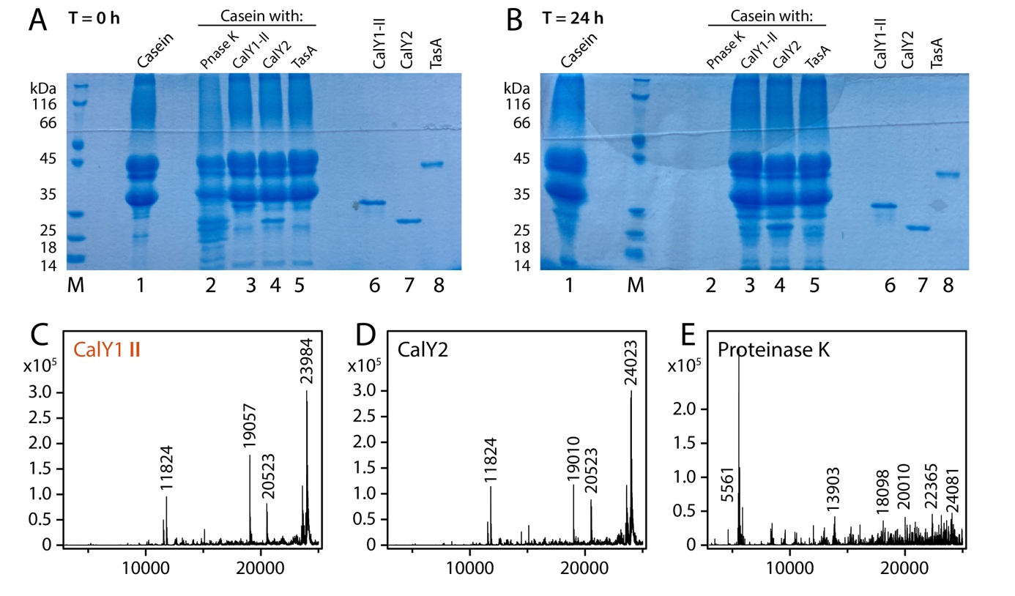
Figure S4. (A) and (B). Protease activity checked at 37 °C with Casein as substrate and analyzed by SDS-PAGE at t₀ and after 24 h, respectively. M marker proteins, lane 1 control Casein, 2 Casein with Proteinase K, 3 Casein with CalY1-II, 4 Casein with CalY2, 5 Casein with TasA, 6 control CalY1-II, 7 control CalY2, 8 Control TasA. (C-E) Protease activity of CalY1-II, CalY2 and Proteinase K, respectively, checked with Casein as substrate and analyzed by mass spectrometry. The peaks at 11824, 20523, and 23984 are due to casein. In (C) and (D) the peaks at 23984 and 24023, respectively, represent two components of a convolute of peaks that vary in size.
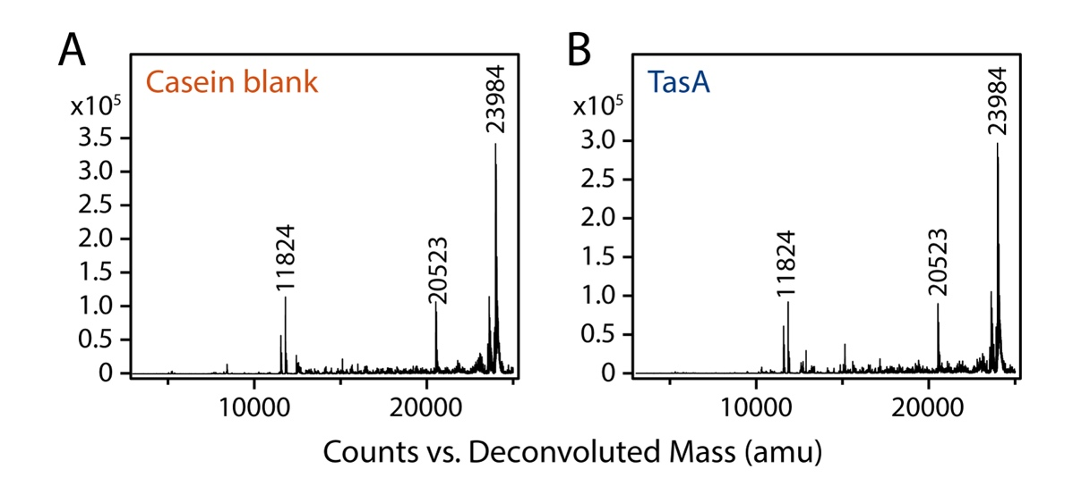
Figure S5. Protease activity checked with Casein as substrate and analyzed by mass spectrometry. (A) Casein control mass spectrum. (B) TasA submitted to the Casein solution and analyzed by mass spectrometry. No protease activity found. The peaks at 11824, 20523, and 23984 are due to casein.
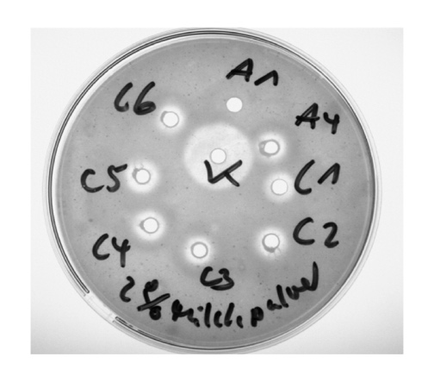
Figure S6. LB Agar with 2% milk powder was used to check used medium from different biofilm experiments for protease activity A1 MOLP medium A4 ∆tasA + CalY1 I C1 WT C2 ∆tasA C3 ∆tasA + TasA C4 ∆tasA + CalY1 II C5 ∆tasA + CalY2 C6 ∆tasA + CalY1II + CalY2 K positive control Proteinase K (Invitrogen 52895) 30 °C 21 h 20 mM phosphate buffer pH 7,0 150 mM NaCl.
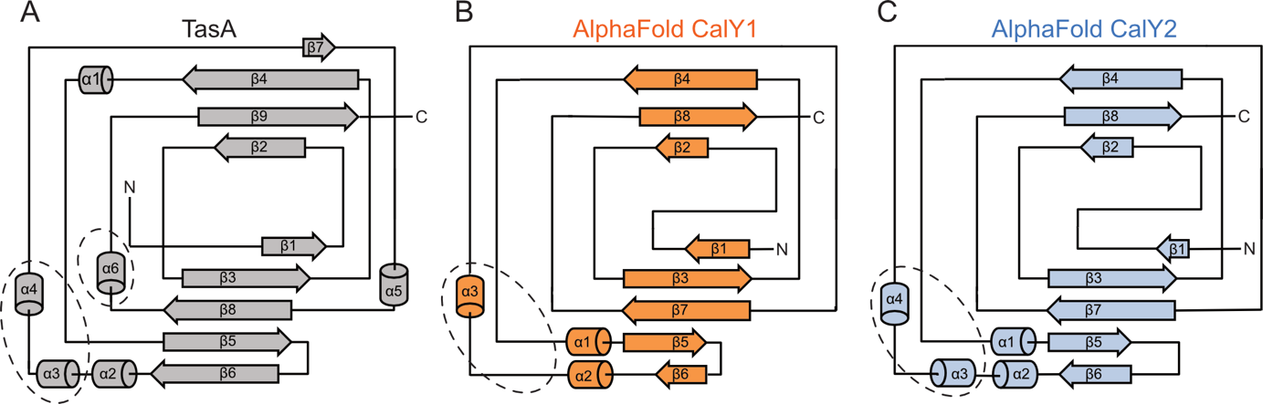

Figure S7. Secondary structure of TasA according to its X-ray structure (A), CalY1 AlphaFold prediction (B) and CalY2 AlphaFold prediction (C). Note the different numbering of helices and strands in A vs. B and C. Areas with differences between TasA and the Camelysines are indicated by ellipsoids (see text).
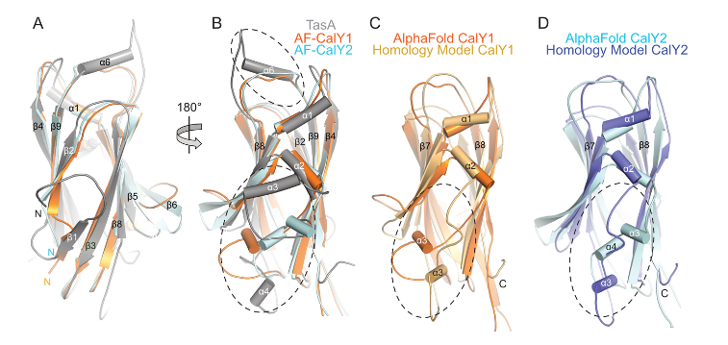
Figure S8. Structures of TasA, CalY1, and CalY2 superimposed in (A), with the first strands in front. (B) View from the side with the helices. (C) Superposition of CalY1 AlphaFold 2 and homology models. (D) Superposition of CalY2 AlphaFold 2 and homology models.
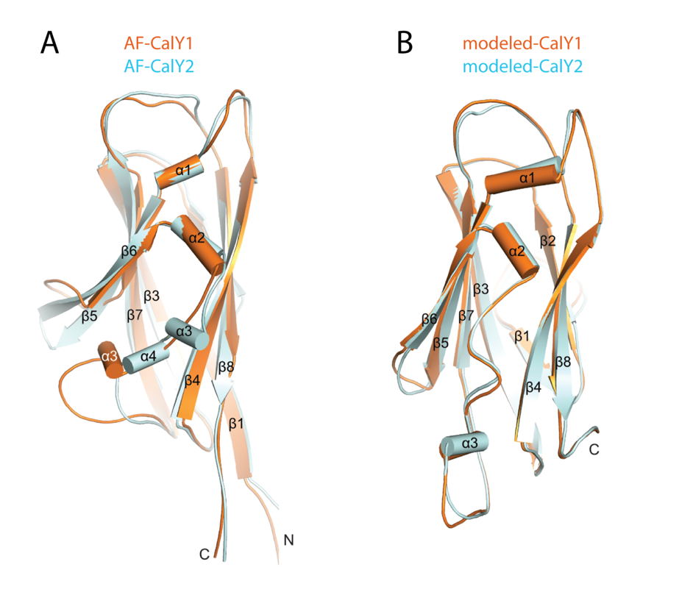
Figure S9. Overlay of CalY1 and CalY2 structures predicted by AlphaFold 2 (A) and modelled on the basis of the TasA X-ray structure (B).
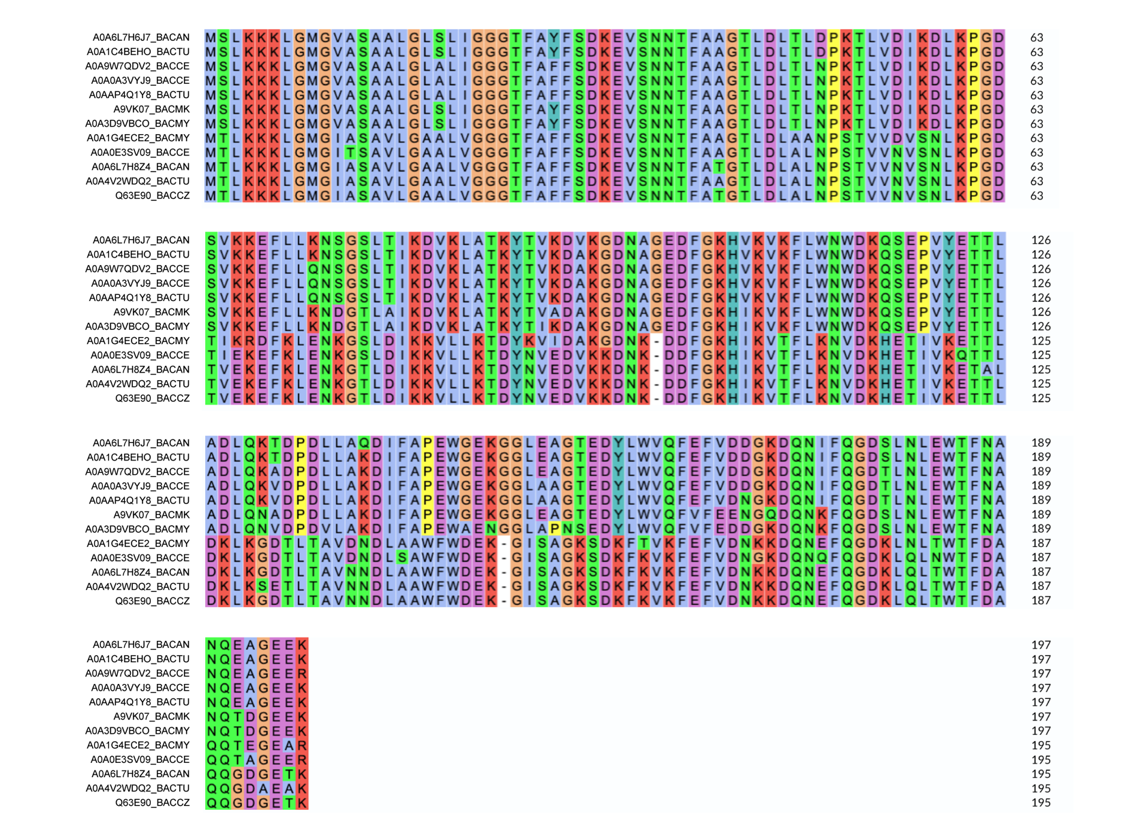

Figure S10. Alignment of B. cereus group CalY1 (top 7) and CalY2 (bottom 5) sequences.
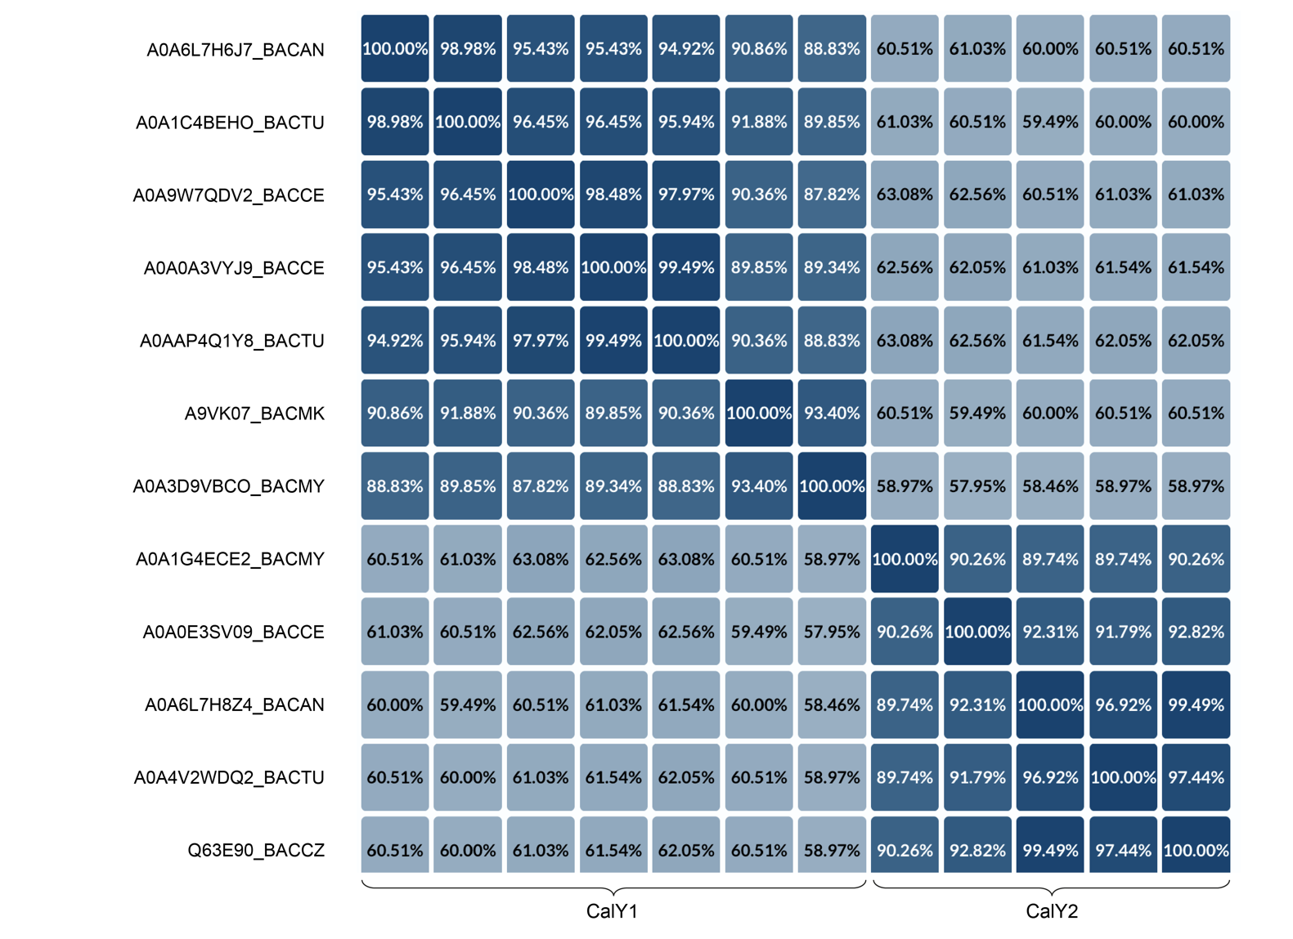

Figure S11. Differences between the sequences shown in the alignment of B. cereus group CalY1 and CalY2 proteins.
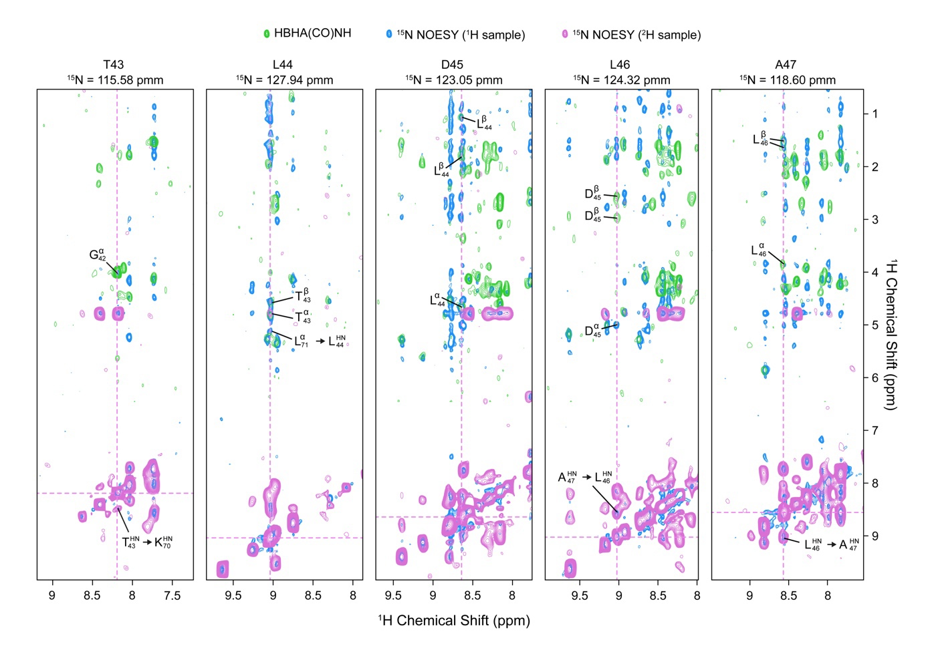
Figure S12. Slices from 3D ¹⁵N-¹H-¹H NOESY NMR spectra of ²H, ¹³C, ¹⁵N labelled (pink) and ¹³C, ¹⁵N labelled CalY2 (blue). Green cross peaks are due to a 3D HaHb(CO)NH spectrum. The Ha_{i} and Hb_{i} signals occur in the slice of residue i+1 and are indicated there. Interactions demonstrating the parallel arrangement of β1-β3 are also indicated. The dotted lines indicate the H_{N} chemical shift of a given residue.
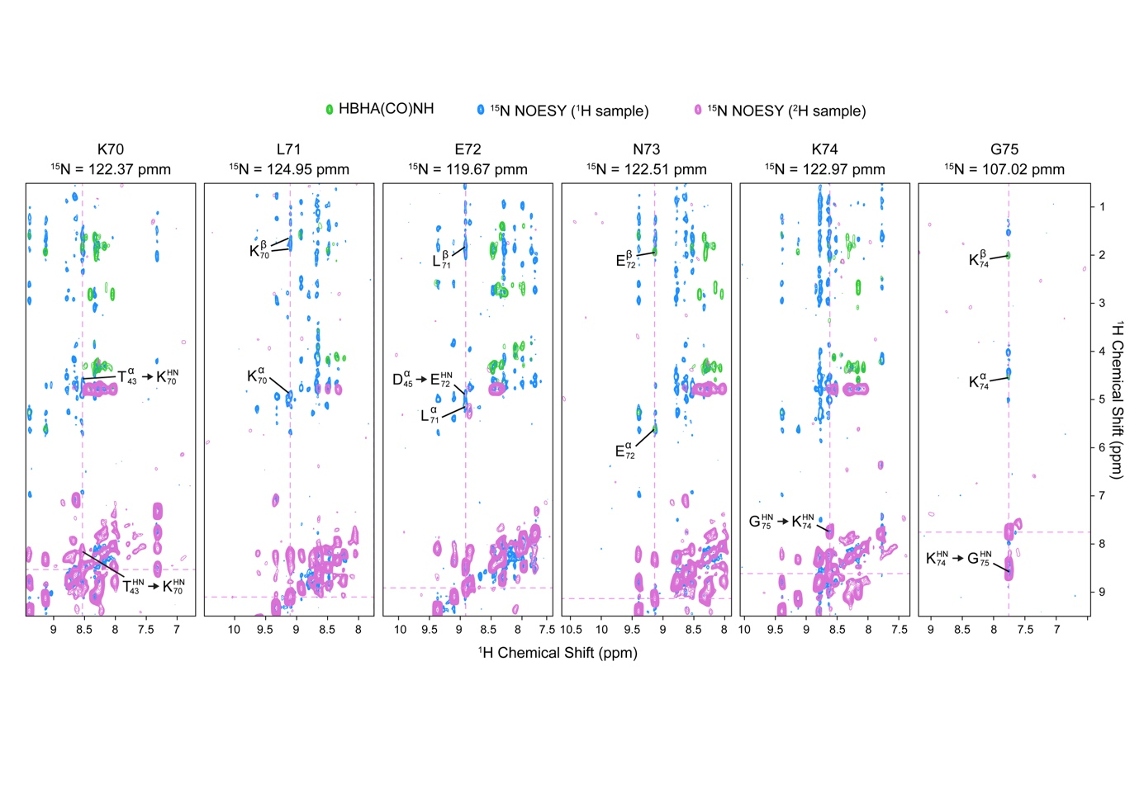
Figure S13. Slices from 3D ¹⁵N-¹H-¹H NOESY NMR spectra of ²H, ¹³C, ¹⁵N labelled (pink) and ¹³C, ¹⁵N labelled CalY2 (blue). Green cross peaks are due to a 3D HaHb(CO)NH spectrum. The Ha_{i} and Hb_{i} signals occur in the slice of residue i+1 and are indicated there. Interactions demonstrating the parallel arrangement of β1-β3 are also indicated. The dotted lines indicate the H_{N} chemical shift of a given residue.
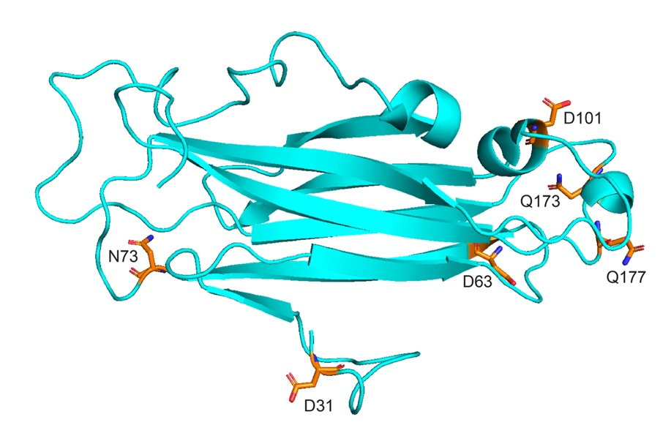
Figure S14. Model of CalY2 with residues proposed to form a metalloprotease active site by MEROPS (D31, D63, N73, D101, Q173 and Q177) highlighted in orange. It is obvious, that no catalytic center can be formed, as the distances are too large.
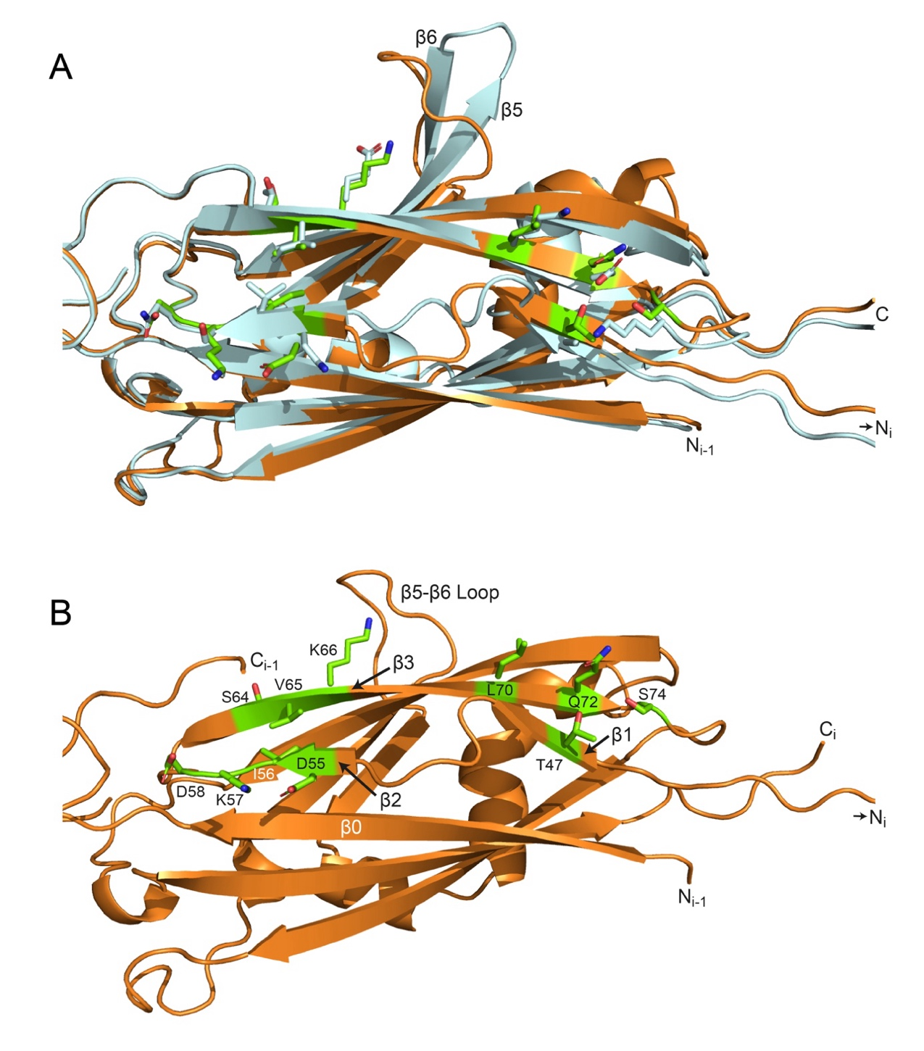
Figure S15. (A) Superposition of one protomer in the AlphaFold filament models of CalY2 (light blue) and CalY1 (orange). Residues of CalY1 that are not conserved in β1 - β2 - β3 between both proteins are shown in green. (B) Same as in A, but without the superposition of CalY2.
D Tables
Table S1. Chemical Shifts of CalY2 (42-189) in solution obtained by automated assignment with NMRtist and manually checked.
Res.Nr. | AA | H | N | CA | CB | C´ | HA_{x} |  | HA_{y} | HB_{x} | HB_{y}
42 | GLY |  |  | 45.571 |  | 174.346 | 4.005
43 | THR | 8.181 | 115.574 | 62.288 | 69.961 | 174.199
44 | LEU | 9.034 | 127.936 | 53.817 | 43.477 | 174.359 |  |  |  |  | 1.074
45 | ASP | 8.640 | 123.054 | 52.522 | 40.529 | 177.596 | 5.009 |  |  | 2.575 | 2.965
46 | LEU | 9.029 | 124.322 | 56.737 | 43.772 | 177.551 | 3.856 |  |  |  | 1.603
47 | ALA | 8.567 | 118.595 | 54.241 | 18.358 | 178.333 | 4.131 |  |  | 1.537
48 | LEU | 7.729 | 115.568 | 54.124 | 42.046 | 177.359 | 4.471 |  |  |  | 1.787
49 | ASN | 8.038 | 115.740 | 54.326 | 38.036
50 | PRO |  |  | 63.550 | 33.679 | 175.563 |  |  |  | 2.172 | 2.326
51 | SER | 8.341 | 112.706 | 56.715 | 66.665 | 173.526 | 5.977 |  |  | 3.845 | 4.019
52 | THR | 9.529 | 117.515 | 60.774 | 71.017 | 174.910 | 4.928 |  |  | 4.226
53 | VAL | 8.055 | 125.942 | 60.664 | 34.267 | 176.242 | 5.278 |  |  | 1.955
54 | VAL | 9.057 | 127.987 | 60.703 | 34.111 | 174.271 | 4.249 |  |  | 1.561
55 | ASN | 8.859 | 126.606 | 53.044 | 39.694 | 174.644 | 5.101 |  |  | 1.961 | 2.754
56 | VAL | 8.609 | 124.188 | 61.139 | 32.417 | 174.412 | 4.133 |  |  | 1.954
57 | SER | 7.974 | 118.204 | 58.565 | 64.745 | 173.004 | 3.850 |  |  | 3.850 | 4.122
58 | ASN | 8.751 | 117.228 | 54.160 | 37.873 | 174.056 | 4.475 |  |  | 2.985 | 2.986
59 | LEU | 8.157 | 120.945 | 55.019 | 43.478 | 175.671 | 4.470 |  |  |  | 1.753
60 | LYS | 8.640 | 125.343 | 44.311 | 31.803
61 | PRO |  |  | 64.645 | 31.301 | 177.281 | 3.880 |  |  | 2.094
62 | GLY | 9.104 | 114.788 | 45.422 |  | 174.493
63 | ASP | 8.340 | 122.029 | 54.446 | 43.070 | 176.047 | 4.476 |  |  | 2.821 | 3.084
64 | THR | 8.419 | 112.211 | 60.977 | 72.137 |  |  |  |  | 4.017
65 | ILE | 8.783 | 123.125 | 60.549 | 42.028 | 174.187 |  |  |  | 1.857
66 | GLU | 8.867 | 126.104 | 56.782 |  | 176.764 |  |  |  |  | 1.930
67 | LYS | 8.297 | 121.673 | 54.657 | 32.907
68 | GLU |  |  | 54.953 | 33.147 | 176.764
69 | PHE | 8.535 | 122.095 | 56.958 | 42.747 | 173.461 | 4.908 |  |  | 2.339
70 | LYS | 8.531 | 122.372 | 55.339 | 34.581 | 174.525 | 4.908 |  |  |  | 1.929
71 | LEU | 9.097 | 124.945 | 52.930 | 44.199 | 175.398 | 5.121 |  |  |  | 1.754
72 | GLU | 8.923 | 119.666 | 54.584 | 33.490 | 175.663 | 5.613 |  |  | 1.309
73 | ASN | 9.128 | 122.514 | 50.899 | 38.509 | 174.867 | 5.295 |  |  | 2.104 | 3.369
74 | LYS | 8.620 | 122.972 | 55.843 | 30.744 | 177.545 | 5.017 |  |  |  | 2.007
75 | GLY | 7.763 | 107.024 | 44.433 |  | 172.973 | 4.027 | 4.432
76 | SER | 8.388 | 110.606 | 58.764 | 64.156 | 174.383 | 4.423
77 | LEU | 7.609 | 121.248 | 53.063 | 44.293 | 176.970 | 4.768 |  |  | 1.582 | 1.599
78 | ASP | 8.938 | 124.668 | 55.261 | 40.102 | 175.136 | 4.184 |  |  | 2.499 | 2.665
79 | ILE | 7.778 | 123.220 | 60.936 | 39.849 | 175.151 | 4.095 |  |  | 1.639
80 | LYS | 8.565 | 126.852 | 57.473 | 33.971 | 175.920 | 4.231 |  |  |  | 1.793
81 | LYS | 7.833 | 118.585 | 55.074 | 36.107 | 174.703 |  |  |  | 1.547 | 1.548
82 | VAL | 8.190 | 121.756 | 61.430 | 34.690 | 173.009 | 4.398 |  |  | 1.895
83 | LEU | 8.745 | 126.608 | 53.127 | 42.050 | 175.431 |  |  |  | 1.298 | 1.298
84 | LEU | 8.361 | 124.380 | 53.333 | 43.621 | 176.235 | 4.371 |  |  | 1.353 | 1.762
85 | LYS | 9.126 | 130.734 |  | 33.066
86 | THR
87 | ASP
88 | TYR |  |  | 57.826 | 38.899 | 175.386 | 4.559
89 | ASN | 8.440 | 121.199 |  | 38.674 | 172.627 |  |  |  |  | 2.737
90 | VAL | 7.796 | 119.846 | 62.603 | 32.777 | 176.259
91 | GLU | 8.352 | 124.707 | 56.530 | 30.419
92 | ASP
93 | VAL
94 | LYS |  |  | 56.675 | 33.118 | 175.473
95 | LYS | 8.353 | 121.436 | 57.789 | 30.578 | 175.701 | 4.017 |  |  |  | 1.970
96 | ASP | 8.028 | 117.770 | 54.699 | 40.965 | 176.056 | 4.322 |  |  | 2.719
97 | ASN | 8.324 | 117.926 | 53.425 | 38.931 | 175.262 | 4.766 |  |  |  | 2.890
98 | LYS | 8.401 | 122.112 | 56.587 | 33.027 | 176.542 | 4.307 |  |  |  | 1.814
99 | ASP | 8.095 | 121.768 |  | 41.233
100 | ASP |  | 117.945 | 56.898 | 41.004 | 173.291
101 | PHE | 8.967 | 117.945 | 52.746 | 41.231 | 177.734 |  |  |  | 2.841
102 | GLY | 8.534 | 103.536 | 47.061 |  | 175.273 | 3.244
103 | LYS | 7.503 | 117.800 | 57.945 | 32.699 | 177.106
104 | HIS | 7.750 | 113.825 | 55.318 | 29.245 | 172.420 | 4.455 |  |  | 2.791
105 | ILE | 7.093 | 119.708 | 58.099 | 37.160 | 174.384 | 5.278 |  |  | 1.820
106 | LYS | 9.280 | 129.682 | 55.732 | 34.493 | 175.231 | 4.566 |  |  |  | 1.744
107 | VAL | 9.023 | 127.678 | 60.415 | 34.047 | 174.295
108 | THR | 8.627 | 122.766 | 61.887 | 70.544 | 172.955
109 | PHE | 9.329 | 125.183 | 57.611 | 40.768 | 175.260 | 5.172 |  |  |  | 2.944
110 | LEU | 9.638 | 124.480 | 54.780 | 45.670 | 175.206 | 5.521 |  |  | 1.474 | 1.622
111 | LYS | 8.984 | 120.525 | 54.441 | 37.199 | 175.018 | 5.008 |  |  |  | 1.875
112 | ASN | 9.154 | 124.080 | 53.227 | 39.304 | 176.450 | 4.780 |  |  | 2.778 | 2.783
113 | VAL | 8.227 | 120.718 | 62.318 | 32.800 | 175.665 | 4.134
114 | ASP | 8.548 | 123.315 | 53.369 | 39.076 | 173.785 | 4.724 |  |  | 2.821 | 2.895
115 | LYS | 8.350 | 121.731 | 56.628 | 32.974 | 176.673 | 4.306 |  |  |  | 1.824
116 | HIS | 8.179 | 122.115
117 | GLU |  |  | 57.193 | 30.695 | 176.103 |  |  |  | 1.952 | 1.960
118 | THR | 9.033 | 121.693 | 61.375 | 71.867 | 173.048 |  |  |  | 4.035
119 | ILE | 8.795 | 126.591 | 61.422 | 38.865 | 176.317 | 4.194 |  |  | 1.922
120 | VAL | 8.492 | 124.992 | 62.580 | 32.885
121 | LYS |  |  | 55.403 | 33.001 | 173.386 | 4.147
122 | GLN | 8.760 | 127.640 | 55.093 | 32.979 | 173.800 | 5.480
123 | THR | 9.039 | 121.197 | 59.376 | 68.236 | 173.140 | 4.170
124 | THR | 8.609 | 112.515 | 59.957 | 71.302 | 174.634 | 5.680 |  |  | 4.361
125 | LEU | 8.540 | 121.902 | 58.466 | 42.463 | 178.310 | 4.069
126 | ASP | 8.490 | 116.195 | 56.999 | 40.307 | 178.670 | 4.388 |  |  | 2.519 | 2.519
127 | LYS | 7.331 | 121.967 | 58.162 | 31.946 | 178.571 | 4.213 |  |  |  | 2.025
128 | LEU | 7.756 | 119.058 | 55.305 | 42.374 | 176.943 | 4.354
129 | LYS | 8.278 | 121.512 | 56.856 | 32.841 | 177.209 | 4.321
130 | GLY | 8.483 | 109.684 | 45.454 |  | 174.216 | 4.015 | 4.316
131 | ASP | 8.195 | 120.706 | 54.646 | 41.583 | 176.622 | 4.708 |  |  | 2.724
132 | THR | 8.157 | 114.169 | 64.003 |  | 174.752 | 4.443
133 | LEU | 8.288 | 123.738 | 57.156 | 42.480 | 178.441 | 4.777 |  |  | 1.671 | 1.671
134 | THR | 7.803 | 109.803 | 61.608 | 69.713 | 173.799 | 4.381 |  |  | 4.376
135 | ALA | 7.936 | 123.936 | 52.954 | 17.696 | 176.715 | 4.752 |  |  | 1.429
136 | VAL | 8.308 | 120.123 | 62.480 | 32.683 | 176.281 | 4.175
137 | ASP
138 | ASN
139 | ASP
140 | LEU |  |  | 56.865 | 42.053 | 178.248 |  |  |  | 2.346
141 | SER | 8.187 | 110.605 | 59.584 | 63.668 | 178.197
142 | ALA | 6.950 | 123.489 | 54.415 | 17.824 | 179.537 | 4.174 |  |  | 1.490
143 | TRP | 7.239 | 116.910 | 57.070 | 29.418 | 178.314 | 4.457 |  |  | 2.392 | 4.457
144 | PHE | 7.745 | 111.317 | 58.612 | 39.541 | 177.398 | 3.653 |  |  | 1.157
145 | TRP | 7.533 | 117.597 | 56.005 | 29.665 | 177.155 | 5.452 |  |  | 3.241 | 3.755
146 | ASP | 8.830 | 121.577 |  | 41.170
147 | GLU |  |  | 58.128 | 28.365 | 176.891 | 3.934 |  |  |  | 2.296
148 | LYS | 8.266 | 118.380 | 56.927 | 33.057 | 177.670 | 4.282 |  |  | 2.021 | 2.021
149 | GLY | 7.596 | 106.276 | 45.280 |  | 171.386 | 3.581 | 4.521
150 | ILE | 8.152 | 117.692 | 58.973 | 39.695 | 175.524 | 4.049
151 | SER | 8.482 | 126.194 | 59.216 |  | 173.073 |  |  |  | 3.575
152 | ALA | 8.652 | 124.931 | 54.368 | 18.388 | 178.508 | 3.716 |  |  | 1.116
153 | GLY | 8.443 | 113.112 | 46.180 |  | 174.562 | 3.819 | 4.159
154 | LYS | 7.850 | 120.095 | 54.635 | 33.543 | 174.366 | 4.641 |  |  | 1.686 | 1.927
155 | SER | 7.971 | 111.640 | 56.680 | 67.253 | 173.208 | 5.391 |  |  | 3.827 | 3.827
156 | ASP | 9.105 | 119.585 | 53.547 | 45.333 | 174.117 | 4.981 |  |  |  | 2.597
157 | LYS | 9.373 | 119.561 | 55.176 | 37.112 | 174.916 | 5.681 |  |  | 1.850 | 1.850
158 | PHE | 8.731 | 116.495 | 56.489 | 41.694 | 171.901 | 5.148 |  |  | 2.563 | 3.148
159 | LYS | 8.676 | 120.092 | 54.501 | 37.098 | 174.367 | 5.445 |  |  | 1.787 | 1.787
160 | VAL | 9.196 | 121.406 | 58.995 | 35.596 | 173.529 | 5.272
161 | LYS | 8.737 | 124.337 | 54.216 | 36.453 | 174.843 | 5.281 |  |  | 1.601 | 1.768
162 | PHE | 9.395 | 122.620 | 56.217 | 41.304 | 174.716 | 5.378 |  |  | 2.612
163 | GLU | 8.915 | 120.715 | 54.426 | 35.226 | 174.260 | 5.108 |  |  |  | 2.101
164 | PHE | 9.144 | 125.296 | 56.248 | 39.414 | 175.927 | 5.286 |  |  |  | 2.821
165 | VAL | 8.777 | 126.513 | 62.428 | 33.352 | 175.005 | 3.909
166 | ASP | 8.669 | 124.599 | 53.933 | 41.656 | 175.817 | 4.636 |  |  | 2.604 | 2.822
167 | ASN | 8.626 | 121.398 | 52.937 | 38.808 | 176.177 | 4.772 |  |  | 2.892 | 2.891
168 | GLY | 8.713 | 108.890 | 45.805 |  | 174.446 | 3.928 | 4.089
169 | LYS | 8.114 | 120.063 | 56.349 | 33.255 | 176.444 | 4.405 |  |  | 1.863 | 1.863
170 | ASP | 8.474 | 119.964 | 54.712 | 41.143 | 174.346 | 3.878 |  |  | 2.741 | 2.741
171 | GLN | 8.432 | 120.429 | 56.415 | 29.285 | 176.347 | 4.333 |  |  | 1.948 | 2.159
172 | ASN | 8.541 | 118.773 | 53.998 | 38.772 | 175.955 |  |  |  | 2.782 | 2.782
173 | GLN | 8.303 | 120.100 | 56.834 | 28.937 | 175.653 | 4.137 |  |  | 1.810
174 | PHE | 8.068 | 118.709 | 57.380 | 39.044 | 175.757 | 4.562 |  |  | 2.687 | 2.974
175 | GLN | 7.804 | 121.423 | 57.093 | 29.169 | 176.435 | 4.212 |  |  | 2.018
176 | GLY | 8.514 | 111.639 | 45.467 |  | 173.830 | 3.864 | 3.973
177 | ASP | 7.913 | 120.620 | 54.518 | 41.244 |  | 4.305
178 | LYS | 7.980 | 120.288 | 54.996 | 32.822 | 175.949 | 4.084
179 | LEU | 8.293 | 126.123 | 55.230 | 42.548 | 177.388 | 4.315
180 | GLN | 8.469 | 121.550 | 54.330 | 33.728 |  | 4.345 |  |  |  | 2.731
181 | LEU | 8.160 | 123.104 | 55.703 | 42.398 | 177.182 | 4.322 |  |  | 1.658
182 | ASN | 8.235 | 123.797 | 52.739 | 41.271
183 | TRP |  |  | 54.063 | 32.841 | 175.402 | 5.861 |  |  | 2.516
184 | THR | 8.812 | 118.518 | 61.918 | 69.838 | 174.105
185 | PHE | 8.281 | 122.375 | 56.276 | 39.134 |  | 4.533 |  |  | 2.397
186 | ASP | 8.788 | 122.876 | 53.309 | 42.311 | 175.307 |  |  |  |  | 2.923
187 | ALA | 8.675 | 130.516 | 51.459 | 21.009 | 177.033 | 5.038 |  |  | 1.598
188 | GLN | 8.724 | 120.537 | 55.220 | 30.694 | 175.276 | 4.546 |  |  | 1.923 | 2.230
189 | GLN | 8.304 | 127.293 | 57.716 | 30.491

Table S2. Parameters used for recording of solid-state NMR spectra.
- Acquisition parameters for solid-state NMR spectra.
Acquisition parameters |  | 2D hNH
 | F2 | F1
Quad. Mode |  | States-TPPI
TD points | 2048 | 256
Nucleus | ¹H | ¹⁵N
SW / ppm | 40.1 | 32.9
Aq.time / ms | 42.6 | 64.0
Scans | 64

Acquisition parameters |  |  |  | 3D hCONH
 | F3 | F2 |  |  | F1
Quad. Mode |  | States-TPPI |  |  | States-TPPI
TD points | 2048 | 80 |  |  | 48
Nucleus | ¹H | ¹⁵N |  |  | ¹³C
SW / ppm | 40.1 | 32.9 |  |  | 13.3
Aq.time / ms | 42.6 | 20.0 |  |  | 12.0
Scans | 32

Acquisition parameters |  |  |  | 3D hcoCacoNH
 | F3 | F2 |  |  | F1
Quad. Mode |  | States-TPPI |  |  | States-TPPI
TD points | 1536 | 63 |  |  | 50
Nucleus | ¹H | ¹⁵N |  |  | ¹³C
SW / ppm | 40.1 | 32.9 |  |  | 24.9
Aq.time / ms | 31.9 | 16.0 |  |  | 6.7
Scans | 48

Acquisition parameters |  |  |  | 3D hcaCbcaNH
 | F3 | F2 |  |  | F1
Quad. Mode |  | States-TPPI |  |  | States-TPPI
TD points | 1536 | 48 |  |  | 64
Nucleus | ¹H | ¹⁵N |  |  | ¹³C
SW / ppm | 40.1 | 32.9 |  |  | 66.3
Aq.time / ms | 31.9 | 12.0 |  |  | 3.2
Scans | 48

Acquisition parameters |  |  |  | 3D hCaNH
 | F3 | F2 |  |  | F1
Quad. Mode |  | Echo-Antiecho |  |  | Echo-Antiecho
TD points | 1536 | 64 |  |  | 64
Nucleus | ¹H | ¹⁵N |  |  | ¹³C
SW / ppm | 40.1 | 32.9 |  |  | 24.9
Aq.time / ms | 31.9 | 16.0 |  |  | 8.5
Scans | 32

Acquisition parameters |  |  |  | 3D hCOcaNH
 | F3 | F2 |  |  | F1
Quad. Mode |  | Echo-Antiecho |  |  | Echo-Antiecho
TD points | 1536 | 64 |  |  | 44
Nucleus | ¹H | ¹⁵N |  |  | ¹³C
SW / ppm | 40.1 | 32.9 |  |  | 12.4
Aq.time / ms | 31.9 | 16.0 |  |  | 11.7
Scans | 64

Acquisition parameters |  |  | 4D hCOCaNH (5 % NUS)
 | F4 | F3 |  | F2 | F1
Quad. Mode |  | Echo-Antiecho |  | Echo-Antiecho | Echo-Antiecho
TD points | 1024 | 40 |  | 36 | 36
Nucleus | ¹H | ¹⁵N |  | ¹³C (Ca) | ¹³C (CO)
SW / ppm | 40.1 | 32.9 |  | 26.5 | 13.3
Aq.time / ms | 21.3 | 10.0 |  | 4.5 | 9.0
Scans | 64

Acquisition parameters |  |  | 4D hCaCONH (5 % NUS)
 | F4 | F3 |  | F2 | F1
Quad. Mode |  | Echo-Antiecho |  | Echo-Antiecho | Echo-Antiecho
TD points | 1024 | 40 |  | 36 | 36
Nucleus | ¹H | ¹⁵N |  | ¹³C (CO) | ¹³C (Ca)
SW / ppm | 40.1 | 32.9 |  | 13.3 | 26.5
Aq.time / ms | 21.3 | 10.0 |  | 9.0 | 4.5
Scans | 64

Acquisition parameters |  |  | 4D hCxCaNH (5 % NUS)
 | F4 | F3 |  | F2 | F1
Quad. Mode |  | Echo-Antiecho |  | Echo-Antiecho | Echo-Antiecho
TD points | 1024 | 40 |  | 32 | 80
Nucleus | ¹H | ¹⁵N |  | ¹³C (Ca) | ¹³C (Cx)
SW / ppm | 40.1 | 32.9 |  | 24.9 | 63.0
Aq.time / ms | 21.3 | 10.0 |  | 4.3 | 4.2
Scans | 64

Acquisition parameters |  |  | 4D hCxCacoNH (5 % NUS)
 | F4 | F3 |  | F2 | F1
Quad. Mode |  | Echo-Antiecho |  | Echo-Antiecho | Echo-Antiecho
TD points | 1024 | 40 |  | 32 | 80
Nucleus | ¹H | ¹⁵N |  | ¹³C (Ca) | ¹³C (Cx)
SW / ppm | 40.1 | 32.9 |  | 24.9 | 63.0
Aq.time / ms | 21.3 | 10.0 |  | 4.3 | 4.2
Scans | 80

Acquisition parameters |  |  |  | 3D hNHH
 | F3 | F2 |  |  | F1
Quad. Mode |  | States-TPPI |  |  | States-TPPI
TD points | 1024 | 64 |  |  | 80
Nucleus | ¹H | ¹⁵N |  |  | ¹H
SW / ppm | 40.1 | 32.9 |  |  | 8.3
Aq.time / ms | 21.3 | 16.0 |  |  | 8.0
Scans | 32*3 (3 blocks)

Acquisition parameters |  |  |  | 3D hNhhNH
 | F3 | F2 |  |  | F1
Quad. Mode |  | States-TPPI |  |  | States-TPPI
TD points | 1536 | 56 |  |  | 56
Nucleus | ¹H | ¹⁵N |  |  | ¹⁵N
SW / ppm | 40.1 | 32.9 |  |  | 32.9
Aq.time / ms | 31.9 | 14.0 |  |  | 14.0
Scans | 48*2 (2 blocks)

- RF fields and conditions for magnetization transfer in solid-state NMR spectra.
Hard pulses | µs | RF / kHz
¹H | 2.5 | 100.0
¹⁵N | 7.0 | 35.7
¹³C | 5.0 | 50.0

RF fields |  |  |  | 2D hNH
H-N CP |  | RF ¹H / kHz | RF ¹⁵N / kHz | RF ¹³C / kHz
Contact time/µs | 1500 | 50.0 | 16.5
Shape |  | tangential | rectangular
N-H CP |  | RF ¹H / kHz | RF ¹⁵N / kHz | RF ¹³C / kHz
Contact time/µs | 1250 | 50.0 | 15.6
Shape |  | inverse tangential | rectangular

RF fields |  |  |  |  | 3D hCONH
H-CO CP |  | RF ¹H / kHz |  | RF ¹⁵N / kHz |  | RF ¹³C / kHz
Contact time/µs | 2500 | 50.0 |  |  |  | 15.1
Shape |  | tangential |  |  |  | rectangular
CO-N CP |  | RF ¹H / kHz |  | RF ¹⁵N / kHz |  | RF ¹³C / kHz
Contact time/µs | 9000 |  |  | 28.2 |  | 35.1
Shape |  |  |  | tangential |  | rectangular
N-H CP |  | RF ¹H / kHz |  | RF ¹⁵N / kHz |  | RF ¹³C / kHz
Contact time/µs | 1250 | 50.0 |  | 16.7
Shape |  | inverse tangential |  | rectangular

RF fields |  |  |  |  | 3D hcoCacoNH
H-CO CP |  | RF ¹H / kHz |  | RF ¹⁵N / kHz |  | RF ¹³C / kHz
Contact time/µs | 2500 | 50.0 |  |  |  | 15.1
Shape |  | tangential |  |  |  | rectangular
CO-Ca |  | J-based |  | 1/4*J = 4.7 ms (~53 Hz)
Ca-CO |  | J-based |  | 1/4*J = 4.5 ms
CO-N CP |  | RF ¹H / kHz |  | RF ¹⁵N / kHz |  | RF ¹³C / kHz
Contact time/µs | 9000 |  |  | 28.2 |  | 35.1
Shape |  |  |  | tangential |  | rectangular
N-H CP |  | RF ¹H / kHz |  | RF ¹⁵N / kHz |  | RF ¹³C / kHz
Contact time/µs | 1250 | 50.0 |  | 16.7
Shape |  | inverse tangential |  | rectangular

RF fields |  |  |  |  | 3D hcaCbcaNH
H-Ca CP |  | RF ¹H / kHz |  | RF ¹⁵N / kHz |  | RF ¹³C / kHz
Contact time/µs | 3000 | 50.0 |  |  |  | 13.7
Shape |  | tangential |  |  |  | rectangular
Ca-Cb-Ca |  | J-based |  | 1/4*J = 7.2 ms (~35 Hz) [each]
Ca-N CP |  | RF ¹H / kHz |  | RF ¹⁵N / kHz |  | RF ¹³C / kHz
Contact time/µs | 9000 |  |  | 27.7 |  | 33.5
Shape |  |  |  | tangential |  | rectangular
N-H CP |  | RF ¹H / kHz |  | RF ¹⁵N / kHz |  | RF ¹³C / kHz
Contact time/µs | 1250 | 50.0 |  | 14.1
Shape |  | inverse tangential |  | rectangular

RF fields |  |  |  |  | 3D hCaNH
H-Ca CP |  | RF ¹H / kHz |  | RF ¹⁵N / kHz |  | RF ¹³C / kHz
Contact time/µs | 2200 | 48.2 |  |  |  | 17.1
Shape |  | lin. ramp 100-80 |  |  |  | rectangular
Ca-N TROP |  | RF ¹H / kHz |  | RF ¹⁵N / kHz |  | RF ¹³C / kHz
Contact time/µs | 3333 |  |  | 52.9 |  | 64.5
Shape |  |  |  | TROP 55 kHz |  | TROP 55 kHz
N-H TROP |  | RF ¹H / kHz |  | RF ¹⁵N / kHz |  | RF ¹³C / kHz
Contact time/µs | 733 | 64.1 |  | 67.9
Shape |  | TROP 55 kHz |  | TROP 55 kHz

RF fields |  |  |  |  | 3D hCOcaNH
H-CO CP |  | RF ¹H / kHz |  | RF ¹⁵N / kHz |  | RF ¹³C / kHz
Contact time/µs | 2000 | 79.1 |  |  |  | 17.3
Shape |  | lin. ramp 90-100 |  |  |  | rectangular
CO-Ca /µs | 1650 | TROP 55 kHz MAS and 600MHz B₀ |  |  |  | 70.7
Ca-N TROP |  | RF ¹H / kHz |  | RF ¹⁵N / kHz |  | RF ¹³C / kHz
Contact time/µs | 3333 |  |  | 52.9 |  | 64.5
Shape |  |  |  | TROP 55 kHz |  | TROP 55 kHz
N-H TROP |  | RF ¹H / kHz |  | RF ¹⁵N / kHz |  | RF ¹³C / kHz
Contact time/µs | 733 | 64.1 |  | 71.4
Shape |  | TROP 55 kHz |  | TROP 55 kHz

RF fields |  | 4D hCOCaNH (5 % NUS)
H-CO CP |  | RF ¹H / kHz | RF ¹⁵N / kHz | RF ¹³C / kHz
Contact time/µs | 2000 | 85.3 |  | 22.8
Shape |  | lin. ramp 90-100 |  | rectangular
CO-Ca /µs | 1650 | TROP 55 kHz MAS and 600MHz B₀ |  | 72.2
Ca-N TROP |  | RF ¹H / kHz | RF ¹⁵N / kHz | RF ¹³C / kHz
Contact time/µs | 3333 |  | 54.9 | 69.2
Shape |  |  | TROP 55 kHz | TROP 55 kHz
N-H TROP |  | RF ¹H / kHz | RF ¹⁵N / kHz | RF ¹³C / kHz
Contact time/µs | 733 | 95.3 | 70.0
Shape |  | TROP 55 kHz | TROP 55 kHz
RF fields |  | 4D hCaCONH (5 % NUS)
H-Ca CP |  | RF ¹H / kHz | RF ¹⁵N / kHz | RF ¹³C / kHz
Contact time/µs | 3000 | 85.3 |  | 22.8
Shape |  | lin. ramp 90-100 |  | rectangular
Ca-CO /µs | 1650 | TROP 55 kHz MAS and 600MHz B₀ |  | 72.2
Ca-N TROP |  | RF ¹H / kHz | RF ¹⁵N / kHz | RF ¹³C / kHz
Contact time/µs | 3333 |  | 54.9 | 69.2
Shape |  |  | TROP 55 kHz | TROP 55 kHz
N-H TROP |  | RF ¹H / kHz | RF ¹⁵N / kHz | RF ¹³C / kHz
Contact time/µs | 733 | 95.3 | 70.0
Shape |  | TROP 55 kHz | TROP 55 kHz

RF fields |  | 4D hCxCaNH (5 % NUS)
H-Cx CP |  | RF ¹H / kHz | RF ¹⁵N / kHz | RF ¹³C / kHz
Contact time/µs | 10000 | 85.3 |  | 22.4
Shape |  | lin. ramp 90-100 |  | rectangular
C-C transfer |  | DIPSI-3, duration 13.9 ms |  | 14.4
Ca-N TROP |  | RF ¹H / kHz | RF ¹⁵N / kHz | RF ¹³C / kHz
Contact time/µs | 3333 |  | 54.9 | 69.2
Shape |  |  | TROP 55 kHz | TROP 55 kHz
N-H TROP |  | RF ¹H / kHz | RF ¹⁵N / kHz | RF ¹³C / kHz
Contact time/µs | 733 | 95.3 | 70.0
Shape |  | TROP 55 kHz | TROP 55 kHz

RF fields |  | 4D hCxCacoNH (5 % NUS)
H-Cx CP |  | RF ¹H / kHz | RF ¹⁵N / kHz | RF ¹³C / kHz
Contact time/µs | 10000 | 85.3 |  | 22.4
Shape |  | lin. ramp 90-100 |  | rectangular
C-C transfer |  | DIPSI-3, duration 13.9 ms |  | 14.4
Ca-CO /µs | 1650 | TROP 55 kHz MAS and 600MHz B₀ |  | 72.2
CO-N TROP |  | RF ¹H / kHz | RF ¹⁵N / kHz | RF ¹³C / kHz
Contact time/µs | 3333 |  | 54.9 | 69.2
Shape |  |  | TROP 55 kHz | TROP 55 kHz
N-H TROP |  | RF ¹H / kHz | RF ¹⁵N / kHz | RF ¹³C / kHz
Contact time/µs | 733 | 95.3 | 70.0
Shape |  | TROP 55 kHz | TROP 55 kHz

RF fields |  |  |  | 3D hNHH
H-N CP |  | RF ¹H / kHz | RF ¹⁵N / kHz | RF ¹³C / kHz
Contact time/µs | 1500 | 50.0 | 16.5
Shape |  | tangential | rectangular
N-H CP |  | RF ¹H / kHz | RF ¹⁵N / kHz | RF ¹³C / kHz
Contact time/µs | 1000 | 50.0 | 16.5
Shape |  | inverse tangential | rectangular
H-H transfer |  | 1.5 ms RFDR

RF fields |  |  |  | 3D hNhhNH
H-N CP |  | RF ¹H / kHz | RF ¹⁵N / kHz | RF ¹³C / kHz
Contact time/µs | 1500 | 50.0 | 15.0
Shape |  | tangential | rectangular
N-H CP |  | RF ¹H / kHz | RF ¹⁵N / kHz | RF ¹³C / kHz
Contact time/µs | 1250 | 50.0 | 14.1
Shape |  | inverse tangential | rectangular
H-H transfer |  | 1.5 ms RFDR
H-N CP |  | RF ¹H / kHz | RF ¹⁵N / kHz | RF ¹³C / kHz
Contact time/µs | 1500 | 50.0 | 15.0
Shape |  | tangential | rectangular
N-H CP |  | RF ¹H / kHz | RF ¹⁵N / kHz | RF ¹³C / kHz
Contact time/µs | 1250 | 50.0 | 14.1
Shape |  | inverse tangential | rectangular

Table S3. Chemical shifts of CalY2 filament NMR signals.
Res.Nr. | AA | H | N | CA | CB | C´
28 | PHE |  |  | 55.49 | 39.62 | 172.49
29 | PHE | 10.38 | 120.17 | 51.10 | 39.66 | 175.61
30 | SER | 10.47 | 116.90 | 58.26 | 65.76 | 172.63
31 | ASP | 8.13 | 113.19 | 54.61 | 43.93 | 173.72
39 | PHE | 6.98 | 118.70 | 55.15 |  | 173.50
40 | ALA | 8.54 | 125.67 | 50.20 | 20.39 | 175.61
41 | ALA | 9.35 | 124.99 | 51.03 | 20.32 | 179.66
42 | GLY | 9.86 | 108.33 | 43.66 |  | 171.18
43 | THR | 8.04 | 104.66 | 58.15 | 71.89 | 171.79 | CG2: 21.18
44 | LEU | 8.31 | 126.58 | 52.40 | 43.87 | 174.50 | CDx: 25.04
50 | PRO |  |  | 63.00 |  | 173.91 | CG: 27.15
51 | SER | 8.05 | 109.14 | 60.50 | 62.98 | 175.72 | CG2: 20.71
52 | THR | 7.89 | 117.22 | 61.98 | 69.36 | 172.97
53 | VAL | 7.97 | 128.67 | 64.96 |  | 175.96
54 | VAL | 8.72 | 116.88 | 60.48 |  | 173.19 | CGx: 19.97
55 | ASN | 8.44 | 125.36 | 52.18 | 37.37 | 173.85
56 | VAL | 8.06 | 122.11 | 59.60 | 34.23 | 172.95 | CGx: 20.33
57 | SER | 8.68 | 122.31 | 56.04 | 65.27 | 173.72
58 | ASN | 9.02 | 120.34 | 52.68 | 38.49 | 174.68
59 | LEU | 9.32 | 116.50 | 55.34 | 44.43 | 176.59 | CDx: 25.89
60 | LYS | 8.69 | 118.88 | 52.18 | 33.11 | 171.87 | CG: 20.55 | CD: 27.76
61 | PRO |  |  | 63.00 |  | 176.53 | CG: 27.96
62 | GLY | 10.08 | 114.49 | 43.84 |  | 175.08
63 | ASP | 8.44 | 123.62 | 54.90 | 41.52 | 175.97
64 | THR | 8.39 | 108.10 | 58.63 | 72.47 | 173.35 | CG2: 19.99
65 | ILE | 9.04 | 118.85 | 60.49 | 42.39 | 173.67 | CG2: 18.36
66 | GLU | 9.18 | 129.83 | 54.38 | 31.62 | 176.04 | CG: 36.20
67 | LYS | 9.24 | 124.11 | 52.85 | 38.11 | 174.89 | CG: 22.67 | CD: 27.02 | CE: 41.95
68 | GLU | 8.39 | 118.52 | 54.16 | 32.70 | 175.73 | CG: 36.28
86 | THR | 8.93 | 120.33 | 62.82 | 70.90 | 172.94 | CG2: 19.94
87 | ASP | 8.91 | 125.06 | 52.68 | 44.07 | 173.43
88 | TYR | 8.40 | 114.98 | 56.68 | 40.58 | 173.25
89 | ASN | 8.73 | 115.96 | 51.77 | 42.14 | 173.30
90 | VAL | 8.94 | 122.94 | 60.99 | 33.58 | 175.56 | CGx: 19.11 | CGy: 16.91
91 | GLU | 9.65 | 130.57 | 54.98 | 28.97 | 173.53 | CG: 34.89
92 | ASP | 8.60 | 126.13 | 50.54 | 39.91 | 179.20
93 | VAL | 8.46 | 121.69 | 66.02 | 30.55 | 177.87 | CGx: 18.58
94 | LYS | 6.75 | 116.06 | 55.29 | 30.80 | 174.92 | CG: 24.49 | CD: 27.62
95 | LYS | 7.54 | 117.32 | 57.07 | 27.84 | 175.53 | CG: 23.68 | CE: 40.49
96 | ASP | 8.84 | 116.56 | 52.14 | 40.64 | 177.11
97 | ASN | 10.04 | 125.24 | 54.38 | 35.53 | 177.42
98 | LYS | 8.66 | 122.30 | 54.89 | 32.51 | 175.09 | CE: 40.24
99 | ASP | 7.92 | 119.07 | 51.23 | 44.76 | 175.03
100 | ASP | 8.39 | 121.45 | 52.95 | 41.31 | 177.52
101 | PHE | 8.71 | 130.18 | 55.94 | 38.74 | 177.12
102 | GLY | 8.57 | 102.98 | 46.10 |  | 173.62
103 | LYS | 7.40 | 115.20 | 57.11 | 31.19 | 177.22 | CG: 24.48 | CD: 28.83 | CE: 41.23
104 | HIS | 7.91 | 115.84 | 55.59 | 31.38 | 172.74
105 | ILE | 6.84 | 119.16 | 57.56 | 36.16 | 174.37
106 | LYS | 9.09 | 128.49 | 54.65 | 34.49 | 174.87 | CG: 23.44 | CD: 28.65
107 | VAL | 9.13 | 125.46 | 60.07 | 33.00 | 173.38
118 | THR | 9.32 | 125.20 | 62.93 | 67.57 | 173.36 | CG2: 21.72
119 | ILE | 8.97 | 129.51 | 62.05
120 | VAL | 7.49 | 114.05 | 60.29 | 34.96 | 173.19
121 | LYS | 8.78 | 123.88 | 54.93 | 34.54 | 174.92
122 | GLN | 8.86 | 124.51 | 55.73 | 30.28 | 174.87 | CG: 23.15
123 | THR | 7.91 | 113.64 | 61.52 | 72.77 | 173.55 | CG2: 20.05
124 | THR | 8.49 | 119.00 | 61.49 | 68.96 | 176.33 | CG2: 21.79
125 | LEU | 8.09 | 118.60 | 58.02 | 40.48 | 178.39
126 | ASP | 8.56 | 116.50 | 56.59 | 39.75 | 178.02
151 | SER | 9.08 | 127.86 | 59.24 | 63.27
152 | ALA | 8.60 | 124.39 | 53.92 | 16.88 | 178.56
153 | GLY | 7.72 | 111.49 | 45.46 |  | 174.57
164 | PHE | 8.40 | 127.38 | 52.08 | 34.62 | 173.97
165 | VAL | 9.21 | 129.33 | 63.71 | 31.24 | 176.55 | CGx: 19.42
166 | ASP | 9.57 | 128.53 | 52.67 | 39.51 | 176.17
167 | ASN | 7.38 | 125.81 | 51.90 | 36.55 | 176.74
168 | GLY | 9.32 | 109.09 | 45.29 |  | 173.08
169 | LYS | 7.74 | 118.83 | 52.69 | 34.23 | 173.96
170 | ASP | 8.00 | 118.88 | 55.26 | 40.05 | 178.03
171 | GLN | 8.42 | 128.56 | 54.72 | 30.24 | 176.31
172 | ASN | 9.40 | 119.09 | 56.74 | 37.92 | 177.35
173 | GLN | 8.77 | 120.28 | 57.36 | 26.06 | 174.91
174 | PHE | 7.83 | 119.00 | 56.47 | 38.12 | 175.21
175 | GLN | 7.18 | 118.16 | 58.76 | 26.47 | 177.99 | CG: 31.43
176 | GLY | 7.44 | 110.89 | 45.44 |  | 172.88
177 | ASP | 7.86 | 121.73 | 54.48 | 40.54 | 175.10
189 | GLN | 8.05 | 118.21 | 55.26 | 30.55 | 176.06 | CG: 33.04
190 | THR | 9.08 | 111.05 | 60.64 | 70.16 | 173.25 | CG2: 21.96
191 | ALA | 8.21 | 119.36 | 51.78 | 18.30 | 179.24
192 | GLY | 8.87 | 106.91 | 44.77 |  | 172.39
193 | GLU | 9.83 | 124.81 | 54.03 | 34.51 | 174.56 | CG: 35.83
194 | GLU | 8.29 | 119.33 | 56.05 | 28.04 | 176.58 | CG: 35.47
195 | ARG | 9.35 | 130.80 | 53.58 | 28.93 | 180.98 | CG: 23.07 | CD: 39.83

Table S3 end.

