TITLE: Associations of adiposity with gut microbiota composition among adults – results from a federated analysis of individual participant data from eight European observational studies
AUTHORS: Carolina Schwedhelm¹, Mariona Pinart¹, Sofia K Forslund-Startceva^{2,3,4,5,6}, Kolade Oluwagbemigun⁷, Andreas Dötsch⁸, Kristina Schlicht⁹, Florian Schwarz¹⁰, Sofia M Siampani¹, Demetris Avraam¹¹, Maria De Angelis¹², Jildau Bouwman¹³, Patrizia Brigidi¹⁴, Giovanna Caderni¹⁵, Francesco Maria Calabrese¹², Rafael RC Cuadrat¹⁰, Carlotta De Filippo¹⁶, Francesca De Filippis^{17,18}, Danilo Ercolini^{17,18}, Marco Fabbrini^{14,19}, Matthias Laudes⁹, Ute Nöthlings⁷, Serdar Özsezen¹³, Itai Sharon^{20,21}, Matthias B Schulze^{10,22}, Silvia Turroni¹⁹, Francesco Vitali¹⁶, Tobias Pischon^{1,3,23}, Katharina Nimptsch¹
AFFILIATIONS:
- Max Delbrück Center for Molecular Medicine in the Helmholtz Association (MDC), Molecular Epidemiology Research Group, Berlin, Germany
- Experimental and Clinical Research Center, A Cooperation of Charité-Universitätsmedizin Berlin and Max Delbrück Center for Molecular Medicine in the Helmholtz Association (MDC), Berlin, Germany
- Charité-Universitätsmedizin Berlin, Corporate Member of Freie Universität Berlin, Humboldt-Universität zu Berlin, Berlin Institute of Health, Berlin, Germany
- Host-Microbiome Factors in Cardiovascular Disease Lab, Max Delbrück Center for Molecular Medicine in the Helmholtz Association (MDC), Berlin, Germany
- Structural and Computational Biology Unit, European Molecular Biology Laboratory, Heidelberg, Germany
- German Centre for Cardiovascular Research (DZHK), Partner Site Berlin, Berlin, Germany
- Department of Nutrition and Food Sciences, Nutritional Epidemiology, University of Bonn, Bonn, Germany
- Department of Physiology and Biochemistry of Nutrition, Max Rubner-Institut (MRI) – Federal Research Institute of Nutrition and Food, Karlsruhe, Germany
- Institute of Diabetes and Clinical Metabolic Research, University of Kiel, Kiel, Germany
- Department of Molecular Epidemiology, German Institute of Human Nutrition Potsdam-Rehbruecke, Nuthetal, Germany
- Section of Epidemiology, Department of Public Health, University of Copenhagen, Copenhagen, Denmark
- Department of Soil Plant and Food Sciences, University of Bari Aldo Moro, Bari, Italy
- Microbiology and Systems Biology Group, Toegepast Natuurwetenschappelijk Onderzoek (TNO), Leiden, The Netherlands
- Microbiomics Unit, Department of Medical and Surgical Sciences, University of Bologna, Bologna, Italy
- NEUROFARBA Department, Pharmacology and Toxicology Section, University of Florence, Florence, Italy
- Institute of Agricultural Biology and Biotechnology National Research Council, Pisa, Italy
- Department of Agricultural Sciences, University of Naples Federico II, Portici, Italy
- Task Force on Microbiome Studies, University of Naples Federico II, Naples, Italy
- Unit of Microbiome Science and Biotechnology, Department of Pharmacy and Biotechnology, University of Bologna, Bologna, Italy
- Migal-Galilee Research Institute, Kiryat Shmona, Israel
- Faculty of Sciences and Techology, Tel-Hai Academic College, Upper Galilee, Israel
- Institute of Nutritional Science, University of Potsdam, Nuthetal, Germany
- Biobank Technology Platform, Max-Delbrueck-Center for Molecular Medicine in the Helmholtz Association (MDC), Berlin, Germany

Corresponding author:
Dr. Katharina Nimptsch
Molecular Epidemiology Research Group
Max Delbrück Center for Molecular Medicine in the Helmholtz Association (MDC)
Robert-Rössle-Straße 10
13125 Berlin-Buch, Germany
Telephone:+49 30 9406-1933
Fax: +49 30 9406-4576
E-Mail: Katharina.nimptsch@mdc-berlin.de
ORCID ID: 0000-0001-7877-205X

SUPPLEMENTAL METHODS:
Details on study-specific ethical approvals:
Diet4MicroGut was approved by the Ethics Committee of (a) Azienda Sanitaria Locale (Bari) (protocol N.1050), (b) Azienda Ospedaliera Universitaria of Bologna (protocol N.0018396), (c) Province of Parma (protocol N.22884) and (d) University of Torino (protocol N.1/2013/C).
DONALD was approved by the Scientific Committee of the Research Institute of Child Nutrition.
EPIC-Potsdam substudy was approved by the Ethical Committee of the State of Brandenburg, Germany (S9/2002).
ErNst was approved by the Ethics Committee of the State Medical Chamber of Baden-Württemberg (EK LÄK BW; F-2018-055) in October 2018.
FoCus was approved by the local ethics committee of the Kiel University (A156-03/Date 2011/07/28).
Meatic was approved by the Tuscany Regional Ethics Committee of the University Hospital of Careggi, Florence (SPE, #12390).
MetaCardis was approved by Ethics Committee CPP Ile-de France, Ethics Committee at the Medical Faculty at the University of Leipzig, and the Ethical Committees of the Capital Region of Denmark.
NU-AGE was approved by the ethics committee of the coordinator center (the Independent Ethics Committee of the S. Orsola-Malpighi Hospital Bologna (Italy)) and by the local/national ethics committees of all the other four recruiting centers.

Local data harmonization process
A data catalogue with the names, descriptions, units or categories, and value format of the harmonized variables was circulated among the participating studies. Harmonized variables included besides the exposure (BMI) and outcome variables (Shannon Index, relative abundances at the phylum and genus level) age in years, sex (male/female), smoking status (never/former/current), school education (less than 12 years/12 years or more) and further variables related to prevalent diseases, medication, probiotics use, and dietary intake variables. Each study harmonized their data to match the data catalogue; if studies could not provide some variables, those variables were omitted (missing) and the rest of the dataset was prepared. A list of the requested variables and availability per study is available in Supplemental Table 1. Study partners uploaded the harmonized datasets to their local servers together with the corresponding data dictionaries.
Centralized data harmonization
In some studies, further necessary data harmonization steps based on the uploaded data were performed using DataSHIELD: 1) the EPIC-Potsdam sub-study provided two smoking variables, one according to the definition of the harmonized variable but missing in 34 individuals, and a second smoking variable available in all participants with microbiota data, but with different response categories (smoked in the past 24h or seven days prior to the stool sample: yes/no). To obtain the harmonized variable, missing values in the first smoking variable were classified as 3=current smoker if the response in the second variable was “yes”. 2) In FoCus, energy intake (kcal/day) was derived from macronutrient and alcohol intake (g/day) using 4 kcal/g for carbohydrates and protein, 9 kcal/g of fat, and 7 kcal/g of alcohol. 3) Also, in FoCus, N=14 with an uninterpretable category in school education were assigned to a missing category for this variable.
The variable “prevalent cardiometabolic diseases” was derived by combining prevalent hypertension, diabetes, cardiovascular diseases and dyslipidemia (i.e., set to “1” if any individual disease variable was present). The current use of medication was derived by combining diabetes medication, statins, and nonsteroidal anti-inflammatory drug usage (i.e., set to “1” if any individual medication variable was taken).
F:B ratio was calculated by adding a pseudocount of 0.01% to both relative abundances of Firmicutes (a_{F}) and Bacteroidetes (a_{B}) and calculating a_{F}/a_{B}.. Similarly, (P:B) ratio was calculated by dividing both taxa’s abundances after adding a pseudocount of 0.01%.

SUPPLEMENTAL TABLE 1: Harmonized variables available for the federated meta-analysis of eight European studies
Harmonized variable name | Description | Units or categories
Sociodemographic & lifestyle variables
AGE | Age | years
SEX | Sex | 1=male  2=female
SMOKE_ST | Smoking status | 1=never smoker  2=former smoker  3=current smoker
EDU | School education | 1=less than 12 years  2=12 or more years
PREV_HYP | Prevalent hypertension | 1=yes  0=no
PREV_DIAB | Prevalent diabetes | 1=yes  0=no
PREV_CVD | Prevalent cardiovascular diseases | 1=yes  0=no
PREV_DYS | Prevalent dyslipidemia | 1=yes  0=no
REG_PREBIOTICS | Regular use of probiotics | 1=yes  0=no
MED_DIAB | Current use of diabetes medication | 1=yes  0=no
MED_STAT | Current use of statins | 1=yes  0=no
MED_NSAID | Current use of nonsteroidal anti-inflammatory drugs | 1=yes  0=no
PAST_AB | Use of antibiotics in the past months | 1=yes  0=no
PAST_AB_TIME | Time period for “Use of antibiotics in the past months” | 1=in the past 0-3 months  2=in the past 4-6 months  3=in the past 7-12 months  4=in the past 12+ months
Anthropometric variables
WEIGHT | Body weight | kg
HEIGHT | Height | cm
Dietary intake variables
DIET_M | Dietary assessment method | 1=24-hour recall, 2=FFQ, 3=Food record, 4=other
MMYY_DIET | Month of dietary assessment | months
ENERGY | Energy intake | kcal/day
CARB | Carbohydrate intake | g/day
FIBER | Fiber intake | g/day
FAT | Total fat intake | g/day
SFA | Saturated fatty acid intake | g/day
MUFA | Monounsaturated fatty acid intake | g/day
PUFA | Polyunsaturated fatty acid intake | g/day
PROT | Protein intake | g/day
ALC | Alcohol intake | g/day
Gut microbiome variables
P_ACTINOBACTERIA | relative abundance of phylum actinobacteria | %
P_BACTEROIDETES | relative abundance of phylum bacteroidetes | %
P_FIRMICUTES | relative abundance of phylum firmucutes | %
P_PROTEOBACTERIA | relative abundance of phylum proteobacteria | %
P_VERRUCOMICROBIA | relative abundance of phylum verrucomicrobia | %
G_BIFIDOBACTERIUM | relative abundance of genus bifidobacterium | %
G_COLLINSELLA | relative abundance of genus collinsella | %
G_BACTEROIDES | relative abundance of genus bacteroides | %
G_ODORIBACTER | relative abundance of genus odoribacter | %
G_PARABACTEROIDES | relative abundance of genus parabacteroides | %
G_PARAPREVOTELLA | relative abundance of genus paraprevotella | %
G_PREVOTELLA | relative abundance of genus prevotella | %
G_RIKENELLA | relative abundance of genus rikenella | %
G_BLAUTIA | relative abundance of genus blautia | %
G_CLOSTRIDIUM | relative abundance of genus clostridium | %
G_COPROCOCCUS | relative abundance of genus coprococcus | %
G_DIALISTER | relative abundance of genus dialister | %
G_DOREA | relative abundance of genus dorea | %
G_EUBACTERIUM | relative abundance of genus eubacterium | %
G_FAECALIBACTERIUM | relative abundance of genus faecalibacterium | %
G_LACHNOSPIRA | relative abundance of genus lachnospira | %
G_OSCILLOSPIRA | relative abundance of genus oscillospira | %
G_ROSEBURIA | relative abundance of genus roseburia | %
G_RUMINOCOCCUS | relative abundance of genus ruminococcus | %
G_STREPTOCOCCUS | relative abundance of genus streptococcus | %
G_SUBDOLIGRANULUM | relative abundance of genus subdoligranulum | %
G_VEILLONELLA | relative abundance of genus veillonella | %
G_ENTEROBACTER | relative abundance of genus enterobacter | %
G_SUTTERELLA | relative abundance of genus sutterella | %
G_AKKERMANSIA | relative abundance of genus akkermansia | %
S_W_INDEX | Shannon-Wiener alpha diversity index
SUPPLEMENTAL TABLE 2: Spearman correlation between dietary fiber intake and body mass index in participants from the included studies with dietary intake data

 |  | Spearman correlation between BMI and total fiber intake |  | Spearman correlation between BMI and energy-adjusted fiber residuals
 | N | r | p-value | r | p-value
Diet4MicroGut | 143 | 0.12 | 0.16 | -0.01 | 0.90
DONALD | 79 | 0.18 | 0.11 | 0.06 | 0.59
ErNst | 107 | -0.05 | 0.61 | -0.24 | 0.01
FoCus | 1443 | -0.05 | 0.04 | -0.14 | <0.0001
MeaTIc | 85 | -0.02 | 0.89 | -0.04 | 0.70
NU-AGE | 201 | -0.11 | 0.11 | -0.08 | 0.24

SUPPLEMENTAL TABLE 3: Baseline characteristics of the participants from the included studiesª, by BMI category
Characteristics | Diet4MicroGut |  |  |  | DONALD |  |  | EPIC-Potsdam substudy |  |  | ErNst |  |  | FoCus |  |  | MeaTIc |  |  | MetaCardis |  |  | NU-AGE
BMI (kg/m²) | <25 |  | 25 to > 30 | > 30 | <25 | 25 to > 30 | > 30 | <25 | 25 to > 30 | > 30 | <25 | 25 to > 30 | > 30 | <25 | 25 to > 30 | > 30 | <25 | 25 to > 30 | > 30 | <25 | 25 to > 30 | > 30 | <25 | 25 to > 30 | > 30
N | 125 |  | 18 | 0 | 57 | 14 | 8 | 1164 | 1374 | 761 | 65 | 33 | 9 | 507 | 418 | 595 | 50 | 26 | 9 | 430 | 504 | 1025 | 61 | 102 | 37
Sociodemographic
Sex, female | 80  (64) |  | 3  (16.7) | - | 40  (70.2) | 8  (57.1) | 3  (37.5) | 810 (69.6) | 683 (49.7) | 414 (54.4) | 37  (56.9) | 10 (30.3) | 6  (66.7) | 354 (69.8) | 185 (44.3) | 418 (70.3) | 38  (76) | 16 (61.5) | 6  (66.7) | 223 (51.9) | 139 (27.6) | 613 (59.8) | 34 (55.7) | 47 (46.1) | 19 (51.4)
Age, y | 38.16 ± 9.63 |  | 37.11 ± 8.15 | - | 23.98 ± 5.56 | 27.64 ± 6.79 | 27.88 ± 6.96 | 66.97 ± 8.38 | 69.37 ± 7.89 | 68.78 ± 7.79 | 47.55 ± 17.30 | 48.70 ± 17.41 | 62.33 ± 12.99 | 50.62 ± 15.46 | 55.4 ± 13.63 | 50.04 ± 13 | 34.44 ± 9.75 | 38.73 ± 10.74 | 47.67 ± 5.59 | 57.18 ± 12.0 | 62.16 ± 8.26 | 53.49 ± 12.94 | 71.33 ± 3.73 | 71.20 ± 3.87 | 71.00 ± 3.89
Smoking status | NA |  | NA | - |  | Disc. | Disc. |  |  |  |  | Disc. |  |  |  |  |  |  |  |  |  |  | NA | NA | NA
Current | - |  | - | - | 37  (64.9) | - | - | 659 (56.6) | 663 (48.3) | 333 (43.8) | 46  (70.8) | - | 5  (55.6) | 91 (17.9) | 77 (18.4) | 106 (17.8) | 0  (0) | 0  (0) | 0  (0) | 60 (14.0) | 64 (12.7) | 148 (14.4) | - | - | -
Former | - |  | - | - | 6  (10.5) | - | - | 368 (31.6) | 573 (41.7) | 369 (48.5) | 14  (21.5) | - | 4  (44.4) | 194 (38.3) | 198 (47.4) | 285 (47.9) | 0  (0) | 0  (0) | 0  (0) | 169 (39.3) | 252 (50.0) | 446 (43.5) | - | - | -
Never | - |  | - | - | 9  (15.8) | - | - | 125 (10.7) | 123  (9.0) | 52 (6.8) | 5  (7.7) | - | 0  (0) | 208 (41.0) | 134 (32.1) | 179 (30.1) | 50  (100) | 26  (100) | 9  (100) | 199 (46.3) | 186 (36.3) | 422 (41.2) | - | - | -
Education, >12 y | NA |  | NA | - | 26  (45.6) | 10 (71.4) | Disc. | 566 (48.6) | 632 (46) | 297 (39) | NA | NA | NA | 291 (57.4) | 174 (41.2) | 159 (26.7) | NA | NA | NA | 223 (51.9) | 195 (38.7) | 390 (38.0) | NA | NA | NA
Prevalent cardiometabolic diseases^{b} | 0  (0) |  | 0  (0) | - | NA | NA | NA | 1141 (98) | 1365 (99.3) | Disc. | 6  (9.2) | 6  (18.2) | 6  (66.7) | 108 (21.3) | 174 (41.6) | 385 (64.7) | 27  (54) | 20 (76.92) | Disc. | 367 (85.3) | 493 (97.8) | 981 (95.7) | NA | NA | NA
Current use of medication^{c} | 0  (0) |  | 0  (0) | - | NA | NA | NA | 324 (27.8) | 609 (44.3) | 421 (55.3) | 5  (7.7) | Disc. | Disc. | 54 (10.7) | 69 (16.5) | 208 (35) | 0  (0) | Disc. | Disc. | 134 (31.2) | 355 (70.4) | 522 (50.9) | NA | NA | NA
Regular use of probiotics | 0  (0) |  | 0  (0) | - | NA | NA | NA | NA | NA | NA | NA | NA | NA | NA | NA | NA | 0  (0) | 0  (0) | 0  (0) | NA | NA | NA | NA | NA | NA
Recent use of antibiotics^{d} | 125 (100) |  | 18  (100) | - | 16  (28.1) | Disc. | Disc. | 0  (0) | 6  (0.4) | 4  (0.5) | 4  (6.2) | 4  (12.1) | 0  (0) | NA | NA | NA | 50  (100) | 26  (100) | 9  (100) | 169 (39.3) | 174 (34.5) | 477 (46.5) | NA | NA | NA
Physical activity, MET-h/day^{e} | NA |  | NA | - | 5.45 [4.01, 7.32] | 6.18 [4.11, 9.43] | 6.37 [3.69, 8.54] | NA | NA | NA | NA | NA | NA | 1.96 [1.15, 3.36] | 2.29 [1.25, 3.56] | 2.36 [1.36, 4.04] | NA | NA | NA | 11.51 [7.22, 18.0] | 11.62 [6.78, 19.83] | 9.86 [5.27, 17.32] | NA | NA | NA
Dietary intake
Total energy, kcal/d | 2324 [2097, 2540] |  | 2732 [2380, 2962] | - | 1548 [1404, 1674] | 1582 [1375, 1770] | 1552 [1465, 1818] | NA | NA | NA | 1765 [1479, 2622] | 2075 [1545, 2963] | 1785 [1454, 2539] | 2078 [1753, 2493] | 2054 [1696, 2548] | 2061 [1669, 2606] | 1658 [1598, 1797] | 1700 [1610, 1873] | 1817 [1664, 2018] | NA | NA | NA | 1742 [1522, 1993] | 1760 [1502, 2042] | 1652 [1336, 1952]
Carbohydrate intake, g/d | 304.02 [265.88, 352.45] |  | 337.80 [283.66, 384.74] | - | 193.93 [171.30, 211.74] | 195.71 [171.46, 231.23] | 197.15 [182.98, 243.13] | NA | NA | NA | 248.84 [173.69, 348.68] | 263.90 [178.11, 389.81] | 236.21 [159.31, 336.27] | 215.62 [176.81, 268.18] | 203 [168.92, 264.84] | 220.24 [167.44, 280.39] | 204.91 [179.21, 229.19] | 205.92 [179.23, 235.77] | 218.35 [194.40, 232.27] | NA | NA | NA | 229.06 [183.88, 271.60] | 228.15 [178.04, 258.39] | 200.78 [150.64, 253.63]
Fibre intake, g/d | 37.04 [26.61, 46.78] |  | 41.15 [28.51, 53.21] | - | 14.27 [12.94, 15.79] | 14.75 [12.70, 17.67] | 16.23 [15.61, 19.54] | NA | NA | NA | 22.75 [17.34, 35.04] | 26.69 [15.60, 36.63] | 20.20 [14.23, 25.06] | 21.23 [17.33, 27.03] | 20.34 [16.57, 25.15] | 20.65 [16.49, 25.86] | 15.73 [13.45, 21.72] | 16.18 [13.42, 20.31] | 16.77 [14.68, 21.44] | NA | NA | NA | 23.11 [16.90, 28.33] | 20.41 [15.29, 26.27] | 19.76 [14.00, 24.18]
Protein intake, g/d | 73.25 [64.02, 84.83] |  | 95.27 [80.24, 109.38] | - | 49.28 [42.97, 54.29] | 49.81 [45.75, 58.61] | 57.78 [55.51, 64.52] | NA | NA | NA | 71.42 [54.56, 95.77] | 83.69 [62.49, 108.2] | 66.39 [49.92, 97.62] | 72.31 [59.57, 89.52] | 75.48 [61.5, 94.72] | 77.94 [62.69, 98.79] | 67.5 [60.24, 78.18] | 68.51 [61.71, 80.58] | 72.39 [64.24, 77.33] | NA | NA | NA | 66.96 [59.01, 72.78] | 68.14 [57.19, 77.70] | 67.69 [56.93, 78.31]
Total fat intake, g/d | 93.35 [81.58, 105.62] |  | 101.02 [91.62, 131.01] | - | 58.80 [55.29, 66.54] | 59.53 [52.56, 69.85] | 58.60 [56.74, 62.62] | NA | NA | NA | 64.62 [44.64, 82.86] | 75.81 [56.56, 93.67] | 57.17 [51.87, 84.94] | 92.06 [75.54, 116.35] | 94.58 [76.53, 115.69] | 90.66 [73.01, 110.48] | 71.73 [65.69, 77.65] | 71.95 [66.56, 77.35] | 68.69 [66.57, 73.37] | NA | NA | NA | 58.32 [52.36, 75.16] | 60.23 [51.61, 70.87] | 58.00 [49.72, 67.17]
Saturated fatty acid intake, g/d | 23.75 [16.42, 35.28] |  | 30.75 [17.76, 43.97] | - | 27.75 [24.08, 30.77] | 26.85 [23.66, 31.24] | 25.51 [24.64, 30.19] | NA | NA | NA | 29.09 [21.34, 36.91] | 33.65 [24.16, 42.38] | 28.48 [23.44, 37.45] | 37.76 [30.14, 48.1] | 38.17 [30.49, 46.85] | 36.18 [28.61, 45.25] | 17.63 [13.77, 19.85] | 20.07 [16.69, 21.59] | 18.59 [15.27, 22.9] | NA | NA | NA | 18.14 [14.71, 21.36] | 19.04 [15.81, 23.87] | 18.64 [15.32, 23.92]
Monounsaturated fatty acid intake, g/d | 51.04 [44.34, 57.47] |  | 56.40 [50.22, 65.64] | - | 19.70 [17.91, 22.53] | 20.31 [17.10, 23.37] | 20.45 [18.00, 21.64] | NA | NA | NA | 20.36 [15.02, 28.00] | 26.08 [20.22, 29.51] | 18.95 [16.54, 29.00] | 15.17 [12.4, 19.56] | 16.08 [12.91, 20.04] | 15.78 [12.74, 19.07] | 34.13 [29.6, 37.6] | 31.22 [28.89, 34.69] | 27.92 [25.05, 29.66] | NA | NA | NA | 27.50 [21.90, 32.71] | 27.37 [22.28, 32.42] | 26.68 [23.00, 30.75]
Polyunsaturated fatty acid intake, g/d | 15.37 [12.68, 19.53] |  | 16.94 [14.69, 21.20] | - | 7.91 [6.95, 9.00] | 7.89 [6.98, 9.45] | 8.50 [7.82, 9.23] | NA | NA | NA | 8.42 [6.01, 12.41] | 9.53 [8.05, 14.38] | 7.21 [6.40, 9.53] | 31.99 [25.98, 40.79] | 33.59 [27.21, 41.5] | 31.78 [25.48, 39.33] | 7.92 [6.98, 9.03] | 8.25 [6.78, 10.57] | 6.92 [5.66, 11.4] | NA | NA | NA | 8.26 [6.70, 10.99] | 7.70 [6.27, 10.16] | 7.32 [5.92, 9.07]
Nondrinkers | 27 (22.6) |  | disc.(<3 drank) | - | 0  (0) | 0  (0) | 0  (0) | NA | NA | NA | 0  (0) | 0  (0) | 0  (0) | 0  (0) | 0  (0) | 0  (0) | NA | NA | NA | NA | NA | NA | 11  (18) | 20 (19.6) | 11 (29.7)
Alcohol, g/d | 4.68 [0.25, 9.91] |  | 4.17 [2.42, 16.88] | - | 0.49 [0.31, 1.38] | 1.37 [0.50, 2.43] | 0.61 [0.45, 1.72] | NA | NA | NA | 5.12 [2.20, 9.50] | 6.23 [1.17, 10.39] | 4.13 [3.27, 8.26] | 8.14 [3.23, 17.07] | 8.09 [3.01, 17.47] | 2.67 [1.14, 7.91] | NA | NA | NA | NA | NA | NA | 5.87 [0.83, 15.11] | 5.30 [0.78, 15.32] | 4.35 [0.00, 10.26]
Gut microbiota composition
Shannon-Weiner alpha diversity index | 5.96 [5.38, 6.44] |  | 5.52 [4.80, 6.19] | - | 6.18 [5.87, 6.38] | 6.10 [5.60, 6.27] | 5.83 [5.58, 5.97] | 4.27 [4.02, 4.49] | 4.26 [4.02, 4.49] | 4.18 [3.90, 4.43] | 4.27 [4.07, 4.47] | 4.18 [3.99, 4.47] | 4.18 [3.72, 4.47] | 4.23 [3.88, 4.53] | 4.23 [3.88, 4.53] | 4.00 [3.65, 4.37] | 4.17 [3.95, 4.39] | 4.28 [3.97, 4.55] | 4.30 [4.21, 4.45] | 3.78 [3.43, 3.98] | 3.58 [3.15, 3.88] | 3.40 [2.97, 3.76] | 2.01 [1.64, 2.17] | 2.02 [1.68, 2.20] | 1.78 [1.54, 2.05]
F:B ratio | 1.61 [0.92, 2.99] |  | 1.60 [0.77, 2.62] | - | 1.91 [1.45, 2.19] | 1.87 [1.63, 2.42] | 1.42 [1.37, 1.57] | 1.49 [1.16, 1.95] | 1.38 [1.10, 1.82] | 1.26 [0.98, 1.69] | 4.18 [2.76, 6.59] | 4.63 [2.17, 6.38] | 9.02 [3.25, 21.50] | 1.04 [0.75, 1.44] | 0.95 [0.71, 1.31] | 1.06 [0.70, 1.78] | 1.80 [1.24, 2.50] | 1.94 [1.19, 2.72] | 2.86 [1.32, 5.32] | 0.57 [0.34, 0.92] | 0.52 [0.29, 0.85] | 0.46 [0.26, 0.81] | 13.70 [4.50, 53.85] | 16.60 [7.00, 54.42] | 20.87 [10.04, 305.65]
P:B ratio, high (>0.01) | 65 (52.0) |  | 10  (55.6) | - | 0  (0) | 0  (0) | 0  (0) | 30  (2.6) | 42  (3.1) | 22  (2.9) | 28  (43.1) | 15  (45.5) | 5  (55.6) | 185 (36.5) | 181 (43.3) | 287 (48.2) | 3 (6) | Disc. | Disc. | 173 (40.2) | 234 (46.4) | 423 (41.3) | 36  (59.0) | 55  (53.9) | 16  (43.2)
F:B ratio, Firmicutes to Bacteroidetes ratio; P:B ratio, Prevotella to Bacteroides ratio; disc., disclosive.
ª Values are mean ± SD or median [25th, 75th percentiles] or counts (%).
^{b} Hypertension, diabetes, cardiovascular diseases, and dyslipidemia. No data on dyslipidemia available for FoCus.
^{c} Statins, non-steroidal anti-inflammatory drugs (NSAIDs), and/or diabetes medications. No data on NSAID available for MeaTIc and MetaCardis.
^{d} Study-specific definitions: Diet4MicroGut and ErNst, past 12+ months; DONALD and MeaTIc, past 6 months; EPIC-Potsdam substudy, past 3 months; MetaCardis, past 5 years up to 3 months before enrollment.
^{e} DONALD and FoCus: total physical activity (excludes sedentary and sleeping time); MetaCardis: leisure-time physical activity.

SUPPPLEMENTAL TABLE 4: Taxa prevalence and distribution in samples across eight European studies (N=7,415)
Taxa | All studies (n=8) | Diet4MicroGut |  | DONALD |  | EPIC-Potsdam substudy |  | ErNst |  | FoCus |  | MeaTIc |  | MetaCardis |  | NU-AGE
Taxa | Prevalence  N (%) | Prevalence  N (%) | Median [IQR] | Prevalence  N (%) | Median [IQR] | Prevalence  N (%) | Median [IQR] | Prevalence  N (%) | Median [IQR] | Prevalence  N (%) | Median [IQR] | Prevalence  N (%) | Median [IQR] | Prevalence  N (%) | Median [IQR] | Prevalence  N (%) | Median [IQR]
PHYLUM
Actinobacteria | 7318 (99) | 142 (99) | 0.81  [0.30, 2.41] | 79 (100) | 4.19  [2.85, 6.12] | 3287 (100) | 1.48  [0.68, 3.07] | 107 (100) | 3.12  [1.79, 5.86] | 1471 (97) | 0.23  [0.07, 0.65] | 85 (100) | 3.22  [1.80, 8.24] | 1977 (100) | 0.48  [0.21, 0.98] | 170 (85) | 4.61  [0.76, 10.42]
Bacteroidetes | 2564 (99)ª | 142 (99) | 34.49  [22.90, 49.84] | 79 (100) | 32.26  [27.4, 38.08] | discl.(<3 zero) | 36.66  [30.90, 42.68] | 107 (100) | 17.22  [11.26, 25.34] | discl.(<3 zero) | 42.9  [34.21, 51.71] | 85 (100) | 32.49  [24.43, 41.29] | 1982 (100) | 31.79  [20.44, 47.93] | 169 (84.5) | 5.1  [1.25, 11.56]
Firmicutes | 5894 (100) ª | 142 (99) | 56.42  [43.79, 69.42] | 79 (100) | 57.26  [52.77, 62.60] | 3299 (100) | 51.58  [45.63, 57.10] | 107 (100) | 73.83  [66.17, 80.58] | discl.(<3 zero) | 43.69  [35.14, 53.25] | 85 (100) | 58.99  [51.54, 68.79] | 1982 (100) | 15.14  [11.17, 19.84] | 200 (100) | 84.08  [74.87, 90.97]
Proteobacteria | 3801 (97) ª | 137 (96) | 0.30  [0.11, 0.72] | 79 (100) | 2.89  [1.83, 4.00] | 3296 (100) | 4.74  [2.88 , 8.03] | 107 (100) | 0.58  [0.33, 1.13] | discl.(<3 zero) | 8.11  [3.57, 16.16] | 85 (100) | 0.64  [0.24, 1.12] | discl.(<3 zero) | 0.95  [0.44, 1.99] | 97 (48.5) | 0.00  [0.00, 1.07]
Verrucomicrobia | 4806 (66) ª | 23 (16) | 0.00  [0.00, 0.00] | discl.(<3 zero) | 0.07  [0.00, 0.84] | 2577 (78) | 0.40  [0.03, 1.74] | 91 (85) | 0.27  [0.02, 2.21] | 878 (58) | 0.02  [0.00, 0.23] | 76 (89.41) | 0.08  [0.003, 1.87] | 1122 (57) | 0.01  [0.00, 0.69] | 39 (19.5) | 0.00  [0.00, 0.00]
GENUS
Bifidobacterium | 5651 (76) | 10 (7) | 0.00  [0.00, 0.00] | 79 (100) | 2.64  [1.45, 4.06] | 2894 (88) | 0.62  [0.15, 1.78] | 104 (97) | 1.94  [0.78, 3.60] | 571 (38) | 0.00  [0.00, 0.02] | 85 (100) | 1.63  [0.80, 4.67] | 1802 (91) | 0.26  [0.06, 0.68] | 106 (53) | 0.72  [0.00, 7.71]
Collinsella | 6185 (83) | 121 (85) | 0.35  [0.08, 1.23] | 79 (100) | 0.79  [0.23, 1.63] | 2882 (87) | 0.31  [0.11, 0.79] | 92 (86) | 0.51  [0.07, 1.16] | 1164 (77) | 0.08  [0.01, 0.28] | 79 (92.94) | 0.53  [0.17, 1.38] | 1708 (86) | 0.14  [0.06, 0.28] | 60 (30) | 0.00  [0.00, 1.43]
Bacteroides | 5340 (98) ª | 143 (100) | 14.22  [3.50, 25.24] | 79 (100) | 19.66  [14.23, 25.68] | 3291 (100) | 17.17  [9.52, 25.30] | 107 (100) | 8.19  [4.02, 13.57] | 1516 (100) | 29.27  [18.15, 40.82] | 85 (100) | 16.87  [11.24, 24.73] | discl.(<3 zero) | 13.42  [6.25, 25.99] | 119 (59.5) | 1.43  [0.00, 5.03]
Odoribacter | 6374 (87) ª | 88 (62) | 0.03  [0.00, 0.09] | discl.(<3 zero) | 0.45  [0.30, 0.68] | 3039 (92) | 0.29  [0.15, 0.48] | 98 (92) | 0.07  [0.03, 0.12] | 1242 (82) | 0.20  [0.04, 0.44] | 81 (95.29) | 0.12  [0.04, 0.22] | 1823 (92) | 0.36  [0.18, 0.55] | 3 (1.5) | 0.00  [0.00, 0.00]
Parabacteroides | 6683 (93) ª | 138 (97) | 1.15  [0.47, 2.06] | 79 (100) | 1.09  [0.65, 1.82] | 3127 (95) | 1.49  [0.82, 2.45] | discl.(<3 zero) | 0.59  [0.27, 1.03] | 1408 (93) | 2.23  [0.93, 3.97] | discl.(<3 zero) | 1.21  [0.63, 2.11] | 1889 (95) | 1.36  [0.68, 2.54] | 42 (21) | 0.00  [0.00, 0.00]
Paraprevotella | 1703 (23) | NA | NA | 47 (59) | 0.00  [0.00, 0.01] | 807 (24) | 0.00  [0.00, 0.00] | 58 (54) | 0.001  [0.00, 0.28] | 572 (38) | 0.00  [0.00, 0.56] | 59 (69.41) | 0.09  [0.00, 0.62] | 160 (8) | 0.00  [0.00, 0.00] | 0 (0) | 0.00  [0.00, 0.00]
Prevotella | 2725 (37) | 84 (59) | 0.14  [0.00, 19.11] | 50 (63) | 0.00  [0.00, 0.00] | 270 (8) | 0.00  [0.00, 0.00] | 85 (79) | 0.02  [0.001, 1.77] | 841 (55) | 0.02  [0.00, 6.47] | 26 (30.59) | 0.00  [0.00, 0.002] | 1336 (67) | 0.01  [0.00, 9.49] | 33 (16.5) | 0.00  [0.00, 0.00]
Rikenella | 255 (5) | NA | NA | 39 (49) | 0.00  [0.00, 0.00] | 90 (3) | 0.00  [0.00, 0.00] | 8 (7) | 0.00  [0.00, 0.00] | 91 (6) | 0.00  [0.00, 0.00] | 12 (14.12) | 0.00  [0.00, 0.00] | NA | NA | 15 (7.5) | 0.00  [0.00, 0.00]
Blautia | 5492 (74) | 143 (100) | 5.13  [2.59, 9.90] | 79 (100) | 5.01  [3.88, 6.92] | 3284 (100) | 0.64  [0.39, 1.04] | 107 (100) | 8.59  [6.11, 13.43] | 1434 (94) | 0.30  [0.13, 0.71] | 85 (100) | 2.37  [1.20,4. 29] | 285 (14) | 0.00  [0.00, 0.00] | 75 (37.5) | 0.00  [0.00, 8.68]
Clostridium | 3686 (51) ª | discl.(<3 zero) | 0.47  [0.30, 0.84] | NA | NA | 10 (0) | 0.00  [0.00, 0.00] | 101 (94) | 0.40  [0.08, 1.01] | 1513 (100) | 2.08  [1.12, 3.73] | 79 (92.94) | 0.06  [0.02, 0.19] | 1943 (98) | 0.11  [0.03, 0.41] | 40 (20) | 0.00  [0.00, 0.00]
Coprococcus | 6377 (87) ª | 143 (100) | 3.37  [1.75, 5.53] | 79 (100) | 0.16  [0.09, 0.22] | 3071 (93) | 0.91  [0.37, 1.75] | 107 (100) | 1.83  [0.64, 3.19] | 1175 (77) | 0.14  [0.02, 0.44] | discl.(<3 zero) | 1.04  [0.30, 1.75] | 1802 (91) | 0.24  [0.12, 0.43] | 0 (0) | 0.00  [0.00, 0.00]
Dialister | 4210 (57) ª | 102 (71) | 0.31  [0.00, 1.71] | discl.(<3 zero) | 0.76  [0.01, 1.88] | 2048 (62) | 0.98  [0.00, 3.47] | 88 (82) | 1.01  [0.003, 2.94] | 1133 (75) | 3.59  [0, 11.72] | 72 (84.71) | 0.24  [0.002, 1.89] | 726 (37) | 0.00  [0.00, 0.34] | 41 (20.5) | 0.00  [0.00, 0.00]
Dorea | 6397 (89) ª | 17 (12) | 0.00  [0.00, 0.00] | discl.(<3 zero) | 0.14  [0.08, 0.22] | 3096 (94) | 0.26  [0.13, 0.50] | discl.(<3 zero) | 1.06  [0.66, 1.66] | 1266 (83) | 0.12  [0.04, 0.31] | 85 (100) | 1.08  [0.49, 2.23] | 1890 (95) | 0.20  [0.11, 0.33] | 43 (21.5) | 0.00  [0.00, 0.00]
Eubacterium | 2290 (31) | 117 (82) | 0.07  [0.02, 0.15] | 12 (15) | 0.00  [0.00, 0.00] | 24 (0.7) | 0.00  [0.00, 0.00] | 6 (6) | 0.00  [0.00, 0.00] | 33 (2) | 0.00  [0.00, 0.00] | 6 (7.06) | 0.00  [0.00, 0.00] | 1951 (98) | 2.66  [1.25, 4.83] | 141 (70.5) | 13.15  [0.00, 28.94]
Faecalibacterium | 7124 (96) | 143 (100) | 10.89  [6.66, 13.66] | 79 (100) | 8.58  [6.13, 12.33] | 3234 (98) | 6.32  [4.03, 9.01] | 107 (100) | 3.23  [1.78, 5.26] | 1451 (95) | 3.80  [1.38, 8.56] | 85 (100) | 7.55  [4.2, 11.73] | 1912 (96) | 3.56  [2.07, 5.46] | 113 (56.5) | 4.65  [0.00, 13.08]
Lachnospira | 3458 (66) ª | 138 (97) | 0.43  [0.18, 1.14] | 79 (100) | 0.85  [0.50, 1.55] | 3193 (97) | 1.37  [0.63, 2.35] | discl.(<3 zero) | 1.10  [0.52, 2.43] | 24 (2) | 0.00  [0.00, 0.00] | discl.(<3 zero) | 0.17  [0.05, 0.54] | NA | NA | 24 (12) | 0.00  [0.00, 0.00]
Oscillospira | 1678 (43) | 133 (93) | 0.42  [0.12, 0.83] | 71 (90) | 0.02  [0.01, 0.04] | 1369 (42) | 0.00  [0.00, 0.07] | 85 (79) | 0.01  [0.002, 0.04] | NA | NA | 20 (23.53) | 0.00  [0.00, 0.00] | NA | NA | 0 (0) | 0.00  [0.00, 0.00]
Roseburia | 6969 (94) | 143 (100) | 2.10  [1.18, 3.84] | 79 (100) | 1.18  [0.80, 2.23] | 3157 (96) | 1.20  [0.52, 2.33] | 107 (100) | 2.10  [0.92, 3.82] | 1454 (96) | 0.90  [0.34, 1.94] | 85 (100) | 3.79  [1.64, 6.84] | 1908 (96) | 0.77  [0.32, 1.61] | 36 (18) | 0.00  [0.00, 0.00]
Ruminococcus | 6956 (94) | 143 (100) | 0.69  [0.38, 1.16] | 79 (100) | 2.07  [1.13, 2.84] | 3146 (95) | 2.53  [1.12, 4.88] | 107 (100) | 4.23  [2.28, 6.56] | 1295 (85) | 0.53  [0.12, 1.46] | 85 (100) | 3.97  [1.76, 7.83] | 1976 (100) | 1.22  [0.54, 2.31] | 125 (62.5) | 2.95  [0.00, 8.61]
Streptococcus | 6227 (84) | 117 (82) | 0.14  [0.03, 0.55] | 79 (100) | 0.37  [0.16, 0.73] | 2533 (77) | 0.07  [0.02, 0.23] | 107 (100) | 0.30  [0.14, 0.69] | 1302 (86) | 0.12  [0.03, 0.44] | 85 (100) | 0.19  [0.08, 0.48] | 1945 (98) | 0.06  [0.02, 0.17] | 59 (29.5) | 0.00  [0.00, 0.54]
Subdoligranulum | 5102 (71) ª | NA | NA | 79 (100) | 2.23  [1.17, 3.17] | 3152 (96) | 1.88  [0.92, 3.40] | discl.(<3 zero) | 1.32  [0.66, 2.40] | 1413 (93) | 2.04  [0.75, 4.15] | 85 (100) | 3.37  [2.03, 5.59] | 250 (13) | 0.00  [0.00, 0.00] | 123 (61.5) | 9.12  [0.00, 19.59]
Veillonella | 3446 (48) ª | 39 (27) | 0.00  [0.00, 0.02] | discl.(<3 zero) | 0.03  [0.01, 0.05] | 1244 (38) | 0.00  [0.00, 0.05] | 96 (90) | 0.03  [0.01, 0.11] | 627 (41) | 0.00  [0.00, 0.05] | NA | NA | 1426 (72) | 0.01  [0.00, 0.05] | 14 (7) | 0.00  [0.00, 0.00]
Enterobacter | 712 (10) ª | NA | NA | 57 (72) | 0.00  [0.00, 0.02] | 234 (7) | 0.00  [0.00, 0.00] | 0 (0) | 0.00  [0.00, 0.00] | 88 (6) | 0.00  [0.00, 0.00] | NA | NA | 333 (17) | 0.00  [0.00, 0.00] | discl.(<3 nonzero) | 0.00  [0.00, 0.00]
Sutterella | 4326 (58) | 63 (44) | 0.00  [0.00, 0.06] | 76 (96) | 0.85  [0.01, 1.41] | 2391 (72) | 0.85  [0.00, 2.06] | 84 (79) | 0.07  [0.003, 0.23] | 809 (53) | 0.02  [0.00, 1.00] | 40 (47.06) | 0.00  [0.00, 0.01] | 848 (43) | 0.00  [0.00, 0.35] | 15 (7.5) | 0.00  [0.00, 0.00]
Akkermansia | 4680 (63) | 23 (16) | 0.00  [0.00, 0.00] | 76 (96) | 0.06  [0.00, 0.73] | 2436 (74) | 0.31  [0.00, 1.61] | 90 (84) | 0.24  [0.01, 2.21] | 874 (58) | 0.02  [0.00, 0.32] | 20 (23.53) | 0.00  [0.00, 0.00] | 1122 (57) | 0.01  [0.00, 0.69] | 39 (19.5) | 0.00  [0.00, 0.00]
ª Prevalence shown excludes studies with disclosive results (<3 observations in a category).

SUPPLEMENTAL TABLE 5: Individual person data analyses of the associations between BMI (per 5-unit increase) and alpha diversity, relative abundance of prevalent taxa on the phylum and genus levelª and F:B and P:B ratios
Gut microbiome composition characteristic | Mean difference per 5 BMI (kg/m²)-units increase^{b}
Gut microbiome composition characteristic | N | β (95% CI) | Adjusted P value^{c}
Alpha diversity | 7175 | -0.06 (-0.07; -0.05) | <0.0001
F:B ratio^{d} | 7385 | -0.02 (-0.03; -0.01) | 0.004
Prevalent taxa (present in >90% of samples)
Phlyum
Actinobacteria^{d} | 7385 | 0.04 (0.02; 0.06) | 0.001
Bacteroidetes | 7385 | 0.69 (0.44; 0.94) | <0.0001
Firmicutes | 7385 | -0.07 (-0.26; 0.11) | 0.57
Proteobacteria^{d} | 7385 | 0.05 (0.03; 0.07) | <0.0001
Genus
Bacteroides (Bacteroidetes)^{d} | 7386 | 0.00 (-0.02; 0.02) | 0.91
Parabacteroides (Bacteroidetes)^{d} | 7386 | -0.02 (-0.05; 0.01) | 0.18
Faecalibacterium (Firmicutes)^{d} | 7386 | -0.12 (-0.14; -0.09) | <0.0001
Roseburia (Firmicutes)^{d} | 7386 | 0.01 (-0.01; 0.04) | 0.36
Ruminococcus (Firmicutes)^{d} | 7386 | -0.07 (-0.10, -0.05) | <0.0001
 | Odds per 5 BMI (kg/m²)-units increase^{g}
 | N | OR (95% CI) | Adjusted P value^{c}
P:B ratio (high vs. low)^{h} | 7386 | 1.09 (1.05; 1.13) | <0.0001
F:B, Firmicutes to Bacteroidetes ratio; P:B, Prevotella to Bacteroides ratio.
ª Participants with alpha diversity of zero were excluded; N=4 in FoCus and N=1 in NU-AGE. Excluding taxa present in <10% of samples.
^{b} Linear regression using generalized linear models using robust standard errors to address heteroscedasticity of residuals observed in some models. All models are sex and age adjusted.
^{c} Using Benjamini-Hochberg FDR controlling procedure.
^{d} Ratios and taxa were log-transformed (natural logarithm). A pseudocount of 0.01% was added to relative abundance (all observations) to allow for log-transformation in the presence of zeros.

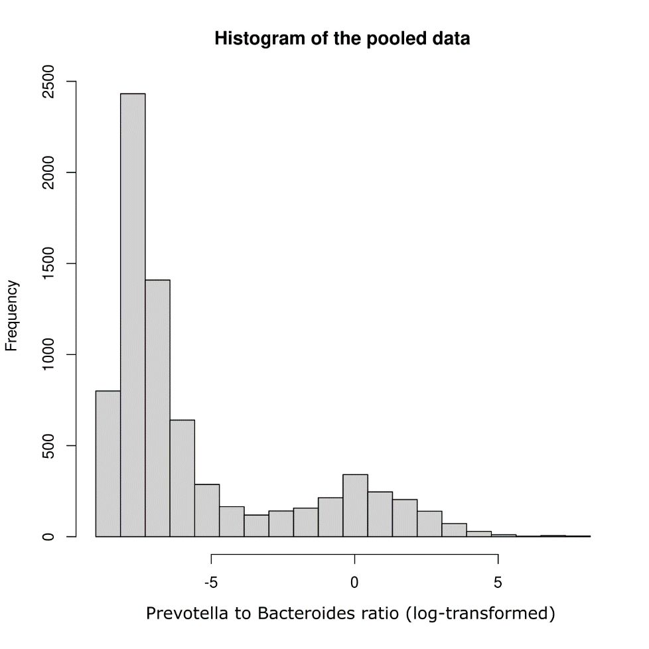
SUPPLEMENTAL FIGURE 1: Histogram of log-transformed Prevotella to Bacteroides ratio among adults from 8 European studies.

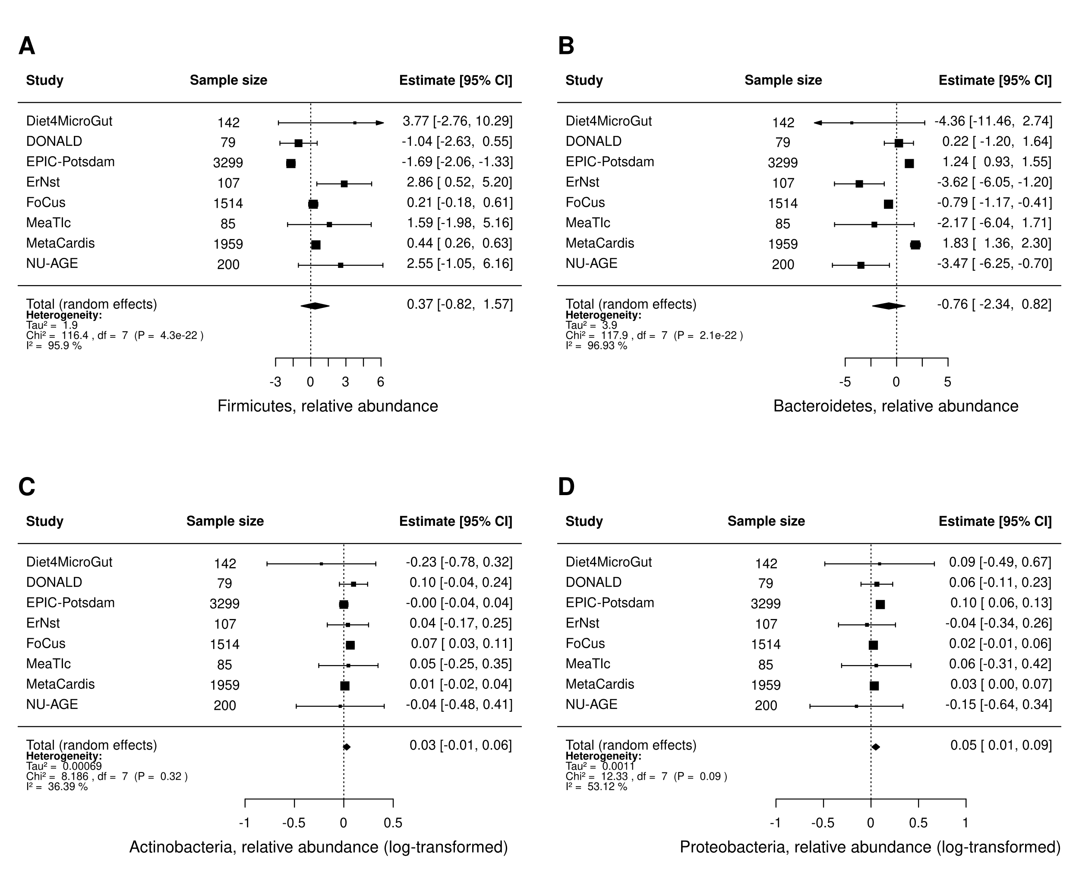
SUPPLEMENTAL FIGURE 2: Forest plots of random-effects study level meta-analysis among adults from 8 European studies, sex and age adjusted, showing the mean difference in relative abundance of prevalent taxa (present in >90% of samples) on the phylum level per 5-unit BMI increment. Phyla are A) Firmicutes, B) Bacteroidetes, C) Actinobacteria (log-transformed), and D) Proteobacteria (log-transformed).

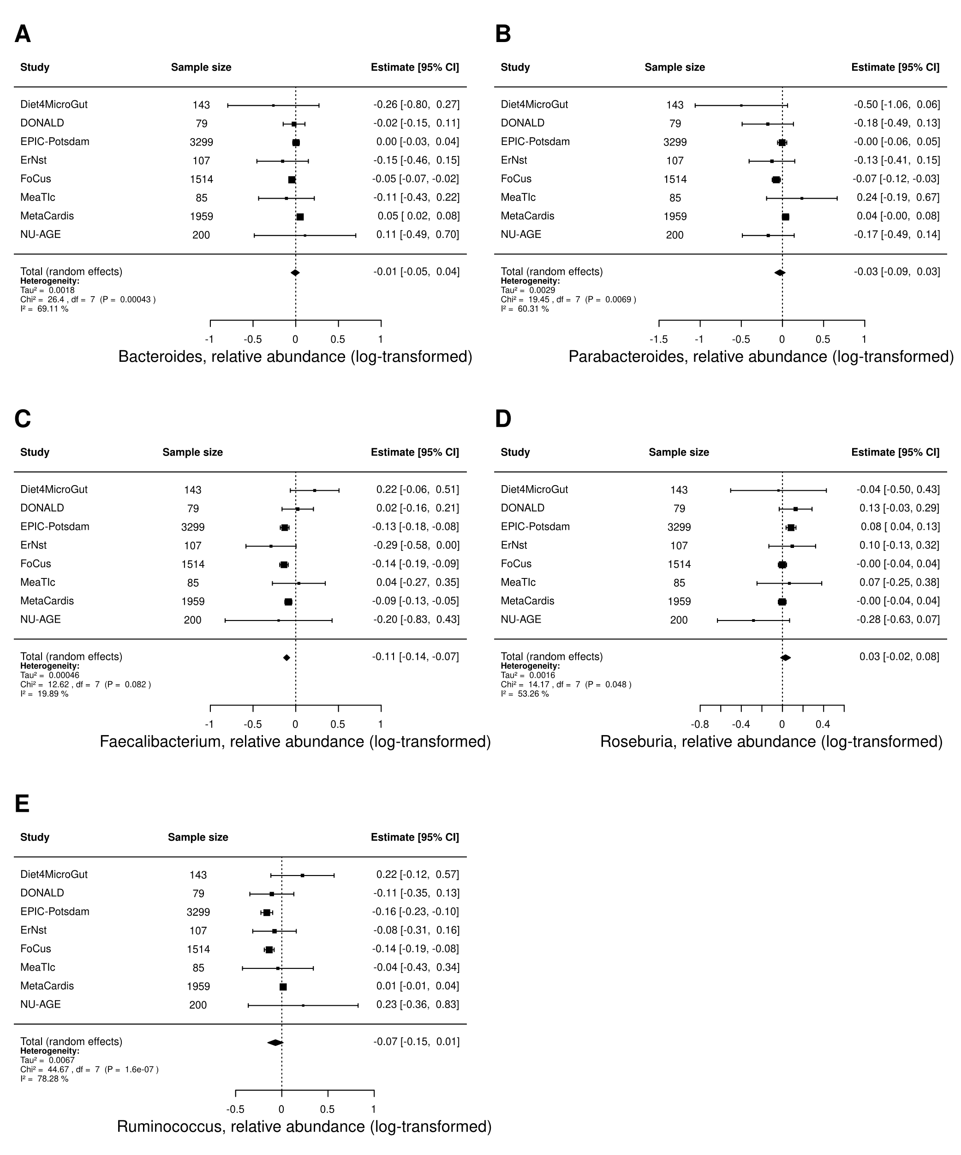
SUPPLEMENTAL FIGURE 3: Forest plots of random-effects study level meta-analysis among adults from 8 European studies, sex and age adjusted, showing the mean difference in log-transformed relative abundance of prevalent taxa (present in >90% of samples) on the genus level per 5-unit BMI increment. Genera are A) Bacteroides, B) Proteobacteria, C) Faecalibacterium, D) Roseburia, and E) Ruminococcus.

