Supplemental material

Supplemental methods

Suppl. Methods S1: Inclusion and exclusion criteria
Healthy adult subjects with no history of cardiovascular, respiratory or metabolic disease, medication or recreational drug use, including smoking, were enrolled. Exclusion criteria for healthy controls were cardiovascular disease, diabetes mellitus, neurological, orthopaedic, dermatological diseases or malignancies.
Cancer patients undergoing chemotherapy with substances potentially causing CIPN were recruited in the Division of Haematology and Oncology, Charité-Universitätsmedizin Berlin. Inclusion criterium was cumulative doses of at least one substance to be above the CIPN-threshold with the following minimal cumulative doses of the following substances: (nab-)paclitaxel (> 250 mg/m²), docetaxel (> 100 mg/m²), cisplatin (> 300 mg/m²), carboplatin (> 500 mg/m²), oxaliplatin (> 540 mg/m²), or vincristine (> 4 mg/m²) (1, 2). CIPN was graded according to the CTCAE 4.0 (3), with patients with CIPN by the clinician having at least grade 2.
Generally, participants were not considered eligible if they had dermatological diseases of the hands, malignant diseases (except CTX), alcohol dependence or pregnancy.

Suppl. Methods S2: Silicone filled pads for pressure-adjusted static compression (PSC)
The pads were designed to be used on hands and had to fulfil the requirement of controlled pressure-increase over the palmar arterial arch (region of interest, ROI) as well as comfort to being able to use the hands for normal at-house activities, including usage of screens with the fingertips (Figure S1).

A) 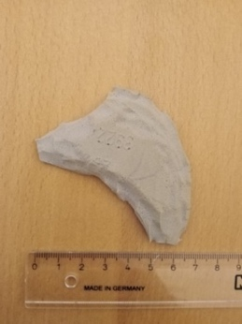 B)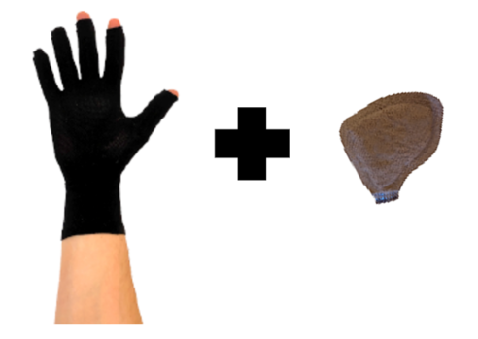
Figure S1 Development of silicone filled pads for PSC. A, Prototype, B, fabric compression glove with pad

Suppl. Methods S3: Standard protocol for general preparation and conduction of investigation
Room temperature was kept at 22°C to 24°C and the measurement environment was darkened. Subjects were asked to refrain from vigorous exercise for 12 h and to have consumed their last light meal 2 h, caffeine 6 h and alcohol 24 h before the investigation. They did not handle cold objects and did not consume hot/cold drinks or food up to 1 h before the measurement. All investigations were performed in the morning hours. Participants wore light clothing.
Before and during the entire investigation, participants were seated and held the arm in a horizontal position with their hands supported on their legs, approximately 40 cm below the heart to ensure continuous venous filling. A rest period of 60 minutes for acclimatisation and rest periods of at least 20 minutes up to 60 minutes were performed between consecutive or repeated investigations. Blood pressure and heart rate were recorded prior and after any investigation.
Application of the intervention was randomised to either the dominant or non-dominant hand.
Sites for probes in the palm (region of interest) instead of the commonly used thenar muscle were chosen to avoid limitations by extrapolating local and potential heterogeneous responses to other regions with a different biological tissue composition (4-6).

Suppl. Methods S4: Distal venous wrist compression
To differentiate the effects of PSC on local blood flow from venous occlusion, distal venous wrist compression was performed using a blood pressure cuff on the wrist. After 5 minutes of continuous palm NIRS recording, the cuff was manually inflated to subdiastolic pressures of approximately 30 mmHg and held constant for 5 minutes. The cuff was then deflated (duration: 1 second). Similarly, after 5 min for baseline recording, compression with PCS for 5 minutes was used for direct comparison. Both interventions were followed by 10-minute follow-up period with NIRS recording.

Supplemental data

Table S1 Cumulative doses of applicated chemotherapy
Potentially CIPN-causing chemotherapeutics |  |  | Other chemotherapeutics
Substance group | no. of patients per substance group (n=24) ¹ | average cumulative dose [mg/m²] | Substance group | no. of patients per substance group (n=24) ¹ | average cumulative dose [mg/m²]
(Nab-)Paclitaxel  Carboplatin  Cisplatin  Vincristin  Docetaxel  Oxaliplatin  VEGF-inhibitors | 15  8  6  6  4  3  7 | 570.0  750.0  335.0  8.4  337.5  792.5 | Cyclophosphamid  Doxorubicin  5-FU  Gemcitabin  Rituximab  Pembrolizumab  Nivolumab  Obinutuzumab  Irinotecan  Ifosfamid  ARA-C  Etoposid | 7  6  6  5  5  3  2  1  1  1  1  1 | 3000  250  2400  300  2250  600  3360  4000 ²  1440  6820  12000  400
¹ multiple substances per patient in the context of polychemotherapy; ² area independent unit [mg]; median number of CIPN-causing CTX per patient = 1; median number of total cytotoxic agents per patient = 3. Abbreviation: CIPN, chemotherapy-induced neuropathy.

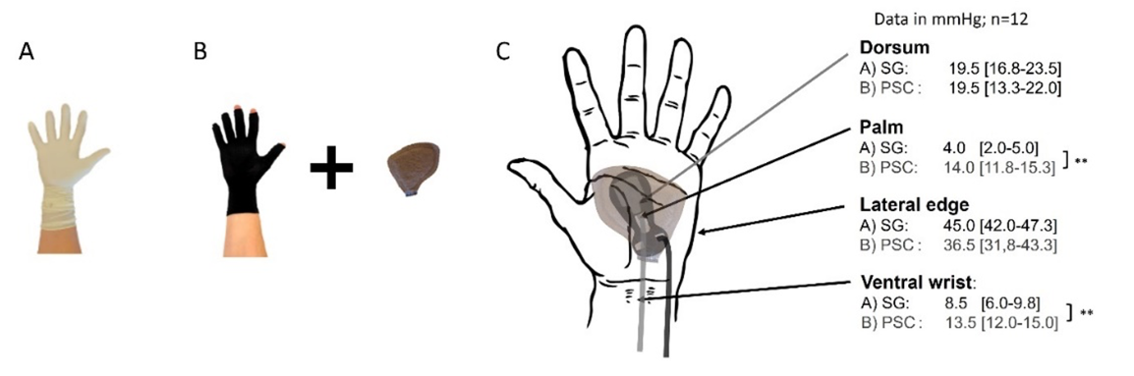
Figure S2 Compression pressures under different compression conditions. Hands: (A) Two undersized surgical gloves (SG) and (B) fabric compression glove with an inserted palmar pad (PSC) were used to measure (C) pressure over palm, dorsum, lateral edge and ventral wrist. Data is presented as median with interquartile range; all values in mmHg; n=12; statistics: *p<0.05; **p<0.01; ***p<0.001. Abbreviations: PSC, pressure-adjusted static compression; SG, surgical glove.

Supplemental references

1. Loprinzi CL, Lacchetti C, Bleeker J, Cavaletti G, Chauhan C, Hertz DL, et al. Prevention and Management of Chemotherapy-Induced Peripheral Neuropathy in Survivors of Adult Cancers: ASCO Guideline Update. J Clin Oncol. 2020;38(28):3325-48.
2. Mezzanotte JN, Grimm M, Shinde NV, Nolan T, Worthen-Chaudhari L, Williams NO, et al. Updates in the Treatment of Chemotherapy-Induced Peripheral Neuropathy. Curr Treat Options Oncol. 2022;23(1):29-42.
3. U.S. DEPARTMENT OF HEALTH AND HUMAN SERVICES, National Institutes of Health, National Cancer Institute: Common Terminology Criteria for Adverse Events (CTCAE) 4.0.May 28, 2009 (v4.03: June 14, 2010).
4. Bendahan D, Chatel B, Jue T. Comparative NMR and NIRS analysis of oxygen-dependent metabolism in exercising finger flexor muscles. Am J Physiol Regul Integr Comp Physiol. 2017;313(6):R740-r53.
5. Benni PB, MacLeod D, Ikeda K, Lin HM. A validation method for near-infrared spectroscopy based tissue oximeters for cerebral and somatic tissue oxygen saturation measurements. J Clin Monit Comput. 2018;32(2):269-84.
6. Grassi B, Quaresima V. Near-infrared spectroscopy and skeletal muscle oxidative function in vivo in health and disease: a review from an exercise physiology perspective. J Biomed Opt. 2016;21(9):091313.

