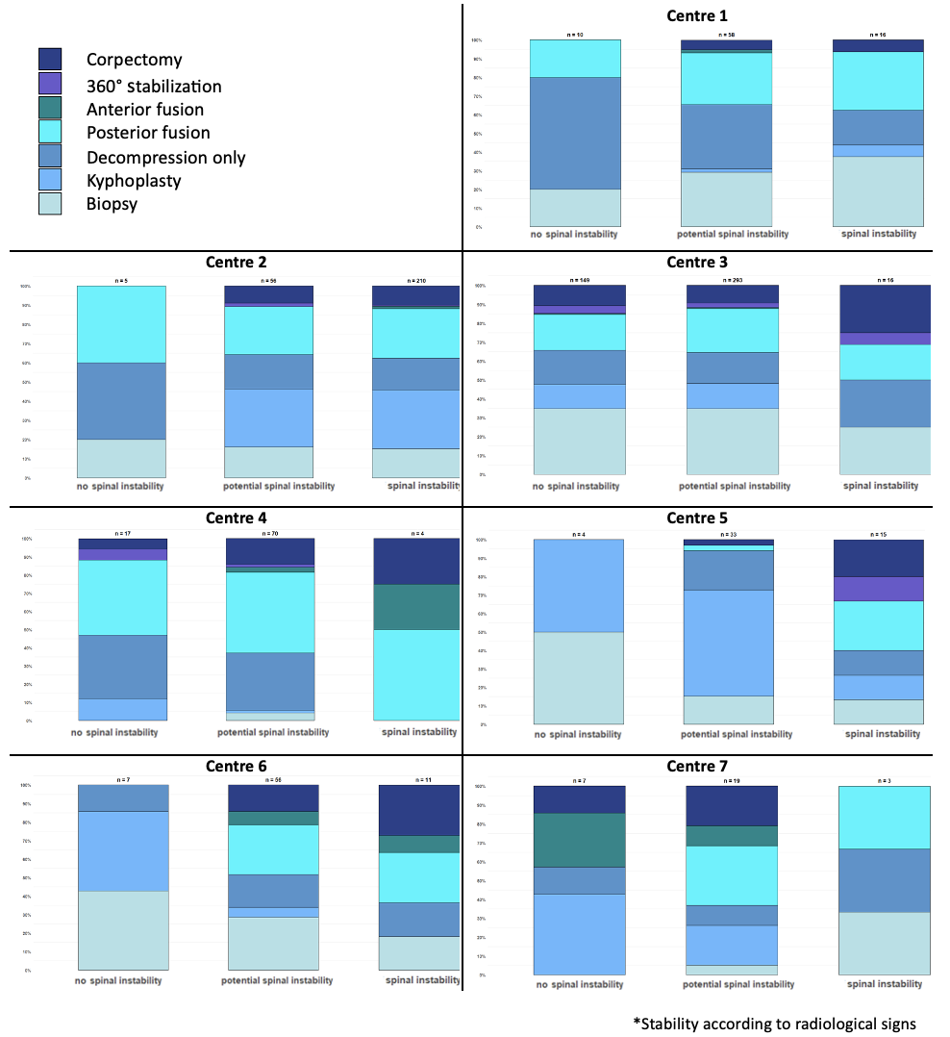
Supplemental Figure 1: This supplemental file highlights the large practice variations in surgical management in relation to the retrospectively assessed radiological and clinical parameters of spinal instability (in reference to the SINS) within each of the seven participating centers.

