Supplementary data - Probiotic Ice Cream Influences Gut and Vaginal Microbiota in Women at High Risk of Preterm Birth

Supplementary Table S1. Table of all included women, sample time points and compliance periods.
Patient ID | Randomization | Baseline, GA | Compliance, 1. period (Baseline – Time point 2) | Time point 2, GA | Compliance, 2. period  (Time point 2 – Time point 3) | Time point 3, GA | Compliance, 3. period (Time point 3 - Birth)
1 | Intervention | 14+4 | Poor | 28+2 | None | 32+2 | None
2 | Control | 13+0 | - | 20+4 | - | 29+3 | -
3 | Intervention | 16+3 | Excellent | N/A Because of late abortion | N/A Because of late abortion | N/A Because of abortion | N/A Because of late abortion
4 | Control | 16+4 | - | 24+3 | - | 36+3 | -
5 | Intervention | 14+1 | Poor | 20+0 | Poor | 29+1 | None
6 | Intervention | 12+3 | Excellent | 19+4 | Good | 32+6 | None
7 | Intervention | 11+2 | Poor | 18+1 | None | 31+1 | None
8 | Intervention | 13+0 | Poor | 20+5 | N/A | N/A Missing | N/A
9 | Control | 11+0 | - | 21+2 | - | 28+2 | -
10 | Control | 13+3 | - | 16+1 | - | 31+2 | -
11 | Intervention | 13+2 | N/A | N/A Missing | N/A | 31+3 | N/A
12 | Intervention | 12+3 | N/A | Excluded | Excluded | Excluded | Excluded
13 | Intervention | 11+1 | None | Excluded | Excluded | Excluded | Excluded
14 | Control | 18+4 | - | 32+1 | - | 38+6 | -
15 | Intervention | 13+2 | Good | 18+6 | Good | 32+5 | None
16 | Intervention | 12+6 | None | 20+4 | None | 34+3 | None
17 | Control | 12+1 | - | 18+2 | - | 27+0 | -
18 | Intervention | 12+2 | Excellent | 19+1 | Good | 31+6 | Good
19 | Intervention | 12+2 | None | 19+4 | None | 31+1 | None
20 | Intervention | 12+4 | N/A | Excluded | Excluded | Excluded | Excluded
21 | Control | 12+5 | - | 20+5 | - | Missing | -
22 | Intervention | 11+6 | N/A | Excluded | Excluded | Excluded | Excluded
23 | Control | 12+5 | - | 20+4 | - | 34+0 | -
24 | Intervention | 12+3 | N/A | Excluded | Excluded | Excluded | Excluded
25 | Intervention | 14+5 | N/A | Excluded | Excluded | Excluded | Excluded
26 | Control | 14+6 | - | 22+3 | - | 32+0 | -
27 | Intervention | 14+2 | Excellent | 20+0 | Excellent | 28+2 | Excellent
28 | Control | 13+2 | - | 20+0 | - | 28+0 | -
29 | Intervention | 12+5 | Excellent | 22+6 | N/A | 27+0 | N/A
30 | Intervention | 12+1 | Poor | 16+0 | None | 24+2 (early) | None
31 | Control | 12+4 | - | 19+5 | - | 30+5 | -
32 | Intervention | 12+6 | Good | 20+5 | Good | 31+0 | Good
33 | Intervention | 14+0 | Poor | 20+1 | Poor | 32+6 | Poor
34 | Intervention | 15+2 | N/A | 20+3 | N/A | N/A Missing | N/A
35 | Intervention | 12+1 | Poor | 20+1 | None | 32+6 | None
36 | Control | 13+2 | - | 21+6 | - | 30+5 | -
37 | Control | 12+5 | - | 20+2 | - | 38+2 | -
38 | Intervention | 9+1 | N/A | 19+6 | N/A | 40+0 | N/A
39 | Intervention | 13+1 | Excellent | 20+1 | Excellent | 36+1 | Poor
40 | Control | 15+5 | - | N/A Missing | - | 32+0 | -
41 | Intervention | 13+1 | Excellent | N/A Missing | Poor | N/A missing | N/A
42 | Intervention | 12+1 | Poor | N/A Because of late abortion | N/A Because of late abortion | N/A Because of late abortion | N/A Because of late abortion
43 | Intervention | 10+2 | Good | 22+6 | None | 35+0 | None

Supplementary Figure S1. Analysis on baseline comparability between the groups:
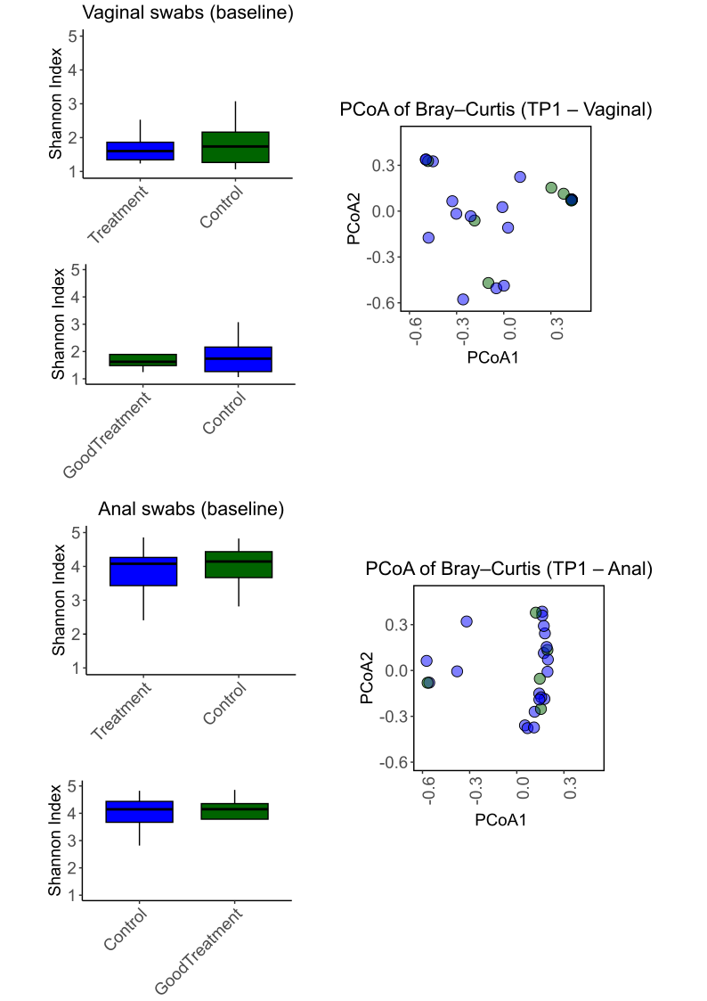
Figure S1. Baseline alpha and beta diversity across different constellations of groups. Intervention versus control and also control or no to poor adherence versus good to excellent adherence. Alpha diversity (Shannon index) was calculated from OTU-level genus profiles. Differences in alpha diversity at baseline (TP1) were tested using Wilcoxon rank-sum tests between the assigned Treatment vs Control group (top row) and between the Good to excellent adherence vs Control group (middle row), stratified by swab site (vaginal and rectal). No significant differences were observed for either comparison (all FDR-adjusted p-values > 0.1). Beta diversity was assessed using Bray–Curtis dissimilarity and visualized via principal coordinates analysis (PCoA; right panels). Group differences in community composition at baseline were tested using PERMANOVA (adonis2). Again, no significant separation between groups was detected for either swab site (vaginal: p = 0.865; rectal: p = 0.994).

Supplementary Figure S2. Gestational age effect:
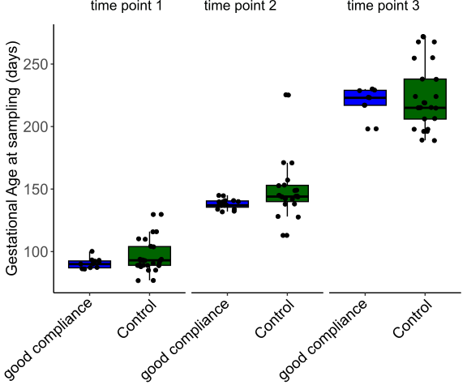
Figure S2. Gestational age at sampling across time points and groups. Boxplots showing gestational age (in days) at the time of microbiome sampling for each participant, stratified by time point (TP1–TP3) and group (intervention group with good to excellent adherence vs. control group). Each dot represents an individual sample. Blue boxes indicate the intervention group with good compliance, and green boxes represent the control group. As expected, gestational age increases across time points, confirming the longitudinal design. At each time point, sampling occurred within a relatively consistent gestational window per group, although minor variability is visible. This supports the interpretation that temporal trends observed in microbiome dynamics are not due to large differences in sampling age between groups.
Timepoint | Wilcoxon p-value | Levene’s p-value | Interpretation
TP1 | 0.2271 | 0.0649 (·) | No significant GA difference at baseline, but slightly higher variability in one group
TP2 | 0.01191 | 0.0392 (*) | Significant GA difference at time point 2 between the groups  Significant difference in variance GA is more variable in one group
TP3 | 0.8755 | 0.0945 (·) | Trend toward variance difference

Supplementary Figure S3. Baseline-adjusted linear models of alpha and beta diversity at time point 2 and 3 in vaginal and rectal swabs:
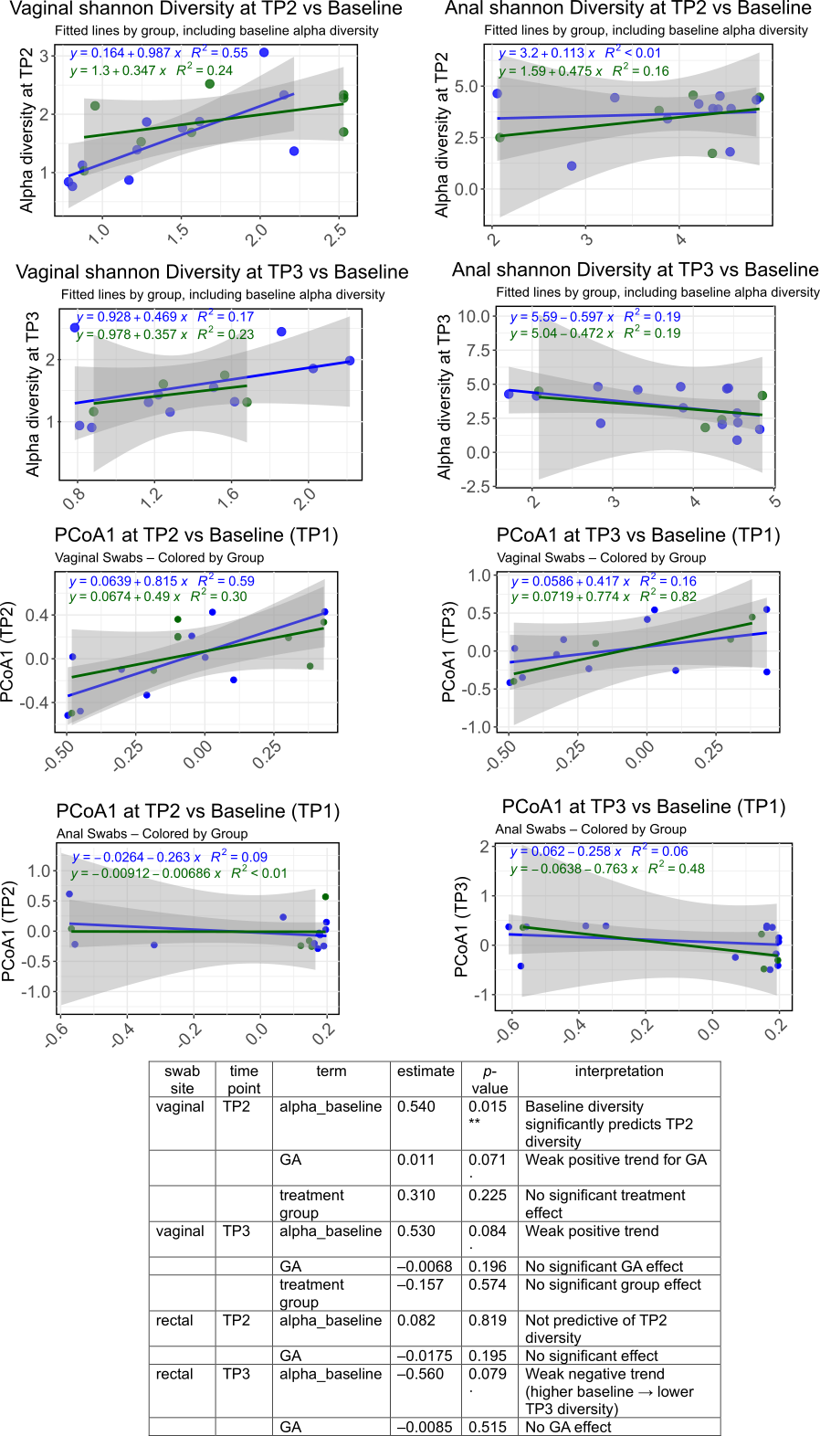
Figure S3. Baseline-adjusted linear models of alpha and beta diversity at TP2 and TP3 in vaginal and rectal swabs. Linear regression plots showing the relationship between baseline diversity (TP1) and post-intervention diversity at time points 2 and 3 (TP2, TP3) in vaginal (left panels) and rectal (right panels) swabs. Models were stratified by treatment group (green: good compliance, blue: control), and lines were fitted separately for each group using linear models adjusted for gestational age and baseline values.
Top two rows: Alpha diversity (Shannon index). In vaginal swabs at time point 2 (top left), baseline alpha diversity strongly predicted TP2 values, especially in the good compliance group (R² = 0.55). At time point 3, vaginal alpha diversity remained moderately associated with baseline (R² = 0.17–0.23). In rectal swabs, associations were weaker across both time points, with modest or negative trends and lower R² values (0.16 at TP2, 0.19 at TP3), suggesting more variability in rectal community structure over time.
Bottom two rows: Beta diversity (PCoA1 from Bray–Curtis dissimilarity). In vaginal swabs, PCoA1 at time point 2 was strongly predicted by baseline PCoA1 (R² = 0.59 in the control group, 0.30 in the treatment group). At time point 3, baseline structure remained predictive (R² = 0.16–0.82), particularly in the good compliance group. In contrast, rectal swabs showed weak or no association at time point 2 (R² = 0.09 and < 0.01), and only modest trends at time point 3 (R² = 0.06–0.48). Shaded areas represent 95% confidence intervals. Together, these results indicate that baseline microbial structure is a more consistent predictor of future composition in the vaginal niche than in the rectal site, and that treatment group had no clear impact on these patterns.

Supplementary Figure S4. Taxon-Level Longitudinal Modelling and Model Selection:
To explore how individual microbial taxa responded over time, we applied a structured modelling framework to longitudinal abundance data. After applying a prevalence filter (≥10% of samples), we modelled each taxon’s abundance at time point 2 and time point 3, stratified by swab site (vaginal and rectal). Four nested linear models were fit per taxon, and the best-fitting model was selected using stepwise likelihood ratio tests (LRTs) with FDR correction (q < 0.1). This allowed us to classify taxa based on whether their dynamics were driven by baseline abundance, treatment group, GA or interactions between the covariates (GA * treatment group or treatment group * baseline).
This approach revealed a range of taxon-specific responses. In vaginal swabs, several taxa were influenced by treatment group or by interactions between group and baseline abundance, particularly at time point 3 (Figure S4, Supplementary table 2). For instance, Firmicutes Gallicola exhibited a significant group * baseline interaction, indicating that the impact of initial abundance on time point 3 levels differed between groups. In contrast, other taxa such as Firmicutes Lachnospiraceae GC10 in rectal swabs were stably maintained over time, with time point 2 abundances strongly predicted by baseline levels and no detectable treatment or GA effect.
Overall, while a subset of taxa showed evidence of treatment-related modulation, the majority were best explained by baseline abundance, highlighting ecological stability and individual persistence. Interaction effects, though less frequent, suggest that treatment can alter the temporal behaviour of specific taxa in a group-dependent manner.
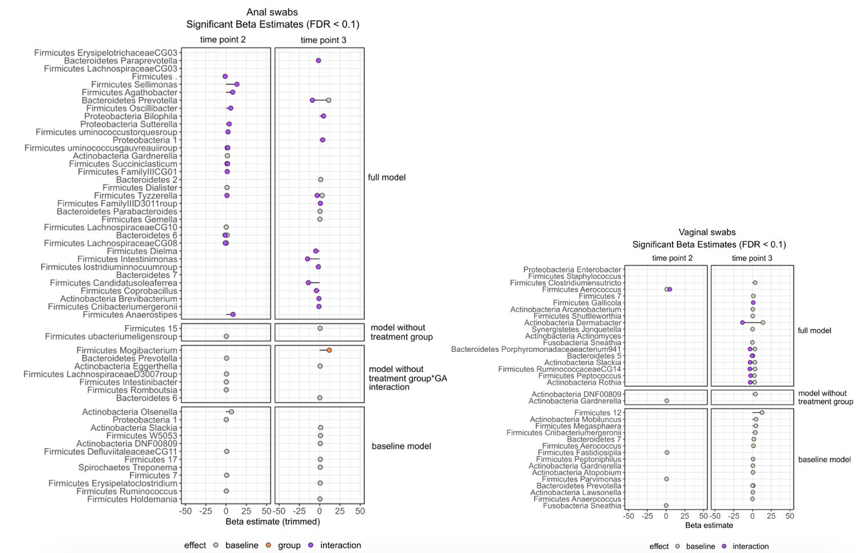
Figure S4. Beta coefficient estimates from the best-fitting linear model are shown for each taxon at time points 2 and 3 (TP2, TP3). Separate panels depict significant predictors of taxon abundance, grouped by the model used (as selected via likelihood ratio tests): Full model: Includes baseline abundance, gestational age (GA), treatment group, and interaction terms. Model without treatment group: Omits the group term, retaining baseline and GA only. Model without GA × group interaction: Includes GA and group, but no interaction terms. Baseline model: Includes only baseline abundance as a predictor. Dot colour indicates the type of significant effect: Green: baseline effect (taxon abundance at TP2/TP3 is predicted by TP1) Purple: interaction effect (baseline effect differs by treatment group). Orange: treatment group effect (differential abundance between treatment and control). Taxa with significant baseline effects (green) exhibit persistence or stability over time. Taxa with interaction effects (purple) are modulated by treatment, meaning their longitudinal trajectory differs between groups. Taxa with group effects (orange) show direct treatment-associated changes, even after adjusting for baseline. Each taxon is displayed only if it passed the FDR threshold (q < 0.1) for at least one model term.
Model | Formula | Interpretation
full | Abundance ~ baseline + GA + group + group:baseline + group:GA | The full model includes baseline abundance, gestational age (GA), treatment group, and both interactions — group modifies the effect of baseline and GA.
no_interaction | Abundance ~ baseline + GA + group | The group model tests the independent effect of treatment group and GA, but without interactions.
no_group | Abundance ~ baseline + GA | The baseline+GA model tests whether variation is explained by GA and baseline abundance, but ignores treatment group.
null | Abundance ~ baseline | The null model assumes only baseline abundance predicts the outcome. No group or GA included.

Supplementary Table S2.
Taxon | Timepoint | Swabsite | Model | effect | effect_size | padj
Firmicutes_Lachnospiraceae.UCG.003 | TP3 | Anal_Swabs | full | group | 1001.12894244666 | 0.000322700784190037
Bacteroidetes_..7 | TP3 | Anal_Swabs | full | group | -219.548656095774 | 0.0690450569203005
Bacteroidetes_Prevotella.7 | TP3 | Anal_Swabs | full | group | 1186.01829955154 | 0.00835209969307608
Firmicutes_Anaerostipes | TP2 | Anal_Swabs | full | group | -3682.1609008592 | 0.0931031867007572
Firmicutes_Coprobacillus | TP3 | Anal_Swabs | full | group | -776.924876050121 | 0.000322700784190037
Firmicutes_Criibacterium.bergeronii | TP3 | Anal_Swabs | full | group | -1686.70333535243 | 0.000322700784190037
Firmicutes_Erysipelotrichaceae.UCG.003 | TP3 | Anal_Swabs | full | group | 1438.9641819058 | 0.0335467543161721
Actinobacteria_Brevibacterium | TP3 | Anal_Swabs | full | group | -1039.62219870169 | 0.000322700784190037
Bacteroidetes_Paraprevotella | TP3 | Anal_Swabs | full | group | 2569.99449816306 | 0.0240033452765488
Firmicutes_. | TP2 | Anal_Swabs | full | group | 54.306322801432 | 0.061489721586478
Firmicutes_.Clostridium..innocuum.group | TP3 | Anal_Swabs | full | group | -317.41659251673 | 0.000393406239410142
Firmicutes_Candidatus.Soleaferrea | TP3 | Anal_Swabs | full | group | -496.726126202613 | 6.26589827281363e-07
Firmicutes_Mogibacterium | TP3 | Anal_Swabs | no_interaction | group | 11.967316298728 | 0.0240033452765488
Actinobacteria_Actinomyces | TP2 | Vag_Swabs | full | baseline | -387.051224632608 | 0.0893767275912398
Actinobacteria_Arcanobacterium | TP3 | Vag_Swabs | full | baseline | 0.5 | 0.00306884906418475
Actinobacteria_Dermabacter | TP3 | Vag_Swabs | full | baseline | 14 | 2.09815637564378e-18
Actinobacteria_Gardnerella | TP2 | Anal_Swabs | full | baseline | 1.72680581049671 | 0.0219106585446196
Actinobacteria_Slackia | TP3 | Vag_Swabs | full | baseline | 3.12908829012032 | 6.44002892742461e-08
Bacteroidetes_..5 | TP3 | Vag_Swabs | full | baseline | 0.5 | 9.3710668396725e-244
Bacteroidetes_Parabacteroides | TP3 | Anal_Swabs | full | baseline | 0.497354634191397 | 0.0389681975343881
Bacteroidetes_Porphyromonadaceae.bacterium.C941 | TP3 | Vag_Swabs | full | baseline | 3.29000410509031 | 6.30187528715122e-16
Bacteroidetes_Prevotella.7 | TP3 | Anal_Swabs | full | baseline | 11.2262969515916 | 9.25088287892406e-08
Firmicutes_..7 | TP3 | Vag_Swabs | full | baseline | 1.16666666666667 | 1.42562204466731e-16
Firmicutes_.Ruminococcus..gauvreauii.group | TP2 | Anal_Swabs | full | baseline | 1.45398123069241 | 5.60366437008642e-08
Firmicutes_Clostridium.sensu.stricto.1 | TP3 | Vag_Swabs | full | baseline | 3.61504978542624 | 1.07497381273335e-22
Firmicutes_Dialister | TP2 | Anal_Swabs | full | baseline | 1.17497893253208 | 0.0125164310444842
Firmicutes_Gemella | TP3 | Anal_Swabs | full | baseline | 0.408144746512318 | 0.0116953978065121
Firmicutes_Lachnospiraceae.UCG.010 | TP2 | Anal_Swabs | full | baseline | 0.23550129795316 | 0.0919615589928016
Firmicutes_Peptococcus | TP3 | Vag_Swabs | full | baseline | 2.6189039408867 | 1.09588312159378e-14
Firmicutes_Shuttleworthia | TP3 | Vag_Swabs | full | baseline | 0.42601793944004 | 6.63573463787986e-49
Firmicutes_Succiniclasticum | TP2 | Anal_Swabs | full | baseline | 1.2713356376947 | 4.34226438142603e-10
Fusobacteria_Sneathia | TP3 | Vag_Swabs | full | baseline | 4.55469930197732e-18 | 3.83667977293801e-06
Synergistetes_Jonquetella | TP3 | Vag_Swabs | full | baseline | 0.226415094339623 | 3.77668160334349e-28
Bacteroidetes_..6 | TP2 | Anal_Swabs | full | baseline | 1.43297771378246 | 6.89075372935481e-09
Firmicutes_Aerococcus | TP2 | Vag_Swabs | full | baseline | 0.86293876582736 | 0.0188039388151304
Firmicutes_Lachnospiraceae.UCG.008 | TP2 | Anal_Swabs | full | baseline | 0.5 | 0.00316302262004315
Firmicutes_Tyzzerella.4 | TP3 | Anal_Swabs | full | baseline | 3.13256063880298 | 0.00490377161470033
Actinobacteria_Rothia | TP3 | Vag_Swabs | full | baseline | 3 | 3.07350641845e-08
Firmicutes_Ruminococcaceae.UCG.014 | TP3 | Vag_Swabs | full | baseline | 3.44545256812603 | 3.76037416196742e-06
Bacteroidetes_..2 | TP3 | Anal_Swabs | full | baseline | 1.33616212200281 | 5.18641447992006e-06
Bacteroidetes_Prevotella | TP2 | Anal_Swabs | no_interaction | baseline | 0.622259449855229 | 0.0893767275912398
Actinobacteria_Eggerthella | TP3 | Anal_Swabs | no_interaction | baseline | 0.626243452750407 | 0.0337073497928495
Firmicutes_Intestinibacter | TP2 | Anal_Swabs | no_interaction | baseline | 0.339983498271243 | 0.00627989868644558
Firmicutes_Lachnospiraceae.ND3007.group | TP2 | Anal_Swabs | no_interaction | baseline | 0.54129898260503 | 0.017346497430601
Firmicutes_Romboutsia | TP2 | Anal_Swabs | no_interaction | baseline | 0.313918903690017 | 0.002254760640735
Bacteroidetes_..6 | TP3 | Anal_Swabs | no_interaction | baseline | 0.233824128912552 | 6.06137923509413e-08
Firmicutes_.Eubacterium..eligens.group | TP2 | Anal_Swabs | no_group | baseline | 0.403250490483595 | 0.00790418503832363
Actinobacteria_DNF00809 | TP3 | Vag_Swabs | no_group | baseline | 3.85307558003946 | 0.000647814155466014
Actinobacteria_Gardnerella | TP2 | Vag_Swabs | no_group | baseline | 0.930515490742585 | 3.45381606745697e-05
Firmicutes_..15 | TP3 | Anal_Swabs | no_group | baseline | 0.578522708264552 | 5.18641447992006e-06
Actinobacteria_Atopobium | TP3 | Vag_Swabs | null | baseline | 0.695974776965079 | 3.14777739720168e-16
Actinobacteria_DNF00809 | TP3 | Anal_Swabs | null | baseline | 0.902661156589719 | 5.73991412634708e-05
Actinobacteria_Gardnerella | TP3 | Vag_Swabs | null | baseline | 0.588942818165109 | 0.0333301660477831
Actinobacteria_Lawsonella | TP3 | Vag_Swabs | null | baseline | 0.515916194003936 | 0.00697218139189253
Actinobacteria_Mobiluncus | TP3 | Vag_Swabs | null | baseline | 4.81118881118882 | 0.000256740211447519
Actinobacteria_Olsenella | TP2 | Anal_Swabs | null | baseline | 6.63302752293578 | 6.13328038489535e-09
Actinobacteria_Slackia | TP3 | Anal_Swabs | null | baseline | 1.2876647834275 | 0.000383818517361979
Bacteroidetes_..7 | TP3 | Vag_Swabs | null | baseline | 1.95652173913043 | 8.1603250451073e-08
Bacteroidetes_Prevotella | TP3 | Vag_Swabs | null | baseline | 0.977711204263333 | 0.00589867395891018
Bacteroidetes_Prevotella.7 | TP3 | Vag_Swabs | null | baseline | 0.152116830414858 | 1.54737460156456e-18
Firmicutes_..12 | TP3 | Vag_Swabs | null | baseline | 12.7826086956522 | 1.45740922957947e-13
Firmicutes_..17 | TP3 | Anal_Swabs | null | baseline | 0.894387001477105 | 2.41149407732498e-05
Firmicutes_..7 | TP2 | Anal_Swabs | null | baseline | 0.77384203960832 | 0.00259608862923214
Firmicutes_Aerococcus | TP3 | Vag_Swabs | null | baseline | 1.3359158083296 | 0.00697218139189253
Firmicutes_Anaerococcus | TP3 | Vag_Swabs | null | baseline | 0.105874680068617 | 0.0154935795229229
Firmicutes_Criibacterium.bergeronii | TP3 | Vag_Swabs | null | baseline | 3.73913043478261 | 1.98172752262327e-25
Firmicutes_Defluviitaleaceae.UCG.011 | TP2 | Anal_Swabs | null | baseline | 0.901315789473685 | 0.0116953978065121
Firmicutes_Erysipelatoclostridium | TP3 | Anal_Swabs | null | baseline | 0.771633444937806 | 0.00201696697346986
Firmicutes_Fastidiosipila | TP2 | Vag_Swabs | null | baseline | 1.20905734776346 | 1.01821124908485e-05
Firmicutes_Holdemania | TP3 | Anal_Swabs | null | baseline | 0.415841584158416 | 0.0768076184211581
Firmicutes_Megasphaera | TP3 | Vag_Swabs | null | baseline | 4.54385370809347 | 4.73684893013393e-25
Firmicutes_Parvimonas | TP2 | Vag_Swabs | null | baseline | 0.597335932423652 | 7.63530860461641e-09
Firmicutes_Peptoniphilus | TP3 | Vag_Swabs | null | baseline | 0.77252336681297 | 0.00201990784913291
Firmicutes_Ruminococcus.1 | TP2 | Anal_Swabs | null | baseline | 0.440539972290133 | 2.07437717509329e-10
Firmicutes_W5053 | TP3 | Anal_Swabs | null | baseline | 1.10125178820571 | 0.0154935795229229
Fusobacteria_Sneathia | TP2 | Vag_Swabs | null | baseline | 0.0686014805773488 | 2.54341637837274e-15
Proteobacteria_..1 | TP2 | Anal_Swabs | null | baseline | 0.293421811886901 | 0.017346497430601
Spirochaetes_Treponema.2 | TP3 | Anal_Swabs | null | baseline | 0.803475134811265 | 0.0389681975343881
Proteobacteria_Sutterella | TP2 | Anal_Swabs | full | interaction | 3.9367306753122 | 0.0147355358286874
Actinobacteria_Actinomyces | TP2 | Vag_Swabs | full | interaction | 387.30368318086 | 0.055331017361604
Actinobacteria_Dermabacter | TP3 | Vag_Swabs | full | interaction | -13.3333333333333 | 8.94148384328507e-18
Actinobacteria_Slackia | TP3 | Vag_Swabs | full | interaction | -3.12908829012032 | 5.46359674443138e-05
Bacteroidetes_..5 | TP3 | Vag_Swabs | full | interaction | -0.5 | 2.46827578179648e-226
Bacteroidetes_Porphyromonadaceae.bacterium.C941 | TP3 | Vag_Swabs | full | interaction | -3.29000410509031 | 1.86459318783569e-12
Bacteroidetes_Prevotella.7 | TP3 | Anal_Swabs | full | interaction | -8.95607350163669 | 1.81416265891922e-06
Firmicutes_.Ruminococcus..gauvreauii.group | TP2 | Anal_Swabs | full | interaction | 2.30027755032923 | 0.00142528829273495
Firmicutes_.Ruminococcus..torques.group | TP2 | Anal_Swabs | full | interaction | 2.50989468712116 | 0.0377170982653101
Firmicutes_Agathobacter | TP2 | Anal_Swabs | full | interaction | 8.31429848562862 | 9.44527943705076e-05
Firmicutes_Anaerostipes | TP2 | Anal_Swabs | full | interaction | 8.65339697594555 | 0.0122242383939878
Firmicutes_Coprobacillus | TP3 | Anal_Swabs | full | interaction | -4.02514850400931 | 4.71517485149267e-05
Firmicutes_Criibacterium.bergeronii | TP3 | Anal_Swabs | full | interaction | -0.768084911846199 | 0.0116099140622792
Firmicutes_Dielma | TP3 | Anal_Swabs | full | interaction | -4.69619202198901 | 0.0478569774821611
Firmicutes_Family.XIII.AD3011.group | TP3 | Anal_Swabs | full | interaction | 0.9903230315182 | 0.0524987640317766
Firmicutes_Family.XIII.UCG.001 | TP2 | Anal_Swabs | full | interaction | 1.49410151292225 | 0.0867200492531406
Firmicutes_Gallicola | TP3 | Vag_Swabs | full | interaction | 1 | 1.01193967118597e-259
Firmicutes_Intestinimonas | TP3 | Anal_Swabs | full | interaction | -14.9426882302174 | 0.0322348182550693
Firmicutes_Oscillibacter | TP2 | Anal_Swabs | full | interaction | 5.83264003907617 | 0.00858962264680879
Firmicutes_Peptococcus | TP3 | Vag_Swabs | full | interaction | -2.6189039408867 | 2.75606628952494e-09
Firmicutes_Staphylococcus | TP2 | Vag_Swabs | full | interaction | 174.842449508102 | 0.00013160968973351
Firmicutes_Succiniclasticum | TP2 | Anal_Swabs | full | interaction | 1.9447682584092 | 5.46359674443138e-05
Firmicutes_Tyzzerella | TP2 | Anal_Swabs | full | interaction | 1.0845336592151 | 5.52343406582431e-06
Proteobacteria_Bilophila | TP3 | Anal_Swabs | full | interaction | 4.92555895826306 | 0.00203238653979795
Proteobacteria_Enterobacter | TP2 | Vag_Swabs | full | interaction | 2555.00447513806 | 1.03662514365433e-63
Actinobacteria_Brevibacterium | TP3 | Anal_Swabs | full | interaction | -0.782445558935802 | 0.0377170982653101
Bacteroidetes_..6 | TP2 | Anal_Swabs | full | interaction | -1.26522367741617 | 4.35362503134895e-08
Bacteroidetes_Paraprevotella | TP3 | Anal_Swabs | full | interaction | -1.30634316652927 | 0.0872739913895304
Firmicutes_. | TP2 | Anal_Swabs | full | interaction | -1.08256467096993 | 0.0207028586526788
Firmicutes_.Clostridium..innocuum.group | TP3 | Anal_Swabs | full | interaction | -1.44663495938173 | 0.00320657739592631
Firmicutes_Aerococcus | TP2 | Vag_Swabs | full | interaction | 5.00998480751042 | 5.90329203627972e-06
Firmicutes_Lachnospiraceae.UCG.008 | TP2 | Anal_Swabs | full | interaction | -0.969447138700291 | 0.00142528829273495
Firmicutes_Sellimonas | TP2 | Anal_Swabs | full | interaction | 13.3988049285588 | 0.0496092111801373
Firmicutes_Tyzzerella.4 | TP3 | Anal_Swabs | full | interaction | -3.0029248921287 | 0.0138966693311137
Actinobacteria_Rothia | TP3 | Vag_Swabs | full | interaction | -3.00000000000001 | 2.21760177724919e-05
Firmicutes_Ruminococcaceae.UCG.014 | TP3 | Vag_Swabs | full | interaction | -3.44545256812603 | 0.00478722340473592
Firmicutes_Candidatus.Soleaferrea | TP3 | Anal_Swabs | full | interaction | -13.9054671223428 | 8.08654873686064e-07
Proteobacteria_..1 | TP3 | Anal_Swabs | full | interaction | 3.8246552360929 | 0.0723738721053777

Supplementary Figure S5. Rectal-to-Vaginal Microbial Shift Analysis and Permutation Testing:
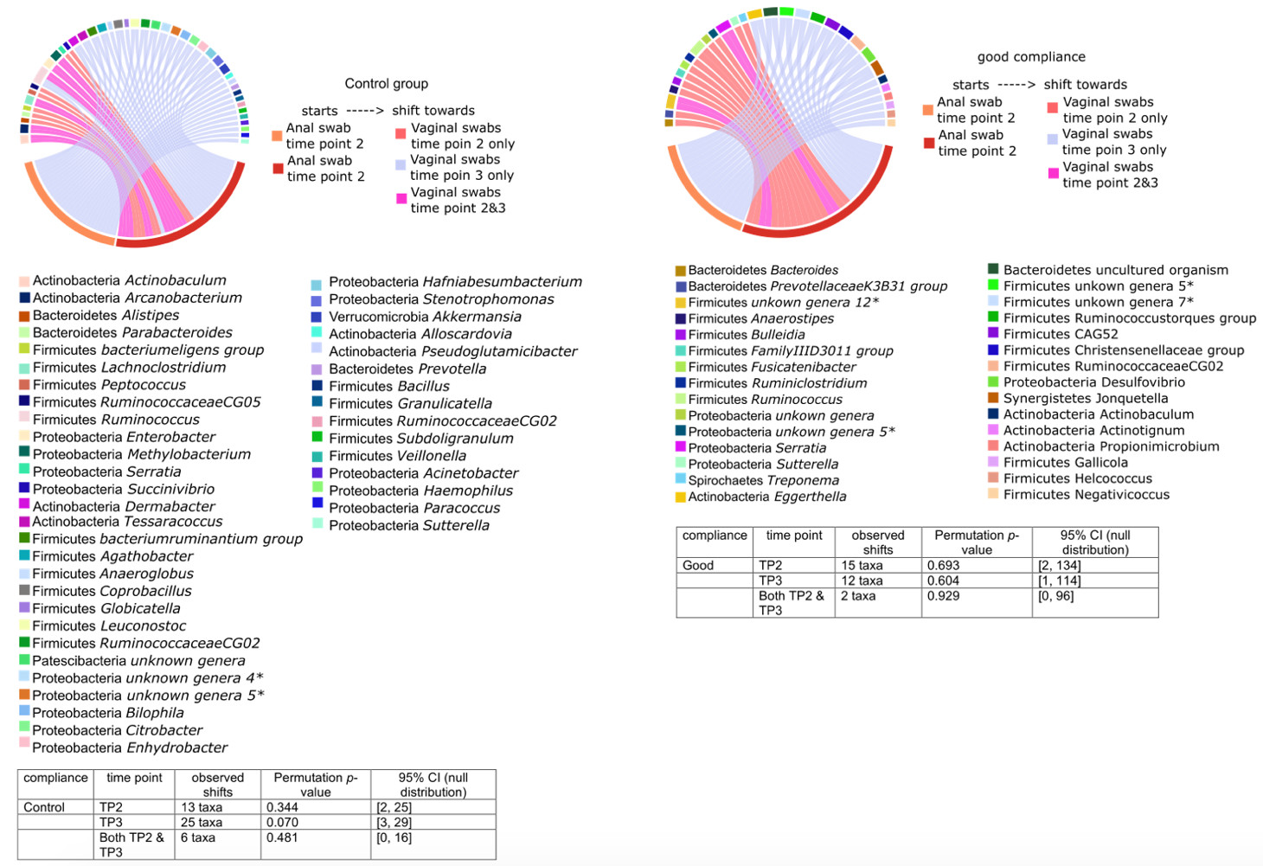
Figure S5. Chord diagram of rectal-to-vaginal microbial shifts over time. Chord diagrams illustrate genus-level shifts from rectal to vaginal swabs across time points in the good to excellent adherence group vs control and no to poor adherence group. Each arc represents a genus that was present in rectal swabs at a given time point but absent in vaginal swabs at that same time, and that subsequently appeared in vaginal swabs at time point 2, time point 3, or both. These genera are considered candidates for temporal rectal-to-vaginal transfer. Links (chords) are coloured by shift pattern: pink for genera shifting only to time point 2, blue for time point 3 only, and purple for genera appearing in both time points 2 and 3. Sectors (outer grid labels) represent the individual genera, coloured by phylum, with source nodes (Rectal_TP1–TP3) in red-orange hues. The diagram reflects the direction and timing of microbial movement across anatomical sites. Although such shifts were observed, permutation tests showed that their frequency was not significantly greater than expected by chance. This suggests that the few transitions detected may reflect background ecological processes rather than treatment-driven microbial convergence.

Supplementary Figure S6. Cliff’s Delta effect size on difference in baseline amount of lactobacilli between intervention group and control group. Non-significant (FDR >0.1):
