Supplementary information

Thrombospondin-1 (THBS1) is dysregulated in preeclampsia
Authors:
Stefan M. Botha^{a,b,c,d,e,f,g,*}, Lucy A. Bartho^{a,b,c}, Sunhild Hartmann^{a,b,c,d,e,f,g}, Ping Cannon^{a,b,c}, Anna Nguyen^{a,b,c}, Tuong-Vi Nguyen ^{a,b,c}, Natasha Pritchard ^{b,c}, Ralf Dechend ^{d,e,f,g,h}, Olivia Nonn^{d,e,f,g}, Stephen Tong ^{a,b,c}, Tu'uhevaha J. Kaitu'u-Lino^{a,b,c}

Affiliations:
ªTranslational Obstetrics Group, Mercy Hospital for Women, University of Melbourne, Heidelberg, Victoria, 3084, Australia
^{b}The Department of Obstetrics, Gynaecology and Newborn Health, Mercy Hospital for Women, University of Melbourne, Australia
^{c}Mercy Perinatal, Mercy Hospital for Women, Heidelberg, Victoria, Australia
^{d}Charité – Universitätsmedizin Berlin, Corporate Member of Freie Universität Berlin and Humboldt-Universität zu Berlin, Berlin, Germany
^{e}Experimental and Clinical Research Center, a Cooperation Between the Max-Delbrück-Center for Molecular Medicine in the Helmholtz Association and the Charité-Universitätsmedizin Berlin, Berlin, Germany
^{f}Max-Delbrück-Center for Molecular Medicine in the Helmholtz Association (MDC), Berlin, Germany
^{g}DZHK (German Center for Cardiovascular Research), Partner Site Berlin, Germany
^{h}HELIOS Clinic, Department of Cardiology and Nephrology, Berlin, Germany

*Corresponding author: stefan.botha@student.unimelb.edu.au

Table S1: Patient characteristics for THBS1 mRNA analysis of placental tissue samples from pregnancies complicated by early-onset preeclampsia (< 34 weeks’ gestation). Abbreviations: BMI - Body mass index, SBP - Systolic blood pressure and DBP - Diastolic blood pressure. Mann-Whitney U tests used for comparison of medians. Chi-square tests used for categorical variables. BMI data missing for 8/30 control samples and 12/78 preeclampsia samples. Birthweight, SBP and DBP data missing for 1/78 preeclampsia samples. Unpaired t-test was used for comparison of means (for normally distributed data), Mann-Whitney U tests for medians (if not normally distributed), and Chi-square tests for categorical variables. 95% CI shown in square brackets for each group. 95% confidence interval (CI) shown in square brackets for each group where relevant.

 | Control (n = 30) | Preeclampsia (n = 78) | P-value (Control vs Preeclampsia)
Maternal Age (years)  Mean ± SEM  [95%: CI] | 30 ± 1.09  [27.76-32.24] | 30.54 ± 0.62  [29.31-31.77] | 0.691
Gestation at Delivery (weeks)  Mean ± SEM  [95%: CI] | 30.05 ± 0.44  [29.15-30.95] | 29.64 ± 0.28  [29.09-30.19] | 0.449
BMI (kg/m2)  Median (IQR)  [95%: CI] | 28.2 (19 - 45)  25.74-32.89 | 27.05 (18 - 50)  28.34-32.21 | 0.580
Parity no. (%)  0  1  ≥ 2 |  |  | 0.051
Parity no. (%)  0  1  ≥ 2 | 13 (43.33) | 53 (67.95)
Parity no. (%)  0  1  ≥ 2 | 10 (33.33) | 17 (21.79)
Parity no. (%)  0  1  ≥ 2 | 7 (23.33) | 8 (10.26)
SBP at Delivery (mmHg)  Median (IQR) ****  [95%: CI] | 120 (105 - 135)  [117.6-124.1] | 170 (140 - 220)  [168.9-176.6] | < 0.0001
DBP at Delivery (mmHg)  Median (IQR) ****  [95%: CI] | 71.5 (55 - 85)  [69.22-74.98] | 105 (80 - 130)  [101.2-105.6] | < 0.0001
Birth weight (g)  Median (IQR) ***  [95%: CI] | 1572 (674 - 2274)  [1382-1700] | 1127 (420 - 2637)  [1075-1279] | 0.0001
Assigned female at birth no. (%) | 12 (40) | 39 (50) | 0.351

Table S2: Patient characteristics for THBS1 protein analysis of placental tissue samples from pregnancies complicated by early-onset preeclampsia (< 34 weeks’ gestation). Abbreviations: BMI - Body mass index, SBP - Systolic blood pressure and DBP - Diastolic blood pressure. Mann-Whitney U tests used for comparison of medians. Chi-square tests used for categorical variables. BMI data missing for 5/21 control samples and 10/43 preeclampsia samples. Unpaired t-test was used for comparison of means (for normally distributed data), Mann-Whitney U tests for medians (if not normally distributed), and Chi-square tests for categorical variables. 95% CI shown in square brackets for each group where relevant.

 | Control (n = 21) | Preeclampsia (n = 43) | P-value (Control vs Preeclampsia)
Maternal Age (years)  Mean ± SEM  [95%: CI] | 30.14 ± 1.61  [26.78-33.50] | 31.51 ± 0.83  [29.83-33.19] | 0.587
Gestation at Delivery (weeks)  Mean ± SEM  [95%: CI] | 30.12 ± 0.54  [28.99-31.24] | 30.17 ± 0.36  [29.44-30.89] | 0.952
BMI (kg/m2)  Median (IQR)  [95%: CI] | 28.2 (19.6 - 41)  [25.98-32.72] | 27 (17 - 50)  [27.15-32.37] | 0.996
Parity no. (%) ***  0  1  ≥ 2 |  |  | 0.0006
Parity no. (%) ***  0  1  ≥ 2 | 5 (23.81) | 32 (74.42)
Parity no. (%) ***  0  1  ≥ 2 | 11 (52.38) | 7 (16.28)
Parity no. (%) ***  0  1  ≥ 2 | 5 (23.81) | 4 (9.30)
SBP at Delivery (mmHg)  Median (IQR) ****  [95%: CI] | 120 (100 - 135)  [117.1-126.3] | 170 (140 - 220)  [168.9-180.6] | < 0.0001
DBP at Delivery (mmHg)  Median (IQR) ****  [95%: CI] | 70 (60 - 85)  [69.01-76.32] | 100 (80 - 130)  [99.52-105.9] | < 0.0001
Birth weight (g)  Median (IQR) *  [95%: CI] | 1585 (674 - 2450)  [1354-1767] | 1253 (420 - 2530)  [1101-1390] | 0.014
Assigned female at birth no. (%) | 10 (47.62) | - (46.51) | >0.999

Table S3: Patient characteristics for analysis of circulating THBS1 from pregnancies complicated by early-onset preeclampsia (< 34 weeks’ gestation). Abbreviations: BMI - Body mass index, SBP - Systolic blood pressure and DBP - Diastolic blood pressure. Mann-Whitney U tests used for comparison of medians. Chi-square tests used for categorical variables. BMI data missing for 3/35 preeclampsia samples. Birthweight, SBP and DBP data missing for 1/27 control samples, and 1/35 preeclampsia samples. Unpaired t-test was used for comparison of means (for normally distributed data), Mann-Whitney U tests for medians (if not normally distributed), and Chi-square tests for categorical variables. 95% CI shown in square brackets for each group where relevant.

 | Control (n = 27) | Preeclampsia (n = 35) | P-value (Control vs Preeclampsia)
Maternal Age (years)  Mean ± SEM  [95%: CI] | 32.37 ± 0.67  [30.99-33.75] | 30.14 ± 1.32  [27.47-32.82] | 0.142
Gestation at Delivery (weeks)  Mean ± SEM ****  [95%: CI] | 37.68 ± 1.46  [34.67-40.68] | 29.96 ± 0.50  [28.96-30.97] | < 0.0001
Gestation at blood collection (weeks)  Mean ± SEM  [95%: CI] | 27.76 ± 0.96  [25.78-29.74] | 29.86 ± 0.45  [28.95-30.76] | 0.259
BMI (kg/m2)  Median (IQR) **  [95%: CI] | 25 (19.1 - 44.2)  [23.76-27.83] | 28.7 (20 - 50.2)  [28.56-34.75] | 0.0025
Parity no. (%)  0  1  ≥ 2 |  |  | 0.1431
Parity no. (%)  0  1  ≥ 2 | 13 (48.15) | 25 (71.43)
Parity no. (%)  0  1  ≥ 2 | 8 (29.63) | 7 (20)
Parity no. (%)  0  1  ≥ 2 | 6 (22.22) | 3 (8.57)
SBP at Delivery (mmHg)  Median (IQR) ****  [95%: CI] | 120 (90 - 130)  [114.2-121.2] | 170 (150 - 220)  [166.4-177.7] | < 0.0001
DBP at Delivery (mmHg)  Median (IQR) ****  [95%: CI] | 75 (60 - 85)  [71.70-77.07] | 100 (90 - 130)  [99.96-105.9] | < 0.0001
Birth weight (g)  Median (IQR) ****  [95%: CI] | 3445 (2830 - 4870)  [3378-3718] | 1284 (431 - 2960)  [1109-1468] | < 0.0001
Assigned female at birth no. (%) | 10 (37.04) | 17 (48.57) | 0.3113

Table S4: Patient characteristics for analysis of circulating THBS1 in patients preceding diagnosis of term preeclampsia (36 weeks’ gestation). Abbreviations: BMI - Body mass index. Mann-Whitney U tests used for comparison of medians. Chi-square tests used for categorical variables. BMI data missing for 1/182 control samples. Gestation at delivery data missing for 51/182 control samples and 15/21 preeclampsia samples. Unpaired t-test was used for comparison of means (for normally distributed data), Mann-Whitney U tests for medians (if not normally distributed), and Chi-square tests for categorical variables. 95% CI shown in square brackets for each group where relevant.
 | Control (n = 184) | Preeclampsia (n = 21) | P-value (Control vs Preeclampsia)
Maternal Age (years)  Mean ± SEM *  [95%: CI] | 32.11 ± 0.30  [31.52-32.71] | 33.67 ± 1.03  [31.52-35.81] | 0.1181
Gestation at Delivery (weeks)  Mean ± SEM ****  [95%: CI] | 39.60 ± 0.10  [39.41-39.79] | 37.30 ± 0.52  [35.97-38.64] | < 0.0001
Gestation at blood collection (weeks)  Median (IQR)  [95%: CI] | 36.14 (34.85 - 37.14)  [36.01-36.17] | 36.28 (34.85 - 37.28)  [35.94-36.50] | 0.2694
BMI (kg/m2)  Median (IQR) *  [95%: CI] | 24.55 (17.99 - 45.53)  [26.72-35.19] | 27.88 (20.24 - 36.06)  [25.84-29.76] | 0.026
Parity no. (%) **  0  1  ≥ 2 |  |  | 0.0012
Parity no. (%) **  0  1  ≥ 2 | 89 (48.37) | 19 (90.48)
Parity no. (%) **  0  1  ≥ 2 | 74 (40.22) | 2 (9.52)
Parity no. (%) **  0  1  ≥ 2 | 21 (11.41) | 0 (0.00)
Birth weight (g)  Median (IQR) ***  [95%: CI] | 3480 (2460 - 4470)  [3437-3555] | 3120 (2230 - 4094)  [2847-3309] | 0.0005
Assigned female at birth no. (%) | 93 (50.54) | 10 (47.62) | 0.7995

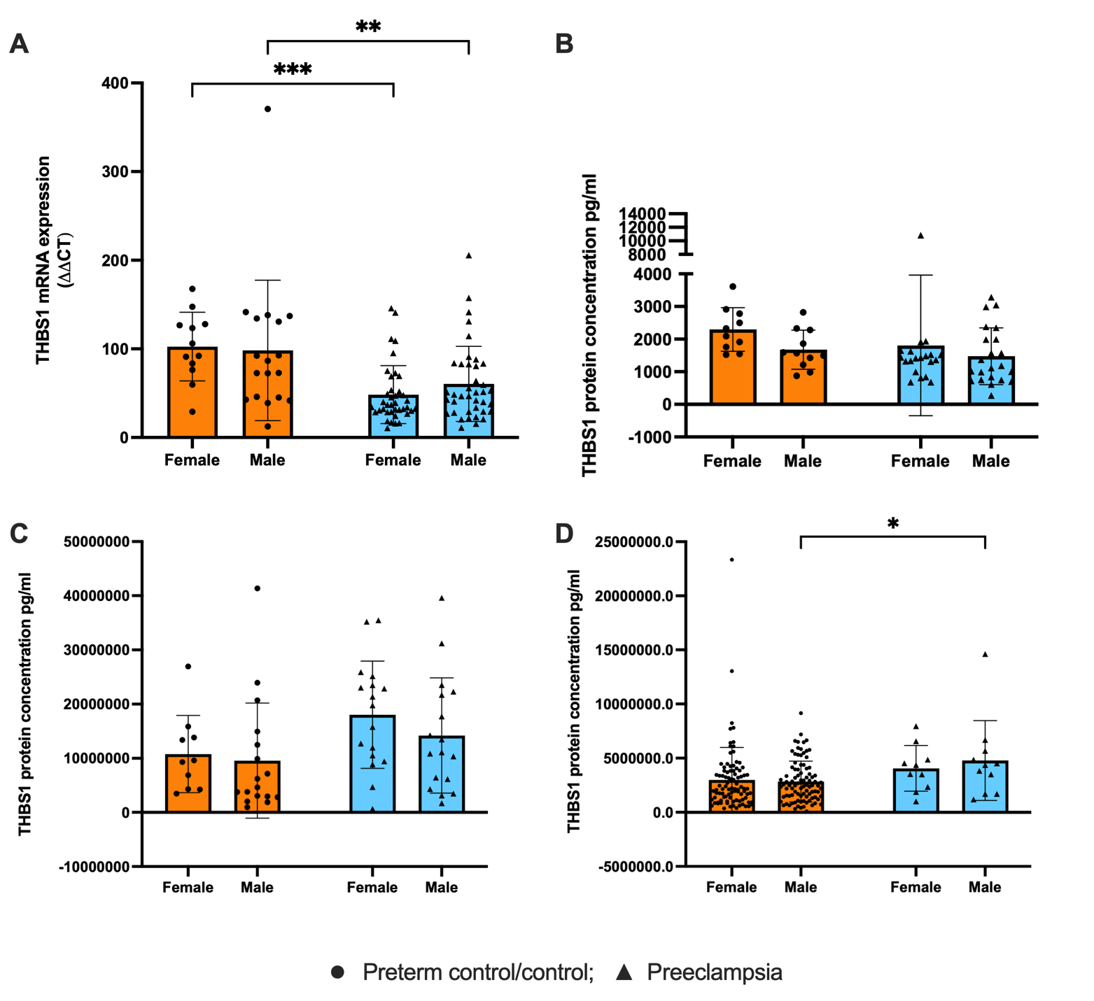
Supplementary figure 1: Analysis of fetal sex correlation with THBS1 mRNA expression and protein secretion/levels. THBS1 expression was compared between control and preeclamptic samples stratified by fetal sex. (A) THBS1 mRNA expression was examined via RT-qPCR in placentas obtained from patients with early-onset preeclampsia (n=78, triangle), relative to gestation-matched controls (n=30, circle). There was a significant reduction in THBS1 mRNA expression in preeclamptic placentas compared with controls for both female (p < 0.001) and male (p < 0.01) pregnancies, with no significant sex-disease interaction. (B) THBS1 protein concentration in placentas obtained from patients with early-onset preeclampsia (n=43, triangle), relative to gestation-matched controls (n=21, circle). THBS1 trended lower in preeclampsia versus control for both sexes, with no sex-disease association. (C) Circulating THBS1 protein concentration in blood from patients with early-onset preeclampsia (n=35, triangle), relative to gestation-matched controls (n=27, circle). Circulating THBS1 levels showed a trend toward increase in preeclampsia compared with controls for both female and male pregnancies, with no significant sex–disease interaction (Supplementary Fig. 1C). (D) Circulating THBS1 measured in the BUMPS cohort - women who developed preeclampsia at term (36 weeks’ gestation) (n=21, triangle) compared to gestation-matched controls (n=184, circle). Circulating THBS1 levels were higher in preeclampsia compared with controls, showing a trend in female pregnancies and a significant increase in male pregnancies (p = 0.0184), with no significant sex–disease interaction. Data are presented as mean ± SD with individual values, statistical analysis by two-way ANOVA. *p<0.05, ** p<0.01, *** p<0.001.

Supplementary figure 2: Dot plot of markers used for cell identities in scRNA-seq analysis. Transcriptomic analysis performed on a publicly available scRNA-seq dataset of n=3 three-dimensional human trophoblast stem cell (hTSC)-derived organoids treated under hTSC conditions or induced to differentiate to extravillous trophoblasts (EVTs) for 21 days [43]. 2 transcriptomic cell states were identified for analysis of THBS1 expression in each cell culture condition: proliferative cytotrophoblast (CTBprol), pre-fusion cytotrophoblast (CTBpf), cytotrophoblast (CTB), progenitor EVT (pEVT), invasive EVT (iEVT) and syncytiotrophoblast (STB).

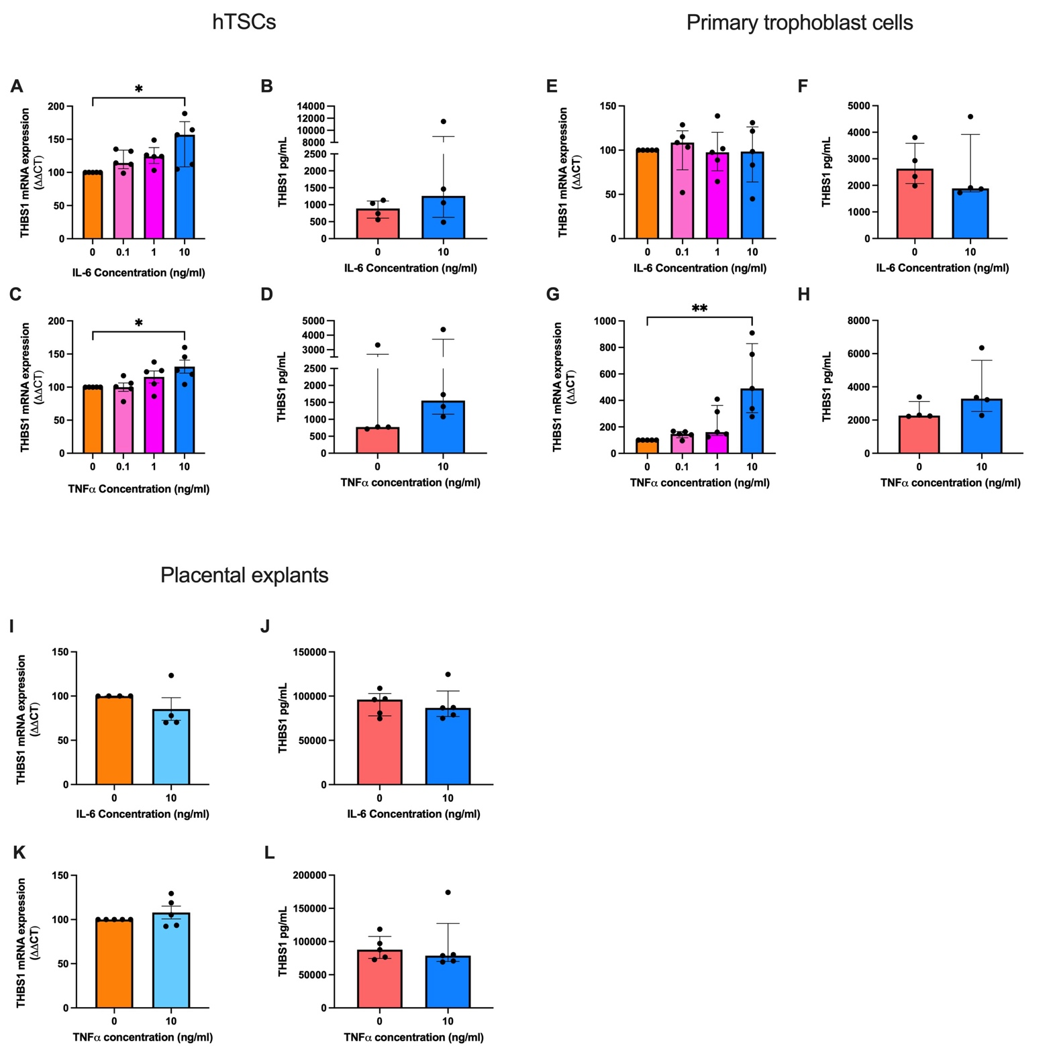
Supplementary figure 3: Inflammatory modulation of THBS1 expression and secretion in trophoblast cells and placental explants. In hTSCs: (A) THBS1 expression was significantly increased following treatment with increased doses of IL-6. (B) THBS1 protein levels were unchanged following treatment with IL-6. (C) THBS1 expression was significantly increased following treatment with increased doses of TNFα. (D) THBS1 protein levels were unchanged following treatment with TNFα. In primary cytotrophoblast cells: THBS1 expression (E) and protein levels (F) were unchanged when treated with IL-6. (G) THBS1 expression was significantly increased following treatment with increased doses of TNFα but protein levels (H) were unchanged. In placental explants: THBS1 expression (I) and protein levels (J) were unchanged following treatment with IL-6. Following treatment with TNFα - THBS1 expression (K) and secretion (L) was unchanged. mRNA expression was normalised to the geometric mean of housekeeper gene(s) depending on the treatment. To calculate significance, one-way ANOVA or Unpaired t test (parametric) or Mann-Whitney U or Kruskal Wallis test (non-parametric) was used where appropriate. Data expressed as mean ± SEM or median ± IQR where relevant. Experiments repeated in n = 4–5 biological replicates, as indicated by data points shown, and in technical triplicates. *p<0.05, ** p<0.01.

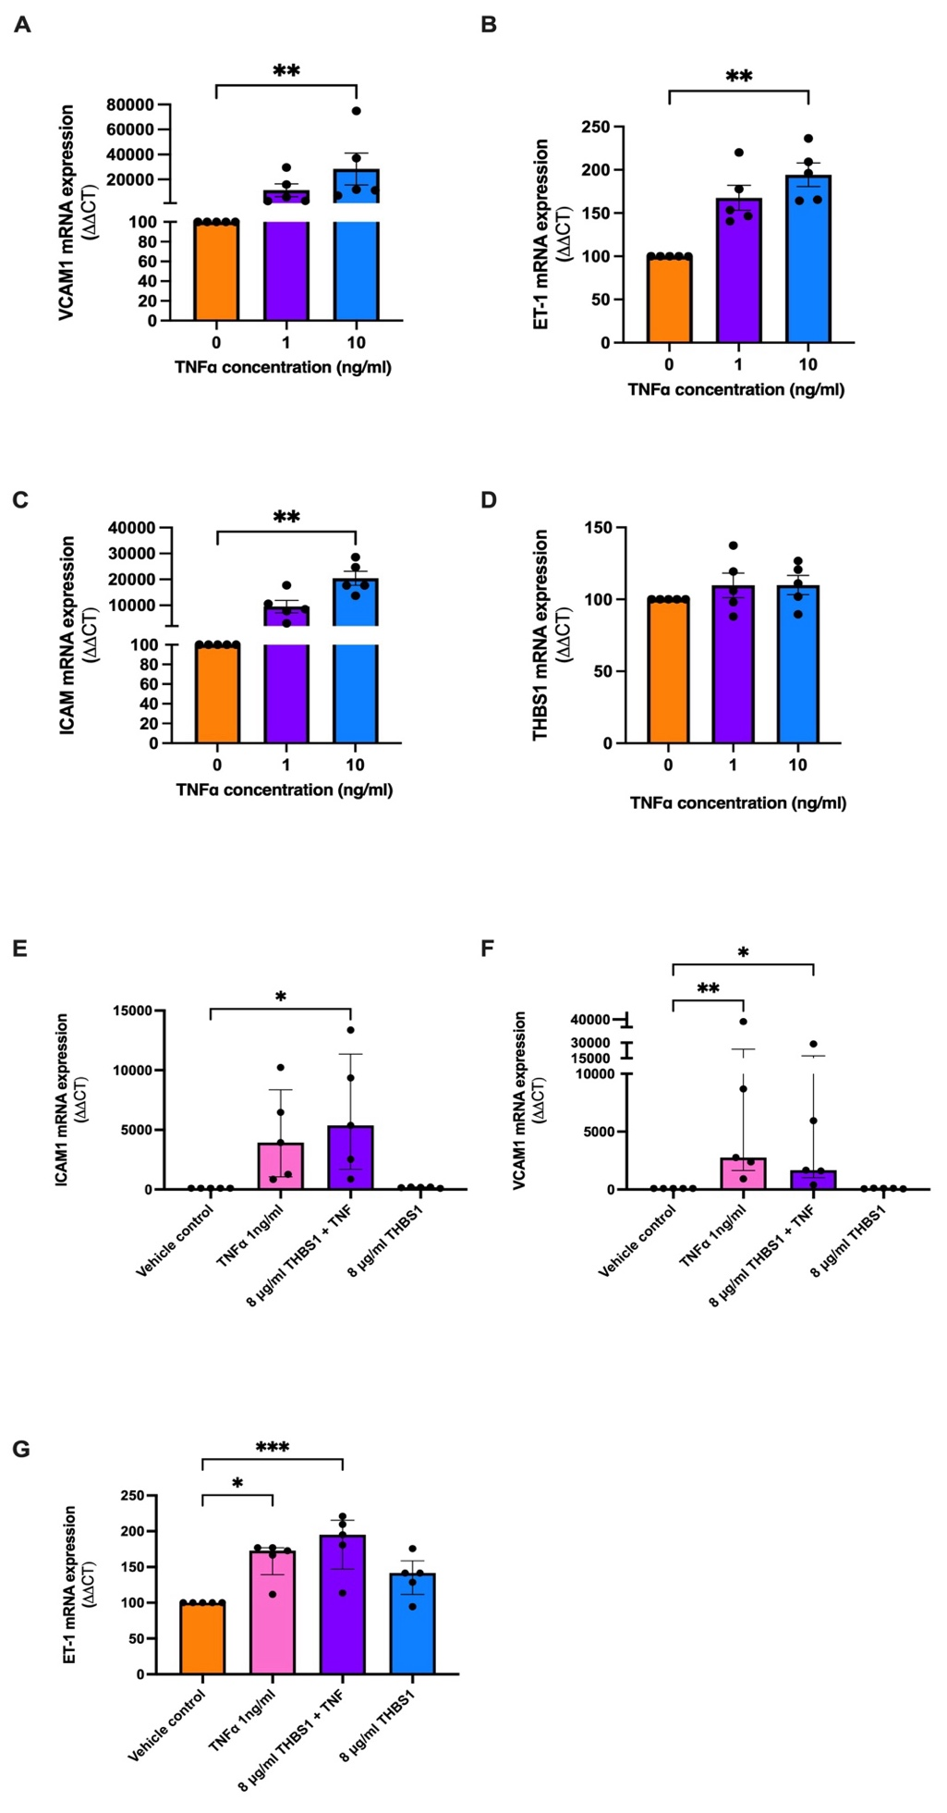
Supplementary figure 4: Induced endothelial dysfunction in HUVECs has no effect on THBS1 expression and recombinant THBS1, alone, has no effect on endothelial dysfunction. Successful induction of endothelial dysfunction in HUVECs was confirmed by significant induction of markers: ICAM1 (A), VCAM1 (B) and ET-1 (C). (D) THBS1 expression in HUVECs was unchanged following treatment with increased doses of TNFα. Induction of endothelial dysfunction in HUVECs was assessed by significant induction of markers: ICAM1 (E), VCAM1 (F) and ET-1 (G). Recombinant THBS1 had no effect on HUVECs with induced dysfunction and HUVECs under control conditions. mRNA expression was normalised to the appropriate housekeeping gene. To calculate significance, Kruskal Wallis test was used. Data expressed as mean ± SEM. Experiments repeated n=5 in duplicate. *** p<0.001, ** p<0.01, * p<0.05.
mRNA expression was normalised to the appropriate housekeeping gene. To calculate significance, Kruskal Wallis test was used. Data expressed as mean ± SEM. Experiments repeated n=5 in duplicate. ** p<0.01.

