Supplementary Materials for

Directed Vascularization in Bone Regeneration Requires Bone Marrow Reconstitution

Julia Mehl, Tobias Thiele, Agnes Ellinghaus, Holger Gerhardt, Georg N. Duda

Figure S1: Exemplary images of the surgical procedure for bone graft transplantation.
Figure S2: The blood vessels were primarily concentrated within the center of the medullary cavity of the bone graft.
Figure S3: Pre-osteoblasts originated from the proximal bone marrow and populated the graft by day 14.
Figure S4: Fibrillar collagen assembly primarily occurred at the host-graft transition zones while being absent within the bone graft.
Figure S5: Vessel sprouts invading the bone graft from the proximal host bone marrow preceded fibrillar collagen.
Figure S6: The flushing of the graft bone marrow resulted in varying vessel orientations at the proximal host-graft transition zone compared to samples that retained their graft bone marrow.
Figure S7: Distribution of tissue components in the bone graft with non-flushed versus flushed bone marrow.

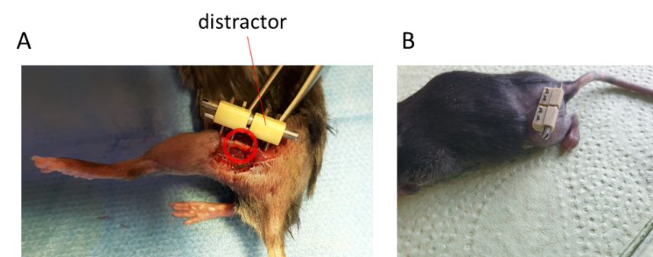

Figure S1: Exemplary images of the surgical procedure for bone graft transplantation. A) Intraoperative view of a mouse in which a 2-mm bone graft was transplanted into the midshaft of the femur and stabilized using a distractor. The distraction system was applied to stabilize both the osteotomy sites and the bone graft. B) Postoperative view showing the sutured wound after surgery. Animals were then returned to their cages for the respective healing period.

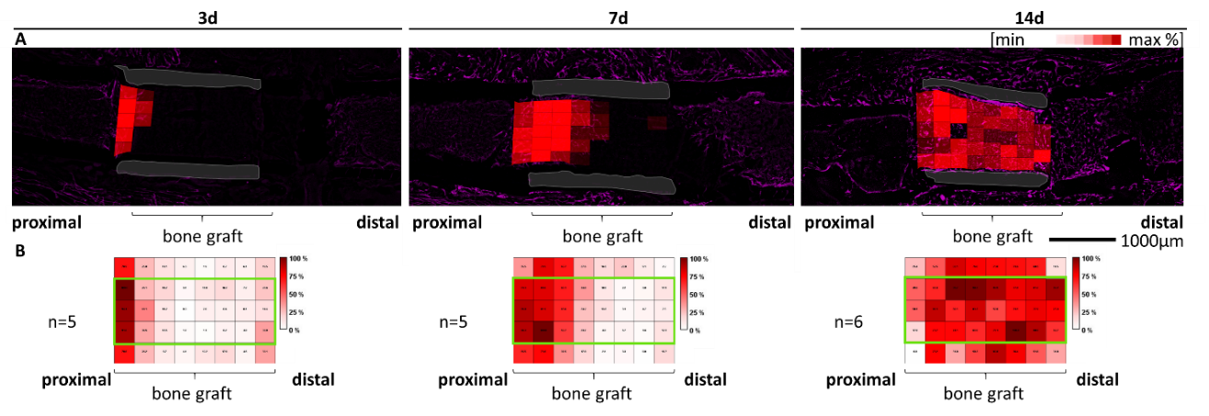

Figure S2: The blood vessels were primarily concentrated within the center of the medullary cavity of the bone graft. A) Vessel density and distribution based on CD146 staining. B) Heat map shows vessel density within the medullary bone graft. The time course from 3 days (n = 5) to 7 days (n = 5) to 14 days (n = 6) after surgery illustrates sprouting of vessels from the proximal to the distal areas. Increased vessel density in the center of the medullary cavity of the bone graft (green box).

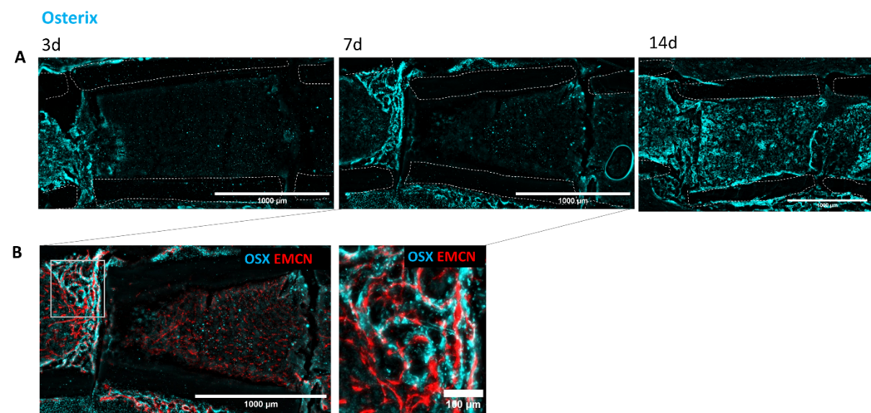
Figure S3: Pre-osteoblasts originated from the proximal bone marrow and populated the graft by day 14. A) At 3 days, OSX-expressing cells began infiltrating the graft from the proximal host bone marrow, progressing to complete graft repopulation by day 14. B) Superimposition of OSX with EMCN staining at the 7-day time point revealed a close spatial association of OSX-expressing cells with blood vessels (scale bar overview images: 1000 µm; zoom-in image: 100 µm).

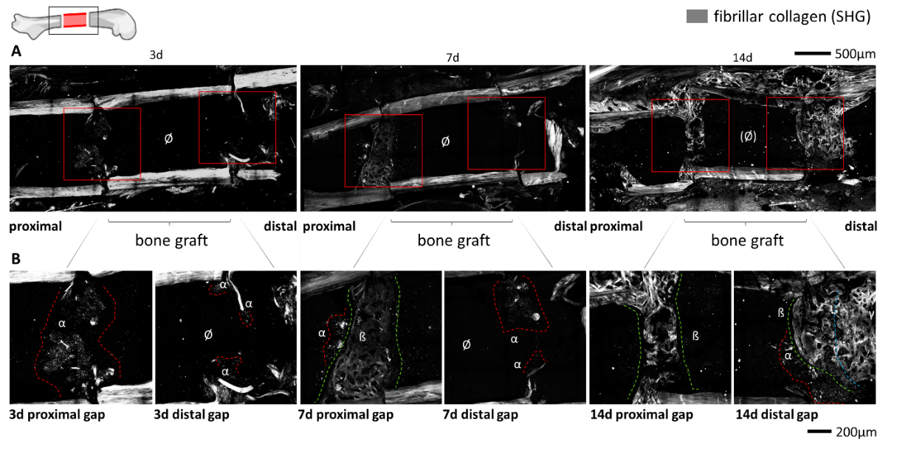
Figure S4: Fibrillar collagen assembly primarily occurred at the host-graft transition zones while being absent within the bone graft. A) To visualize fibrillar collagen, second harmonic generation (SHG) imaging was performed on the previously shown samples for 3 days, 7 days and 14 days post-transplantation (Figures 3-6). Overview images of the host bone with the bone graft illustrates the absence of fibrillar collagen in the bone graft itself, while fibrillar collagen was assembled at the transition zones. B) Zoom-in images showing the proximal and distal gaps. At the 3-day time point, clear punctate structures are visible in the proximal gap arising from SHG imaging, while almost completely absent in the distal area. On the 7th day after the surgery, the proximal gap shows collagen formation with a fibrillar structure, while in the distal area dot-like structured formations begin. 14 days after the surgery, dense collagen fiber structures are visible in both the proximal and distal areas. Gray = fibrillar collagen by SHG, red dashed area α = initiation of fibrillar collagen assembly by point structure formations; green dashed area ß = formation of mature fibrillar collagen, Ø = area absent of fibrillar collagen; blue dashed area γ = pin-callus.

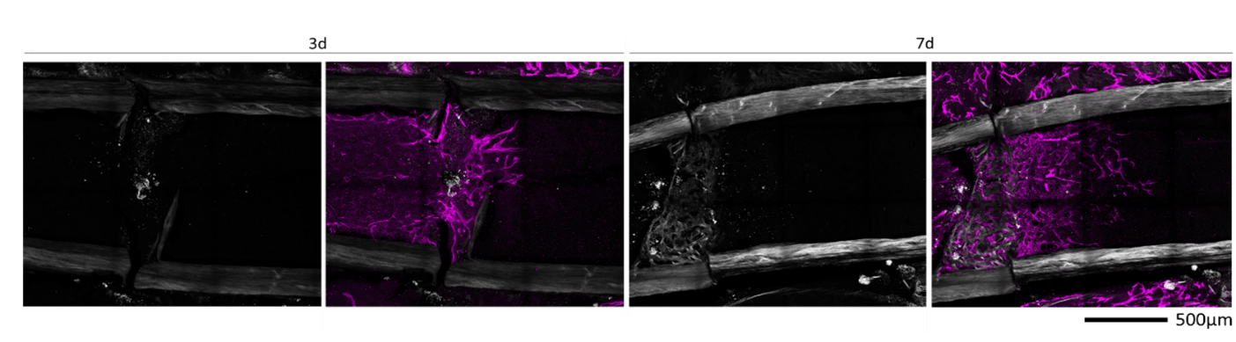
Figure S5: Vessel sprouts invading the bone graft from the proximal host bone marrow preceded fibrillar collagen. Fibrillar collagen, depicted by SHG, was superimposed with CD147 staining for blood vessel visualization. At 3 days post-transplantation, minimal fibrillar collagen was observed, while vessel sprouts penetrated the bone graft's bone marrow. By 7 days, fibrillar collagen began assembly at the proximal gap. Importantly, the appearance of vessel sprouts preceded the development of fibrillar collagen, penetrating the bone graft. Gray indicates fibrillar collagen (SHG), while magenta represents blood vessels (CD146).

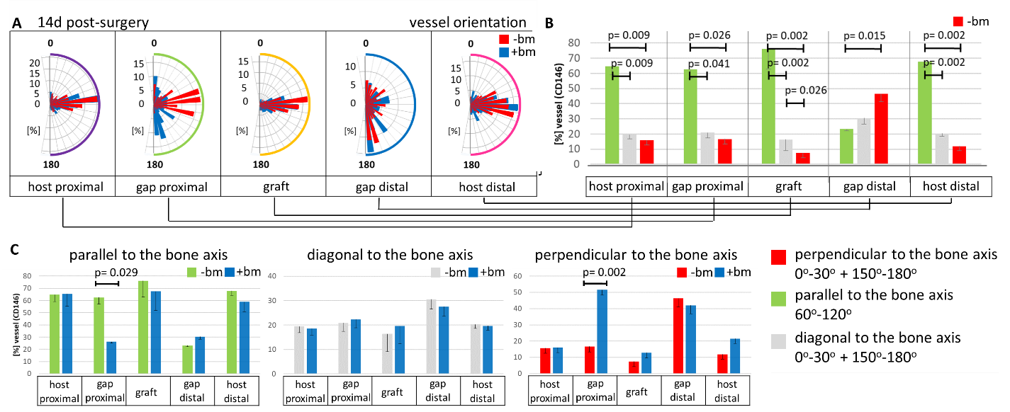

Figure S6: The flushing of the graft bone marrow resulted in varying vessel orientations at the proximal host-graft transition zone compared to samples that retained their graft bone marrow. A) Vessel orientations 14 days after surgery, comparing the flushed bone graft (-bm) to the non-flushed graft (+bm). The orientation analysis of vessels in specific zones is represented by different colors (violet=proximal host bone, green=proximal gap, blue=distal gap, pink=distal host bone, yellow= proximal vessel ingrowth). Orientation plots (polar rose chart) showing the percentage of orientation from 0-180°. Red indicates graft -bm at 14 days post-surgery, while blue represents graft +bm at 14 days post-surgery. B) Orientations were further categorized as perpendicular (red, 0-30° or 150-180°), diagonal (grey, 30-60° or 120-150°) or parallel (green, 60-120°) to the central bone axis. C) Comparison of grouped orientations between the flushed and non-flushed grafts at 14 days post-surgery. Samples with flushed bone marrow exhibited vessels aligning parallel to the bone axis at the host-graft transition zone. This is in stark contrast to samples containing non-flushed bone marrow, where vessels mainly aligned perpendicular to the bone axis at the proximal host-graft transition zone. However, vessel orientations in other areas remained comparable between both groups.
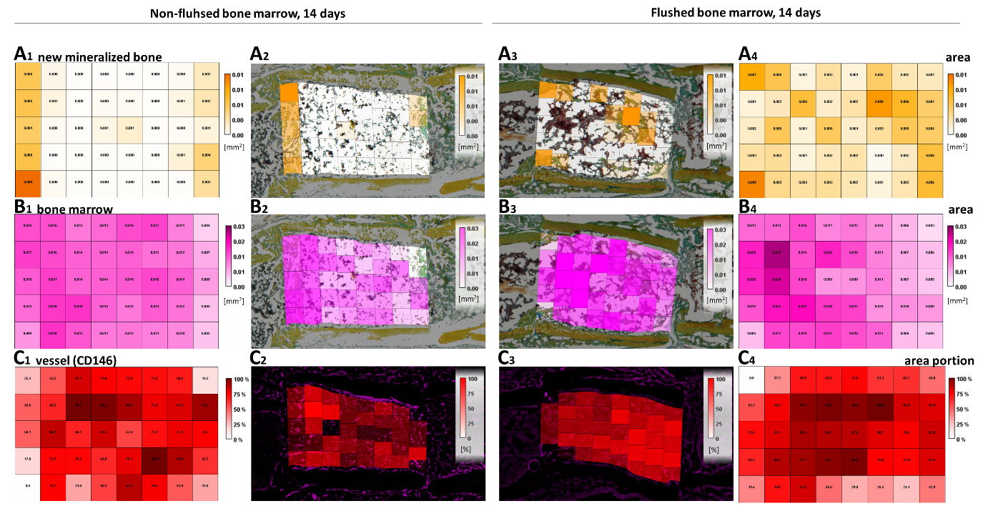
Figure S7: Distribution of tissue components in the bone graft with non-flushed versus flushed bone marrow. A) Distribution of new mineralized bone density within the graft, with the color scale ranging from 0 = white to 0.01 = dark orange. Subsections A1 and A4 show combined heat maps for the respective groups (+bm and -bm). A2 and A3 illustrate such analyses based on Movat pentachrome staining and provide example images for each group. B) Distribution of bone marrow density within the graft using a color scale from 0 = white to 0.07 = dark purple. Subsections B1 and B4 show combined heat maps for the groups (+bm and -bm). B2 and B3 show such analyses based on Movat pentachrome staining with example images for each group. C) Distribution of vessel density within the graft, using a color scale from 0 = white to 100 = dark red. Subsections C1 and C4 show combined heat maps for the groups (+bm and -bm). C2 and C3 show such analyses based on CD146 immunofluorescence staining and include example images for each group.

