Supplementary material
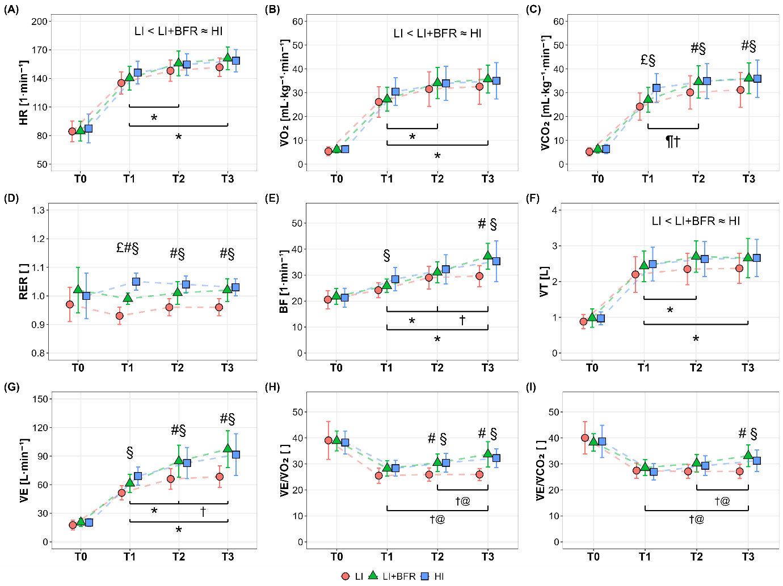
Supplementary figure S1. Cardiorespiratory responses during low-intensity continuous cycling (LI), LI with blood flow restriction (LI+BFR), and high-intensity interval cycling (HI). (A) heart rate (HR), (B) oxygen consumption (V̇O₂), (C) carbon dioxide release (V̇CO₂), (D) respiratory exchange ratio (RER), (E) breath frequency (BF), (F) tidal volume (VT), (G) minute ventilation (V̇E), (H) ventilatory equivalent for oxygen (V̇E/V̇O₂), (I) ventilatory equivalent for carbon dioxide (V̇E/V̇CO₂). Data are depicted as means ± standard deviations for the baseline (T0) and three 4-min blocks during the exercise period (T1: 0 – 4 min, T2: 8 – 12 min, and T3: 16 – 20 min). §p < 0.05, between LI and HI; #p < 0.05, between LI and LI+BFR; £p < 0.05, between LI+BFR and HI; †p < 0.05, difference between time points within LI+BFR; @p < 0.05, difference between time points within HI; Main condition effect across time points is depicted above individual figures, < (p < 0.05) and ≈ (p > 0.05); *p < 0.05, difference between time points (main time effect across conditions).

