# Supplementary Materials

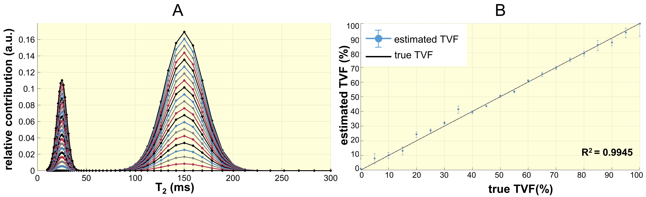

**Figure S.1**: **Assessing bi-exponential fitting error (A)** Simulated multi-compartment spectrum based on T2_short and T2_long values derived from spectral analysis. The multi-compartment model was developed for a multi-echo spin-echo signal decay using a Bloch simulation. Gaussian-distributed white noise was added to achieve an SNR (mean/σ) comparable to that observed in magnitude images from *in vivo* studies. Simulated T2 decay curves were generated by repeating simulations across 60 logarithmically spaced T2 values between 10 ms and 300 ms, with the long component's contribution varying from 0% to 100%. Other simulation parameters were consistent with those used in short TE range protocol (first TE=6.4 ms, ΔTE=6.4 ms, 13 echoes, αrefocusing pulse°=170° to reflect imperfect refocusing). **(B)** TVF assessment with bi-exponential fitting, as similar to *in vivo* TVF assessment, was performed with T2_short constrained to 10–40 ms and T2_long fixed at 150 ms Results show strong agreement between ground truth TVF and fitted values.