Supplementary Material

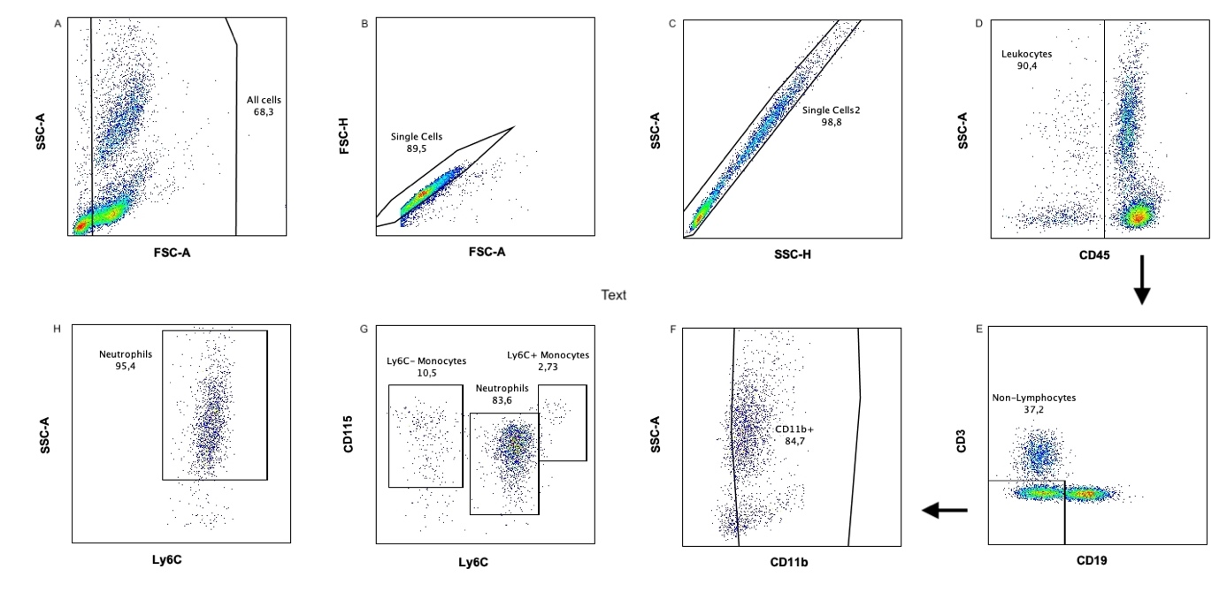
Suppl. Figure: Flow cytometric dot plots of mouse blood 48h after induction of deep vein thrombosis. Identification of all leukocytes (D), monocytes (G) and free neutrophils (H).

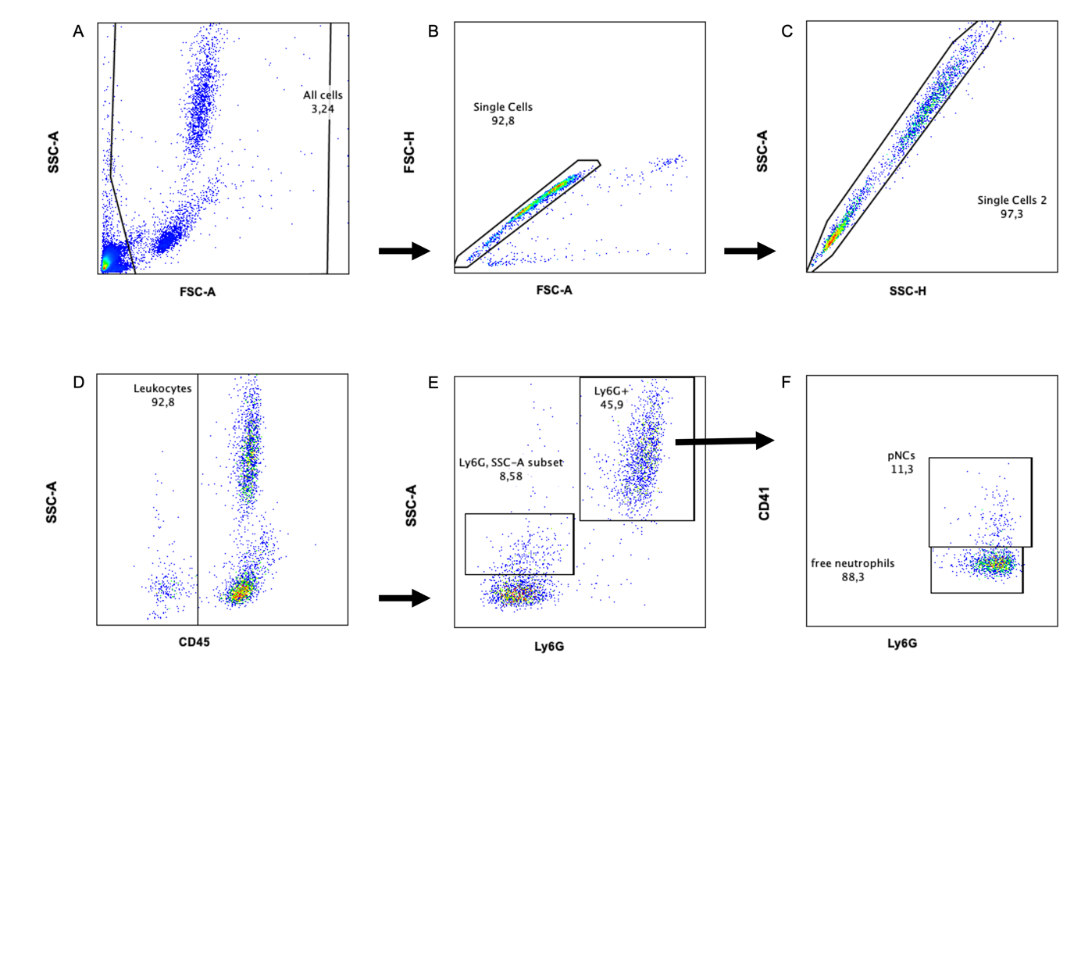
Suppl. Figure: Flow cytometric dot plots of mouse blood 48h after induction of deep vein thrombosis. Identification of all leukocytes (D), all neutrophils (E) and platelet-neutrophil-complexes (F).

