**Supplementary Figure 1:**

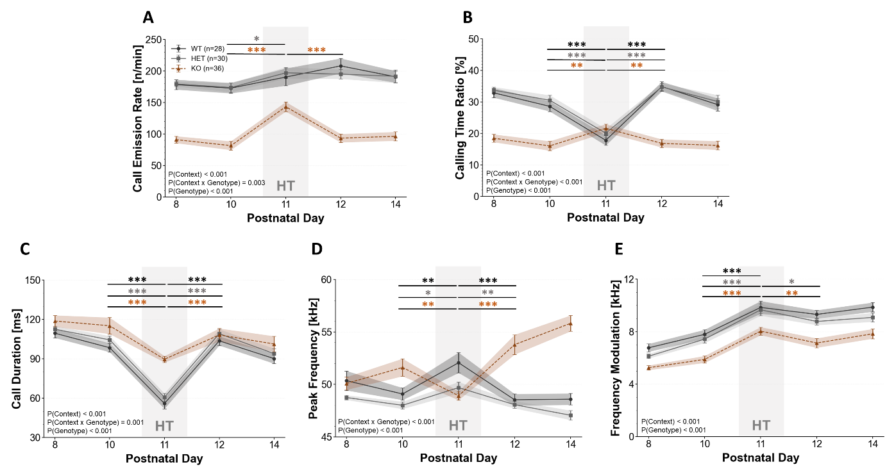

**Supplementary Figure 1: *Tph2* deficiency in neonatal rats leads to alterations in social adjustment and socio-affective communication, as reflected in the emission of isolation-induced ultrasonic vocalizations (USV) when exposed to social test conditions, i.e., maternal preference test and homing test, compared to non-social test conditions, i.e., isolation box test.** Developmental trajectories of (**A**) call emission rate (n/min), (**B**) calling time ratio (%), (**C**) call duration (ms), (**D**) peak frequency (kHz), and (**E**) frequency modulation (kHz) of isolation-induced USV emitted by *Tph2−/−* knockout (KO; red triangle), *Tph2+/−* heterozygous (HET; gray square), and *Tph2+/+* wildtype (WT, black circle) rat pups across P8 to P14 during the exposure to the isolation box and on P11 during the homing test (HT, light gray highlighting). P = postnatal day. Data are expressed as mean±SEM. Within WT: ***(black) p<.001; **(black) p<.010. Within HET: ***(gray) p<.001; **(gray) p<.010; *(gray) p<.050. Within KO: ***(red) p<.001; **(red) p<.010. Of note, all five test days (i.e., before, during, and after social context change) were included in the ANOVAs for repeated measurements, yet *post-hoc* tests were applied exclusively for comparing P7 (maternal preference test) and P11 (homing test) to the days before and after, i.e., P7 vs. P6/ P8 and P11 vs. P10/ P12, respectively, for the sake of clarity. Because of the inclusion of all three genotypes, the statistical approach applied here differed slightly as compared to the corresponding Figure 2. Number of rats: N(WT)=28, N(HET)=30, N(KO)=36.

**Supplementary Figure 2:**

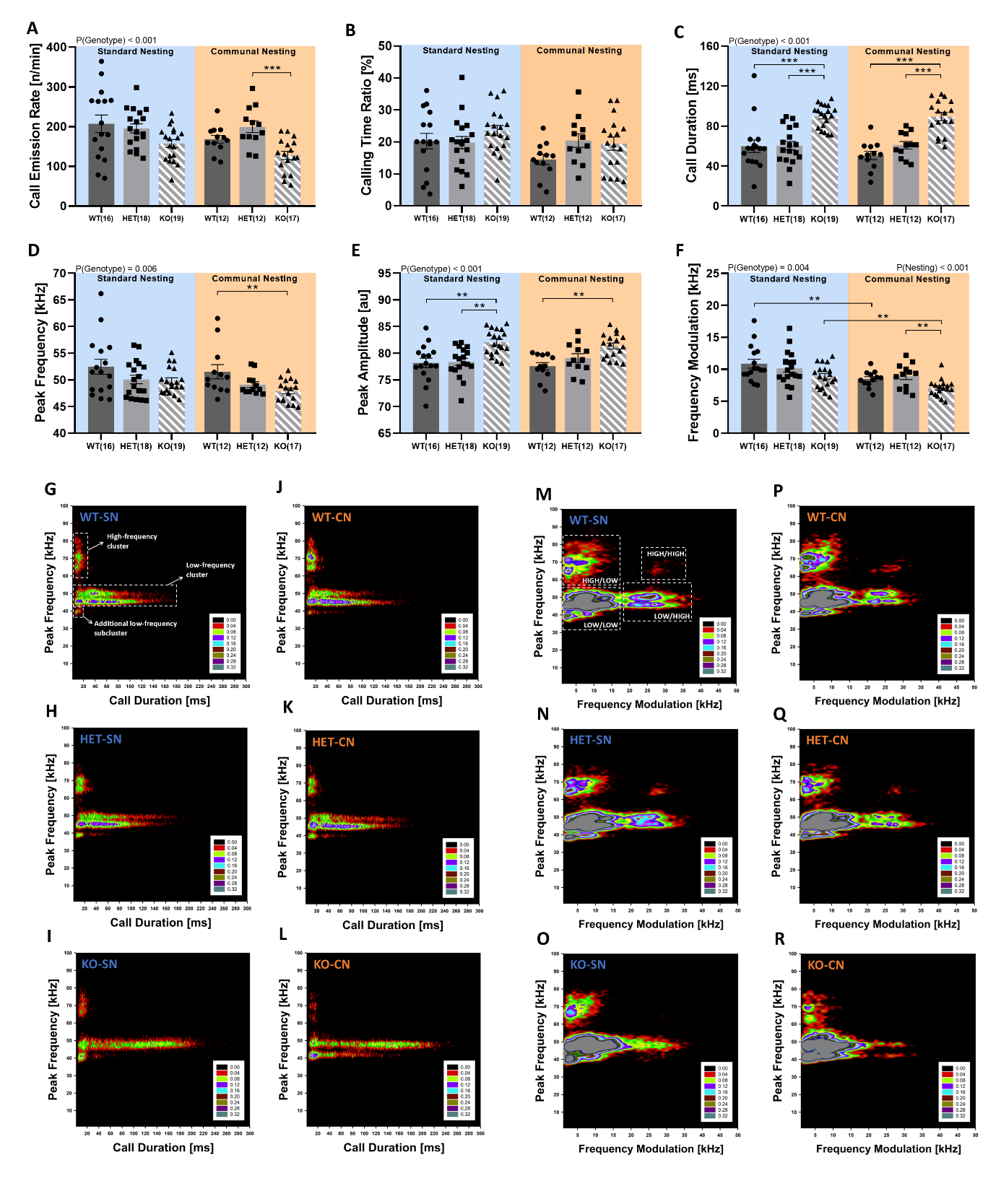

**Supplementary Figure 2:** ***Tph2* deficiency in neonatal rats causes robust changes in socio-affective communication under social test conditions, i.e., homing test, only mildly modulated by communal nesting, as reflected in the emission of isolation-induced ultrasonic vocalizations (USV) and the clustering of their subtypes during the homing test.** (**A**) Call emission rate (n/min), (**B**) calling time ratio (%), (**C**) call duration (ms), (**D**) peak frequency (kHz), **(E)** peak amplitude (au), and (**F**) frequency modulation (kHz) of isolation-induced USV emitted during the homing test on postnatal day 11 by *Tph2−/−* knockout (KO; triangle), *Tph2+/−* heterozygous (HET; square), and *Tph2+/+* wildtype (WT, circle) rat pups. (**G-R**) Density plots depicting the distribution of individual isolation-induced USV in *Tph2-/-* knockout (KO) and *Tph2+/-* heterozygous (HET) rat pups, as compared to *Tph2+/+*wildtype (WT) littermate controls, depending on nesting condition, i.e., WT-SN (**G**, **M**; ~33,000 calls), WT-CN (**J**, **P**; ~20,000 calls), HET-SN (**H,N**;~35,000 calls), HET-CN (**K,Q**;~24,000 calls), KO-SN (**I**, **O**; ~30,000 calls), and KO-CN (**L**, **R**; ~22,000 calls). Color coding reflects frequencies as percentages. SN = standard nesting (blue), CN = communal nesting (orange). Data are expressed as mean±SEM. *** p<.001; ** p<.010. Of note, because of the inclusion of all three genotypes, the statistical approach applied here differed slightly as compared to the corresponding Figure 3. Number of rats: N(WT-SN)=16, N(HET-SN)=18, N(KO-SN)=19, N(WT-CN)=12, N(HET-CN)=12, N(KO-CN)=17.

**Supplementary Figure 3:**

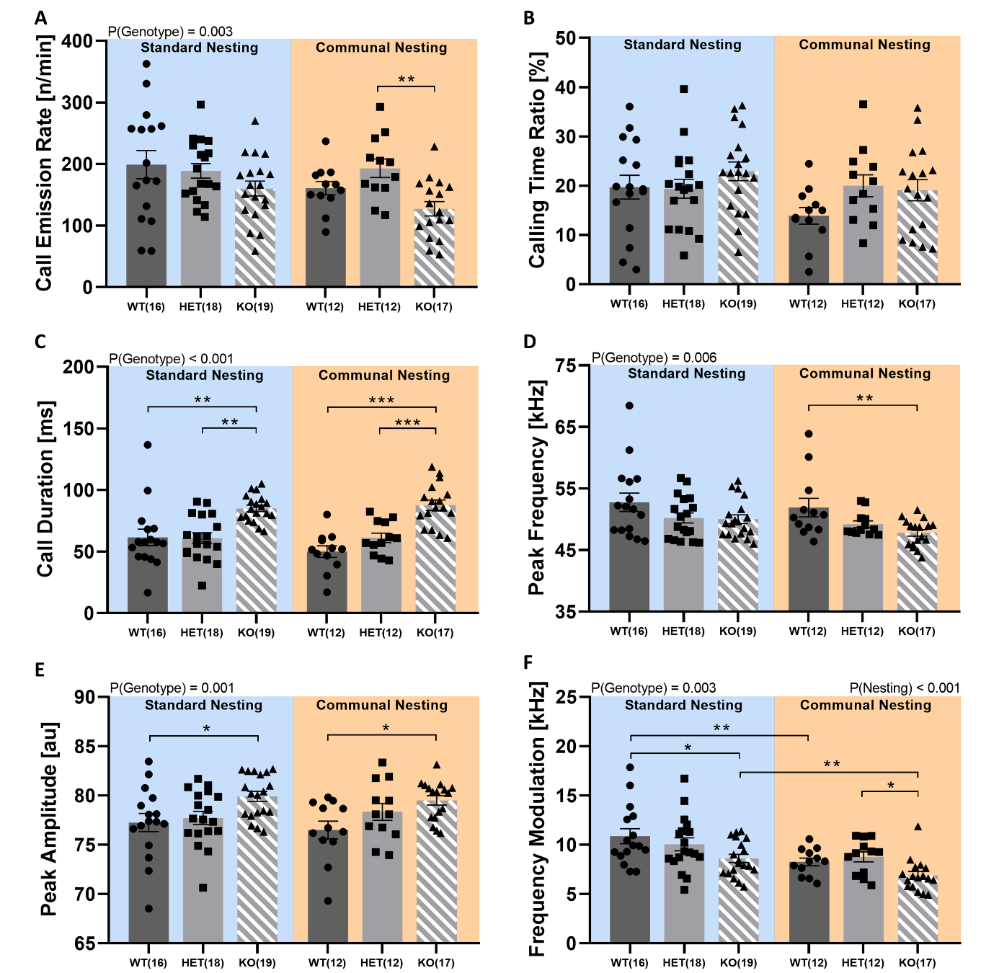

**Supplementary Figure 3: *Tph2* deficiency in neonatal rats causes robust changes in socio-affective communication under social test conditions, i.e., homing test, only mildly modulated by communal nesting, as reflected in the emission of isolation-induced ultrasonic vocalizations (USV) in the soiled bedding zone of the homing test.** (**A**) Call emission rate (n/min), (**B**) calling time ratio (%), (**C**) call duration (ms), (**D**) peak frequency (kHz), **(E)** peak amplitude (au), and (**F**) frequency modulation (kHz) of isolation-induced USV emitted during the homing test on postnatal day 11 by *Tph2−/−* knockout (KO; triangle), *Tph2+/−* heterozygous (HET; square), and *Tph2+/+* wildtype (WT, circle) rat pups while being in the soiled bedding zone.SN = standard nesting (blue), CN = communal nesting (orange). Data are expressed as mean±SEM. *** p<.001; ** p<.010; * p<.050. Number of rats: N(WT-SN)=16, N(HET-SN)=18, N(KO-SN)=19, N(WT-CN)=12, N(HET-CN)=12, N(KO-CN)=17.

**Supplementary Figure 4:**

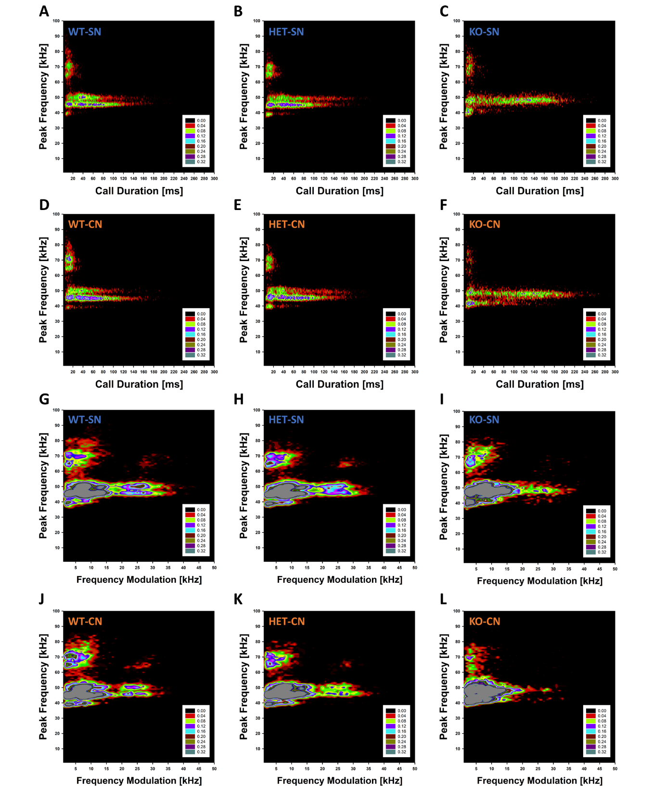

**Supplementary Figure 4: *Tph2* deficiency in rats is associated with changes in the clustering of subtypes of isolation-induced ultrasonic vocalizations (USV) in the soiled bedding zone of the homing test.** (**A-L**) Density plots depicting the distribution of individual isolation-induced USV in *Tph2-/-* knockout (KO) and *Tph2+/-* heterozygous (HET) rat pups, as compared to *Tph2+/+*wildtype (WT) littermate controls, depending on nesting condition, i.e., WT-SN (**A**, **G**; ~28,000 calls), WT-CN (**D**, **J**; ~18,000 calls), HET-SN (**B**, **H**; ~31,000 calls), HET-CN (**E**, **K**; ~21,000 calls), KO-SN (**C**, **I**; ~12,000 calls), and KO-CN (**F**, **L**; ~11,000 calls). Color coding reflects frequencies as percentages. SN = standard nesting (blue), CN = communal nesting (orange). Of note, individual isolation-induced USV depicted here were recorded on postnatal day 11 during the homing test, exclusively while rat pups were in the soiled bedding zone. Number of rats: N(WT-SN)=16, N(HET-SN)=18, N(KO-SN)=19, N(WT-CN)=12, N(HET-CN)=12, N(KO-CN)=17.

**Supplementary Figure 5:**

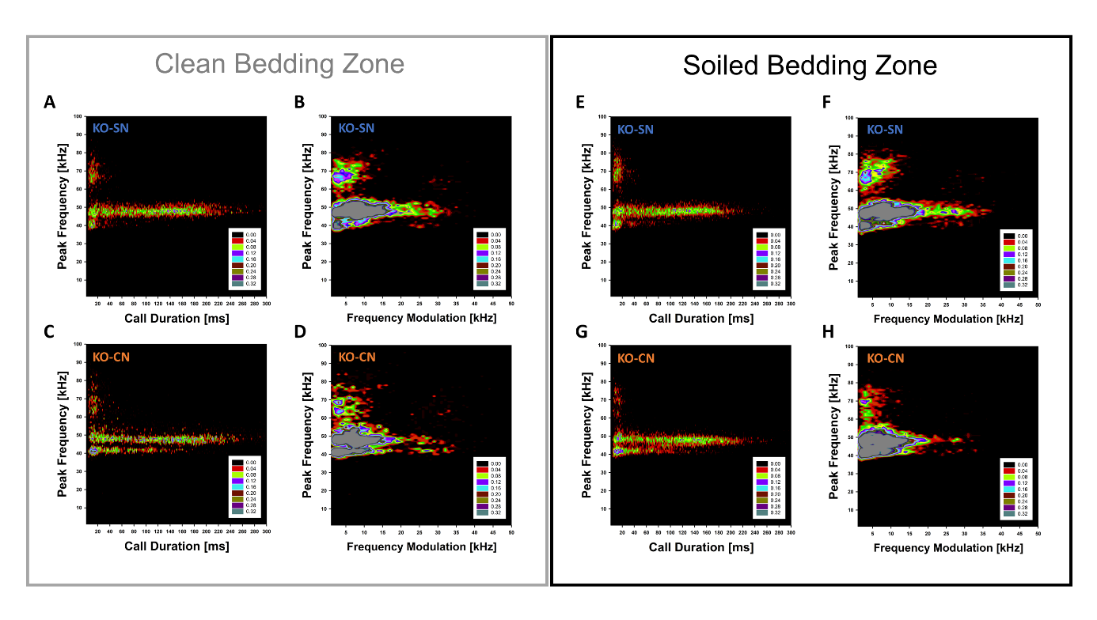

**Supplementary Figure 5: *Tph2* deficiency in rats is associated with changes in the clustering of subtypes of isolation-induced ultrasonic vocalizations (USV) in the homing test, moderately modulated by different bedding zones.** Density plots depicting the distribution of individual isolation-induced USV from clean bedding zone **(A-D)** versus soiled bedding zone **(E-H)** in *Tph2-/-* (KO), depending on nesting condition, i.e., KO-SN in clean bedding zone (**A, B**; ~8,800 calls), KO-CN in clean bedding zone (**C**, **D**; ~4,200 calls), KO-SN in soiled bedding zone (**E**, **F**; ~12,000 calls), KO-CN in soiled bedding zone (**G**, **H**; ~11,000 calls). Color coding reflects frequencies as percentages. SN = standard nesting (blue), CN = communal nesting (orange). Individual isolation-induced ultrasonic vocalizations depicted here were recorded on postnatal day 11 during the homing test.