Supplementary Materials for

**Advanced Peptide Nanoparticles Enable Robust and Efficient delivery of gene editors across cell types**

Oskar Gustafsson *et al.*

*Corresponding author. Email: Samir.EL-Andaloussi@ki.se

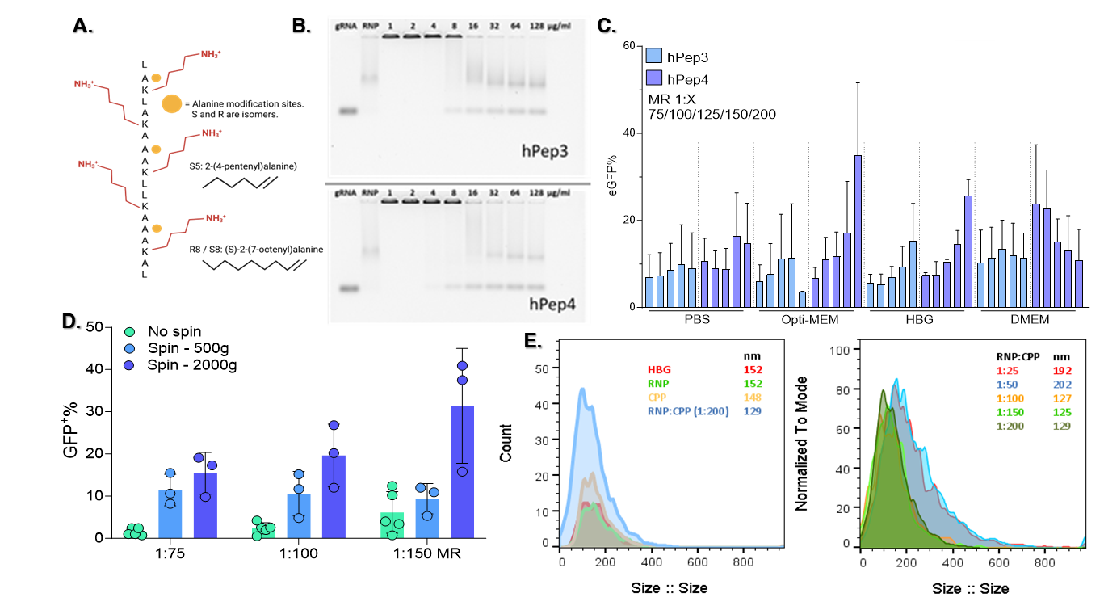

**Supplementary Figure 1. Structure, stability, size, and optimization of RNP:CPP complexes.**

**A.** Amino acid backbone of the hPep peptide with alanine modification sites marked out. **B.** Hexametaphosphate challenge of formed RNP-CPP particles (in HBG), where the hexametaphosphate disrupts both Cas9 – gRNA and RNP – CPP interactions. A larger amount of hexametaphosphate before complex disruption indicates more stable particles. **C.** Testing of hPep3 and hPep4 in different buffers with increasing MR (200 ng Cas9 per 96-well. HEK293T SL cells). Mean value of n=3 independent experiments ± SD. **D.** Spinfection testing of hPep:RNP particles (in HBG). The 96-well plates were spun for 30 min after adding nanoparticles (50 ng Cas9 per 96-well, HEK293T cells). Mean value of n=3 independent experiments ± SD. **E.** ZetaView analysis of hPep3-Cas9 RNP particles formed in HBG. The left graph shows particle size and count. The right graph shows the normalized count and size of increasing RNP:CPP MR. At lower MR, the particles are more heterogeneous and larger, while at 1:100 and above, the population decreases in size down to around 130 nm. 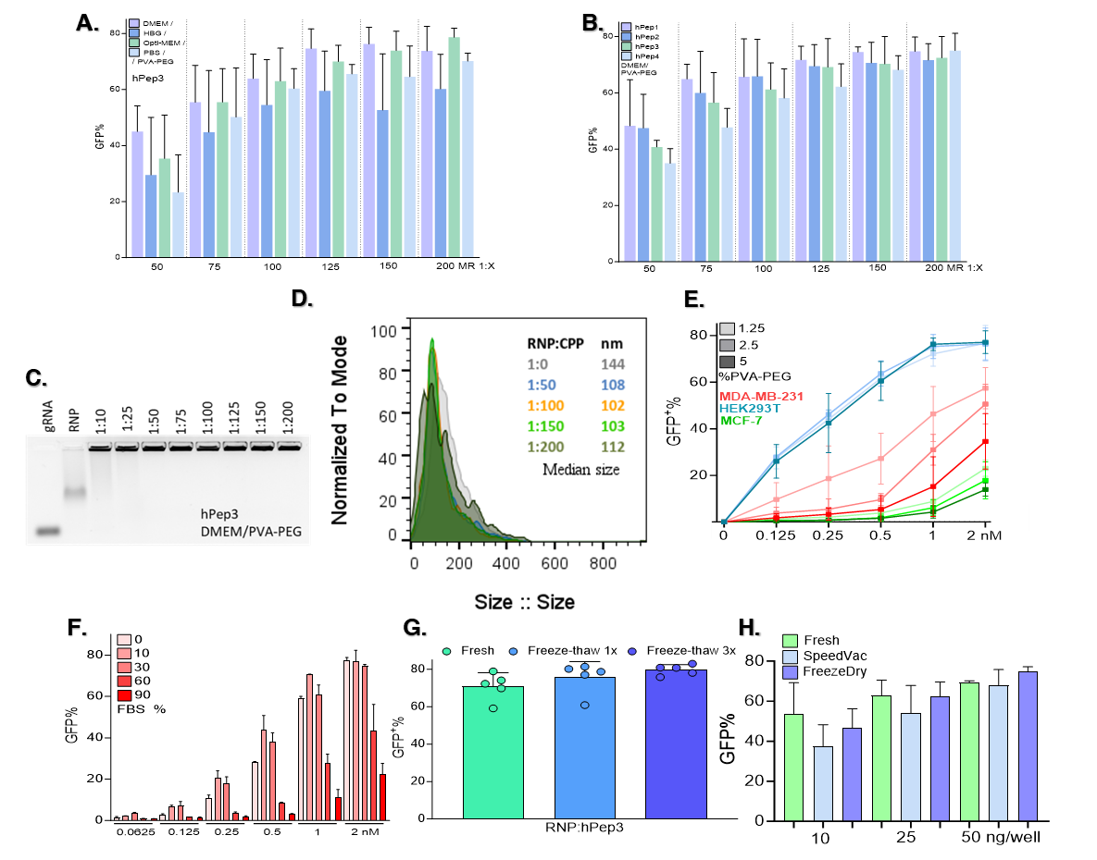**Supplementary Figure 2. Optimization and testing of Cas9:hPep3 in challenging conditions.**

**A.** Buffer testing when using PVA-PEG in the solution (5 w/v%) with increasing MR (25 ng Cas9 per 96-well, HEK293T cells). Mean value of n=3 independent experiments ± SD. **B.** Testing of hPep1-4 in DMEM/PVA-PEG (5 w/v%) with increasing MR (25 ng Cas9 per 96-well, HEK293T cells). Mean value of n=3 independent experiments ± SD. **C.** Gel mobility assay of RNP-hPep3 formed in DMEM/PVA-PEG. The RNP was formed using ATTO550-tagged trRNA. **D.** ZetaView analysis of hPep3-Cas9 RNP particles formed in DMEM/PVA-PEG. The graph shows the normalized count and size of increasing RNP:CPP MR. **E.** RNP-hPep3 testing in challenging cell lines, MDA-MD-231 and MFC-7, with different w/v% of PVA-PEG in the solution. Mean value of n=3 independent experiments ± SD. **F.** Testing of Cas9-hPep3 in increasing serum concentrations with a 2 h media change. Mean value of n=independent experiments ± SD. **G.** Freeze-thaw testing of formed RNP-hPep3 complexes (50 ng per 96-well, HEK293T). Mean value of n=5 independent experiments ± SD. **H.** Testing of RNP-hPep4 compatibility with different storage methods (10/25/50 ng Cas9 per 96-well, HEK293T cells). Mean value of n=3 independent experiments ± SD.

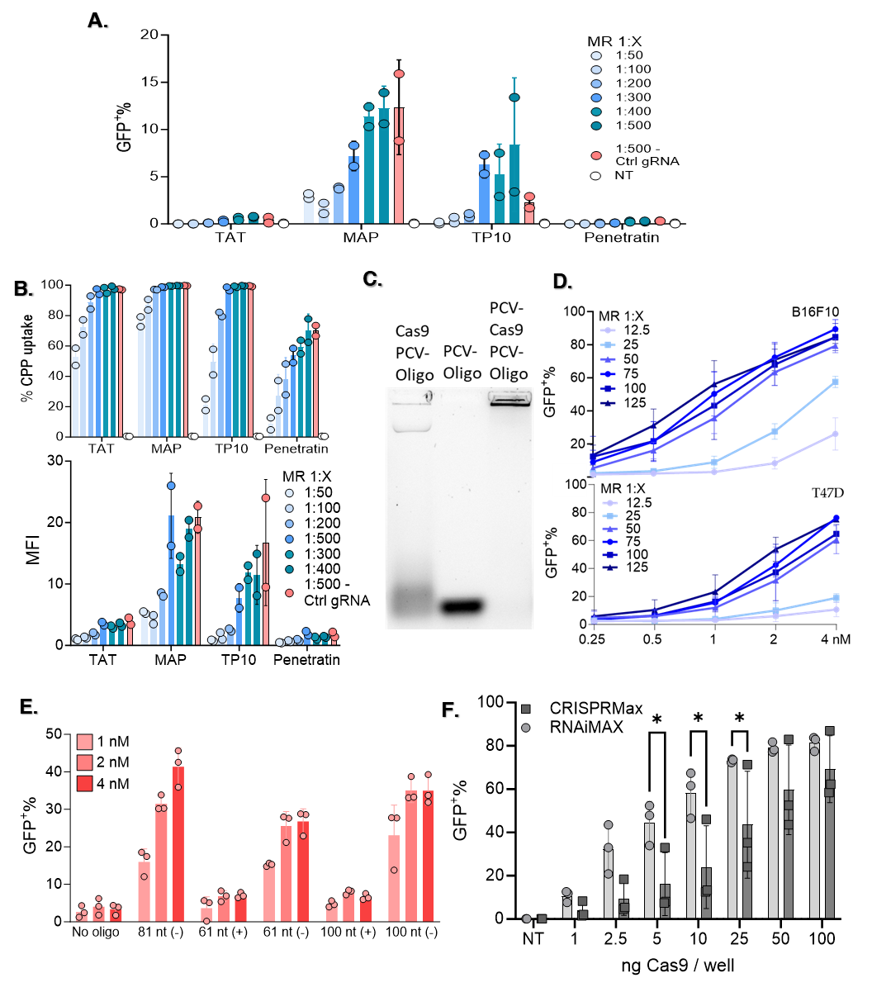**Supplementary Figure 3. Activity of alternative CPPs, extended HDR, Cre delivery, and positive controls. A&B**. Editing and uptake using older generations of CPPs. CPPs (TAT (Transactivating transcriptional), MAP(model amphipathic peptide), TP10 (transportan 10), Penetratin), were labelled with Oregon Green 488 Dye. A negative control, using a non-cleaving gRNA, was used to set gates for GFP readout. Analysis was done after 3 days. The uptake shows both % of cells positive for the CPP and the MFI (mean fluorescence intensity) of these cells. The ctrl gRNA has no activity in SL cells. Mean value of n=2 independent experiments ± SD. **C.** Gel electrophoresis of Cas9/PCV-Cas9 incubated with PCV-oligo showed that PCV-Cas9 can bind to PCV-oligo. **D.** Cre screening in breast cancer-derived B16F10 (murine) and T47D (human) cell lines harboring the TL reporter. Cre recombinase was complexed with hPep3 in DMEM/PVA-PEG buffer with increasing MR and added to cells in increasing doses. Mean value of n=3 independent experiments ± SD. **E.** Cas9 mediated HDR screening as in Fig 2C., but now also displaying the ssDNA matching the (+) strand of the target DNA. With the editing rates achieved by the (+) binding oligos barely going over the no oligo control. Mean value of n=3 independent experiments ± SD. **F.** Comparison of RNAiMAX vs CRISPRMax for the delivery of Cas9 to HEK293T SL cells. 100 ng Cas9/well corresponds to approximately 5.5 nM. Results were analysed using 2-way ANOVA and multiple comparisons (* indicating statistical significance of p<0.05 Mean value of n=3 independent experiments ± SD.

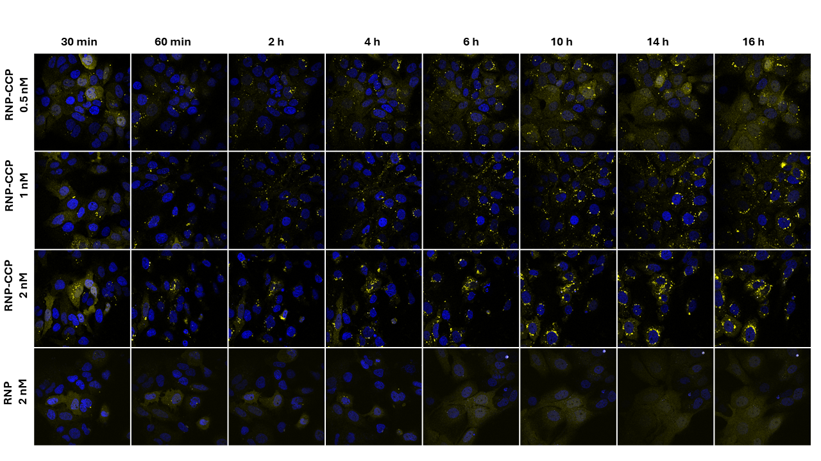

**A.**

**B.**



**C.**



**D.**



**Supplementary Figure 4. Extended results showing the rapid endosomal rupture/gene editing and negation of adverse cellular effects.**

**A.** Representative images of Huh7 Gal9-mCherry reporter cells treated with RNP-hPep3 (MR 1:125) at increasing concentrations. Cells were imaged between 30 min and 16 h post-treatment, with puncta quantified at each time point. Hoechst (blue) and mCherry (yellow) were used. **B.** RNAiMAX editing (green left y-axis) and WST-1 outcomes (blue right y-axis) with increasing doses added to HEK293T cells. Mean value of n=3 independent experiments ± SD. **C.** Effect of medium change at different time points after RNP-CPP treatment of HEK293T SL cells on gene editing efficiency (green left y-axis) and WST-1 outcome (blue right y-axis). Mean value of n=3 independent experiments ± SD. **D.** The kinetics of RNAiMAX transfection of HEK293T SL cells were tested by changing media at 2h. Media change for RNAiMAX strongly reduced transfection efficiency. Mean value of n=3 independent experiments ± SD.

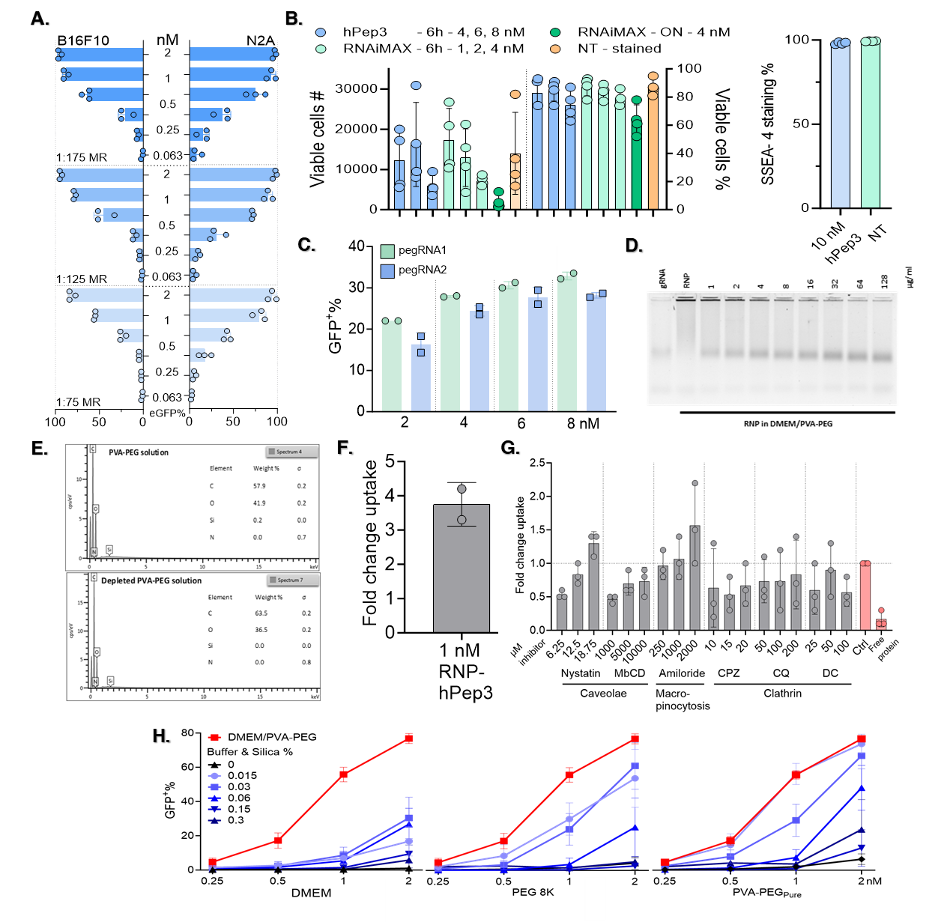

**Supplementary Figure 5. Extended ABE8e-hPep3 delivery to B16F10/N2A/iPSC, Prime editing, and characterization of PVA-PEG-associated silica.**

**A.** B16F10-ABE-GFP and N2A-ABE-GFP cells were treated with ABE8e-hPep3 at increasing doses and MR. B16F10 and N2A reached 95 %+ and 97 %+ base conversion, respectively. The highest editing reached in an N2A triplicate was 99.2%. Mean value of n=3 independent experiments ± SD. **B..** Cell number and viability of iPSC cells treated with ABE8e:hPep3 or RNAiMAX as recorded by the flow cytometry. Results are from 4 different donor iPSC cells from 4 different donors, done in triplicate, mean ± SD. Also shown is % of cells positive for the pluripotency marker SSEA-4, done with iPSC from 4 different donors in triplicate. **C.** Editing outcome of increasing amount of PE2 targeting the ABE8e reporter locus in HEK293T cells. An MR of 1:200 PE2: hPep3 was used. Each datapoint is a single well in a 24-well. **D.** Atto550 tagged Cas9 RNP was incubated in DMEM/PVA-PEG solution. The formed particles were then disrupted with increasing amounts of hexametaphosphate to investigate their stability. Dissociation was observed at the lowest tested concentration and increased with hexametaphosphate concentration. **E.** Energy-dispersive X-ray spectroscopy investigated the elemental composition of the silica pellet and silica-depleted PVA-PEG. Images are representative of 3 replicates. Silica was not detected in any of the depleted samples. **F.** Fold change of Atto550 labelled RNP-CPP uptake in treated HeLa cells kept at 37⁰C over those kept at 4⁰C. Mean value of n=2 independent experiments ± SD. **G.** Fold change of 2nM, Atto550 labelled, RNP-hPep3uptake in HeLa cells treated with various endocytosis inhibitors. Ctrl treatment is RNP-hPep3-treated HeLa cells without inhibitor. Mean value of n=3 independent experiments ± SD.

**H.** PVA-PEG derived silica was added to different buffers and then used for RNP-hPep3 formulation, followed by addition to HEK293T SL cells. With 0.015 w/v% matching the original concentration of silica in the PVA-PEG buffer. Mean value of n=3 independent experiments ± SD.

**Supplementary Figure 6. MuSC growth and marker expression after treatment.**

**A. & B.** Growth analysis of human MuSC over 7 days after treatment with hPep3-ABE8e targeting NCAM1 exon 7 (n = 3 technical repeats per donor, mean ± SD). Cells were seeded on day -1 and treated at day 0. **C.** Confocal microscopy images of MuSC from donor #3 immunostained for myogenic and proliferation markers after treatment with hPep3-ABE8e targeting NCAM1 exon 7. Scale bars: 50 µm. **D.** Confocal microscopy images of MuSC from donor #3 induced to fuse into multinucleated myotubes after treatment with hPep3-ABE8e. Scale bar: 50 µm. Untr.: Untransfected.

**Supplementary Figure 7. Increasing editing in human MuSC with a second round of treatment of ABE8e:hPep3.**

**A.** Schematics of the experimental setup. **B.** A>G conversion rates at adenines A5 and A8 in human MUSC treated with a single round (at day 0) or two rounds (day 0 + re-editing at day 4) of hPep3-ABE8e targeting NCAM1 exon 7, determined by Sanger sequencing and EditR analysis (n = 2 technical repeats, mean independent experiments ± SD).