Supplementary Materials for

How vascularization is reciprocally coupled to chondrogenesis and osteogenesis in bone healing: lessons from the growth plate

Julia Mehl, Katharina Schmidt-Bleek, Agnes Ellinghaus, Stefan Mundlos, Holger Gerhardt, Georg N. Duda*, Viola Vogel*

Fig. S1: Comparison of endochondral ossification at the distal growth plate and the fracture zone within one femur.
Fig. S2: Fibrillar collagen network as revealed by SHG imaging in the osteotomy gap 7 days post-osteotomy under semi-rigid fixation.
Fig. S3: Spatial distribution of SOX9-positive and OSX-positive cells under semi-rigid fixation.
Fig. S4: Fibrillar collagen network as revealed by SHG imaging in the osteotomy gap 7 days post-osteotomy under rigid fixation.
Fig. S5: Formation of avascular cartilage tissue at the distal side next to the fractured bone under rigid fixation 14 days post-osteotomy.
Fig. S6: Vessels originating from OSX-rich regions invaded the hypertrophic zone of cartilage.

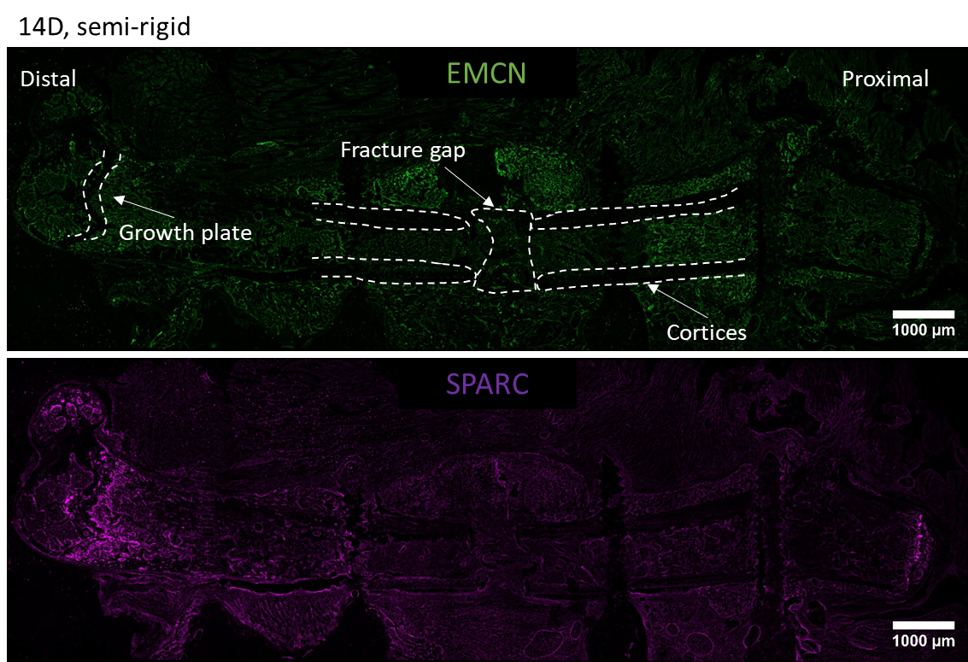
Fig. S1: Comparison of endochondral ossification at the distal growth plate and the fracture zone within one femur. Overview of the entire femur 14 days post-osteotomy under semi-rigid fixation, stained for EMCN to visualize blood vessels and SPARC. High SPARC expression is prominently observed at the growth plate, extending towards the site of de novo bone formation.

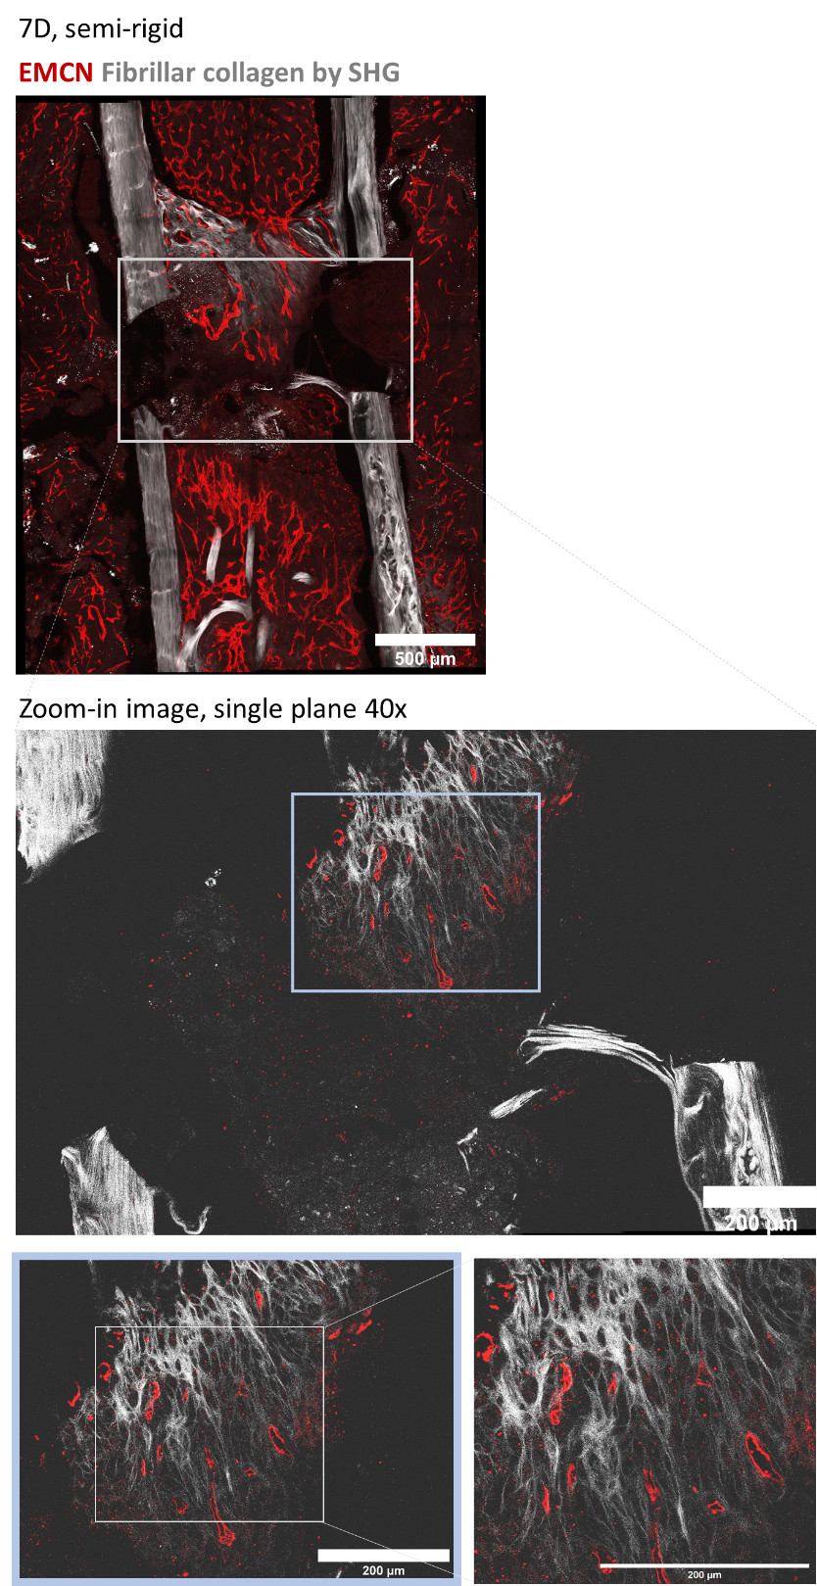
Fig. S2: Fibrillar collagen network as revealed by SHG imaging in the osteotomy gap 7 days post-osteotomy under semi-rigid fixation. For vessel visualization EMCN staining was performed. Zoom-in and single plane image revealed differences in the collagen and vascular network between the proximal and distal sides. While no collagen fibers were present at the distal side, the structure of the collagen II network within the center of the osteotomy gap showed similar features as the hypertrophic collagen matrix found in cartilage.
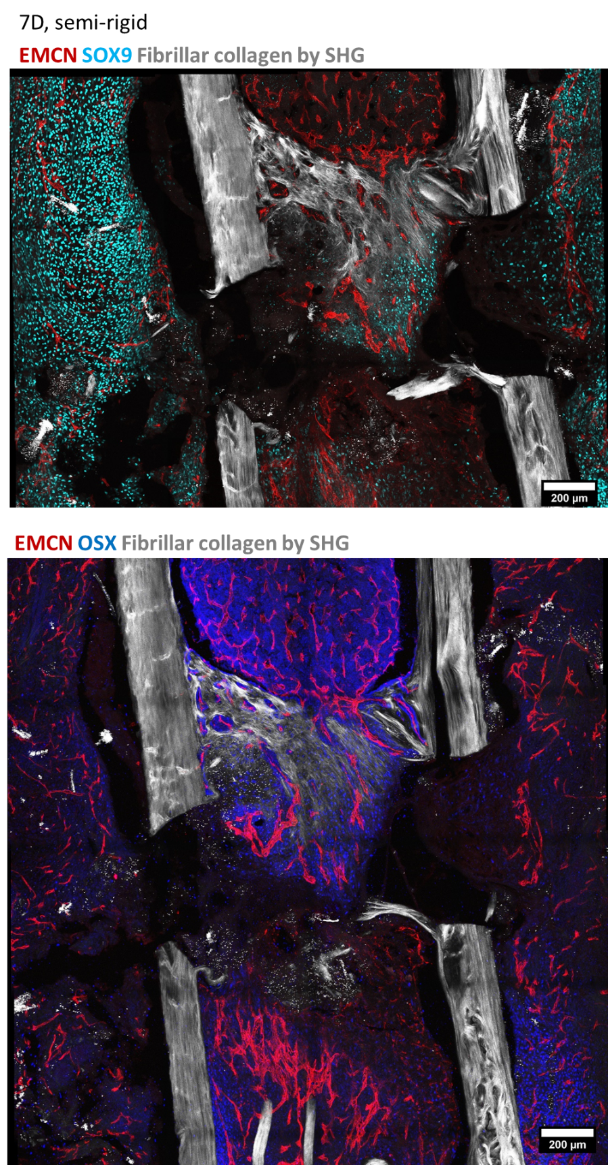
Fig. S3: Spatial distribution of SOX9-positive and OSX-positive cells under semi-rigid fixation. Two representative images 7 days after osteotomy under semi-rigid fixation. SOX9 staining revealed abundant SOX9-expressing cells in the surrounding soft tissue and within the collagen II-rich area in the central part of the osteotomy gap. In contrast, OSX staining revealed the presence of OSX-expressing cells mainly in the proximal and distal bone marrow.

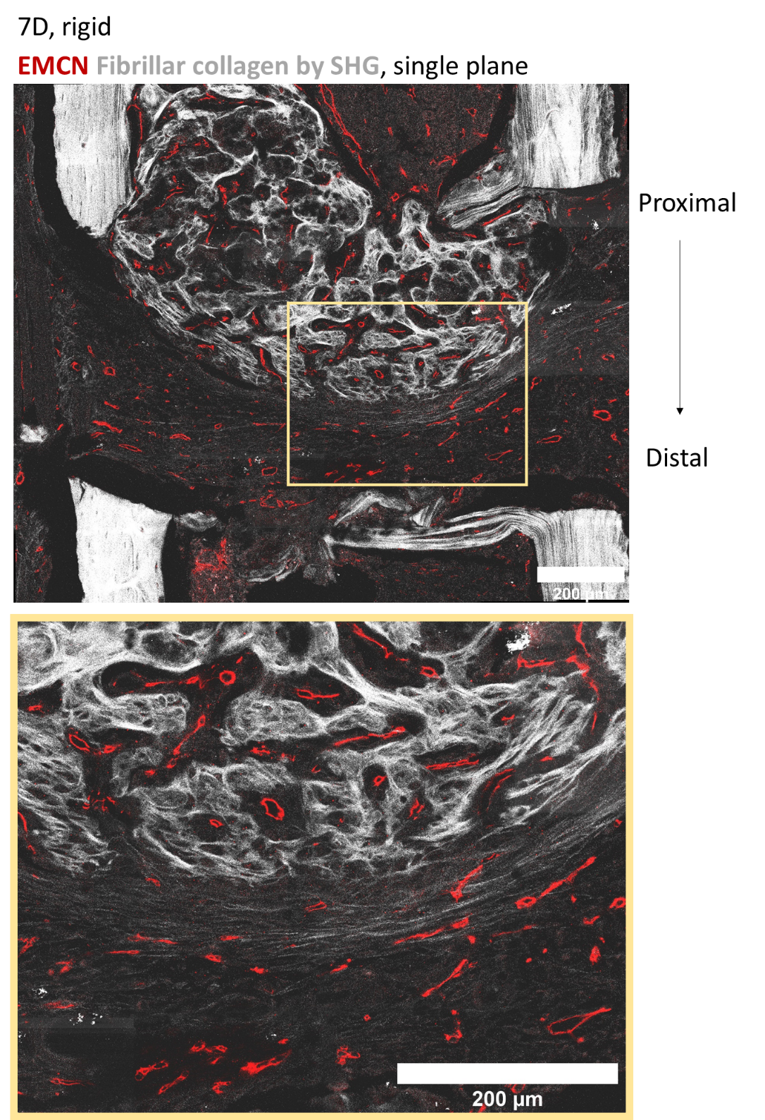
Fig. S4: Fibrillar collagen network as revealed by SHG imaging in the osteotomy gap 7 days post-osteotomy under rigid fixation. For vessel visualization EMCN staining was performed. Shown are single plane images. Differences in the collagen and vascular network were observed between the proximal and distal sides. On the proximal side, the collagen I/III network appeared more mature with vessels embedded in this matrix. Conversely, on the distal side, collagen II fibers were highly aligned and vessels emerged along these collagen fibers.

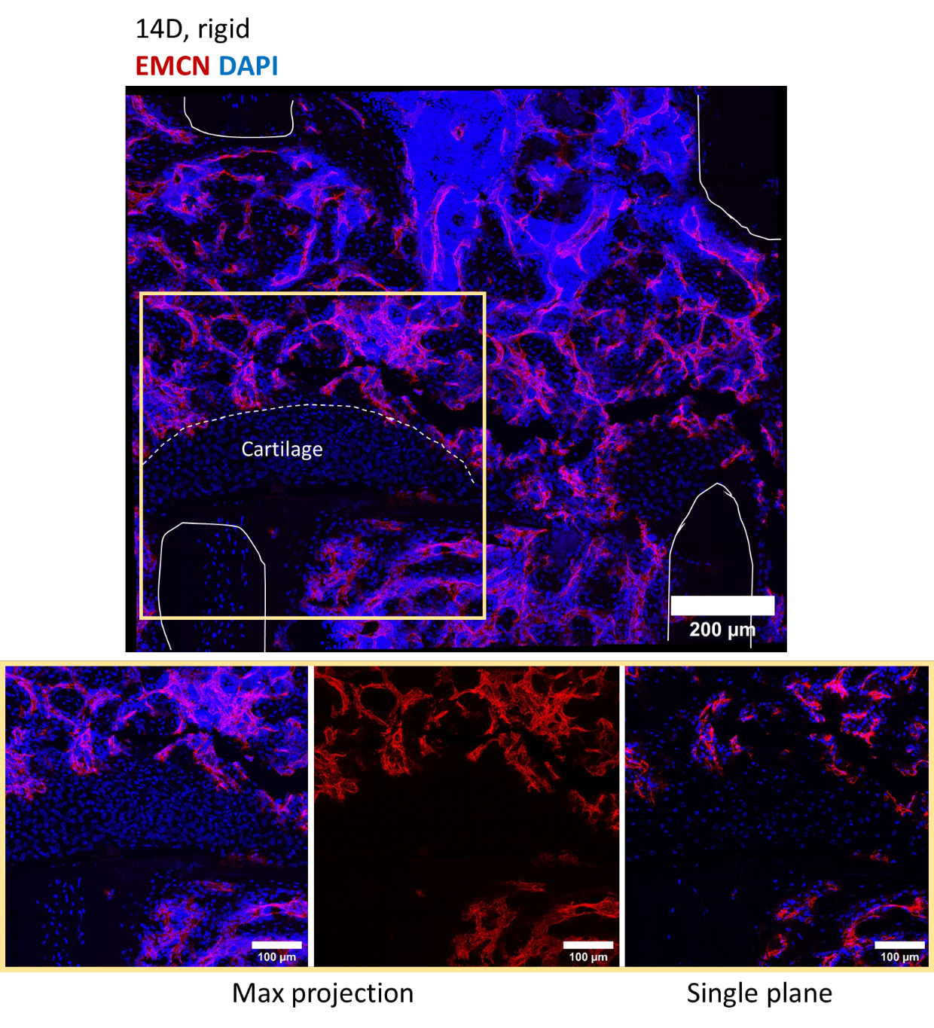
Fig. S5: Formation of avascular cartilage tissue at the distal side next to the fractured bone under rigid fixation 14 days post-osteotomy. Representative image of the osteotomy gap 14 days after surgery under rigid fixation with EMCN staining for vessel visualization along with DAPI staining. Absence of vessels in the cartilage area with fewer cells as compared to the surrounding vascularized tissue.

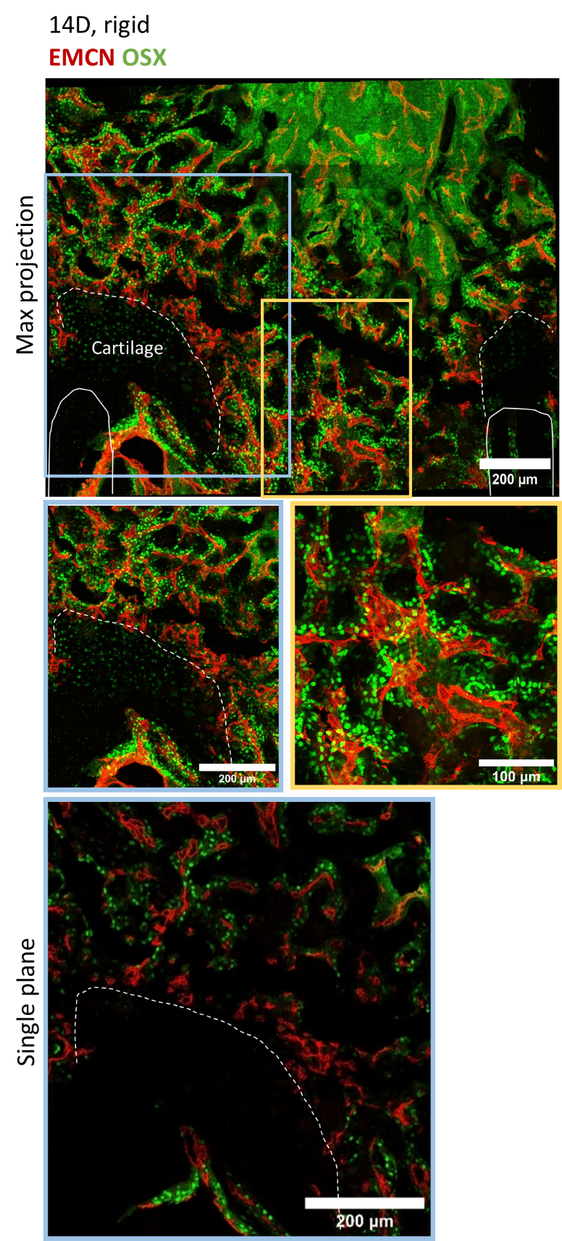
Fig. S6: Vessels originating from OSX-rich regions invaded the hypertrophic zone of cartilage. A representative image of the osteotomy gap 14 days after surgery under rigid fixation. EMCN staining was conducted to visualize vessels, along with OSX staining. OSX-expressing cells were primarily aligned along vessels, with only a few detected in the cartilage tissue at the distal side. An additional single plane at the bottom illustrates OSX-expressing cells adjacent to vessels without co-localization with EMCN staining.

