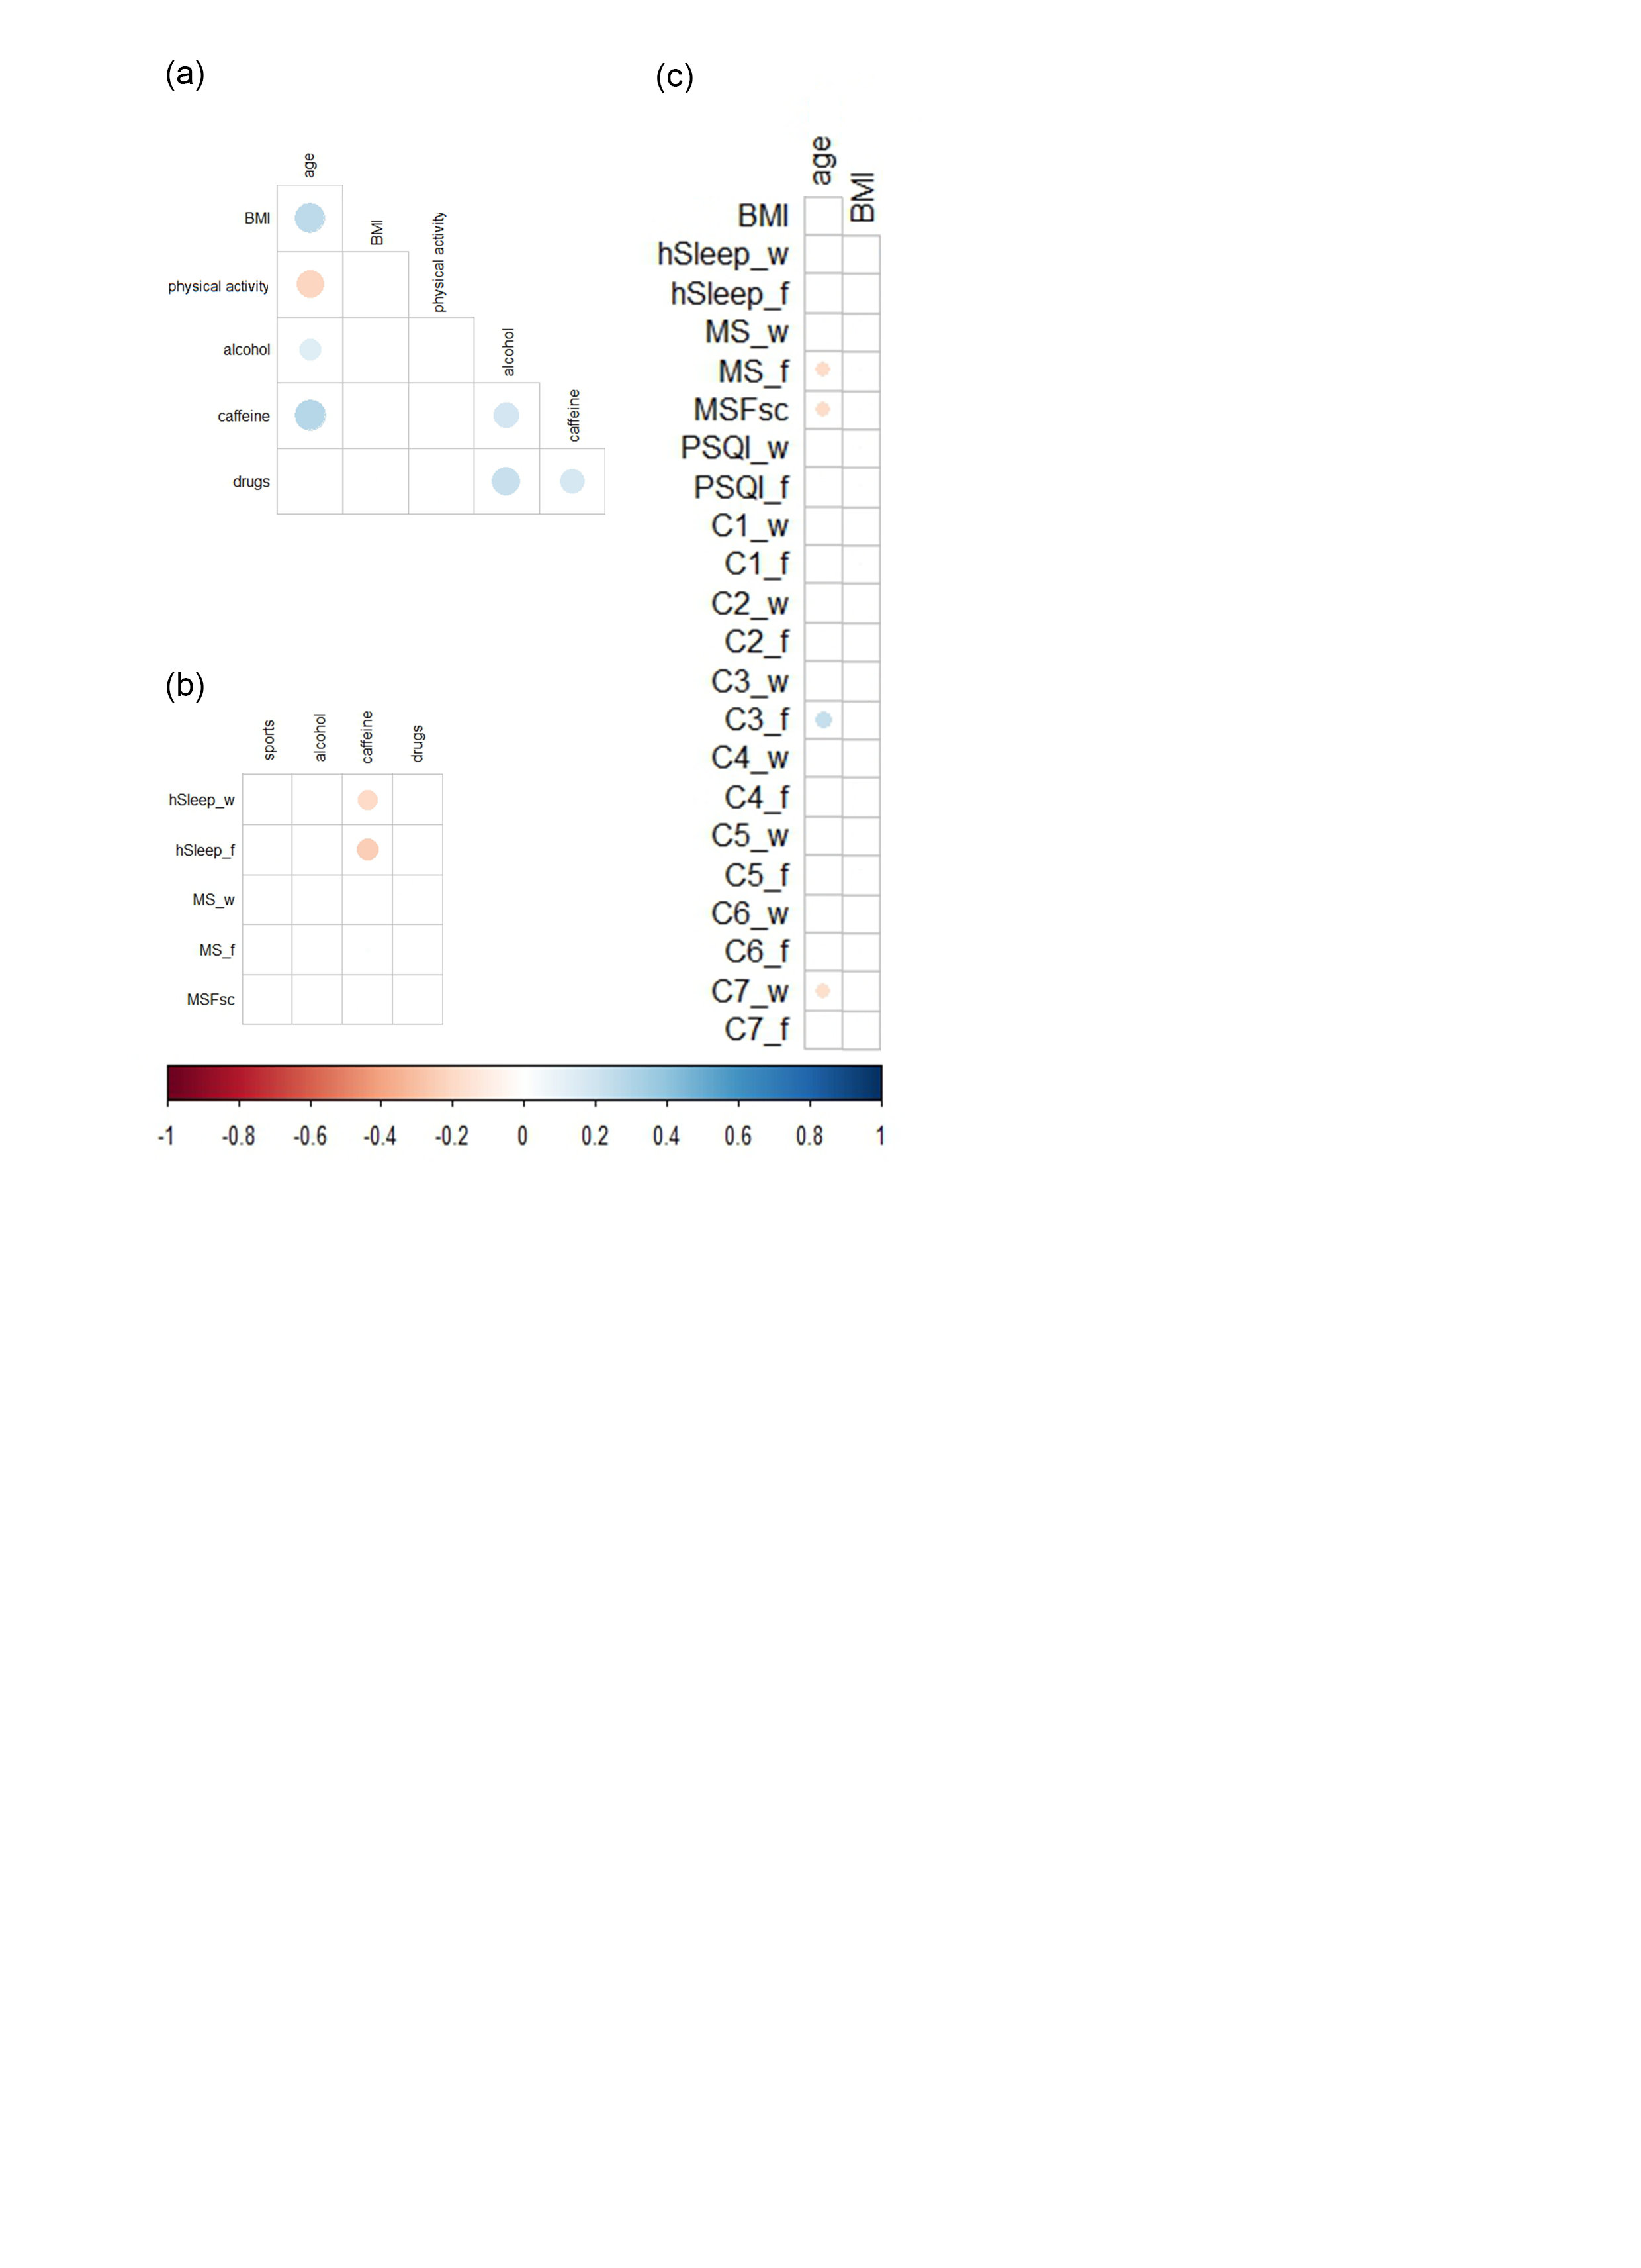

Supplementary Figure 1 Correlations among general characteristics, lifestyle factors, and sleep variables. Dots in matrices illustrate Spearman’s correlation coefficients (*r),* which were significant (P<0.05) after Holm-Bonferroni correction*)*. The size of the dots corresponds to the strength of the correlations. (a) Correlations among general characteristics and life style factors; (b) Correlations between life style factors and MCTQ-derived variables; (c) Correlations between general characteristics and sleep variables.

Notes: (n=351) Abbreviations: BMI, body mass index; sports, frequency of physical activity.



Supplementary Figure 2 Correlations between tiredness on waking and daytime dysfunction with (other) PSQI components/subcomponents. Dots in matrices illustrates Spearman’s correlation coefficients (*r),* which were significant (P<0.05) after Holm-Bonferroni correction. The size of the dots corresponds to the strength of the correlations. Variables are expressed separately for workdays (_w) and workfree days (_f). Correlations between tiredness on waking and (a) PSQI components, (b) C5 subcomponents. Correlations between daytime dysfunction (C7) and (c) PSQI components, (d) C5 subcomponents. (n=351)

C:\Users\admin\AppData\Local\Microsoft\Windows\INetCache\Content.Word\Suppl3Corr.tif

Supplementary Figure 3 Association of C5 (sleep disturbances) subcomponents with anxiety/depression (PHQ4), perceived workload (WL), and lifestyle factors. Dots in matrices illustrates Spearman’s correlation coefficients (*r),* which were significant (P<0.05) after Holm-Bonferroni correction. The size of the dots corresponds to the strength of the correlations. C5 subcomponents are expressed separately for workdays (_w) and workfree days (_f). Correlations of C5 subcomponents with (a) PHQ4 and WL (b) lifestyle factors. (n=351)