**Supplementary Materials**

**S.1 Description of the Data Cleaning, Subsampling and Missing Rates**

In order to obtain a mildly-impaired sample from the 44 bvFTD patients of the DESCRIBE-FTD cohort, 2 patients with CDR-Global over 1 (medium and severe dementia), and 2 patients with sum of the additional two behavioral and language subscores of the CDR plus NACC FTLD over 3.0 were excluded. In addition, 1 participant with missing CDR-Global and CDR-FTLD scores was also excluded as this patient´s MMSE-Total score was 19 and Faux-Pas Control Questions total score (FP-CQ) was 9/20. Two patients without any CDR data were kept as one had MMSE-Total score 29; the other one had 19/20 in the FPT control questions score. Also, 4 patients with FPT control questions score lower than the minimum value of the HCs (i.e., 16/20) were excluded. Note that these patients also had extremely low FPT total accuracy scores. In total, 9 patients were excluded based on the CDR, CDR-FTLD and FPT control question criteria. The final complete sample size for the Mini-SEA analyses was 35 bvFTDs and 56 HCs after the exclusion of the 2 healthy control mutation carriers.

For the main group comparisons and the cut-off definition, demographic matching was conducted via nearest neighbor method ensuring matched participants from bvFTDs yielding the closest propensity score to one or more HCs. In these estimates, sex variable was adjusted as exact matching to overcome extreme imbalance between groups in the sex ratio. In addition, a large caliper (.94) to the standard deviation of the propensity scores was added to keep the sample as large as possible.

For conducting logistic regression models with other neuropsychological variables, 3 bvFTDs and 2 HCs without any CERAD-NAB+ battery data were excluded from the complete sample. The total subsample size became 32 bvFTDs and 54 HCs. Participants with some missing outcome variables were kept for the further missing imputation. One control participant had 2 missings (Semantic Fluency “Animals”, Boston Naming Test) and 1 participant had 3 missings (TMT-A, TMT-B, TMT-B/A) with the missing percentage of 1.85 % for each variable. In the bvFTD patient group, Phonemic Fluency “S-Words”, Figure Recall and Word List Discrimination variables showed single missing values (3.13 %). The MMSE and TMT-A variables showed 2 missings (6.25 %). TMT-B variable showed the highest missing rate (5 missings; 15.63 %).

**S2. VBM Analysis Procedure:**

The processing is divided in two parts: first “initial voxel-based processing” included spatial adaptive non-local means (SANLM) denoising filter (Manjon et al., 2010), followed by internal resampling to properly accommodate low-resolution images and anisotropic spatial resolutions. Afterwards bias-corrected and affine-registered followed by the standard SPM "unified segmentation" (Ashburner and Friston, 2005). The second part: “refined voxel-based processing” implements skull striping, parcellation and local white matter hyperintensity detection on unified segmented images. Then, all tissue classes undergo a local intensity transformation that is especially useful to mitigate the impacts of increased grey matter intensities in the occipital lobe, motor cortex, or basal ganglia prior to the final adaptive maximum a posteriori (AMAP) segmentation. A partial volume estimation (Tohka et al., 2004) is then applied to modify this last AMAP segmentation phase (Rajapakse et al., 1997), which does not rely on a priori information of the tissue probabilities. This effectively calculates the fractional content for each tissue type per voxel. Finally, the tissue segments are spatially normalised to MNI152 NLIN 2009a in 1.5mm isotropic tissue specific maps using Geodesic Shooting (Ashburner and Friston, 2011) registrations.

Ashburner, J., & Friston, K. J. (2005). Unified segmentation. *Neuroimage*, *26*(3), 839-851. <https://doi.org/10.1016/j.neuroimage.2005.02.018>

Ashburner, J., & Friston, K. J. (2011). Diffeomorphic registration using geodesic shooting and Gauss–Newton optimisation. *NeuroImage*, *55*(3), 954-967. <https://doi.org/10.1016/j.neuroimage.2010.12.049>

Rajapakse, J. C., Giedd, J. N., & Rapoport, J. L. (1997). Statistical approach to segmentation of single-channel cerebral MR images. *IEEE Transactions on Medical Imaging, 16*(2), 176-186. <https://doi.org/10.1109/42.563663>

Tohka, J., Zijdenbos, A., & Evans, A. (2004). Fast and robust parameter estimation for statistical partial volume models in brain MRI. *NeuroImage*, *23*(1), 84-97. <https://doi.org/10.1016/j.neuroimage.2004.05.007>

Manjón, J. V., Coupé, P., Martí‐Bonmatí, L., Collins, D. L., & Robles, M. (2010). Adaptive non‐local means denoising of MR images with spatially varying noise levels. *Journal of Magnetic Resonance Imaging*, *31*(1), 192-203. <https://doi.org/10.1002/jmri.22003>

**S3. Graphical Demonstration of the Implemented Masks**

**Figure S3.1 Emotion Mask**

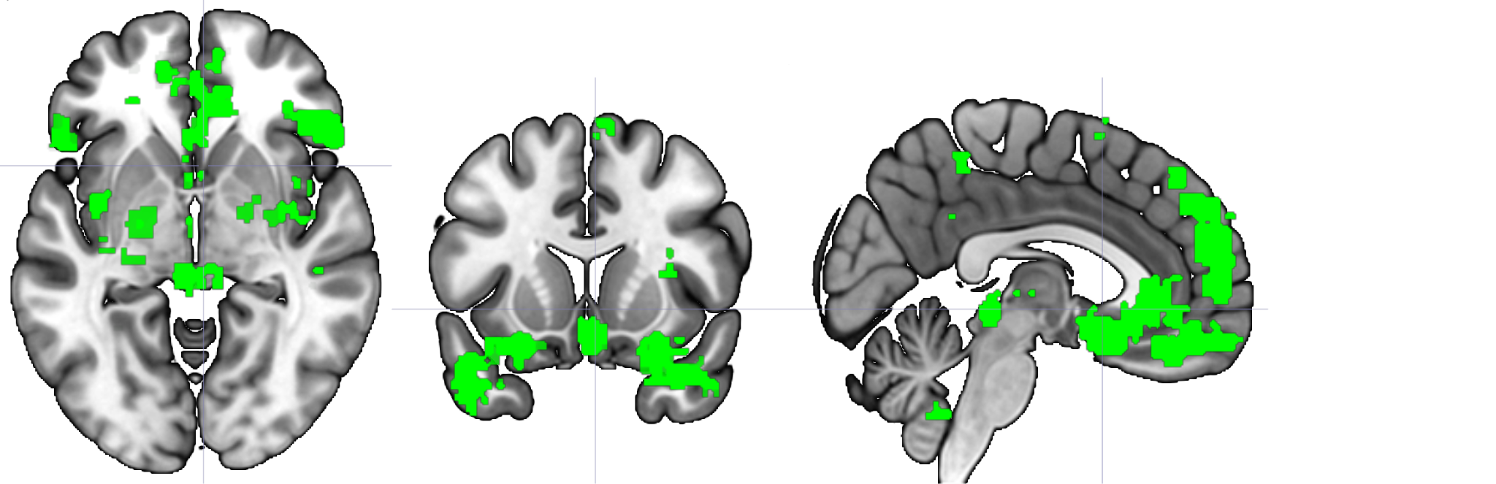

*Note.* This figure demonstrates the regions contained in the Emotion Mask:Amygdala (BIL), Parahippocampal Gyrus (BIL), Anterior Cingulate, Inferior Frontal Gyrus-Triangularis (R), Superior Frontal Gyrus (L), Insula (BIL), Medial Frontal Gyrus (L), Superior Temporal Gyrus (BIL), Fusiform Gyrus (R). BIL = Bilateral; L = Left; R = Right.

**Figure S3.2 Theory of Mind Mask**

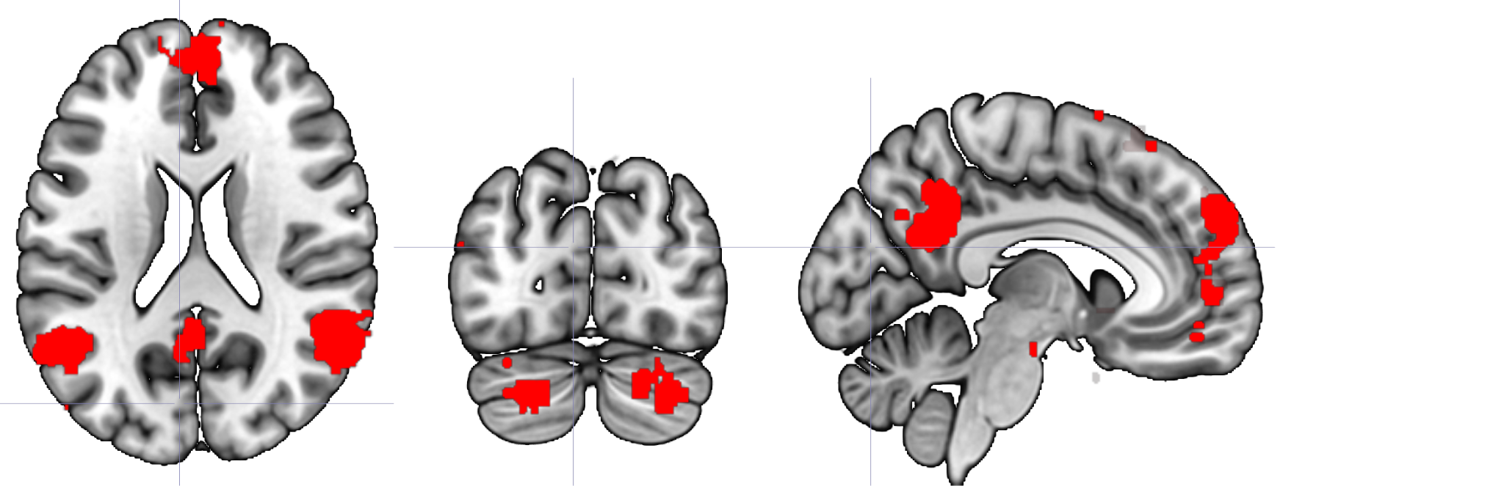

*Note.* This figure demonstrates the regions contained in the Theory of Mind Mask: Precuneus (BIL), Superior Temporal Gyrus (BIL), Middle Temporal Gyrus (BIL), Medial Frontal Gyrus, Inferior Frontal Gyrus (BIL), Superior Frontal Gyrus (BIL), Pons, Cerebellum Crus I & II (BIL), Cerebellum IX Lobe (BIL). BIL = Bilateral.

**S4. Clinical Characteristics of the bvFTD Subsample with CERAD-NAB+ Variables (n=32)**

*Table S4.*

|  |  |  |  |
| --- | --- | --- | --- |
|  | **Mean** | **SD** | **Range** |
| CDR-Global | 0.78 | 0.25 | [0.5 : 1] |
| CDRFTD-Behav | 1.24 | 0.59 | [0.5 : 2] |
| CDRFTD-Lang | 0.40 | 0.42 | [0 : 1] |
| CDRFTD-SOB | 6.41 | 2.39 | [3 : 10.5] |
| Disease Onset | 60.9 | 11.5 | [35 : 84] |
| Symptom Duration | 2.71 | 3.01 | [0 : 16] |
| Diagnosis Duration | 0.65 | 1.46 | [0 : 7.31] |

*Note. CDRFTLD-Behav, -Lang, -Total indicate the behavior, language and, total score of the CDRFTLD scale respectively. CDRFTLD-SOB is the sum of boxes of all CDRFTLD items while CDRFTLD-Total is the sum of the two FTLD items (Behavior and Language domains). Symptom Duration indicates subjective report of the symptom begin and the Diagnosis Duration is calculated by the date of the first official diagnosis.*

**S5. Spearman Rank-Order Correlations of the Functional Activities Questionnaire with the Mini-SEA Scores**

*Table S5*

|  |  |  |  |  |  |  |  |  |  |  |  |  |  |
| --- | --- | --- | --- | --- | --- | --- | --- | --- | --- | --- | --- | --- | --- |
|  | FERT | FPT | Mini-  SEA C. | Finance | Paper-  work | Shopping | Games/  Hobby | Kitchen | Meal | Tracking Events | Media | Memory | Travel |
| FPT | 0.38* |  |  |  |  |  |  |  |  |  |  |  |  |
| Mini-SEA C. | 0.75*** | 0.88*** |  |  |  |  |  |  |  |  |  |  |  |
| Finance | 0.02 | -0.41* | -0.33 |  |  |  |  |  |  |  |  |  |  |
| Paperwork | -0.14 | -0.28† | -0.29 | 0.72*** |  |  |  |  |  |  |  |  |  |
| Shopping | -0.09 | -0.16 | -0.17 | 0.66*** | 0.76*** |  |  |  |  |  |  |  |  |
| Games/Hobby | 0.01 | -0.07 | -0.09 | 0.54** | 0.52* | 0.74*** |  |  |  |  |  |  |  |
| Kitchen | 0.06 | -0.30 | -0.16 | 0.30 | 0.26 | 0.36* | 0.33 |  |  |  |  |  |  |
| Meal | -0.07 | -0.33 | -0.28 | 0.72*** | 0.44* | 0.66*** | 0.61** | 0.48* |  |  |  |  |  |
| Tracking events | -0.34† | -0.40* | -0.44* | 0.46* | 0.41* | 0.63*** | 0.44* | 0.27 | 0.60** |  |  |  |  |
| Media | -0.26 | -0.29 | -0.31 | 0.25 | 0.24 | 0.43* | 0.20 | 0.20 | 0.49** | 0.67*** |  |  |  |
| Memory | -0.04 | -0.35† | -0.27 | 0.49* | 0.40* | 0.58*** | 0.37 | 0.28 | 0.58** | 0.59** | 0.56** |  |  |
| Travel | -0.04 | -0.35† | -0.26 | 0.62*** | 0.53*** | 0.53*** | 0.28 | 0.61** | 0.48* | 0.40* | 0.26 | 0.33 |  |
| FAQ Total | -0.15 | -0.41* | -0.37† | 0.79*** | 0.76*** | 0.89*** | 0.68*** | 0.54** | 0.83*** | 0.76*** | 0.53** | 0.69*** | 0.70*** |

*Note.* † p < .10; * p < .05; ** p < .01; *** p < .001. “FERT”: Facial Emotion Recognition Test; “FPT”: Faux-Pas Test; “Mini-SEA C.”: Mini-SEA composite score. “Finance”: Writing checks, paying bills, balancing checkbook. “Paperwork”: Assembling tax records, business affairs, or papers. “Shopping”: Shopping alone for clothes, household necessities, or groceries. “Games/Hobby”: Playing a game of skill, working on a hobby. “Kitchen”: Heating water, making a cup of coffee, turning off stove after use. “Meal”: Preparing a balanced meal.“Tracking events”: Keeping track of current events. “Media”: Paying attention to, understanding, discussing TV, book, magazine. “Memory”: Remembering appointments, family occasions, holidays, medications. “Travel”: Traveling out of neighborhood, driving, arranging to take buses. “FAQ Total”: Functional Activities Questionnaire total score.

**S6. Descriptives of the Demographically Matched Subsamples of the VBM Analyses**

The sample extracted for the VBM analyses showed no significant difference in the age (bvFTD: 61.43 (9.97); HC: 59.50 (14.66); *p* = 0.91, W=95) and education variables (bvFTD: 13.3 (2.09); HC: 14.4, (1.74); *p* = 0.15, W=67) with the same sex ratio (5f, 9m; 35.7 % female) in each group. The bvFTD group had the average age of disease onset 58.54 (9.85). Non-parametric group comparisons indicated significant between group differences in the Mini-SEA composite (bvFTD: 19.69 (4.97); HC: 26.13 (2.58); W=20, *p* = .003), FERT (bvFTD: 9.46 (2.67); HC: 12.12 (1.36); W=38, *p* = .002) and FPT (bvFTD: 10.23 (3.37); HC: 14.01 (1.45); W=30, *p* = .01) scores. Average age of disease onset was 58.53 (9.85) with minimum 44 and maximum 80 years of age. Average years of the diagnosis was 1.08 (2.06) with a maximum 7.31 years. Average years of the first symptom begin was 2.23 (1.78) with maximum 5 years.

**S7. Significant clusters showing decreased GM volume in bvFTD compared to healthy controls at p<0.05, k=330 familywise error corrected.**

*Table S7*

|  |  |  |  |  |  |  |  |  |
| --- | --- | --- | --- | --- | --- | --- | --- | --- |
| **Cluster**  **No.** | **Cluster Label** | **Side** | **Cluster Size** | **MNI Coordinates (mm)** | | | **t-value** | **p-value** |
| **(mm3)** | **X** | **Y** | **Z** |
| 1 | Anterior Cingulate Cortex  Right Middle Cingulate Cortex  Anterior Cingulate Cortex | L  R  L | 1699 | 0  3  -4 | 26  30  14 | 22  32  27 | 6.32  5.61  5.01 | <.001 |
| 2 | Fusiform Gyrus  Inferior Temporal Gyrus | R  R | 348 | 40  51 | -51  -45 | -15  -20 | 4.77  3.56 | .026 |
| 3 | Middle Frontal Gyrus  Fusiform Gyrus  Fusiform Gyrus | L  L  L | 4304 | -26  -34  -33 | 54  -12  -4 | -14  -39  -44 | 5.74  5.59  5.22 | <.001 |
| 4 | Lenticular Nucleus of Putamen  Mediodorsal Magnocellular Nucleus  Orbitofrontal Cortex | R  R  L | 1204 | 6  3  -2 | -2  -24  12 | -6  -2  -14 | 5.32  4.76  4.49 | <.001 |
| 5 | Parahippocampal Gyrus  Insula | R  R | 4628 | 16  39 | -2  22 | -38  -6 | 5.26  4.83 | <.001 |
| 6 | Middle Temporal Gyrus  Inferior Temporal Gyrus  Fusiform Gyrus | R  R  R | 502 | 44  40  36 | 9  6  -10 | -38  -46  -45 | 4.92  4.34  4.32 | .004 |
| 7 | Middle Temporal Gyrus  Superior Temporal Gyrus | R  R | 886 | 56  45 | -8  -9 | -21  -12 | 4.73  4.50 | <.001 |
| 8 | Cerebellum Crus II  Cerebellum Crus I | L  L | 1501 | -45  -39 | -60  -66 | -46  -36 | 4.60  4.35 | <.001 |
| 9 | Middle Temporal Gyrus | R | 330 | 56 | -28 | -3 | 4.49 | .032 |

*Note.* bvFTD: Behavioral-variant Frontotemporal Dementia, L=Left, R= Right.