Supplement to

Associations of road traffic noise with adipose tissue depots and hepatic fat content – Results from the German National Cohort (NAKO)

Fiona Niedermayer^{1,2}*, Susanne Rospleszcz^{2,9}, Clara Matthiessen³, Barbara Hoffmann³, Sophia Stoecklein⁴, Tobias Haueise^{5,6}, Tobias Norajitra^{7,8}, Christopher L. Schlett⁹, Johanna Nattenmüller^{9,10}, Fabian Bamberg⁹, Jürgen Machann^{5,6,11}, Matthias Günther¹², Jochen Hirsch¹², Rajini Nagrani¹³, Henry Völzke¹⁴, Claudia Meinke-Franze¹⁴, Norbert Hosten¹⁵, Tobias Nonnenmacher¹⁶, Bettina Katalin Budai^{16,17}, Viktoria Palm^{16,17,18}, Verena Katzke¹⁹, Karin Halina Greiser¹⁹, Jeanette Schulz-Menger^{20,21}, Thoralf Niendorf²², Beate Endemann²², Tobias Pischon^{23,24,25}, Jeroen Staab²⁶, Marco Dallavalle², Alexandra Schneider², Kathrin Wolf², Annette Peters^{1,2,6}

Figure S1. Directed acyclic graph proposing the potential causal relationship between road traffic noise, adipose tissue and hepatic fat content including potential covariates.
Legend: U stands for unmeasured confounders, which would be regional factors such as walkability of the neighborhood, access to public transport, etc.. We assumed that the study center can be used as a proxy for these unmeasured confounders. Abbreviations: AT = adipose tissue, CMD = cardiometabolic disease, NDVI = normalized difference vegetation index, U = unmeasured factor

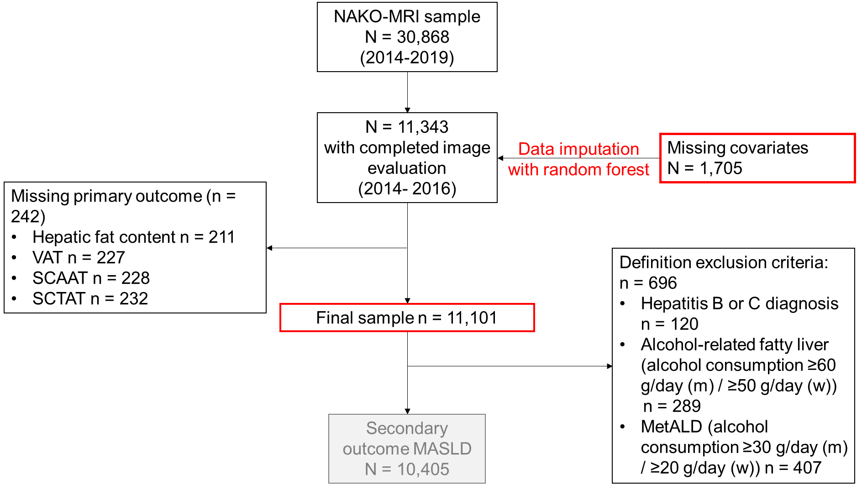Figure S2 Flowchart of the analytical German National Cohort sample.
Legend: Data imputation is described in Methods S2. Abbreviations: NAKO = German National Cohort, MASLD = metabolic-dysfunction associated steatosis liver disease, SCAAT = subcutaneous abdominal adipose tissue, SCTAT = subcutaneous thoracic adipose tissue, VAT = visceral adipose tissue

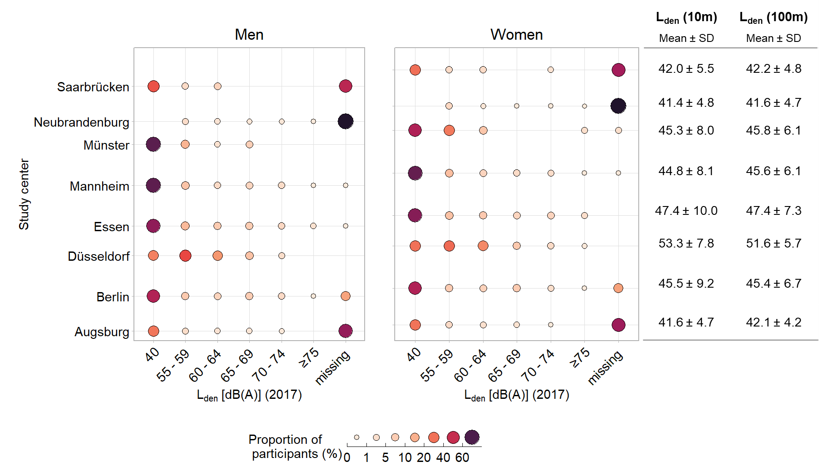
Figure S3 Distribution of categorical (L_{den}) and continuous (L_{den} 10m and L_{den} 100m) road traffic noise by study center in the German National Cohort. Legend: missing are participants in areas not covered by the END obligation 2002/49/EG, 40 dB(A) is a lower detection limit assigned to participants covered by the END but with noise levels below the reporting threshold of 55 dB(A). Abbreviation: L_{den} = day–evening–night road traffic noise level;
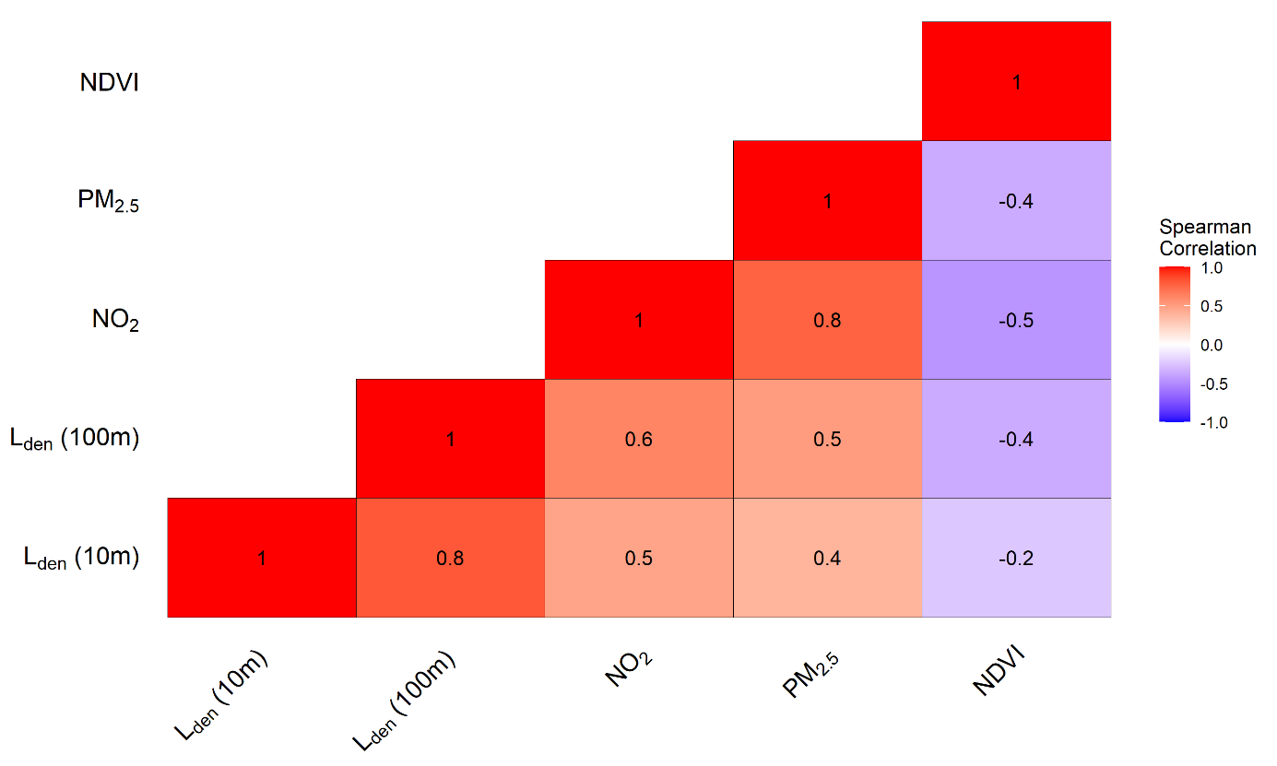
Figure S4 Spearman correlation between road traffic noise and environmental exposures used in two exposure models in the German National Cohort.
Abbreviation: L_{den} = day–evening–night road traffic noise level, NO₂= nitrogen dioxide, PM_{2.5} = particulate matter with diameter < 2.5 µm, NDVI = normalized difference vegetation index

Figure S5 Road traffic noise distribution and exposure-response functions for the association between L_{den} (10m) and outcomes in the German National Cohort. (A) Men; (B) Women. Legend: Exposure response functions are derived from models with natural cubic spline with 3 degrees of freedom adjusted for study center, age, alcohol consumption, physical activity, smoking behavior, income. Vertical lines give placement of the knots. Abbreviation: HFC = hepatic fat content, L_{den} = day–evening–night road traffic noise level, MASLD = MASLD = metabolic-dysfunction associated steatosis liver disease, SCAAT = subcutaneous abdominal adipose tissue, SCTAT = subcutaneous thoracic adipose tissue, VAT = visceral adipose tissue
A
B

Figure S6 Road traffic noise distribution and exposure-response functions for the association between L_{den} (100m) and outcomes in the German National Cohort. (A) Men; (B) Women. Legend: Exposure response functions are derived from models including natural cubic spline with 3 degrees of freedom adjusted for study center, age, alcohol consumption, physical activity, smoking behavior, income. Vertical lines give placement of the knots. Abbreviation: HFC = hepatic fat content, L_{den} = day–evening–night road traffic noise level, MASLD = metabolic-dysfunction associated steatosis liver disease, SCAAT = subcutaneous abdominal adipose tissue, SCTAT = subcutaneous thoracic adipose tissue, VAT = visceral adipose tissue
B
A
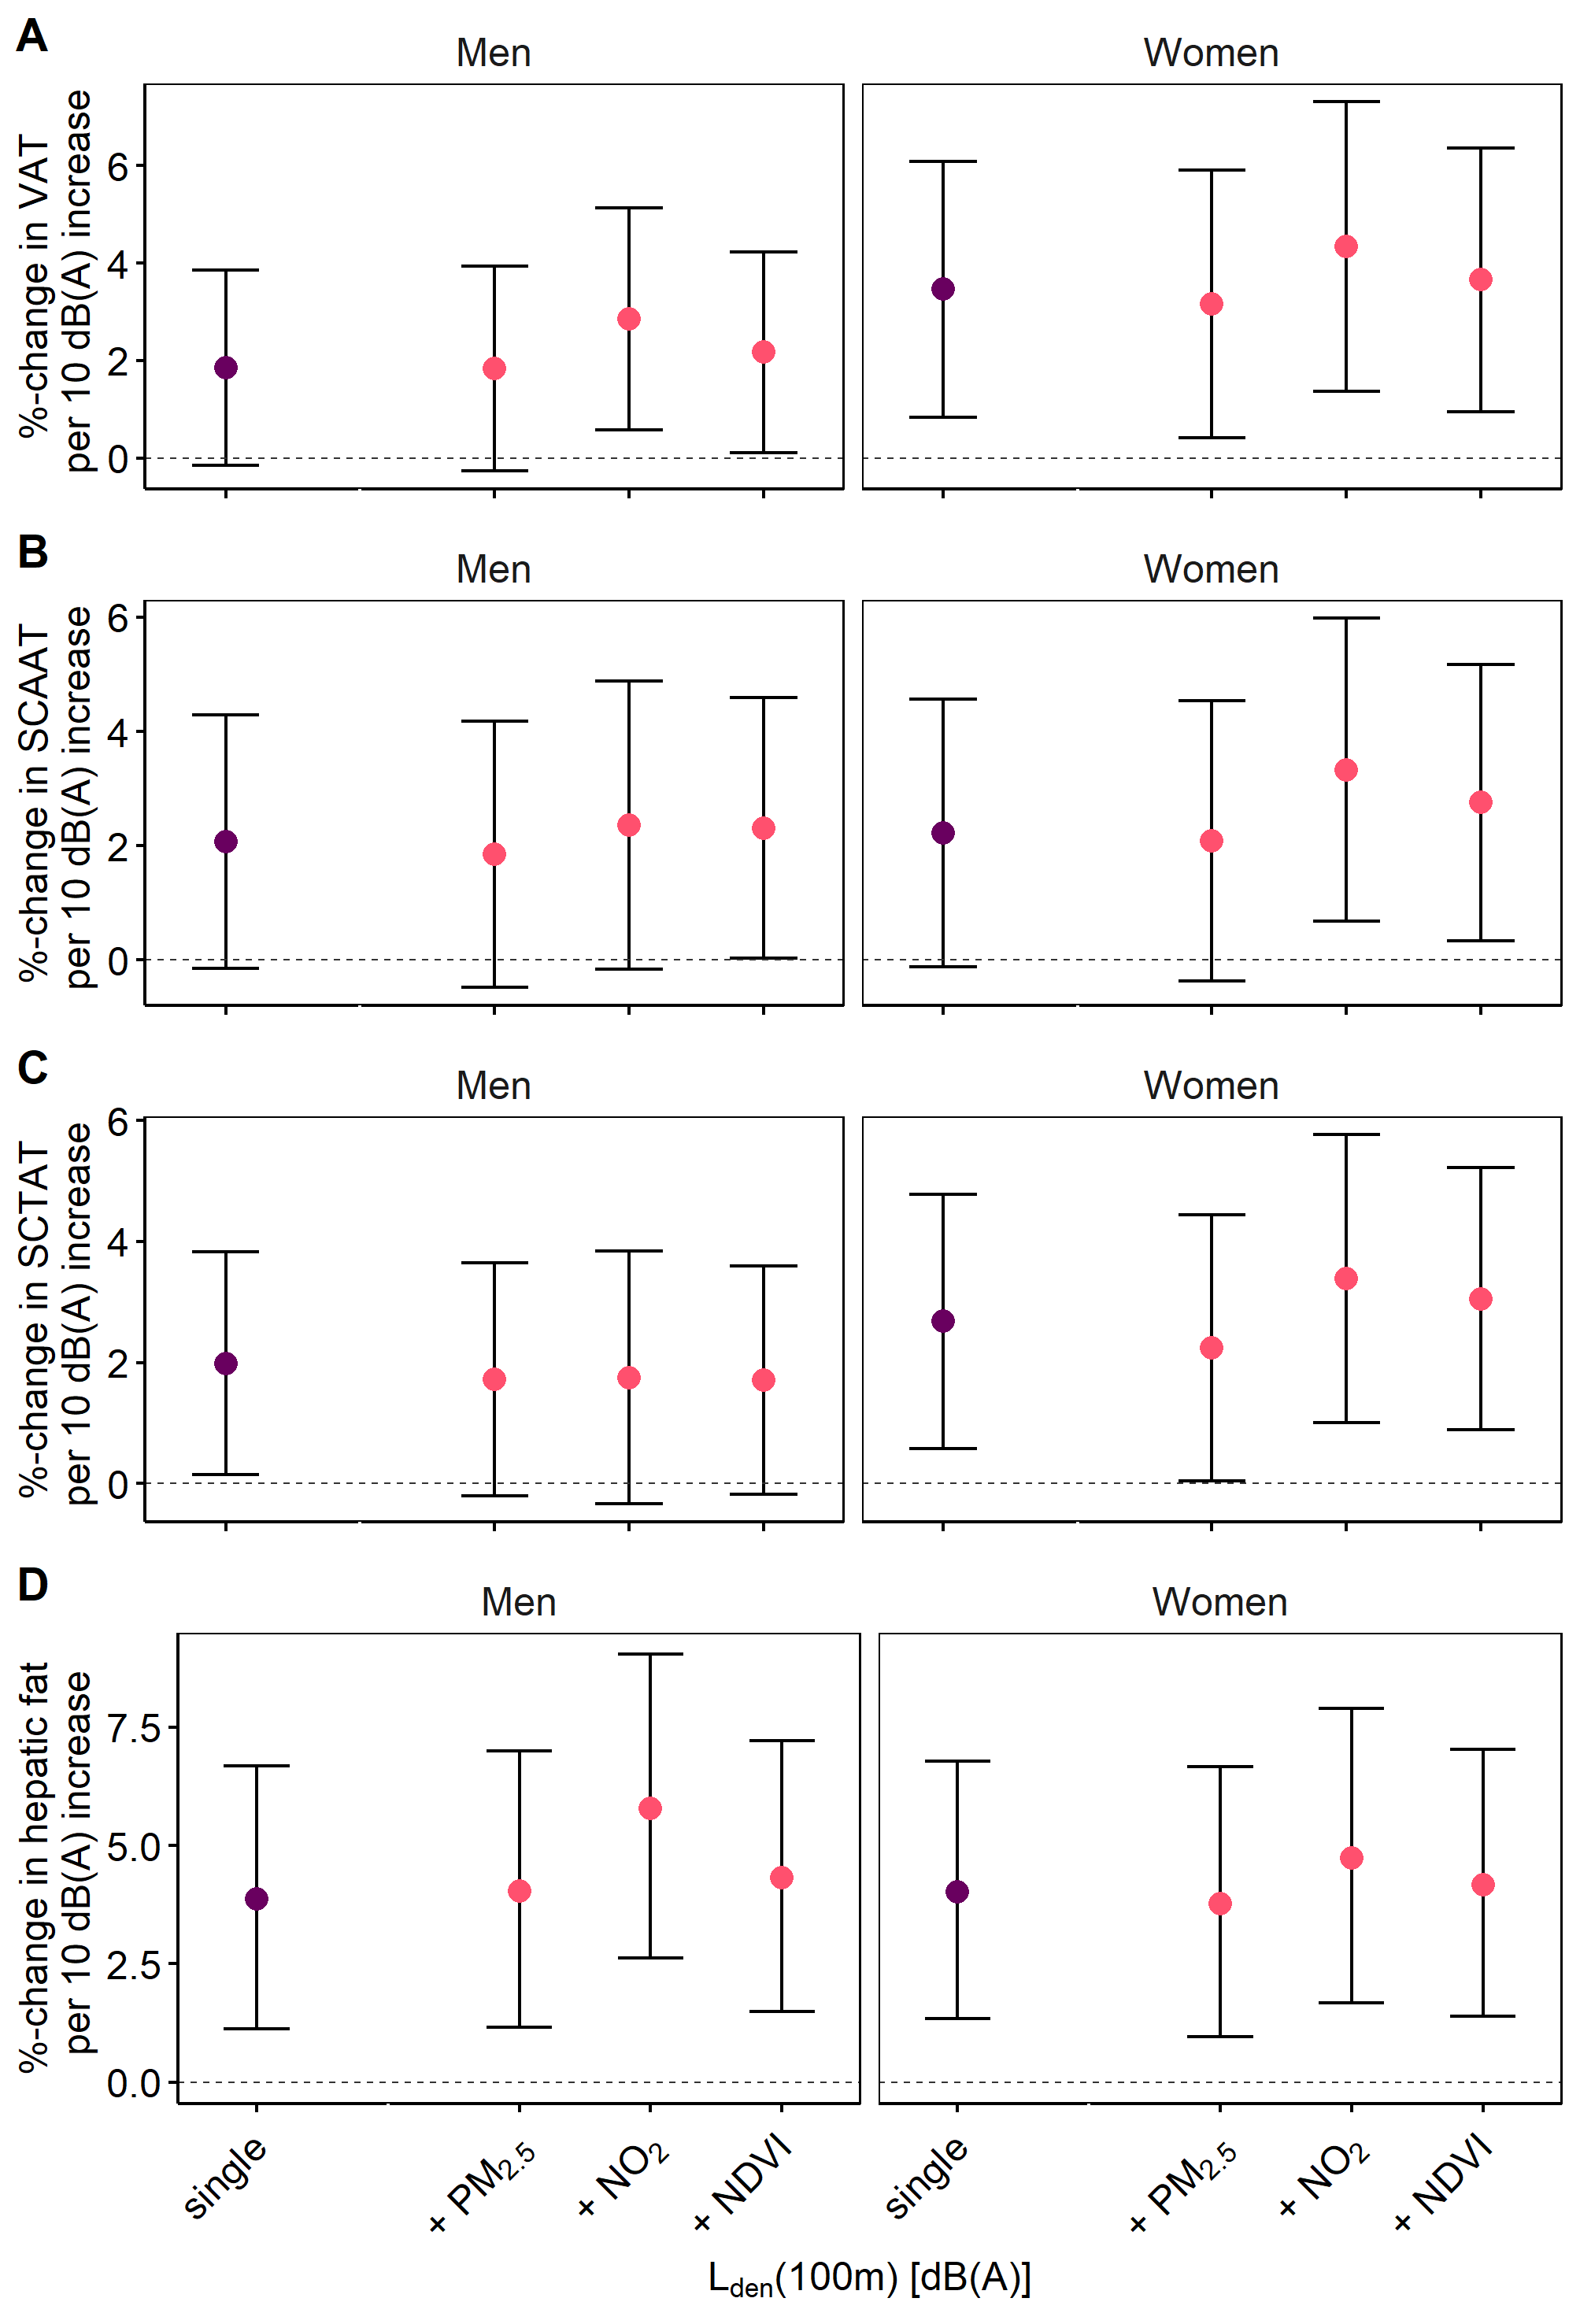
Figure S7 Comparison of the estimates of road traffic noise (100m buffer) in single (purple circles) and two exposure (pink circles) models adjusting for air pollutants (PM_{2.5}, NO₂) and surrounding greenness (NDVI) in the German National Cohort. (A) VAT, (B) SCAAT, (C) SCTAT, and (D) hepatic fat content. Legend: Estimates are derived from linear regression models adjusted for study center, age, alcohol consumption, physical activity, smoking behavior, income and are given as percentage change of the arithmetic (geometric for hepatic fat content) outcome mean per 10 dB(A) increase in exposure with 95% confidence intervals. Abbreviation: L_{den} = day–evening–night road traffic noise level, NDVI = normalized difference vegetation index, NO₂= nitrogen dioxide, PM_{2.5} = particulate matter with diameter < 2.5 µm, SCAAT = subcutaneous abdominal adipose tissue, SCTAT = subcutaneous thoracic adipose tissue, VAT = visceral adipose tissue,
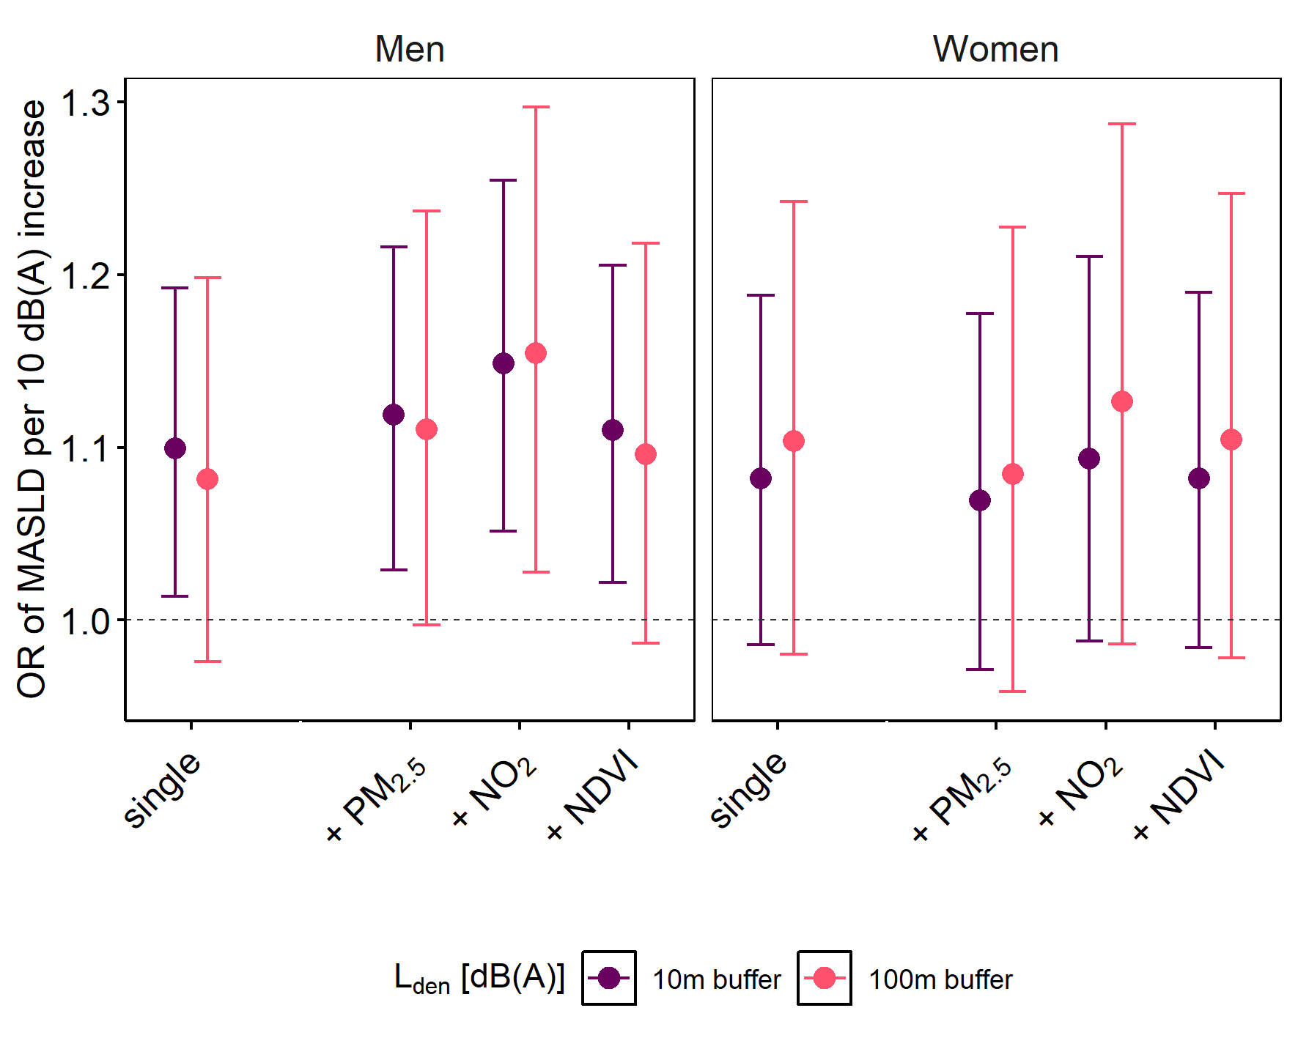
Figure S8 Comparison of the estimates of road traffic noise (10m and 100m buffer) in single and two exposure models adjusting for air pollutants (PM_{2.5}, NO₂) and surrounding greenness (NDVI) for the outcome MASLD in the German National Cohort. Legend: Odds ratios are derived from logistic regression models adjusted for study center, age, alcohol consumption, physical activity, smoking behavior, income. Abbreviation: L_{den} = day–evening–night road traffic noise level, MASLD = metabolic-dysfunction associated steatosis liver disease, NDVI = normalized difference vegetation index, NO₂= nitrogen dioxide, OR = odds ratio, PM_{2.5} = particulate matter with diameter < 2.5 µm

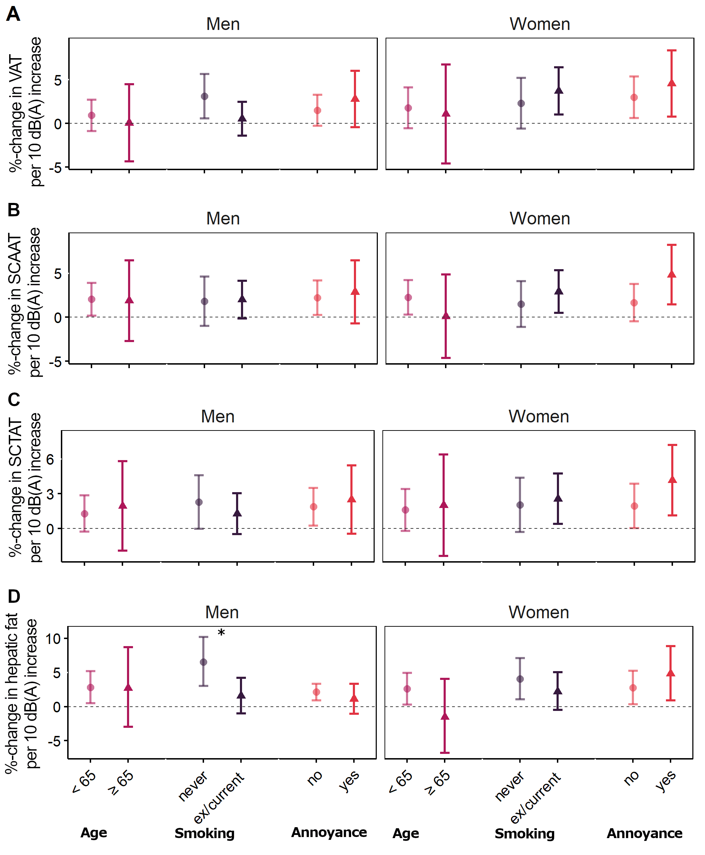
Figure S9 Strata-specific associations of L_{den} (10m buffer) with VAT (A), SCAAT (B), SCTAT (C), and hepatic fat content (D) derived from linear regression with a multiplicative interaction term between exposure and potential effect modifier in the German National Cohort. Legend: Models were adjusted for study center, age, alcohol consumption, physical activity, smoking behavior, income. Effect estimates are given as percentage change of the arithmetic (geometric for hepatic fat content) outcome mean per 10 dB(A) increase in exposure with 95% confidence intervals. Asterix indicate significant interaction term with p < 0.05. Abbreviation: L_{den} = day–evening–night road traffic noise level, SCAAT = subcutaneous abdominal adipose tissue, SCTAT = subcutaneous thoracic adipose tissue, VAT = visceral adipose tissue
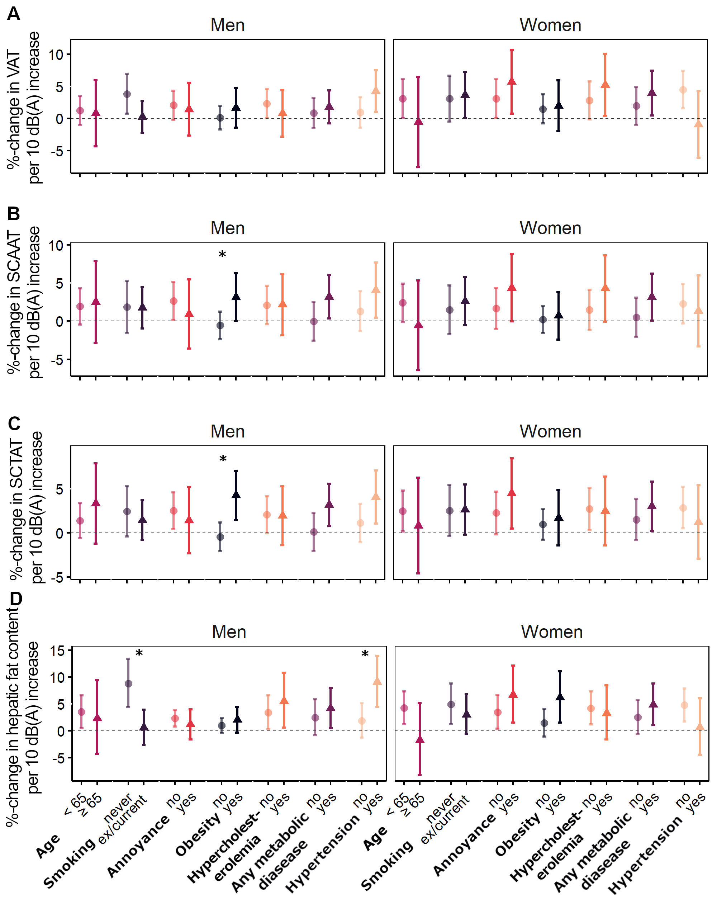
Figure S10 Strata-specific associations of L_{den} (100m buffer) with VAT (A), SCAAT (B), SCTAT (C), and hepatic fat content (D) derived from linear regression with a multiplicative interaction term between exposure and potential effect modifier in the German National Cohort. Legend: Models were adjusted for study center, age, alcohol consumption, physical activity, smoking behavior, income. Effect estimates are given as percentage change of the arithmetic (geometric for hepatic fat content) outcome mean per 10 dB(A) increase in exposure with 95% confidence intervals. Asterix indicate significant interaction term with p < 0.05. Abbreviation: L_{den} = day–evening–night road traffic noise level, SCAAT = subcutaneous abdominal adipose tissue, SCTAT = subcutaneous thoracic adipose tissue, VAT = visceral adipose tissue
%-change in hepatic fat content per 10 dB(A) increase
%-change in SCTAT per 10 dB(A) increase
Table S1 Distribution of different road traffic noise variables used in various sensitivity analyses in the German National Cohort.
 | Overall | Men | Women
Categorical | n = 11,101 | n = 5,690 | n = 5,411
NA | 4,864 (43.8) | 2,486 (43.7) | 2,378 (43.9)
40 dB(A) | 4,126 (37.2) | 2,121 (37.3) | 2,005 (37.1)
55 – 59 dB(A) | 844 (7.6) | 432 (7.6) | 412 (7.6)
60 – 64 dB(A) | 508 (4.6) | 249 (4.4) | 258 (4.8)
65 – 69 dB(A) | 437 (3.9) | 236 (4.1) | 201 (3.7)
70 – 74 dB(A) | 260 (2.3) | 139 (2.4) | 121 (2.2)
≥75 dB(A) | 63 (0.6) | 27 (0.5) | 36 (0.7)
Binary* | n = 6,237 | n = 3,204 | n = 3,033
< 55 dB(A) | 4,126 (66.2) | 2,121 (66.2) | 2,005 (66.1)
≥ 55 dB(A) | 2,111 (33.8) | 1,083 (33.8) | 1,028 (33.9)
Sensitivity continuous* | n = 6,237 | n = 3,204 | n = 3,033
L_{den} 10m, [dB(A)] | 46.8 (9.3) | 46.8 (9.4) | 46.7 (9.3)
L_{den} 100m, [dB(A)] | 46.8 (6.9) | 46.9 (7.0) | 46.8 (6.8)
Categorical based on continuous noise 100m buffer variable* | n = 6,795 | n = 3,478 | n = 3,317
40 dB(A) | 1,611 (14.5) | 832 (14.6) | 779 (14.4)
>40 – 54.9 dB(A) | 4,226 (38.1) | 2,144 (37.7) | 2,082 (38.5)
≥ 55 dB(A) | 958 (8.6) | 502 (8.8) | 456 (8.4)
*Participants with NA in categorical road traffic noise variable were excluded from the regression analysis. Abbreviations: L_{den} = day–evening–night road traffic noise level

Table S2 Descriptive statistics of exposures used for two-exposure models in the German National Cohort.
 | Men (n = 5,690) |  |  |  |  |  | Women (n = 5,411)
 | Mean (SD) | Min | 25th percentile | Median | 75th percentile | Max | Mean (SD) | Min | 25th percentile | Median | 75th percentile | Max
L_{den} 10m (dB(A)) | 43.86 (7.80) | 40 | 40 | 40 | 40.31 | 74.27 | 43.84 (7.73) | 40 | 40 | 40 | 40.53 | 73.54
L_{den} 100m (dB(A)) | 44.10 (6.27) | 40 | 40 | 40 | 47.16 | 69.4 | 44.04 (6.12) | 40 | 40 | 40 | 47.17 | 69.86
NO₂ (µg/m³) | 26.03 (9.83) | 4.73 | 18.29 | 24.71 | 33.51 | 74.97 | 25.79 (9.72) | 5.41 | 18.18 | 24.52 | 33.05 | 74.51
PM_{2.5} (µg/m³) | 17.64 (2.04) | 10.13 | 16.23 | 17.39 | 19.48 | 23.08 | 17.64 (2.05) | 10.94 | 16.3 | 17.4 | 19.49 | 23.09
NDVI | 0.54 (0.09) | 0.25 | 0.48 | 0.55 | 0.61 | 0.82 | 0.54 (0.09) | 0.25 | 0.48 | 0.55 | 0.61 | 0.79
Abbreviation: L_{den} = day–evening–night road traffic noise level, NO₂= nitrogen dioxide, PM_{2.5} = particulate matter with diameter < 2.5 µm, NDVI = normalized difference vegetation index

Table S3. Sensitivity analysis comparing associations of road traffic noise with adipose tissue depots, hepatic fat content and MASLD in the German National Cohort after additional adjustment for population density and area-level SES.
 | Adjustment | Men (n = 5,690) |  | Women (n = 5,411)
 |  | %-change (95% CI) | p | %-change (95% CI) | p
VAT [l]
L_{den} (10m) | Main | 1.72 (0.14; 3.30) | 0.03 | 3.13 (1.09; 5.18) | <0.01
 | Main + population density | 1.93 (0.34; 3.52) | 0.02 | 3.22 (1.16; 5.27) | <0.01
 | Main + area level SES | 1.78 (0.18; 3.37) | 0.03 | 3.14 (1.08; 5.21) | <0.01
 | Main + population density & area level SES | 1.90 (0.30; 3.50) | 0.02 | 3.20 (1.13; 5.26) | <0.01
L_{den} (100m) | Main | 1.85 (-0.15; 3.86) | 0.07 | 3.47 (0.84; 6.09) | 0.01
 | Main + population density | 2.38 (0.35; 4.40) | 0.04 | 3.77 (1.11; 6.43) | 0.01
 | Main + area level SES | 1.98 (-0.06; 4.02) | 0.06 | 3.50 (0.83; 6.18) | 0.01
 | Main + population density & area level SES | 2.27 (0.22; 4.33) | 0.05 | 3.56 (0.88; 6.24) | 0.01
SCAAT [l]
L_{den} (10m) | Main | 2.18 (0.43; 3.93) | 0.02 | 2.38 (0.55; 4.20) | 0.01
 | Main + population density | 2.46 (0.70; 4.22) | 0.01 | 2.57 (0.74; 4.41) | 0.01
 | Main + area level SES | 2.37 (0.60; 4.13) | 0.01 | 2.58 (0.73; 4.42) | 0.01
 | Main + population density & area level SES | 2.51 (0.74; 4.28) | 0.01 | 2.67 (0.82; 4.51) | 0.01
L_{den} (100m) | Main | 2.07 (-0.15; 4.29) | 0.07 | 2.22 (-0.12; 4.57) | 0.06
 | Main + population density | 2.40 (0.17; 4.64) | 0.04 | 2.50 (0.13; 4.86) | 0.04
 | Main + area level SES | 2.43 (0.17; 4.70) | 0.04 | 2.58 (0.19; 4.97) | 0.04
 | Main + population density & area level SES | 2.54 (0.27; 4.81) | 0.03 | 2.68 (0.29; 5.08) | 0.03
SCTAT [l]
L_{den} (10m) | Main | 1.79 (0.34; 3.25) | 0.02 | 2.39 (0.75; 4.03) | <0.01
 | Main + population density | 1.85 (0.38; 3.31) | 0.01 | 2.55 (0.90; 4.19) | <0.01
 | Main + area level SES | 1.59 (0.12; 3.05) | 0.03 | 2.30 (0.64; 3.95) | 0.01
 | Main + population density & area level SES | 1.67 (0.20; 3.13) | 0.03 | 2.41 (0.75; 4.07) | <0.01
L_{den} (100m) | Main | 1.99 (0.15; 3.83) | 0.03 | 2.68 (0.58; 4.79) | 0.01
 | Main + population density | 2.05 (0.19; 3.90) | 0.03 | 2.90 (0.78; 5.03) | 0.01
 | Main + area level SES | 1.61 (-0.27; 3.49) | 0.09 | 2.53 (0.38; 4.68) | 0.02
 | Main + population density & area level SES | 1.67 (-0.21; 3.55) | 0.08 | 2.67 (0.52; 4.82) | 0.02
Hepatic fat content [%]
L_{den} (10m) | Main | 3.57 (1.41; 5.78) | <0.01 | 3.08 (1.00; 5.21) | <0.01
 | Main + population density | 4.00 (1.82; 6.23) | <0.01 | 3.13 (1.03; 5.28) | <0.01
 | Main + area level SES | 3.57 (1.39; 5.80) | <0.01 | 3.21 (1.10; 5.36) | <0.01
 | Main + population density & area level SES | 3.86 (1.67; 6.10) | <0.01 | 3.22 (1.1; 5.38) | <0.01
L_{den} (100m) | Main | 3.87 (1.13; 6.69) | 0.01 | 4.03 (1.33; 6.79) | <0.01
 | Main + population density | 4.41 (1.63; 7.25) | <0.01 | 4.11 (1.39; 6.90) | <0.01
 | Main + area level SES | 3.91 (1.11; 6.78) | 0.01 | 4.30 (1.54; 7.13) | <0.01
 | Main + population density & area level SES | 4.13 (1.32; 7.01) | <0.01 | 4.31 (1.55; 7.15) | <0.01
MASLD¹ |  | OR (95% CI) |  | OR (95% CI)
L_{den} (10m) | Main | 1.10 (1.01; 1.19) | 0.02 | 1.08 (0.99; 1.19) | 0.1
 | Main + population density | 1.12 (1.03; 1.21) | 0.01 | 1.09 (0.99; 1.19) | 0.08
 | Main + area level SES | 1.11 (1.02; 1.20) | 0.01 | 1.08 (0.98; 1.18) | 0.12
 | Main + population density & area level SES | 1.12 (1.03; 1.21) | 0.01 | 1.08 (0.98; 1.19) | 0.11
L_{den} (100m) | Main | 1.08 (0.98; 1.20) | 0.14 | 1.10 (0.98; 1.24) | 0.10
 | Main + population density | 1.10 (0.99; 1.22) | 0.07 | 1.11 (0.99; 1.25) | 0.09
 | Main + area level SES | 1.10 (0.99; 1.22) | 0.08 | 1.10 (0.97; 1.24) | 0.13
 | Main + population density & area level SES | 1.10 (0.99; 1.23) | 0.06 | 1.10 (0.98; 1.24) | 0.12
Legend: Effect estimates are given as percentage change of the arithmetic (geometric for hepatic fat content) outcome mean per 10 dB(A) increase in exposure with 95% confidence intervals derived from linear and logistic regression models stratified by sex. Main model adjusted for study center, age, alcohol consumption, physical activity, smoking behavior, income. Area-level SES was represented by unemployment rate at district level, population density was given as inhabitants per 500 m².
¹Sample size deviate from full sample (n = 5,147 men and n = 5,258 women) due to MASLD definition. Abbreviations: CI = confidence interval, L_{den} = day–evening–night road traffic noise level, MASLD = metabolic dysfunction–associated steatotic liver disease, OR = odds ratio, SCAAT = subcutaneous abdominal adipose tissue, SCTAT = subcutaneous thoracic adipose tissue, SES = socioeconomic status, VAT = visceral adipose tissue

Table S4 Results of sensitivity analysis on the associations of road traffic noise used as continuous, binary, and categorical variable with adipose tissue depots and hepatic fat content in the German National Cohort.
 | Men |  |  | Women
 | n | %-change (95% CI) | p | n | %-change (95% CI) | p
VAT [l]
Continuous
L_{den} (10m)¹ | 3,204 | 2.28 (0.49; 4.07) | 0.03 | 3,033 | 3.23 (0.98; 5.48) | <0.01
L_{den} (100m)¹ | 3,204 | 2.98 (0.57; 5.40) | 0.01 | 3,033 | 4.48 (1.36; 7.59) | <0.01
Categorical
40 dB(A) | 2,121 | Ref |  | 2,005 | Ref
55 – 59 dB(A) | 432 | 4.95 (-0.03; 9.93) | 0.05 | 412 | 6.39 (0.00; 12.78) | 0.05
60 – 64 dB(A) | 249 | 3.86 (-2.30; 10.03) | 0.22 | 258 | 9.94 (2.52; 17.36) | 0.01
65 – 69 dB(A) | 236 | 5.33 (-0.89; 11.54) | 0.09 | 201 | 5.37 (-2.87; 13.6) | 0.20
≥ 70¹ dB(A) | 166 | 6.16 (-1.17; 13.49) | 0.10 | 157 | 7.75 (-1.51; 17.01) | 0.10
Binary
<55 dB(A) | 2,121 | Ref |  | 2,005 | Ref
≥55 dB(A) | 1,083 | 4.98 (1.40; 8.56) | 0.01 | 1,028 | 7.31 (2.81; 11.8) | <0.01
Categorical based on L_{den} 100m buffer variable
40 dB(A) | 832 | Ref |  | 779 | Ref
>40 – 54.9 dB(A) | 2,144 | 0.77 (-2.95; 4.48) | 0.69 | 2,082 | 4.17 (-0.55; 8.88) | 0.08
≥ 55 dB(A) | 502 | 3.70 (-1.50; 8.91) | 0.16 | 456 | 12.14 (5.47; 18.81) | <0.01
SCAAT [l]
Continuous
L_{den} (10m)¹ | 3,204 | 3.05 (1.08; 5.03) | <0.01 | 3,033 | 2.97 (0.99; 4.96) | <0.01
L_{den} (100m)¹ | 3,204 | 3.76 (1.09; 6.42) | <0.01 | 3,033 | 4.24 (1.49; 6.98) | <0.01
Categorical
40 dB(A) | 2,121 | Ref |  | 2,005 | Ref
55 – 59 dB(A) | 432 | 5.46 (-0.02; 10.95) | 0.05 | 412 | 2.59 (-3.04; 8.23) | 0.37
60 – 64 dB(A) | 249 | 7.64 (0.85; 14.44) | 0.03 | 258 | 11.34 (4.79; 17.89) | <0.01
65 – 69 dB(A) | 236 | 8.24 (1.38; 15.09) | 0.02 | 201 | 5.47 (-1.79; 12.74) | 0.14
≥ 70¹ dB(A) | 166 | 8.79 (0.71; 16.87) | 0.03 | 157 | 4.16 (-4.01; 12.33) | 0.32
Binary
<55 dB(A) | 2,121 | Ref |  | 2,005 | Ref
≥55 dB(A) | 1,083 | 7.12 (3.18; 11.07) | <0.01 | 1,028 | 5.71 (1.75; 9.68) | <0.01
Categorical based on L_{den} 100m buffer variable
40 dB(A) | 832 | Ref |  | 779 | Ref
>40 – 54.9 dB(A) | 2,144 | 3.05 (-1.03; 7.13) | 0.14 | 2,082 | 3.65 (-0.51; 7.81) | 0.09
≥ 55 dB(A) | 502 | 6.24 (0.52; 11.95) | 0.03 | 456 | 12.48 (6.6; 18.37) | <0.01
SCTAT [l]
Continuous
L_{den} (10m)¹ | 3,204 | 1.94 (0.27; 3.61) | 0.02 | 3,033 | 2.38 (0.56; 4.20) | 0.01
L_{den} (100m)¹ | 3,204 | 2.17 (-0.09; 4.43) | 0.06 | 3,033 | 3.31 (0.79; 5.82) | 0.01
Categorical
40 dB(A) | 2,121 | Ref |  | 2,005 | Ref
55 – 59 dB(A) | 432 | 2.80 (-1.85; 7.44) | 0.24 | 412 | 1.89 (-3.27; 7.05) | 0.47
60 – 64 dB(A) | 249 | 6.86 (1.1; 12.61) | 0.02 | 258 | 7.03 (1.03; 13.02) | 0.02
65 – 69dB(A) | 236 | 4.12 (-1.68; 9.92) | 0.16 | 201 | 3.70 (-2.95; 10.36) | 0.28
≥ 70¹ dB(A) | 166 | 6.38 (-0.46; 13.23) | 0.07 | 157 | 5.98 (-1.51; 13.46) | 0.12
Binary
<55 dB(A) | 2,121 | Ref |  | 2,005 | Ref
≥55 dB(A) | 1,083 | 4.58 (1.24; 7.93) | 0.01 | 1,028 | 4.26 (0.63; 7.89) | 0.02
Categorical based on L_{den} 100m buffer variable
40 dB(A) | 832 | Ref |  | 779 | Ref
>40 – 54.9 dB(A) | 2,144 | 1.05 (-2.40; 4.50) | 0.55 | 2,082 | 3.38 (-0.43; 7.18) | 0.08
≥ 55 dB(A) | 502 | 4.43 (-0.41; 9.26) | 0.07 | 456 | 10.32 (4.93; 15.7) | 0.00
Hepatic fat content [%]
Continuous
L_{den} (10m)¹ | 3,204 | 1.94 (0.27; 3.61) | 0.02 | 3,033 | 2.38 (0.56; 4.20) | 0.01
L_{den} (100m)¹ | 3,204 | 2.17 (-0.09; 4.43) | 0.06 | 3,033 | 3.31 (0.79; 5.82) | 0.01
Categorical
40 dB(A) | 2,121 | Ref |  | 2,005 | Ref
55 – 59 dB(A) | 432 | 7.70 (1.01; 14.83) | 0.02 | 412 | 2.84 (-3.33; 9.41) | 0.38
60 – 64 dB(A) | 249 | 4.14 (-3.81; 12.74) | 0.32 | 258 | 8.72 (1.17; 16.83) | 0.02
65 – 69 dB(A) | 236 | 8.73 (0.37; 17.8) | 0.04 | 201 | 4.33 (-3.68; 13.00) | 0.30
≥ 70¹ dB(A) | 166 | 13.29 (3.08; 24.51) | 0.01 | 157 | 8.81 (-0.54; 19.03) | 0.07
Binary
<55 dB(A) | 2,121 | Ref |  | 2,005 | Ref
≥55 dB(A) | 1,083 | 7.99 (3.12; 13.08) | <0.01 | 1,028 | 5.59 (1.09; 10.3) | 0.01
Categorical based on L_{den} 100m buffer variable
40 dB(A) | 832 | Ref |  | 779 | Ref
>40 – 54.9 dB(A) | 2,144 | 1.52 (-3.25; 6.52) | 0.54 | 2,082 | 3.86 (-0.81; 8.75) | 0.11
≥ 55 dB(A) | 502 | 7.62 (0.61; 15.13) | 0.03 | 456 | 12.32 (5.24; 19.87) | <0.01
MASLD |  | OR (95% CI) |  |  | OR (95% CI)
Continuous
L_{den} (10m) | 2,900 | 1.10 (1.01; 1.19) | 0.01 | 2,944 | 1.09 (0.98; 1.21) | 0.11
L_{den} (100m) | 2,900 | 1.14 (1.01; 1.29) | 0.03 | 2,944 | 1.13 (0.98; 1.30) | 0.08
Categorical
40 dB(A) | 1,917 | Ref |  | 1,950 | Ref
55 – 59 dB(A) | 388 | 1.32 (1.03; 1.69) | 0.03 | 402 | 1.20 (0.90; 1.59) | 0.21
60 – 64 dB(A) | 228 | 1.28 (0.94; 1.74) | 0.16 | 248 | 1.19 (0.85; 1.67) | 0.31
65 – 69 dB(A) | 214 | 1.24 (0.91; 1.69) | 0.18 | 190 | 0.86 (0.57; 1.28) | 0.45
≥ 70¹ dB(A) | 153 | 1.49 (1.04; 2.13) | 0.03 | 154 | 1.54 (1.03; 2.31) | 0.04
Binary
<55 dB(A) | 1,917 | Ref |  | 1,950 | Ref
≥55 dB(A) | 983 | 1.32 (1.10; 1.57) | 0.01 | 994 | 1.17 (0.95; 1.43) | 0.13
Categorical based on L_{den} 100m buffer variable
40 dB(A) | 761 | Ref |  | 760 | Ref
>40 – 54.9 dB(A) | 1,936 | 0.99 (0.82; 1.19) | 0.93 | 2,021 | 1.09 (0.88; 1.35) | 0.43
≥ 55 dB(A) | 456 | 1.24 (0.96; 1.60) | 0.11 | 442 | 1.37 (1.02; 1.85) | 0.04
Legend: Effect estimates are given as percentage change of the arithmetic (geometric for hepatic fat content) outcome mean per 10 dB(A) increase in exposure with 95% confidence intervals derived from linear and logistic regression models stratified by sex. Models are adjusted for study center, age, alcohol consumption, physical activity, smoking behavior, and income. For all the road traffic exposure variables, participants with missing in the categorical variable were excluded.
¹Categories 70 – 74 dB(A) and ≥ 75 dB(A) were subsumed due to small sample size. Abbreviations: L_{den} = day–evening–night road traffic noise level, MASLD = metabolic-dysfunction associated steatosis liver disease

Table S5 Participant characteristics for the complete-case German National Cohort sample stratified by sex.
 | Overall  (n = 9,444) | Men  (n =4,870) | Women  (n = 4,574)
Sex, female n (%) | 4,574 (48.4) | - | 4,574 (100.0)
Age (years), mean (SD) | 51.8 (11.3) | 51.9 (11.4) | 51.6 (11.1)
Study center, n (%)
Augsburg | 2,173 (23.0) | 1,211 (24.9) | 962 (21.0)
Berlin | 1,900 (20.1) | 973 (20.0) | 927 (20.3)
Düsseldorf | 215 (2.3) | 120 (2.5) | 95 (2.1)
Essen | 1,388 (14.7) | 695 (14.3) | 693 (15.2)
Mannheim | 1,025 (10.9) | 533 (10.9) | 492 (10.8)
Münster | 63 (0.7) | 37 (0.8) | 26 (0.6)
Neubrandenburg | 2,599 (27.5) | 1,261 (25.9) | 1,338 (29.3)
Saarbrücken | 81 (0.9) | 40 (0.8) | 41 (0.9)
Examination year, n (%)
2014 | 433 (4.6) | 226 (4.6) | 207 (4.5)
2015 | 3,231 (34.2) | 1,652 (33.9) | 1,579 (34.5)
2016 | 5,780 (61.2) | 2,992 (61.4) | 2,788 (61.0)
VAT (l), mean (SD) | 3.7 (2.3) | 4.8 (2.4) | 2.5 (1.5)
SCAAT (l), mean (SD) | 6.9 (3.6) | 6.2 (3.0) | 7.7 (3.9)
SCTAT (l), mean (SD) | 3.3 (1.6) | 2.81 (1.2) | 3.8 (1.8)
Hepatic fat content (%), mean (SD) | 7.5 (6.5) | 8.7 (6.9) | 6.3 (5.9)
MASLD, yes n (%) | 2,966 (31.4) | 1,922 (39.5) | 1,044 (22.8)
L_{den} (10m) (dB(A)), mean (SD) | 43.8 (7.7) | 43.8 (7.7) | 43.8 (7.7)
L_{den} (100m) (dB(A)), mean (SD) | 44.0 (6.2) | 44.0 (6.2) | 44.0 (6.1)
Degree of urbanization, n (%)
urban | 6,238 (66.1) | 3,177 (65.2) | 3,061 (66.9)
suburban | 1,372 (14.5) | 755 (15.5) | 617 (13.5)
rural | 1,834 (19.4) | 938 (19.3) | 896 (19.6)
Physical activity (min/week), mean (SD) | 1,466 (1,614) | 1,510 (1,668) | 1,420 (1,553)
Alcohol consumption (g/day), mean (SD) | 10.9 (16.9) | 14.8 (20.4) | 6.6 (10.5)
Income (Euros), mean (SD) | 2,273 (1,454) | 2,420 (1,601) | 2,116 (1,261)
Smoking behavior, n (%)
never smoker | 4,474 (47.4) | 2,055 (42.2) | 2,419 (52.9)
ex-smoker | 3,135 (33.2) | 1,830 (37.6) | 1,305 (28.5)
smoker | 1,835 (19.4) | 985 (20.2) | 850 (18.6)
Noise annoyance, high-extreme n (%) | 1,518 (16.1) | 730 (15.0) | 788 (17.2)
Living duration (years), mean (SD) | 15.1 (11.8) | 15.1 (12.1) | 15.2 (11.6)
Population density (n/500 m²), mean (SD) | 1,336 (1,297) | 1,325 (1,296) | 1,347 (1,299)
Unemployment rate (%) at district level, mean (SD) | 9.5 (3.8) | 9.3 (3.8) | 9.7(3.7)
Body-Mass-Index (kg/m²), mean (SD) | 26.8 (4.7) | 27.3 (4.1) | 26.2 (5.2)
Waist circumference (cm), mean (SD) | 91.9 (13.7) | 97.3 (12.0) | 86.1 (13.0)
Obesity (BMI ≥ 30 kg/m²), yes n (%) | 1,984 (21.4) | 1,061 (22.3) | 923 (20.6)
Hypercholesterolemia, yes n (%) | 2,538 (27.0) | 1,364 (28.2) | 1174 (25.8)
Diabetes, yes n (%) | 537 (5.7) | 321 (6.6) | 216 (4.7)
Any metabolic disease, yes (%) | 3,942 (41.7) | 2,094 (43.0) | 1,848 (40.4)
Hypertension, yes n (%) | 2,572 (27.3) | 1,606 (33.0) | 966 (21.1)
Abbreviations: BMI = Body-Mass-Index, L_{den} = day–evening–night road traffic noise level, MASLD = metabolic-dysfunction associated steatosis liver disease, SCAAT = subcutaneous abdominal adipose tissue, SCTAT = subcutaneous thoracic adipose tissue, VAT = visceral adipose tissue

Table S6 Associations of road traffic noise with adipose tissue depots, hepatic fat content and non-alcoholic fatty liver disease derived from linear and logistic regression models in the complete-case German National Cohort sample (n = 9,444).
 | Men (n = 4,870) |  | Women (n = 4,574)
 | %-change (95% CI) | p | %-change (95% CI) | p
VAT [l]
L_{den} (10m) | 2.39 (0.67; 4.11) | 0.01 | 2.96 (0.72; 5.19) | 0.01
L_{den} (100m) | 2.82 (0.65; 5.00) | 0.01 | 2.99 (0.10; 5.88) | 0.04
SCAAT [l]
L_{den} (10m) | 2.64 (0.75; 4.53) | 0.01 | 2.22 (0.23; 4.20) | 0.03
L_{den} (100m) | 2.92 (0.53; 5.32) | 0.02 | 1.94 (-0.63; 4.51) | 0.14
SCTAT [l]
L_{den} (10m) | 2.19 (0.63; 3.76) | 0.01 | 2.31 (0.53; 4.09) | 0.01
L_{den} (100m) | 2.84 (0.85; 4.83) | 0.01 | 2.58 (0.28; 4.88) | 0.03
Hepatic fat content [%]
L_{den} (10m) | 4.42 (2.07; 6.82) | <0.01 | 2.94 (0.68; 5.25) | 0.01
L_{den} (100m) | 4.55 (1.58; 7.62) | <0.01 | 3.40 (0.47; 6.41) | 0.02
MASLD¹ | OR (95% CI) |  | OR (95% CI)
L_{den} (10m) | 1.13 (1.03; 1.24) | 0.007 | 1.08 (0.97; 1.20) | 0.147
L_{den} (100m) | 1.13 (1.01; 1.27) | 0.038 | 1.10 (0.96; 1.25) | 0.183
Effect estimates are given as percentage change of the arithmetic (geometric for hepatic fat content) outcome mean per 10 dB(A) increase in exposure with 95% confidence intervals derived from linear and logistic regression models stratified by sex and adjusted for study center, age, alcohol consumption, physical activity, smoking behavior, and income.
¹Sample size deviate from full sample (n = 4,256 men and n = 4,279 women) due to MASLD definition. Abbreviations: L_{den} = day–evening–night road traffic noise level, MASLD = metabolic-dysfunction associated steatosis liver disease, SCAAT = subcutaneous abdominal adipose tissue, SCTAT = subcutaneous thoracic adipose tissue, VAT = visceral adipose tissue;

Table S7 Associations between road traffic noise and prevalent MASLD and MetALD derived from logistic regression models in the German National Cohort.
 | Men (n = 5,470) |  | Women (n = 5,342)
 | OR (95% CI) | p | OR (95% CI) | p
L_{den} (10m) | 1.09 (1.01; 1.17) | 0.04 | 1.11 (1.01; 1.21) | 0.03
L_{den} (100m) | 1.07 (0.97; 1.18) | 0.16 | 1.13 (1.01; 1.27) | 0.03
Effect estimates are given as odds ratio per 10 dB(A) increase in exposure, with 95% confidence intervals derived from logistic regression models stratified by sex and adjusted for study center, age, alcohol consumption, physical activity, smoking behavior, and income.
Abbreviations: CI = Confidence interval, L_{den} = day–evening–night road traffic noise level, MASLD = metabolic-dysfunction associated steatosis liver disease, MetALD = metabolic-associated alcoholic liver disease, OR = odds ratio

Table S8. Sensitivity analysis comparing associations of road traffic noise with adipose tissue depots, hepatic fat content and MASLD in the German National Cohort after different confounder adjustments.
 | Adjustment | Men (n = 5,690) |  | Women (n = 5,411)
 |  | %-change (95% CI) | p | %-change (95% CI) | p
VAT [l]
L_{den} (10m) | Main | 1.72 (0.14; 3.30) | 0.03 | 3.13 (1.09; 5.18) | <0.01
 | Main without income | 1.88 (0.30; 3.46) | 0.02 | 3.59 (1.54; 5.65) | <0.01
 | Main without lifestyle factors | 1.83 (0.24; 3.42) | 0.02 | 3.06 (1.02; 5.10) | <0.01
L_{den} (100m) | Main | 1.85 (-0.15; 3.86) | 0.07 | 3.47 (0.84; 6.09) | 0.01
 | Main without income | 2.05 (0.05; 4.06) | 0.05 | 4.07 (1.43; 6.71) | <0.01
 | Main without lifestyle factors | 2.08 (0.06; 4.10) | 0.04 | 3.34 (0.71; 5.96) | 0.01
SCAAT [l]
L_{den} (10m) | Main | 2.18 (0.43; 3.93) | 0.02 | 2.38 (0.55; 4.20) | 0.01
 | Main without income | 2.27 (0.52; 4.02) | 0.01 | 2.64 (0.81; 4.47) | 0.01
 | Main without lifestyle | 2.16 (0.41; 3.92) | 0.02 | 2.24 (0.42; 4.07) | 0.02
L_{den} (100m) | Main | 2.07 (-0.15; 4.29) | 0.07 | 2.22 (-0.12; 4.57) | 0.06
 | Main without income | 2.18 (-0.04; 4.40) | 0.05 | 2.57 (0.22; 4.92) | 0.03
 | Main without lifestyle factors | 2.11 (-0.11; 4.34) | 0.06 | 2.03 (-0.31; 4.38) | 0.09
SCTAT [l]
L_{den} (10m) | Main | 1.79 (0.34; 3.25) | 0.02 | 2.39 (0.75; 4.03) | <0.01
 | Main without income | 1.88 (0.43; 3.33) | 0.01 | 2.67 (1.03; 4.32) | <0.01
 | Main without lifestyle factors | 1.91 (0.46; 3.37) | 0.01 | 2.34 (0.70; 3.98) | 0.01
L_{den} (100m) | Main | 1.99 (0.15; 3.83) | 0.03 | 2.68 (0.58; 4.79) | 0.01
 | Main without income | 2.09 (0.25; 3.93) | 0.03 | 3.05 (0.94; 5.16) | 0.01
 | Main without lifestyle factors | 2.20 (0.36; 4.05) | 0.02 | 2.58 (0.47; 4.68) | 0.02
Hepatic fat content [%]
L_{den} (10m) | Main | 3.57 (1.41; 5.78) | <0.01 | 3.08 (1.00; 5.21) | <0.01
 | Main without income | 3.81 (1.64; 6.02) | <0.01 | 3.48 (1.38; 5.62) | <0.01
 | Main without lifestyle factors | 3.72 (1.55; 5.94) | <0.01 | 2.99 (0.91; 5.11) | 0.01
L_{den} (100m) | Main | 3.87 (1.13; 6.69) | 0.01 | 4.03 (1.33; 6.79) | <0.01
 | Main without income | 4.17 (1.42; 6.99) | <0.01 | 4.55 (1.83; 7.34) | <0.01
 | Main without lifestyle factors | 4.15 (1.39; 6.98) | <0.01 | 3.92 (1.23; 6.69) | <0.01
MASLD¹ |  | OR (95% CI) |  | OR (95% CI)
L_{den} (10m) | Main | 1.10 (1.01; 1.19) | 0.02 | 1.08 (0.99; 1.19) | 0.1
 | Main without income | 1.11 (1.03; 1.21) | 0.01 | 1.11 (1.02; 1.22) | 0.02
 | Main without lifestyle factors | 1.09 (1.01; 1.18) | 0.03 | 1.09 (0.99; 1.19) | 0.07
L_{den} (100m) | Main | 1.08 (0.98; 1.20) | 0.14 | 1.10 (0.98; 1.24) | 0.10
 | Main without income | 1.13 (1.02; 1.25) | 0.02 | 1.16 (1.03; 1.30) | 0.01
 | Main without lifestyle factors | 1.11 (1.01; 1.23) | 0.03 | 1.13 (1.01; 1.27) | 0.03
Legend: Effect estimates are given as percentage change of the arithmetic (geometric for hepatic fat content) outcome mean per 10 dB(A) increase in exposure, with 95% confidence intervals derived from linear and logistic regression models stratified by sex. All models are adjusted for study center, age, alcohol consumption, physical activity, smoking behavior, and income.
¹Sample size deviate from full sample (n = 5,147 men and n = 5,258 women) due to MASLD definition. Abbreviations: CI = confidence interval, L_{den} = day–evening–night road traffic noise level, MASLD = metabolic dysfunction–associated steatotic liver disease, OR = odds ratio, SCAAT = subcutaneous abdominal adipose tissue, SCTAT = subcutaneous thoracic adipose tissue, VAT = visceral adipose tissue

Table S9. Sensitivity analysis comparing associations of road traffic noise with adipose tissue depots, hepatic fat content and MASLD in the German National Cohort after excluding those who lived less than five or ten years at the residencies.
 | Adjustment | N (men/women) | Men |  | Women
 |  |  | %-change (95% CI) | p | %-change (95% CI) | p
VAT [l]
L_{den} (10m) | Total sample | 5,690/5,411 | 1.72 (0.14; 3.30) | 0.03 | 3.13 (1.09; 5.18) | <0.01
 | Living duration ≥ 5 years | 4,623/4,508 | 1.76 (-0.03; 3.54) | 0.05 | 3.44 (1.18; 5.69) | <0.01
 | Living duration ≥ 10 years | 3,633/3,598 | 1.78 (-0.28; 3.84) | 0.09 | 4.94 (2.37; 7.51) | <0.01
L_{den} (100m) | Total sample | 5,690/5,411 | 1.85 (-0.15; 3.86) | 0.07 | 3.47 (0.84; 6.09) | 0.01
 | Living duration ≥ 5 years | 4,623/4,508 | 2.12 (-0.11; 4.34) | 0.06 | 3.72 (0.87; 6.56) | 0.01
 | Living duration ≥ 10 years | 3,633/3,598 | 1.95 (-0.58; 4.47) | 0.13 | 4.80 (1.61; 7.98) | <0.01
SCAAT [l]
L_{den} (10m) | Total sample | 5,690/5,411 | 2.18 (0.43; 3.93) | 0.02 | 2.38 (0.55; 4.20) | 0.01
 | Living duration ≥ 5 years | 4,623/4,508 | 2.16 (0.20; 4.12) | 0.03 | 2.86 (0.83; 4.89) | 0.01
 | Living duration ≥ 10 years | 3,633/3,598 | 2.24 (-0.04; 4.51) | 0.05 | 3.64 (1.35; 5.94) | <0.01
L_{den} (100m) | Total sample | 5,690/5,411 | 2.07 (-0.15; 4.29) | 0.07 | 2.22 (-0.12; 4.57) | 0.06
 | Living duration ≥ 5 years | 4,623/4,508 | 2.26 (-0.19; 4.70) | 0.07 | 2.65 (0.09; 5.21) | 0.04
 | Living duration ≥ 10 years | 3,633/3,598 | 2.34 (-0.45; 5.13) | 0.10 | 3.16 (0.31; 6.01) | 0.03
SCTAT [l]
L_{den} (10m) | Total sample | 5,690/5,411 | 1.79 (0.34; 3.25) | 0.02 | 2.39 (0.75; 4.03) | <0.01
 | Living duration ≥ 5 years | 4,623/4,508 | 1.78 (0.14; 3.42) | 0.03 | 2.85 (1.04; 4.67) | <0.01
 | Living duration ≥ 10 years | 3,633/3,598 | 2.10 (0.20; 4.00) | 0.03 | 3.74 (1.68; 5.79) | <0.01
L_{den} (100m) | Total sample | 5,690/5,411 | 1.99 (0.15; 3.83) | 0.03 | 2.68 (0.58; 4.79) | 0.01
 | Living duration ≥ 5 years | 4,623/4,508 | 2.10 (0.05; 4.14) | 0.05 | 3.29 (1.01; 5.58) | 0.01
 | Living duration ≥ 10 years | 3,633/3,598 | 2.06 (-0.27; 4.4) | 0.08 | 3.78 (1.23; 6.33) | <0.01
Hepatic fat content [%]
L_{den} (10m) | Total sample | 5,690/5,411 | 3.57 (1.41; 5.78) | <0.01 | 3.08 (1.00; 5.21) | <0.01
 | Living duration ≥ 5 years | 4,623/4,508 | 3.90 (1.40; 6.46) | <0.01 | 3.25 (0.83; 5.72) | 0.01
 | Living duration ≥ 10 years | 3,633/3,598 | 3.75 (0.78; 6.81) | 0.01 | 4.15 (1.28; 7.1) | <0.01
L_{den} (100m) | Total sample | 5,690/5,411 | 3.87 (1.13; 6.69) | 0.01 | 4.03 (1.33; 6.79) | <0.01
 | Living duration ≥ 5 years | 4,623/4,508 | 4.39 (1.26; 7.62) | 0.01 | 4.13 (1.07; 7.28) | 0.01
 | Living duration ≥ 10 years | 3,633/3,598 | 3.46 (-0.16; 7.21) | 0.06 | 4.52 (0.96; 8.20) | 0.01
MASLD¹ |  |  | OR (95% CI) |  | OR (95% CI)
L_{den} (10m) | Total sample | 5,147/5,258 | 1.10 (1.01; 1.19) | 0.02 | 1.08 (0.99; 1.19) | 0.10
 | Living duration ≥ 5 years | 4,143/4,368 | 1.09 (0.99; 1.19) | 0.08 | 1.08 (0.97; 1.19) | 0.17
 | Living duration ≥ 10 years | 3,223/3,477 | 1.09 (0.98; 1.22) | 0.12 | 1.10 (0.98; 1.24) | 0.10
L_{den} (100m) | Total sample | 5,147/5,258 | 1.08 (0.98; 1.20) | 0.14 | 1.10 (0.98; 1.24) | 0.10
 | Living duration ≥ 5 years | 4,143/4,368 | 1.07 (0.96; 1.20) | 0.24 | 1.09 (0.96; 1.24) | 0.19
 | Living duration ≥ 10 years | 3,223/3,477 | 1.08 (0.94; 1.23) | 0.27 | 1.11 (0.97; 1.28) | 0.14
Legend: Effect estimates are given as percentage change of the arithmetic (geometric for hepatic fat content) outcome mean per 10 dB(A) increase in exposure, with 95% confidence intervals derived from linear and logistic regression models stratified by sex. All models are adjusted for study center, age, alcohol consumption, physical activity, smoking behavior, and income.
¹Sample size deviate from full sample due to MASLD definition. Abbreviations: CI = confidence interval, L_{den} = day–evening–night road traffic noise level, MASLD = metabolic dysfunction–associated steatotic liver disease, OR = odds ratio, SCAAT = subcutaneous abdominal adipose tissue, SCTAT = subcutaneous thoracic adipose tissue, VAT = visceral adipose tissue

