**Supplementary material**

**- Supplementary Table 1: MR Imaging Parameters at 7T** **(page 2)**

**- Supplementary Table 2: Summary of clinical characteristics in all patients of MOGAD** **(pages 3-5)**

**- Supplementary Table 3: Clinical and paraclinical characteristics of patients with cortical lesions and/or CVS (focus on MOGAD and MS diagnostic criteria) (pages 6-8)**

**- Supplementary Table 4: Demographic and clinical characteristics in MOGAD cases from BTH and CUB (page 9)**

**- Supplementary Table 5: Brain MRI characteristics in MOGAD cases from BTH and CUB (pages 10-11)**

**- Supplementary Figure 1: Exemplary MOGAD lesions at different locations (page 12)**

**- Supplementary Figure 2: Examples and schematic representation of SWI-phase for changes related to MOGAD (page 13)**

**Supplementary Table 1.** **MR Imaging Parameters at 7T**

|  |  |  |  |  |  |  |  |  |  |  |
| --- | --- | --- | --- | --- | --- | --- | --- | --- | --- | --- |
|  | **T1-MPRAGE** | | **FLAIR** | | **T2\*** | | **SWI** | | **FLAWS** | |
| **BTH** | **CUB** | **BTH** | **CUB** | **BTH** | **CUB** | **BTH** | **CUB** | **BTH** | **CUB** |
| **Repetition time (ms)** | 2200 | 2300 | 6600 | 8000 | 2500 | 1820 | 19 | 30 | 5000 | - |
| **Echo time**  **(ms)** | 3.0 | 2.98 | 95 | 398 | 10/20/30 | 4.08/7.14/10.2/  13.26/16.32/  19.37/22.43/25.49 | 12 | 15 | 1.44 | - |
| **Inversion time (ms)** | 1050 | 900 | 2200 | 2150 | - | - | - | - | 700/1700 | - |
| **Acquisition resolution (mm2)** | 0.7×0.7 | 1.0×1.0 | 0.3×0.3 | 0.8×0.8 | 0.1×0.1 | 0.5×0.5 | 0.1×0.1 | 0.3×0.3 | 0.75×0.75 | - |
| **Slice thickness**  **(mm)** | 0.7 | 1.0 | 2 | 0.8 | 1.2 | 2.0 | 1.2 | 1.0 | 0.75 | - |
| **Acquisition time (min:sec)** | 6:29 | 9:13 | 5:18 | 6:01 | 19:08 | 12:09 | 7:45 | 9:26 | 8:52 | - |

BTH, Beijing Tiantan Hospital; CUB, Charité Universitätsmedizin Berlin.

**Supplementary Table 2.** **Summary of clinical characteristics in all patients of MOGAD**

|  |  |  |  |  |  |  |  |  |  |  |  |  |  |
| --- | --- | --- | --- | --- | --- | --- | --- | --- | --- | --- | --- | --- | --- |
| **Num** | **Disease duration (month)** | **Number of attacks** | **Disease modifying therapy** | **Serum MOG antibody titer**  **(Negative=0)** | **CSF MOG antibody titer**  **(Negative=0)** | **OB** | **EDSS** | **Optic Neuritis** | **Myelitis** | **Cerebral monofocal or polyfocal deficits** | **ADEM** | **Cerebral**  **cortical encephalitis** | **Brainstem and cerebellar deficits** |
| **MOG_001** | 5 | 1 | No | 1:32 | 0 | - | 1 | 0 | 0 | 1 | 0 | 0 | 0 |
| **MOG_002** | 1 | 1 | No | 1:32 | 1:3.2 | - | 4 | 0 | 1 | 0 | 0 | 0 | 0 |
| **MOG_003** | 5 | 3 | No | 1:32 | 0 | - | 5 | 3 | 0 | 0 | 0 | 0 | 0 |
| **MOG_004** | 229 | 7 | Methotrexate | 1:100 | 0 | - | 4 | 1 | 3 | 2 | 1 | 2 | 2 |
| **MOG_005** | 8 | 2 | No | 1:10 | 1:1 | - | 0 | 1 | 0 | 0 | 0 | 1 | 1 |
| **MOG_006** | 1 | 1 | No | 1:32 | 1:100 | - | 3 | 0 | 0 | 0 | 0 | 0 | 2 |
| **MOG_008** | 62 | 9 | Rituximab | 1:32 | 0 | - | 2 | 4 | 0 | 3 | 0 | 3 | 1 |
| **MOG_007** | 1 | 1 | No | 1:100 | 1:32 | - | 2 | 0 | 0 | 0 | 0 | 1 | 0 |
| **MOG_009** | 1 | 1 | No | 1:100 | 0 | - | 0 | 0 | 0 | 1 | 0 | 0 | 0 |
| **MOG_010** | 163 | 5 | No | 1:10 | 0 | - | 4 | 1 | 3 | 4 | 0 | 0 | 0 |
| **MOG_011** | 22 | 4 | Rituximab | 1:32 | 0 | - | 3.5 | 0 | 4 | 0 | 0 | 0 | 0 |
| **MOG_012** | 78 | 3 | Rituximab | 1:100 | 0 | - | 1 | 3 | 0 | 0 | 0 | 0 | 0 |
| **MOG_013** | 1 | 1 | No | 1:10 | 1:32 | - | 1.5 | 1 | 0 | 1 | 0 | 1 | 0 |
| **MOG_014** | 36 | 2 | No | 1:32 | 1:10 | - | 2 | 1 | 1 | 1 | 0 | 0 | 1 |
| **MOG_015** | 1 | 1 | No | 1:32 | 1:10 | - | 8.5 | 1 | 1 | 1 | 0 | 0 | 0 |
| **MOG_016** | 26 | 2 | MMF | 1:32 | 0 | - | 1 | 1 | 1 | 0 | 0 | 0 | 0 |
| **MOG_017** | 21 | 1 | Rituximab | 1:1000 | 1:100 | + | 0 | 0 | 0 | 0 | 0 | 1 | 1 |
| **MOG_018** | 300 | 3 | No | 1:10 | 0 | - | 4.5 | 2 | 0 | 0 | 0 | 1 | 1 |
| **MOG_019** | 39 | 4 | Rituximab | 1:10 | 0 | - | 2.5 | 0 | 0 | 3 | 0 | 1 | 2 |
| **MOG_020** | 1 | 1 | No | 1:100 | 0 | - | 0 | 0 | 0 | 1 | 0 | 0 | 0 |
| **MOG_021** | 72 | 3 | MMF | 0 | 1:10 | - | 0 | 1 | 0 | 1 | 0 | 0 | 1 |
| **MOG_022** | 9 | 1 | No | 1:10 | 1:1 | + | 0 | 0 | 0 | 0 | 0 | 1 | 0 |
| **MOG_023** | 40 | 3 | MMF | 1:100 | 0 | + | 0 | 1 | 0 | 1 | 0 | 0 | 1 |
| **MOG_024** | 24 | 4 | Rituximab | 1:32 | 1:10 | - | 1 | 2 | 0 | 4 | 0 | 0 | 4 |
| **MOG_025** | 27 | 1 | No | 1:100 | 1:32 | + | 0 | 0 | 1 | 0 | 0 | 0 | 0 |
| **MOG_026** | 4 | 2 | No | 1:10 | 0 | + | 1.5 | 0 | 0 | 2 | 0 | 1 | 0 |
| **MOG_027** | 32 | 2 | No | 1:10 | 0 | - | 0 | 2 | 0 | 0 | 0 | 0 | 0 |
| **MOG_028** | 1 | 1 | No | 1:10 | 1:3.2 | - | 3 | 0 | 1 | 0 | 0 | 0 | 0 |
| **MOG_029** | 1 | 1 | No | 1:100 | 1:100 | + | 4 | 0 | 1 | 0 | 0 | 0 | 0 |
| **MOG_030** | 19 | 2 | MMF | 1:10 | 0 | - | 3 | 1 | 1 | 0 | 0 | 0 | 0 |
| **MOG_031** | 15 | 2 | Rituximab | 1:100 | 1:100 | - | 0 | 0 | 0 | 0 | 0 | 2 | 0 |
| **MOG_032** | 23 | 2 | No | 1:10 | 0 | - | 1 | 2 | 0 | 0 | 0 | 0 | 0 |
| **MOG_033** | 2 | 1 | No | 1:1000 | 1:100 | - | 3.5 | 0 | 0 | 0 | 0 | 1 | 0 |
| **MOG_034** | 2 | 1 | No | 1:320 | 0 | + | 4 | 1 | 0 | 0 | 0 | 1 | 0 |
| **MOG_035** | 30 | 2 | No | 1:100 | 0 | - | 2 | 2 | 0 | 0 | 0 | 0 | 0 |
| **MOG_036** | 1 | 1 | No | 1:320 | 1:32 | - | 6.5 | 1 | 1 | 0 | 0 | 0 | 2 |
| **MOG_037** | 4 | 1 | No | 1:100 | 0 | - | 1 | 0 | 0 | 1 | 0 | 0 | 0 |
| **MOG_038** | 8 | 2 | MMF | 1:100 | 0 | - | 2 | 1 | 1 | 0 | 0 | 0 | 0 |
| **GER _009** | 16 | 1 | MMF | 0 | NA | - | 2 | 1 | 0 | 0 | 0 | 0 | 0 |
| **GER _043** | 178 | 9 | Azathioprine | 1:10 | NA | NA | 2 | 3 | 5 | 0 | 0 | 0 | 1 |
| **GER _045** | 80 | 6 | Rituximab | 1:32 | NA | NA | 2.5 | 4 | 2 | 0 | 0 | 0 | 0 |
| **GER _047** | 30 | 1 | No | 1:640 | NA | NA | 2.5 | 0 | 1 | 0 | 0 | 0 | 0 |
| **GER _065** | 30 | 9 | Tocilizumab | 1:320 | 1:100 | - | 2 | 9 | 0 | 0 | 0 | 0 | 0 |
| **GER _087** | 561 | 5 | Rituximab | 1:10 | NA | NA | 4 | 3 | 2 | 0 | 0 | 0 | 0 |
| **GER_088** | 72 | 6 | Azathioprine | 1:10 | 0 | NA | 1.5 | 6 | 0 | 0 | 0 | 0 | 0 |

OB, Oligoclonal Bands; ADEM, acute disseminated encephalomyelitis; MMF, Mycophenolate Mofetil.

**Supplementary Table 3.** **Clinical and paraclinical characteristics of patients with cortical lesions and/or CVS (focus on MOGAD and MS diagnostic criteria)**

|  |  |  |  |  |  |  |  |  |  |  |  |  |  |
| --- | --- | --- | --- | --- | --- | --- | --- | --- | --- | --- | --- | --- | --- |
| **Num** | **Number of attacks** | **Serum MOG antibody titer** | **CSF MOG antibody titer** | **OB** | **Optic neuritis** | **Myelitis** | **Brain lesion** | | | | | **CVS+ lesion Percentage** | **Reasons for excluding**  **the diagnosis of MS** |
| **Cortical** | **Juxtacortical** | **Periventricular** | **Brain stem** | **Cerebellum** |
| **MOG_001** | 1 | 1:32 | 0 | 0 | 0 | 0 | 3 | 0 | 0 | 0 | 0 | 0% | Not meet the dissemination in time for 2017 McDonald criteria |
| **MOG_003** | 3 | 1:32 | 0 | 0 | 3 | 0 | 0 | 0 | 0 | 0 | 0 | 50% | Not meet the dissemination in space for 2017 McDonald criteria |
| **MOG_004** | 7 | 1:100 | 0 | 0 | 1 | 3 | 1 | 9 | 2 | 1 | 0 | 14% | Seizure onset and CVS positive lesions less than 40% |
| **MOG_006** | 1 | 1:32 | 1:100 | 0 | 0 | 0 | 1 | 0 | 0 | 1 | 0 | 20% | Not meet the dissemination in time for 2017 McDonald criteria |
| **MOG_007** | 1 | 1:100 | 1:32 | 0 | 0 | 0 | 1 | 1 | 0 | 0 | 0 | 18% | Not meet the dissemination in time for 2017 McDonald criteria |
| **MOG_008** | 9 | 1:32 | 0 | 0 | 4 | 0 | 0 | 0 | 0 | 1 | 0 | 13% | Not meet the dissemination in space for 2017 McDonald criteria |
| **MOG_009** | 1 | 1:100 | 0 | 0 | 0 | 0 | 1 | 0 | 0 | 0 | 0 | 0% | Not meet the dissemination in time for 2017 McDonald criteria |
| **MOG_011** | 4 | 1:32 | 0 | 0 | 0 | 4 | 4 | 0 | 0 | 0 | 0 | 17% | 1. LETM with conus involved; 2. Steroid treatment response was good (T2 lesion was resolved obviously); 3. The proportion of CVS positive lesions less than 40%. |
| **MOG_012** | 3 | 1:100 | 0 | 0 | 3 | 0 | 1 | 0 | 0 | 0 | 0 | 33% | Not meet the dissemination in space for 2017 McDonald criteria |
| **MOG_013** | 1 | 1:10 | 1:32 | 0 | 1 | 0 | 4 | 6 | 0 | 0 | 0 | 12% | Not meet the dissemination in time for 2017 McDonald criteria |
| **MOG_014** | 2 | 1:32 | 1:10 | 0 | 1 | 1 | 12 | 11 | 0 | 1 | 0 | 16% | 1. Bilateral ON with optic disc swelling; 2. Steroid treatment response was good (visual acuity improved dramatically); 3. Serum and CSF MOG-IgG titre were double positive. 4. The proportion of CVS positive lesions less than 40%. |
| **MOG_016** | 2 | 1:32 | 0 | 0 | 1 | 1 | 0 | 0 | 0 | 1 | 0 | 33% | 1. Bilateral ON with optic disc swelling; 2. Steroid treatment response was good (visual acuity improved dramatically); 3. The proportion of CVS positive lesions less than 40%. |
| **MOG_017** | 1 | 1:1000 | 1:100 | 1 | 0 | 0 | 1 | 0 | 0 | 0 | 0 | 0% | Not meet the dissemination in space for 2017 McDonald criteria |
| **MOG_018** | 3 | 1:10 | 0 | 0 | 2 | 0 | 0 | 0 | 2 | 2 | 0 | 14% | Seizure onset and CVS positive lesions less than 40% |
| **MOG_022** | 1 | 1:10 | 1:1 | 1 | 0 | 0 | 0 | 0 | 0 | 0 | 0 | 50% | Not meet the dissemination in space for 2017 McDonald criteria |
| **MOG_023** | 3 | 1:100 | 0 | 1 | 1 | 0 | 0 | 0 | 0 | 2 | 0 | 50% | Not meet the dissemination in space for 2017 McDonald criteria |
| **MOG_024** | 4 | 1:32 | 1:10 | 0 | 2 | 0 | 0 | 0 | 0 | 1 | 0 | 41% | Not meet the dissemination in space for 2017 McDonald criteria |
| **MOG_026** | 2 | 1:10 | 0 | 1 | 0 | 0 | 0 | 2 | 1 | 0 | 0 | 25% | Seizure onset and CVS positive lesions less than 40% |
| **MOG_033** | 1 | 1:1000 | 1:100 | 0 | 0 | 0 | 0 | 1 | 0 | 1 | 0 | 25% | Not meet the dissemination in time for 2017 McDonald criteria |
| **MOG_034** | 1 | 1:320 | 0 | 1 | 1 | 0 | 0 | 1 | 0 | 0 | 0 | 50% | Not meet the dissemination in space for 2017 McDonald criteria |
| **MOG_037** | 1 | 1:100 | 0 | 0 | 0 | 0 | 0 | 0 | 0 | 0 | 0 | 23% | Not meet the dissemination in time for 2017 McDonald criteria |
| **GER_009** | 1 | 0 | not tested | 0 | 1 | 0 | 1 | 0 | 0 | 0 | 0 | 0% | Not meet the dissemination in time for 2017 McDonald criteria |
| **GER_043** | 9 | 1:10 | / | / | 3 | 5 | 0 | 0 | 0 | 0 | 0 | 100% | Not meet the dissemination in space for 2017 McDonald criteria |
| **GER_047** | 1 | 1:640 | not tested | not tested | 0 | 1 | 1 | 0 | 0 | 0 | 0 | 0% | Not meet the dissemination in time for 2017 McDonald criteria |
| **GER_065** | 9 | 1:320 | 1:100 | 0 | 9 | 0 | 0 | 0 | 0 | 0 | 0 | 50% | Not meet the dissemination in space for 2017 McDonald criteria |
| **GER_087** | 5 | 1:10 | n.a. (not tested) | n.a. | 3 | 2 | 0 | 0 | 0 | 0 | 0 | 33% | Not meet the dissemination in space for 2017 McDonald criteria |

**Supplementary Table 4 Demographic and clinical characteristics in MOGAD** **cases from BTH and CUB**

|  |  |  |  |  |
| --- | --- | --- | --- | --- |
| **MOGAD** | **Total** | **Cases from BTH** | **Cases from CUB** | ***p* Value** |
| **No.** | 45 | 38 | 7 |  |
| **Female/Male** | 1:1.05 | 1:1 | 1:1.33 | 0.728 |
| **Age, year, mean ± SD (Range)** | 33.80 ± 12.09 (15-59) | 32.71±11.36 (15-58) | 39.71±15.10 (22-59) | 0.162 |
| **Ethnicity** |  |  |  |  |
| **Asian, n/total (%)** | 38/45 (84.4) | 38/38 (100) | 0/7 (0) | < 0.0001 |
| **Caucasian, n/total (%)** | 7/45 (15.6) | 0/38 (0) | 7/7 (100) | < 0.0001 |
| **Disease duration, month,** **Median (IQR)** | 21 (2-39) | 12 (1-33) | 72 (30-178) | 0.006 |
| **Time from last attack to MRI, month, Median (IQR)** | 2 (1-18) | 1.45 (0.88-7.2) | 38.1 (23.95-60.58) | <0.001 |
| **Number of attacks, Median (IQR)** | 2 (1-3) | 2(1-3) | 6 (1-9) | 0.035 |
| **No. of patients on disease modifying therapy** | 19/45 (9 Rituximab; 6 MMF;2 AZA; 1 MTX;  1 Tocilizumab） | 13/38 (7 Rituximab; 5 MMF;1 MTX） | 6/7 (2 Rituximab; 1 MMF;2 AZA;  1 Tocilizumab） | 0.011 |
| **EDSS score, Median (IQR)** | 2 (1-3.5) | 2(0-3.63) | 2(2-2.5) | 0.470 |
| **Core clinical demyelinating event** |  |  |  |  |
| **ON, n/total (%)** | 59/154 (38.3) | 33/117 (28.2) | 26/37 (70.3) | <0.001 |
| **Myelitis, n/total (%)** | 30/154 (19.5) | 20/117 (17.1) | 10/37 (27.0) | 0.233 |
| **ADEM, n/total (%)** | 1/154 (0.6) | 1/117 (0.9) | 0/37 (0) | >0.999 |
| **Cerebral monofocal or polyfocal deficits, n/total (%)** | 27/154 (17.5) | 27/117 (23.1) | 0/37 (0) | <0.001 |
| **Brainstem and cerebellar deficits, n/total (%)** | 20/154 (13.0) | 19/117 (16.2) | 1/37 (2.7) | 0.046 |
| **Cerebral cortical encephalitis often with seizure, n/total (%)** | 17/154 (11.0) | 17/117 (14.5) | 0/37 (0) | 0.013 |

BTH, Beijing Tiantan Hospital; CUB, Charité Universitätsmedizin Berlin; MMF, Mycophenolate Mofetil; AZA, Azathioprine; MTX, Methotrexate;

ON, optic neuritis; ADEM, acute disseminated encephalomyelitis.

**Supplementary Table 5 Brain MRI characteristics in MOGAD cases from BTH and CUB**

|  |  |  |  |  |
| --- | --- | --- | --- | --- |
| **MOGAD** | **Total**  **n= 45** | **Cases from BTH**  **n= 38** | **Cases from** **CUB**  **n= 7** | ***p* Value** |
| **Brain lesions** |  |  |  |  |
| Presence of brain lesions, No./total (%) | 36/45 (80) | 30/38 (78.9) | 6/7 (85.7) | 0.681 |
| Total number of lesions, n (Median, IQR) | 282 (2, 1-6.25) | 266 (2.5, 1-7.25) | 16 (2, 1-4) | 0.433 |
| Cortical, n/total (%) | 31/282 (11.0) | 29/266 (10.9) | 2/16 (12.5) | 0.988 |
| WM, n/total (%) | 228/282(80.9) | 215/266 (80.8) | 13/16 (81.3) | 0.657 |
| Juxtacortical, n/total (%) | 37/282 (13.1) | 37/266 (13.9) | 0/16 (0) | 0.397 |
| Periventricular, n/total (%) | 10/282 (3.5) | 10/266 (3.8) | 0/16 (0) | 0.591 |
| Corpus callosum, n/total (%) | 6/282 (2.1) | 6/266 (2.3) | 0/16 (0) | 0.679 |
| Other WM, n/total (%) | 175/282 (62.1) | 162/266 (60.9) | 13/16 (81.3) | 0.963 |
| Deep GM, n/total (%) | 6/282 (2.1) | 5/266 (1.9) | 1/16 (6.3) | 0.963 |
| Brainstem, n/total (%) | 16/282 (5.7) | 16/266 (6.0) | 0/16 (0) | 0.157 |
| Cerebellum, n/total (%) | 1/282 (0.4) | 1/266 (0.4) | 0/16 (0) | 0.915 |
| **Cortical lesions, n (Median, IQR)** | 31 (0, 0-1) | 29 (0, 0-0.75) | 2 (0, 0-0.5) | 0.984 |
| Leukocortical, n/total (%) | 10/31 (32.3) | 8/29 (27.6) | 2/2 (0) | 0.363 |
| Intracortical, n/total (%) | 16/31 (51.6) | 16/29 (55.2) | 0/2 (0) | 0.451 |
| Subpial, n/total (%) | 5/31 (16.1) | 5/29 (17.2) | 0/2 (0) | >0.999 |
| **CVS** |  |  |  |  |
| Patients with CVS+ lesions, No./total (%) | 21/45 (46.7) | 18/38 (47.4) | 3/7 (42.9) | 0.826 |
| Lesions with CVS, n/total (%) | 53/282 (18.8) | 49/266 (18.4) | 4/16 (25.0) | 0.513 |
| Cortical, n/total (%) | 3/31 (9.7) | 3/29 (10.3) | 0/2 (0) | 0.632 |
| WM, n/total (%) | 47/228 (20.6) | 43/215 (20.0) | 4/13 (30.8) | 0.477 |
| Juxtacortical, n/total (%) | 2/37 (5.4) | 2/37 (5.4) | 0/0 (0) | / |
| Periventricular, n/total (%) | 0/10 (0) | 0/10 (0) | 0/0 (0) | / |
| Corpus callosum, n/total (%) | 0/6 (0) | 0/6 (0) | 0/0 (0) | / |
| Other WM, n/total (%) | 45/175 (25.7) | 41/162 (25.3) | 4/13 (30.8) | 0.743 |
| Deep GM, n/total (%) | 0/6 (0) | 0/5 | 0/1 | / |
| Brainstem, n/total (%) | 3/16 (18.8) | 3/16 | 0/0 | / |
| Cerebellum, n/total (%) | 0/1 (0) | 0/1 | 0/0 | / |
| Average CVS+ rate (per individual patient) (%) | 18 | 17 | 21 | 0.885 |
| Number of patients met the 40% CVS+ proportion threshold, No./total (%) | 7/45 (15.6) | 5/38 (13.2) | 2/7 (28.6) | 0.296 |
| Number of patients met 3 CVS+ lesions,  No./total (%) | 7/45 (17.8) | 7/38 (18.4) | 0/7 (0) | 0.574 |
| **MVS** |  |  |  |  |
| Patients with MVS+ lesions, No./total (%) | 30/45 (66.7) | 27/38 (71.1) | 3/7 (42.9) | 0.199 |
| Lesions with MVS, n/total (%) | 154/282 (54.6) | 148/266 (55.6) | 6/16 (37.5) | 0.198 |
| Cortical, n/total (%) | 5/31 (16.1) | 5/29 (17.2) | 0/2 (0) | 0.521 |
| WM, n/total (%) | 137/228 (60.1) | 132/215 (61.4) | 5/13 (38.5) | 0.144 |
| Juxtacortical, n/total (%) | 31/37 (83.8) | 31/37 (83.8) | 0/0 (0) | / |
| Periventricular, n/total (%) | 8/10 (80.0) | 8/10 (0.8) | 0/0 (0) | / |
| Corpus callosum, n/total (%) | 1/6 (16.7) | 1/6 (16.7) | 0/0 (0) | / |
| Other WM, n/total (%) | 97/175 (55.4) | 92/162 (56.8) | 5/13 (38.5) | 0.251 |
| Deep GM, n/total (%) | 4/6 (66.7) | 3/5 (60.0) | 1/1 (100.0) | >0.999 |
| Brainstem, n/total (%) | 8/16 (50.0) | 8/16 (50.0) | 0/0 (0) | / |
| Cerebellum, n/total (%) | 0/1(0) | 0/1 (0) | 0/0 (0) | / |
| Average MVS rate (per individual patient) (%) | 52 | 57 | 27 | 0.071 |
| **Phase shifts of lesions** |  |  |  |  |
| Paramagnetic phase shift, n/total (%) | 39/282 (13.8) | 35/266 (13.2) | 4/16 (25.0) | 0.183 |
| Nodular, n/total (%) | 29/282 (10.3) | 25/266 (9.4) | 4/16 (25.0) | 0.046 |
| Irregular, n/total (%) | 10/282 (3.5) | 10/266 (3.8) | 0/16 (0) | 0.430 |
| No phase shift | 243/282 (86.2) | 231/266 (86.8) | 12/16 (75.0) | 0.183 |

BTH, Beijing Tiantan Hospital; CUB, Charité Universitätsmedizin Berlin; WM, whiter matter; GM, grey matter; CVS, central vein sign; MVS, multiple veins sign.

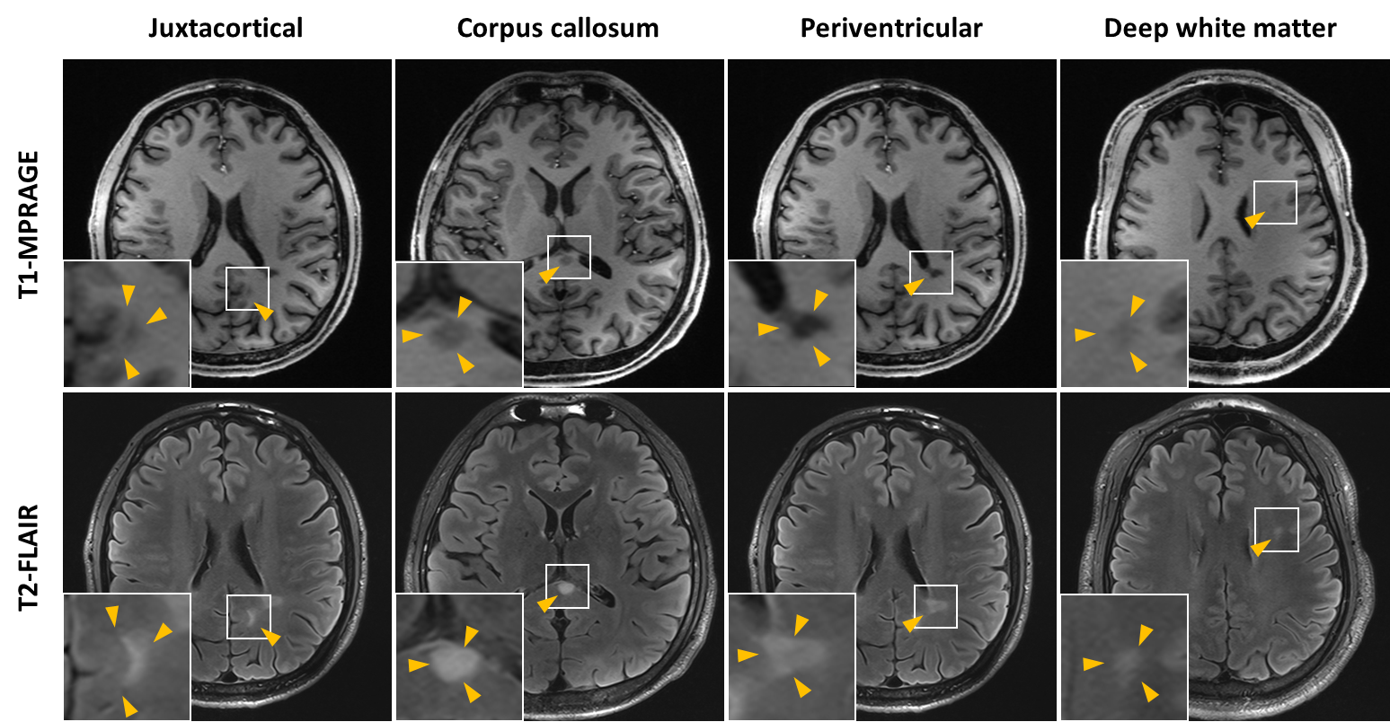

**Supplementary Figure 1** Exemplary MOGAD lesions at different locations (juxtacortical, corpus callosum, periventricular and deep white matter). Although lesions were observed in MOGAD patients at the periventricular level and at the cortico-white matter junction (labelled as juxtacortical), they did not appear as typical MS-like periventricular or juxtacortical lesions, as can be seen in the lesion examples.

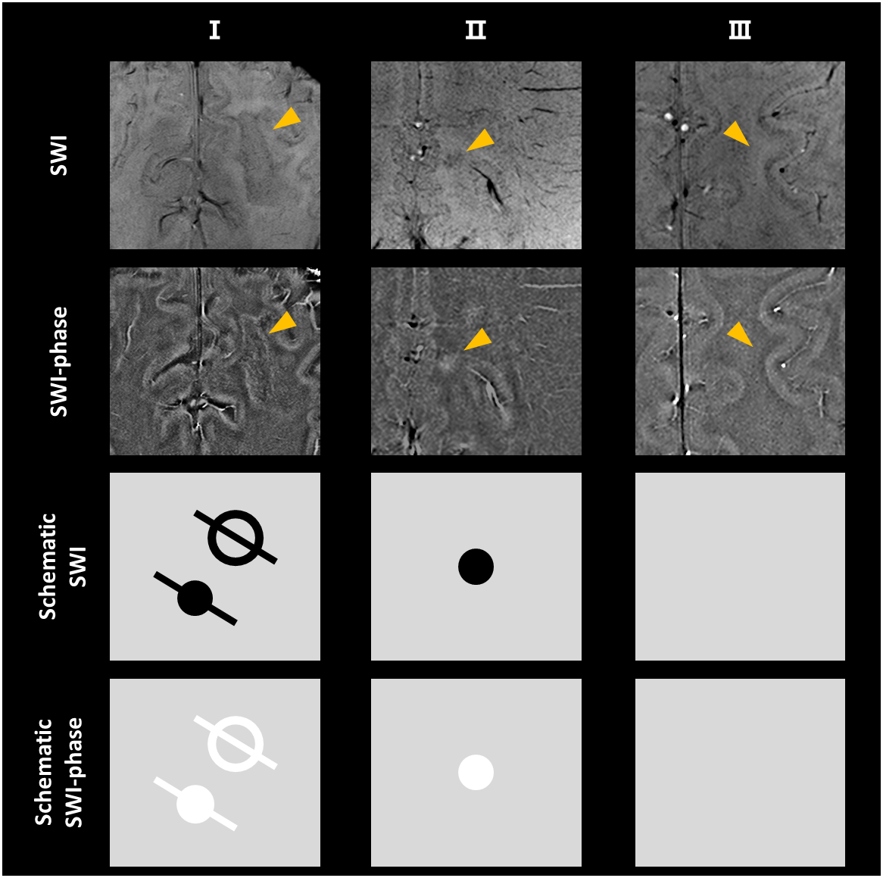

**Supplementary Figure 2** Examples (upper) and schematic representation (lower) of SWI-phase for changes related to MOGAD.