- Supplementary Material -
Neuropsychiatric Changes Following Striatal Stroke – Results from the Observational PostPsyDis Study

Anna Kufner, Ana Sofía Ríos, Benjamin Winter, Uchralt Temuulen, Ahmed Khalil, Ulrike Grittner, Johanna Schöner, Asli Akdeniz, Ulrike Lachmann, Golo Kronenberg, Arno Villringer, Karen Gertz, Matthias Endres

Inclusion criteria | Exclusion criteria
- Acute ischemic stroke within the middle cerebral artery (MCA) or anterior choroidal artery (AchA) territories, with or without striato-capsular involvement.  - MCA infarcts with striatal involvement:  - Lesion size >125 mm³ (0.125 mL).  - Includes lacunar striato-capsular or territorial cortical infarcts.  - Non-striatal MCA infarcts:  - Lesion size between 10–100 cm³ (10–100 mL).  - AchA infarcts:  - Required involvement of the posterior capsule, putamen, and/or pallidum.  - Additional criteria:  - Age ≥18 years.  - Ability to provide informed consent.  - National Institute of Health Stroke Scale (NIHSS) score ≤20 on admission.  - MRI performed within 24–48 hours of symptom onset | - NIHSS score ≥20.  - Clinical instability (e.g., hemodynamic or cardio-respiratory instability, severe infection).  - Life expectancy <1 year.  - Significant pre-existing brain damage:  - 2 prior strokes.  - Extensive global atrophy.  - Subcortical leukoencephalopathy.  - Brain tumors.  - Severe aphasia.  - Pre-existing dementia (Mini Mental State Examination [MMSE] score ≤18).  - Prior psychiatric conditions (e.g., depression, substance abuse).  - Parkinson’s disease (including dopamine agonist use).  - MRI contraindications.
Supplementary Table 1: Summary of main inclusion and exclusion criteria for enrollment in the PostPsyDis study.

 |  | Only Striatal  (N=18) | Non-striatal  (N=30) | p-value | Effect Size* | 95% CI
Primary study endpoints | GDS-30 total score, median (IQR) | 4.5 (2-8) | 3 (2-6) | 0.40 | 0.30 | -0.29 – 0.88
 | Depression yes/no, n (%) | 4 (22.2) | 3 (10) | 0.24 | 0.39 | 0.08 – 1.9
 | PTSS-10 total score, median (IQR) | 9.5 (2-17) | 6 (3-10) | 0.67 | 0.14 | -0.45 – 0.72
 | PTSD yes/no, n (%) | 4 (22.2) | 4 (13.3) | 0.42 | 0.54 | 0.12 – 2.5
Supplementary Table 2: Sub-group analysis including only patients with lesions restricted to the striatum (N=18) in comparison to patients with non-striatal lesions (N=30). Assessment of primary outcome parameters based on lesion location assessed at 90 days post-stroke.

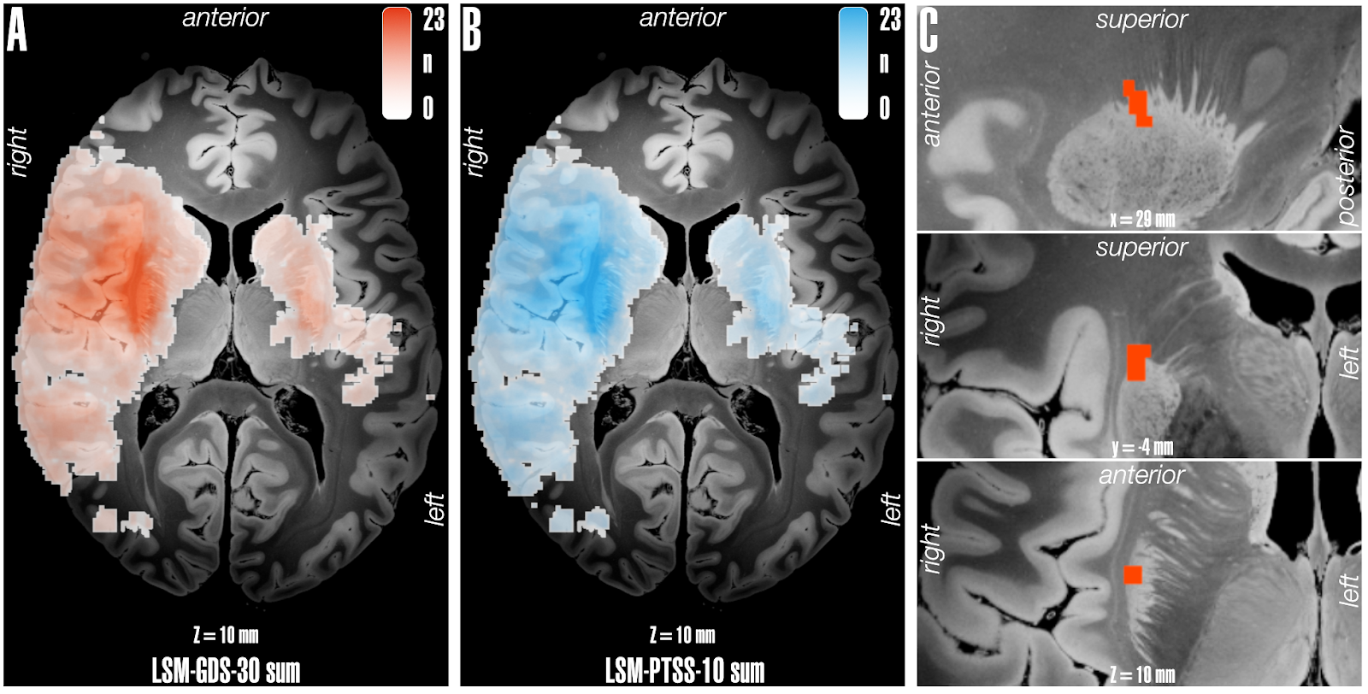Supplementary Figure 1: Voxel-wise lesion symptom mapping. Sum of lesions included for VLSM analysis of A) depression and B) PTSD 12 months after stroke, in both analyses, voxels with a minimum overlap of 3 were included (n=23). No voxels survived significance threshold (FWE-p<0.050) in either whole-brain LSM or ROI-based LSM analyses for both outcomes of interest.

Linear regression analysis for GDS-30 at T3
 | Univariable model |  | Multivariable model
 | Beta coefficient (95% CI) | p-value | Beta coefficient (95% CI) | p-value
Striatal infarction | 1.6 (-0.28-3.5) | 0.094 | 1.7 (-0.19-3.7) | 0.076
Age | -0.04 (-0.12-0.03) | 0.263 | -0.05 (-0.5 – 2.4) | 0.628
Female | .19 (-0.17-2.1) | 0.837 | 0.47 (-0.19 – 3.7) | 0.628
Lesion volume (mL) | 0.008 (-0.03-4.3) | 0.664 | 0.01 (-0.02 – 0.05) | 0.491
Linear regression analysis for PTSS-10 at T3
 | Univariable model |  | Multivariable model
 | Beta coefficient (95% CI) | p-value | Beta coefficient (95% CI) | p-value
Striatal infarction | 1.6 (-2.2 – 5.4) | 0.405 | 1.8 (-1.9 – 5.5) | 0.352
Age | -0.09 (-0.24 – 0.05) | 0.209 | -0.14 (-0.29 – 0.001) | 0.067
Female | 4.1 (0.43-7.7) | 0.029 | 5.1 (1.3 – 8.8) | 0.009
Lesion volume (mL) | 0.02 (-0.05 – 0.09) | 0.567 | 0.04 (-0.4 – 0.11) | 0.319
Supplementary Table 3: Univariable and multivariable linear regression models for GDS-30 and PTSS-10 total scores assessed 90 days post-stroke (T3), presenting crude and adjusted beta coefficients with 95% confidence intervals (CI).

Linear regression analysis for GDS-30 at T3
 | Multivariable model
 | Beta coefficient (95% CI) | p-value
Striatal infarction | 1.5 (-0.39- 3.5) | 0.117
Age | -0.05 (-0.12 – 0.03) | 0.221
Female | 0.32 (-1.6 – 2.2) | 0.741
Lesion volume (mL) | 0.01 (-0.02 – 0.05) | 0.509
Antidepressants at any time (binary) | 2.7 (-0.58 – 6.1) | 0.104
Linear regression analysis for PTSS-10 at T3
 | Multivariable model
 | Beta coefficient (95% CI) | p-value
Striatal infarction | 1.3 (-2.4 – 5.1) | 0.476
Age | -0.14 (-0.28 – 0.001) | 0.065
Female | 4.8 (1.0 – 8.4) | 0.013
Lesion volume (mL) | 0.03 (-0.04 – 0.11) | 0.331
Antidepressants at any time (binary) | 5.5 (-0.94 – 11.8) | 0.094
Supplementary Table 4: Sensitivity analysis including medication status as an additional covariate. Multivariable regression analysis for GDS-30 and PTSS-10 total score (continuous score) assessed 90 days post-stroke (T3) presenting crude and adjusted beta coefficients with 95% confidence intervals (CI).
Dependent variable: Geriatric Depression Score
Fixed-effects
 | Coefficient | Std. Error | p-value | 95% CI
Time-point of assessment  T2 (1d)  T3 (90d)  T4 (12mo) | - reference -  0.90  2.8 | - reference -  0.58  0.60 | -  0.115  <0.001 | -0.19 – 2.0  1.6 – 3.9
Age | -0.019 | 0.036 | 0.610 | -0.08 – 0.05
Female | 0.70 | 0.95 | 0.455 | -1.2 – 2.4
Lesion volume (mL) | 0.010 | 0.021 | 0.619 | -0.04 – 0.04
Striatal network damage score | -0.24 | 0.6 | 0.696 | -0.62 – 1.2
Random-effects
 | Estimate | Std. Error
Subject ID | 3.2 | 0.38 |  | 2.5 – 4.0
Dependent variable: Post-Traumatic Stress Syndrome 10-Question Inventory
Fixed-effects
 | Coefficient | Std. Error | p-value | 95% CI
Time-point of assessment  T3 (90d)  T4 (12mo) | - reference -  0.93 | - reference -  1.1 | -  0.394 | -1.2 – 3.0
Age | -0.18 | 0.08 | 0.025 | -0.3 - -0.02
Female | 5.5 | 2.1 | 0.008 | 1.3 – 9.2
Lesion volume (mL) | 0.06 | 0.05 | 0.158 | -0.04 – 0.13
Striatal network damage score | -2.8 | 2.2 | 0.208 | -3.4 – 0.55
Random-Effects
 | Estimate | Std. Error
Subject ID | 6.4 | 0.55 |  | 5.4 – 7.6
Supplementary Table 5: Linear Mixed-models for each primary outcome variable GDS-30 assessed at T2, T3, and T4 and PTSS-10 (assessed at T3 and T4). All models included subjects as a random effect and striatal network damage score, time point of assessment, female sex, age, and lesion volume in millilitres (mL).

