**Supplemental Figures**

Figure S1: Intraoperative fluid balance

Figure S2: Urinary markers of glomerular or tubular injury following living donor kidney transplantation

Figure S3: Changes in bodyweight following living donor kidney transplantation

Figure S4: Urinary potassium and glucose excretion following living donor kidney transplantation

Figure S5: Serum sodium concentration and serum osmolality

**Figure S1: Intraoperative fluid balance**

Comparison of volume balance during transplantation between non-polyuric and polyuric patients (N=22 vs. 10). Student's t-test.

Ein Bild, das Text, Diagramm, Screenshot, Reihe enthält.

**Figure S2: Urinary markers of glomerular or tubular injury following living donor kidney transplantation**

(A) Total Protein, (B) Albumin, (C) α1-Microglobuline exrcretion normalized by urinary creatinine in polyuric vs. non-polyuric patients during the first five days after living donor kidney transplantation defined by urine output on day one. N=22 vs. 10, 2way ANOVA with Sidak’s multiple comparison test.



**Figure S3: Changes in body weight following living donor kidney transplantation**

Change in body weight in polyuric vs. non-polyuric patients during the first ten days after living donor kidney transplantation, normalized to pre-transplant body weight. N=22 vs. 10, analyzed by 2-way ANOVA with Sidak's multiple comparison test.

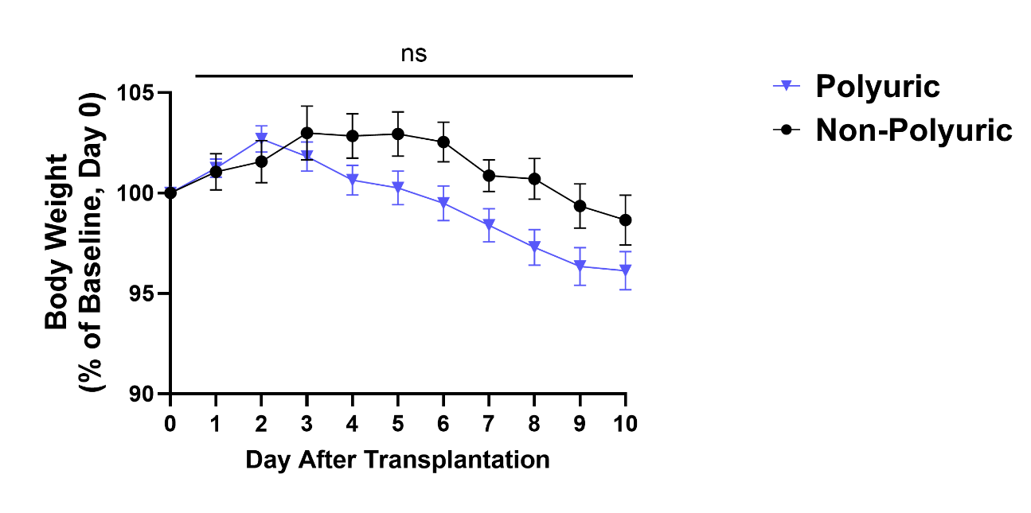

**Figure S4: Urinary potassium and glucose excretion following living donor kidney transplantation**

(A) Urinary potassium excretion per day (UVK), (B) fractional excretion of potassium (FEK %), (C) total glucose excretion (UVGlucose) and (D) fractional excretion of glucose (FEGlucose %) in polyuric vs. non-polyuric patients in the first ten days following living donor kidney transplantation defined by urine output on day one. N=22 vs. 10, 2way ANOVA with Sidak’s multple comparison test.



**Figure S5: Serum sodium concentration and serum osmolality**

(A) Serum sodium concentration and (B) serum osmolality (in polyuric vs. non-polyuric patients in the first ten days following living donor kidney transplantation defined by urine output on day one. N=22 vs. 10, 2way ANOVA with Sidak’s multiple comparison test.

