**Supplementary Material**

* Supplementary Methods
* Supplementary Figure S1: Comparison of three sgRNA for CRISPR-Cas9-mediated disruption of the *PRTN3* gene.
* Supplementary Figure S2: Schematic for the PR3-specific CRISPR/Cas9-gRNA ribonucleoprotein electroporation and *in vitro* differentiation of CD34+ HSPCs to generate PR3KO neutrophils.
* Supplemental Table S1. Sequences and chemical modification of the three sgRNA-#1 to #3.
* Supplementary Table S2. Primer for gDNA PCR and sequencing of HEK293 cells after gene editing using sgRNA-#1-3.
* Supplementary References

**Supplementary Methods**

**sgRNA design**

The sgRNA for targeting exon 2 of human *PRTN3* gene were designed as previously describedS1 using CRISPRscan (https://www.crisprscan.org/) with UCSC Genome Browser (human GRCh38/hg38).S2 Potential sgRNA candidates were initially manually screened for low numbers of predicted off-targets using COSMID.S3 Three chemically modified sgRNA (#1-3, Supplementary Table S1) were synthesized by Synthego (Redwood City, CA), incorporating 2'-O-Methyl (2'-O-Me) modifications at the 3’ and 5’ ends of the sgRNA and 3' end phosphorothioate (PTO) linkages to enhance their stability and gene editing efficacy.S4

**Differentiation of CD34+ stem and progenitor cells from umbilical cord blood into neutrophils**

CD34+ hematopoietic stem and progenitor cells (HSPCs) were isolated from umbilical cord blood (Ethics vote EA4/024/18), expanded, and differentiated as described.S5 Briefly, cells were washed, stained using CD34+ progenitor isolation kit (Miltenyi), and sorted on LS column. Cells were expanded in stem span serum-free medium (Stem Cell Technologies, Vancouver, Canada) with penicillin/streptomycin, 100 ng/ml stem cell factor (SCF), 20 ng/ml TPO, and 50 ng/ml FLT3-L (PeproTech, London, United Kingdom). Neutrophil differentiation was done in RPMI with 10% FCS and 10 ng/ml G-CSF (PeproTech) for 10 days.

**Cell culture and nucleofection**

HEK293 cells were cultivated in Dulbecco's modified Eagle's medium with 10% FCS and penicillin/streptomycin and nucleofected using the Amaxa™ technology (Lonza, Basel, Switzerland). Cells were harvested, washed and resuspended in supplemented Cell Line Nucleofector V Solution (2x 105 cells in 15 µl). The solution was mixed with 5 µl of a ribonucleoprotein complex formed by incubating 5 µg Alt-RTM SpCas9 Nuclease V3 (IDT, Coralville, USA) and 6 µg sgRNA (Synthego) at 37 °C for 10 min. For each nucleofection, 2x 105 cells with Alt-RTM SpCas9 Nuclease V3 (IDT) and sgRNA (Synthego) in a molar ratio of 1:6 was used in a 20 µl reaction. Nucleofection was performed using 16-well nucleofection cuvettes from SF Cell line 4D Nucleofector X kit (Lonza) and the CM-130 pulse program. Thereafter, 80 µl supplemented DMEM medium was added, and cells were plated in a 12-well plate.

CD34+ HSPCs were nucleofected using P3 Primary cell 4D-Nucleofector X kit (Lonza) and supplemented Nucleofector Solution Set P3 as described above. 4x 105 HSPCs, 5 µg Alt-RTM SpCas9 Nuclease V3, and 6 µg sgRNA (Synthego) in a 20 µl reaction were used with a molar ratio of 1:6 for each nucleofection. The Nucleofector pulse program EO-100 was selected.

**Genomic DNA isolation and sequencing**

HEK293 were lysed 24 hours after nucleofection in 1 M Tris/ 0.5 M sodium EDTA/ 1 M NaCl and protein precipitated with 5 M sodium perchlorate. Genomic DNA (gDNA) was isolated by chloroform/isopropanol precipitation and the PR3 PCR products were sequenced using the Advantage GC 2 polymerase mix & PCR kit (Takara, Saint-Germain-en-Laye, France) and the primer listed in Supplementary Table S2. PCR products were purified from agarose gel using NucleoSpin Gel and the PCR Clean-up kit (Macherey-Nagel GmbH & Co. KG, Düren, Germany). 50 ng of the purified PCR products were sequenced using BigDye Terminator v1.1 Cycle Sequencing kit from Thermo Fisher Scientific (Schwerte, Germany) and purified with a ZR DNA Sequencing Clean-up kit (ZYMO Research, Freiburg, Germany). Sequencing was performed in a 48-capillary sequencer 3730xl Genetic Analyzer (Applied Biosystems/Thermo Fisher Scientific, Darmstadt, Germany).

**SDS‐PAGE and immunoblotting analysis**

Cell lysis, SDS‐PAGE, and immunoblot were performed as described.S5 In brief, cells were lysed, mixed with loading buffer, separated on a 12% SDS‐PAGE, blotted onto polyvinylidene difluoride (PVDF) membrane, developed with the indicated antibodies, and visualized by an ECL detection system (Super Signal West Dura Extended Duration substrate, Fisher Scientific, Schwerte, Germany) on a Chemi Only Imager (VWR International, Darmstadt, Germany). Monoclonal rabbit anti-human PR3 (clone EPR6277, 1:4,000, Abcam, Cambridge, UK), polyclonal rabbit anti-NE (1:1,000, Abcam), polyclonal goat anti-CD177 (1:1,000, R+D systems, Minneapolis, MN), and monoclonal rabbit anti-actin (clone 13E5, 1:2,000, Cell Signaling Europe, Frankfurt/Main, Germany) antibodies were used together with corresponding secondary horseradish peroxidase conjugated antibodies (1:1,000).

**Fluorescence resonance energy transfer (FRET) to measure PR3-specific proteolytic activity**

PR3-specific proteolytic activity was measured as described previously.S6 Briefly, cells were lysed on ice, soluble fractions were separated from cell debris by centrifugation. Five to 30 µg cell lysates in 150 μl HEPES buffer containing 0.02% lauryl maltoside (LM) were incubated with the human PR3-specific FRET substrate 2-Abz-VAD-(nor)V-ADYQ-EDA-Dnp or NE-specific FRET substrate 2-Abz-APEEIMRRQ-EDA-Dnp (20 μM final) Fluorescence was measured by plate reader (excitation 320 nm, emission 420 nm, Molecular Devices) and the Vmax is reported.

**Flow cytometry to assess neutrophil membrane-PR3 (mPR3) and mCD177**

For mPR3 and mCD177 double staining, cells were incubated with 5 µg/ml Alexa488 conjugated anti-PR3 (clone 43-8-3) or corresponding Alexa488-isotype for 15 min on ice. After washing CD177 was stained with anti-CD177-pacific blue (PB) and mouse IgG-PB mabs were used as isotype control (Exbio, Vestec, Czech Republic). 2x 105 events per sample were collected using a BD FACS Calibur or a BD FACS CANTO II and analyzed with FlowJo software (TreeStar, Ashland, OR).

**Assessment of neutrophil differentiation by flow cytometry**

Cells were resuspended in phosphate-buffered saline (PBS) for staining and flow cytometry using fluorochrome-conjugated antibodies to CD45 (2D1; BD Biosciences, Heidelberg, Germany), CD11b (M1/70; eBioscience, San Diego, CA), CD15 (W6D3, BioLegend, San Diego, CA) and CD16 (3G8, BioLegend). Cell populations were gated as live CD45 cells after exclusion of doublets. A FACS CANTO II flow cytometer with BD Q13 FACSdiva software (BD Biosciences) as used and data analyzed with Q14 using FlowJo software (Treestar, Ashland, OR).

**Preparation of human IgG**

Normal- and ANCA-IgG were prepared from healthies and patients with active MPO- and PR3-ANCA disease using a High-Trap-protein-G column in an Äkta-FPLC system (Cytiva Europe GmbH, Freiburg, Germany).

**ANCA testing by indirect immunofluorescence**

Differentiated HSPCs were centrifuged on glass slides using a Cytospin Hettich Universal device (Hettich GmbH, Tuttlingen, Germany), permeabilized in ice-cold 99% ethanol, and incubated with PR3- or MPO-ANCA patient sera (1:10 diluted in PBS) for 60 min at RT. Cells were stained with Alexa488-conjugated anti-human IgG (1:250, Molecular Probes, Eugene, Oregon, USA) for 60 min. Fluorescence images were acquired using a Leica Microscope (Leica DMI6000 B, Wetzlar, Germany) with a 40x objective.

**Measurement of superoxide release**

Superoxide was measured using superoxide dismutase (SOD)-inhibitable ferricytochrome c reduction as described previously.S7 Briefly, 5x 105 cells/ml were pretreated with cytochalasin B, primed with TNF (2 ng/ml, 15 min) and stimulated with antibodies (mabs 5 µg/ml, or 75 µg/ml purified IgGs). Samples with and without SOD (300 U/ml) were scanned repetitively at 550 nm using a Microplate Reader (Molecular Devices) and 45 min results are reported.

**Measurement of intracellular ROS production**

Cells (1x 107/ml in HBSS) were loaded with CM-H2DCFDA (1 µM, Thermo Fischer Scientific, Waltham, MA) for 15 min at 37 °C. Cells (5x 105) were incubated with the indicated stimuli for 45 min. Data were collected from 2x 105 cells per sample using a BD FACS CANTO II and analyzed with FlowJo software (TreeStar, Ashland, OR). The shift of green fluorescence in the FL-1 mode was determined, and the mean fluorescence intensity (MFI) representing the amount of generated hydrogen peroxide is reported.

**Measurement of MPO degranulation**

Cells (5x 105) were pretreated with 5 µg/ml cytochalsin B prior receptor-independent stimulation with 25 ng/ml phorbol ester (PMA) or receptor-dependent stimulation with 2ng/ml TNF/ 2x 10-6M N-formyl-methionyl-leucyl-phenylalanine (fmlp) for further 30 min. After centrifugation, cell-free supernatant was assessed for MPO enzymatic activity with the substrate 2,2'-azino-bis(3-ethylbenzothiazoline-6-sulfonic acid (ABTS, Merck, Darmstadt, Germany). Absorption was measured by plate reader (wavelength 405 nm, VersaMax, Molecular Devices, CA) and the Vmax is reported.

**Phagocytosis of pHrodo E. coli bioparticles**

Cells (5x 105) were incubated with pHrodo Green E. coli bioparticles (100 µg/ml, Thermo Fischer Scientific) at 37 °C in a total assay volume of 100 µl for 120 min. Data were collected from 2x 105 cells per sample using a BD FACS CANTO II and analyzed with FlowJo software (TreeStar, Ashland, OR).

**Apoptosis assessment by annexin V and 7-AAD staining**

2x 106 differentiated neutrophils were incubated in RPMI medium with 10% FCS for up to 72 h. Phosphatidylserine exposure was determined by Annexin V-FITC (BD Biosciences, San Jose, CA) and necrosis by 7-AAD (Merck, Darmstadt, Germany) staining.

**Statistics**

Individual data points, means, and standard deviations (SD) are reported. For statistical analysis, repeated measures 1-way ANOVA with Sidak’s post-hoc test, and for comparisons between two groups paired t-test (two-tailed) was performed using GraphPad Prism8 software. P values of less than 0.05 were considered significant.

**Supplementary Figures**

**Supplementary Figure S1:** Comparison of three sgRNA for CRISPR-Cas9-mediated disruption of the *PRTN3* gene (**a**) Organization of the *PRTN3* gene consisting of five exons is shown at the top and the genomic DNA (gDNA) of the region of interest is enlarged. The amino acid sequence of PR3 together with the spacer sequence of the sgRNA-#1 is depicted below. The unedited and edited PR3 gDNA and amino acid sequences are shown for comparison. The Cas9-executed cleavage between nucleotides 3 and 4 of the target DNA after the protospacer adjacent motif (PAM; blue box) is marked as double stand brake (DSB) site by an arrow. The sgRNA-#1 spacer sequence is indicated as a red box together with the resulting frameshift by insertion of one thymine (red letter). The gDNA DSB occurred on chromosome 19 at the hg38: 843,591-843,592 position (UCSC Genome Browser). (**b**) Sanger sequencing chromatograms of *PRTN3* as modified by the three different sgRNAs (#1-3, left), and the parallel TIDE analysis (http://shinyapps.datacurators.nl/tide/) of the region of interest (right), are depicted. The TIDE analysis estimates the spectrum and frequency of small insertions (from the DSB to the right on the x-axis) and deletions (from the DSB to the left). These indels are generated in a pool of genome edited cells. Grey bars indicate the percentage of cells with unmodified sequence at the DSB position. Red bars show the cell percentage with significant modifications at indicated positions (*P < 0.001*). Black bars indicate *P > 0.001*.

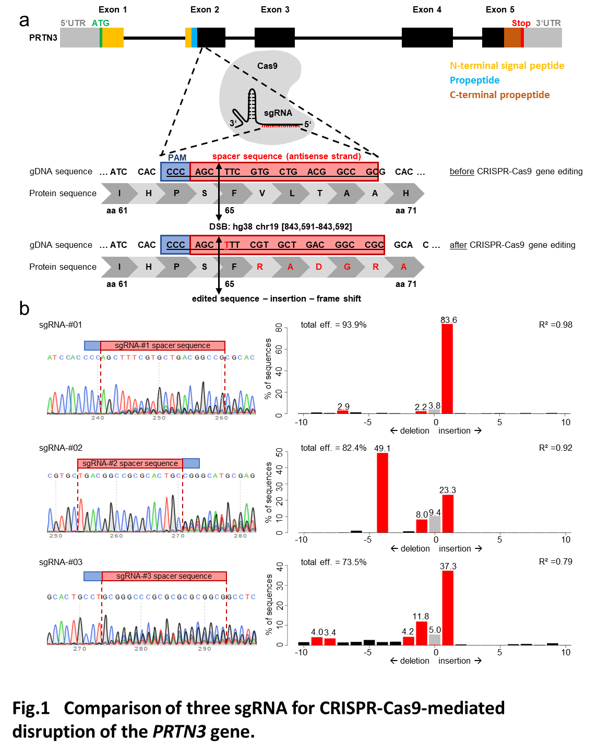

**Supplementary Figure S2: Schematic for the PR3-specific CRISPR/Cas9-gRNA ribonucleoprotein electroporation and *in vitro* differentiation of CD34+ HSPCs to generate PR3KO neutrophils.**

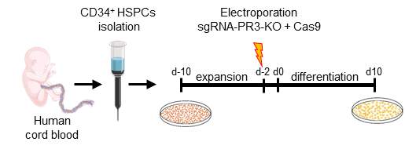

**Supplementary Table S1**. Sequences and chemical modification of the three sgRNA-#1 to #3.

|  |  |  |
| --- | --- | --- |
| sgRNA | sequence | chemically modification |
| sgRNA-#01 | GCGGCCGUCAGCACGAAGCU | 3’ and 5’ ends: 2'-O-Methyl (2'-O-Me)  3' end: phosphorothioate (PTO) linkages |
| sgRNA-#02 | UGACGGCCGCGCACUGCCUG |
| sgRNA-#03 | CGGCCGCUCACAUGUCCCGC |

**Supplementary Table S2.** Primer for gDNA PCR and sequencing of HEK293 cells after gene editing using sgRNA-#1-3.

|  |  |  |
| --- | --- | --- |
| Method | Primer name | Primer sequence |
| PCR of region of interest with genomic DNA | PRTN3-KO-For | GAGTCCTTCCCACCAGCCAG |
| PRTN3-KO-Rev | CTCCGAGCACCACGTTCACC |
| Sanger sequencing | PRTN3-KO-For | GAGTCCTTCCCACCAGCCAG |

**Supplementary References**

S1. Gundry MC, Brunetti L, Lin A*, et al.* Highly Efficient Genome Editing of Murine and Human Hematopoietic Progenitor Cells by CRISPR/Cas9. *Cell Rep* 2016; **17:** 1453-1461.

S2. Perez G, Barber GP, Benet-Pages A*, et al.* The UCSC Genome Browser database: 2025 update. *Nucleic Acids Res* 2024.

S3. Cradick TJ, Qiu P, Lee CM*, et al.* COSMID: A Web-based Tool for Identifying and Validating CRISPR/Cas Off-target Sites. *Mol Ther Nucleic Acids* 2014; **3:** e214.

S4. Hendel A, Bak RO, Clark JT*, et al.* Chemically modified guide RNAs enhance CRISPR-Cas genome editing in human primary cells. *Nat Biotechnol* 2015; **33:** 985-989.

S5. von Vietinghoff S, Tunnemann G, Eulenberg C*, et al.* NB1 mediates surface expression of the ANCA antigen proteinase 3 on human neutrophils. *Blood* 2007; **109:** 4487-4493.

S6. Jerke U, Hernandez DP, Beaudette P*, et al.* Neutrophil serine proteases exert proteolytic activity on endothelial cells. *Kidney Int* 2015; **88:** 764-775.

S7. Schreiber A, Luft FC, Kettritz R. Membrane proteinase 3 expression and ANCA-induced neutrophil activation. *Kidney Int* 2004; **65:** 2172-2183.