**Pharmacological characterisation of a clinical candidate, TG-0054, a small molecule inverse agonist targeting CXCR4**

Kylie S. Pan, Ziming Wang, Cy Pfeil, Nick D. Bergkamp, Simon Mobach, Susanne Roth, Aurélien Rizk, Martin J. Lohse, Paolo Annibale, Marco Siderius, Mirjam Zimmermann, Martine J. Smit, Reggie Bosma

**Molecular Pharmacology**

**MOLPHARM-AR-2024-000985**

Supplementary Information

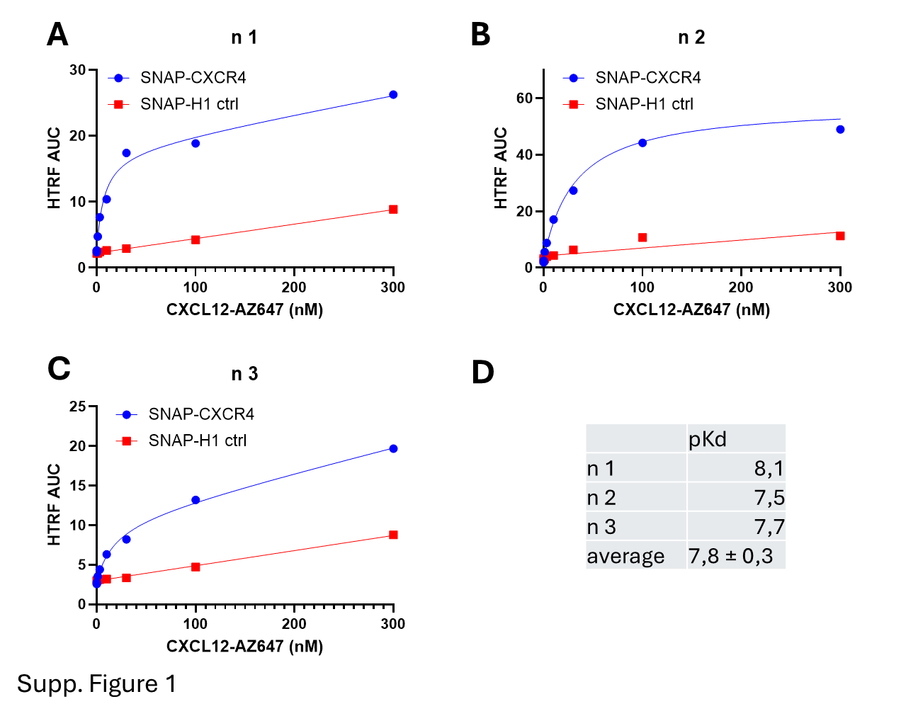

Supplementary Figure 1: Saturation binding of CXCL12-AZ647 to SNAP-CXCR4 HEK293. (A-C) three biologically independent replicates of HTRF ratios, obtained from HEK293 cells stably expressing SNAP-CXCR4 or SNAP-H1 upon treatment with increasing concentrations of CXCL12-AZ647 and quantified by AUC over the course of 25 min following ligand addition. The values resulting from HEK293 SNAP-CXCR4 cells were fitted using the Graphpad Prism 10 one-site total binding model, yielding the pKd values presented in (D), whereas SNAP-H1 values were fitted with a linear regression.

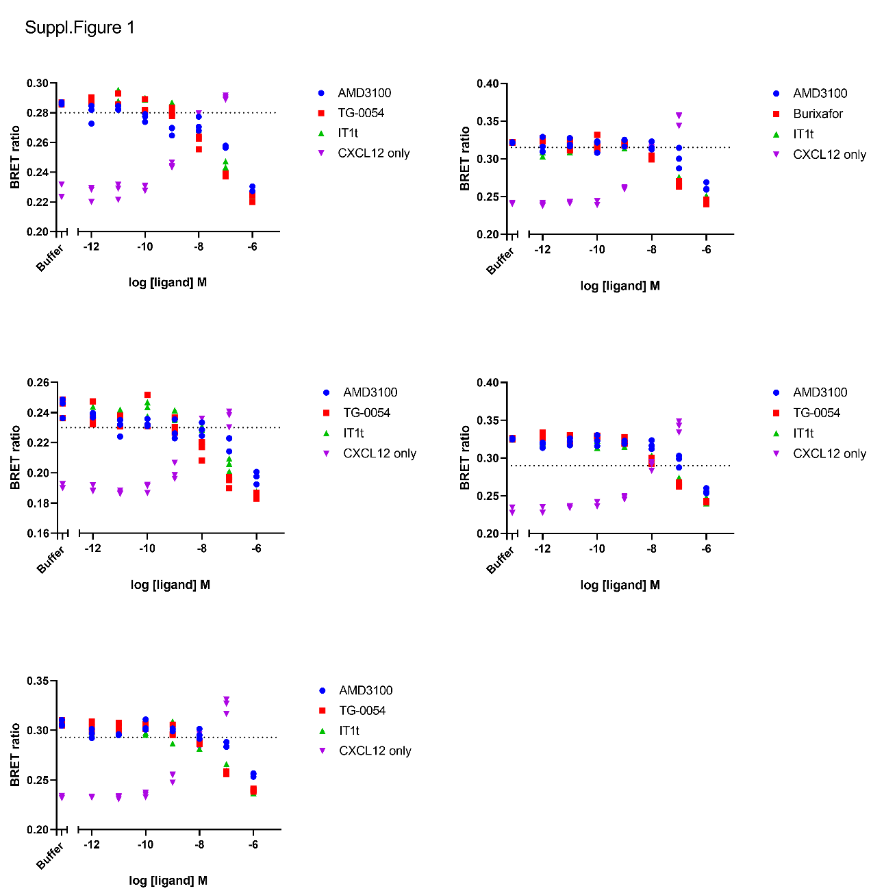

Supplementary Figure 2: Recruitment of Venus-miniGα*i* to CXCR4-NLuc by 10 nM CXCL12 alone or with AMD3100, TG-0054, IT1t. HEK293 transiently transfected with CXCR4-NLuc and ~~m~~Venus-tagged effectors. Data points show 3 technical replicates. The dotted line represents the mean effect of 10 nM CXCL12 alone.

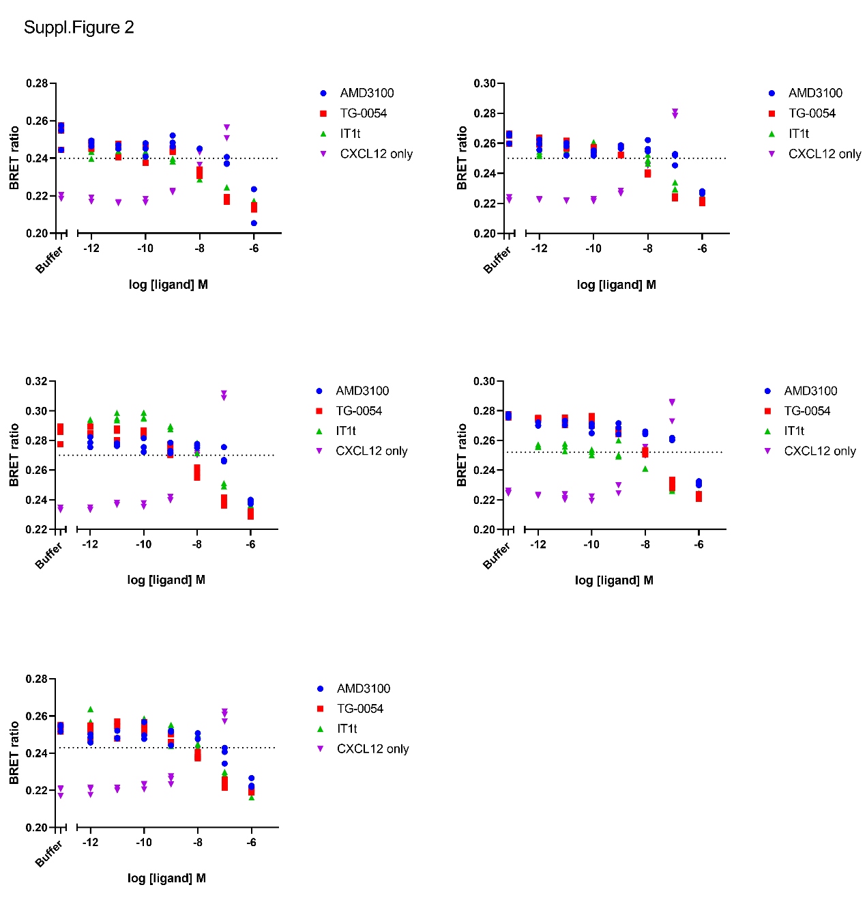

Supplementary Figure 3: Recruitment of *β*-arr2 to CXCR4-NLuc by by 10 nM CXCL12 alone or with AMD3100, TG-0054, or IT1t. HEK293 transiently transfected with CXCR4-NLuc and mVenus-tagged effectors. Data points show 3 technical replicates. The dotted line represents the mean effect of 10 nM CXCL12 alone.

Supplementary Figure 4: TG-0054 and IT1t inhibit WT CXCR4-mediated cAMP modulation above basal level. HEK293 cells with stable SNAP-CXCR4 expression, transiently transfected with EPAC FRET sensor. Cells were sequentially exposed to fixed concentrations of forskolin (t = 7 min, cycle 4) and buffer or CXCL12 (t = 22 min, cycle 14) then increasing concentrations of AMD3100, TG-0054 or IT1t (t = 53 min, cycle 35). Graphs show representative traces of duplicates per condition.

Supplementary Figure 5: representative first and last confocal images of HEK293AD cell basolateral membranes used for spatial (SpIDA, A) and temporal brightness (TB, B) analysis, of EYFP-tagged CXCR4 or B1AR, following 30 min treatment with either vehicle or 10 μM TG-0054/ IT1t. SpIDA images were bleached at 15% laser power over 3 frames, TB images were bleached at 2% laser power over 100 frames.