**Circulating amyloid beta 1-40 peptide as an associate of renal function decline mediating increased mortality.**

Georgios Mavraganis1,*, Georgios Georgiopoulos1,2,*, Georgios Zervas1, Evmorfia Aivalioti1, Dimitrios Delialis1, Ioannis Petropoulos1, Nikolaos Rachiotis1, Christina Konstantaki1, Chrysoula Moustou1, Maria-Aggeliki Dimopoulou1, Marco Sachse3,4, Simon Tual-Chalot5, Kateryna Sopova4,6, Erasmia Psimmenou1, Konstantinos Stellos4-8,**, Kimon Stamatelopoulos1,5,**

1Department of Clinical Therapeutics, Alexandra Hospital, National and Kapodistrian University of Athens Medical School, 80 Vas. Sofias Str, Athens 11528, Greece.

2Department of Physiology, School of Medicine, University of Patras, Patras, Greece.

3Department of Cardiovascular Surgery, University Heart and Vascular Centre, University Medical Centre Hamburg-Eppendorf, Hamburg, Germany

4Department of Cardiovascular Research, Medical Faculty Mannheim, Heidelberg University, Mannheim, Germany.

5Biosciences Institute, Vascular Biology and Medicine Theme, Faculty of Medical Sciences, Newcastle University, Newcastle upon Tyne, United Kingdom.

6Department of Cardiology, Angiology, Haemostaseology and Medical Intensive Care, University Medical Centre Mannheim, Heidelberg University, Mannheim, Germany.

7German Centre for Cardiovascular Research (DZHK), Partner Site Heidelberg/Mannheim, Mannheim, Germany.

8Helmholtz Institute for Translational AngioCardioScience (HI-TAC), Mannheim, Germany.

* contributed equally  
** last-equal authors

**Address for Correspondence**

Kimon Stamatelopoulos, MD, PhD, Department of Clinical Therapeutics, Alexandra Hospital, Medical School, National and Kapodistrian University of Athens, PO Box 11528, 80 Vas. Sofias Str, Athens, Greece, Email: kstamatel@med.uoa.gr, Tel. +30-2132162487, Fax. +30-2103381487.

|  |  |  |
| --- | --- | --- |
| **Supplementary Table 1. Percentage of missing data in the cohort** | | |
| **Variable** | **Missing cases** | |
| **n** | **%** |
| **Age (years)** | 0 | 0 |
| **Sex (male) (n, %)** | 0 | 0 |
| BMI (kg/m2) | 79 | 9.7 |
| Smoking (n, %) | 21 | 2.6 |
| **Hypertension (n, %)** | 17 | 2.1 |
| Hyperlipidemia (n, %) | 19 | 2.3 |
| **Diabetes mellitus (n, %)** | 18 | 2.2 |
| **Presence of CAD (n, %)** | 0 | 0 |
| **Statins (n, %)** | 27 | 3.3 |
| **Antihypertensive treatment (n, %)** | 26 | 3.2 |
| **Antiplatelet treatment (n, %)** | 27 | 3.3 |
| **SBP (mmHg)** | 73 | 9.0 |
| DBP (mmHg) | 73 | 9.0 |
| Fasting glucose (mg/dl) | 78 | 9.6 |
| Total cholesterol (mg/dl) | 77 | 9.5 |
| **HDL-C (mg/dl)** | 80 | 9.9 |
| LDL-C (mg/dl) | 79 | 9.7 |
| Triglycerides (mg/dl) | 79 | 9.7 |
| **Aβ1-40 level (pg/mL)** | 0 | 0 |
| **Creatinine (mg/dl)** | 0 | 0 |
| **GFR (ml/min/1.73m2)** | 0 | 0 |
| Abbreviations: BMI, body mass index; CAD, coronary artery disease; SBP, systolic blood pressure; DBP, diastolic blood pressure; HDL-C, high-density lipoprotein cholesterol; LDL-C, low-density lipoprotein cholesterol; Aβ1-40, amyloid-beta 1-40; GFR, glomerular filtration rate. | | |

**Supplementary Table 2. Descriptive characteristics of the population with follow-up information between 1st and 2nd visiting time interval (n=189)**

|  |  |  |  |  |
| --- | --- | --- | --- | --- |
| **Variable** | **Baseline** | **Follow-up** | **P-value** | |
| **Cardiometabolic risk factors** | | | |
| Age (years) | 59.2 (11.7) | 60.4 (11.7) | 0.306 | |
| BMI (kg/m2) | 28.1 (4.8) | 28.3 (4.8) | 0.707 | |
| Waist-to-hip ratio | 0.97 (0.08) | 0.98 (0.10) | 0.444 | |
| Smoking (n, %) | 70 (37.0) | 62 (32.8) | 0.604 | |
| Hypertension (n, %) | 105 (55.6) | 109 (57.7) | 0.551 | |
| Hyperlipidemia (n, %) | 186 (98.4) | 187 (98.9) | 0.653 | |
| Diabetes mellitus (n, %) | 60 (31.7) | 61 (32.3) | 0.856 | |
| Presence of CAD (n, %) | 92 (48.7) | 92 (48.7) | 0.990 | |
| **Statins (n, %)** | **111 (58.7)** | **151 (79.9)** | **<0.001** | |
| Antihypertensive treatment (n, %) | 117 (61.9) | 126 (66.7) | 0.334 | |
| Antiplatelet treatment (n, %) | 92 (48.7) | 93 (49.2) | 0.878 | |
| B-blockers (n, %) | 80 (42.3) | 85 (45.0) | 0.604 | |
| RAAS inhibitors (n, %) | 85 (45.0) | 93 (49.2) | 0.410 | |
| SBP (mmHg) | 127.1 (18.1) | 126.3 (16.0) | 0.664 | |
| DBP (mmHg) | 72.5 (10.5) | 73.5 (10.4) | 0.374 | |
| Aortic SBP (mmHg) | 119.1 (18.7) | 118.9 (17.2) | 0.941 | |
| Aortic DBP (mmHg) | 72.5 (10.3) | 77.2 (54.4) | 0.251 | |
| Fasting glucose (mg/dl) | 105.8 (32.3) | 102.3 (24.8) | 0.236 | |
| **Total cholesterol (mg/dl)** | **175.2 (60.0)** | **150.0 (47.8)** | **<0.001** | |
| HDL-C (mg/dl) | 48.1 (15.6) | 48.7 (14.9) | 0.708 | |
| **LDL-C (mg/dl)** | **112.6 (54.8)** | **84.1 (44.4)** | **<0.001** | |
| Triglycerides (mg/dl) | 129.7 (76.4) | 121.1 (84.4) | 0.303 | |
| **Aβ1-40 level (pg/mL)** | **75.8 (28.0)** | **82.7 (33.4)** | **0.030** | |
| **Creatinine (mg/dl)** | **0.79 (0.53)** | **0.87 (0.79)** | **0.001** | |
| **GFR (ml/min/1.73m2)** | **105.9 (28.6)** | **101.3 (22.5)** | **<0.001** | |
| GFR<60 ml/min/1.73m2 (n, %) | 6 (3.3) | 13 (7.1) | 0.110 | |
| Note: Continuous variables are presented as mean (SD) and nominal as count (absolute percentages). Boldface values indicate statistical significance, which was set at the level of p-value <0.05.  Abbreviations: BMI, body mass index; CAD, coronary artery disease; RAAS, renin-angiotensin-aldosterone system; SBP, systolic blood pressure; DBP, diastolic blood pressure; HDL-C, high-density lipoprotein cholesterol; LDL-C, low-density lipoprotein cholesterol; GFR, glomerular filtration rate. | | | |

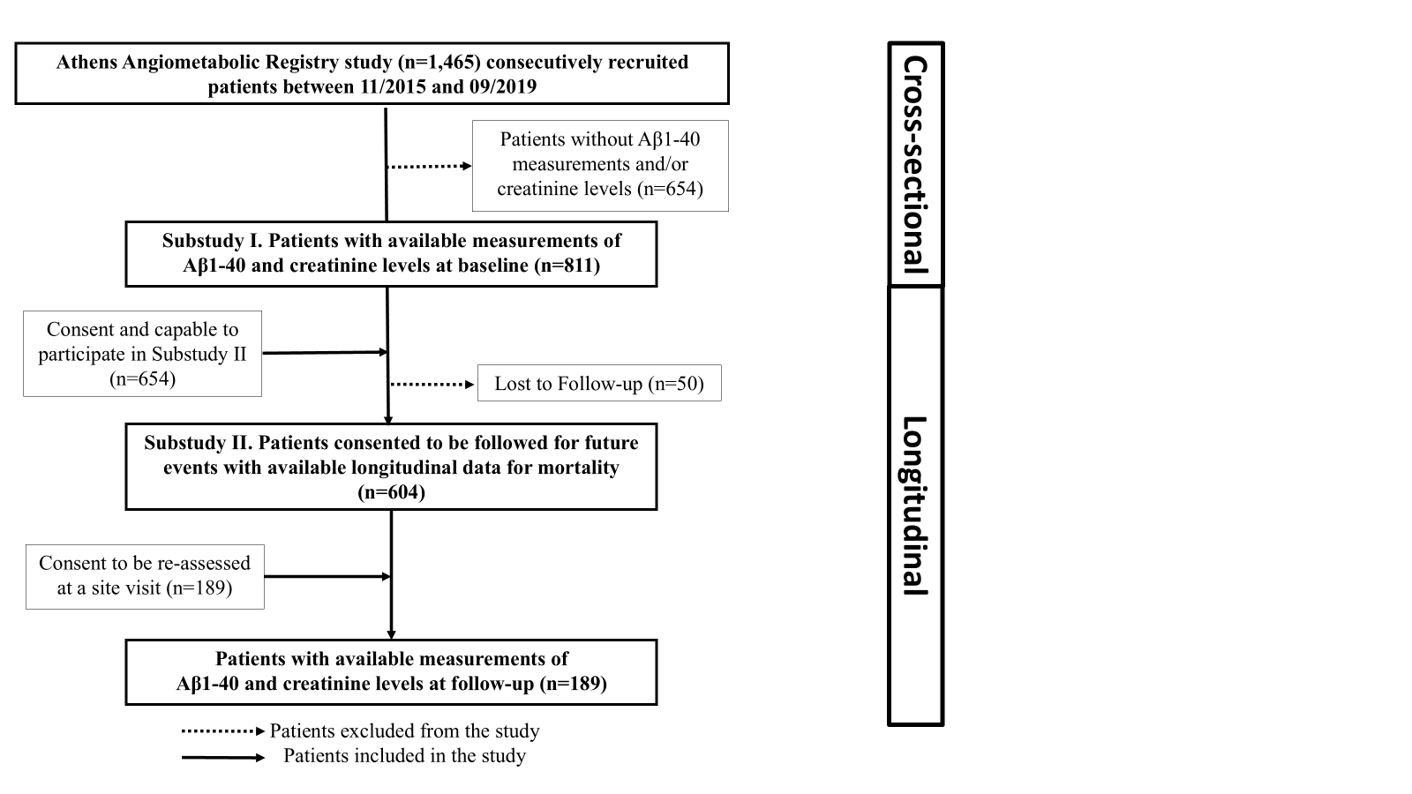

**Supplementary Figure 1. Flow chart of the study**

Abbreviations: Αβ1-40, amyloid-beta 1-40.