**SUPPLEMENTARY DATA ONLINE**

**Sex-specific Prediction of Cardiogenic Shock After Acute Coronary Syndromes:  
The SEX-SHOCK Score**

Yifan Wang *et al*.

TABLE OF CONTENTS

Table S1. Parameters of hemodynamic impairment in female and male ACS patients developing cardiogenic shock during hospital stay. 2

Table S2. Candidate variables identified in AMIS-Plus for the development of SEX-SHOCK. 3

Table S3. Multicollinearity assessment of variables included in SEX-SHOCK. 5

Table S4. Summary of missing values stratified by cohort and sex. 6

Table S5. Management characteristics of patients included in AMIS-Plus stratified by sex. 8

Table S6. Baseline characteristics of patients included in RICO stratified by sex. 10

Table S7. Management and outcomes of patients included in RICO stratified by sex. 14

Table S9. Variables identified by backward elimination and forward selection in female patients. 17

Table S10. Variables identified by backward elimination and forward selection in male patients. 18

Table S11. Performance of SEX-SHOCK in AMIS-Plus and RICO. 19

Table S12. Performance of SEX-SHOCKlight in the derivation and validation cohorts. 19

Table S13. Assigned points for different levels of each predictor included in the SEX-SHOCK score. 20

Figure S1. Study flow chart. 22

Figure S2. Calibration plots of the ORBI and SEX-SHOCK score in females (left) and males (right). 23

Figure S3. TRIPOD checklist. 24

Figure S4. STROBE checklist. 26

Figure S5. Ranking of candidate variables by logistic regression, random forest, and multilayer perceptron. 28

Figure S6. Flow chart of the variable selection process. 29

Figure S7. Performance of LR, RF and MLP modelling for the prediction of in-hospital cardiogenic shock. 30

Figure S8. Flow chart of the modelling approach selection process. 31

Figure S9. Cross-validation of SEX-SHOCK in the derivation cohort. 32

Figure S10. Performance of ORBI and SEX-SHOCK in both external validation cohorts. 33

Figure S11. Decision curve analysis comparing the ORBI and SEX-SHOCK in external validation cohorts. 34

Figure S12. Performance of SEX-SHOCK *vs*. SEX-SHOCKlight in derivation and validation cohorts. 35

Figure S13. Performance of ORBI *vs*. SEX-SHOCKlight in both validation cohorts. 36

# Table S1. Parameters of hemodynamic impairment in female and male ACS patients developing cardiogenic shock during hospital stay.

|  |  |  |  |  |
| --- | --- | --- | --- | --- |
| **AMIS-Plus** | **All CS patients (N=1’099)** | **Females (N=334)** | **Males (N=765)** | **P Value** |
| SBP ≤90 mmHg | 1’099 (100) | 334 (100) | 765 (100) | 0.999 |
| Clinical signs of hypoperfusion | 1’099 (100) | 334 (100) | 765 (100) | 0.999 |
| Tachycardia (≥100 bpm) | 335 (32.7) | 88 (28.7) | 247 (34.4) | 0.088 |
| Acute kidney injury | 185 (16.9) | 51 (15.3) | 134 (17.6) | 0.383 |
| Killip III or IV | 373 (34.4) | 117 (35.8) | 256 (33.8) | 0.579 |
| Others (mottled, cold extremities, delayed capillary refill, volume overload, extensive rales, BiPap or mechanical ventilation, acutely altered mentation, elevated lactate levels, increased liver function tests) | 469 (42.7) | 152 (45.5) | 317 (41.4) | 0.235 |
| Inotropes/vasopressors | 612 (57.0) | 183 (55.8) | 429 (57.5) | 0.649 |
| Mechanical circulatory support |  |  |  |  |
| IABP | 181 (26.7) | 49 (23.1) | 132 (28.3) | 0.184 |
| Percutaneous left ventricular assist device | 8 (1.2) | 1 (0.5) | 7 (1.5) | 0.442 |
| **SPUM-ACS** | **All CS patients (N=204)** | **Females (N=45)** | **Males (N=159)** | **P Value** |
| SBP ≤90 mmHg | 204 (100) | 45 (100) | 159 (100) | 0.999 |
| Clinical signs of hypoperfusion | 204 (100) | 45 (100) | 159 (100) | 0.999 |
| Tachycardia (≥100 bpm) | 44 (22.2) | 6 (14.0) | 38 (24.5) | 0.205 |
| Acute kidney injury | 43 (21.6) | 10 (22.2) | 33 (21.4) | 0.999 |
| Killip III or IV | 82 (41.0) | 17 (37.8) | 65 (41.9) | 0.744 |
| Others (mottled, cold extremities, delayed capillary refill, volume overload, extensive rales, BiPap or mechanical ventilation, acutely altered mentation, elevated lactate levels, increased liver function tests) | 88 (43.1) | 21 (46.7) | 67 (42.1) | 0.711 |
| Inotropes/vasopressors | 119 (58.3) | 29 (64.4) | 90 (56.6) | 0.441 |
| Mechanical circulatory support |  |  |  |  |
| IABP | 111 (54.4) | 22 (48.9) | 89 (56.0) | 0.501 |
| Percutaneous left ventricular assist device | 22 (10.8) | 4 (8.9) | 18 (11.3) | 0.848 |

Data are shown as median [IQR] or N (valid %). Acute kidney injury refers to Kidney Disease Improving Global Outcomes (KDIGO) stage ≥1 and was defined as an absolute (≥ 0.3 mg/dL) or a relative (≥ 1.5 times) increase in serum creatinine levels within hospitalization as compared with baseline values. Note that individual components of cardiogenic shock are not available in RICO.

# Table S2. Candidate variables identified in AMIS-Plus for the development of SEX-SHOCK.

|  |  |  |  |
| --- | --- | --- | --- |
| **Candidate Variables** | **Symbol** | **Candidate Variables** | **Symbol** |
| **Clinical characteristics** |  | **Hemodynamic on admission** |  |
| Age | **#** | Killip I |  |
| Presentation as cardiac arrest | **#** | Killip II | **#** |
| Intensive care unit |  | Killip III | **#** |
| **Biochemical variables** |  | Heart rate, bpm | **#** |
| NT-proBNP |  | BP, mmHg | **#** |
| Troponin |  | Estimated glomerular filtration rate |  |
| Glucose | **#** | Left-ventricular ejection fraction | **§** |
| HbA1c, % |  | **ECG on admission** |  |
| Haemoglobin, g/dl |  | ST-segment elevation | **§** |
| CRP, mg/l | **§** | Q-waves | **§** |
| Creatinine, µmol/l | **§** | ST-depression | **§** |
| **Treatment delays** |  | T-wave changes | **§** |
| First-medical-contact-to-PCI-delay (min) | **#** | Left bundle branch block | **§** |
| Symptom-onset-to-admission-delay (min) |  | Right bundle branch block | **§** |
| **Medical history** |  | **Vessels and thrombosis abnormalities** |  |
| FHx of CAD (in first degree relative <60y) | **§** | 1-VD | **§** |
| Previous stable angina | **§** | 2-VD | **§** |
| Previous myocardial infarction | **§** | 3-VD | **§** |
| Previous PCl | **§** | LMCAD | **§** |
| Previous CABG | **§** | Left main coronary angiography abnormalities | **#** |
| Hypertension | **§** | **Infarct-related coronary artery** |  |
| Diabetes (including newly diagnosed) | **§** | Left main |  |
| Hypercholesterolemia |  | Left anterior descending artery (or one of its branches) |  |
| **Comorbidities** |  | Left circumflex artery (or one of its branches) |  |
| Malignant neoplasm | **§** | Right coronary artery (or one of its branches) |  |
| Leukaemia | **§** | **Type of MI** |  |
| Lymphoma | **§** | Type 1 |  |
| Metastatic solid tumour | **§** | Type 2 |  |
| Peripheral arterial disease | **§** | Type 3 |  |
| Prior stroke/TIA | **#** | Type 4a |  |
| Chronic lung disease | **§** | Type 4b |  |
| Mixed connective tissue disease | **§** | Type 5 |  |
| Acute renal failure (needing treatment) | **§** | **Location of MI** |  |
| Bleeding |  | Anterior | **#** |
| **Mechanical circulatory support** |  | Inferior |  |
| Intra-aortic balloon counterpulsation |  | Posterior |  |
| Percutaneous left ventricular assist device |  | Lateral |  |
| Impella/ECMO |  | **Type of intervention** |  |
| **Vasopressor use** |  | PCI with stent |  |
|  |  | Thrombus aspiration |  |
|  |  | Thrombolysis |  |
|  |  | **Assessment of PCI** |  |
|  |  | TIMI flow of culprit vessel at the start of PCI | **#** |
|  |  | TIMI flow at the end of PCI |  |
|  |  | **PCI complications** |  |
|  |  | PCI-related myocardial infarction |  |
|  |  | Emergency CABG after PCI |  |
|  |  | Pericardiocentesis (pericardial drainage) |  |
|  |  | Intraprocedural death |  |

**§**Variables considered for model development **#ORBI** variables. **CABG** = coronary artery bypass grafting; **FHx of CAD** = family history of coronary artery disease; **HbA1c** = hemoglobin A1c; **MI** = acute myocardial infarction; **LMCAD** = left main coronary artery disease; **NT-proBNP** = N-terminal-pro-b-type natriuretic peptide; **PCI**= percutaneous coronary intervention; **TIMI** = thrombolysis in myocardial infarction; **1/2/3-VD** = 1/2/3-vessel disease. Troponin is coded as a binary variable in AMIS-Plus indicating whether troponin levels measured at presentation are above or below the local cut-off values according to the fourth universal definition of MI.

# Table S3. Multicollinearity assessment of variables included in SEX-SHOCK.

|  |  |  |  |  |
| --- | --- | --- | --- | --- |
| **Variables** | **Females** | | **Males** | |
| **VIF** | **Tolerance** | **VIF** | **Tolerance** |
| CRP | 1.103891394 | 0.905886218 | 1.116894236 | 0.895339923 |
| Creatinine | 1.118845262 | 0.893778643 | 1.127614233 | 0.886828111 |
| ST-segment elevation | 1.059868366 | 0.943513395 | 1.06235639 | 0.941303699 |
| LVEF | 1.045476672 | 0.956501495 | 1.026636633 | 0.974054468 |
| Age >70 years | 1.085221582 | 0.921470801 | 1.105443412 | 0.904614374 |
| Presentation as cardiac arrest | 1.133062963 | 0.882563488 | 1.197222014 | 0.835266966 |
| Killip class III | 1.088614694 | 0.918598661 | 1.067157174 | 0.937069089 |
| Heart rate >90/min | 1.075976099 | 0.929388674 | 1.068207355 | 0.936147833 |
| SBP <125 and PP <45 mmHg | 1.064107739 | 0.939754466 | 1.059324181 | 0.943998086 |
| Glycaemia >10 mmol/L | 1.13486414 | 0.881162745 | 1.161385774 | 0.861040338 |
| Culprit lesion of the left main | 1.02642972 | 0.974250824 | 1.015953294 | 0.984297217 |
| Post-PCI TIMI flow <3 | 1.034607882 | 0.96654976 | 1.023064382 | 0.977455591 |

A variance inflation factor >5 or a tolerance value <0.2 was considered to indicate multicollinearity, suggesting that the predictive utility of one or more variables might be compromised due to high correlations with the other independent variables in the model. **VIF** = Variance inflation factor.

# Table S4. Summary of missing values stratified by cohort and sex.

|  |  |  |  |  |  |
| --- | --- | --- | --- | --- | --- |
|  |  | **Males** | | **Females** | |
|  | **Variables** | **N Valid (%)** | **N Missing (%)** | **N Valid (%)** | **N Missing (%)** |
| **AMIS-Plus** | **Age >70 years** | 27169 (100) | 0 (0) | 8481 (100) | 0 (0) |
| **Anterior MI** | 26801 (98.65) | 368 (1.35) | 8377 (98.77) | 104 (1.23) |
| **Presentation as cardiac arrest** | 27169 (100) | 0 (0) | 8481 (100) | 0 (0) |
| **SBP <125 and PP <45 mmHg** | 26421 (97.25) | 748 (2.75) | 8240 (97.16) | 241 (2.84) |
| **First-medical-contact-to-PCI-delay >90 min** | 19907 (73.27) | 7262 (26.73) | 5901 (69.58) | 2580 (30.42) |
| **Glycaemia >10 mmol/L** | 21992 (80.95) | 5177 (19.06) | 6941 (81.84) | 1540 (18.16) |
| **Heart rate >90/min** | 26346 (96.97) | 823 (3.03) | 8235 (97.10) | 246 (2.90) |
| **Killip class II** | 27161 (99.97) | 8 (0.03) | 8474 (99.92) | 7 (0.08) |
| **Killip class III** | 27161 (99.97) | 8 (0.03) | 8474 (99.92) | 7 (0.08) |
| **Culprit lesion of the left main** | 26924 (99.10) | 245 (0.90) | 8401 (99.06) | 80 (0.94) |
| **Post-PCI TIMI flow <3** | 19124 (70.39) | 8045 (29.61) | 5813 (68.54) | 2668 (31.46) |
| **Previous stroke/TIA** | 26684 (98.22) | 485 (1.79) | 8318 (98.08) | 163 (1.92) |
| **Creatinine** | 25012 (92.06) | 2157 (7.94) | 7848 (92.54) | 633 (7.46) |
| **CRP** | 18369 (67.61) | 8800 (32.39) | 5850 (68.98) | 2631 (31.02) |
| **LVEF** | 26674 (98.18) | 495 (1.82) | 8337 (98.30) | 144 (1.70) |
| **ST-segment elevation** | 27163 (99.98) | 6 (0.02) | 8481 (100) | 0 (0) |
| **RICO** | **Age >70 years** | 10121 (100) | 0 (0) | 3580 (100) | 0 (0) |
| **Anterior MI** | 10121 (100) | 0 (0) | 3580 (100) | 0 (0) |
| **Presentation as cardiac arrest** | 10121 (100) | 0 (0) | 3580 (100) | 0 (0) |
| **SBP <125 and PP <45 mmHg** | 9236 (91.26) | 885 (8.74) | 3312 (92.51) | 268 (7.49) |
| **First-medical-contact-to-PCI-delay >90 min** | 5110 (50.49) | 5011 (49.51) | 1810 (50.56) | 1770 (49.44) |
| **Glycaemia >10 mmol/L** | 9791 (96.74) | 330 (3.26) | 3464 (96.76) | 116 (3.24) |
| **Heart rate >90/min** | 9284 (91.73) | 837 (8.27) | 3330 (93.02) | 250 (6.98) |
| **Killip class II** | 10121 (100) | 0 (0) | 3580 (100) | 0 (0) |
| **Killip class III** | 10121 (100) | 0 (0) | 3580 (100) | 0 (0) |
| **Culprit lesion of the left main** | 10111 (99.90) | 10 (0.10) | 3576 (99.89) | 4 (0.11) |
| **Post-PCI TIMI flow <3** | 9497 (93.84) | 624 (6.17) | 3333 (93.10) | 247 (6.90) |
| **Previous stroke/TIA** | 10041 (99.21) | 80 (0.79) | 3545 (99.02) | 35 (0.98) |
| **Creatinine** | 9982 (98.63) | 139 (1.37) | 3521 (98.35) | 59 (1.65) |
| **CRP** | 8873 (87.67) | 1248 (12.33) | 3218 (89.89) | 362 (10.11) |
| **LVEF** | 9015 (89.07) | 1106 (10.93) | 3177 (88.74) | 403 (11.26) |
| **ST-segment elevation** | 9957 (98.38) | 164 (1.62) | 3505 (97.91) | 75 (2.10) |
| **SPUM-ACS** | **Age >70 years** | 3342 (100) | 0 (0) | 844 (100) | 0 (0) |
| **Anterior MI** | 3147 (94.17) | 195 (5.84) | 790 (93.60) | 54 (6.40) |
| **Presentation as cardiac arrest** | 3342 (100) | 0 (0) | 844 (100) | 0 (0) |
| **SBP <125 and PP <45 mmHg** | 3334 (99.76) | 8 (0.24) | 840 (99.53) | 4 (0.47) |
| **First-medical-contact-to-PCI-delay >90 min** | 2268 (67.86) | 1074 (32.14) | 558 (66.11) | 286 (33.89) |
| **Glycaemia >10 mmol/L** | 3106 (92.94) | 236 (7.06) | 773 (91.59) | 71 (8.41) |
| **Heart rate >90/min** | 3333 (99.73) | 9 (0.27) | 842 (99.76) | 2 (0.24) |
| **Killip class II** | 3338 (99.88) | 4 (0.12) | 844 (100) | 0 (0) |
| **Killip class III** | 3338 (99.88) | 4 (0.12) | 844 (100) | 0 (0) |
| **Culprit lesion of the left main** | 3342 (100) | 0 (0) | 844 (100) | 0 (0) |
| **Post-PCI TIMI flow <3** | 3319 (99.31) | 23 (0.69) | 835 (98.93) | 9 (1.07) |
| **Previous stroke/TIA** | 3342 (100) | 0 (0) | 844 (100) | 0 (0) |
| **Creatinine** | 3329 (99.61) | 13 (0.39) | 842 (99.76) | 2 (0.24) |
| **CRP** | 3068 (91.80) | 274 (8.20) | 771 (91.35) | 73 (8.65) |
| **LVEF** | 2131 (63.76) | 1211 (36.24) | 532 (63.03) | 312 (36.97) |
| **ST-segment elevation** | 3122 (93.42) | 220 (6.58) | 783 (92.77) | 61 (7.23) |

**AMIS-Plus =** Acute Myocardial Infarction in Switzerland Plus; **CRP** = C-reactive protein; **LVEF** = left-ventricular ejection fraction; **MI** = acute myocardial infarction; **RICO =** obseRvatoire des Infarctus de Côte-d’Or; **SPUM-ACS =** Special Programme University Medicine Acute Coronary Syndrome; **TIA** transient ischaemic attack.

# Table S5. Management characteristics of patients included in AMIS-Plus stratified by sex.

|  |  |  |  |  |  |  |  |  |  |
| --- | --- | --- | --- | --- | --- | --- | --- | --- | --- |
|  | | **All Patients (N=35650)** | | **Females (N=8481)** | | **Males (N=27169)** | | **P Value** | |
| **Resuscitation measures** | |  | |  | |  | |  | |
| Temporary pacing | | 695 (2.0) | | 232 (2.8) | | 463 (1.7) | | <0.001 | |
| CPR | | 721 (2.0) | | 204 (2.4) | | 517 (1.9) | | 0.005 | |
| Mechanical circulatory support (IABP or others) | | 999 (2.8) | | 269 (3.2) | | 730 (2.7) | | 0.022 | |
| Invasive mechanical ventilation (intubation) | | 1339 (3.8) | | 333 (4.0) | | 1006 (3.7) | | 0.383 | |
| Non-invasive mechanical ventilation (mask) | | 499 (1.4) | | 163 (1.9) | | 336 (1.3) | | <0.001 | |
| Defibrillation/cardioversion | | 1227 (3.5) | | 295 (3.5) | | 932 (3.5) | | 0.89 | |
| Permanent pacemaker implantation | | 202 (0.6) | | 68 (0.8) | | 134 (0.5) | | 0.001 | |
| Permanent defibrillator implantation | | 64 (0.2) | | 10 (0.1) | | 54 (0.2) | | 0.161 | |
| **Medications within 24 hours** | |  | |  | |  | |  | |
| Antiplatelets | |  | |  | |  | |  | |
| Aspirin | | 34655 (97.5) | | 8202 (97.0) | | 26453 (97.6) | | 0.002 | |
| Clopidogrel | | 17710 (50.0) | | 4444 (52.8) | | 13266 (49.2) | | <0.001 | |
| Prasugrel | | 6762 (28.2) | | 1172 (20.4) | | 5590 (30.6) | | <0.001 | |
| Ticagrelor | | 10170 (50.8) | | 2444 (51.1) | | 7726 (50.7) | | 0.639 | |
| GP IIb/IIIa antagonists | | 7619 (21.7) | | 1532 (18.3) | | 6087 (22.8) | | <0.001 | |
| Anticoagulants | |  | |  | |  | |  | |
| Apixaban | | 98 (0.6) | | 34 (0.9) | | 64 (0.5) | | 0.016 | |
| Rivaroxaban | | 199 (1.0) | | 58 (1.2) | | 141 (0.9) | | 0.094 | |
| Unfractionated heparin | | 27034 (76.6) | | 6336 (75.4) | | 20698 (76.9) | | 0.006 | |
| Low-molecular-weight heparin | | 9090 (25.9) | | 2225 (26.6) | | 6865 (25.6) | | 0.07 | |
| Bivaluridin | | 375 (1.3) | | 106 (1.6) | | 269 (1.2) | | 0.046 | |
| Fondaparinux | | 1170 (4.1) | | 270 (4.0) | | 900 (4.1) | | 0.569 | |
| Antihypertensives | |  | |  | |  | |  | |
| Beta-blockers | | 21132 (59.8) | | 4963 (59.1) | | 16169 (60.1) | | 0.096 | |
| ACE inhibitor | | 18044 (51.2) | | 3984 (47.6) | | 14060 (52.4) | | <0.001 | |
| Angiotensin II receptor antagonist | | 3404 (9.7) | | 959 (11.5) | | 2445 (9.2) | | <0.001 | |
| Ca2+ channel blocker | | 4190 (12.0) | | 1096 (13.1) | | 3094 (11.6) | | <0.001 | |
| Medication for acute heart failure | |  | |  | |  | |  | |
| Nitrate | | 16912 (48.2) | | 3964 (47.5) | | 12948 (48.4) | | 0.165 | |
| Diuretic | | 5535 (15.9) | | 1762 (21.2) | | 3773 (14.2) | | <0.001 | |
| **Supportive therapy during hypovolemia** | |  | |  | |  | |  | |
| Vasopressors | | 2357 (6.8) | | 694 (8.4) | | 1663 (6.3) | | <0.001 | |
| Intra-aortic balloon counter pulsation | | 493 (2.1) | | 124 (2.2) | | 369 (2.0) | | 0.559 | |
| Left-ventricular assist device | | 14 (0.1) | | 2 (0.0) | | 12 (0.1) | | 0.594 | |
| Impella/ECMO | | 127 (0.8) | | 34 (0.9) | | 93 (0.8) | | 0.501 | |
| **Type of intervention** | |  | |  | |  | |  | |
| PCI with stent | | 32334 (91.6) | | 7634 (90.9) | | 24700 (91.8) | | 0.011 | |
| Distal protection device | | 60 (0.3) | | 8 (0.1) | | 52 (0.3) | | 0.075 | |
| Thrombus aspiration | | 5476 (22.9) | | 1106 (19.3) | | 4370 (24.0) | | <0.001 | |
| Thrombolysis | | 492 (1.4) | | 98 (1.2) | | 394 (1.5) | | 0.048 | |
| **Primary outcome** | |  | |  | |  | |  | |
| Cardiogenic shock during hospitalization | | 1099 (3.1) | | 334 (3.9) | | 765 (2.8) | | <0.001 | |

Data are presented as median [IQR] or N (valid %). **ACE inhibitor** = angiotensin-converting enzyme inhibitor; **CPR** = cardiopulmonary resuscitation; **ECMO** = extracorporeal membrane oxygenation; **GP** = glycoprotein; **IABP** = intra-aortic balloon pump; **PCI** = percutaneous coronary intervention;

# Table S6. Baseline characteristics of patients included in RICO stratified by sex.

|  | **All Patients (N=13701)** | **Females (N=3580)** | **Males (N=10121)** | **P Value** |
| --- | --- | --- | --- | --- |
| **Demographics** |  |  |  |  |
| Age, years | 66 (55-77) | 75 (63-83) | 63 (54-74) | <0.001 |
| BMI, kg/m² | 27 (24-30), N=13609 | 26 (23-30), N=3537 | 27 (24-30), N=10072 | <0.001 |
| **Blood test on admission** |  |  |  |  |
| NT-proBNP, ng/L | 527.00 (139.00-1937.00), N=11954 | 1146.79 (328.00-3984.29), N=3169 | 391.00 (108.00-1437.00), N=8785 | <0.001 |
| Troponin level above cut-off for Ml | 13701 (100.0%) | 3580 (100.0%) | 10121 (100.0%) | NA |
| Glycemia, mmol/l | 7.02 (5.93-8.99), N=15255 | 7.37 (6.10-9.67), N=3464 | 6.92 (5.88-8.79), N=9791 | <0.001 |
| Hb A1c, % | 5.90 (5.60-6.40), N=11095 | 6.00 (5.60-6.60), N=2905 | 5.80 (5.50-6.30), N=8190 | <0.001 |
| Hemoglobin, g/dl | 14.40 (13.30-15.40), N=5275 | 13.30 (12.30-14.30), N=1374 | 14.80 (13.80-15.70), N=3901 | <0.001 |
| *C-reactive protein ≥3mg/L | 7980/12091 (66.0%) | 2291/3218 (71.2%) | 5689/8873 (64.1%) | <0.001 |
| Creatinine, µmol/l | 84.00 (70.94-101.00), N=13503 | 75.00 (62.07-95.00), N=3521 | 87.84 (74.04-104.00), N=9982 | <0.001 |
| **Management delay** |  |  |  |  |
| Onset-to-PCI, min | 420 (210-1170), N=6718 | 483 (230-1280), N=1741 | 407 (210-1140), N=4977 | <0.001 |
| Onset-to-door, min | 185 (105-482), N=12915 | 210 (116-540), N=3322 | 180 (102-480), N=9593 | <0.001 |
| **Medical history** |  |  |  |  |
| FHx of CAD (first degree relatives <60 years) | 4041/13156 (30.7%) | 1117/3396 (32.9%) | 2924/9760 (30.0%) | 0.001 |
| Previous MI | 2051/13559 (15.1%) | 461/3530 (13.1%) | 1590/10029 (15.9%) | <0.001 |
| Previous percutaneous coronary intervention | 1817/13564 (13.4%) | 386/3524 (11.0%) | 1431/10040 (14.3%) | <0.001 |
| Previous coronary artery bypass grafting | 460/13560 (3.4%) | 102/3537 (2.9%) | 358/10023 (3.6%) | 0.052 |
| Arterial hypertension | 7221/13664 (52.8%) | 2364/3572 (66.2%) | 4857/10092 (48.1%) | <0.001 |
| Diabetes mellitus | 2855/13629 (20.9%) | 876/3562 (24.6%) | 1979/10067 (19.7%) | <0.001 |
| Dyslipidemia | 6241/13492 (46.3%) | 1698/3535 (48.0%) | 4543/9957 (45.6%) | 0.014 |
| **Comorbidities** |  |  |  |  |
| Neoplasia | 879/11877 (7.4%) | 307/3010 (10.2%) | 572/8867 (6.5%) | <0.001 |
| Peripheral artery disease | 826/13580 (6.1%) | 199/3543 (5.6%) | 627/10037 (6.2%) | 0.177 |
| Prior stroke or TIA | 770/13586 (5.7%) | 247/3545 (7.0%) | 523/10041 (5.2%) | <0.001 |
| Dementia | 116 (0.8%) | 59 (1.6%) | 57 (0.6%) | <0.001 |
| Chronic lung disease | 847/13509 (6.3%) | 184/3525 (5.2%) | 663/9984 (6.6%) | 0.003 |
| Moderate to severe renal disease | 449/13505 (3.3%) | 143/3527 (4.1%) | 306/9978 (3.1%) | 0.005 |
| **Complications** |  |  |  |  |
| AV block | 409/13636 (3.0%) | 127/3559 (3.6%) | 282/10077 (2.8%) | 0.021 |
| Recurrent MI or ischemic episodes | 604/13636 (4.4%) | 193/3558 (5.4%) | 411/10078 (4.1%) | <0.001 |
| Stroke or TIA | 118/13635 (0.9%) | 44/3560 (1.2%) | 74/10075 (0.7%) | 0.005 |
| Atrial fibrillation during hospitalization | 990/13636 (7.3%) | 329/3562 (9.2%) | 661/10074 (6.6%) | <0.001 |
| New heart failure (Killip III-IV) | 789 (5.8%) | 292 (8.2%) | 497 (4.9%) | <0.001 |
| **Hemodynamics on admission** |  |  |  |  |
| Killip |  |  |  | <0.001 |
| I | 11491 (83.9%) | 2755 (77.0%) | 8736 (86.3%) |  |
| II | 1748 (12.8%) | 642 (17.9%) | 1106 (10.9%) |  |
| III | 462 (3.4%) | 183 (5.1%) | 279 (2.8%) |  |
| IV | 0 (0.0%) | 0 (0.0%) | 0 (0.0%) |  |
| Heart rate, bpm | 76 (65-89), N=12614 | 78 (68-90), N=3330 | 75 (64-88), N=9284 | <0.001 |
| Systolic blood pressure, mmHg | 140 (122-160), N=12588 | 140 (120-160), N=3320 | 140 (123-160), N=9268 | 0.465 |
| Diastolic blood pressure, mmHg | 81 (70-94), N=12548 | 80 (68-90), N=3312 | 83 (71-96), N=9236 | <0.001 |
| eGFR, mL/min/1.73 m² | 78.9 (59.9-93.7), N=13499 | 68.5 (49.9-85.6), N=3520 | 81.9 (64.2-95.7), N=9979 | <0.001 |
| Left ventricular ejection fraction | N=12192 | N=3177 | N=9015 | <0.001 |
| <35% | 882 (7.2%) | 244 (7.7%) | 638 (7.1%) |  |
| 35-50% | 4658 (38.2%) | 1323 (41.6%) | 3335 (37.0%) |  |
| >50% | 6652 (54.6%) | 1610 (50.7%) | 5042 (55.9%) |  |
| **SCAI class** |  |  |  |  |
| A† | 10016 (73.1) | 2388 (66.7) | 7628 (75.4) | <0.001 |
| B‡ | 3685 (26.9) | 1192 (33.3) | 2493 (24.6) | <0.001 |
| **ECG on admission** |  |  |  |  |
| ST-segment elevations | 7458/13462 (55.4%) | 1932/3505 (55.1%) | 5526/9957 (55.5%) | 0.699 |
| Q-waves | 4596/13201 (34.8%) | 1166/3435 (33.9%) | 3430/9766 (35.1%) | 0.213 |
| ST-segment depressions | 3120/13148 (23.7%) | 903/3444 (26.2%) | 2217/9704 (22.8%) | <0.001 |
| T-wave changes | 3389/12999 (26.1%) | 1009/3402 (29.7%) | 2380/9597 (24.8%) | <0.001 |
| Left bundle branch block | 477/13514 (3.5%) | 165/3537 (4.7%) | 312/9977 (3.1%) | <0.001 |
| Right bundle branch block | 422/5993 (7.0%) | 81/1567 (5.2%) | 341/4426 (7.7%) | <0.001 |
| **Type of vessel disease** |  |  |  | 0.013 |
| 1-VD | 6285 (45.9%) | 1632 (45.6%) | 4653 (46.0%) |  |
| 2-VD | 4315 (31.5%) | 1083 (30.3%) | 3232 (31.9%) |  |
| 3-VD | 2592 (18.9%) | 704 (19.7%) | 1888 (18.7%) |  |
| LMCAD | 475 (3.5%) | 148 (4.1%) | 327 (3.2%) |  |
| **Culprit vessel** |  |  |  |  |
| Left main | 174/10943 (1.6%) | 58/2878 (2.0%) | 116/8065 (1.4%) | 0.034 |
| Left anterior descending artery (or one of its branches) | 5351/11897 (45.0%) | 1480/3122 (47.4%) | 3871/8775 (44.1%) | 0.001 |
| Left circumflex artery (or one of its branches) | 2540/11423 (22.2%) | 578/2962 (19.5%) | 1962/8461 (23.2%) | <0.001 |
| Right coronary artery (or one of its branches) | 4730/11799 (40.1%) | 1233/3065 (40.2%) | 3497/8734 (40.0%) | 0.854 |
| ¶**Type of MI** | N=6630 | N=1751 | N=4879 | <0.001 |
| Type 1 | 6246 (94.2%) | 1613 (92.1%) | 4633 (95.0%) |  |
| Type 2 | 294 (4.4%) | 117 (6.7%) | 177 (3.6%) |  |
| Type 3 | 0 (0.0%) | 0 (0.0%) | 0 (0.0%) |  |
| Type 4a | 19 (0.3%) | 6 (0.3%) | 13 (0.3%) |  |
| Type 4b | 26 (0.4%) | 5 (0.3%) | 21 (0.4%) |  |
| Type 4c | 45 (0.7%) | 10 (0.6%) | 35 (0.7%) |  |
| **Location of MI** |  |  |  |  |
| Anterior | 5069 (37.0%) | 1417 (39.6%) | 3652 (36.1%) | <0.001 |
| Inferior | 5157 (37.6%) | 1308 (36.5%) | 3849 (38.0%) | 0.113 |
| Other | 1516 (11.1%) | 397 (11.1%) | 1119 (11.1%) | 0.957 |
| **Type of intervention** |  |  |  |  |
| PCI with stent | 12545/13169 (95.3%) | 3263/3421 (95.4%) | 9282/9748 (95.2%) | 0.701 |
| Thrombus aspiration | 2151/13371(16.1%) | 516/3493 (14.8%) | 1635/9878 (16.6%) | 0.014 |
| Thrombolysis | 1806/11525 (15.7%) | 368/3010 (12.2%) | 1438/8515 (16.9%) | <0.001 |
| **Assessment of PCI** |  |  |  |  |
| **§**TIMI flow of culprit vessel at the start of PCI | N=12022 | N=3159 | N=8863 | 0.003 |
| 0 | 4688 (39.0%) | 1145 (36.2%) | 3543 (40.0%) |  |
| 1 | 680 (5.7%) | 185 (5.9%) | 495 (5.6%) |  |
| 2 | 1414 (11.8%) | 378 (12.0%) | 1036 (11.7%) |  |
| 3 | 5240 (43.6%) | 1451 (45.9%) | 3789 (42.8%) |  |
| **§**TIMI flow at the end of PCI | N=12830 | N=3333 | N=9497 | 0.752 |
| 0 | 61 (0.5%) | 19 (0.6%) | 42 (0.4%) |  |
| 1 | 102 (0.8%) | 29 (0.9%) | 73 (0.8%) |  |
| 2 | 603 (4.7%) | 158 (4.7%) | 445 (4.7%) |  |
| 3 | 12064 (94.0%) | 3127 (93.8%) | 8937 (94.1%) |  |

Data are presented as median [IQR] or N (valid %). **AV block** = atrioventricular block; **BMI** = body mass index; **CABG** = coronary artery bypass grafting; **eGFR** = estimated glomerular filtration rate, calculated according to the *Chronic Kidney Disease Epidemiology Collaboration* (CKD-EPI) creatinine equation; **FHx of CAD** = family history of coronary artery disease; **HbA1c** = haemoglobin A1c; **LMCAD** = left main coronary artery disease; **MI** = acute myocardial infarction; **NT-proBNP** = N-terminal-pro-b-type natriuretic peptide; **TIA** = transient ischemic attack; **TIMI** = thrombolysis in myocardial infarction; **1/2/3 VD** = 1/2/3-vessel disease. *In the RICO cohort, the exact values for CRP levels below 3.0 mg/L are unavailable. ¶Defined according to the universal definition of myocardial infarction. **§**TIMI flow are from "0" (occlusion) to "3" (normally perfused) in RICO database. †Defined as warm and well-perfused with normal JVP (Killip I), and SBP ≥100 mmHg. ‡Defined as elevated JVP (Killip II or higher), SBP <90 mmHg, and/or no signs of classic CS.

# Table S7. Management and outcomes of patients included in RICO stratified by sex.

|  | **All Patients (N=13701)** | **Males (N=10121)** | **Females (N=3580)** | **P Value** |
| --- | --- | --- | --- | --- |
| **Resuscitation measures** |  |  |  |  |
| Permanent pacemaker implantation | 43/13435 (0.3%) | 34/9941 (0.3%) | 9/3494 (0.3%) | 0.447 |
| Permanent defibrillator implantation | 14/7568 (0.2%) | 13/5534 (0.2%) | 1/2034 (0.0%) | 0.132 |
| **Medications within 48 hours** |  |  |  |  |
| Antiplatelets |  |  |  |  |
| Aspirin | 13313 (97.2%) | 9859 (97.4%) | 3454 (96.5%) | 0.004 |
| Clopidogrel | 8409 (61.4%) | 6134 (60.6%) | 2275 (63.5%) | 0.002 |
| Prasugrel | 879 (6.4%) | 732 (7.2%) | 147 (4.1%) | <0.001 |
| Ticagrelor | 5026 (36.7%) | 3772 (37.3%) | 1254 (35.0%) | 0.017 |
| GP IIb/IIIa antagonists | 3618 (26.4%) | 2739 (27.1%) | 879 (24.6%) | 0.003 |
| Anticoagulants |  |  |  |  |
| Rivaroxaban | 227 (1.7%) | 160 (1.6%) | 67 (1.9%) | 0.242 |
| Unfractionated heparin | 4318 (31.5%) | 3056 (30.2%) | 1262 (35.3%) | <0.001 |
| Low molecular weight heparin | 10157 (74.1%) | 7699 (76.1%) | 2458 (68.7%) | <0.001 |
| Fondaparinux | 151 (1.1%) | 113 (1.1%) | 38 (1.1%) | 0.786 |
| Antihypertensives |  |  |  |  |
| Beta-blocker | 10753 (78.5%) | 8031 (79.3%) | 2722 (76.0%) | <0.001 |
| Angiotensin-converting enzyme inhibitor | 8469 (61.8%) | 6431 (63.5%) | 2038 (56.9%) | <0.001 |
| Angiotensin II receptor antagonist | 1088 (7.9%) | 721 (7.1%) | 367 (10.3%) | <0.001 |
| Ca-channel blocker | 1854 (13.5%) | 1308 (12.9%) | 546 (15.3%) | <0.001 |
| Anti-anginal medication |  |  |  |  |
| Ivabradine | 142 (1.0%) | 104 (1.0%) | 38 (1.1%) | 0.863 |
| Nitrates | 6420 (46.9%) | 4747 (46.9%) | 1673 (46.7%) | 0.860 |
| Medications for acute heart failure |  |  |  |  |
| Diuretic | 3057 (22.3%) | 1930 (19.1%) | 1127 (31.5%) | <0.001 |
| Antiarrhythmic drugs |  |  |  |  |
| Amiodarone | 994 (7.3%) | 713 (7.0%) | 281 (7.8%) | 0.111 |
| Others |  |  |  |  |
| Insulin | 2667 (19.5%) | 1843 (18.2%) | 824 (23.0%) | <0.001 |
| **Supportive therapy during hypovolemia** |  |  |  |  |
| Vasopressors | 875 (6.4%) | 581 (5.7%) | 294 (8.2%) | <0.001 |
| Amine | 733 (5.3%) | 492 (4.9%) | 241 (6.7%) | <0.001 |
| Digoxin | 151 (1.1%) | 94 (0.9%) | 57 (1.6%) | 0.001 |
| Intra-aortic balloon counter pulsation | 299/13676 (2.2%) | 204/10102 (2.0%) | 95/3574 (2.7%) | 0.025 |
| **Progression of cardiogenic shock** |  |  |  |  |
| Cardiac arrest | 377 (2.8%) | 297 (2.9%) | 80 (2.2%) | 0.028 |
| Intensive care unit | 13701 (100%) | 10121 (100%) | 3580 (100%) | NA |
| **Outcomes** |  |  |  |  |
| Cardiogenic shock during hospitalization | 564 (4.1%) | 373 (3.7%) | 191 (5.3%) | <0.001 |
| Hemoglobin loss ≥ 3g/dL | 413/13638 (3.0%) | 235/10076 (2.3%) | 178/3562 (5.0%) | <0.001 |
| Blood transfusion | 286/13632 (2.1%) | 167/10072 (1.7%) | 119/3560 (3.3%) | <0.001 |
| Death in hospital | 430 (3.1%) | 254 (2.5%) | 176 (4.9%) | <0.001 |

Data are presented as median [IQR] or N (valid %). **GP** = glycoprotein.

|  |  |  |  |  |  |  |  |  |  |  |  |
| --- | --- | --- | --- | --- | --- | --- | --- | --- | --- | --- | --- |
| **Cohort** | **Sex** | **Brier Score** | **AUC (95% CI)** | **Youden index** | **Accuracy** | **False omission rate** | **Sensitivity** | **Specificity** | **PPV** | **NPV** | **F1 Score** |
| **AMIS-Plus** | Female | 0.035 | 0.784 (0.757 - 0.811) | 0.04 | 0.754 | 0.015 | 0.713 | 0.756 | 0.107 | 0.985 | 0.186 |
| Male | 0.025 | 0.811 (0.794 - 0.828) | 0.027 | 0.788 | 0.011 | 0.707 | 0.791 | 0.089 | 0.989 | 0.158 |
| **RICO** | Female | 0.045 | 0.776 (0.740 - 0.812) | 0.060 | 0.773 | 0.024 | 0.665 | 0.780 | 0.145 | 0.976 | 0.238 |
| Male | 0.032 | 0.835 (0.814 - 0.857) | 0.038 | 0.801 | 0.013 | 0.727 | 0.804 | 0.124 | 0.987 | 0.212 |

**Table S8.** **Performance of ORBI in AMIS-Plus and RICO.**

# Table S9. Variables identified by backward elimination and forward selection in female patients.

|  |  |  |  |  |  |  |  |  |  |  |  |  |
| --- | --- | --- | --- | --- | --- | --- | --- | --- | --- | --- | --- | --- |
| **Backward Elimination** | | | | | |  | **Forward Selection** | | | | | |
|  | Estimate | Std. Error | z value | Pr(>|z|) | Sig. |  |  | Estimate | Std. Error | z value | Pr(>|z|) | Sig. |
| (Intercept) | -7.4160 | 0.5273 | -14.0629 | 0.0000 | *** |  | (Intercept) | -7.2733 | 0.6031 | -12.0603 | 0.0000 | *** |
| CRP | 0.0698 | 0.0268 | 2.6067 | 0.0091 | ** |  | CRP | 0.0701 | 0.0270 | 2.6003 | 0.0093 | ** |
| Creatinine | 0.6129 | 0.0754 | 8.1294 | 0.0000 | *** |  | Creatinine | 0.6072 | 0.0764 | 7.9450 | 0.0000 | *** |
| LVEF | -0.4425 | 0.0717 | -6.1761 | 0.0000 | *** |  | LVEF | -0.4566 | 0.0743 | -6.1409 | 0.0000 | *** |
| ST-segment elevation | 0.3422 | 0.1032 | 3.3175 | 0.0009 | *** |  | ST-segment elevation | 0.3560 | 0.1065 | 3.3440 | 0.0008 | *** |
| Age >70 years | 0.3914 | 0.1164 | 3.3627 | 0.0008 | *** |  | Age >70 years | 0.3893 | 0.1172 | 3.3218 | 0.0009 | *** |
| Presentation as cardiac arrest | 1.2347 | 0.1702 | 7.2523 | 0.0000 | *** |  | Previous stroke/TIA | 0.1223 | 0.1724 | 0.7095 | 0.4780 |  |
| Killip class III | 0.6379 | 0.1558 | 4.0937 | 0.0000 | *** |  | Presentation as cardiac arrest | 1.2296 | 0.1707 | 7.2026 | 0.0000 | *** |
| Heart rate >90/min | 0.2709 | 0.1057 | 2.5639 | 0.0104 | * |  | Anterior MI | -0.0732 | 0.1065 | -0.6873 | 0.4919 |  |
| SBP <125 and PP <45 mmHg | 0.7803 | 0.1055 | 7.3970 | 0.0000 | *** |  | First-medical-contact-to-PCI-delay >90 min | -0.0600 | 0.2737 | -0.2191 | 0.8266 |  |
| Glycaemia >10 mmol/L | 0.6186 | 0.1051 | 5.8867 | 0.0000 | *** |  | Killip class II | -0.0414 | 0.1342 | -0.3083 | 0.7579 |  |
| Culprit lesion of the left main | 0.6634 | 0.2149 | 3.0863 | 0.0020 | ** |  | Killip class III | 0.6245 | 0.1626 | 3.8402 | 0.0001 | *** |
| Post-PCI TIMI flow <3 | 0.4994 | 0.1779 | 2.8073 | 0.0050 | ** |  | Heart rate >90/min | 0.2802 | 0.1065 | 2.6301 | 0.0085 | ** |
|  |  | | | |  |  | SBP <125 and PP <45 mmHg | 0.7798 | 0.1056 | 7.3814 | 0.0000 | *** |
|  |  |  | Glycaemia >10 mmol/L | 0.6181 | 0.1053 | 5.8686 | 0.0000 | *** |
|  |  |  | Culprit lesion of the left main | 0.6664 | 0.2151 | 3.0980 | 0.0019 | ** |
|  |  |  | Post-PCI TIMI flow <3 | 0.4982 | 0.1796 | 2.7742 | 0.0055 | ** |

.p<0.05, *p<0.01, **p<0.001, and ***p<0.0001.

# Table S10. Variables identified by backward elimination and forward selection in male patients.

|  |  |  |  |  |  |  |  |  |  |  |  |  |
| --- | --- | --- | --- | --- | --- | --- | --- | --- | --- | --- | --- | --- |
| **Backward Elimination** | | | | | |  | **Forward Selection** | | | | | |
|  | **Estimate** | **Std. Error** | **z value** | **Pr(>|z|)** | **Sig.** |  |  | **Estimate** | **Std. Error** | **z value** | **Pr(>|z|)** | **Sig.** |
| (Intercept) | -8.2053 | 0.4487 | -18.2877 | 0.0000 | *** |  | (Intercept) | -8.1590 | 0.4541 | -17.9682 | 0.0000 | *** |
| CRP | 0.0844 | 0.0180 | 4.6772 | 0.0000 | *** |  | CRP | 0.0841 | 0.0180 | 4.6627 | 0.0000 | *** |
| Creatinine | 0.5952 | 0.0558 | 10.6606 | 0.0000 | *** |  | Creatinine | 0.5930 | 0.0560 | 10.5961 | 0.0000 | *** |
| LVEF | -0.6104 | 0.0502 | -12.1494 | 0.0000 | *** |  | LVEF | -0.6184 | 0.0516 | -11.9749 | 0.0000 | *** |
| ST-segment elevation | 0.5697 | 0.0744 | 7.6613 | 0.0000 | *** |  | ST-segment elevation | 0.5819 | 0.0766 | 7.6009 | 0.0000 | *** |
| Age >70 years | 0.4254 | 0.0732 | 5.8099 | 0.0000 | *** |  | Age >70 years | 0.4247 | 0.0732 | 5.7979 | 0.0000 | *** |
| Previous stroke/TIA | 0.2231 | 0.1177 | 1.8956 | 0.0580 | . |  | Previous stroke/TIA | 0.2210 | 0.1177 | 1.8771 | 0.0605 | . |
| Presentation as cardiac arrest | 1.0804 | 0.0992 | 10.8953 | 0.0000 | *** |  | Presentation as cardiac arrest | 1.0817 | 0.0992 | 10.9045 | 0.0000 | *** |
| First-medical-contact-to-PCI-delay >90 min | 0.5082 | 0.1965 | 2.5860 | 0.0097 | ** |  | Anterior MI | -0.0485 | 0.0726 | -0.6687 | 0.5037 |  |
| Killip class II | 0.1594 | 0.0957 | 1.6648 | 0.0960 | . |  | First-medical-contact-to-PCI-delay >90 min | 0.5075 | 0.1966 | 2.5816 | 0.0098 | ** |
| Killip class III | 0.5764 | 0.1246 | 4.6269 | 0.0000 | *** |  | Killip class II | 0.1583 | 0.0958 | 1.6530 | 0.0983 | . |
| Heart rate >90/min | 0.5690 | 0.0722 | 7.8831 | 0.0000 | *** |  | Killip class III | 0.5768 | 0.1246 | 4.6302 | 0.0000 | *** |
| SBP <125 and PP <45 mmHg | 0.9000 | 0.0695 | 12.9458 | 0.0000 | *** |  | Heart rate >90/min | 0.5697 | 0.0722 | 7.8905 | 0.0000 | *** |
| Glycaemia >10 mmol/L | 0.7769 | 0.0730 | 10.6368 | 0.0000 | *** |  | SBP <125 and PP <45 mmHg | 0.8992 | 0.0695 | 12.9328 | 0.0000 | *** |
| Culprit lesion of the left main | 0.6976 | 0.1374 | 5.0775 | 0.0000 | *** |  | Glycaemia >10 mmol/L | 0.7756 | 0.0731 | 10.6130 | 0.0000 | *** |
| Post-PCI TIMI flow <3 | 0.6306 | 0.1435 | 4.3937 | 0.0000 | *** |  | Culprit lesion of the left main | 0.6990 | 0.1374 | 5.0863 | 0.0000 | *** |
|  |  | | | |  |  | Post-PCI TIMI flow <3 | 0.6289 | 0.1435 | 4.3812 | 0.0000 | *** |

.p<0.05, *p<0.01, **p<0.001, and ***p<0.0001.

|  |  |  |  |  |  |  |  |  |  |  |  |
| --- | --- | --- | --- | --- | --- | --- | --- | --- | --- | --- | --- |
| **Cohort** | **Sex** | **Brier Score** | **AUC (95% CI)** | **Youden index** | **Accuracy** | **False omission rate** | **Sensitivity** | **Specificity** | **PPV** | **NPV** | **F1 Score** |
| **AMIS-Plus** | Female | 0.035 | 0.808 (0.783 - 0.832) | 0.036 | 0.755 | 0.014 | 0.737 | 0.755 | 0.110 | 0.986 | 0.191 |
| Male | 0.025 | 0.831 (0.815 - 0.847) | 0.028 | 0.795 | 0.010 | 0.728 | 0.797 | 0.094 | 0.990 | 0.167 |
| **RICO** | Female | 0.044 | 0.819 (0.787 - 0.851) | 0.061 | 0.798 | 0.020 | 0.707 | 0.803 | 0.168 | 0.980 | 0.272 |
| Male | 0.030 | 0.875 (0.858 - 0.893) | 0.041 | 0.827 | 0.010 | 0.772 | 0.829 | 0.148 | 0.990 | 0.248 |

# Table S11. Performance of SEX-SHOCK in AMIS-Plus and RICO.

**AUC =** area under the receiver operating characteristic curve; **CI =** confidence interval; **PPV =** positive predictive value; **NPV =** negative predictive value.

# Table S12. Performance of SEX-SHOCKlight in the derivation and validation cohorts.

|  |  |  |  |  |  |  |  |  |  |  |
| --- | --- | --- | --- | --- | --- | --- | --- | --- | --- | --- |
| **Cohort** | **Sex** | **Brier Score** | **Youden index** | **Accuracy** | **False omission rate** | **Sensitivity** | **Specificity** | **PPV** | **NPV** | **F1 Score** |
|
| **AMIS-Plus** | Female | 0.035 | 0.042 | 0.788 | 0.016 | 0.677 | 0.792 | 0.118 | 0.984 | 0.201 |
| Male | 0.025 | 0.029 | 0.792 | 0.010 | 0.716 | 0.794 | 0.092 | 0.990 | 0.163 |
| **RICO** | Female | 0.044 | 0.056 | 0.767 | 0.018 | 0.749 | 0.768 | 0.154 | 0.982 | 0.255 |
| Male | 0.031 | 0.031 | 0.756 | 0.009 | 0.818 | 0.754 | 0.113 | 0.991 | 0.199 |
| **SPUM-ACS** | Female | 0.043 | 0.065 | 0.813 | 0.021 | 0.689 | 0.820 | 0.177 | 0.979 | 0.282 |
| Male | 0.037 | 0.054 | 0.824 | 0.017 | 0.704 | 0.830 | 0.172 | 0.983 | 0.276 |

# Table S13. Assigned points for different levels of each predictor included in the SEX-SHOCK score.

|  | **Females** | | **Males** | |
| --- | --- | --- | --- | --- |
| **Variable** | **Levels** | **Points** | **Levels** | **Points** |
| Post-PCI TIMI flow <3 | No | 49 | No | 49 |
| Yes | 67 | Yes | 61 |
| Culprit lesion of the left main | No | 49 | No | 49 |
| Yes | 65 | Yes | 71 |
| Glycaemia >10 mmol/L | No | 49 | No | 49 |
| Yes | 59 | Yes | 69 |
| SBP <125 and PP <45 mmHg | No | 49 | No | 49 |
| Yes | 70 | Yes | 66 |
| Heart rate >90/min | No | 49 | No | 49 |
| Yes | 55 | Yes | 62 |
| Killip class III | No | 49 | No | 49 |
| Yes | 76 | Yes | 66 |
| Presentation as cardiac arrest | No | 49 | No | 49 |
| Yes | 81 | Yes | 77 |
| Age >70 years | <70 | 49 | <70 | 49 |
| >=70 | 54 | >=70 | 55 |
| LVEF | <35% | 49 | <35% | 49 |
| 35% - 50% | 22 | 35% - 50% | 18 |
| >50% | 0 | >50% | 0 |
| ST-segment elevation | No | 49 | No | 49 |
| Yes | 50 | Yes | 68 |
| Creatinine | 4 | 15 | 4.5 | 21 |
| 5 | 31 | 5.5 | 35 |
| 6 | 46 | 6.5 | 50 |
| 7 | 62 | 7.5 | 65 |
| 8 | 77 | 8.5 | 80 |
| 9 | 92 | 9.5 | 94 |
| CRP | 0 | 43 | 0 | 45 |
| 4 | 52 | 6 | 55 |
| 8 | 61 | 10 | 61 |
| **Total points and  predicted probability** | **Total Points** | **Pr (CS)** | **Total Points** | **Pr (CS)** |
| 500 | 0.001342 | 500 | 0.0005 |
| 520 | 0.002959 | 520 | 0.0012 |
| 540 | 0.006512 | 540 | 0.0028 |
| 560 | 0.014270 | 560 | 0.0063 |
| 580 | 0.030970 | 580 | 0.0142 |
| 600 | 0.065930 | 600 | 0.0317 |
| 620 | 0.134900 | 620 | 0.0693 |
| 640 | 0.256100 | 640 | 0.1449 |
| 660 | 0.431900 | 660 | 0.2783 |
| 680 | 0.626700 | 680 | 0.4674 |
| 700 | 0.787600 | 700 | 0.6663 |
| 720 | 0.891100 | 720 | 0.8196 |
| N/A | N/A | 740 | 0.9118 |

# A diagram of patients with numbers and a number of patients with a number of patients with a number of patients with a number of patients with a number of patients with a number of patients with a number Description automatically generatedFigure S1. Study flow chart.

**A**

**C**

**B**

**Flowchart of the derivation and validation cohorts.** The derivation cohort is depicted in **(A)**, while the validation cohorts are shown in **(B)** and **(C)**. **AMIS-Plus** = Acute Myocardial Infarction in Switzerland Plus; **RICO** = obseRvatoire des Infarctus de Côte-d'Or; **SPUM-ACS** = Special Programme University Medicine Acute Coronary Syndrome.

# Figure S2. Calibration plots of the ORBI and SEX-SHOCK score in females (left) and males (right).

**A**

**AMIS-Plus**

**(Switzerland)**

**B**

**RICO**

**(France)**

Calibration plots showing the predicted probability *vs.* observed probability of in-hospital cardiogenic shock in female patients (red line; left) and in male patients (blue line; right) in **(A)** AMIS-Plus, **(B)** RICO, and **(C)** SPUM-ACS.

**SPUM-ACS**

**(Switzerland)**

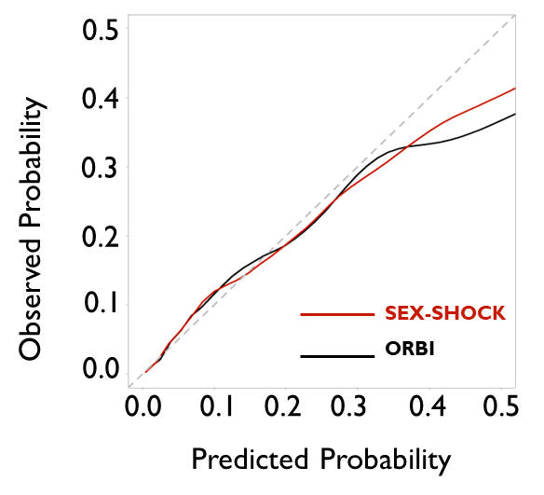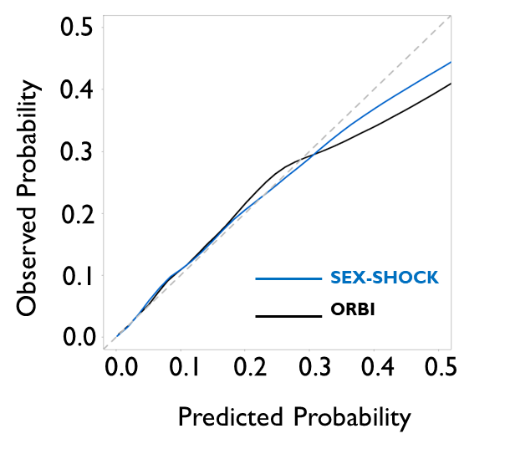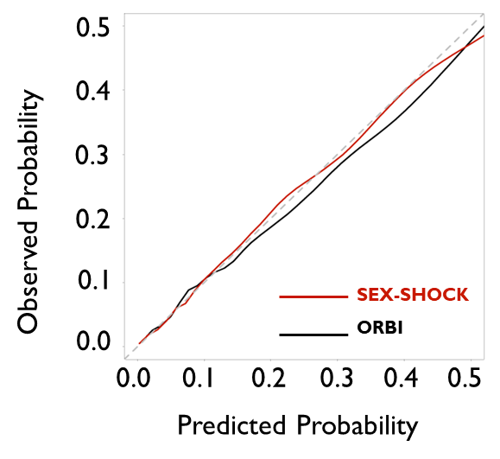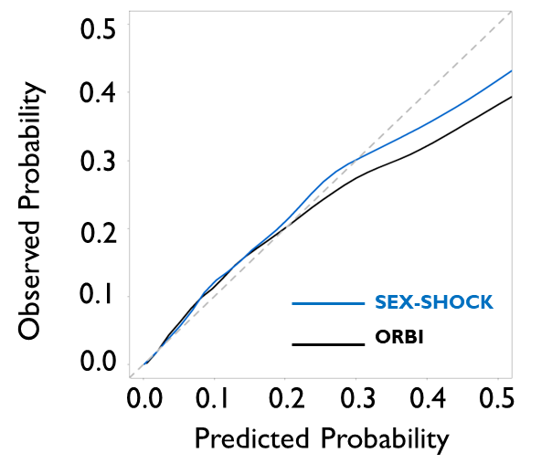

Predicted Probability

Predicted Probability

Observed Probability

Predicted Probability

Observed Probability

Observed Probability

Predicted Probability

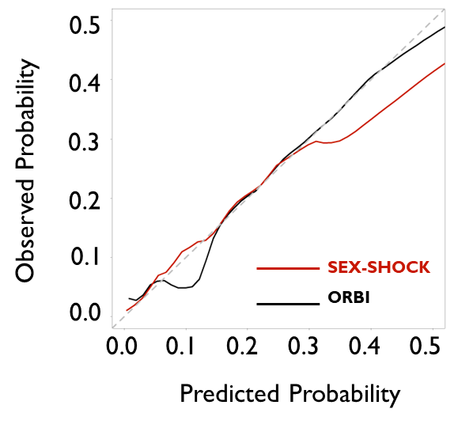

Predicted Probability

Observed Probability

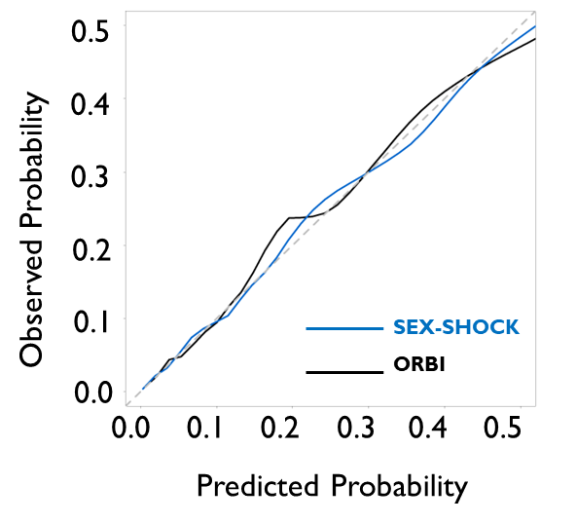

Predicted Probability

Observed Probability

Observed Probability

**C**

# Macintosh HD:Users:garycollins:CSM:research:TRIPOD:Checklist:final:word:TRIPODlogo.PNGFigure S3. TRIPOD checklist.

|  |  |  |  |  |
| --- | --- | --- | --- | --- |
| **Section/Topic** | **Item** |  | **Checklist Item** | **Page** |
| **Title and abstract** | | | | |
| Title | 1 | D;V | Identify the study as developing and/or validating a multivariable prediction model, the target population, and the outcome to be predicted. | 1 |
| Abstract | 2 | D;V | Provide a summary of objectives, study design, setting, participants, sample size, predictors, outcome, statistical analysis, results, and conclusions. | 2 |
| **Introduction** | | | | |
| Background and objectives | 3a | D;V | Explain the medical context (including whether diagnostic or prognostic) and rationale for developing or validating the multivariable prediction model, including references to existing models. | 4 |
| 3b | D;V | Specify the objectives, including whether the study describes the development or validation of the model or both. | 5 |
| **Methods** | | | | |
| Source of data | 4a | D;V | Describe the study design or source of data (e.g., randomized trial, cohort, or registry data), separately for the development and validation data sets, if applicable. | 5 |
| 4b | D;V | Specify the key study dates, including start of accrual; end of accrual; and, if applicable, end of follow-up. | 5 |
| Participants | 5a | D;V | Specify key elements of the study setting (e.g., primary care, secondary care, general population) including number and location of centres. | 5 |
| 5b | D;V | Describe eligibility criteria for participants. | 5 |
| 5c | D;V | Give details of treatments received, if relevant. | N/A |
| Outcome | 6a | D;V | Clearly define the outcome that is predicted by the prediction model, including how and when assessed. | 5 |
| 6b | D;V | Report any actions to blind assessment of the outcome to be predicted. | N/A |
| Predictors | 7a | D;V | Clearly define all predictors used in developing or validating the multivariable prediction model, including how and when they were measured. | 6 |
| 7b | D;V | Report any actions to blind assessment of predictors for the outcome and other predictors. | N/A |
| Sample size | 8 | D;V | Explain how the study size was arrived at. | N/A |
| Missing data | 9 | D;V | Describe how missing data were handled (e.g., complete-case analysis, single imputation, multiple imputation) with details of any imputation method. | 7 |
| Statistical analysis methods | 10a | D | Describe how predictors were handled in the analyses. | 6,7 |
| 10b | D | Specify type of model, all model-building procedures (including any predictor selection), and method for internal validation. | 6 |
| 10c | V | For validation, describe how the predictions were calculated. | 6 |
| 10d | D;V | Specify all measures used to assess model performance and, if relevant, to compare multiple models. | 6 |
| 10e | V | Describe any model updating (e.g., recalibration) arising from the validation, if done. | N/A |
| Risk groups | 11 | D;V | Provide details on how risk groups were created, if done. | N/A |
| Development vs. validation | 12 | V | For validation, identify any differences from the development data in setting, eligibility criteria, outcome, and predictors. | 6,7 |
| **Results** | | | | |
| Participants | 13a | D;V | Describe the flow of participants through the study, including the number of participants with and without the outcome and, if applicable, a summary of the follow-up time. A diagram may be helpful. | Suppl_21 |
| 13b | D;V | Describe the characteristics of the participants (basic demographics, clinical features, available predictors), including the number of participants with missing data for predictors and outcome. | Table 1, Suppl_6 |
| 13c | V | For validation, show a comparison with the development data of the distribution of important variables (demographics, predictors and outcome). | Suppl_10-14 |
| Model development | 14a | D | Specify the number of participants and outcome events in each analysis. | Suppl_21 |
| 14b | D | If done, report the unadjusted association between each candidate predictor and outcome. | N/A |
| Model specification | 15a | D | Present the full prediction model to allow predictions for individuals (i.e., all regression coefficients, and model intercept or baseline survival at a given time point). | Suppl_16-17 |
| 15b | D | Explain how to the use the prediction model. | 11,12 |
| Model performance | 16 | D;V | Report performance measures (with CIs) for the prediction model. | 10,11 |
| Model-updating | 17 | V | If done, report the results from any model updating (i.e., model specification, model performance). | N/A |
| **Discussion** | | | | |
| Limitations | 18 | D;V | Discuss any limitations of the study (such as nonrepresentative sample, few events per predictor, missing data). | 15 |
| Interpretation | 19a | V | For validation, discuss the results with reference to performance in the development data, and any other validation data. | 14 |
| 19b | D;V | Give an overall interpretation of the results, considering objectives, limitations, results from similar studies, and other relevant evidence. | 13,14 |
| Implications | 20 | D;V | Discuss the potential clinical use of the model and implications for future research. | 15,16 |
| **Other information** | | | | |
| Supplementary information | 21 | D;V | Provide information about the availability of supplementary resources, such as study protocol, Web calculator, and data sets. | 1,12 |
| Funding | 22 | D;V | Give the source of funding and the role of the funders for the present study. | 16,17 |

*Items relevant only to the development of SEX-SHOCK are denoted by D, items relating solely to validation are denoted by V, and items relating to both are denoted by D;V. Note the page numbers refer to initially provided documents and may have changed during typesetting.

# Figure S4. STROBE checklist.

|  |  |  |
| --- | --- | --- |
|  | **Item No** | **Recommendation** |
| **Title and abstract** | 1 | (*a*) Indicate the study’s design with a commonly used term in the title or the abstract |
| (*b*) Provide in the abstract an informative and balanced summary of what was done and what was found |
| **Introduction** | | |
| Background/rationale | 2 | Explain the scientific background and rationale for the investigation being reported |
| Objectives | 3 | State specific objectives, including any prespecified hypotheses |
| **Methods** | | |
| Study design | 4 | Present key elements of study design early in the paper |
| Setting | 5 | Describe the setting, locations, and relevant dates, including periods of recruitment, exposure, follow-up, and data collection |
| Participants | 6 | (*a*) Give the eligibility criteria, and the sources and methods of selection of participants. Describe methods of follow-up |
| (*b*)For matched studies, give matching criteria and number of exposed and unexposed |
| Variables | 7 | Clearly define all outcomes, exposures, predictors, potential confounders, and effect modifiers. Give diagnostic criteria, if applicable |
| Data sources/ measurement | 8* | For each variable of interest, give sources of data and details of methods of assessment (measurement). Describe comparability of assessment methods if there is more than one group |
| Bias | 9 | Describe any efforts to address potential sources of bias |
| Study size | 10 | Explain how the study size was arrived at |
| Quantitative variables | 11 | Explain how quantitative variables were handled in the analyses. If applicable, describe which groupings were chosen and why |
| Statistical methods | 12 | (*a*) Describe all statistical methods, including those used to control for confounding |
| (*b*) Describe any methods used to examine subgroups and interactions |
| (*c*) Explain how missing data were addressed |
| (*d*) If applicable, explain how loss to follow-up was addressed |
| (*e*) Describe any sensitivity analyses |
| **Results** | | |
| Participants | 13* | (a) Report numbers of individuals at each stage of study—eg numbers potentially eligible, examined for eligibility, confirmed eligible, included in the study, completing follow-up, and analysed |
| (b) Give reasons for non-participation at each stage |
| (c) Consider use of a flow diagram |
| Descriptive data | 14* | (a) Give characteristics of study participants (eg demographic, clinical, social) and information on exposures and potential confounders |
| (b) Indicate number of participants with missing data for each variable of interest |
| (c) Summarise follow-up time (eg, average and total amount) |
| Outcome data | 15* | Report numbers of outcome events or summary measures over time |
| Main results | 16 | (*a*) Give unadjusted estimates and, if applicable, confounder-adjusted estimates and their precision (eg, 95% confidence interval). Make clear which confounders were adjusted for and why they were included |
| (*b*) Report category boundaries when continuous variables were categorized |
| (*c*) If relevant, consider translating estimates of relative risk into absolute risk for a meaningful time period |
| Other analyses | 17 | Report other analyses done—eg analyses of subgroups and interactions, and sensitivity analyses |
| **Discussion** | | |
| Key results | 18 | Summarise key results with reference to study objectives |
| Limitations | 19 | Discuss limitations of the study, taking into account sources of potential bias or imprecision. Discuss both direction and magnitude of any potential bias |
| Interpretation | 20 | Give a cautious overall interpretation of results considering objectives, limitations, multiplicity of analyses, results from similar studies, and other relevant evidence |
| Generalisability | 21 | Discuss the generalisability (external validity) of the study results |
| **Other information** | | |
| Funding | 22 | Give the source of funding and the role of the funders for the present study and, if applicable, for the original study on which the present article is based |

*Give information separately for exposed and unexposed groups.

# A graph with red and black text Description automatically generatedFigure S5. Ranking of candidate variables by logistic regression, random forest, and multilayer perceptron.

**Random Forest**

**Logistic Regression**

**B**

**A**

**Multilayer Perceptron**

**C**

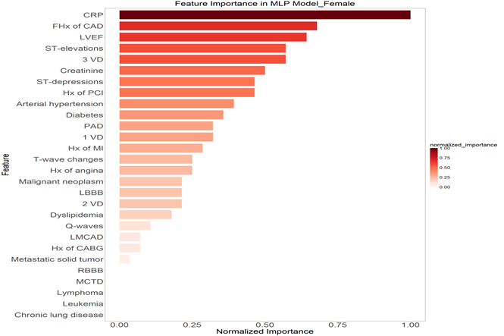

Candidate variables were ranked using **(A)** logistic regression, **(B)** random forest, and **(C)** multilayer perceptron separately in females (left, red) and males (right, blue).

# A screenshot of a computer Description automatically generatedFigure S6. Flow chart of the variable selection process.

**ORBI variables**

* Age >70 years
* Previous stroke/TIA
* Presentation as cardiac arrest
* Anterior myocardial infarction
* First medical contact-to-PCI delay >90 min
* Killip class II on admission
* Killip class III on admission
* Heart rate >90/min on admission
* SBP <125 and PP <45 mmHg on admission
* Glycaemia >10 mmol/L on admission
* Culprit lesion of the left main
* Post-PCI TIMI flow <3

**Full variables**

* Age > 70 years
* Previous stroke/TIA
* Presentation as cardiac arrest
* Anterior myocardial infarction
* First medical contact-to-PCI delay >90 min
* Killip class II on admission
* Killip class III on admission
* Heart rate >90/min on admission
* SBP <125 and PP <45 mmHg on admission
* Glycaemia >10 mmol/L on admission
* Culprit lesion of the left main
* Post-PCI TIMI flow <3
* LVEF
* ST-segment elevation
* Creatinine
* CRP

**SEX-SHOCK variables**

* Post-PCI TIMI flow <3
* Culprit lesion of the left main
* Glycaemia >10 mmol/L
* SBP <125 and PP <45 mmHg
* Heart rate >90/min
* Killip class III
* Presentation as cardiac arrest
* Age >70 years
* LVEF
* ST-segment elevation
* Creatinine
* CRP

# Figure S7. Performance of LR, RF and MLP modelling for the prediction of in-hospital cardiogenic shock.

**C**

**SEX-SHOCK variables**

**B**

**A**

**Full set of variables**

**ORBI variables**

**(A)** ROC curves of the three models trained with ORBI variables in female (left; red) and male patients (right; blue). **(B)** ROC curves of the three models trained with the full set of candidate variables in female and male patients. **(C)** ROC curves of the three models trained with SEX-SHOCK variables in female and male patients.

# A diagram of a person and person Description automatically generatedFigure S8. Flow chart of the modelling approach selection process.

# Figure S9. Cross-validation of SEX-SHOCK in the derivation cohort.

**A**

**B**

ROC curves and corresponding AUCs following 10-fold cross-validation in the training data set for **(A)** female and **(B)** male ACS patients. Data were divided into 10 equal datasets, with nine folds used to train the model and remaining parts for model testing. This process was repeated ten times to generate ten models, with each of the ten datasets used once as testing data.

# Figure S10. Performance of ORBI and SEX-SHOCK in both external validation cohorts.

**A**

**SPUM-ACS**

**(Switzerland)**

**RICO**

**(France)**

**B**

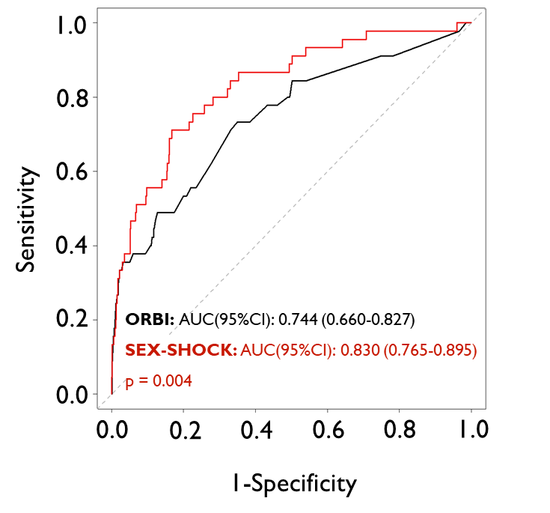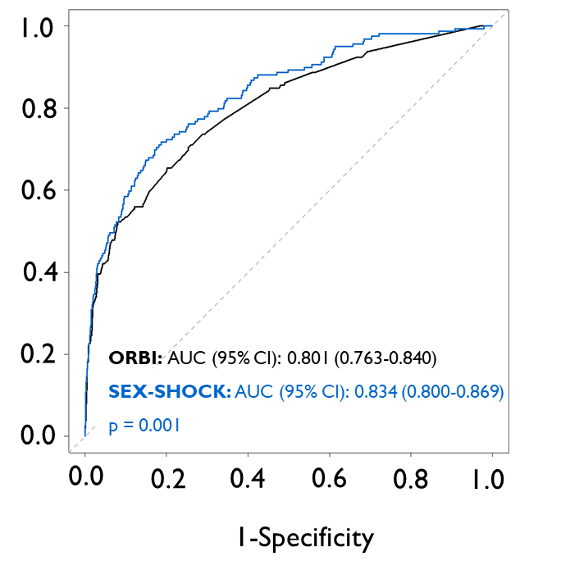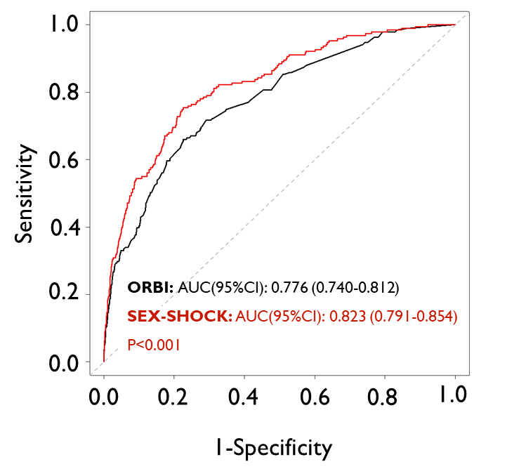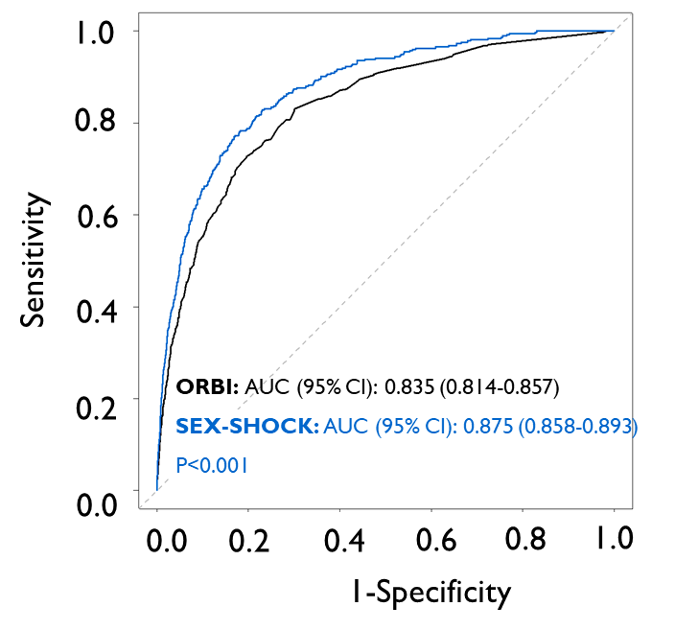

ROC curves of the ORBI and SEX-SHOCK for female patients (red line) and male patients (blue line) in **(A)** RICO and **(B)** SPUM-ACS.

# A graph with a line Description automatically generatedFigure S11. Decision curve analysis comparing the ORBI and SEX-SHOCK in external validation cohorts.

**A**

**RICO**

**(France)**

**B**

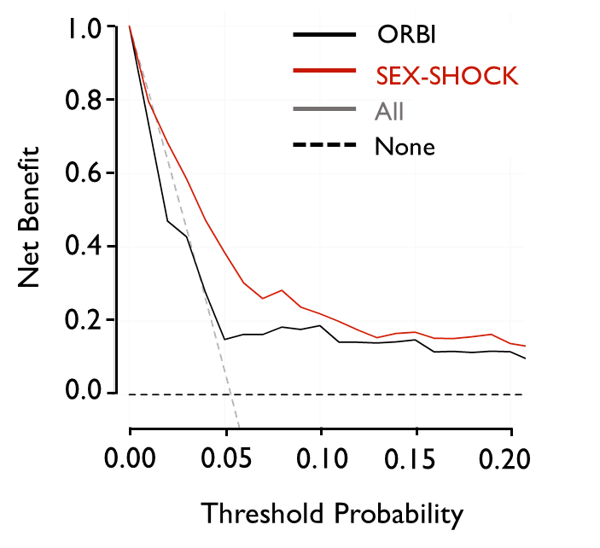

**SPUM-ACS**

**(Switzerland)**

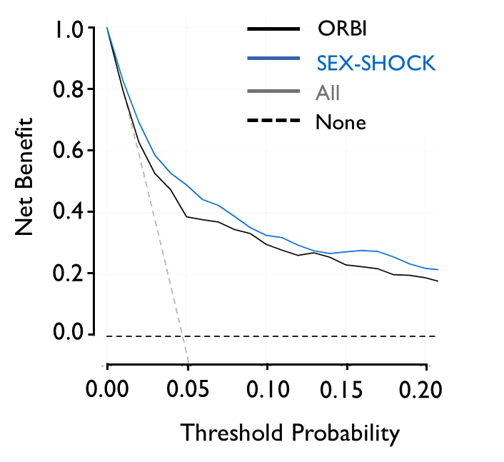

The net benefit of using ORBI and SEX-SHOCK models to predict in-hospital cardiogenic shock in females (left, red line) and males (right, blue line) in **(A)** RICO and **(B)** SPUM-ACS, compared to assuming all or none of the patients are at high risk across different thresholds.

# 

# Figure S12. Performance of SEX-SHOCK *vs*. SEX-SHOCKlight in derivation and validation cohorts.

**B**

**RICO**

**(France)**

**AMIS-Plus**

**(Switzerland)**

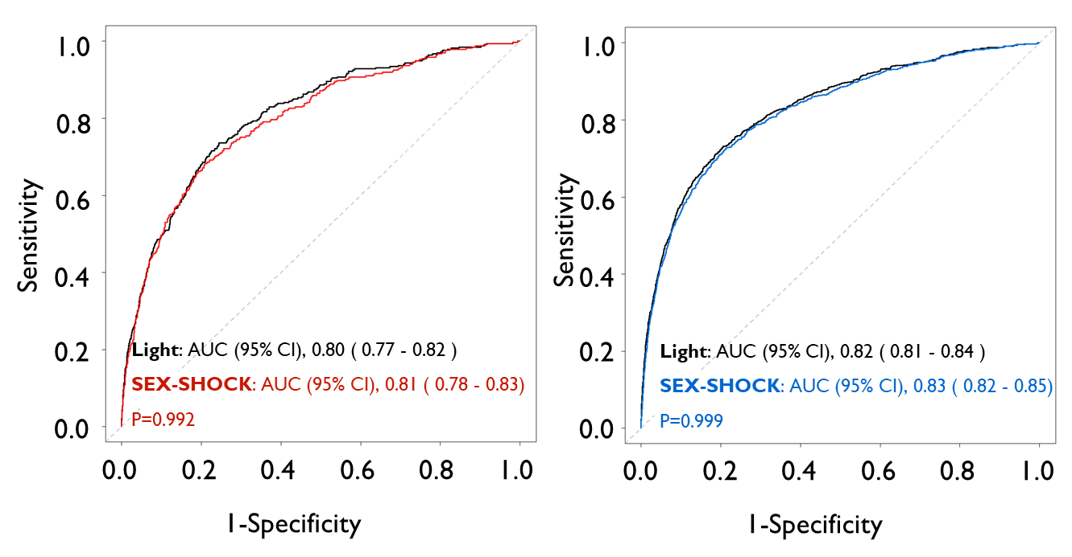

**A**

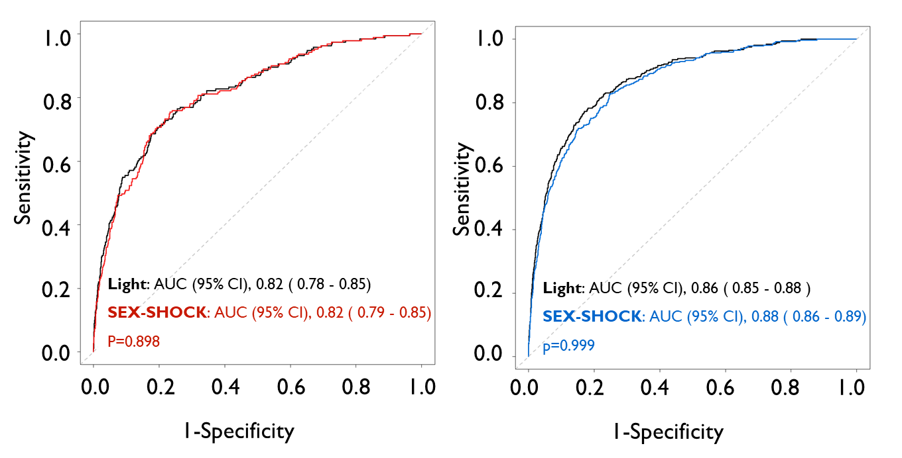

**SPUM-ACS**

**(Switzerland)**

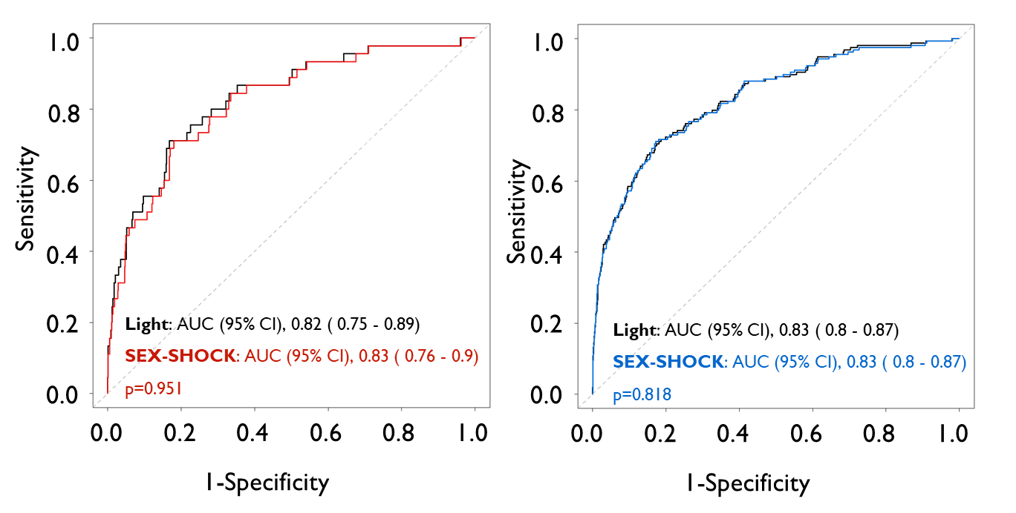

**C**

ROC curves comparing SEX-SHOCK *vs*. SEX-SHOCKlight in females (**left**, red) and males (**right**, blue) in **(A)** AMIS-Plus, **(B)** RICO, and **(C)** SPUM-ACS. The SEX-SHOCKlight model is only informed by non-procedural variables; thus, corresponding risk estimates can be calculated without the availability of data on the culprit lesion and TIMI flow.

# Figure S13. Performance of ORBI *vs*. SEX-SHOCKlight in both validation cohorts.

**SPUM-ACS**

**(Switzerland)**

**RICO**

**(France)**

**B**

**A**

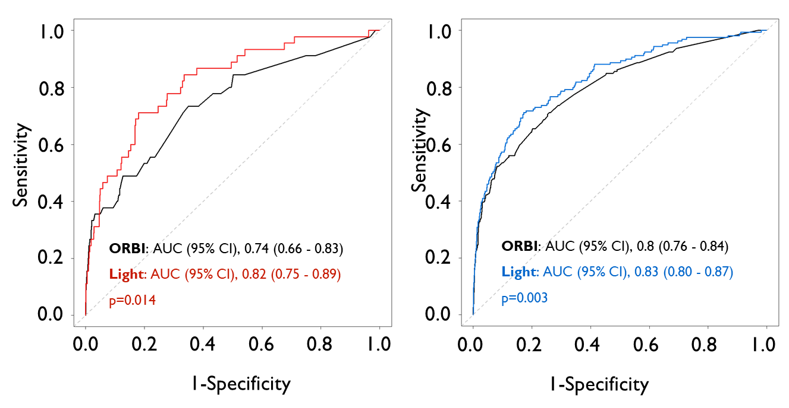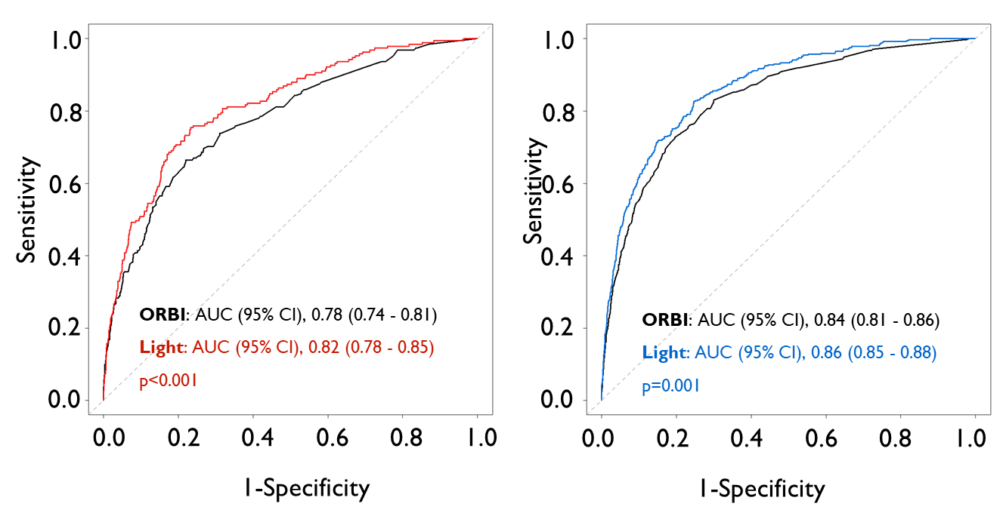

ROC curves comparing ORBI and SEX-SHOCKlight in females (**left**, red) and males (**right**, blue) in both validation cohorts: **(A)** RICO and **(B)** SPUM-ACS. Note that the SEX-SHOCKlight relies on non-procedural variables only; thus, corresponding risk estimates can be calculated without the availability of PCI-related data, including the culprit lesion and TIMI flow.