**SUPPLEMENTARY INFORMATION**

**Foetal TNAP+ progenitors contribute to secondary myogenesis during skeletal muscle development**

To investigate whether the TNAP+ cell lineage also contributes to secondary myogenesis, the tracing system was activated later, according to the experimental scheme in **Supplementary Fig. S1A.** In this experiment, to label foetal but not embryonic progenitors, tamoxifen was administered to *TNAP-CreERT2 : R26R-Confetti* foetuses at E14.5 instead of E11.5. Foetuses were then harvested at E17.5, frozen and processed for immunofluorescence analysis. At the time of collection, in *TNAP-CreERT2 : R26R-Confetti* foetuses it was possible to detect the presence of several RFP+ multinucleated myofibers expressing skMyHC, which derived from foetal TNAP+ cells of the developing muscle (**Suppl.** **Fig. S1B**).

**A**

**B**

RFP

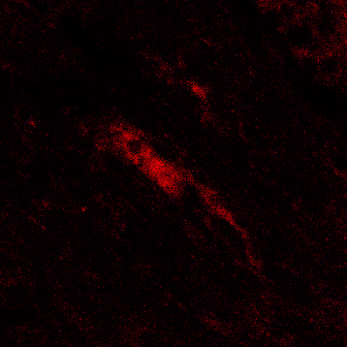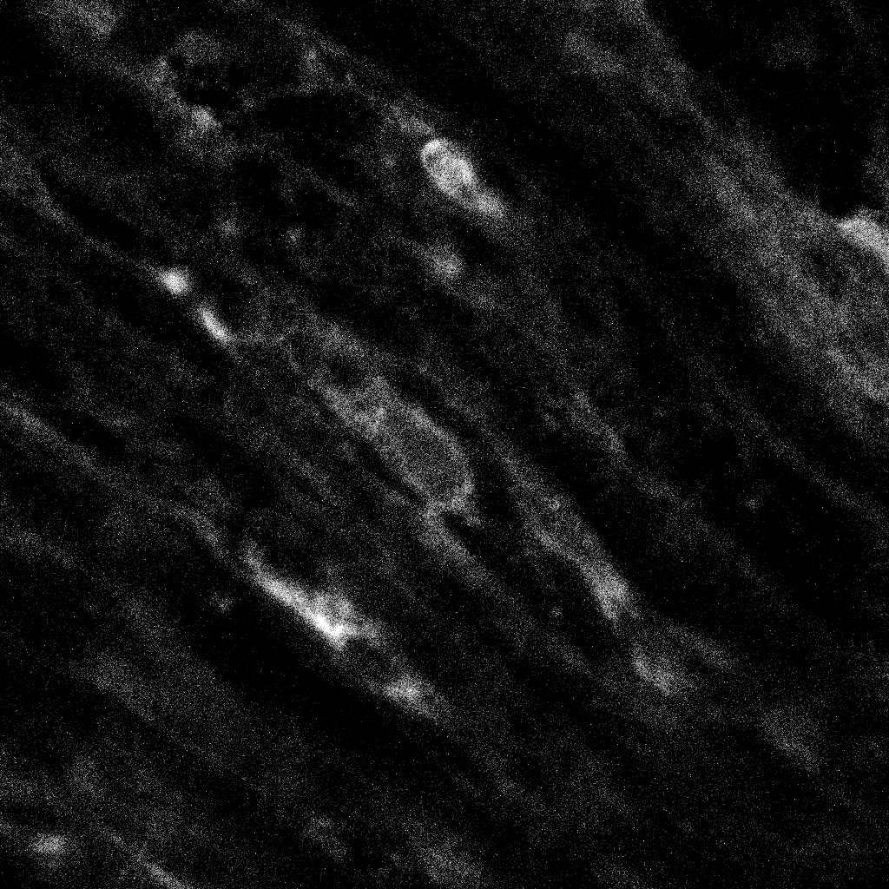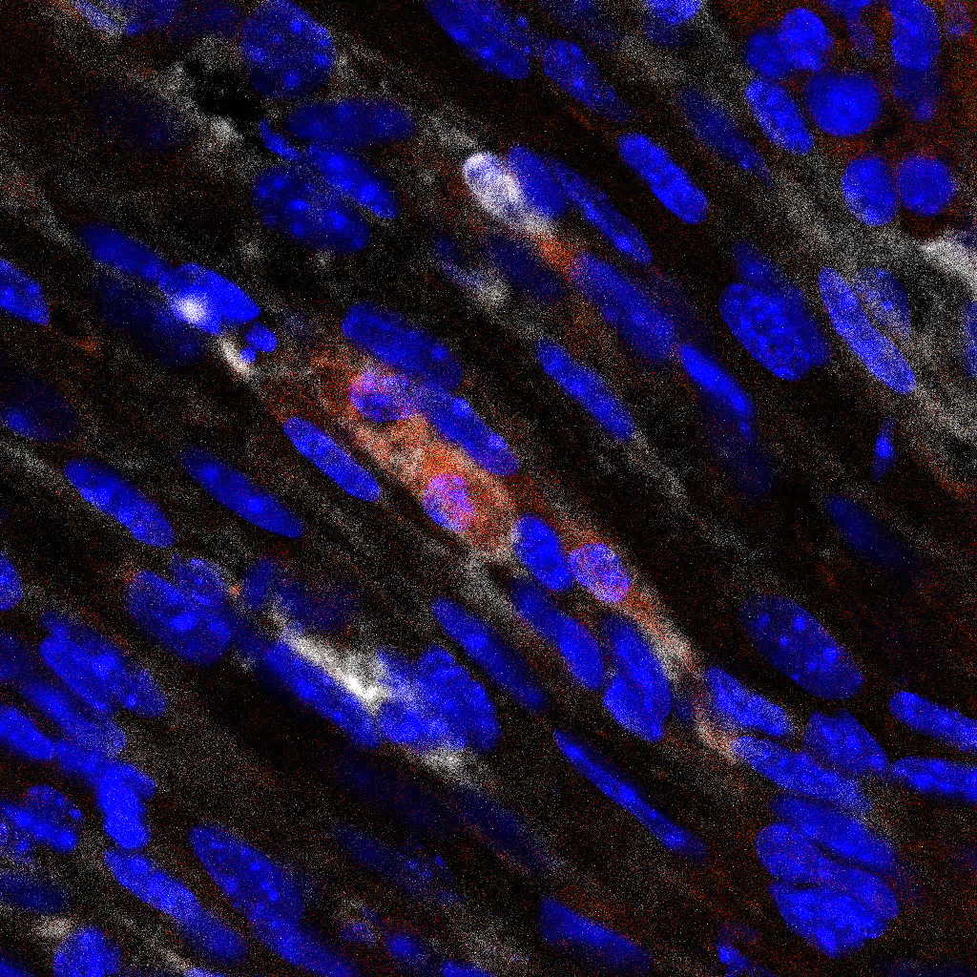

skMHC

DAPI RFP skMHC

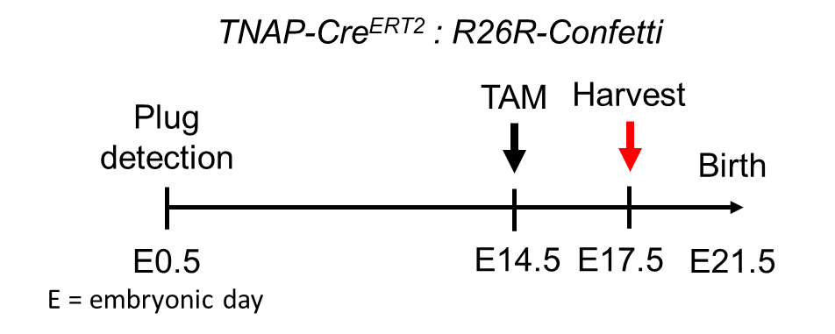

***Supplementary Figure S1. Foetal TNAP+ progenitors also give rise to myogenic derivatives in vivo during development.***

***(A)*** *Experimental protocol of the study followed to activate reporter at E14.5.* ***(B)*** *IF on 10 μm cryosections of E17.5 TNAP-CreERT2 : R26R-Confetti foetus when reporter is activated at E14.5, showing RFP+ (red) myofibers stained for skMyHC (white), with DAPI counterstained nuclei (blue).*

**Foetal NG2+ cells also undergo** **myogenic differentiation in developing skeletal muscle**

To investigate whether NG2+ cells are also capable of myogenic differentiation *in vivo* during skeletal muscle formation, we followed the experimental scheme in **Supplementary Fig. S2A**, by activating the tracing system in *NG2-CreERT2 : R26R-Tomato* at the stage of E14.5 and harvesting the foetuses for analysis at E17.5. In this experiment, the lineage of NG2+ pericytes was examined from the foetal rather than embryonic stage, to avoid strong labelling of other NG2+ cells in the developing nervous system at E11.5. Activation of the reporter was verified by epifluorescence imaging of the harvested foetuses, which showed an outer tdTomato+ signal, particularly in areas rich in NG2+ cells such as in the head and neck (**Suppl.** **Fig. S2B**). Cryosections of the collected foetuses were used to investigate NG2+ cell derivatives in areas corresponding to foetal muscle. Immunostainings revealed cytoplasmic tdTomato+ structures in the skeletal muscle interstitium, many associated with CD31+ endothelial vessels and/or retaining NG2 expression (**Suppl.** **Fig. S2C**). Interestingly, elongated tdTomato+ skMyHC+ myofibers were also found interspersed in the skeletal muscle, suggesting a myogenic contribution of the NG2+ lineage at this stage (**Suppl.** **Fig. S2D**).

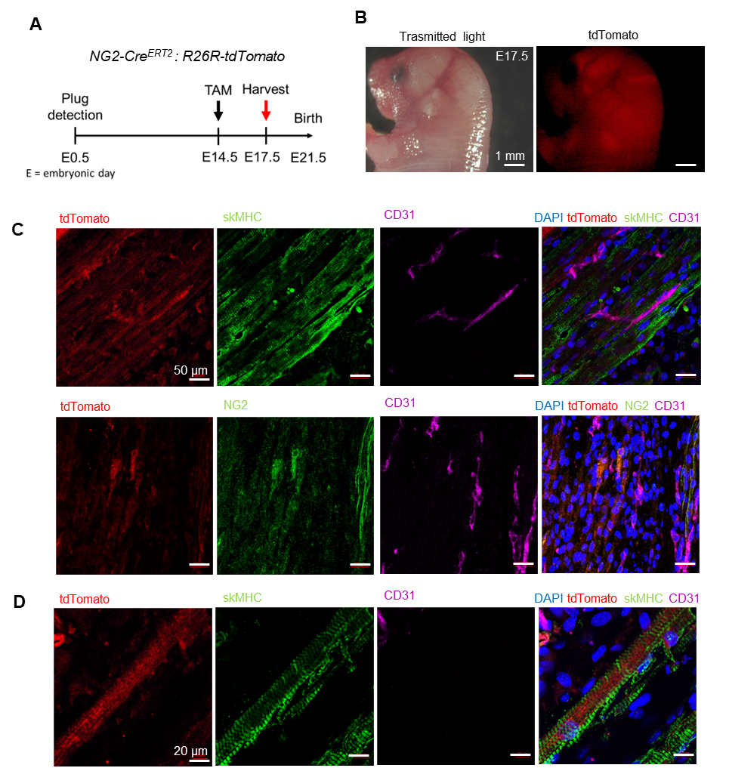

***Supplementary Figure S2. Lineage tracing of NG2+ cells in NG2-CreERT2 : R26R-tdTomato mice.***

***(A)*** *Experimental protocol of the study with NG2-CreERT2 mice.* ***(B)*** *tdTomato+ foetus collected at E17.5, showing upper body of the foetus for reporter expression screening.* ***(C)*** *IF on 10 μm cryosections of NG2-CreERT2 : R26R-Tomato foetus at E17.5, showing tdTomato+ (red) structures dispersed in the skeletal muscle stained for skMyHC (green), mostly associated with CD31+ vessels (magenta) with DAPI counterstained nuclei (blue). At the bottom, similar sections show NG2 (green) co-localising with tdTomato (red) in the interstitium in proximity to CD31+ vessels (magenta).* ***(D)*** *IF on the same sections showing tdTomato+ signal (red) co-localising with skMyHC staining (green), distant from vessels stained by CD31 (magenta), with DAPI counterstained nuclei (blue).*