**Supplementary data to:**

**Gut microbiome alterations precede graft rejection in kidney transplantation patients**

Holle J*, Reitmeir R*, et al.

Corresponding author: Johannes Holle, johannes-benjamin.holle@charite.de

1. **Supplementary Methods**

**Clinical Data Preparation**

The clinical data preparation was done using R (4.03).

Viral Infections: All entries of viral infections and complications were counted as one, except infections labeled as “suspected infection” or “detection of antibodies without signs of acute disease”. Infections are considered as separate occurrences if the distance between diagnoses is at least five days.

Bacterial Infections and Antibiotic Treatment: Bacterial Infections and complications labeled as suspected, probable, or possible disease are excluded. Only infections with a confirmed diagnosis or indicated by antibiotic treatments are counted. A minimum five-day interval is required between distinct infections. The administered antibiotics are binned into 15 broader antibiotic classes and further summarized in total number of taken antibiotics and number of distinct antibiotic classes.

The processing of all clinical variables, including the immunosuppressive drug regimen, viral and bacterial infections, antibiotic and prophylaxis treatments, blood and urine values, and further baseline characteristics, is accessible via GitHub: <https://github.com/rosareitmeir/DZIF-Tx-Cohort-Data-Cleaning-and-Statistical-Analysis>.

**Standard of care treatment**

The patients received a standard triple-drug combination of immunosuppressants (comprising a calcineurin inhibitor, mycophenolate (MPA), and corticosteroids), initially frequently together with an interleukin 2 receptor antagonist (basiliximab). The prophylaxis and surveillance strategy for infectious complications was suggested to be performed according to KDIGO 2009 guidelines1, including antiviral prophylaxis with valganciclovir for patients at high risk for cytomegalovirus (CMV) infections, trimethoprim-sulfamethoxazole prophylaxis against *Pneumocystis jirovecii* and urinary tract infections, *Candida* prophylaxis with oral nystatin or amphotericin B.

**Matching of rejection/non-rejection patients**

We conducted our analysis using R (4.3.2), employing MatchIt (4.5.5)2 package for sample matching. Patients with histologically proven rejection events were assessed (T cell-mediated rejection (TCMR, Banff category 4) and Borderline (Suspicious) for acute TCMR (Banff category 3))3, if the rejection occurred within five years after KT and fecal sampling was obtained before the rejection event (time frame 781 days before the rejection till rejection). Patients without sample before rejection and those with antibody-mediated rejection (ABMR, n=1) were excluded from the analyses, yielding 33 patients with rejection events. Stool samples taken closest before the rejection event were selected for analyses. Control samples were matched based on the absence of rejection and similar baseline characteristics, using nearest neighbour matching with a 2:1 ratio, matching two controls for each rejection case based on the factors primary condition, donor type, time since transplantation, age, and gender. Of the selected 99 patients, one rejection patient was excluded because of primary graft dysfunction (patient still required dialysis three months after KT) and six patients without rejection were excluded because of sustained poor kidney function (plasma creatinine > 2.5 mg/dL).

**Collection of fecal samples and DNA**

The samples were collected following established guidelines as described previously4. Stool samples were received in stool collection tubes containing DNA stabilizer (from Invitek Molecular) and transported on dry ice. For DNA isolation, 1200 µl of stool sample combined with DNA Stabilizer buffer and 5 Zirconia Beads II from the PSP Spin Stool DNA Basic Kit (Stratec, Invitek Molecular) were transferred to a 2 ml microcentrifuge tube. The DNA isolation was performed following the manufacturers. To enrich the bacterial DNA, we subjected the samples to an additional incubation step at 95 °C for 10 minutes, shaking at 900 rpm in a thermomixer, and then the protocol was followed as per the instructions. Finally, DNA was eluted into a 1.5 ml microcentrifuge tube with 200 µl of elution Buffer (preheated to 70 °C). The DNA concentration was measured using a NanoDrop, and the samples were stored at -80 °C until the next steps.

**16S Amplicon sequencing**

To target bacterial DNA, the V3/V4 region of the 16S rRNA gene was amplified in 25 cycles from 2µl of aliquoted working stocks of DNA using primers 341F-ovh and 785R-ovh (Supplemental Table 1)5. AMPure XP magnetic beads (Beckmann Coulter Life Sciences, Germany) were used for the purification of the amplicons according to Illumina’s 16S Metagenomic Sequencing Library Preparation guide. Samples were indexed with Nextera XT indices (Illumina) in a paired fashion for 8 cycles of PCR, followed by a second purification with AMPure XP beads. Indexed samples were pooled in an equimolar amount (4nM), adjusted to a final concentration of 4 pM, and sequenced on a MiSeq system (Illumina) in a paired-end reaction of 600 cycles using the MiSeq reagent kit v3 (Illumina). A 20% (v/v) spike-in of the PhiX standard library at 4 pM was additionally included. As a control to check for artifacts, a single negative control (PCR with nuclease-free water as template), as well as a positive control using a mock community (ZymoBIOMICS, No. D6300, Freiburg, Germany), were included throughout each sequencing run.

Sequencing reads were cleaned for host contamination using BBMap, aligning to human reference genome (HG38 GRCh38) masked for regions homologous to bacterial genes using the Progenomes2 database to filter out human reads. Parameters were adjusted for high specificity (95% identity).

Operational Taxonomic Units (OTUs) were defined using LotuS 2.16, with UPARSE algorithm for de novo sequence clustering. Sequences were quality controlled and clustered, specifically tailored for MiSeq data. The Silva 16S rRNA gene SSU database (version 138.1) was employed for taxonomic assignments. The analysis also included checks for chimeras using RDP classifier.

For comparison, ASV analysis was conducted using the LotuS 2.32 pipeline (Özkurt et al., 2022), in accordance with the OTU analysis. The reference database used was SILVA SSU v138 (Yilmaz et al., 2014). Clustering was performed using DADA2 for ASV clustering (Callahan et al., 2016). Phylogenetic tree building was carried out through multiple sequence alignment using MAFFT (Katoh et al., 2002) and maximum likelihood tree reconstruction using IQ-TREE (Nguyen et al., 2015). For our ASV analysis, we applied DADA2 to infer error-corrected ASVs and validate them against OTU-level results. Both analyses were conducted with rigorous chimera filtering, taxonomic assignment using the Lambda algorithm (Hauswedell et al., 2014), and dereplication filters.

**Gene targeting assay (quantitative PCR)**

To measure the potential of the gut microbiome to produce the SCFA butyrate and propionate, gene targeting qPCR assays (GTA) to quantify abundance of key enzymes for butyrate and propionate synthesis were developed. The genes encoding butyryl-CoA dehydrogenasee (*bcd*), butyryl-CoA:acetate CoA-transferase (*but*) and methylmalonyl-CoA decarboxylase (*mmdA*) in various main SCFA producing bacterial strains were targeted with minimally degenerate primers. Additionally, we used degenerate primers for acetate kinase (acK) from the literature6 to quantify acetate production potential.

Standard curve qPCR was performed on a Quantstudio 5 real-time PCR system (Thermofisher) using *Power*UpSYBR green qPCR master mix (Thermofisher) and primers shown in Supplemental Table 2 and 3. In brief, reactions were run at 50°C for 2 min, 95°C for 2 min, followed by 40 cycles of 95°C for 2 s and 60°C for 30 s, with 6.66ng DNA and 250nM primers in 5µl reaction volume (measured in triplicates). Standards ranging from 108-102 copies/µl were generated using microbial community DNA mix (Sigma-Aldrich), Microbial DNA standard from Escherichia coli (Sigma-Aldrich) or previously isolated fecal bacterial DNA and run in parallel to determine the copies of each target gene within the samples. Standard curve 16s rRNA gene qPCR was performed as a quantification of bacterial load and target genes were normalized to the copies of 16s rRNA within each sample.

**Re-analysis of the CKD dataset**

16S rRNA gene amplicon sequencing data from an existing CKD cohort7, obtained from 696 samples (217 CKD patients and 469 healthy controls), were accessed from the Sequence Read Archive database (bioproject accession number PRJNA562327). The data was then analyzed comparable to the for this generated 16S data from the DZIF cohort (LotuS 2.16 pipeline824, LotuS 2.16, with UPARSE algorithm, and taxonomic classification based on the SILVA (v138.1) database9). After quality control, we performed (i) targeted analysis of the abundance of genera found in the matched rejection-normal progress cohort and (ii) the abundance of typical butyrate and propionate producing bacteria was analyzed, focusing on the same taxa utilized in the design of the GTA (Supplemental Table 2).

**Statistical analysis**

Analysis of alpha diversity and multivariate analysis: Alpha diversity and multivariate analysis were performed on OTU level on the non-rarefied data. Different metrics for alpha Diversities were calculated using the R-package microbiome (v.1.12.0)10. Differences in alpha Diversity were tested using Wilcoxon rank sum test on a significance level of 0.05. For multivariate analysis, Bray-Curtis indices were obtained using the R-package phyloseq (v.1.34.0)11 and tested via PERMANOVA using adonis2 of the R-package vegan (v.2.6-4)12. Repeated measurements were taken into account by setting the Patient ID as strata during the permutation step of PERMANOVA.

Cross-sectional comparison: For the association analysis, the R-package metadecondfoundR (v.0.2.8) was used13. The testing was performed on the rarefied data (minimum read count 10270 reads) and all taxonomic levels with a minimum prevalence of 0.1. Wilcoxon rank sum test was performed for binary variables, Spearman‘s correlation for continuous variables, and Kruskal-Wallis test for ordinal variables. The obtained p-values were adjusted using the Benjamini-Hochberg false discovery rate (FDR) correction. In total, 65 clinical variables were considered as confounding factors (Supplemental Table 1). An association was considered statistically significant when FDR < 0.1.

For individual comparisons of clinical and qPCR parameters, Mann-Whitney *U* test was performed and p < 0.05 was considered statistically significant.

Longitudinal Analysis: For the longitudinal analysis, LongDat (v.1.1.2)14 was used, building negative binomial generalized linear mixed models over time after KT, controlling for sample origin by a random intercept. The models were built on rarefied data with default filtering14. FDR was controlled by Benjamini-Hochberg procedure. A change in abundance over time as considered statistically significant when FDR < 0.1.

Diversity parameters during different periods before and after KT were compared using Mann-Whitney *U* test and p < 0.05 was considered statistically significant.

Functional capacity prediction using Picrust2: PICRUSt215 obtained abundances of the KEGG orthologs (KOs) were z-score scaled and tested for significance with a linear model correcting for age and sex (Benjamini-Hochberg-corrected FDR < 0.05). All significant KOs were mapped to the corresponding GOmixer modules16 and tested for group difference using Wilcoxon rank sum test with a significance level of FDR < 0.05 using the online tools of GOmixer.

1. **Supplementary Figures**

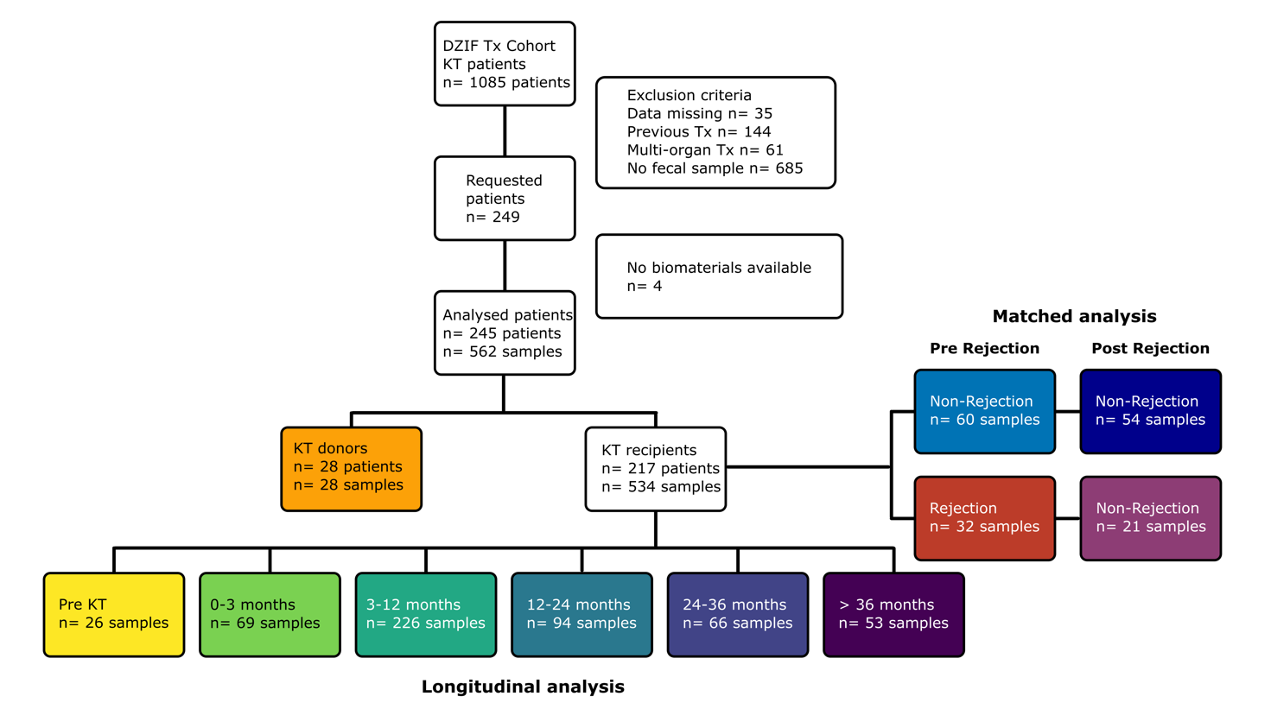

**Supplementary Figure S1. Study design.** Flow chart of the study design with inclusion and exclusion of patients and final sample number.

**Ein Bild, das Text, Screenshot, Multimedia-Software, Software enthält.
**

**Supplementary Figure S2. Individual sampling timelines.** Patients from full cohort and propensity-matched cohort are shown, split into non-rejection (normal progress) and rejection cohort. Vertical grey and white bar indicate ½ year. Squares indicate available stool sample and 16S sequencing data, colored squares indicate samples that were used for pre-rejection analysis. Red triangles indicate rejection events.

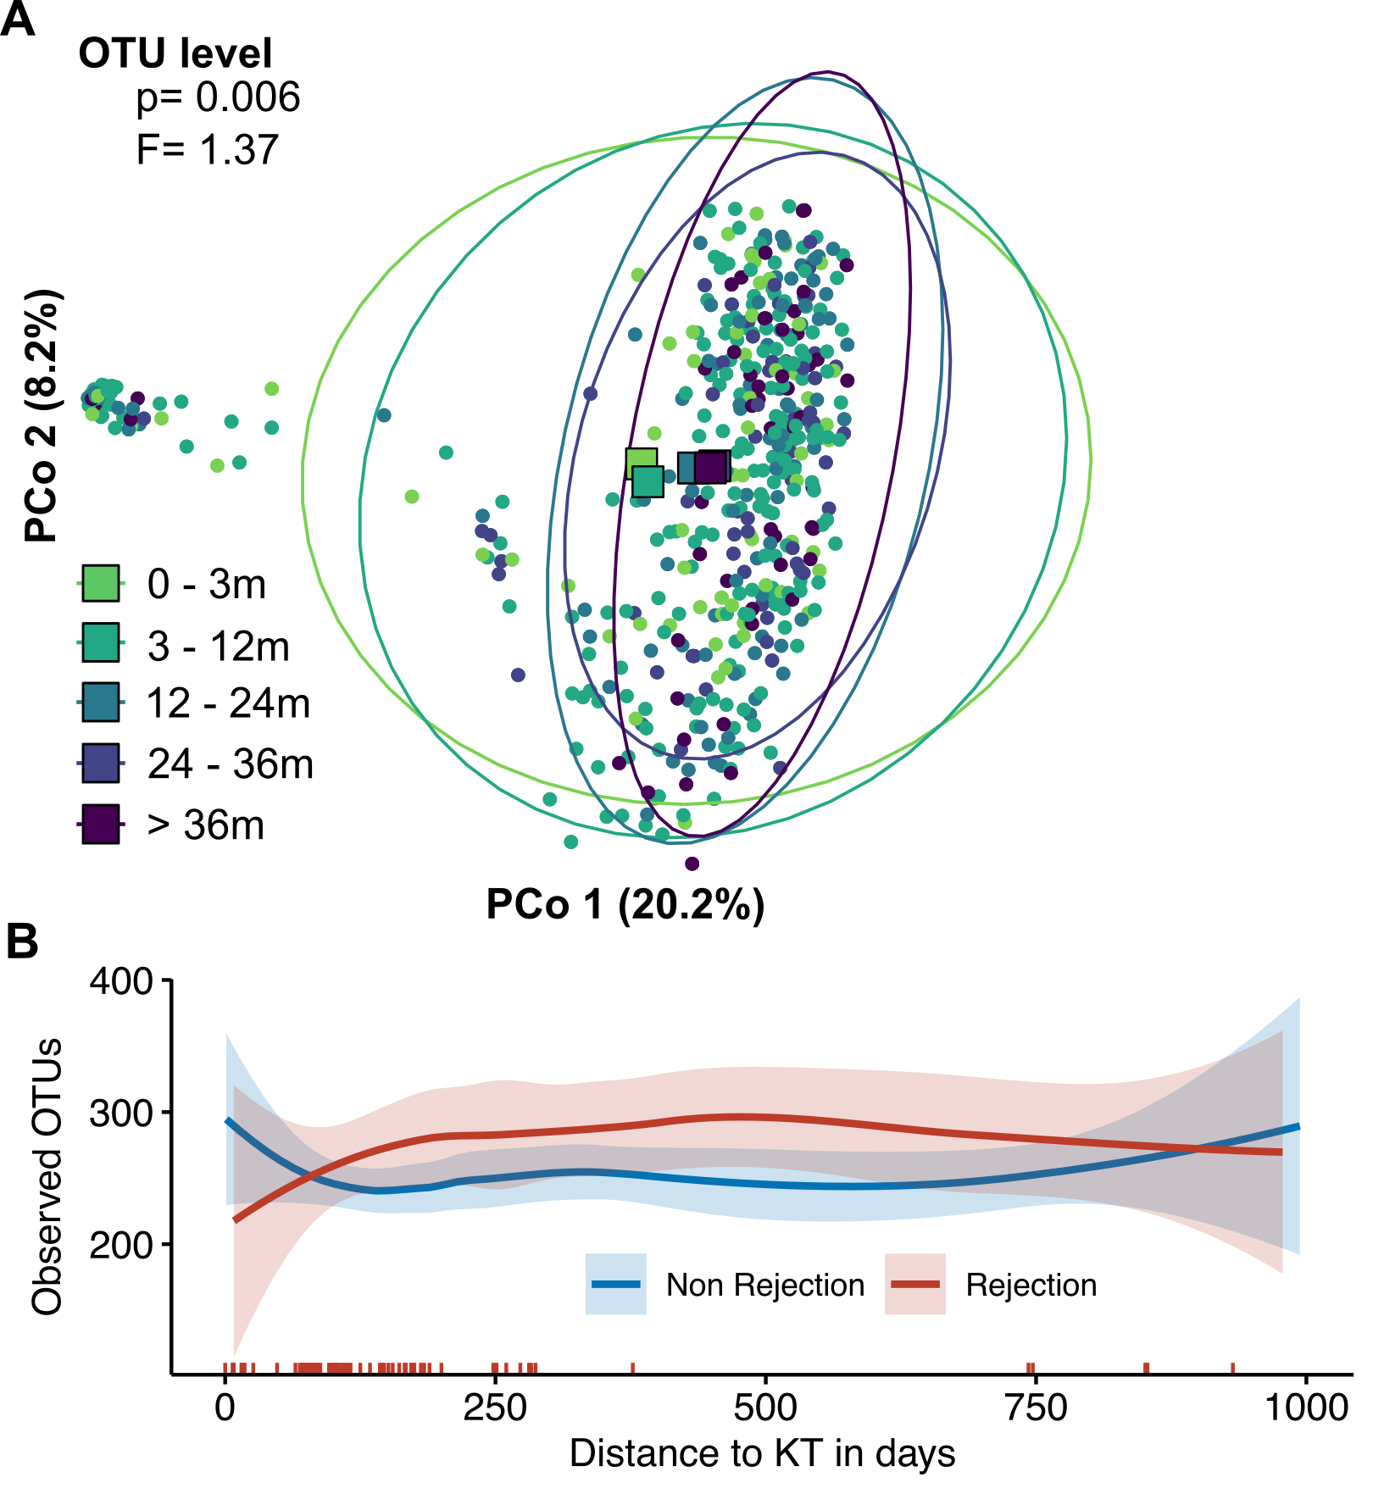

**Supplementary Figure S3. Effects of time after transplantation on beta diversity and number of observed OTU split into in rejection (red) and non-rejection (blue) patients.** A) PCoA based on Bray-Curtis dissimilarity, squares mark the centroids of each group. P-value and F value from statistical comparison by PERMANOVA. B) Horizontal lines indicate the number of detected OTU, shaded area is the 95% confidence interval. Vertical lines on top of the x-axis indicate rejection events.

Ein Bild, das Screenshot, Farbigkeit, Kunst enthält.

**Supplementary Figure S4. Impact of rejection state on gut microbiome composition.** Analysis of fecal samples from patients experiencing kidney rejection at any time compared to patients never experiencing graft rejection. Heatmap showing associations of bacterial genera with kidney transplant rejection. Meta-variables with significant association are shown. Stars indicate de-confounded significant associations; grey dots indicate confounded associations. °/*FDR< 0.1, °°/**FDR< 0.01, °°°/***FDR< 0.001.

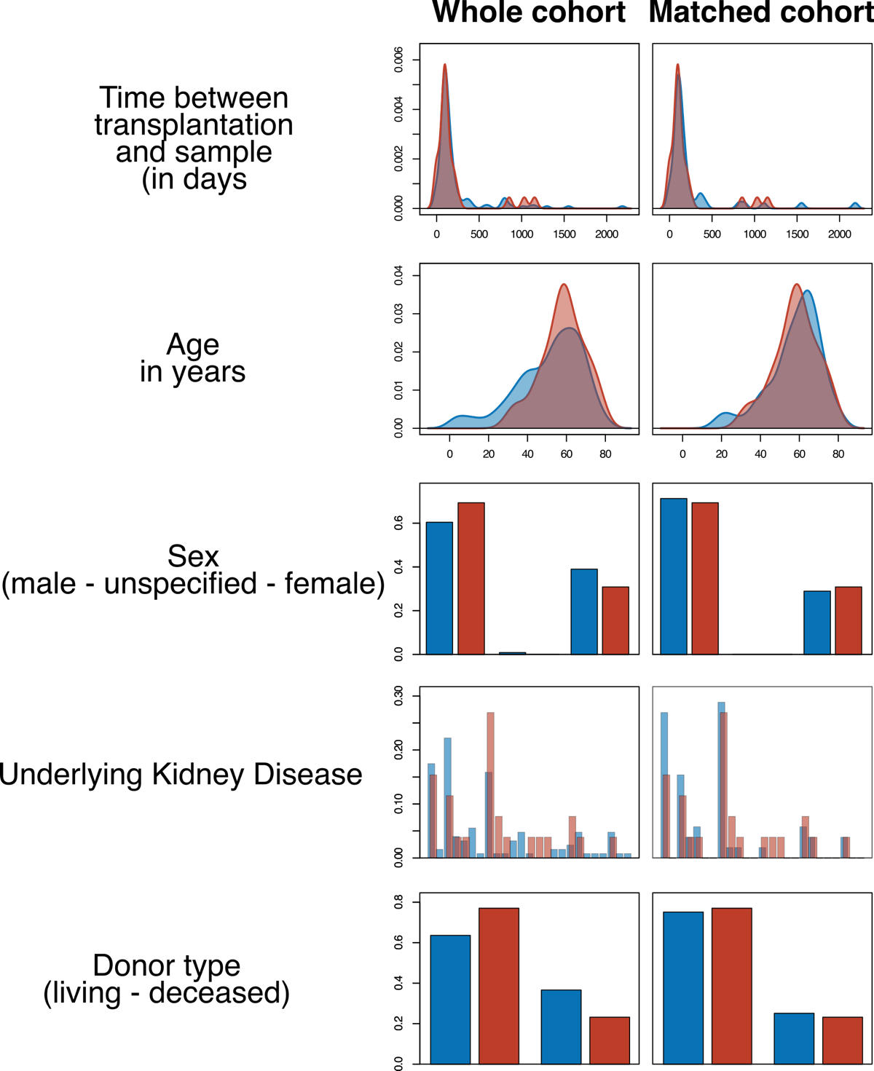

**Supplementary Figure S5: Matching of rejection and non-rejection patients.** Plots indicate metavariables before (left) and after propensity score matching (right). Grey bars/ histogram indicate non-rejection before (left) and after (right) propensity score matching. Rejection is shown in black.

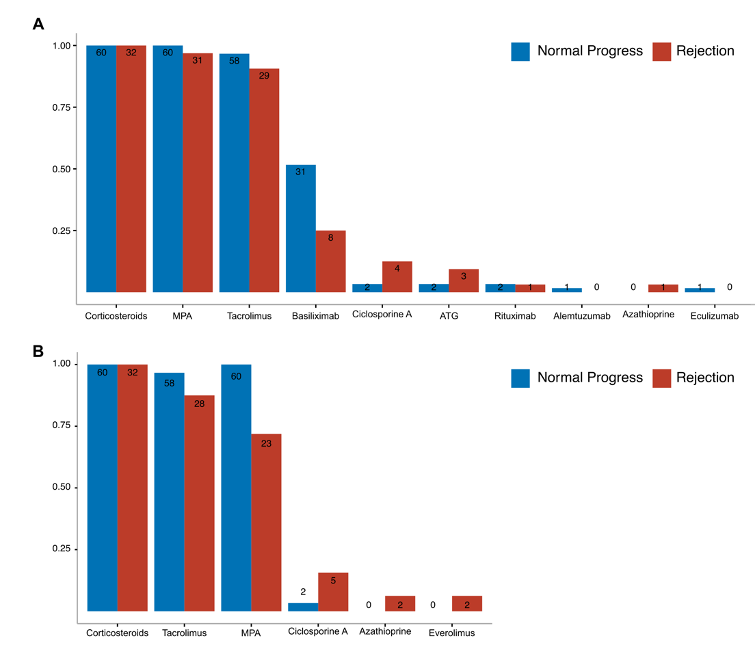

**Supplementary Figure S6: Immunosuppressive treatment at the time of transplantation (A) and at the time of fecal sampling (B).** Fecal samples were analysed from patients before experiencing graft rejection (Rejection, red) and propensity score matched (1:2) controls (normal progress, blue). Bar plots indicate medication at A) transplantation and B) fecal sampling.

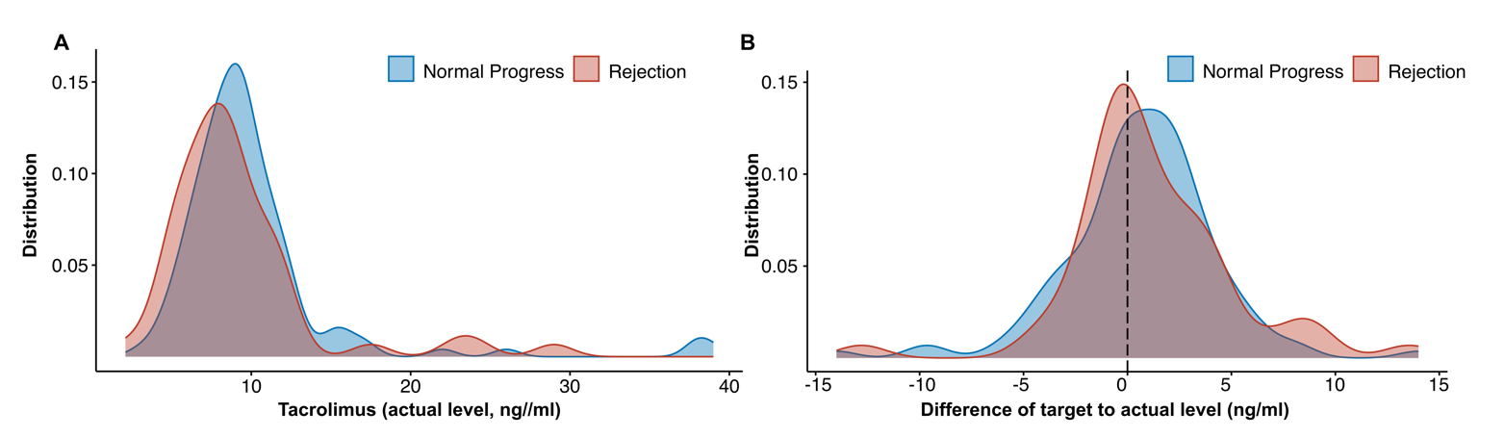

**Supplementary Figure S7. Tacrolimus plasma levels in matched rejection and non-rejection patients.** A) Tacrolimus plasma levels of n=92 patients (matched cohort) for the time between transplantation and sample collection before rejection event (n=121 data points of 51 patienrts for non-rejection and 51 data points of 23 patients for rejection group). B) Difference of target to actual values of Tacrolimus. Target values have been determined by the respective clinical recommendations after kidney transplantation.

Ein Bild, das Screenshot, Diagramm, Text, Reihe enthält.

**Supplementary Figure S8: Anti-infective medications used between kidney transplantation and fecal sampling.** Anti-infective medication used between kidney transplantation and fecal sampling for the matched cohort (normal progress, blue; rejection, red). Medication used both preventive and therapeutic is shown.

Ein Bild, das Kreis, Bernstein, Screenshot enthält.

**Supplementary Figure S9: Impact of basiliximab induction therapy on the gut microbiome composition.** PCoA on Bray-Curtis Dissimilarity of the 16S amplicon sequencing in rejection patients with (brown) and without (orange) basiliximab use during induction. Statistical testing using PERMANOVA shows no difference.

Ein Bild, das Screenshot, Cartoon enthält.

**Supplementary Figure S10: Impact of mycophenole (MPA) withdrawal on the gut microbiome composition.** A) PCoA on Bray-Curtis Dissimilarity of the 16S amplicon sequencing in rejection patients with (light green) and without (dark green) MPA at fecal sampling. Statistical testing using PERMANOVA shows no difference, although some distinct clustering can be seen. B) Correlation of effect sizes in the whole rejection cohort (x-axis) and the cohort excluding patients with MPA withdrawing (y-axis). Axis shows Cliff’s deltas for all detected genera in the gut microbiome. Spearman correlations, individual significances for genera using univariate testing in metadeconfoundR.

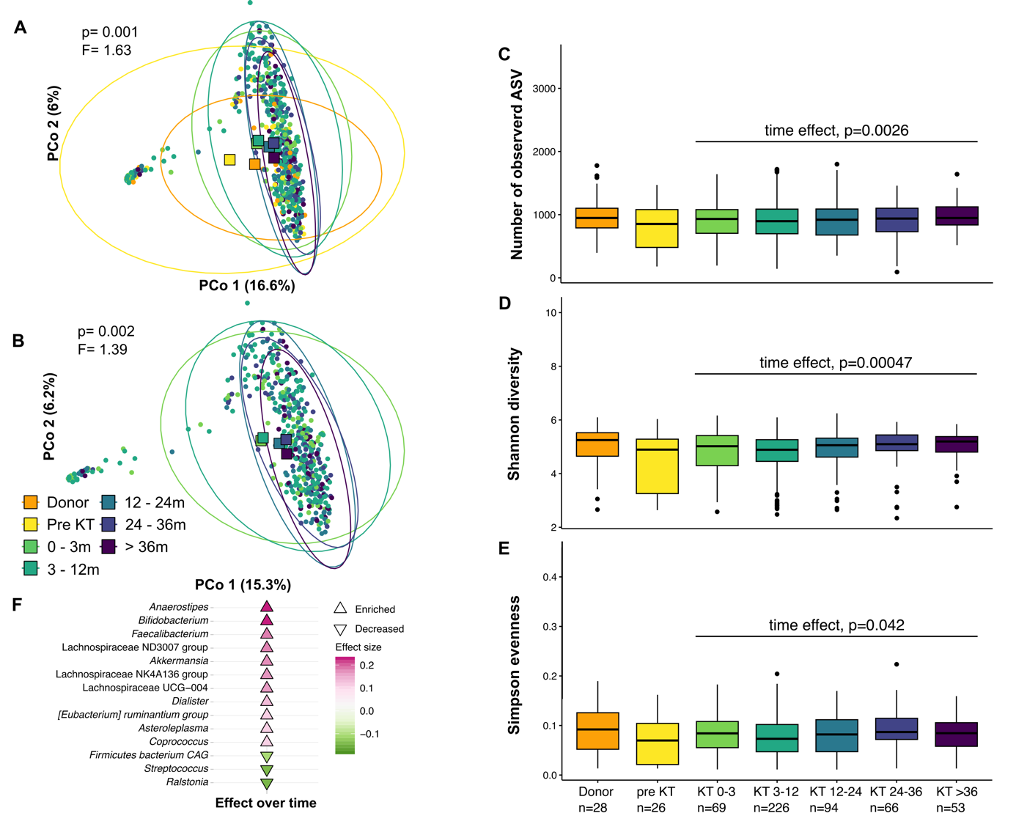 **Supplementary Figure S11. ASV level mapping shows comparable results to OUT level.** Longitudinal changes to the gut microbiome after kidney transplantation and impact on allograft rejection. 16S rRNA gene amplicon sequencing from fecal material from kidney transplantation (KT)-related samples from the transplant cohort of the German Center of Infectious Diseases (DZIF). Samples were grouped according to healthy kidney donors, pre-KT, 0-3 months post-KT, 3-12 months, 12-24 months and over 24 months. A) PCoA based on Bray-Curtis dissimilarity, squares mark the centroids of each group. P-value and F value from statistical comparison by PERMANOVA. B) Same as A) only for samples post KT. Quantification of the C) number of detected ASV, E) Shannon diversity, and E) Simpson evenness. F) Cuneiform plot displaying significantly altered bacterial genus post-transplantation over time.

1. **Supplemental Tables**

**Supplementary Table 1:** Clinical variables used for deconfounding of microbiome features

|  |  |
| --- | --- |
| Variable | Explanation |
| Age | Age of the recipient |
| Sex | Sex of the recipient and donor |
| Age donor | Donor age given in 5 years ranges (yes or no) |
| Primary kidney disease | Underlying primary condition in total seven categories |
| Primary kidney disease (ICD code) | Underlying primary condition according to ICD code |
| Type of KT | Deceased or living donation |
| BMI | Body Mass Index of the recipient and donor |
| Height | Body height of recipient and donor in cm |
| Weight | Body weight of the recipient and donor on day of KT in kg |
| Blood group | Blood type of the recipient: A, B, AB, or 0 |
| EBV and CMV serology (IgG and IgM) | Serology status of EBV and CMV before KT for recipient and donor (negative or positive) |
| Viral infection before sample | Any viral infection diagnosed in the time span of KT to sample |
| Viral infection 30d before sample | Any viral infection diagnosed within 30 days before the sample was taken |
| Oral antibiotics before sample | Taken antibiotic in the time span of KT to sample |
| Oral antibiotics 30d before sample | Taken antibiotic within 30 days before the sample was taken |
| Parenteral antibiotics before sample | Any antibiotic given parenteral in the time span of KT to sample |
| Parenteral antibiotics 30d before sample | Any antibiotic given parenteral within 30 days before the sample was taken |
| Number of antibiotic treatments | Total number of antibiotics taken in the time span of KT to sample |
| Number of antibiotic treatments 30d before sample | Total number of antibiotics taken within 30 days before the sample was taken |
| Antibiotic classes | Number of different types of antibiotics taken in the time span of KT to sample |
| Antibiotic classes 30d before sample | Number of different types of antibiotics taken within 30 days before the sample was taken |
| Min. creeatinine | The minimum creatinine value of the patient after KT |
| Albumin | Albumin blood level in g/L |
| CrP | C-reactive protein in mg/L |
| Creatinine | Creatinine in mg/dL |
| HbA1c | HbA1c in mmol/mol |
| Hemoglobin | Hemoglobin in g/dL |
| Leukocytes | Leukocytes blood count in 1/mul |
| Lymphocytes | Lymphocytes blood count in 1/μL |
| Monocytes | Monocyte blood count in 1/μL |
| Neutrophil | Neutrophil blood count in 1/μL |
| Phosphate | Phosphate in in mg/dL |
| PTH | Parathyroid hormone(PTH) in pg/mL |
| Urea | Urea level in mg/dL |
| Uric Acid | Uric acid in mg/dL |
| Urine Erythrocytes | Urinary lymphocytes in 1/μL |
| Urine Leukocytes | Urinary leukocytes in 1/μL |
| Urine Nitrite | Presence of urinary Nitrite (negative or positive) |
| Urine Protein | Urinary protein in g/L |

**Supplementary Table 2:** Primers used for 16S sequencing.

|  |  |
| --- | --- |
| **Name** | **Sequence 5’ > 3’** |
| 341F-ovh | TCGTCGGCAGCGTCAGATGTGTATAAGAGACAG CCTACGGGNGGCWGCAG |
| 785R-ovh | GTCTCGTGGGCTCGGAGATGTGTATAAGAGACAG GACTACHVGGGTATCTAATCC |

Underlined portions indicate the Illumina-specific adapter overhang sequences (16S Metagenomic Sequencing Library Preparation, Illumina).

**Supplementary Table 3:** Bacterial species included to the gene targeting assays for butyrate and propionate synthesis and corresponding primer sequences.

|  |  |  |  |
| --- | --- | --- | --- |
| **Gene** | **Primers** | **Primer sequence** | **Species** |
| ***bcd*** | 95F | CGGCTACACCCGTGACTA | *Roseburia Intestinalis* |
|  | 96R | ACCGGAAATGACCATCATCTG | *Faecalibacterium Prausnitzii* |
|  |  |  | *Eubacterium Rectales* |
|  |  |  | *Eubacterium Halli* |
|  |  |  | *Anaerostipes* |
|  |  |  |  |
| ***but*** | 548 F | GGMGACTGGGTSGATTAC | *Flavonifactor plautii* |
|  | 549R  550R | TCCACATACATCTCGGTGTG  TAGATATGCATCCGAGCAGAG | *Faecalibacterium Prausnitzii*  *Coproccocus eutactis* |
|  |  |  |  |
| ***mmdA* clone 1** | 645F | GTTTCTGCGATGCGTTCAATA | *Bacteriodes vulgatus* |
|  | 650R | CGGAAGGAATCCCGGTACAT | *Bacteriodes ovatus* |
|  |  |  | *Bacteriodes theta* |
|  |  |  | *Bacteriodes fragilis* |
|  |  |  |  |
| ***mmdA* clone 2** | 646F | GGAGAAATCCTCGCCAAGTT | *Faecalibacterium prausnitzii* |
|  | 651R | CAGCCTCGCCATTCTGATAA | *Clostridium spp.* |
|  |  |  |  |
| **acK** | ACKF | GTCATCGTGTAGTDMABGGHGG | N/A |
|  | ACKR | GGTGGRTTGTGMARWGGTGCDA | N/A |
|  |  |  |  |
| **16S** | 19F | ACTCCTACGGGAGGCAGCAGT | N/A |
|  | 20R | GTATTACCGCGGCTGCTGGCAC | N/A |

**Supplementary References**

1. 1. Kasiske BL, Zeier MG, Chapman JR, et al. KDIGO clinical practice guideline for the care of kidney transplant recipients: a summary. *Kidney Int*. Feb 2010;77(4):299-311. doi:10.1038/ki.2009.377
2. 2. Ho DE, Imai K, King G, Stuart EA. Matching as Nonparametric Preprocessing for Reducing Model Dependence in Parametric Causal Inference. *Political Analysis*. 2007;15(3):199-236. doi:10.1093/pan/mpl013
3. 3. Loupy A, Haas M, Roufosse C, et al. The Banff 2019 Kidney Meeting Report (I): Updates on and clarification of criteria for T cell- and antibody-mediated rejection. *Am J Transplant*. Sep 2020;20(9):2318-2331. doi:10.1111/ajt.15898
4. 4. Karch A, Schindler D, Kuhn-Steven A, et al. The transplant cohort of the German center for infection research (DZIF Tx-Cohort): study design and baseline characteristics. *Eur J Epidemiol*. Feb 2021;36(2):233-241. doi:10.1007/s10654-020-00715-3
5. 5. Klindworth A, Pruesse E, Schweer T, et al. Evaluation of general 16S ribosomal RNA gene PCR primers for classical and next-generation sequencing-based diversity studies. *Nucleic Acids Res*. Jan 7 2013;41(1):e1. doi:10.1093/nar/gks808
6. 6. Wang LL, Guo HH, Huang S, Feng CL, Han YX, Jiang JD. Comprehensive evaluation of SCFA production in the intestinal bacteria regulated by berberine using gas-chromatography combined with polymerase chain reaction. *J Chromatogr B Analyt Technol Biomed Life Sci*. Jul 1 2017;1057:70-80. doi:10.1016/j.jchromb.2017.05.004
7. 7. Ren Z, Fan Y, Li A, et al. Alterations of the Human Gut Microbiome in Chronic Kidney Disease. *Adv Sci (Weinh)*. Oct 2020;7(20):2001936. doi:10.1002/advs.202001936
8. 8. Özkurt E, Fritscher J, Soranzo N, et al. LotuS2: an ultrafast and highly accurate tool for amplicon sequencing analysis. *Microbiome*. 2022/10/19 2022;10(1):176. doi:10.1186/s40168-022-01365-1
9. 9. Quast C, Pruesse E, Yilmaz P, et al. The SILVA ribosomal RNA gene database project: improved data processing and web-based tools. *Nucleic Acids Research*. 2012;41(D1):D590-D596. doi:10.1093/nar/gks1219
10. 10. Lahti L, Sudarshan S. microbiome R package. <http://microbiome.github.io>
11. 11. McMurdie PJ, Holmes S. phyloseq: An R Package for Reproducible Interactive Analysis and Graphics of Microbiome Census Data. *PLOS ONE*. 2013;8(4):e61217. doi:10.1371/journal.pone.0061217
12. 12. Oksanen J, Blanchet FG, Kindt R, et al. Community ecology package. *R package version*. 2013;2(0):321-326.
13. 13. Forslund SK, Chakaroun R, Zimmermann-Kogadeeva M, et al. Combinatorial, additive and dose-dependent drug-microbiome associations. *Nature*. Dec 2021;600(7889):500-505. doi:10.1038/s41586-021-04177-9
14. 14. Chen C-Y, Lӧber U, Forslund SK. LongDat: an R package for covariate-sensitive longitudinal analysis of high-dimensional data. *Bioinformatics Advances*. 2023;doi:10.1093/bioadv/vbad063
15. 15. Douglas GM, Maffei VJ, Zaneveld JR, et al. PICRUSt2 for prediction of metagenome functions. *Nature Biotechnology*. 2020/06/01 2020;38(6):685-688. doi:10.1038/s41587-020-0548-6
16. 16. Darzi Y, Falony G, Vieira-Silva S, Raes J. Towards biome-specific analysis of meta-omics data. *ISME J*. May 2016;10(5):1025-8. doi:10.1038/ismej.2015.188