Exome-sequencing of 5 families with severe early-onset periodontitis
Gesa M. Richter¹, Gunar Wagner^{2¶}, Katharina Reichenmiller^{3¶}, Ingmar Staufenbiel^{4¶}, Orlando Martins⁵, Britt-Sabina Löscher⁶, Manuel Holtgrewe⁷, Søren Jepsen², Henrik Dommisch¹, Arne S. Schaefer¹
¶these authors contributed equally

Affiliations
¹Charité – University Medicine Berlin, corporate member of Freie Universität Berlin, Humboldt-Universität zu Berlin, and Berlin Institute of Health, Institute for Dental and Craniofacial Sciences, Department of Periodontology and Synoptic Dentistry, Berlin, Germany
²Department of Periodontology, Operative and Preventive Dentistry, University of Bonn, Bonn, Germany
³Private practice, Uhlandstrasse 2, Tuebingen, Germany
⁴Department of Conservative Dentistry, Periodontology and Preventive Dentistry, Hanover Medical School, Hanover, Germany
⁵Institute of Periodontology, Dentistry Department, Faculty of Medicine, University of Coimbra, Portugal.
⁶Institute of Clinical Molecular Biology, Christian-Albrechts-University Kiel & University Hospital Schleswig-Holstein, Kiel, Germany
⁷Core Unit Bioinformatics – CUBI, Berlin Institute of Health, Charité – University Medicine Berlin, Germany

Supplemental Material and Methods
Sample collection and whole-Exome Sequencing
Venous blood was collected from the parents and siblings of family 1 and 2 using EDTA Monovettes (Sarstedt, Nümbrecht, Germany). Saliva was collected from the parents and siblings of family 3 – 5 with ORAgene OG-500 saliva collection tubes for DNA extraction (DNA Genotek, Ottawa, Canada ). Genomic DNA (gDNA) was collected from blood and saliva using the DNA extraction kits AllPrep DNA/RNA/miRNA Universal Kit (Qiagen, Hilden, Germany) and OMNIgene Oral (DNA Genotek), respectively. Library preparation for WES was performed with 60ng gDNA using the xGen Exome Research Panel (IDT, Coralville, Iowa, US) in combination wth the Nextera preparation protocol (Illumina, San Diego, California, US) on the robotic system Biomek i7 (Beckmann, Brea, California, US). For quality control, the libraries were quantified using a DNA High Sensitivity D1000 ScreenTape on a 4200 Tapestation System (AgilentTechnologies, Santa Clara, California, US). WES was performed on a NovaSeq6000 S4 (Illumina) and a rapid run mode (2x150 bp, paired end) with ~60-fold coverage of the coding regions. To enrich the Cathepsin C (CTSC) gene sequence for targeted resequencing, the AmpliSeq™ Library PLUS chemistry (Illumina) was used with 10 ng gDNA as input. Targeted resequencing was performed on a MiSeq (Illumina) with 150 bp single reads and a coverage of 4000x.

Supplemental Table 1. Mutations in family 1 selected by potential pathogenicity (CADD score ≥30), the presence of more than one variant in the same gene with a CADD score ≥20, a described autosomal dominant (AD) disease mechanism of the corresponding gene, or genome-wide significant association with periodontitis (PD) of the corresponding gene (“GWAS Hit”).
Gene Symbol | Position | Variant | Inclusion criterion | Reference Sequence ID | Mutation | Common Allele | Rare Allele | Frequency gnomAD Exomes | CADD  score | Son (PD IV, C) | Daughter (PPP age 5, no PD since)
PDE8B | chr5:76,721,610 | p.Q813Rfs*10 | CADD ≥30, AD | None | frameshift truncation | CAG | C | 0 | 35 | 0/1 | 0/1
ZMYND12 | chr1:42,896,432 | p.S358* | CADD ≥30 | rs143931631 | stop gained | G | T | 0.00019 | 35 | 0/1 | 0/1
ZNF662 | chr3:42,956,732 | p.C416Vfs*14 | CADD ≥30 | rs76978847 | frameshift truncation | AT | A | 0.00102 | 34 | 0/1 | 0/1
ARID4A | chr14:58,832,019 | c.3211+1G>A | CADD ≥30 | rs62621193 | splice donor variant (intronic) | G | A | 0.00417 | 34 | 0/1 | 0/1
AQP7 | chr9:33,395,079 | p.M47Rfs*14 | CADD ≥30 | rs529625335 | frameshift variant | CA | C | 0.00116 | 34 | 0/1 | 0/1
NKX2-3 | chr10:101,295,456 | p.L358W | CADD ≥30 | rs151053941 | missense variant | T | G | 0.00538 | 33 | 0/1 | 0/1
MYH4 | chr17:10,368,916 | c.349-1G>C | CADD ≥30 | rs145471603 | splice acceptor variant (intronic) | C | G | 0.00013 | 33 | 0/1 | 0/1
PRPH2 | chr6:42,672,186 | p.G249S | CADD ≥30, AD | None | missense variant | C | T | 0 | 32 | 0/1 | 0/1
PPP1R3A | chr7:113,519,160 | p.Q662Rfs*7 | CADD ≥30, AD | rs527638422 | frameshift truncation | CCT | C | 0.00229 | 32 | 0/1 | 0/1
GINS3 | chr16:58,438,434 | p.D151V | CADD ≥30, >1 variant | rs987621253 | missense variant | A | T | 0 | 32 | 0/1 | 0/1
GINS3 | chr16:58,438,435 | p.D151E | >1 variant | rs758971074 | missense variant | C | G | 0 | 25.2 | 0/1 | 0/1
CTSC | chr11:88,045,626 | p.G139R | CADD ≥30, >1 variant | rs749103588 | missense variant | C | T | 0.00002 | 32 | 0/1 | 0/1
CTSC | chr11:88,029,375 | p.R272H | >1 variant | rs587777534 | missense variant | C | T | 0 | 26.7 | 0/1 | 0/1
SOX15 | chr17:7,492,496 | p.S167Qfs*30 | CADD ≥30 | None | frameshift elongation | T | TG | 0 | 32 | 0/1 | 0/1
PIK3C2G | chr12:18,552,594 | p.L669F | CADD ≥30 | rs61754413 | missense variant; splice region variant | C | T | 0.00343 | 32 | 0/1 | 0/1
MMP20 | chr11:102,465,490 | c.954-2A>T | CADD ≥30 | rs140213840 | splice acceptor variant (intronic) | T | A | 0.00106 | 32 | 0/1 | 0/1
DENND4B | chr1:153,907,347 | p.R888C | CADD ≥30 | rs530088376 | missense variant | G | A | 0.00001 | 32 | 0/1 | 0/1
SETD5 | chr3:9,488,755 | p.E418K | AD | rs147867570 | missense variant | G | A | 0.0001 | 27.5 | 0/1 | 0/1
OPLAH | chr8:145,107,390 | p.V1089I | AD | rs185836803 | missense variant | C | T | 0.00948 | 26.9 | 0/1 | 0/1
LMBR1 | chr7:156,516,874 | c.1159-2A>G | AD | rs148655712 | splice acceptor variant (intronic) | T | C | 0.00023 | 26.9 | 0/1 | 0/1
MYH3 | chr17:10,541,680 | p.R1137C | AD | rs12941197 | missense variant | G | A | 0.00256 | 26.6 | 0/1 | 0/1
ABCA7 | chr19:1,057,343 | p.V1599M | AD | rs117187003 | missense variant | G | A | 0.00338 | 25.4 | 0/1 | 0/1
VIM | chr10:17,277,239 | p.D360E | AD | rs139818786 | missense variant | C | G | 0.00002 | 25 | 0/1 | 0/1
CACNA1H | chr16:1,254,361 | p.K785M | AD | rs28365117 | missense variant | A | T | 0.00357 | 23.8 | 0/1 | 0/1
APC2 | chr19:1,453,313 | p.T70M | >1 variant | rs144391493 | missense variant | C | T | 0.00115 | 23.3 | 0/1 | 0/1
APC2 | chr19:1,465,954 | p.R885Q | >1 variant | rs111389603 | missense variant | G | A | 0.00009 | 22.6 | 0/1 | 0/1
TUBB1 | chr20:57,597,934 | p.D31G | AD | rs745713786 | missense variant | A | G | 0.00003 | 22.4 | 0/1 | 0/1
FLG | chr1:152,284,948 | p.S805F | AD | rs72698904 | missense variant | G | A | 0.00334 | 21.7 | 0/1 | 0/1
PRKAG2 | chr7:151,573,595 | c.111T>A | AD | rs144426409 | slice site affected (synonymous variant) | A | T | 0.00242 | 20.7 | 0/1 | 0/1
The allele frequency cutoff was 0.05 and 50 carriers in our in-house database. The minimum CADD score for included mutations was 20. PD = Periodontal disease; PPP = prepubertal periodontitis.
Supplemental Table 2. Mutations in family 2 selected by potential pathogenicity (CADD score ≥30), the presence of more than one variant in the same gene with a CADD score ≥20, a described autosomal dominant (AD) disease mechanism of the corresponding gene, or genome-wide significant association with periodontitis (PD) of the corresponding gene (“GWAS Hit”).
Gene Symbol | Position | Variant | Inclusion criterion | Reference Sequence ID | Mutation | Common Allele | Rare Allele | Frequency gnomAD Exomes | CADD score | Daughter 1 (PD III, C) | Daughter 2 (PD III, C) | Mother (PD IV, C) | Father (PD III, C)
OR4C15 | chr11:55,322,818 | p.E346* | CADD ≥30 | rs72908448 | stop gained | G | T | 0.00119 | 48 | 0/1 | 0/1 | 0/1 | 0/0
MMD | chr17:53,471,727 | p.R229* | CADD ≥30 | rs1052816837 | stop gained | G | A | 0.00001 | 41 | 0/1 | 0/1 | 0/0 | 0/1
CTU2 | chr16:88,781,328 | c.1415 1419dup | CADD ≥30 | rs1218643869 | splice acceptor variant (intronic) | G | GGACTT | 0 | 35 | 0/1 | 0/1 | 0/1 | 0/0
DNAH9 | chr17:11,540,047 | p.L578Rfs*4 | CADD ≥30 | rs766799921 | frameshift variant | CT | C | 0.00002 | 33 | 0/1 | 0/1 | 0/1 | 0/0
TMEM94 | chr17:73,491,370 | p.R912G | CADD ≥30 | rs557746506 | missense variant | C | G | 0 | 33 | 0/1 | 0/1 | 0/1 | 0/0
TNFAIP3 | chr6:138,198,219 | p.R271Q | CADD ≥30 | rs763827898 | missense variant | G | A | 0 | 33 | 0/1 | 0/1 | 0/0 | 0/1
ANKS6 | chr9:101,498,853 | p.F855S | CADD ≥30 | rs200644058 | missense variant | A | G | 0.00111 | 32 | 0/1 | 0/1 | 0/0 | 0/1
USP34 | chr2:61,475,705 | p.R2112H | CADD ≥30 | rs201497693 | missense variant | C | T | 0.00011 | 32 | 0/1 | 0/1 | 0/1 | 0/0
FAAH | chr1:46,874,198 | p.P340L | CADD ≥30 | rs202117973 | missense variant | C | T | 0.00001 | 31 | 0/1 | 0/1 | 0/1 | 0/0
TBC1D4 | chr13:75,930,356 | p.I401S | CADD ≥30 | None | missense variant | A | C | 0 | 31 | 0/1 | 0/1 | 0/0 | 0/1
TUT7 | chr9:88,940,359 | p.R560Q | CADD ≥30 | rs41310053 | missense variant | C | T | 0.00355 | 31 | 0/1 | 1/1 | 0/1 | 0/1
GNRH1 | chr8:25,280,706 | p.E51D | AD | rs35542850 | missense variant; splice region variant | C | G | 0.00153 | 27 | 0/1 | 0/1 | 0/1 | 0/0
PLAU | chr10:75,675,086 | p.Y333H | AD | rs72816325 | missense variant | T | C | 0.00391 | 26.2 | 0/1 | 0/1 | 0/0 | 0/1
DNAH5 | chr5:13,864,718 | p.D1462Y | >1 variant | rs1189846120 | missense variant | C | A | 0 | 25.9 | 0/1 | 0/1 | 0/0 | 0/1
DNAH5 | chr5:13,759,026 | p.E3450K | >1 variant | rs758739748 | missense variant | C | T | 0.00001 | 21.6 | 0/1 | 0/1 | 0/1 | 0/0
LPA | chr6:160,952,816 | p.Y2023C | AD | rs41267807 | missense variant | T | C | 0.01008 | 23.6 | 0/1 | 0/1 | 0/0 | 0/1
SETBP1 | chr18:42,533,192 | p.S1296N | AD | rs369012871 | missense variant | G | A | 0.00001 | 23 | 0/1 | 0/1 | 0/1 | 0/0
CDK13 | chr7:39,990,917 | p.S226I | AD | None | missense variant | G | T | 0 | 23 | 0/1 | 0/1 | 0/1 | 0/0
ABCA7 | chr19:1,059,056 | p.R1812H | AD | rs114782266 | missense variant | G | A | 0.00896 | 22.7 | 0/1 | 0/1 | 0/1 | 0/0
FOXE1 | chr9:100,616,939 | p.A248G | AD | rs538912281 | missense | C | G | 0.00197 | 21.6 | 0/1 | 0/1 | ./. | ./.
CACNA1B | chr9:141,013,113 | p.V1975I | AD | rs866508790 | missense variant | G | A | 0 | 21.1 | 0/1 | 0/1 | 0/0 | 0/1
The allele frequency cutoff was 0.05 and 50 carriers in our in-house database. The minimum CADD score for included mutations was 20. ./. = filtered out due to QC. PD = Periodontal disease; PPP = prepubertal periodontitis.

Supplemental Table 3. Mutations in family 3 selected by potential pathogenicity (CADD score ≥30), the presence of more than one variant in the same gene with a CADD score ≥ 20, a described autosomal dominant (AD) disease mechanism of the corresponding gene, or genome-wide significant association with periodontitis (PD) of the corresponding gene (“GWAS Hit”).
Gene Symbol | Position | Variant | Inclusion criterion | Reference Sequence ID | Mutation | Common Allele | Rare Allele | Frequency gnomAD Exomes | CADD  score | Daughter (PD III, B) | Mother (PD III, B) | Father (PD III, B) | Unaffected Son
EGFL8 | chr6:32,134,395 | p.Y74* | CADD ≥30 | rs141826798 | stop gained; splice region variant | C | G | 0.00299 | 40 | 0/1 | 0/1 | 0/0 | 0/0
ZNF772 | chr19:57,987,104 | p.W41* | CADD ≥30 | rs73067111 | stop gained | C | T | 0.00668 | 38 | 0/1 | 0/0 | 0/1 | 0/0
DERL3 | chr22:24,180,551 | p.G105Afs*4 | CADD ≥30 | rs536282991 | frameshift truncation | GC | G | 0.00145 | 35 | 0/1 | 0/1 | 0/0 | 0/1
FANCL | chr2:58,386,928 | p.T372Nfs*13 | CADD ≥30 | rs759217526 | frameshift elongation | G | GTAAT | 0.00301 | 35 | 0/1 | 0/1 | 0/0 | 0/0
TAF9 | chr5:68,648,056 | p.L113Qfs*36 | CADD ≥30 | rs1454050637 | frameshift truncation | TGTTA | T | 0 | 34 | 0/1 | 0/1 | 0/0 | 0/0
DLGAP4 | chr20:35,075,211 | p.R507C | CADD ≥30 | rs371961479 | missense variant | C | T | 0.00001 | 34 | 0/1 | 0/1 | 0/0 | 0/0
M1AP | chr2:74,808,893 | p.W226Lfs*4 | CADD ≥30 | rs144217347 | frameshift elongation | C | CA | 0.00208 | 34 | 0/1 | 0/0 | 0/1 | 0/1
UCP2 | chr11:73,686,168 | c.816-2A>G | CADD ≥30 | rs150573868 | splice acceptor variant (intronic) | T | C | 0.00013 | 34 | 0/1 | 0/1 | 0/0 | 0/0
TNS3 | chr7:47,323,416 | p.G1326S | CADD ≥30, >1 variant | rs202189855 | missense variant | C | T | 0.0006 | 33 | 0/1 | 0/0 | 0/1 | 0/0
TNS3 | chr7:47,342,556 | p.P1150L | >1 variant | rs199534852 | missense variant | G | A | 0.00023 | 20.4 | 0/1 | 0/0 | 0/1 | 0/0
NTN1 | chr17:8,926,604 | p.D305V | CADD ≥30 | rs745784631 | missense variant | A | T | 0.00004 | 33 | 0/1 | 0/1 | 0/0 | 0/0
ZNF592 | chr15:85,326,129 | p.R75C | CADD ≥30 | rs368987221 | missense variant | C | T | 0.00002 | 33 | 0/1 | 0/1 | 0/0 | 0/1
TTC7B | chr14:91,007,909 | p.R779C | CADD ≥30 | rs201999311 | missense variant | G | A | 0.00033 | 33 | 0/1 | 0/1 | 0/0 | 0/0
URB2 | chr1:229,783,342 | p.R1331Q | CADD ≥30 | rs553562060 | missense variant | G | A | 0.00012 | 33 | 0/1 | 0/1 | 0/0 | 0/1
PDIA6 | chr2:10,929,894 | p.P274L | CADD ≥30 | rs781237247 | missense variant | G | A | 0.00007 | 32 | 0/1 | 0/1 | 0/0 | 0/0
MEGF8 | chr19:42,879,810 | p.R2474H | CADD ≥30, >1 variant | rs45623135 | missense variant | G | A | 0.00395 | 32 | 0/1 | 0/0 | 0/1 | 0/1
MEGF8 | chr19:42,880,094 | p.V2569I | >1 variant | rs147133204 | missense variant | G | A | 0.00258 | 22.3 | 0/1 | 0/0 | 0/1 | 0/1
SCYL2 | chr12:100,720,403 | p.R505C | CADD ≥30 | rs147018741 | missense variant | C | T | 0.00005 | 32 | 0/1 | 0/0 | 0/1 | 0/0
LARGE1 | chr22:34,022,283 | p.G146R | CADD ≥30 | rs778113194 | missense variant | C | T | 0.00001 | 31 | 0/1 | 0/1 | 0/0 | 0/1
EPN3 | chr17:48,613,991 | p.R25H | CADD ≥30 | rs139367693 | missense variant | G | A | 0.00027 | 31 | 0/1 | 0/1 | 0/0 | 0/1
GDPGP1 | chr15:90,784,369 | p.R77C | CADD ≥30 | rs771242661 | missense variant | C | T | 0.00006 | 31 | 0/1 | 0/1 | 0/0 | 0/1
VPS18 | chr15:41,194,872 | p.R752H | CADD ≥30 | rs117449906 | missense variant | G | A | 0.0011 | 31 | 0/1 | 0/1 | 0/0 | 0/1
KLHL35 | chr11:75,136,602 | p.G404S | CADD ≥30 | rs143705265 | missense variant | C | T | 0.00024 | 31 | 0/1 | 0/1 | 0/0 | 0/0
NEB | chr2:152,484,315 | p.G3289S | CADD ≥30 | rs75639119 | missense variant | C | T | 0.00407 | 30 | 0/1 | 0/1 | 0/0 | 0/1
PLEC | chr8:144,999,746 | p.E1478K | AD | rs868906137 | missense variant | C | T | 0.00061 | 28.2 | 0/1 | 0/1 | 0/0 | 0/1
FMN2 | chr1:240,371,076 | p.L992Sfs*239 | >1 variant | None | frameshift truncation | T | 66 bp deletion | 0.00007 | 27.8 | 0/1 | 0/0 | 0/1 | 0/0
FMN2 | chr1:240,371,070 | p.P988Lfs*287 | >1 variant | rs756221972 | frameshift variant | AC | A | 0.00006 | 23.6 | 0/1 | 0/0 | 0/1 | 0/0
RHBDF2 | chr17:74,474,943 | p.R206P | AD | rs145040227 | missense variant | C | G | 0.00015 | 26.4 | 0/1 | 0/1 | 0/0 | 0/1
DRD4 | chr11:640,265 | p.G339D | AD | rs199815231 | missense variant | G | A | 0.00147 | 25.3 | 0/1 | 0/0 | 0/1 | 0/1
DIAPH3 | chr13:60,545,105 | p.P614S | AD | rs200018583 | missense variant | G | A | 0.00003 | 24.8 | 0/1 | 0/1 | 0/0 | 0/0
TTN | chr2:179,446,723 | p.E20484K | AD | rs752675920 | missense variant | C | T | 0.00003 | 24.6 | 0/1 | 0/1 | 0/0 | 0/1
PRPF8 | chr17:1,587,828 | p.P13L | AD | rs144249808 | missense variant | G | A | 0.0001 | 24.6 | 0/1 | 0/1 | 0/0 | 0/0
KRT10 | chr17:38,975,063 | p.G575V | AD | rs199785115 | missense variant | C | A | 0.00107 | 24.1 | 0/1 | 0/0 | 0/1 | 0/1
ABCA1 | chr9:107,578,620 | p.S1181F | AD, GWAS Hit | rs76881554 | missense variant | G | A | 0.00135 | 23.9 | 0/1 | 0/1 | 0/0 | 0/1
FOXG1 | chr14:29,237,813 | p.T443K | AD | None | missense variant | C | A | 0 | 23.7 | 0/1 | 0/1 | 0/0 | 0/1
TRIM68 | chr11:4,621,894 | p.R357Q | >1 variant | rs139399398 | missense variant | C | T | 0.00004 | 23.4 | 0/1 | 0/0 | 0/1 | 0/0
TRIM68 | chr11:4,621,739 | p.D409Y | >1 variant | None | missense variant | C | A | 0 | 23 | 0/1 | 0/0 | 0/1 | 0/0
ACOT11^{c/h} | chr1:55,074,647 | c.1647G>A | >1 variant | rs45542642 | synonymous variant | G | A | 0.00703 | 23.2 | 0/1 | 0/0 | 0/1 | 0/0
ACOT11^{c/h} | chr1:55,067,043 | p.D329V | >1 variant | rs143572237 | missense variant | A | T | 0.00114 | 21.2 | 0/1 | 0/1 | 0/0 | 0/1
SIGLEC5 | chr19:52,131,256 | p.A277Cfs*71 | GWAS Hit | rs149243374 | frameshift elongation | A | AG | 0.00349 | 23.0 | 0/1 | 0/1 | 0/0 | 0/1
KAT6B | chr10:76,789,060 | p.A1310V | AD | rs369068910 | missense variant | C | T | 0.00005 | 22.7 | 0/1 | 0/1 | 0/0 | 0/0
RYR2 | chr1:237,758,826 | p.C1489R | AD | rs200450676 | missense variant | T | C | 0.00016 | 22.5 | 0/1 | 0/1 | 0/0 | 0/1
PIEZO1 | chr16:88,793,155 | p.V1223I | AD | rs185326407 | splice site affected (intronic) | C | T | 0.00281 | 22.4 | 0/1 | 0/1 | 0/0 | 0/0
ESS2 | chr22:19,127,414 | p.R175Q | AD | rs200671779 | missense variant | C | T | 0.00021 | 22.1 | 0/1 | 0/0 | 0/1 | 0/1
ANKRD26 | chr10:27,326,981 | p.F792Y | AD | None | missense variant; splice region variant | A | T | 0 | 22 | 0/1 | 0/1 | 0/0 | 0/0
TCF12 | chr15:57,511,588 | c.580-11762A>G | AD | rs550829117 | missense variant | A | G | 0 | 22 | 0/1 | 0/0 | 0/1 | 0/1
APOL4 | chr22:36,587,682 | p.G163E | AD | rs146308862 | missense variant | C | T | 0.0019 | 20.8 | 0/1 | 0/0 | 0/1 | 0/1
The allele frequency cutoff was 0.05 and 50 carriers in our in-house database. The minimum CADD score for included mutations was 20. ^{c/h} compound heterozygous. PD = Periodontal disease; PPP = prepubertal periodontitis.

Supplemental Table 4. Mutations in family 4 selected by potential pathogenicity (CADD score ≥30), the presence of more than one variant in the same gene with a CADD score ≥ 20, a described autosomal dominant (AD) disease mechanism of the corresponding gene, or genome-wide significant association with periodontitis (PD) of the corresponding gene (“GWAS hit”).
Gene Symbol | Position | Variant | Inclusion criterion | Reference Sequence ID | Mutation | Common Allele | Rare Allele | Frequency gnomAD Exomes | CADD score | Daughter 1 (PD III, C) | Daughter 2 (PD III, C) | Mother (PD IV, B) | Father (PD III, B) | Unaffected Son
TMEM237 | chr2:202,496,909 | p.Q140* | CADD ≥30 | rs972221242 | stop gained | G | A | 0 | 37 | 0/1 | 0/1 | 0/0 | 0/1 | 0/1
ADIPOQ | chr3:186,572,433 | p.Y225* | CADD ≥30 | rs1473344528 | stop gained | T | A | 0 | 36 | 0/1 | 0/1 | 0/0 | 0/1 | 0/0
FLG | chr1:152,279,525 | p.R2613* | CADD ≥30, AD | rs567795279 | stop gained | T | A | 0.00016 | 36 | 0/1 | 0/1 | 0/0 | 0/1 | 0/0
PADI1 | chr1:17,555,185 | p.R240* | CADD ≥30 | rs199756034 | stop gained | C | T | 0.0001 | 36 | 0/1 | 0/1 | 0/0 | 0/1 | 0/0
FAM168A | chr12:50,727,870 | p.R2174* | CADD ≥30 | rs80201036 | stop gained | G | A | 0.01032 | 35 | 0/1 | 0/1 | 0/0 | 0/1 | 0/1
GCKR | chr2:27,745,372 | p.R540* | CADD ≥30, >1 variant | rs146053779 | stop gained | C | T | 0.00096 | 35 | 0/1 | 0/1 | 0/0 | 0/1 | 0/0
GCKR | chr2:27,726,437 | p.Q234P | >1 variant | rs147073127 | missense variant | A | C | 0.00203 | 22.6 | 0/1 | 0/1 | 0/0 | 0/1 | 0/0
GLT6D1 | chr9:138,516,452 | p.R108* | CADD ≥30, GWAS hit | rs199882249 | stop gained | G | A | 0.00092 | 35 | 0/1 | 0/1 | 0/0 | 0/1 | 0/0
SSC5D | chr19:56,028,725 | p.R1028* | CADD ≥30 | rs750780205 | stop gained | C | T | 0 | 35 | 0/1 | 0/1 | 0/0 | 0/1 | 0/0
ZNF626 | chr19:20,807,996 | p.Y229* | CADD ≥30 | rs372875967 | stop gained | G | C | 0.00025 | 35 | 0/1 | 0/1 | 0/0 | 0/1 | 0/0
ABCD4 | chr14:74,753,420 | p.R579Q | CADD ≥30 | rs143288344 | missense variant | C | T | 0.00428 | 34 | 0/1 | 0/1 | 0/0 | 0/1 | 0/0
OR2T35 | chr1:248,801,829 | p.H244Tfs*5 | CADD ≥30, >1 variant | rs752297450 | frameshift truncation | TG | T | 0.00029 | 34 | 0/1 | 0/1 | 0/1 | 0/0 | 0/0
OR2T35 | chr1:248,801,923 | p.V213Sfs*10 | >1 variant | rs558731268 | frameshift truncation | CAGAT | C | 0.00137 | 23 | 0/1 | 0/1 | 0/1 | 0/0 | 0/0
XDH | chr2:31,610,686 | p.P214Qfs*4 | CADD ≥30 | rs778685046 | frameshift variant | TG | T | 0.00006 | 34 | 0/1 | 0/1 | 0/0 | 0/1 | 0/0
CD36 | chr7:80,293,774 | p.K223Cfs*7 | CADD ≥30 | rs748431584 | frameshift truncation | TAAGTA | T | 0.00009 | 33 | 0/1 | 0/1 | 0/1 | 0/0 | 0/0
IFIH1 | chr2:163,124,596 | c.2807+1G>A | CADD ≥30, AD | rs35732034 | splice donor variant (intronic) | C | T | 0.00658 | 33 | 0/1 | 0/1 | 0/0 | 0/1 | 0/1
KRT73 | chr12:53,007,636 | p.E274K | CADD ≥30 | rs201483959 | missense variant; splice region variant | C | T | 0.00011 | 33 | 0/1 | 0/1 | 0/0 | 0/1 | 0/1
NEK8 | chr17:27,065,189 | p.R383H | CADD ≥30 | rs138066977 | missense variant | G | A | 0.00028 | 33 | 0/1 | 0/1 | 0/1 | 0/0 | 0/0
RAD51AP1 | chr12:4,657,344 | c.457 457+1i... | CADD ≥30 | rs1338107711 | splice donor variant (intronic) | G | GATTTGGATAAGATTACT | 0 | 33 | 0/1 | 0/1 | 0/1 | 0/0 | 0/0
KRTAP15-1 | chr21:31,812,829 | p.Q62* | CADD ≥30 | rs751117715 | stop gained | C | T | 0.00004 | 32 | 0/1 | 0/1 | 0/1 | 0/0 | 0/0
LETM2 | chr8:38,250,430 | p.W94Gfs*20 | CADD ≥30 | rs760241768 | frameshift variant | CT | C | 0.00001 | 32 | 0/1 | 0/1 | 0/1 | 0/0 | 0/1
RAB25 | chr1:156,035,717 | p.E20G | CADD ≥30, AD | rs61751627 | missense variant | A | G | 0.00489 | 32 | 0/1 | 0/1 | 0/0 | 0/1 | 0/0
RPH3A | chr12:113,332,394 | p.P596L | CADD ≥30 | rs754129770 | missense variant | C | T | 0 | 32 | 0/1 | 0/1 | 0/0 | 0/1 | 0/1
SLCO5A1 | chr8:70,667,793 | p.R375Q | CADD ≥30 | rs149362749 | missense variant | C | T | 0.00395 | 32 | 0/1 | 0/1 | 0/0 | 0/1 | 0/0
TANC1 | chr2:160,076,230 | p.E1169G | CADD ≥30 | rs766304396 | missense variant | A | G | 0.00001 | 32 | 0/1 | 0/1 | 0/0 | 0/1 | 0/1
WNT10A | chr2:219,757,826 | p.N363H | CADD ≥30 | rs34972707 | missense variant | A | C | 0.00087 | 32 | 0/1 | 0/1 | 0/1 | 0/0 | 0/1
C11orf54 | chr11:93,493,013 | p.S205P | CADD ≥30 | None | missense variant | T | C | 0 | 31 | 0/1 | 0/1 | 0/0 | 0/1 | 0/1
HMCN1 | chr1:186,024,771 | p.G2370E | AD | rs1404827864 | missense variant | G | A | 0 | 29 | 0/1 | 0/1 | 0/0 | 0/1 | 0/0
RB1CC1 | chr8:53,570,069 | p.S774R | AD | None | missense variant | T | C | 0 | 25.9 | 0/1 | 0/1 | 0/1 | 0/0 | 0/1
OBSCN | chr1:228,473,947 | p.G3058E | >1 variant | None | missense variant | T | C | 0 | 25.7 | 0/1 | 0/1 | 0/1 | 0/0 | 0/0
OBSCN | chr1:228,433,336 | p.E1235A | >1 variant | rs758725573 | missense variant | A | C | 0.0001 | 23 | 0/1 | 0/1 | 0/0 | 0/1 | 0/1
ANO3 | chr11:26,463,582 | p.S55F | AD | rs61746297 | missense variant | C | T | 0.00519 | 25.3 | 0/1 | 0/1 | 0/1 | 0/0 | 0/0
LRRC8A | chr9:131,669,768 | p.V109L | AD | rs370697938 | missense variant | G | T | 0.00004 | 25.3 | 0/1 | 0/1 | 0/1 | 0/0 | 0/0
LIPC | chr15:58,840,586 | p.S289F | AD | rs121912502 | missense variant | C | T | 0.00101 | 23.9 | 0/1 | 0/1 | 0/0 | 0/1 | 0/1
LAMP2 | chrX:119,581,776 | p.G221R | XD | rs145169006 | Missense variant | C | T | 0.00155 | 23.9 | 0/1 | 0/1 | 0/1 | (-)/0ª | (-)/1ª
NLRP1 | chr17:5,487,077 | p.W67C | AD | None | missense variant | T | C | 0 | 23.7 | 0/1 | 0/1 | 0/0 | 0/1 | 0/0
SDHD | chr11:111,958,677 | p.H50R | AD | rs11214077 | missense variant | A | G | 0.00661 | 23.5 | 0/1 | 0/1 | 0/1 | 0/0 | 0/1
IHH | chr2:219,920,419 | p.R249H | AD | rs778096124 | missense variant | C | T | 0.00001 | 23 | 0/1 | 0/1 | 0/0 | 0/1 | 0/1
NOL3 | chr16:67,208,714 | p.R161Efs*46 | AD | rs766843875 | frameshift elongation | T | TA | 0.00039 | 22.8 | 0/1 | 0/1 | 0/1 | 0/0 | 0/0
SPG7 | chr16:89,613,073 | p.R486Q | AD | rs111475461 | missense variant | G | A | 0.00466 | 22.8 | 0/1 | 0/1 | 0/1 | 0/0 | 0/1
GJB2 | chr13:20,763,612 | p.V37I | AD | rs72474224 | Missense variant | C | T | 0.00772 | 22.6 | 0/1 | 0/1 | 0/1 | 0/0 | 0/0
DCHS1 | chr11:6,653,768 | p.G992E | AD | rs145749053 | missense variant | C | T | 0.00133 | 22.5 | 0/1 | 0/1 | 0/1 | 0/0 | 0/0
CCDC141 | chr2:179,699,124 | p.V1457I | AD | rs145610810 | missense variant | C | T | 0.00446 | 22.3 | 0/1 | 0/1 | 0/0 | 0/1 | 0/1
GCN1 | chr12:120,611,607 | p.A406T | >1 variant | rs1038851311 | missense variant | C | T | 0.00001 | 22.3 | 0/1 | 0/1 | 0/0 | 0/1 | 0/1
GCN1 | chr12:120,611,488 | c.1335C>T | >1 variant | rs200379423 | missense variant | G | A | 0.00087 | 20.6 | 0/1 | 0/1 | 0/0 | 0/1 | 0/1
LRP4 | chr11:46,898,799 | c.3228C>T | AD | rs1213262262 | synonymous variant | G | A | 0 | 22.2 | 0/1 | 0/1 | 0/1 | 0/0 | 0/1
SOS2 | chr14:50,697,641 | c.87+274A>G | AD | rs142344508 | coding transcript intron variant | T | C | 0 | 21.7 | 0/1 | 0/1 | 0/0 | 0/1 | 0/0
TTN | chr2:179,482,763 | p.R14131Q | AD | rs72677233 | missense variant | C | T | 0.00336 | 21.6 | 0/1 | 0/1 | 0/0 | 0/1 | 0/1
ABCC6 | chr16:16,276,391 | p.E709K | AD | rs114303883 | missense variant | C | T | 0.00009 | 21.2 | 0/1 | 0/1 | 0/1 | 0/0 | 0/0
PABPN1 | chr14:23,794,509 | c.*20_*22del | AD |  | 3'UTR exonic variant, splice site affected | TAGG | T | 0 | 21.1 | 0/1 | 0/1 | 0/0 | 0/1 | 0/1
The allele frequency cutoff was 0.05 and 50 carriers in our in-house database. The minimum CADD score for included mutations was 20. ^{c/h} compound heterozygous, ª hemizygous. PD = Periodontal disease; PPP = prepubertal periodontitis.

Supplemental Table 5. Mutations in family 5 selected by potential pathogenicity (CADD score ≥30), the presence of more than one variant in the same gene with a CADD score ≥ 20, a described autosomal dominant (AD) disease mechanism of the corresponding gene, or genome-wide significant association with periodontitis (PD) of the corresponding gene (“GWAS Hit”).
Gene Symbol | Position | Variant | Inclusion criterion | Reference Sequence ID | Mutation | Common Allele | Rare Allele | Frequency gnomAD Exomes | CADD  score | Son (PPP IV, C) | Unaffected Daughter | Father (PD IV, C)
CYP20A1 | chr2:204,143,409 | p.Q265* | CADD ≥30 | rs200737569 | stop gained; splice region variant | C | T | 0.00006 | 42 | 0/1 | 0/0 | 0/1
TMPRSS15 | chr21:19,647,591 | p.Q943* | CADD ≥30 | rs780237847 | stop gained | G | A | 0.00001 | 39 | 0/1 | 0/0 | 0/1
GUCA1C | chr3:108,672,558 | p.E18* | CADD ≥30 | rs143174402 | stop gained | C | A | 0.00439 | 36 | 0/1 | 0/0 | 0/0
ABTB1 | chr3:127,396,573 | p.R164* | CADD ≥30 | rs35976576 | stop gained | C | T | 0.00397 | 36 | 0/1 | 0/1 | 0/0
KLHL33 | chr14:20,897,096 | p.A505Lfs*8 | CADD ≥30 | rs370846570 | frameshift variant | GC | G | 0.00082 | 35 | 0/1 | 0/0 | 0/1
REV3L | chr6:111,685,078 | p.N2284Kfs*8 | CADD ≥30, >1 variant | None | frameshift truncation | TGTAAG | T | 0 | 35 | 0/1 | 0/0 | 0/0
REV3L | chr6:111,685,102 | p.F2278Y | >1 variant | None | missense variant | A | T | 0 | 27.8 | 0/1 | 0/0 | 0/0
PTCRA | chr6:42,893,139 | p.R204* | CADD ≥30 | rs1448736580 | stop gained | C | T | 0.00001 | 35 | 0/1 | 0/0 | 0/0
CFAP45 | chr1:159,842,834 | p.R493W | CADD ≥30 | rs148876212 | missense variant | G | A | 0.00015 | 34 | 0/1 | 0/0 | 0/0
TMEM222 | chr1:27,661,952 | p.R208W | CADD ≥30 | rs150461998 | missense variant | C | T | 0.00905 | 34 | 0/1 | 0/0 | 0/1
ITGAD | chr16:31,422,499 | p.R487* | CADD ≥30 | rs755667026 | stop gained | C | T | 0.00002 | 34 | 0/1 | 0/0 | 0/0
RAB3GAP1 | chr2:135,870,840 | p.C161Y | CADD ≥30 | rs747903614 | missense variant; splice region variant | G | A | 0 | 34 | 0/1 | 0/0 | 0/1
DIP2A | chr21:47,965,873 | p.P734L | CADD ≥30 | rs144400668 | missense variant; splice region variant | C | T | 0.00624 | 34 | 0/1 | 0/1 | 0/0
COG6 | chr13:40,301,618 | p.R587C | CADD ≥30 | rs144843064 | missense variant | C | T | 0.00064 | 34 | 0/1 | 0/1 | 0/0
PYROXD1 | chr12:21,590,716 | p.G18S | CADD ≥30 | rs1012852064 | missense variant | G | A | 0.00001 | 33 | 0/1 | 0/0 | 0/1
POSTN | chr13:38,171,321 | p.T73M | CADD ≥30 | rs149175978 | missense variant; splice region variant | G | A | 0.00009 | 33 | 0/1 | 0/0 | 0/0
SYNRG | chr17:35,930,898 | p.L317Afs*30 | CADD ≥30 | None | frameshift truncation | CAG | C | 0 | 33 | 0/1 | 0/1 | 0/0
POLR3D | chr8:22,105,522 | c.361+1G>T | CADD ≥30 | rs773968328 | splice donor variant; coding transcript intron variant | G | T | 0.00003 | 33 | 0/1 | 0/0 | 0/0
MROH9 | chr1:170,934,292 | p.E126K | CADD ≥30 | rs202063984 | missense variant; splice region variant | G | A | 0.00031 | 32 | 0/1 | 0/1 | 0/1
FGGY | chr1:60,019,859 | p.R288Q | CADD ≥30 | rs749366638 | missense variant | G | A | 0.00002 | 32 | 0/1 | 0/1 | 0/0
MMP8 | chr11:102,593,158 | c.347+2T>C | CADD ≥30 | None | splice donor variant; coding transcript intron variant | A | G | 0 | 32 | 0/1 | 0/0 | 0/1
MICAL3 | chr22:18,371,854 | p.V613M | CADD ≥30 | rs930275630 | missense variant | C | T | 0 | 32 | 0/1 | 0/0 | 0/0
SLC6A20 | chr3:45,807,194 | p.E380K | CADD ≥30 | rs771726231 | missense variant | C | T | 0.00001 | 32 | 0/1 | 0/0 | 0/1
COL12A1 | chr6:75,797,391 | p.R3028H | CADD ≥30 | rs41266761 | missense variant | C | T | 0.00407 | 32 | 0/1 | 0/1 | 0/1
KIF21B | chr1:200,977,911 | p.A145T | CADD ≥30 | rs368704611 | missense variant | C | T | 0.00002 | 31 | 0/1 | 0/1 | 0/1
NRP2 | chr2:206,592,624 | p.R334C | CADD ≥30 | rs114144673 | missense variant | C | T | 0.00153 | 31 | 0/1 | 0/0 | 0/0
EPHA1 | chr7:143,092,042 | p.M737I | CADD ≥30 | rs553708553 | missense variant | C | T | 0.00003 | 30 | 0/1 | 0/1 | 0/1
FLNC | chr7:128,481,578 | p.D693A | AD | rs34972246 | missense variant | A | C | 0.00347 | 29.6 | 0/1 | 0/0 | 0/0
CTRC | chr1:15,772,093 | p.G214E | AD | rs1013133526 | missense variant;splice region variant | G | A | 0.00001 | 28.2 | 0/1 | 0/0 | 0/1
MYLK | chr3:123,348,373 | p.I1688L | AD | rs754874304 | missense variant | T | G | 0 | 28.1 | 0/1 | 0/0 | 0/0
MYH1 | chr17:10,415,784 | p.G363E | >1 variant | None | missense variant | C | T | 0 | 27.9 | 0/1 | 0/0 | 0/0
MYH1 | chr17:10,408,175 | p.M881I | >1 variant | rs145689977 | missense variant | C | G | 0.00112 | 21.2 | 0/1 | 0/1 | 0/0
MYH14 | chr19:50,747,534 | p.G384C | AD | rs119103280 | missense variant | G | T | 0.00304 | 24.4 | 0/1 | 0/1 | 0/0
JMJD1C* | chr10:64,973,348 | p.Y641C | >1 variant | rs201696710 | missense variant | T | C | 0.00039 | 27.8 | 0/1 | 0/0 | 0/1
JMJD1C* | chr10:64,927,837 | p.E2294K | >1 variant | rs71508957 | missense variant | C | T | 0.00421 | 26.6 | 0/1 | 0/0 | 0/0
TENM4 | chr11:78,467,922 | p.Y895C | AD | rs753050946 | missense variant | T | C | 0.00004 | 27.1 | 0/1 | 0/0 | 0/1
SYNE1 | chr6:152,697,692 | p.L3057V | >1 variant, AD | rs117360770 | missense variant; splice region variant | G | C | 0.00164 | 26.7 | 0/1 | 0/0 | 0/0
SYNE1 | chr6:152,651,802 | p.R4602Q | >1 variant, AD | rs144963785 | missense variant | C | T | 0.00013 | 25.3 | 0/1 | 0/0 | 0/0
HSPG2* | chr1:22,188,328 | p.R1626H | >1 variant | rs41311989 | missense variant | C | T | 0.00146 | 26.1 | 0/1 | 0/0 | 0/0
HSPG2* | chr1:22,161,190 | p.V3568I | >1 variant | rs115616224 | missense variant | C | T | 0.00245 | 23.4 | 0/1 | 0/0 | 0/1
HSPG2* | chr1:22,202,856 | p.N957H | >1 variant | rs62618730 | missense variant | T | G | 0.00429 | 22.9 | 0/1 | 0/0 | 0/1
MYPN | chr10:69,959,174 | p.P1112L | AD | rs71534278 | missense variant | C | T | 0.00318 | 25.9 | 0/1 | 0/1 | 0/0
VWF | chr12:6,127,603 | p.A1661T | AD | None | missense variant | C | T | 0 | 25.7 | 0/1 | 0/1 | 0/1
KCNQ3* | chr8:133,146,616 | p.P454S | >1 variant | rs74582884 | missense variant | G | A | 0.00212 | 25.6 | 0/1 | 0/0 | 0/1
KCNQ3* | chr8:133,141,865 | p.D635N | >1 variant | rs150821246 | missense variant | C | T | 0.00037 | 24.7 | 0/1 | 0/1 | 0/0
RYR1 | chr19:39,008,175 | p.G3288R | AD | rs769054388 | missense variant | G | A | 0.00003 | 25.2 | 0/1 | 0/0 | 0/0
AHDC1 | chr1:27,877,216 | p.V471M | AD | rs147276945 | missense variant | C | T | 0.0058 | 24.9 | 0/1 | 0/0 | 0/0
TNFRSF13B | chr17:16,852,261 | p.Y79C | AD | rs72553876 | missense variant | T | C | 0.00018 | 24.8 | 0/1 | 0/0 | 0/0
PCDHB15 | chr5:140,626,618 | p.L491P | >1 variant | rs141098531 | missense variant | T | C | 0.00533 | 24.6 | 0/1 | 0/1 | 0/0
PCDHB15 | chr5:140,625,429 | p.L95M | >1 variant | rs142267472 | missense variant | C | A | 0.00534 | 22.9 | 0/1 | 0/1 | 0/0
PCDHB15 | chr5:140,626,117 | p.G324A | >1 variant | rs147373970 | missense variant | G | C | 0.00533 | 22.6 | 0/1 | 0/1 | 0/0
CAPN5 | chr11:76,831,807 | p.A447T | AD | rs144340565 | missense variant | G | A | 0.00002 | 24.2 | 0/1 | 0/1 | 0/0
AARS | chr16:70,287,883 | p.K820R | AD | rs147319762 | missense variant | T | C | 0.00169 | 24.1 | 0/1 | 0/1 | 0/1
ZFHX3 | chr16:72,822,645 | p.S2263L | AD | rs149133285 | missense variant | G | A | 0.00677 | 23.7 | 0/1 | 0/1 | 0/0
CPAMD8* | chr19:17,025,586 | p.R1270C | >1 variant | rs779294937 | missense variant | G | A | 0.00003 | 23.7 | 0/1 | 0/1 | 0/1
CPAMD8* | chr19:17,104,316 | p.N439K | >1 variant | rs762590483 | missense variant | G | T | 0 | 22.9 | 0/1 | 0/0 | 0/0
TRPV3 | chr17:3,419,841 | p.F703S | AD | rs906594232 | missense variant | A | G | 0 | 23.6 | 0/1 | 0/1 | 0/0
FLT4 | chr5:180,056,767 | p.V249L | AD | none | missense variant | C | G | 0 | 23.5 | 0/1 | 0/0 | 0/0
NOTCH2 | chr1:120,548,173 | p.R65Q | AD | rs377214276 | missense variant | C | T | 0.00018 | 23.5 | 0/1 | 0/0 | 0/0
SPTLC2 | chr14:77,978,652 | p.T555M | AD | rs138652708 | missense variant | G | A | 0.00493 | 23.5 | 0/1 | 0/0 | 0/0
TRIP11 | chr14:92,473,994 | p.E506A | >1 variant | rs2273186 | missense variant | T | G | 0.00558 | 23.3 | 0/1 | 0/0 | 0/0
TRIP11 | chr14:92,454,633 | p.R1752K | >1 variant | rs11851376 | missense variant | C | T | 0.01376 | 20.1 | 0/1 | 0/0 | 0/0
TTN | chr2:179,416,659 | p.R28682K | >1 variant | rs11887722 | missense variant | C | T | 0.00854 | 23.3 | 0/1 | 0/0 | 0/1
TTN | chr2:179,560,847 | p.E10001K | >1 variant | rs73038324 | missense variant | C | T | 0.00775 | 23.2 | 0/1 | 0/0 | 0/1
TTN | chr2:179,428,061 | p.A25959T | >1 variant | rs11896637 | missense variant | C | T | 0.00856 | 22.7 | 0/1 | 0/0 | 0/1
MPO | chr17:56,356,464 | p.D264H | AD | none | missense variant | C | G | 0 | 22.9 | 0/1 | 0/1 | 0/0
MLH3 | chr14:75,514,489 | p.E624Q | AD | rs28756986 | missense variant | C | G | 0.00716 | 22.9 | 0/1 | 0/0 | 0/0
ARMC5 | chr16:31,477,594 | p.P731R | AD | rs200951744 | missense variant | C | G | 0.00171 | 22.9 | 0/1 | 0/0 | 0/0
TBP | chr6:170,871,039 | p.Q53Hfs*72 | >1 variant, AD | rs71010672 | frameshift elongation | A | AGC | 0.00187 | 22.9 | 0/1 | 0/1 | 0/0
TBP | chr6:170,871,040 | p.Q53Afs*105 | >1 variant, AD | None | frameshift variant | A | AG | 0.00202 | 22.7 | 0/1 | 0/1 | 0/0
MVD | chr16:88,729,429 | c.60C>T | AD | rs139823729 | synonymous variant | G | A | 0.00153 | 22.5 | 0/1 | 0/1 | 0/0
COL6A2 | chr21:47,552,065 | p.E887K | AD | rs886043283 | missense variant | G | A | 0.00007 | 22.5 | 0/1 | 0/1 | 0/0
KCNMA1 | chr10:78,868,184 | c.1223+55G>A | AD | None | coding transcript intron variant | C | T | 0 | 22 | 0/1 | 0/0 | 0/1
MYH7 | chr14:23,882,073 | p.N1933S | AD | None | missense variant | T | C | 0 | 21.5 | 0/1 | 0/0 | 0/1
WFS1 | chr4:6,290,780 | p.D128Y | AD | rs71524350 | missense variant | G | T | 0.00001 | 20.9 | 0/1 | 0/1 | 0/0
GPD2 | chr2:157,367,271 | c.275-37T>G | AD | rs138539805 | coding transcript intron variant | T | G | 0.00122 | 20.2 | 0/1 | 0/0 | 0/1
The allele frequency cutoff was 0.05 and 50 carriers in our in-house database. The minimum CADD score for included mutations was 20. *putative compound heterozygous mutations. PD = Periodontal disease; PPP = prepubertal periodontitis.
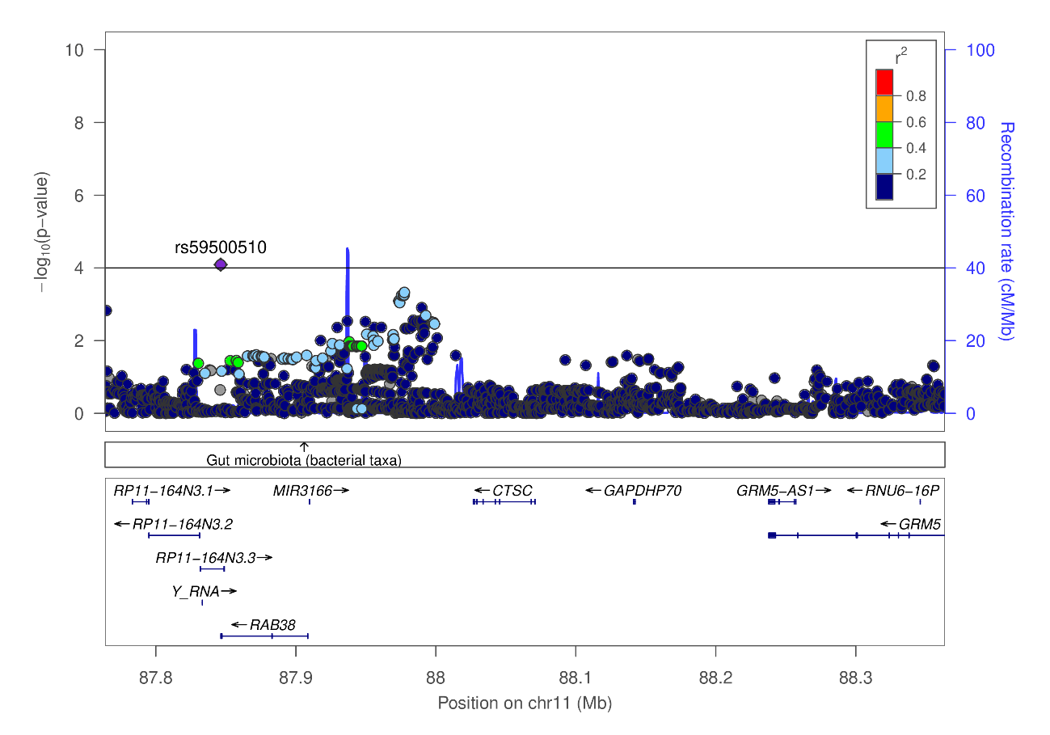
Supplemental Figure 1. Regional association plot of CTSC. P-values are based on imputed genotypes of 896 stage III-IV, grade C PD cases (18-35 years of age) and 7,104 controls.

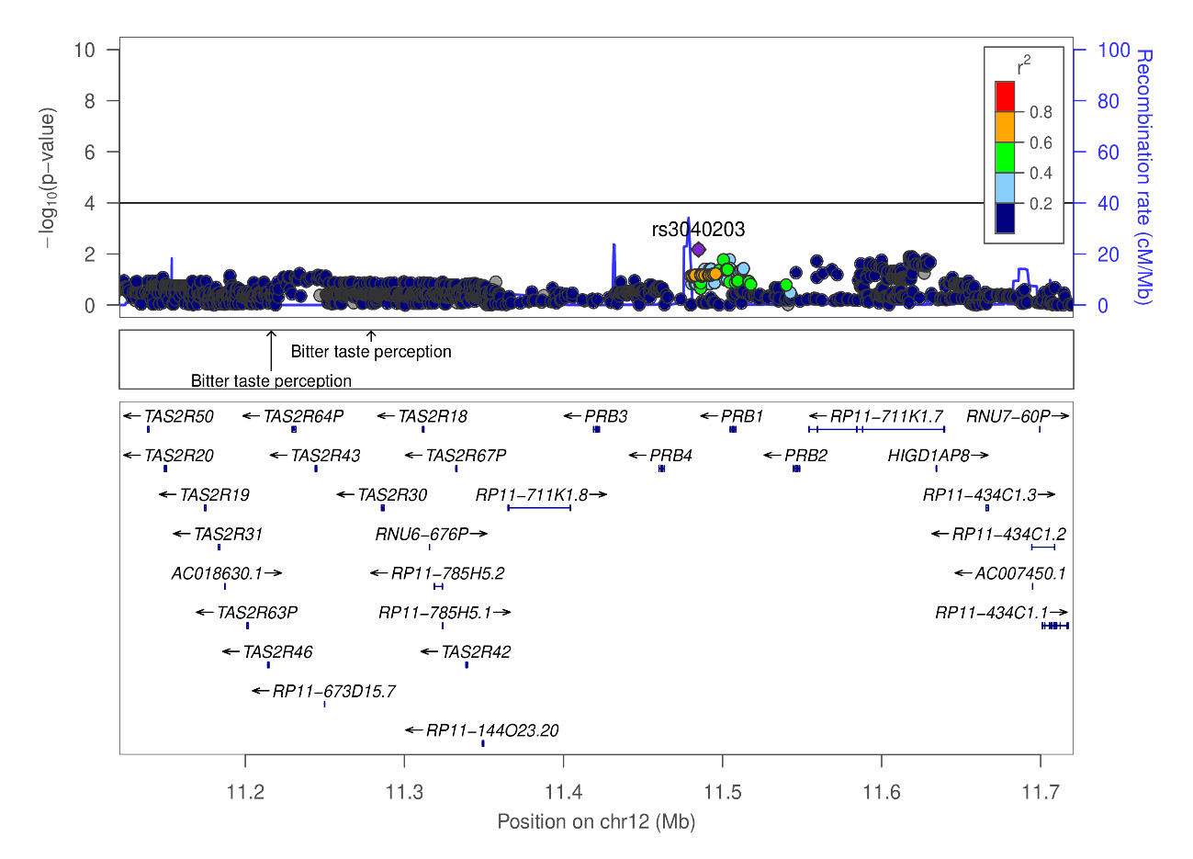
Supplemental Figure 2. Regional association plot of PRB3. P-values are based on imputed genotypes of 896 stage III-IV, grade C PD cases (18-35 years of age) and 7,104 controls.
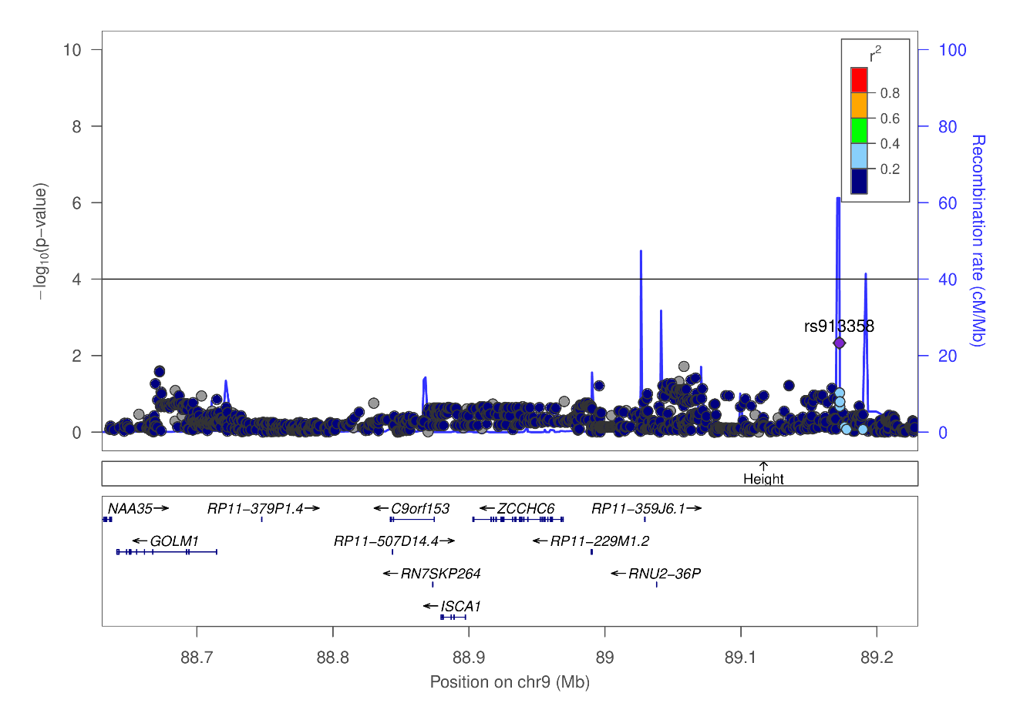
Supplemental Figure 3. Regional association plot of TUT7/ZCCHC6. P-values are based on imputed genotypes of 896 stage III-IV, grade C PD cases (18-35 years of age) and 7,104 controls.

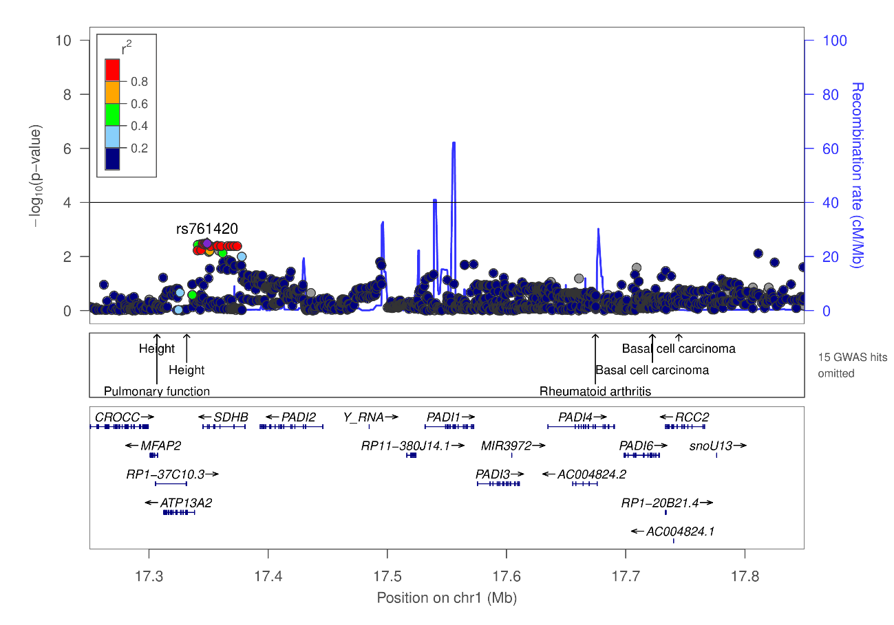
Supplemental Figure 4. Regional association plot of PADI1. P-values are based on imputed genotypes of 896 stage III-IV, grade C PD cases (18-35 years of age) and 7,104 controls.
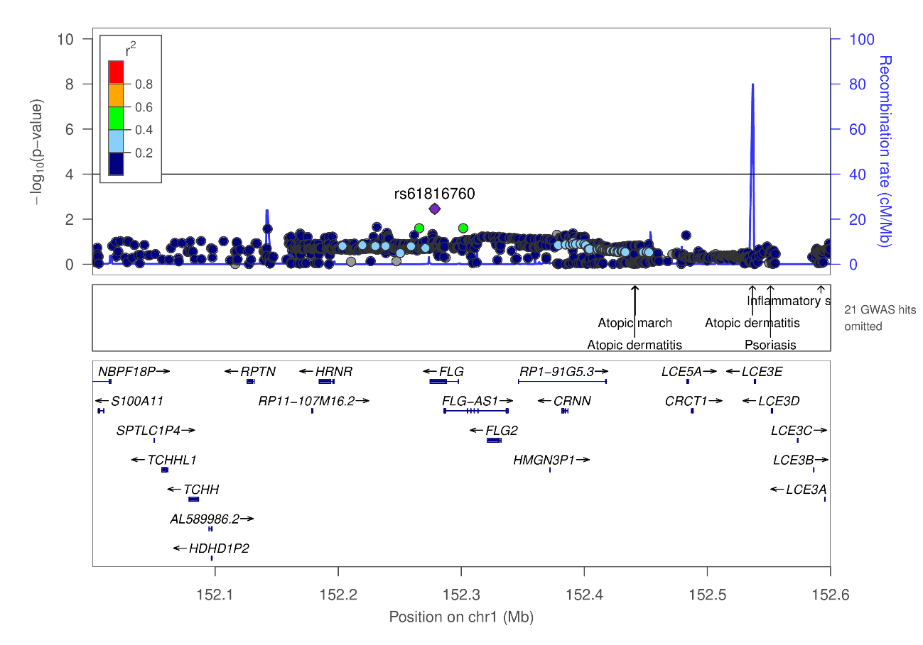
Supplemental Figure 5. Regional association plot of FLG. P-values are based on imputed genotypes of 896 stage III-IV, grade C PD cases (18-35 years of age) and 7,104 controls.

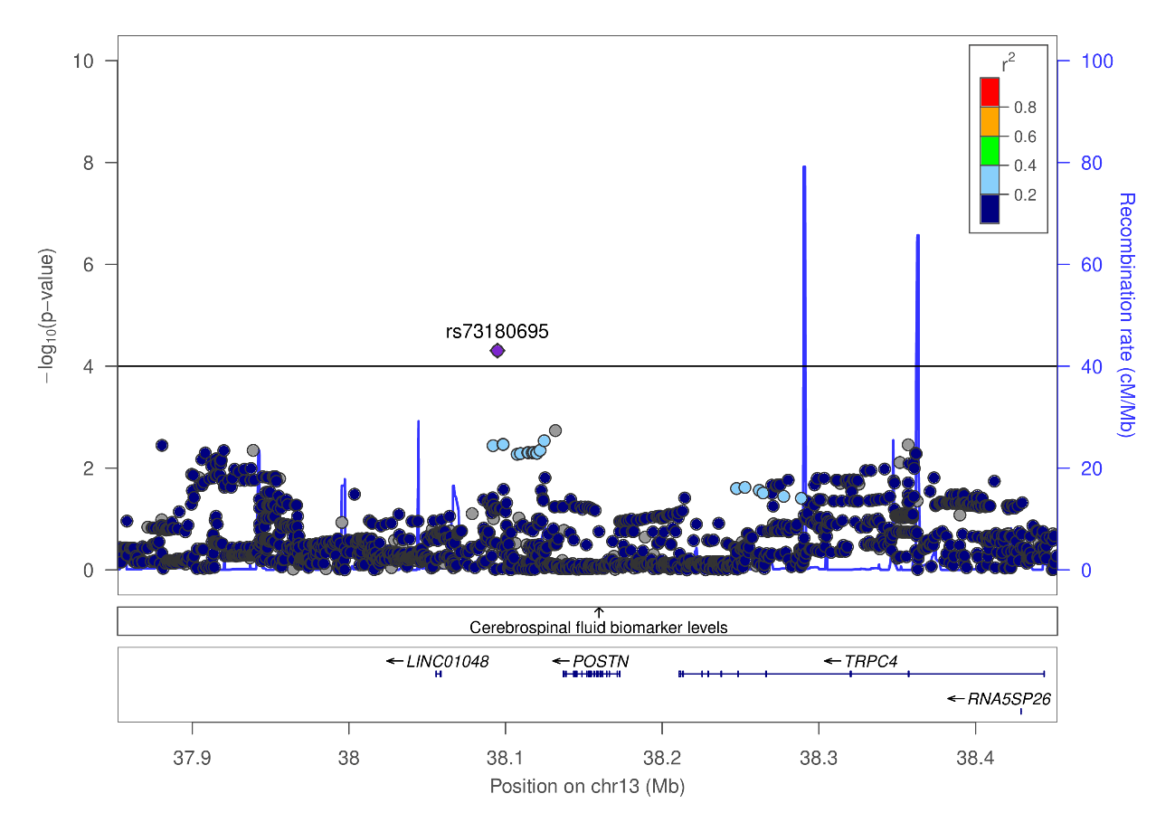
Supplemental Figure 6. Regional association plot of POSTN. P-values are based on imputed genotypes of 896 stage III-IV, grade C PD cases (18-35 years of age) and 7,104 controls.

Clinical characteristics of patients
Family 1. The father (non-smoker) and mother (smoker) had no PD or other diseases. The sister suffered from prepubertal PD (PPP) at the age of five and received periodontal therapy, after which she had not been showing symptoms of PPP and no symptoms of adolescent PD until 21 years of age. The daughter is two years older than her brother, who was diagnosed with PD stage IV, grade C at the age of 19 years. She started cigarette smoking at the age of 19, while the brother started smoking at the age of 17. The family reported that the sister of the great-grandfather was edentulous with 20 years of age. This family was recruited at the Department of Conservative Dentistry, Periodontology and Preventive Dentistry, Hanover Medical School, Hanover, Germany
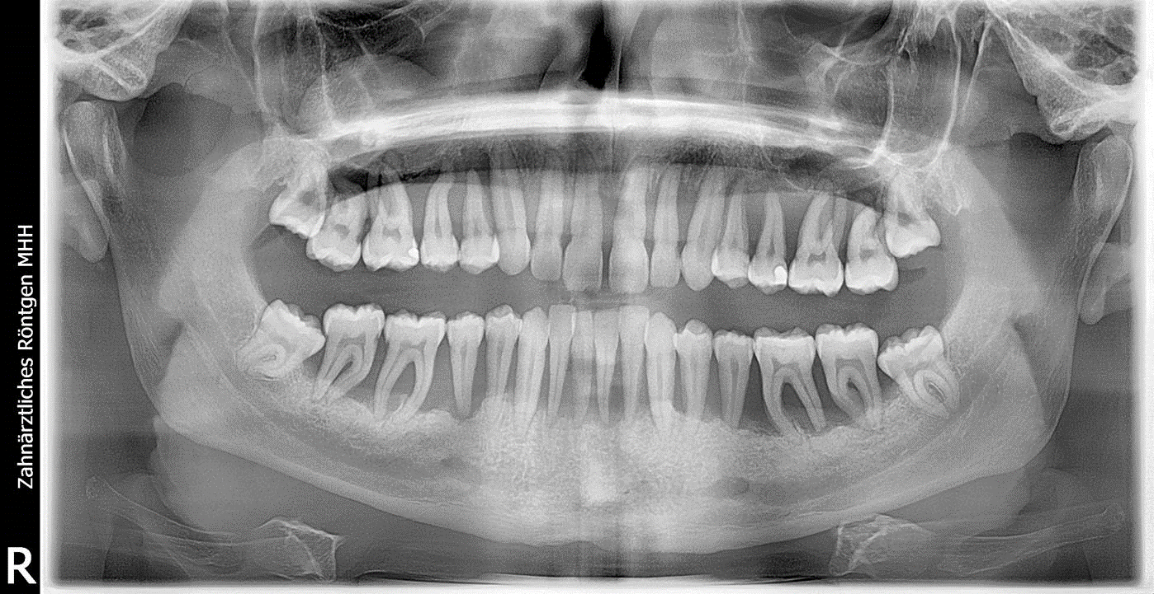
Supplemental Figure 7. Full-mouth radiograph of the son of family 1.

Family 2. The father developed PD stage IV, grade C under the age of 30. The mother developed PD stage III, grade C under the age of 40. Both parents are smokers. Both daughters were non-smokers and developed PD stage III, grade C at the same age (< 17 years). The two father’s brothers self-reported PD that was more moderate than in the father and the two father’s daughters. The grandmother (father’s lineage; grandfather deceased) showed PD stage IV, grade C at the age of 67. The grandparents of the mother’s lineage reported to be edentulous, indicating former PD. All family members gave self-report to be free of other diseases. This family was recruited at the Department of Operative and Conservative Dentistry and Periodontology, University Hospital Tübingen, Germany.
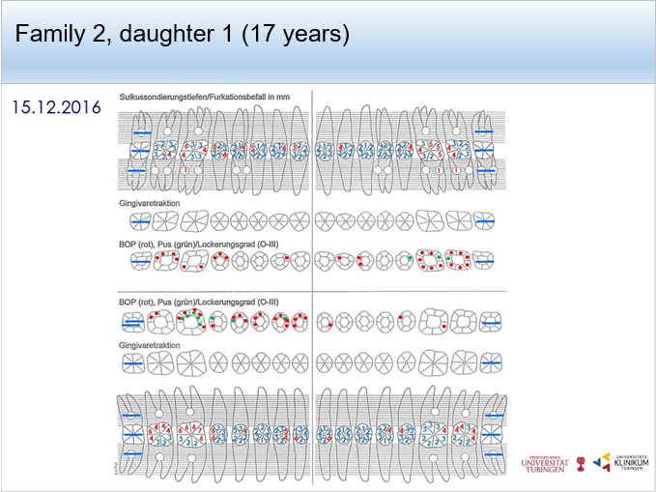

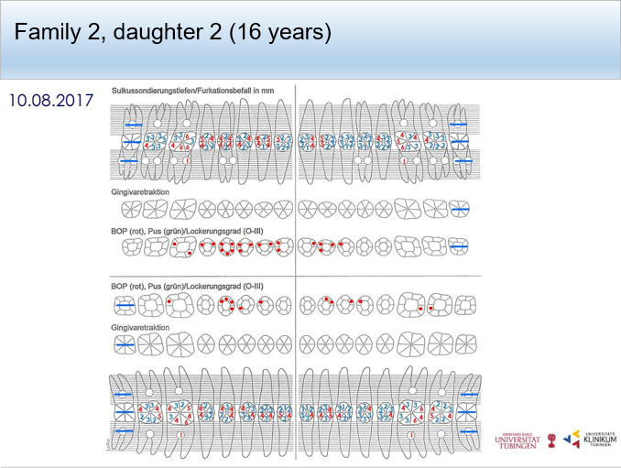
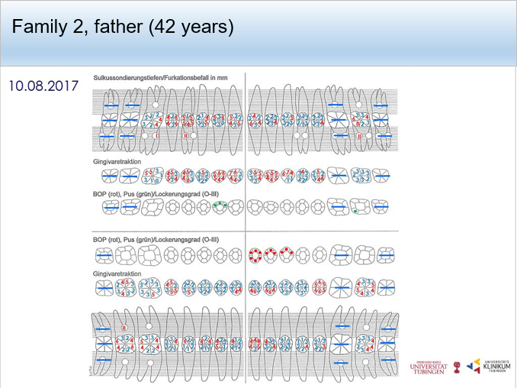

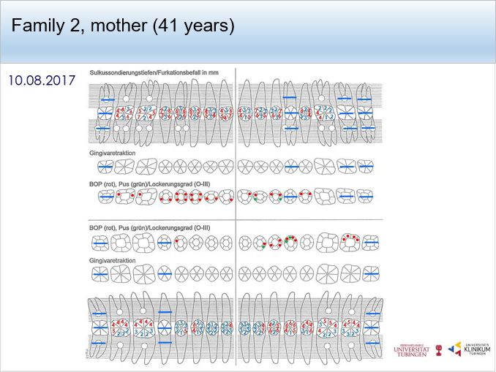
Supplemental Figure 8. Clinical characteristics of Family 2. First and second panel = affected daughters, Third panel = mother, bottom panel = father.

Family 3. The father (non-smoker) had PD stage III, grade B diagnosed at the age of 51. The mother (non-smoker) had PD stage III, grade B diagnosed at the age of 50. The daughter (non-smoker) had PD stage III, grade B diagnosed at the age of 16. The 14-year-old son had no PD. All family members showed no other diseases.
Supplemental Figure 9. Full-mouth radiographs of the children and parents of family 3. First panel = unaffected son, second panel = affected daughter, third panel = affected father, bottom panel = affected mother.

Family 4.The father (smoker) had PD stage IV, grade B diagnosed at the age of 46 with several teeth already missing due to PD. The mother (non-smoker) had PD stage III, grade B diagnosed at the age of 36. Two daughters showed early signs of PD presenting irregular bone loss at the age of 8 and 6. Both daughters received systematic periodontal treatment without any significant clinical improvements. They were diagnosed with PD stage III, grade C at the age of 13 and 14 when participating in this study. The 17-year-old son had no PD. Family 3 and 4 were recruited at the Department of Periodontology, Operative and Preventive Dentistry, University of Bonn, Germany.
Supplemental Figure 10. Full-mouth radiographs of the children and parents of family 4. First panel = affected daughter (age 13), second panel = affected daughter (age 14), third panel = affected mother (no radiographs were available from the affected father and unaffected son).
Family 5. The mother (non-smoker) suffered from leukemia and received bone marrow transplantation before pregnancy. She had no PD or other systemic diseases. The father (non-smoker) was diagnosed with PD stage IV, grade C at the age of 43 and was systemically healthy. The 14-year-old sister was systemically healthy and free of PD. The son had premature loss of deciduous teeth due to extreme mobility at the age of 3 years. At 6 years of age, PPP stage IV, grade C was diagnosed. The family was recruited at the Institute of Periodontology, Dentistry Department, Faculty of Medicine, University of Coimbra, Portugal
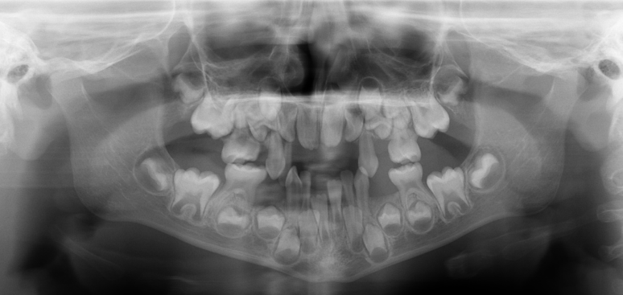
Supplemental Figure 11. Full-mouth radiograph of the affected son of family 5. No radiographs were available from the affected father and the unaffected mother.

