SUPPLEMENTAL DATA

Early-Life Adversity Predicts Markers of Aging-Related Neuroinflammation, Neurodegeneration, and Cognitive Impairment in Women

Lara Fleck, MSc,¹ Claudia Buss, PhD,¹⁻⁴ Martin Bauer, MSc,^{1,5} Maike Stein, MD,⁶⁻⁹ Ralf Mekle, PhD,⁹ Lena Kock, MSc,¹ Heiko Klawitter, MSc,¹ Malvika Godara, PhD,¹ Judith Ramler, MSc,¹ Sonja Entringer, PhD,¹⁻⁴ Matthias Endres, MD,^{3,6,9-12} & Christine Heim, PhD^{1,3,10}

¹Charité – Universitätsmedizin Berlin, corporate member of Freie Universität Berlin and Humboldt-Universität zu Berlin, Institute of Medical Psychology, Berlin, Germany; ²Development, Health, and Disease Research Program, University of California, Irvine, Orange, CA, USA; ³German Center for Mental Health (DZPG), partner site Berlin Potsdam; ⁴German Center for Child and Adolescent Health (DZKJ), partner site Berlin; ⁵Charité – Universitätsmedizin Berlin, Corporate Member of Freie Universität Berlin and Humboldt-Universität zu Berlin, Experimental and Clinical Research Center, Berlin, Germany; ⁶Charité – Universitätsmedizin Berlin, corporate member of Freie Universität Berlin and Humboldt-Universität zu Berlin, Department of Neurology with Experimental Neurology; ⁷Department of Neurology, Beth Israel Deaconess Medical Center, Harvard Medical School, Boston, MA, USA; ⁸Berlin Institute of Health at Charité – Universitätsmedizin Berlin, Digital Health Center, Berlin, Germany; ⁹Charité – Universitätsmedizin Berlin, Center for Stroke Research Berlin, Berlin, Germany; ¹⁰Charité – Universitätsmedizin Berlin, corporate member of Freie Universität Berlin and Humboldt- Universität zu Berlin, NeuroCure Cluster of Excellence, Berlin, Germany; ¹¹German Center for Neurodegenerative Diseases (DZNE), partner site Berlin; ¹²German Center for Cardiovascular Research (DZHK), partner site Berlin

Corresponding Author: Christine Heim, Ph.D., Professor & Chair of the Institute of Medical Psychology, Charité – Universitätsmedizin Berlin, Luisenstr. 57, 10117 Berlin, Germany. Tel: +49 (0) 30 450 529 222; Fax: +49 (0) 30 450 529 990; Email: christine.heim@charite.de
Acknowledgments: Supported by NeuroCure Cluster of Excellence (German Research Foundation – EXC 257) grant to CH and ME and the Neuroscience Clinical Research Center.

Cambridge Neuropsychological Automated Test Battery (CANTAB) Tasks

Cognitive function was assessed using tasks from the prodromal Alzheimer’s disease and mild cognitive impairment test battery. The 3 tasks below were used for analyses (information taken and summarized from https://cambridgecognition.com¹.

Spatial Working Memory (SWM)
Task: Find yellow tokens hidden in colored boxes by selecting and eliminating options. The number of boxes increases up to 12, with colors and positions changing each trial.
Measure (SWMS; -ve sense): Strategy score at the 12-box stage, indicating how often a participant starts their search from the same box. Lower scores indicate better strategy use.

Rapid Visual Information Processing (RVP)
Task: Identify target sequences of digits (e.g., 2-4-6) appearing at 100 digits per minute in a central white box. Respond by pressing a button when the target sequence appears.
Measure (RVPA; +ve sense): Sensitivity to detecting target sequences, reflecting accuracy in identifying the correct sequences.

Pattern Recognition Memory (PRM)
Task: View a series of visual patterns, then choose between previously seen and new patterns in a recognition phase presented in reverse order.
Measure (PRMPCI; +ve sense): Percentage of correctly identified patterns in the immediate forced-choice condition.

Adverse Childhood Experience (ACE) Descriptive Data

Early-life stress was assessed using the German version of the Comprehensive Trauma Interview (CTI)² and events were counted using items corresponding to the Centers for Disease Control definition of Adverse Childhood Experiences (ACE)³ in the CTI. Frequences (SF1), score distributions (SF2), and co-occurrence (SF3) are shown below.

Figure SF1. Adverse Childhood Experience (ACE) Frequencies

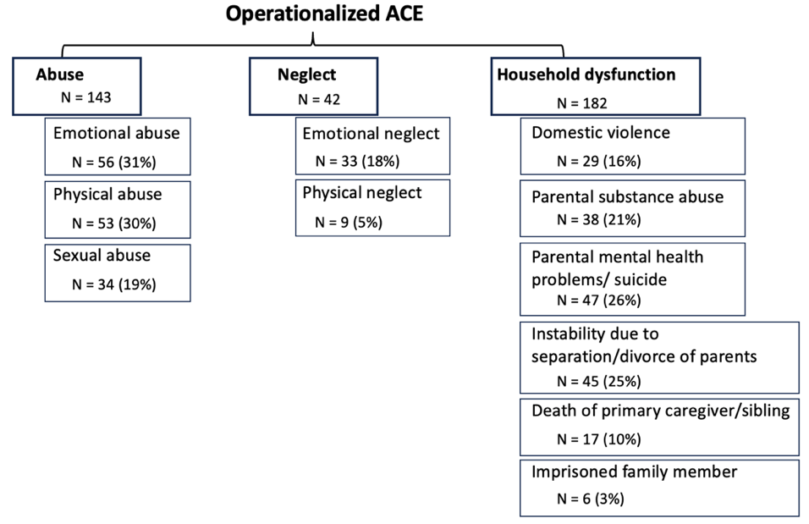
Note. Operational definitions of adverse childhood experiences (ACE). The prevalence is given as the number of women who experienced a specific ACE (N) prior to the onset of menarche and as a percentage of the total number of participants.

Figure SF2. Adverse Childhood Experience (ACE) Score Distribution

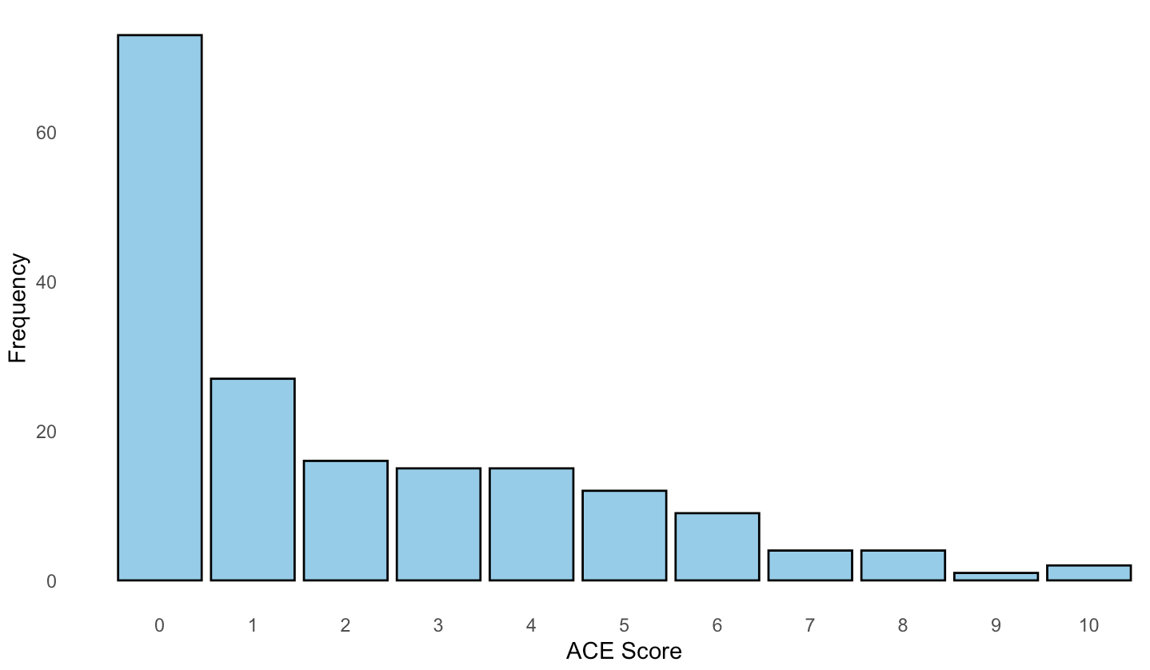
Note. Histogram showing the frequency distribution of participant adverse childhood experience (ACE) scores (calculated for each participant as the sum of the number of experienced stressors before menarche.
Figure SF3. Adverse Childhood Experience (ACE) Co-occurrence
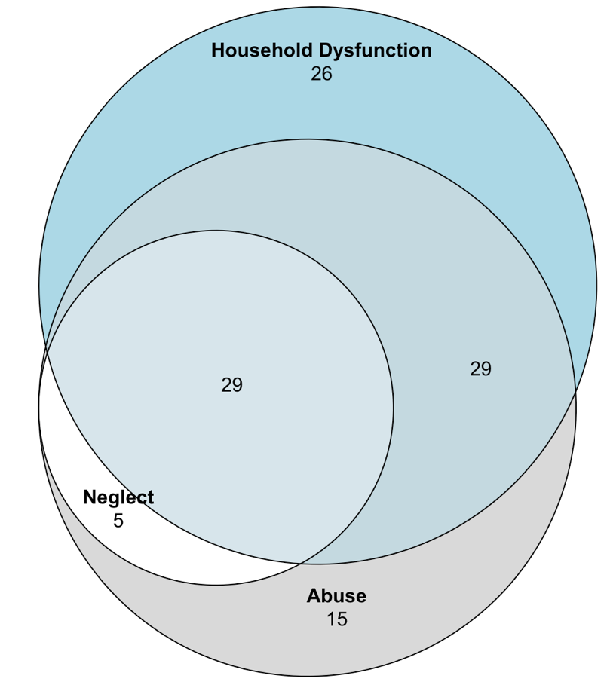
Note. Venn diagram showing overlap between the three sub-types of adverse childhood experience (ACE). Results are given as the number of women who had experienced each sub-type(s) of ACE prior to menarche.
Statistical Analysis

Linear models, with an interaction term between age and adverse childhood experience (ACE) score, were implemented to assess heteroscedasticity and normality (ST1). Generalized additive models (GAMs) were implemented for all DVs to investigate the non-linear interaction effects between ACE score and age in the prediction of outcomes (Model 1). Goodness of fit for Model 1 was tested in comparison to Model 2 which capturs the interaction effect stratified by the levels of age for all DVs. Model fit was assessed using a combination of Akaike Information Criteria, Bayes Information Criteria, residual deviance, and residual degrees of freedom (ST2). Depression severity, state and trait anxiety, posttraumatic stress disorder severity, and SES were integrated as linear covariates into the main model. Bivariate Pearson correlations were conducted between these covariates, age, and ACE scores (ST3). The model performance was compared with and without covariates (ST4).

Table ST1. Linear Model Tests
 | Goldfeld-Quandt test (p value) | Shapiro-Wilk test (p value)
sGFAP | 0.063 | < 0.001
sNfL | 0.013 | < 0.001
sp-tau181 | 0.680 | 0.008
TBV | < 0.001 | < 0.001
tGMV | 0.233 | 0.1353
sGMV | < 0.001 | < 0.001
Left amygdala volume | < 0.001 | 0.001
Right amygdala volume | < 0.001 | < 0.001
tWMV | 0.3823 | 0.008
Lateral ventricular volume | 0.036 | < 0.001
Third ventricular volume | < 0.001 | < 0.001
Fourth ventricular volume | 0.824 | < 0.001
SWMS | 0.016 | < 0.001
RVPA | 0.332 | < 0.001
PRMPCI | 0.189 | < 0.001

Note. DV = dependent variable; sGFAP = serum glial fibrillary acidic protein; sNfL = serum neurofilament light chain; sp-tau181 = serum phosphorylated-tau181; TBV = total brain volume; tGMV = total grey matter volume; sGMV = subcortical grey matter volume; tWMV = total white matter volume; SWMS = spatial working memory strategy; RVPA = rapid visual information processing score; PRMPCI = pattern recognition memory percent correct instant.

Table ST2. Fit Indices of Model 1 and Model 2
 | Model 1 |  |  |  | Model 2
DV | AIC | BIC | Residual deviance | Residual df | AIC | BIC | Residual deviance | Residual df
sGFAP | 185.86 | 208.02 | 27.33 | 162.19 | 187.97 | 204.84 | 28.23 | 164.18
sNfL | 187.87 | 211.35 | 27.52 | 163.73 | 184.00 | 202.06 | 27.46 | 165.78
sp-tau181 | 263.71 | 279.94 | 44.18 | 165.74 | 261.96 | 276.36 | 44.03 | 166.15
TBV | -309.96 | -299.22 | 1.541 | 167 | -311.79 | -309.96 | 1.543 | 168
tGMV | -653.47 | -642.9 | 0.207 | 167 | -655.47 | -653.47 | 0.21 | 168
sGMV | -1275.5 | -1264.1 | 0.005 | 167 | -1276.7 | -1275.5 | 0.005 | 168
tWMV | -814.97 | -804.4 | 0.08 | 167 | -816.97 | -814.97 | 0.08 | 168
Lateral ventricular volume | -1236.2 | -1221.6 | 0.006 | 160.27 | -1238.2 | -1236.2 | 0.007 | 166.3
Third ventricular volume | -2441.8 | -2417.7 | 6.122e-6 | 163.56 | -2437.2 | -2431.8 | 6.013e-6 | 165.3
Fourth ventricular volume | -2227.2 | -2216.2 | 2.0831e-5 | 167 | -2228.8 | -2227.2 | 2.088e-5 | 168
SWMS | 815.34 | 834.75 | 1073.0 | 166.37 | 813.04 | 825.63 | 1085.8 | 169
RVPA | -524.07 | -507.82 | 0.461 | 168.77 | -525.60 | -512.98 | 0.464 | 170
PRMPCI | 1392.02 | 1411.34 | 25186 | 171.48 | 1389.66 | 1392.02 | 25444 | 174

Note. Model 1: Main model with both non-linear predictors; Model 2: model with non-linear (ACE score) + linear specification (age); DV = dependent variable; AIC = Akaike information criterion; BIC = Bayesian information criterion; df = degrees of freedom; ACE = Adverse Childhood Experience; sGFAP = serum glial fibrillary acidic protein; sNfL = serum neurofilament light chain; sp-tau181 = serum phosphorylated-tau181; TBV = total brain volume; tGMV = total grey matter volume; sGMV = subcortical grey matter volume; tWMV = total white matter volume; SWMS = spatial working memory strategy; RVPA = rapid visual information processing score; PRMPCI = pattern recognition memory percent correct instant.

Table ST3. Correlation Table Between Age, ACE scores, and Covariates (psychopathology & SES)

 | Age | ACE score | BDI-II score | STAI-trait score | STAI-state score | DSM-IV PTSD  score
ACE score | 0.077
BDI-II score | 0.058 | 0.512**
STAI-trait score | -0.028 | 0.471** | 0.871**
STAI-state score | -0.005 | 0.490** | 0.788** | 0.828**
DSM-IV PTSD score | 0.129 | 0.498** | 0.692** | 0.603** | 0.561**
SES | -0.207** | -0.295** | -0.267** | -0.151* | -0.172* | -0.267**

Note. Pearson r; ACE = Adverse Childhood Experience; BDI-II = Beck’s Depression Inventory; STAI = State-Trait-Anxiety Inventory; DSM-IV PTSD = Diagnostic and Statistical Manual of Mental Disorders Posttraumatic Stress Disorder; SES = current socioeconomic status; ** p < 0.01.

Table ST4. Estimates and p Values for Main Model with and without Covariates
DV | Covariate | Coefficient estimate (Model 1) | p value  (Model 1) | Coefficient estimate (Model 3) | p value  (Model 3)
sGFAP | Interaction | 4.346 | 0.012 | 4.11 | 0.021
 | BDI-II |  |  | 0.004 | 0.528
 | STAI-trait |  |  | < 0.001 | 0.361
 | STAI-state |  |  | -0.005 | 0.923
 | PTSD |  |  | < 0.001 | 0.988
 | SES |  |  | < 0.001 | 0.987
sNfL | Interaction | 4.674 | < 0.001 | 4.566 | < 0.001
 | BDI-II |  |  | -0.017 | 0.039
 | STAI-trait |  |  | 0.010 | 0.796
 | STAI-state |  |  | < 0.001 | 0.054
 | PTSD |  |  | 0.010 | 0.281
 | SES |  |  | 0.051 | 0.095
sp-tau181 | Interaction | 3.089 | 0.948 | 3 | 0.945
 | BDI-II |  |  | -0.022 | 0.017
 | STAI-trait |  |  | 0.007 | 0.426
 | STAI-state |  |  | 0.005 | 0.260
 | PTSD |  |  | 0.022 | 0.072
 | SES |  |  | 0.009 | 0.824
TBV | Interaction | 3 | 0.006 | 3 | 0.007
 | BDI-II |  |  | 0.002 | 0.190
 | STAI-trait |  |  | < 0.001 | 0.754
 | STAI-state |  |  | < 0.001 | 0.433
 | PTSD |  |  | -0.044 | 0.060
 | SES |  |  | -0.006 | 0.396
tGMV | Interaction | 3 | 0.001 | 3 | < 0.001
 | BDI-II |  |  | < 0.001 | 0.834
 | STAI-trait |  |  | < 0.001 | 0.606
 | STAI-state |  |  | < 0.001 | 0.482
 | PTSD |  |  | < -0.001 | 0.422
 | SES |  |  | < 0.004 | 0.171
DV | Covariate | Coefficient estimate (Model 1) | p value  (Model 1) | Coefficient estimate (Model 3) | p value  (Model 3)
tWMV | Interaction | 3.002 | 0.117 | 3.001 | 0.157
 | BDI-II |  |  | < 0.001 | 0.073
 | STAI-trait |  |  | < -0.001 | 0.437
 | STAI-state |  |  | < -0.001 | 0.886
 | PTSD |  |  | < -0.001 | 0.325
 | SES |  |  | < 0.001 | 0.429
sGMV | Interaction | 3.001 | 0.049 | 3 | 0.030
 | BDI-II |  |  | < -0.001 | 0.646
 | STAI-trait |  |  | < 0.001 | 0.723
 | STAI-state |  |  | < 0.001 | 0.387
 | PTSD |  |  | < -0.001 | 0.496
 | SES |  |  | < -0.001 | 0.173
Lateral ventricular volume | Interaction | 6.164 | 0.129 | 5.706 | 0.183
 | BDI-II |  |  | < -0.001 | 0.294
 | STAI-trait |  |  | < 0.001 | 0.756
 | STAI-state |  |  | < -0.001 | 0.556
 | PTSD |  |  | < 0.001 | 0.467
 | SES |  |  | < -0.001 | 0.616
Third ventricular volume | Interaction | 4.367 | 0.001 | 3.519 | 0.002
 | BDI-II |  |  | < 0.001 | 0.786
 | STAI-trait |  |  | < -0.001 | 0.597
 | STAI-state |  |  | < -0.001 | 0.794
 | PTSD |  |  | < 0.001 | 0.462
 | SES |  |  | < 0.001 | 0.262
Fourth ventricular volume | Interaction | 3.002 | 0.257 | 3.003 | 0.193
 | BDI-II |  |  | < 0.001 | 0.738
 | STAI-trait |  |  | < 0.001 | 0.479
 | STAI-state |  |  | < -0.001 | 0.042
 | PTSD |  |  | < -0.001 | 0.366
 | SES |  |  | < -0.001 | 0.076
DV | Covariate | Coefficient estimate (Model 1) | p value  (Model 1) | Coefficient estimate (Model 3) | p value  (Model 3)
SWMS | Interaction | 3.706 | 0.003 | 3.69 | 0.008
 | BDI-II |  |  | 0.011 | 0.984
 | STAI-trait |  |  | 0.01 | 0.778
 | STAI-state |  |  | 0.004 | 0.746
 | PTSD |  |  | -0.043 | 0.441
 | SES |  |  | -0.241 | 0.203
RVPA | Interaction | 3.079 | 0.024 | 3 | 0.102
 | BDI-II |  |  | <0.001 | 0.720
 | STAI-trait |  |  | <0.001 | 0.591
 | STAI-state |  |  | <0.001 | 0.255
 | PTSD |  |  | -0.002 | 0.199
 | SES |  |  | 0.014 | <0.001
PRMPCI | Interaction | 3.644 | 0.005 | 3.623 | 0.052
 | BDI-II |  |  | -0.131 | 0.944
 | STAI-trait |  |  | 0.021 | 0.915
 | STAI-state |  |  | 0.088 | 0.906
 | PTSD |  |  | 0.059 | 0.693
 | SES |  |  | 2.730 | 0.002

Note. Model 1: Main model with both non-linear predictors; Model 3: main model with both non-linear predictors and linear covariates; sGFAP = serum glial fibrillary acidic protein; sNfL= serum neurofilament light chain; sp-tau181 = serum phosphorylated tau 181; TBV = total brain volume; tGMV = total grey matter volume; sGMV = subcortical grey matter volume; tWMV = total white matter volume; SWMS = spatial working memory strategy; RVPA = rapid visual information processing score; PRMPCI = pattern recognition memory percent correct instant; BDI-II = Beck’s Depression Inventory; STAI = State-Trait-Anxiety Inventory, DSM-IV PTSD = Diagnostic and Statistical Manual of Mental Disorders Posttraumatic Stress Disorder; SES = current socioeconomic status; p values for Model 3 were not adjusted as this was an exploratory sensitivity analysis.

Supplementary Analysis: Age at Menarche Onset

M=12.98 years, SD=1.27

We examined the relationship between age at menarche onset and ACE score using Pearson correlation (r=-0.03; p=0.65). Further, we computed correlations between age at menarche onset and all dependent variables and all were non-significant (p>0.05).

Table ST5: Correlation Table Between Outcomes and Age at Menarche Onset
DV | Correlation between DV and age at menarche; r (p value)
sGFAP | -0.06 (0.44)
sNfL | 0.10 (0.20)
sp-tau181 | 0.09 (0.23)
TBV | 0.10 (0.22)
tGMV | 0.06 (0.47)
sGMV | 0.03 (0.68)
tWMV | 0.15 (0.06)
Lateral ventricular volume | -0.14 (0.06)
Third ventricular volume | -0.12 (0.12)
Fourth ventricular volume | -0.03 (0.63)
SWMS | 0.02 (0.77)
RVPA | -0.14 (0.06)
PRMPCI | -0.01 (0.88)

Note. Pearson r; DV = dependent variable; sGFAP = serum glial fibrillary acidic protein; sNfL= serum neurofilament light chain; sp-tau181 = serum phosphorylated tau 181; TBV = total brain volume; tGMV = total grey matter volume; sGMV = subcortical grey matter volume; tWMV = total white matter volume; SWMS = spatial working memory strategy; RVPA = rapid visual information processing score; PRMPCI = pattern recognition memory percent correct instant.

REFERENCES:

1 CANTAB®. (ed Cambridge Cognition Ltd.) (Cambridge, UK, 2016).
2 Shenk, C. E. et al. Psychometric Evaluation of the Comprehensive Trauma Interview PTSD Symptoms Scale Following Exposure to Child Maltreatment. Child Maltreat 21, 343-352 (2016). https://doi.org/10.1177/1077559516669253
3 Edwards, V. J., Holden, G. W., Felitti, V. J. & Anda, R. F. Relationship between multiple forms of childhood maltreatment and adult mental health in community respondents: results from the adverse childhood experiences study. Am J Psychiatry 160, 1453-1460 (2003). https://doi.org/10.1176/appi.ajp.160.8.1453

