**Supplementary Online Content**

**Brain lesion characteristics in Chinese multiple sclerosis patients: a 7T-MRI cohort study**

**Table of Contents**

**Section 1. MRI acquisition parameters 02**

**Section 2. Image Analysis 03**

2.1 Lesion identification 05

2.2 Lesion characterization 09

**Section 3. Literature review of lesion characteristics in MS with 7T-MRI 10**

3.1 Literature review of cortical lesions characteristics in MS with 7T-MRI 11

3.2 Literature review of central vein sign characteristics in MS with 7T-MRI 15

3.3 Literature review of paramagnetic rim lesion characteristics in MS with 7T-MRI 17

3.4 Comparison of lesion characteristics from Chinese MS cohort and other 7T-MRI study …………….20

3.5 Literature review of MS lesion characteristics from other 7T-MRI study 21

**Section 1. MRI acquisition parameters**

All participants underwent 7T MR system (MAGNETOM Terra, Siemens Healthcare, Erlangen, Germany) using a 32- channel Rx/8Tx head-coil (Nova Medical, Wilmington, Massachusetts, USA) 7T MAGNETOM Terra scanner (Siemens, Erlangen, Germany), using an 32-channel, phased array coil. The scanning procedure consisted of 3D magnetization-prepared rapid acquisition gradient echoes (T1-MPRAGE) sequence to cover the whole brain, fluid-attenuated inversion recovery (FLAIR), susceptibility weighted imaging (SWI), and multi-echo T2*-weighted spoiled gradient echo sequences (T2*WI) to cover the whole brain. FLuid And White matter Suppression (FLAWS) based on the magnetization-prepared with two rapid gradient echoes (MP2RAGE) sequence (FLAWS-MP2RAGE) was adopted for better detecting lesions.

**Supplementary Table 1. MRI acquisition parameters.**

|  |  |  |  |  |  |
| --- | --- | --- | --- | --- | --- |
|  | **T1-MPRAGE** | **FLAIR** | **SWI** | **T2*WI** | **FLAWS** |
| **TR/TE/TI (ms)** | 2200/3.0/1050 | 6600/95/2200 | 19/12/-- | 2500/10, 20, 30/-- | 5000/1.44/700,1700 |
| **Matrix** | 320 x 320 | 336 x 235 | 640 x 640 | 800 x 700 | 256 x 256 |
| **Slices** | 256 | 52 | 120 | 56 | 256 |
| **Voxel Size (mm3)** | 0.7 x 0.7 x 0.7 | 0.3 × 0.3 × 2.0 | 0.1 × 0.1 × 1.2 | 0.1 × 0.1 × 1.2 | 0.75 × 0.75 × 0.75 |
| **Acquisition Time (min: sec)** | 6:29 | 5:18 | 7:45 | 9:34 | 8:52 |

**Section 2. Image Analysis**

This section is the criteria for identifying and classifying lesions. Two experienced neurologists L. Su (8 years) and C.Y. Gao (6 years) are trained according to this criterion. When the interrater reliability reaches 0.8, all MRI images were anonymized for clinical data and analyzed independently, with oversight from a trained neurologist (D-C. Tian, with 11 years experience).

T1-MPRAGE and T2-FLAIR were used to identify lesions. The diameter of the lesion should be at least 3mm. Lesions were marked and segmented manually on T1-MPRAGE image, with simultaneous reference to the T2-FLAIR image. According to the location on T1-MPRAGE, lesions were classified into cortical, juxtacortical, periventricular, and infratentorial lesions. FLAWS showed homogenous WM signal suppression, clear gray matter visualization, which is used for additional visual guidance to determine whether the lesion involves the cortex.

Images were analyzed and labeled in 3D Slicer (Version 4.6.2, https://www.slicer.org/). Images were viewed and lesions were manually demarcated. Lesion volume was calculated automatically based on the manually defined lesion mask and known imaging voxel size.

形状

Supplementary Fig 1. The logic diagram of lesion identification and characterization.

**The method of lesion identification and characterization is as follows (Supplementary Fig 1):**

1. Determine the signal intensity of T1 MPRAGE.

1) Hypointense signal: If T1 MPRAGE was hypointensity, FLAIR and lesion morphology need to be observed.

a. If FLAIR was hyperintense signal, and the lesion does not have a sharp linear shape, the lesion was identified as MS lesion.

b. If FLAIR was isointense signal, and the lesion was hyperintense signal on T2*WI, and the lesion does not have a sharp linear shape, the lesion was identified as MS lesion. If FLAIR was isointense signal, and the lesion was not hyperintense signal on T2*WI, it was not MS lesion1.

c. If FLAIR was hypointense signal, it was not MS lesion.

2) No hypointense signal: If T1 MPRAGE was not hypointense signal, it was not MS lesion.

2. Determine the lesion characterization: Central Vein Sign (CVS) and Paramagnetic Rim Lesion (PRL) and Lesions distribution).

1) Central vein sign was defined in accordance with the North American Imaging in MS Cooperative criteria: The vein had to cross the lesion border at 1 or 2 points and run through the lesion in equidistance to its edges. In ovoid lesions, the vein had to run along or follow the long lesion axis. In patients with a 3-D imaging data set, the central vein had to be visible in at least 2 perpendicular planes2.

2) Paramagnetic rim lesion was defined as “rim-positive” when it showed a hyperintense rim on phase images and

internal isointensity to extralesional white matter3.

3) Determine the characterization of MS lesions distribution (cortical, juxtacortical, periventricular, and infratentorial).

a. Cortical lesions are defined as lesion that involve the cortex.

b. Juxtacortical lesions are defined as lesion abutting the cortex, and not separated from it by white matter.

c. Periventricular lesions are defined as lesion abutting the lateral ventricles without white matter in between.

d. Infratentorial lesions are defined as lesion in the brainstem (typically near the surface), cerebellar peduncles, or cerebellum4.

**References**

1. Duering M, Biessels G. J, Brodtmann A, et al. Neuroimaging standards for research into small vessel disease-advances since 2013. Lancet Neurol. 2023; 22(7): 602-618.

2. Sati P, Oh J, Constable RT, et al. The central vein sign and its clinical evaluation for the diagnosis of multiple sclerosis: a consensus statement from the North American Imaging in Multiple Sclerosis Cooperative. Nat Rev Neurol. 2016; 12(12): 714-722.

3. Absinta M, Sati P, Masuzzo F, et al. Association of Chronic Active Multiple Sclerosis Lesions With Disability In Vivo. JAMA neurology. 2019; 76(12): 1474-1483.

4. Thompson AJ, Banwell BL, Barkhof F, et al. Diagnosis of multiple sclerosis: 2017 revisions of the McDonald criteria. Lancet Neurol. 2017; 17(2): 162-173.

**Step 1 Lesion identification (Determine whether it is MS lesions)**

Determine the signal intensity of T1 MPRAGE

* 1. Hypointense: If T1 MPRAGE was hypointensity, FLAIR and lesion morphology need to be observed.

a. If FLAIR was hyperintense signal, and the lesion does not have a sharp linear shape, the lesion was identified as MS lesion (Supplementary Fig 2).

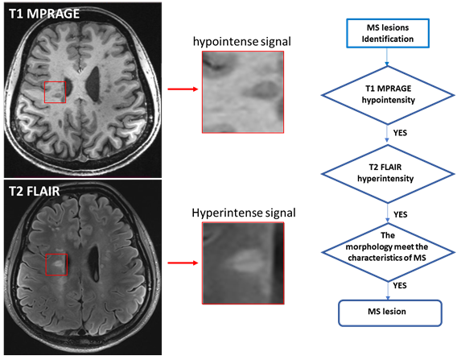

Supplementary Fig 2. Representative image of lesion with T1 hypointensity and FLAIR hyperintensity.

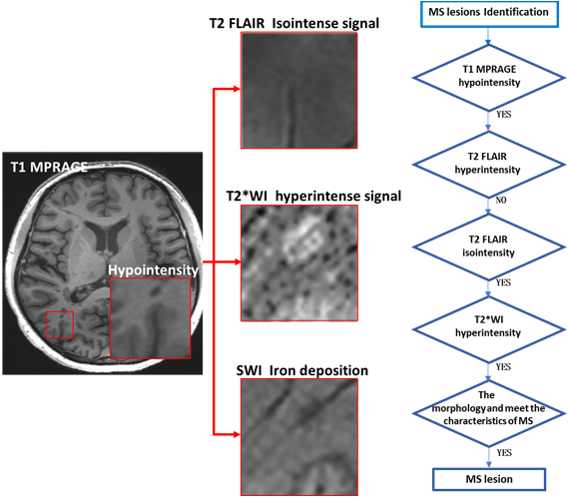

Supplementary Fig 3. Representative image of lesion with T1 hypointensity, FLAIR isointensity and T2*WI hyperintensity.

b. If FLAIR was isointense signal, and the lesion was hyperintense signal on T2*WI, and the lesion does not have a sharp linear shape, the lesion was identified as MS lesion (Supplementary Fig 3). If FLAIR was isointense signal, and the lesion was not hyperintense signal on T2*WI, it was not MS lesion (Supplementary Fig 4).

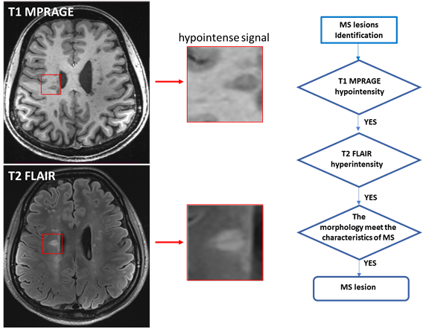

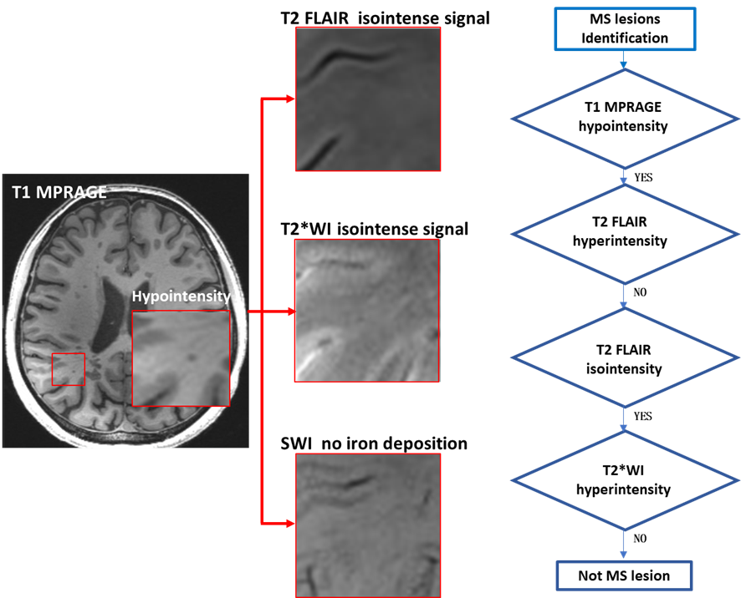

Supplementary Fig 4. Representative image of lesion with T1 hypointensity, FLAIR isointensity and T2*WI isointensity

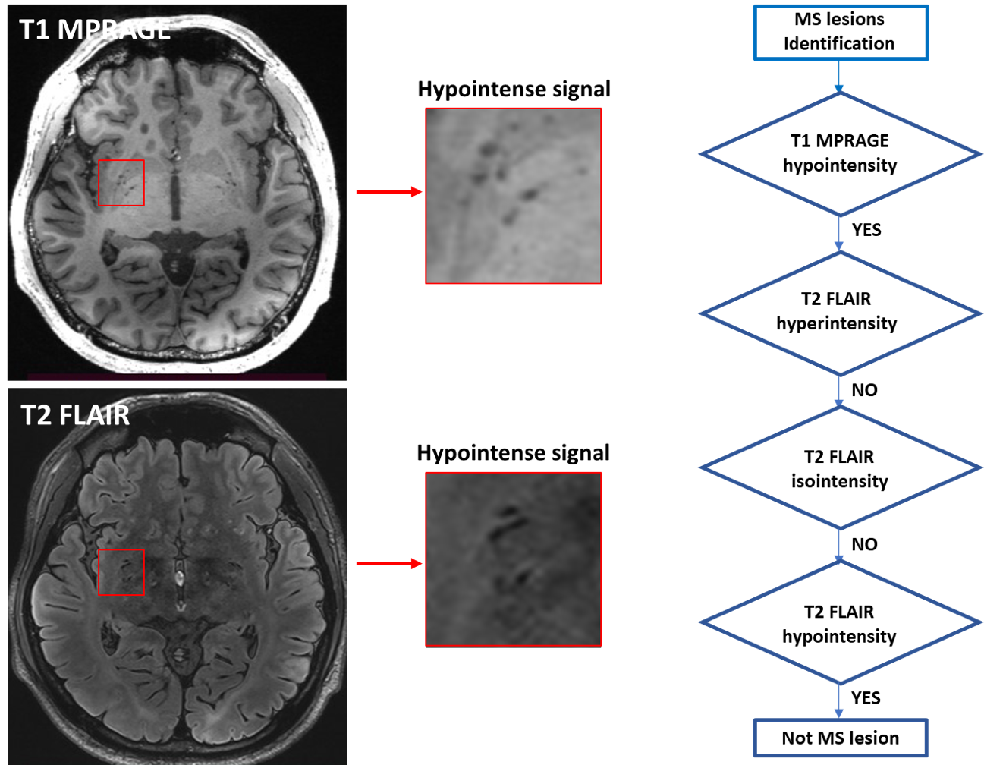Supplementary Fig 5. Representative image of abnormal signal with T1 hypointensity and FLAIR hypointensity.

c. If FLAIR was hypointense signal, it was not MS lesion (Supplementary Fig 5).

* 2. If T1 MPRAGE was not hypointense signal, it was not MS lesion.

**Step 2. Lesion characterization (CVS and PRL and Lesions distribution).**

* 1. Central vein sign was defined in accordance with the North American Imaging in MS Cooperative criteria: The vein had to cross the lesion border at 1 or 2 points and run through the lesion in equidistance to its edges. In ovoid lesions, the vein had to run along or follow the long lesion axis. In patients with a 3-D imaging data set, the central vein had to be visible in at least 2 perpendicular planes (Supplementary Fig 6 A).
* 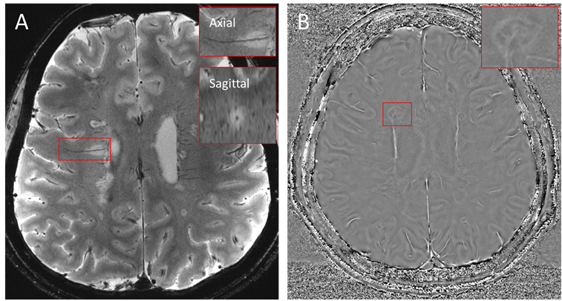2. Paramagnetic rim lesion was defined as “rim-positive” when it showed a hyperintense rim on phase images and internal isointensity to extralesional white matter (Supplementary Fig 6 B).

Supplementary Fig 6. A. A central vessel is visible in most hyperintense lesions on T2*WI. The dark vein are located centrally in the lesion and can be visualized in at least two perpendicular planes (arrows in magnified boxes). B. SWI-phase imaging was acquired showing representative paramagnetic rim lesion (magnified views are in the insets).

* 3. Determine the characterization of MS lesions distribution (cortical, juxtacortical, periventricular, and infratentorial).

a. Cortical lesions are defined as lesion that involve the cortex.

b. Juxtacortical lesion are defined as lesion abutting the cortex, and not separated from it by white matter.

c. Periventricular lesions are defined as lesion abutting the lateral ventricles without white matter in between.

d. Infratentorial lesion are defined as lesion in the brainstem (typically near the surface), cerebellar peduncles, or cerebellum.

**Section 3. Literature review of brain lesion characteristics in MS with 7T-MRI study**

To retrieve all relevant publications, we combined the search terms “Multiple Sclerosis” OR “MS” AND “7T” OR “7-T” OR “7 T” OR “7Tesla” OR “7-Tesla” OR “7 Tesla” OR “7.0-T*” OR “ultra-high field” in PubMed. The time-period covered in the search included all peer-reviewed publications up until June 30th, 2023. Two readers (L. Su and MT. Zhang) independently screened the abstracts of all identified publications. Studies that fulfilled the following criteria were included: 1) peer-reviewed, original articles written in English; 2) a study population including human patients diagnosed with MS; 3) investigation of lesions characteristics using 7T-MRI; 4) provided data allowing for the calculation of patient-level prevalence and/or lesion-level prevalence of cortical lesions or positive CVS lesions or paramagnetic rimlesions. Review articles, commentaries and case reports were excluded prior to full-text assessment.

The primary outcomes for this summary included the patient-level prevalence and the lesion-level prevalence of cortical lesions and central vein sign and chronic active lesions (patient-level prevalence was defined as the proportion of patients with cortical lesions or positive CVS lesions or paramagnetic rim lesions, while lesion-level prevalence was defined as the proportion of total lesions identified as cortical lesions or positive CVS lesions or paramagnetic rim lesions). Data on which were extracted by L. Su and reviewedby D-C Tian. Further data extracted include those pertaining to: (a) background characteristics (author/s, year of publication); (b) imaging parameters (scanner manufacturer, MRI sequence and MRI parameter).

A total of 9617 articles were screened by title and abstract. Excluding animal studies, non-MS studies, non-7T-MRI studies, non-quantitative studies, thirty-four studies included to obtain the prevalence of cortical lesion at lesion-level and patient-level, nineteen publications used to evaluate the prevalence of positive CVS lesions at lesion-level and patient-level, and 29 studies included to analyze the prevalence of paramagnetic rim lesions at lesion-level and patient-level.

**Supplementary Table 2. Summary of cortical lesion in multiple sclerosis with 7T-MRI**

|  |  |  |  |  |  |  |  |  |  |  |  |  |  |  |  |  |
| --- | --- | --- | --- | --- | --- | --- | --- | --- | --- | --- | --- | --- | --- | --- | --- | --- |
| Study | Vendor | Segmentation sequence | Resolution | Segmentation area | Patients enrolled, n | Patient-level prevalence | Lesion-level prevalence | Age(years) | Female (%) | Disease Duration (years) | DMT n (%) | CIS n (%) | RRMS n (%) | PMS n (%) | EDSS | Ethnicity n (%) |
| Abdel-Fahim et al. 2014 | Philips | MTR | 0.5x0.5x1.0 | whole brain | 18 | 100% | NA | 48 (32–65) | 67 | 7.2(2–19) | NA | 0 | 16 (89) | 2 (11) | 3.0 (0–7.5) | NA |
| Barletta et al. 2021 | Siemens | T2* WI | 0.33 x 0.33 x 1 | supratentorial whole brain | 25 | 80% | NA | 38.2±8.9 | 84 | 1.9(0.6-4.7) | 22(88) | NA | NA | NA | 2(0-4) | NA |
| T1-MP2RAGE | 0.75 iso |
| Beck et al. 2018 | Siemens | T1-MP2RAGE | 0.5 iso | whole brain | 13 | 100% | NA | 54±10 | 62 | 24±11 | NA | 0 | 9(69) | 4(31) | NA (1-7) | NA |
| T2*WI | 0.215x0.215x1 |
| T2*WI | 0.5 iso |
| Beck et al. 2020 | Siemens | T1-MP2RAGE | 0.5 iso | whole brain | 10 | 100% | NA | 48±NA | 70 | 9±NA | NA | 0 | 8(80) | 2(20) | 2(0-6.5) | NA |
| T2*WI | 0.5 iso |
| Beck et al. 2022 | Siemens | T1-MP2RAGE | 0.5 iso | whole brain | 64 | 94% | NA | NA (29-77) | 63 | NA(0-42) | 51(80) | 0 | 45(70) | 19(30) | NA (0-7.5) | NA |
| T2*WI | 0.5 iso |
| SWI | 0.5 iso |
| Behrens et al. 2018 | Siemens | T2*-FLASH | 0.5x0.5x2.0 | supratentorial whole brain whole brain | 10 | 20% | 3% | 31.7±NA | 90 | 2.6±NA | NA | 0 | 10(100) | 0 | 1.5(0-2) | NA |
| T1-MPRAGE | 1.0 iso |
| FLAIR | 1.0 iso |
| Bian et al. 2016 | GE | T2* SPGR | 0.47x0.47x1.0 | supratentorial | 14 | 64% | 20% | 41.5(30-58) | 64 | 6(1-25) | 12(86) | 0 | 13(93) | 1(7) | NA | NA |
| T1 WM-Nulled MPRAGE | 1.0 iso |
| T1 CSF-Nulled MPRAGE | 0.8 iso |
| T2 MPFLAIR | 0.8 iso |  |  |  |  |  |  |  |  |  |  |  |  |  |  |
| Bluestein et al. 2012 | Philips | WHAT | 0.38x0.38x0.7 | — | 8 | 100% | NA | NA | NA | NA | NA | 0 | 4(50) | 4(50) | NA | NA |
| Conti et al. 2023 | NA | T2*-FLASH | 0.33x0.3x1 | NA | 100 | 96% | 27% | 43±10 | 76 | NA | NA | 0 | 76(76) | 24(24) | NA | NA |
| Datta et al. 2017 | Siemens | T1-MP2RAGE | 0.7iso | whole brain | 8 | 100% | NA | 20(16-25) | 38 | 4.95(0.5-10) | NA | 0 | 8(100) | 0(0) | 1.75(0-3.5) | NA |
| T2*WI | 0.2x0.2x1.0 |
| de Graaf et al. 2012 | Philips | T2-FLAIR | 0.45x0.45x0.4 | supratentorial brain | 10 | NA | 22% | NA (43-53) | 70 | NA | NA | NA | NA | NA | 4.5(3.5-7.5) | NA |
| DIR | 0.5x0.5x0.4 |
| T1-MPRAGE | 0.5x0.5x0.4 |
| PD | 0.45x0.45x2.0 |
| de Graaf et al. 2013 | Philips | T1WI | 0.5×0.5×0.4 | supratentorial brain | 38 | NA | 8% | 44.2±8.2 | 63 | NA | NA | 0 | 21 (55) | 16 (42) | 4 (0-7.5) | NA |
| T2WI | 0.45x0.45x2.0 |
| FLAIR | 0.49×0.49×0.4 |
| Fartaria et al. 2019 | Siemens | T1-MP2RAGE | Dataset A: 0.7iso Dataset B: 0.75x0.75x0.9 | whole brain | 25 | NA | 17% | NA (18-64) | 68 | NA | NA | 0 | 22(88) | 3(12) | 0 | NA |
| Granberg et al. 2017 | Siemens | T2*WI | 0.33x0.33x1.0 | supratentorial brain | 26 | 92% | NA | 39±8.2 | 81 | 2.5±1.4 | 22(84.62) | 0 | 26(100) | 0 | 1.5 (0-4) | NA |
| Harrison et al. 2015 | Philips | T1-MPRAGE | 0.5iso | whole brain | 36 | 97% | NA | 42.6±10 | 56 | 9.8± 7.5 | 28 (78) | 0 | 30 (83) | 6 (17) | 3 (1-6.5) | NA |
| MPFLAIR | 1iso |
| Herranz et al. 2016 | Siemens | T2*WI | 0.33x0.33x1.0 | supratentorial brain | 27 | 74% | NA | 48±10 | 78 | 7 (1-21) | 21 (78) | 0 | 12 (44) | 15 (56) | 4 (1-7.5) | NA |
| Herranz et al. 2020 | Siemens | T1-MPRAGE | 0.6 x 0.6 x 1.5 | whole brain | 19 | 89% | NA | 48±10 | 79 | 13.5(1-40) | 14 (74) | 0 | 9(47) | 10(53) | 4(2-7.5) | NA |
| T2*WI | 0.33x0.33x1.0 |
| Ighani et al. 2019 | Philips | T1-MP2RAGE | 0.7 iso | whole brain | 41 | 100% | NA | 46±11.4 | 66 | 11.4±8.6 | 32 (78) | 0 | 31(76) | 10(24) | 3.0(1-6.5) | NA |
| MPFLAIR | 0.7 x 0.7 x 1.1 |
| Kilsdonk et al. 2013 | Philips | DIR | 1x1x0.8 | supratentorial brain | 37 | NA | 8% | 43.8±8.3 | 68 | NA | NA | 0 | 22(59) | 15(41) | 4(0-7.5) | NA |
| T2-FLAIR | 0.8iso |
| T2WI | 0.7x1x2 |
| T1WI | 0.8iso |
| Kuchling et al. 2014 | Siemens | T2*WI | 0.5 × 0.5 × 2 | supratentorial brain | 18 | 61% | 8% | 46±NA | 33 | 6.4±NA | NA | 0 | 9(50) | 9(50) | NA (1.5-8) | NA |
| Louapre et al. 2015 | Siemens | T2*WI | 0.33x0.33x1.0 | supratentorial brain | 29 | 100% | NA | 44.1±9.2 | 69 | 11.5±7.1 | NA | 0 | 18(62) | 11(38) | 3(1-7) | NA |
| Mainero et al. 2009 | Siemens | T2WI | 0.33x0.33x1.0 | supratentorial brain | 16 | 100% | NA | 38.8±12.4 | 56 | 10.2±7.4 | 15(94) | 0 | 9(56) | 7(44) | 3.0(1-6.5) | NA |
| T2*WI | 0.33x0.33x1.0 |
| Mehndiratta et al. 2020 | Siemens | T2*WI | 0.33x0.33x1.0 | — | 90 | 98% | NA | 42.3±9.2 | 74 | 9.1±9.2 | 71 (79) | 0 | 61(68) | 29(32) | 2.5(8) | Caucasian 87(97) African American 2(2) Asian 1(1) |
| Mistry et al. 2014 | Philips | T1WI | 0.5iso | supratentorial brain | 19 | 95% | NA | 48.6±NA | 63 | 7±NA | NA | 0 | 16(84) | 3(16) | 3(0-7.5) | NA |
| MT | 0.5x0.5x1.0 |
| Mizell et al. 2022 | Philips | T1-MP2RAGE | 0.7x0.688x0.688 | whole brain | 40 | 100% | NA | 47.1±10.6 | 65 | 12±8.7 | 27(67.5) | 0 | 30(75) | 10(25) | 3(1-6.5) | Black/African American 2 (5) White 30 (75) Other 2 (5) Unknown/refused to answer 6 (15) |
| MPFLAIR | 0.7 iso |
| Mougin et al. 2015 | Philips | NPI/PSIR | 0.6iso | Whole brain | 11 | 100% | NA | 48 ± 9 | 73 | NA | NA | 2(18) | 5(46) | 4(36) | NA | NA |
| Saranathan et al. 2014 | GE | MP-FLAIR | 0.8iso | Whole brain | 7 | NA | 8% | 36(29-47) | NA | NA | NA | 0 | 7(100) | 0 | NA | NA |
| Sinnecker et al. 2012(a) | Siemens | T1-MPRAGE | 0.5 x 0.5 x 2 | supratentorial brain | 20 | 50% | 8% | 42±7.8 | 45 | NA(0.5-14.4) | NA | 0 | 20(100) | 0 | 1.5(1.0-4.5) | NA |
| T2*WI | 1.0 iso |
| Sinnecker et al. 2012(b) | Siemens | T1-MPRAGE | 0.5x0.5x1.0 | supratentorial brain | 18 | 39% | 10% | NA (27-53) | 61 | 6.6 ± 5.8 | NA | 0 | 18(100) | 0 | 1.5(1.0-4.0) | NA |
| T2*WI | 1x1x2 |
| Straub et al. 2023 | Siemens | T1-MP2RAGE | 0.5x0.5x0.6 | — | 20 | 100% | 25% | 48.6±8.2 | 45 | 16.5±9.6 | NA | 0 | 12(60) | 8(40) | 4.5 (0-6.5) | NA |
| T2WI | 0.5x0.5x2.0 |
| T2*WI | 1.0x1.0x4.0 |
| SWI | 0.5x0.5x0.6 |
| Treaba et al. 2019 | Siemens | T2*WI | 0.33x0.33x1.0 | supratentorial brain | 31 | 100% | NA | RRMS 41.3±10.5 SPMS 39.9± 8.5 | 74 | RRMS 6.0±6.2 SPMS 19.9± 9.0 | 26(84) | 0 | 20(65) | 11(35) | RRMS  0.9(1-4) SPMS  2(2-6.5) | NA |
| Treaba et al. 2021 | Siemens | T2*WI | 0.33x0.33x1.0 | supratentorial brain | 102 | 96% | NA | 42±9 | 75 | NA | 87(85) | 0 | 76(75) | 26(25) | 2.25(0-8) | NA |
| Treaba et al. 2021 | NA | T2*-GRE | 0.33x0.3x1 | supratentorial | 100 | 96% | NA | RRMS 41±9 SPMS 47± 9 | 76 | RRMS 3(0.1-40) SPMS 19(6-40) | 85(85) | 0 | 74(74) | 26(26) | RRMS 2(0-6) SPMS 4.7(2-8) | NA |
| Zurawski et al. 2019 | Siemens | T1-MP2RAGE | 0.7iso  0.7iso | whole brain | 30 | 97% | NA | 44±11.3 | 67 | NA (1.3-33.1) | 28(93) | 0 | 30(100) | 0(0) | NA (0-5.5) | NA |
| T2*WI |

**Supplementary Table 3. Summary of central vein sign in multiple sclerosis with 7T-MRI.**

|  |  |  |  |  |  |  |  |  |  |  |  |  |  |  |  |  |
| --- | --- | --- | --- | --- | --- | --- | --- | --- | --- | --- | --- | --- | --- | --- | --- | --- |
| Study | Vendor | Segmentation sequence | Resolution | Segmentation area | Patients enrolled, n | Patient-level prevalence | Lesion-level prevalence | Age(years) | Female (%) | Disease Duration (years) | DMT n (%) | CIS n (%) | RRMS n (%) | PMS n (%) | EDSS | Ethnicity n (%) |
| Behrens et al. 2018 | Siemens | T2*-FLASH | 0.5 x 0.5 x 2.0 | Supratentorial | 10 | 100% | 77% | 31.7 ± 6.8 | 90 | 2.6 ± 2.9 | NA | 0 | 10(100) | 0 | 1.5 (0–2) | NA |
| SWI | 0.5 x 0.5 x 1.0 |
| Bozin et al. 2015 | Siemens | T2* WI | 0.5 x 0.5 x 2.0 | White matter lesions with a diameter of at least 5mm | 28 | NA | 93% | NA(19-55) | 39 | 5.75 ± 5.75 | NA | 4(14) | 22(79) | 2(7) | 1.5(0-7) | NA |
| Chawla et al. 2016 | Siemens | T2*WI | 0.2× 0.2× 2.0 | supratentorial brain | 21 | 100% | 66% | 47.1±10.3 | 71 | NA (4-25) | NA | 0 | 19(90) | 2(10) | NA | NA |
| SWI | 0.2× 0.2× 2.0 or 0.5 × 0.5 × 2.0 |
| Chawla et al. 2018 | Siemens | T2*WI | 0.2 × 0.2 × 2 | supratentorial brain | 9 | NA | 70% | NA (36-70.3) | 67 | 15.7±12.4 | 7(77.78) | 0 | 4(44) | 5(56) | 2±NA | Caucasian 4 (44) African American 4 (44) Hispanic 1 (11) |
| SWI | 0.23 × 0.23 × 2 |
| Dixon et al. 2015 | Philips | T2*WI | 0.32 × 0.32 × 0.90 | Whole brain | 3 | 100% | 69% | 44(27-62) | 33 | NA | NA | 0 | 1(33) | 2(67) | 6.0(1.5-6.5) | NA |
| Gaitán et al. 2012 | Siemens | T2*WI | 0.3 x 0.3 x 1 | 15 enhancing lesions | 8 | NA | 73% | RRMS 33±11 SPMS 48 PPMS 51 | 75 | RRMS 3±3 SPMS 21 PPMS 11 | RRMS 2 (33.33%) SPMS 0 PPMS 0 | 0 | 6(75) | 2(25) | RRMS 1.5 (0–3.5) SPMS 5.5 PPMS 6 | NA |
| Grabner et al. 2011 | Siemens | 3.0 T T2-FLAIR | 0.8 x 0.8 x 4 | Whole brain | 10 | 80% | 25% | RRMS NA (20-51) SPMS NA (51-59) | 70 | RRMS NA  (1-6) SPMS NA (11-36) | NA | 0 | 6(60) | 4(40) | RRMS  1.5(1-3) SPMS 6.1(5.5-6.5) | NA |
| 7.0 T SWI | 0.3 x 0.3 x 1.2 |
| Hammond et al. 2008 | GE | T2* WI | 0.35 x 0.35 x 2.0 | — | 19 | NA | 67% | 42.32±12.9 | 68 | 12±7.6 | 12(63) | 0 | 19(100) | 0 | 2.1±1.2 | NA |
| Hosseini et al. 2018 | Agilent | SWI | 0.5 x 0.5 x 1.25 | white matter lesions | 17 | NA | 76% | NA (26-46) | 65 | NA | NA | 0 | 17(100) | 0 | NA (0-6) | NA |
| Kilsdonk et al. 2013 | Philips | T2-FLAIR | 0.8 iso | supratentorial brain | 16 | 100% | 74% | 50(44-58) | 63 | 12(2-22) | NA | 0 | 6(37.5) | 10(62.5) | NA | NA |
| T2* WI | 0.39 × 0.45 × 0.6 |
| Kilsdonk et al. 2014 | Philips | T2-FLAIR | 0.8 iso | Above the cerebellar peduncles | 33 | NA | 78% | 44.2±8.4 | 61 | 9.6±5.9 | NA | 0 | 19(58) | 14(42) | 4.0(0-7.5) | NA |
| T2* WI | 0.39 × 0.45 × 0.6 |
| Kollia et al. 2009 | Siemens | T2*WI | 0.25x 0.25 x 2 | White matter lesions | 12 | 100% | NA | 32(22-47) | 67 | 5(1-10) | NA | 0 | 12(100) | 0 | 2.8(1-3.5) | NA |
| Kuchling et al. 2014 | Siemens | T2*WI | 0.5 × 0.5 × 2 | supratentorial brain | 18 | NA | 79% | 46±NA | 33 | 6.4±NA | NA | 0 | 9(50) | 9(50) | NA (1.5-8) | NA |
| Sinnecker et al. 2012 | Siemens | T2*WI | 0.5 x 0.5 x 2 | supratentorial brain | 18 | 100% | 92% | NA (27-53) | 61 | 6.6 ± 5.8 | NA | 0 | 18(100) | 0 | 1.5(1-4) | NA |
| Sinnecker et al. 2016 | Siemens | T2*WI | 0.5x0.5x2.0 | Supratentorial | 10 | 100% | 83% | NA(26-49) | 50 | NA (0-12) | NA | 0 | 10(100) | 0 | 1.5(0-2.5) | NA |
| Tallantyre et al. 2008 | Philips | T2*WI | 0.67 iso | — | 8 | NA | 82% | NA | 75 | 15.7±NA | NA | 0 | 4(50) | 4(50) | 6(NA) | NA |
| Tallantyre et al. 2011 | Philips | T2*WI | 0.5 iso | white matter lesions | 28 | NA | 80% | 46.5 (24-65) | 43 | 14.2(1-32) | NA | 0 | 12(43) | 16(57) | 5.5(0-6.5) | NA |
| Tallantyre. et al. 2009 | Philips | 3.0 T T2-FLAIR | 1 x 1 x 2.5 | Whole brain | 7 | NA | 82% | 37(24-48) | 57 | 10.7(1.2-25) | NA | 0 | 7(100) | 0 | 2(0-6) | NA |
| 7.0 T T2*WI | 0.5 iso |
| Wuerfel et al. 2012 | Siemens | T2* WI | 0.5 × 0.5 × 2 | white matter lesions | 10 | NA | 92% | 34±6 | 60 | 4.0 ± 4.75 | NA | 0 | 10(100) | 0 | 1.5(NA) | NA |

**Supplementary Table 4. Summary of paramagnetic rim lesion in multiple sclerosis with 7T-MRI**

|  |  |  |  |  |  |  |  |  |  |  |  |  |  |  |  |  |
| --- | --- | --- | --- | --- | --- | --- | --- | --- | --- | --- | --- | --- | --- | --- | --- | --- |
| Study | Vendor | Segmentation sequence | Resolution | Segmentation area | Patients  enrolled, n | Patient-level prevalence | Lesion-level prevalence | Age(years) | Female (%) | Disease Duration (years) | DMT n (%) | CIS n (%) | RRMS n (%) | PMS n (%) | EDSS | Ethnicity n (%) |
| Absinta et al. 2013 | Siemens | T2* WI | 0.2 x 0.2 x 1.0 | supratentorial white matter lesion | 16 | 75% | 10% | NA | NA | 7.8(0.6-20) | NA | 0 | 13(81) | 3(19) | 2(0-6) | NA |
| Absinta et al. 2016 | Siemens | SWI | 0.2 x 0.2 x 1.0 | supratentorial brain | 17 | 88% | 12% | 37(29-62) | 88 | 6(0.2-19) | 9(53) | 0 | 16(94) | 1(6) | 1.5(1-5.5) | NA |
| Absinta et al. 2018 | Siemens | 3.0 T T2*WI | 0.2 x 0.2 x 1 | supratentorial brain | 192 | 56% | NA | NA | 54 | NA | 149(78) | CIS/RR：131(68) | | 61(32) | 2(0-8) | African American (32/209= 15%) |
| 7.0 T T2*WI | 0.65 iso |
| Absinta et al. 2018 | Siemens | T2*WI | 0.2 × 0.2 × 1 | supratentorial brain | 20 | NA | 35% | 46 (28–71) | 75 | 14 (1–40) | 9(45) | 0 | 16 (80) | 4 (20) | 1.5 (0–7) | NA |
| Altokhis et al. 2022 | Philips | T2*WI | 0.5 iso | white matter lesions | 91 | 46% | 9% | 46(18-75) | 58 | 7(0-40) | 27(30) | 22(24) | 34(37) | 35(39) | 4(0-7) | NA |
| Beck et al. 2022 | Siemens | T2*WI | 0.5 iso | whole brain | 64 | 69% | NA | NA (29-77) | 62.5 | NA (0-42) | 51(80) | 0 | 45(70) | 19(30) | NA (0-7.5) | NA |
| SWI | 0.5 iso |
| Bian et al. 2012 | GE | T2*WI | 0.195x0.260x2.0 0.35x0.35x2.0 | 9-18 sections | 5 | 80% | NA | 51±NA | 60 | 17±NA | 5(100) | 0 | 5(100) | 0 | 3.1±NA | NA |
| Chawla et al. 2016 | Siemens | T2*WI | 0.2× 0.2× 2.0 | supratentorial brain | 21 | NA | 10% | 47.1±10.3 | 71 | 11.5±5.9 | NA | 0 | 19(90) | 2(10) | NA | NA |
| SWI | 0.2× 0.2× 2.0 or 0.5 × 0.5 × 2.0 |
| Chawla et al. 2018 | Siemens | T2*WI | 0.2 × 0.2 × 2 | supratentorial brain | 9 | NA | 4%/4% | 48.9(36-72.8) | 78 | 12(7-48) | 7(78) | 0 | 5(56) | 4(44) | 2(1-7) | NA |
| SWI | 0.23 × 0.23 × 2 |
| Choi et al. 2023 | Philips | GRE | 0.7 iso | whole brain | 36 | 58% | NA | 46.7± 10.1 | 64 | 11.6± 9.1 | 27(75) | 0 | 25(69) | 11(31) | 3.0(1-6.5) | NA |
| Conti et al. 2023 | NA | T2*-FLASH | 0.33x0.3x1 | NA | 100 | 63% | 3% | 43±10 | 76 | NA | NA | 0 | 74(74) | 26(26) | NA | NA |
| Croninet al. 2016 | Phillips | T2*WI | 0.5 iso | supratentorial brain | 39 | 26% | 12% | NA | NA | NA | NA | 5(13) | 22(56) | 12(31) | NA | NA |
| Dal-Bianco et al. 2017 | Siemens | SWI | 0.3 x 0.3 x 1.2 | supratentorial white matter lesion | 10 | 88% | 15% | 42 ± 14.5 | 7 | 14 ± 11.9 | NA | 0 | 6 | 4 | 2.5 (0–6.5) | NA |
| Dal-Bianco et al. 2021 | Siemens | SWI | 0.3 × 0.3 × 1.2 | supratentorial brain | 33 | 73% | 14% | 36.6(18.6-62.6) | 52 | 6.4 (0.9-32) | 28(85) | 0 | 30(91) | 3(9) | 1.5(0-6.5) | NA |
| Dal-Bianco et al. 2021 | Siemens | SWI | 0.3×0.3×1.2 | supratentorial | 29 | 72% | 16% | 38(22-69) | 52 | 11 (5-40) | 24(83) | 0 | 24(83) | 5(17) | 2(0-8) | NA |
| Grabner et al. 2011 | Siemens | 3.0 T T2-FLAIR | 0.8 x 0.8 x 4 | whole brain | 10 | 70% | 7% | RRMS NA (20 - 51)  PPMS NA (51 - 59) | 70 | RRMS NA (1 - 6)  PPMS NA (11 - 36) | NA | 0 | 6(60) | 4(40) | NA (5.5-6.5) | NA |
| 7.0 T SWI | 0.3 x 0.3 x 1.2 |
| Hammond et al. 2008 | GE | T2* WI | 0.35 x 0.35 x 2.0 | — | 19 | NA | 8% | 42.32±12.9 | 68 | 12.0±7.6 | NA | 0 | 19(100) | 0 | 2.1±1.2 | NA |
| Harrison et al. 2016 | Philips | T2* WI | 1.0 iso | supratentorial brain | 24 | NA | 16% | 44.3±10.0 | 50 | 11.2±7.6 | 19(79) | 0 | 21(87.5) | 3(12.5) | 3(1.5-6.5) | NA |
| Kilsdonk et al. 2013 | Philips | FLAIR | 0.8 iso | supratentorial brain | 16 | 38% | 6% | 50.4±3.9 | 62.5 | NA | NA | 0 | 6(37.5) | 10(62.5) | NA | NA |
| T2* WI | 0.39 × 0.45 × 0.6 |
| Kilsdonk et al. 2014 | Philips | FLAIR | 0.8 iso | Above the cerebellar peduncles | 33 | 24% | 3% | 44.2±8.4 | 61 | 9.6±5.9 | NA | 0 | 19(58) | 14(42) | NA (0-7.5) | NA |
| T2* WI | 0.39 × 0.45 × 0.6 |
| Kollia et al. 2009 | Siemens | T2*WI | 0.25x 0.25 x 2 | whole brain | 12 | 25% | NA | 32 (22-47) | 8 | 5 (1-10) | NA | 0 | 12 | 0 | 2.8 (1–3.5) | NA |
| Kuchling et al. 2014 | Siemens | T2*WI | 0.5 × 0.5 × 2 | supratentorial brain | 18 | NA | 23% | RRMS 45 ± 5 PPMS 46 ± 7 | RRMS 50 PPMS 50 | RRMS 9.75 ± 6.1  PPMS 8 ± 5.7 | NA | 0 | 9 (50) | 9 (50) | RRMS 2.0 (1.5–4.5) PPMS 5.5 (3.5–8.0) | NA |
| Li et al.2016 | Philips | SWI | 1.0 iso | — | 24 | NA | 14% | Female:44.7±11.3 Male:43.8±9.0 | 50 | NA | NA | 0 | 21(87.5) | 3(12.5) | 3(1.5-6.5) | NA |
| Sinnecker et al. 2012 | Siemens | T2*WI | 0.5 x 0.5 x 2 | supratentorial brain | 18 | NA | 23% | NA (27-53) | 61 | NA (0.58-18) | NA | 0 | 18(100) | 0 | 1.5(1-4) | NA |
| Sinnecker et al. 2016 | Siemens | T2* WI | 0.5 x 0.5 x 2 | Supratentorial | 10 | 90% | 32% | NA (26-49) | 50 | NA (0-12) | NA | 0 | 10(100) | 0 | 1.5(0-2.5) | NA |
| SWI | 0.5 x 0.5 x 1 |
| Treaba et al. 2021 | NA | T2*-GRE | 0.33 x 0.3 x 1 | Supratentorial | 100 | 63% | 3% | RRMS 41±9 SPMS 47± 9 | 76 | RRMS 3(0.1-40)  SPMS 19(6-40) | 85(85) | 0 | 74(74) | 26(26) | RRMS 2(0-6) SPMS 4.7(2-8) | NA |
| Wuerfel et al. 2012 | Siemens | SWI | 0.5 × 0.5 × 2 | white matter lesions | 10 | NA | 41% | 34±10 | 60 | NA (0.5-14.3) | NA | 0 | 10(100) | 0 | 1.5(0-4) | NA |
| Yao et al. 2012 | GE | T2*WI | 0.31 x 0.31 x 0.8 | — | 21 | 48% | 7% | NA (28-60) | 48 | NA (0.1-33) | NA | 0 | 19(90) | 2(10) | NA (0-6) | NA |
| Yao et al. 2015 | GE | T2*WI | 0.31 x 0.31 x 0.8 | — | 15 | 67% | NA | NA (28-57) | 47 | NA (0.3-33) | NA | 0 | 13(87) | 2(13) | 1.5(0-6) | NA |

**Supplementary Fig 7. Comparison of lesion characteristics from Chinese MS cohort and other 7T-MRI study**

**Supplementary Table 5. Literature review of MS lesion characteristics from Western study group**

|  |  |  |
| --- | --- | --- |
| **Characteristic** | **Patient-level prevalence** | **Lesion-level prevalence** |
| **Cortical lesion** | | |
| Literature number | 29 | 12 |
| Range | 20% to 100% | 3% to 27% |
| Median (Interquartile Range) | 97% (89%, 100%) | 9% (8%, 21%) |
| **Positive central vein sign lesion** | | |
| Literature number | 8 | 18 |
| Range | 80% to 100% | 25% to 93% |
| Median (Interquartile Range) | 100% (100%, 100%) | 78% (71%, 82%) |
| **Paramagnetic rim lesion** | | |
| Literature number | 19 | 22 |
| Range | 24% to 90% | 3% to 41% |
| Median (Interquartile Range) | 67% (47%, 74%) | 12% (7%, 16%) |