# Supplementary material

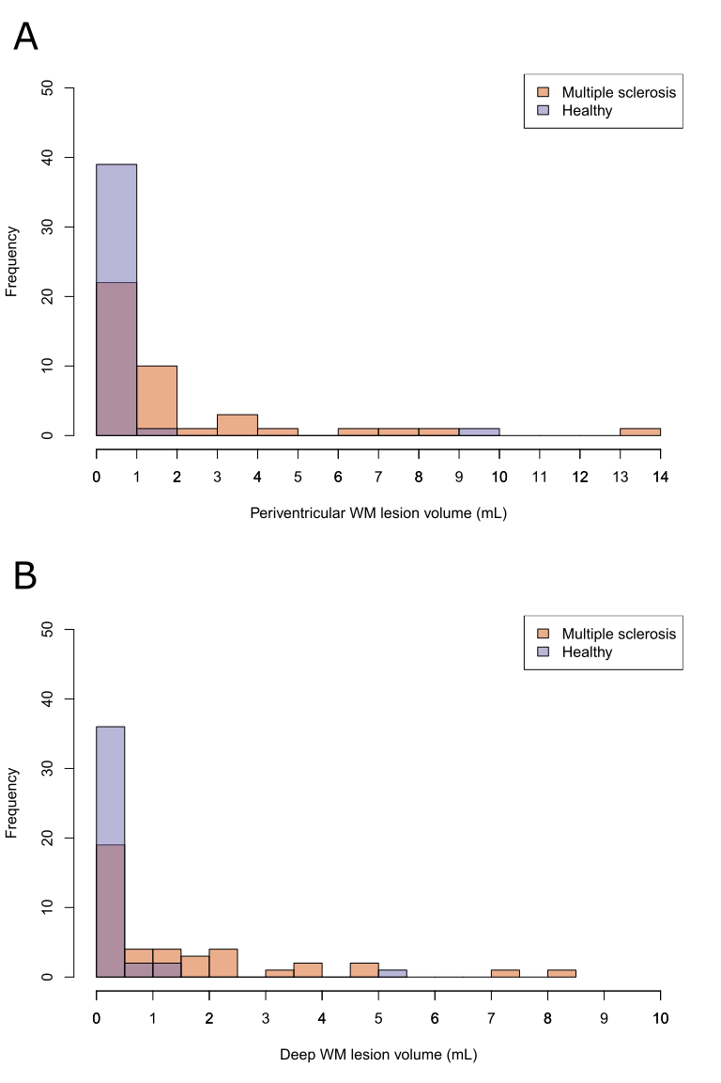

***Supplementary Figure 1.*** Histograms of the distributions of periventricul*ar white matter lesion volumes (A) and deep white matter lesion volumes (B) in multiple sclerosis patients and healthy participants.*

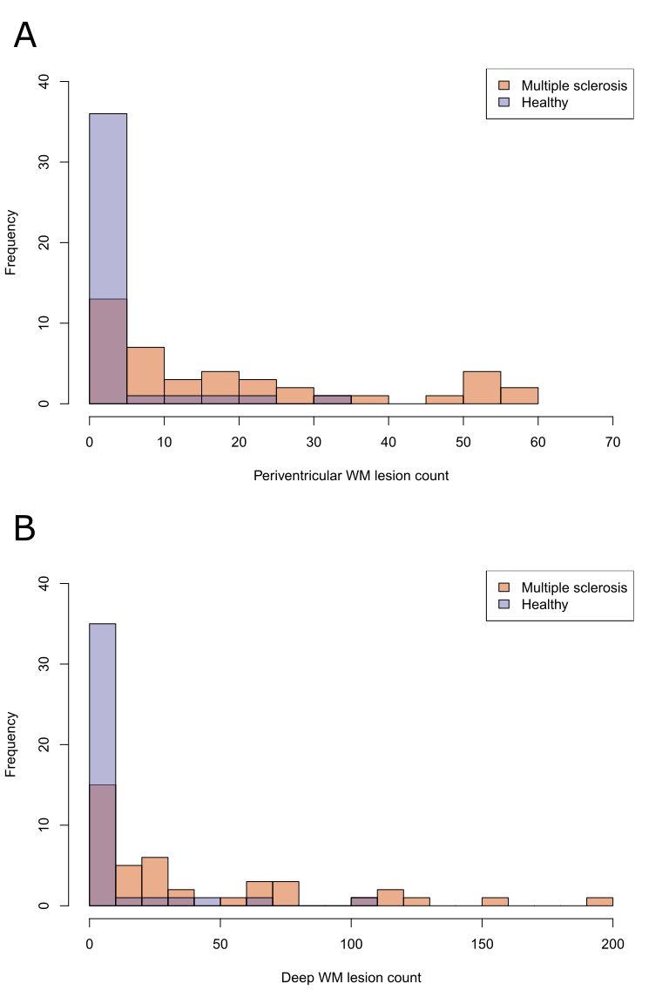

***Supplementary Figure 2.*** Histograms of the distributions of periventricul*ar white matter lesion counts (A) and deep white matter lesion counts (B) in multiple sclerosis patients and healthy participants.*

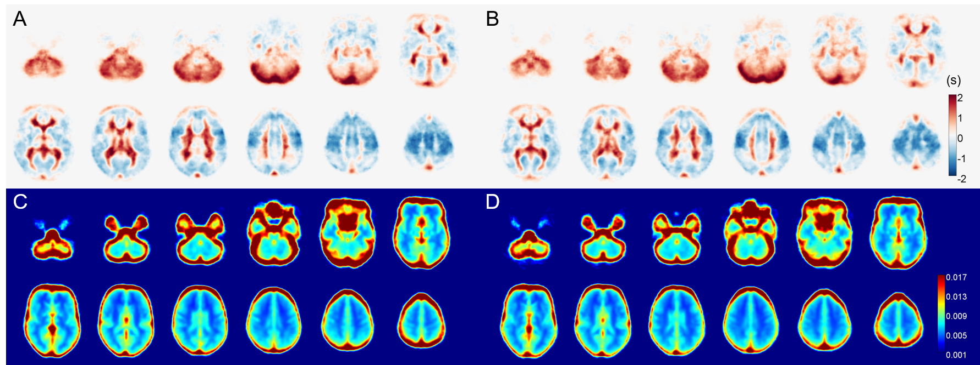

***Supplementary Figure 3.*** *Mean BOLD delay (in seconds; A and B) and coefficient of variation (CoV [unitless]; C and D) maps from the multiple sclerosis (A and C) and healthy participant (B and D) groups. Maps from both study groups appear very similar, with longer BOLD delay in the periventricular regions and the infratentorial compartment and larger CoV in the grey matter than the white matter.*

***Supplementary Table 1.*** *Pearson’s correlation between hemodynamic parameters in lesions and lesion volume.*

| **Hemodynamic metric** | **Location** | **Coefficient** | **p-value** |
| --- | --- | --- | --- |
| **BOLD delay** | *Deep NAWM* | 0.14 | 0.219 |
| *Periventricular NAWM* | 0.10 | 0.429 |
| **CoV** | *Deep NAWM* | **0.26** | **0.025** |
| *Periventricular NAWM* | 0.14 | 0.274 |
| **OLE** | *Deep NAWM* | -0.10 | 0.387 |
| *Periventricular NAWM* | -0.11 | 0.374 |

*NAWM = normal-appearing white matter, CoV = coefficient of variation of the BOLD signal, OLE = oxygen level estimate.*

***Supplementary Table 2.*** *Multiple linear regression results of the association between hemodynamic metrics with disability and behavioral measures in the multiple sclerosis group.*

| **Hemodynamic metric** | **Measure** | **Location** | **Estimate** | **Standard error** | **p-value** |
| --- | --- | --- | --- | --- | --- |
| **CoV** | **EDSS** | *Periventricular lesions* | **-250.07** | **87.47** | **0.0071** |
| *Deep WM lesions* | 21.53 | 190.38 | 0.9106 |
| *NAWM* | -13.54 | 112.94 | 0.9049 |
| *Cortical grey matter* | -93.49 | 58.59 | 0.1193 |
| *Deep grey matter* | -21.76 | 73.85 | 0.770 |
| **SDMT** | *Periventricular lesions* | -2716.86 | 1356.18 | 0.0542 |
| *WM lesions* | -3791.06 | 1857.63 | 0.0505 |
| *NAWM* | -1474.15 | 1066.68 | 0.1716 |
| *Cortical grey matter* | -404.24 | 944.18 | 0.6715 |
| *Deep grey matter* | -1358.15 | 1206.91 | 0.2691 |
| **BOLD delay** | **EDSS** | *Periventricular lesions* | -0.09 | 0.18 | 0.6031 |
| *Deep WM lesions* | 0.11 | 0.19 | 0.5445 |
| *NAWM* | -0.008 | 0.28 | 0.9789 |
| *Cortical grey matter* | -0.28 | 0.34 | 0.4204 |
| *Deep grey matter* | 0.05 | 0.62 | 0.9413 |
| **SDMT** | *Periventricular lesions* | 0.83 | 2.13 | 0.7001 |
| *Deep WM lesions* | 0.14 | 2.66 | 0.9574 |
| *NAWM* | -1.00 | 3.75 | 0.7901 |
| *Cortical grey matter* | **-11.48** | **4.06** | **0.0082** |
| *Deep grey matter* | 1.46 | 4.39 | 0.7413 |

*All linear regression models are adjusted for age, sex, and disease duration. Statistically significant results (p<0.05) are in bold. CoV = coefficient of variation of the BOLD signal, EDSS = Expanded Disability Status Scale, SDMT = Symbol Digit Modalities Test, WM = white matter, NAWM = normal-appearing white matter*