# Supplemental Material

# Challenges and opportunities in the clinical translation of high-resolution spatial transcriptomics

[Tancredi Massimo Pentimalli](https://orcid.org/0000-0002-8461-7918)1,2*, [Nikos Karaiskos](https://orcid.org/0000-0001-7771-3947)1*, [Nikolaus Rajewsky](https://orcid.org/0000-0002-4785-4332)1,2,3,4,5,6*

1 Laboratory for Systems Biology of Regulatory Elements, Berlin Institute for Medical Systems Biology (BIMSB), Max-Delbrück-Centrum for Molecular Medicine in the Helmholtz Association (MDC), Hannoversche Str. 28, 10115 Berlin

2 Charité - Universitätsmedizin, Charitéplatz 1, 10117 Berlin, Germany

3 German Center for Cardiovascular Research (DZHK), Site Berlin, Berlin, Germany

4 NeuroCure Cluster of Excellence, Berlin, Germany

5 German Cancer Consortium (DKTK)

6 National Center for Tumor Diseases (NCT), Site Berlin, Berlin, Germany

*Correspondence:[tancredimassimo.pentimalli@mdc-berlin.de](mailto:tancredimassimo.pentimalli@mdc-berlin.de), [nikolaos.karaiskos@mdc-berlin.de](mailto:nikolaos.karaiskos@mdc-berlin.de), [rajewsky@mdc-berlin.de](mailto:rajewsky@mdc-berlin.de)

#### Supplemental Table 1. Preclinical studies leveraging high-resolution ST methods

|  |  |  |  |  |  |  |
| --- | --- | --- | --- | --- | --- | --- |
| **Clinical specialty** | **Condition** | **Tissue** | **Assay** | **Plexy** | **Application** | **Reference** |
| Gastroenterology | Healthy, IM | Stomach (gastrectomy x2) | CosMx SMI | 1000-plex, Universal Cell Characterization | Tissue atlasing | [(55)](https://sciwheel.com/work/citation?ids=15500049&pre=&suf=&sa=0) |
| IBD | Colon (biopsy x9) | CosMx SMI | 1000-plex, Universal Cell Characterization | Tissue atlasing | [(67)](https://sciwheel.com/work/citation?ids=15207954&pre=&suf=&sa=0) |
| Gynecology | Healthy | Breast (mammoplasty, mastectomy x15) | Molecular Cartography | 100-plex, custom (scRNAseq markers) | Tissue atlasing | [(74)](https://sciwheel.com/work/citation?ids=11657129&pre=&suf=&sa=0) |
| MERFISH | 266-plex, custom (scRNAseq markers) |
| Nephrology | Healthy | Kidney (biopsy x6) | Slide-seq | Unbiased | Tissue atlasing | [(60)](https://sciwheel.com/work/citation?ids=15151513&pre=&suf=&sa=0) |
| Neurology | Healthy, AD | Brain (Postmortem x6) | In situ sequencing | 84-plex, custom (cell types and PIGs) | Disease mechanisms | [(61)](https://sciwheel.com/work/citation?ids=9326244&pre=&suf=&sa=0) |
| AD | Brain (Postmortem x25) | MERFISH | 140-plex, custom (brain cell subtypes) | Disease mechanisms | [(151)](https://sciwheel.com/work/citation?ids=14969369&pre=&suf=&sa=0) |
| Oncology | HNSCC | Larynx, Lymph nodes (Resection x1) | open-ST | Unbiased | Method development (3D, subcellular) | [(33)](https://sciwheel.com/work/citation?ids=15875886&pre=&suf=&sa=0) |
| Drug injected tumors (Resection x2) | CosMx SMI | 1000-plex, Universal Cell Characterization | In vivo drug response | [(98)](https://sciwheel.com/work/citation?ids=15649526&pre=&suf=&sa=0) |
| HCC, ICC | Liver, Lymph nodes (Resection x43) | Stereo-seq | Unbiased | Spatial heterogeneity | [(83)](https://sciwheel.com/work/citation?ids=15745824&pre=&suf=&sa=0) |
| HCC | Liver (Resection x6) | MERFISH | 400-plex, custom (immune celltype/functional markers, scRNAseq markers) | Immunotherapy response/resistance | [(87)](https://sciwheel.com/work/citation?ids=14993514&pre=&suf=&sa=0) |
| Liver (Resection x2) | CosMx SMI | 1000-plex, Universal Cell Characterization | Disease mechanisms | [(90)](https://sciwheel.com/work/citation?ids=15832827&pre=&suf=&sa=0) |
| Stereoseq | Unbiased |
| NSCLC | Lung (Resection x1) | CosMx SMI | 1000-plex, Universal Cell Characterization | Method development (3D, multimodal) | [(46)](https://sciwheel.com/work/citation?ids=15214256&pre=&suf=&sa=0) |
| Lung (Resection x4) | MERFISH | 479-plex, custom (immune, stromal and epithelial celltype/state  markers, scRNAseq reference) | Immunotherapy response/resistance | [(88)](https://sciwheel.com/work/citation?ids=14779213&pre=&suf=&sa=0) |
| HGG | Brain (Resection x2) | CosMx SMI | 1000-plex, Universal Cell Characterization | Spatial heterogeneity | [(84)](https://sciwheel.com/work/citation?ids=15903440&pre=&suf=&sa=0) |
| Xenium | 339-plex, custom (scRNAseq markers) |
| HGSC | Adnexa, Omentum (Resection x60) | CosMx | 1000-plex, Universal Cell Characterization | Disease mechanisms | [(85)](https://sciwheel.com/work/citation?ids=15535354&pre=&suf=&sa=0) |
| In situ sequencing | 280plex, Human Breast Panel |
| MERFISH | 140-plex, custom |

IM: Intestinal metaplasia, IBD: Inflammatory bowel disease, AD: Alzheimer’s disease, PD: Parkinson’s disease, HNSCC: Head and neck squamous cell carcinoma, HCC: Hepatocellular carcinoma, ICC: Intrahepatic cholangiocarcinoma, NSCLC: Non-small cell lung carcinoma, HGG: High-grade glioma, HGSC: High-grade serous carcinoma

Supplemental Figure 1. High-resolution spatial transcriptomic approaches

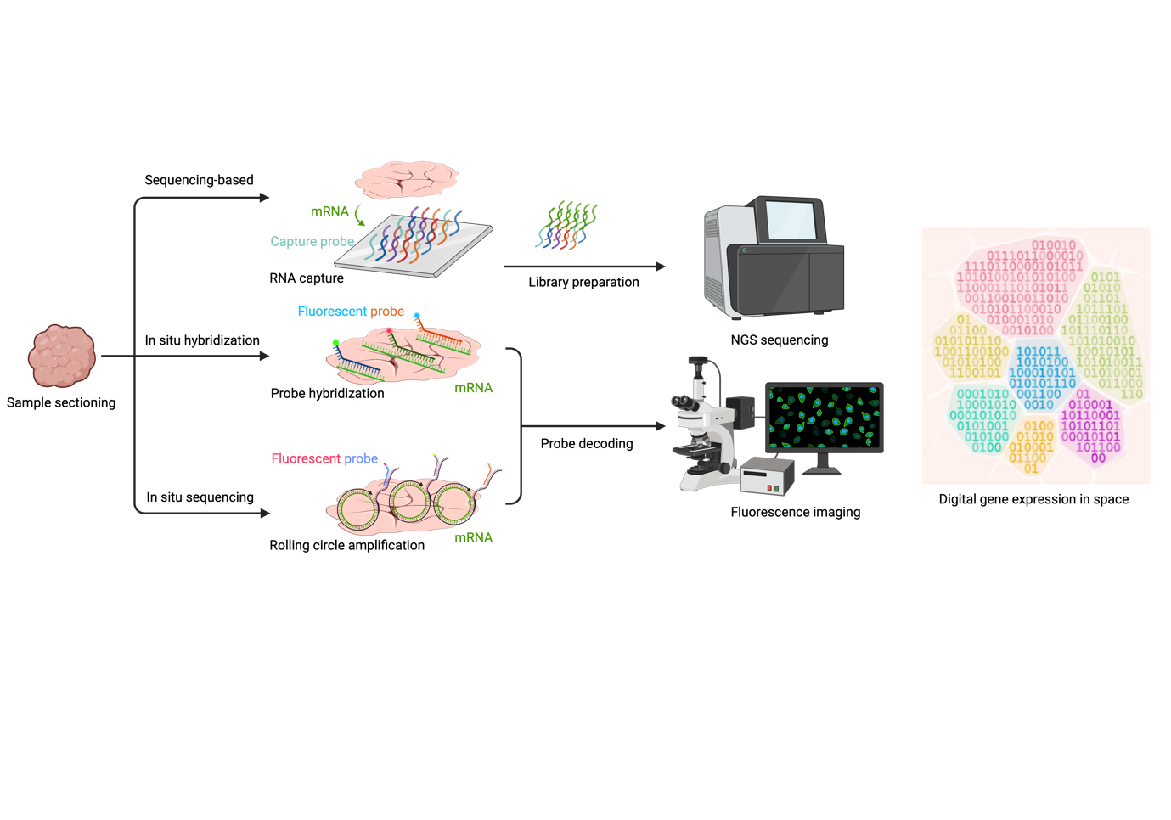

**Supplemental Figure 1 High-resolution spatial transcriptomic approaches**. Core functioning principles of high-resolution spatial transcriptomics methods. In sequencing-based methods (top row), mRNA molecules are released upon tissue permeabilization and bind to capture probes immobilized in the underlying capture area. Following reverse transcription, probes are detached for library preparation and NGS sequencing. In imaging-based methods, fluorescent probes bind either directly to their RNA targets (in situ hybridization, middle row) or following rolling circle amplification (in situ sequencing, bottom row). Fluorescence imaging then decodes probe location and barcodes. All approaches ultimately produce a spatially-resolved, digital gene expression image at single-cell resolution.