**Supplementary Figures and Figure legends**

|  |
| --- |
|  |
| ***Supplementary Figure 1: Gating strategy for flow cytometric analyses.*** *Gating strategy for the analysis of VNFNFNGL-specific T cell subsets in mice. Lymphocytes and singlets were gated based on SSC and FSC; live cells were identified by staining with 7-AAD. CD8+ and CD4- T cells were gated within the CD3+ population and progressively gated for primed cells (CD11hi and CD44hi) and primed subsets, including TEFF (CD62Llo), TTDE (CD62LloKLRG1hi), TEM (CD62LloKLRG1lo) or TCM (CD62LhiKLRG1lo) subpopulations, which were further sub-gated for the antigen-specific subpopulations based on tetramer labeling.* |
|  |
| ***Supplementary Figure 2: Protection against SARS-CoV-2 D614G-mediated disease elicited by a single dose of MCMVS-vaccine. (A)*** *Schematic representation of the experimental setup. Created with BioRender.com* ***(B)*** *CD3+CD8+CD4- T cells from murine blood one month post-vaccination (PBS n=8, MCMVWT n=9, MCMVS n=9) or three months post-vaccination (PBS n=15, MCMVWT n=17, MCMVS n=21) were gated for the primed subpopulation (CD11hiCD44hi - leftmost panel). Primed CD8+ T cells were then progressively gated into TEFF (CD62Llo), TTDE (CD62LloKLRG1hi), or TEM (CD62LloKLRG1lo) subpopulations. Frequencies of cells in each subset as a fraction of the parental population are shown.* ***(C)*** *The percentages of SARS-CoV-2 Spike peptide (VNFNFNGL)-specific cells in each subset shown in (B) are shown.* ***(D)*** *VNFNFNGL-specific memory responses over time in murine blood from MCMVS-immunized mice (n=9) shown as the percentage of antigen-specific T cells within the total CD8+ compartment. Each line connects values from an individual mouse at the indicated time points.* ***(E)*** *Serum neutralization titers (VNT50) at one month (PBS n=3, MCMVWT n=10, MCMVS n=8) or three months (MCMVS n=19) post-vaccination. Each symbol indicates an individual mouse. All data (except for (D) are shown as mean ± SD. Statistical assessments were performed using Brown-Forsythe and One-Way ANOVA and Dunnett T3 correction for multiple comparisons or Ordinary One-Way ANOVA with correction for multiple comparisons following Sidák if groups were uniformly negative (both two-tailed). (* p < 0.05, ** p <0.01, *** p<0.001).* |
|  |
| ***Supplementary Figure 3: SARS-CoV-2 viral loads in immunized and control mice. (A-B)*** *Relative SARS‑CoV‑2 viral RNA loads in the representative organs (trachea, stomach, heart, spleen) of SARS-CoV-2 D614G-challenged mice at* ***(A)*** *six weeks* *(PBS n=8-9, MCMVWT n=8-9, MCMVS n=7) and* ***(B)*** *twelve weeks (PBS n=3-5, MCMVWT n=4-5, MCMVS n=4-5) post-immunization. One MCMVS-immunized animal is shown separately as crossed red symbol as this animal did not show any immunogenicity and is suspected to represent a technical vaccination-failure. Organs were harvested at the indicated time points of 3 and 5-7 days (restricted by animals reaching the humane endpoint before day seven) after SARS-CoV-2 D614G challenge. SARS-CoV-2 viral RNA was normalized to the housekeeping gene mGAPDH and log-transformed. Values below 1 were set to 1 for graphical representation (before transformation). All data are shown as mean ± SD. No statistical assessment was performed for any panel.* |

|  |
| --- |
|  |
| ***Supplementary Figure 4: Clinical presentation following SARS-CoV-2 Omicron BA.1-challenge and sustained neutralizing antibody responses against SARS-CoV-2 Beta and Omicron BA.1 upon MCMVS-immunization.******(A)*** *Relative body mass (left) and clinical scoring (right) of MCMVWT-treated (n=4) or MCMVS-immunized (n=4) mice upon challenge with SARS-CoV-2 Omicron BA.1 at six weeks post-immunization.* ***(B)*** *Relative body mass (left) and clinical scoring (right) of MCMVWT-treated (n=12) or MCMVS-immunized (n=12) mice upon challenge with SARS-CoV-2 Omicron BA.1 at 20 weeks post-immunization. Mice were challenged with 2x103 PFU of SARS-CoV-2 Omicron BA.1. (****C, D)*** *Post-challenge pseudo-virus serum neutralization titers (PVNT50) at six weeks (n=4; left) and 20 weeks (n=12; right) post-vaccination against SARS-CoV-2 Index, Beta and Omicron BA.1 variants. Titers were assessed three days after SARS-CoV-2* ***(C)*** *Beta and* ***(D)*** *Omicron BA.1 challenge. All data are shown as mean ± SD. Red-dotted lines* *indicate the maximal acceptable burden for animal experiments. The humane endpoint (>20% reduction in body mass or a clinical score of ≥8) was pre-defined by authorized animal trial permits. Black dotted lines indicate the lower limit of confidence (LLOC). Statistical significance for longitudinal assessments (A and B) was calculated with Greenhouse-Geisser corrected Two-Way ANOVA and Tukey post-hoc testing. Statistical assessments for panel (C and D), comparing all groups within one time-point were statistically assessed using Brown-Forsythe and One-Way ANOVA and Dunnett T3 correction for multiple comparisons (two-tailed) (*** p<0.001, N/A no comparison possible).* |

|  |
| --- |
|  |
| ***Supplementary Figure 5: Low-dose immunization with MCMVS elicits long-lasting immunogenicity in aged mice. (A)*** *Schematic representation of the experimental setup. Mice were treated with PBS or immunized with*  *2x105 PFU of either MCMVS, MCMVWT  in all settings.* *Created with BioRender.com.* ***(B-J)*** *CD8 T cell response and SARS-CoV-2 antibody response in aged K18-hACE2 mice were measured in the blood and followed up to 270 d p.v. after immunization with a low dose (2x105 PFU) of MCMVS (PBS n=5, MCMVWT n=10, MCMVS n=10).* ***(B)*** *Longitudinal frequency of VNFNFNGL-specific memory responses over time in murine blood from MCMVS-immunized mice (n=9) shown as the percentage of antigen-specific T cells within the total CD8+ compartment. Each line connects values from an individual mouse at the indicated time points.* ***(C-D)*** *Primed CD8 T cells of MCMVS-immunized mice were progressively gated into antigen-specific effector-like cells: CD8+/CD44+/Tet+/CD127-/KLRG1+* ***(C)*** *and effector-memory cells (TEM): CD8+/CD44+/Tet+/CD127+/KLRG1* ***(D). (E)*** *Longitudinal anti-Spike IgG response in the sera of MCMVS immunized K18-hACE2 mice were determined by ELISA and visualized by the Absorbance O.D..* ***(F-H)*** *Measurement of the immune responses of mice treated with PBS (white) or immunized with either MCMVWT  (black) or MCMVS(red) using the VNFNFNGL-peptide* ***(F)****, a peptide pool of overlapping peptides covering the S-protein of Index-Sars-CoV-2* ***(G)*** *or Omicron BA.1.* ***(H)****.* ***(I)*** *IFN-γ, TNF-α and IL-2 production by CD8 T cells was stimulated using the VNFNFNGL-peptide, a peptide pool of overlapping peptides covering the S-protein of Index-Sars-CoV-2 or Omicron BA.1. in MCMVS immunized mice****. (J-K)*** *Frequency of SARS-CoV-2 Spike peptide (VNFNFNGL)-specific CD8 T cells in murine spleens* *after 270 d p.i..* ***(K)*** *Primed CD8 T cells of MCMVS-immunized mice were progressively gated into antigen-specific effector-memory cells (TEM): CD8+/CD44+/Tet+/CD127+/KLRG1-, effector-like cells: CD8+/CD44+/Tet+/CD127-/KLRG1+ or central memory cells (TCM): CD8+/CD44+/Tet+/CD127+/CD62L+ after 270 d p.v..* ***(L-M)*** *Immune response in aged K18-hACE2 mice at 16 months after immunization of MCMVS.* ***(L)*** *Frequency of SARS-CoV-2 Spike peptide (VNFNFNGL)-specific CD8 T cells in murine spleens (MCMVWT n=6, MCMVS n=5).* ***(M)*** *Primed CD8 T cells of MCMVS-immunized mice were progressively gated into antigen-specific effector-memory cells (TEM): CD8+/CD44+/Tet+/CD127+/KLRG1-, effector-like cells: CD8+/CD44+/Tet+/CD127-/KLRG1+ or central memory cells (TCM): CD8+/CD44+/Tet+/CD127+/CD62L+.*  *All data are shown as mean ± SD. Statistical assessment of panel (B and E) was calculated with Greenhouse-Geisser corrected Two-Way ANOVA and Tukey post-hoc testing. All other comparisons (C,D and F-M) were statistically assessed using Brown-Forsythe and One-Way ANOVA and Dunnett T3 correction for multiple comparisons (two-tailed). (* p<0.05, ** p <0.01, *** p < 0.001).* |

|  |
| --- |
|  |
| ***Supplementary Figure 6:******Aged MCMVS-immunized mice show long-lasting protection against heterologous SARS-CoV-2 infection. (A)*** *Relative body mass,* ***(B)*** *clinical scoring, and* ***(C)*** *survival of mice that were challenged with the SARS-CoV-2 Delta variant (top) or Omicron BA.1 variant (bottom) at six weeks post-immunization with MCMVWT (n=4-5) or MCMVS (n=5).**Mice were challenged with 2x103 PFU of SARS-CoV-2 Delta or Omicron BA.1.* ***(D,E)*** *Viral loads as SARS-CoV-2 N gene copy numbers per ng RNA in murine brains at day five following SARS-CoV-2 Delta* ***(D)*** *or Omicron BA.1* ***(E)*** *infection at six weeks (MCMVWT n=4-5, MCMVS n=5) or twelve weeks (MCMVWT n=10-11, MCMVS n=8-10). All data (except for C) are shown as mean ± SD. Red-dotted lines indicate the maximal acceptable burden for animal experiments. The humane endpoint (>20% reduction in body mass (A) or a clinical score of ≥8 (B)) was pre-defined by authorized animal trial permits. For survival analyses, a log-rank (Mantel-cox) test was used to assess statistical significance. Statistical significance for longitudinal assessments (A and B) was calculated with Greenhouse-Geisser corrected Two-Way ANOVA and Tukey post-hoc testing. All other comparisons (D and E) were statistically assessed using Brown-Forsythe and One-Way ANOVA and Dunnett T3 correction for multiple comparisons (two-tailed). (* p<0.05, ** p <0.01, *** p < 0.001).* |

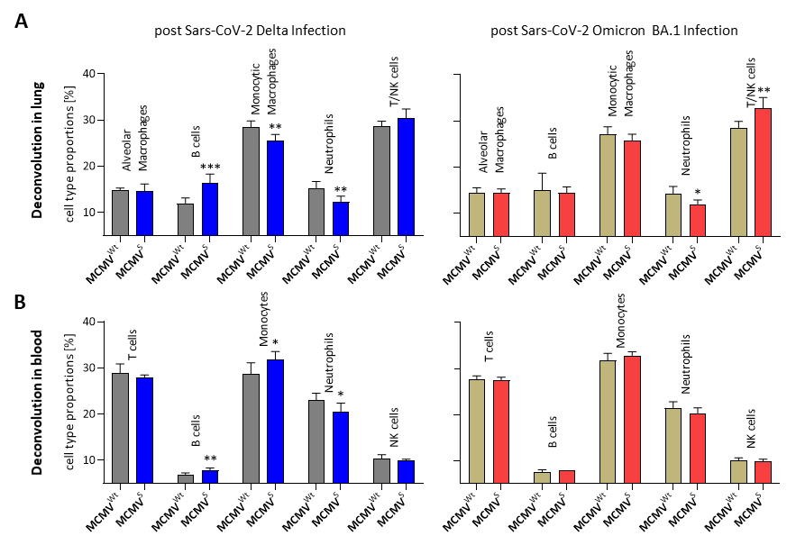

***Supplementary Figure 7:******Cell-type deconvolution of bulk RNA sequencing data from lung and blood.*** *Cell-type deconvolution of bulk RNA sequencing data from lung and blood. Cell-type proportion predicted by deconvolution of bulk RNA-sequencing data performed with the package granulator for cell type prediction, based on lung tissue and blood from SARS-CoV-2-infected hamsters, as reference matrix. Shown are fractions of the cell type selected of the total count.* ***(A-B)*** *Deconvolution in lung* ***(A)*** *tissue and blood* ***(B)*** *of mice challenged with SARS-CoV-2 Delta (left) or Omicron BA.1 (right) at twelve weeks post-immunization (MCMVWT n=11, MCMVS n=9). The cell-type proportion predicted for* ***(A)*** *Alveolar Macrophages, B cells, Monocytic macrophages, Neutrophils and both T cell and NK cells (T/NK cells) and* ***(B)*** *T cells, B cells, Monocytes, Neutrophils and NK cells. Add data are shown as mean ± SD. Statistical significance was calculated using Brown-Forsythe and One-Way ANOVA and Dunnett T3 correction for multiple comparisons (two-tailed). (* p < 0.05, ** p <0.01, *** p < 0.001).*