**Supplementary data**

**Supplementary Table 1: Univariate analysis of prognostic factors for OS, EFS and PFS in the total cohort**

|  |  |  |  |  |  |  |  |  |  |  |  |  |  |
| --- | --- | --- | --- | --- | --- | --- | --- | --- | --- | --- | --- | --- | --- |
| **Characteristics** | **Univariate Analysis of OS** | | | | **Univariate Analysis of EFS Univariate Analysis of PFS** | | | | | | | | |
|  | **n** | **Median Survival** | **2-year OS (%)** | ***P* Value** | **n** | **Median Survival** | **2-year EFS (%)** | ***P* Value** | **n** | **Median Survival** | **2-year PFS (%)** | ***P* Value** |
| Age | 79 |  |  | 0.059 | 79 |  |  | 0.314 | 79 |  |  | 0.971 |
| 80-82 |  | 51 | 60 |  |  | 12 | 40 |  |  | 17 |  |  |
| >82 |  | 36 | 52 |  |  | 15 | 41 |  |  | 22 47 | 46 |  |
| Gender | 79 |  |  | 0.941 | 79 |  |  | 0.423 | 79 |  |  | 0.286 |
| Male |  | 36 | 51 |  |  | 17 | 42 |  |  | 15 38 |  |  |
| Female |  | 51 | 60 |  |  | 5 | 38 |  |  | 32 | 56 |  |
| ECOG performance status | 79 |  |  | <0.001 | 79 |  |  | 0.002 | 79 |  |  | <0.001 |
| 0-1 |  | 79 | 70 |  |  | 12 | 46 |  |  | 52 | 58 |  |
| 2-4 |  | 17 | 44 |  |  | 12 | 36 |  |  | 15 | 38 |  |
| CCI | 79 |  |  | 0.255 | 79 |  |  | 0.123 | 79 |  |  | 0.588 |
| 0 |  | 75 | 68 |  |  | 49 | 50 |  |  | 49 | 58 |  |
| 1-5 |  | 19 | 47 |  |  | 10 | 34 |  |  | 15 | 40 |  |
| Stage | 77 |  |  | 0.913 | 77 |  |  | 0.830 | 77 |  |  | 0.766 |
| 1-2 |  | 37 | 54 |  |  | 15 | 38 |  |  | 15 | 36 |  |
| 3-4 |  | 52 | 58 |  |  | 15 | 44 |  |  | 32 | 53 |  |
| IPI score | 77 |  |  | 0.065 | 77 |  |  | 0.361 | 77 |  |  | 0.271 |
| 0-1 |  | 19 | 41 |  |  | 5 | 26 |  |  | 9 | 25 |  |
| 2-5 |  | 51 | 57 |  |  | 17 | 44 |  |  | 32 | 52 |  |
| B symptoms | 76 |  |  | 0.552 | 76 |  |  | 0.757 | 76 |  |  | 0.540 |
| Absent |  | 51 | 54 |  |  | 15 | 40 |  |  | 22 | 46 |  |
| Present |  | 59 | 66 |  |  | 5 | 44 |  |  | 32 | 54 |  |
| Extranodal | 67 |  |  | 0.896 | 67 |  |  | 0.918 | 67 |  |  | 0.872 |
| Absent |  | 37 | 52 |  |  | 12 | 34 |  |  | 17 | 42 |  |
| Present |  | 36 | 56 |  |  | 12 | 42 |  |  | 32 | 56 |  |
| Albumin | 77 |  |  | 0.879 | 77 |  |  | 0.874 | 77 |  |  | 0.929 |
| ≤34 g/L |  | 17 | 42 |  |  | 11 | 35 |  |  | 17 | 46 |  |
| >34 g/L |  | 57 | 62 |  |  | 15 | 43 |  |  | 15 | 46 |  |
| LDH | 79 |  |  | 0.007 | 79 |  |  | 0.004 | 79 |  |  | 0.087 |
| ≤ Normal value |  | 54 | 66 |  |  | 17 | 36 |  |  | 54 | 60 |  |
| >Normal value |  | 32 | 50 |  |  | 12 | 48 |  |  | 15 | 42 |  |
| Vitamin D | 40 |  |  | 0.408 | 40 |  |  | 0.527 | 40 |  |  | 0.982 |
| <10 ng/mL. |  | 36 | 56 |  |  | 6 | 40 |  |  | 32 | 56 |  |
| ≥10 ng/mL |  | 12 | 50 |  |  | 12 | 50 |  |  | 12 | 50 |  |
| ß2-Mikroglobulin | 64 |  |  | 0.285 | 64 |  |  | 0.597 | 64 |  |  | 0.994 |
| ≤3.0 |  | 75 | 60 |  |  | 4 | 38 |  |  | 28 | 62 |  |
| >3.0 |  | 32 | 50 |  |  | 12 | 36 |  |  | 17 | 40 |  |

Abbreviations: ECOG; Eastern Cooperative Oncology Group, CCI; Charlson Comorbidity Index IPI; International Prognostic Index, LDH; lactate dehydrogenase

**Supplementary Table 2: Univariate analysis of prognostic factors for OS, EFS and PFS in the R-CHOP-14 cohort**

|  |  |  |  |  |  |  |  |  |  |  |  |  |
| --- | --- | --- | --- | --- | --- | --- | --- | --- | --- | --- | --- | --- |
| **Characteristics** | **Univariate Analysis of OS** | | | | **Univariate Analysis of EFS Univariate Analysis of PFS** | | | | | | | |
|  | **n** | **Median Survival** | **2-year OS** | ***P* Value** | **n** | **Median Survival** | **2-year EFS** | ***P* Value** | **n** | **Median Survival** | **2-year PFS** | ***P* Value** |
| Age | 55 |  |  | 0.175 | 55 |  |  | 0.384 | 55 |  |  | 0.503 |
| 80-82 |  | 32 | 53 |  |  | 12 | 40 |  |  | 22 | 48 |  |
| >82 |  | 37 | 61 |  |  | 9 | 38 |  |  | 12 | 44 |  |
| Gender | 55 |  |  | 0.807 | 55 |  |  | 0.184 | 55 |  |  | 0.366 |
| Male |  | 36 | 52 |  |  | 22 | 46 |  |  | 17 | 35 |  |
| Female |  | 51 | 60 |  |  | 5 | 34 |  |  | 28 | 54 |  |
| ECOG performance status | 55 |  |  | 0.004 | 55 |  |  | 0.107 | 55 |  |  | 0.009 |
| 0-1 |  | 75 | 49 |  |  | 75 | 66 |  |  | 52 | 59 |  |
| 2-4 |  | 22 | 66 |  |  | 22 | 57 |  |  | 15 | 36 |  |
| CCI | 55 |  |  | 0.818 | 55 |  |  | 0.552 | 55 |  |  | 0.866 |
| 0 |  | 59 | 67 |  |  | 5 | 37 |  |  | 28 | 56 |  |
| 1-5 |  | 32 | 50 |  |  | 15 | 40 |  |  | 17 | 41 |  |
| Stage | 53 |  |  | 0.913 | 46 |  |  | 0.782 | 53 |  |  | 0.624 |
| 1-2 |  | 37 | 51 |  |  | 5 | 26 |  |  | 12 | 30 |  |
| 3-4 |  | 52 | 63 |  |  | 12 | 43 |  |  | 32 | 57 |  |
| IPI score | 53 |  |  | 0.068 | 53 |  |  | 0.340 | 53 |  |  | 0.167 |
| 0-1 |  | 37 | 55 |  |  | 5 | 38 |  |  | 9 | 34 |  |
| 2-5 |  | 51 | 57 |  |  | 12 | 42 |  |  | 28 | 52 |  |
| B symptoms | 53 |  |  | 0.358 | 53 |  |  | 0.683 | 53 |  |  | 0.687 |
| Absent |  | 37 | 52 |  |  | 12 | 38 |  |  | 17 | 42 |  |
| Present |  | 59 | 77 |  |  | 5 | 46 |  |  | 36 | 62 |  |
| Extranodal | 49 |  |  | 0.684 | 49 |  |  | 0.886 | 49 |  |  | 0.922 |
| Absent |  | 52 | 62 |  |  | 6 | 33 |  |  | 22 | 44 |  |
| Present |  | 22 | 50 |  |  | 9 | 37 |  |  | 28 | 50 |  |
| Albumin | 55 |  |  | 0.718 | 55 |  |  | 0.906 | 55 |  |  | 0.694 |
| ≤34 g/L |  | 22 | 47 |  |  | 12 | 36 |  |  | 22 |  |  |
| >34 g/L |  | 51 | 62 |  |  | 7 | 42 |  |  | 15 |  |  |
| LDH | 55 |  |  | 0.011 | 55 |  |  | 0.002 | 55 |  |  | 0.221 |
| ≤ Normal value |  | 59 | 72 |  |  | 9 | 49 |  |  | 54 | 59 |  |
| >Normal value |  | 22 | 47 |  |  | 12 | 34 |  |  | 15 | 40 |  |
| Vitamin D | 30 |  |  | 0.299 | 30 |  |  | 0.305 | 30 |  |  | 0.795 |
| <10 ng/mL. |  | 54 | 61 |  |  | 5 | 40 |  |  | 32 | 60 |  |
| ≥10 ng/mL |  | * | * |  |  | * | * |  |  | 86 | 66 |  |
| ß2-Mikroglobulin | 53 |  |  | 0.535 | 53 |  |  | 0.388 | 53 |  |  | 0.951 |
| ≤3.0 |  | 75 | 55 |  |  | 4 | 30 |  |  | 28 | 57 |  |
| >3.0 |  | 36 | 54 |  |  | 9 | 40 |  |  | 17 | 40 |  |

Abbreviations: ECOG; Eastern Cooperative Oncology Group, CCI; Charlson Comorbidity Index IPI; International Prognostic Index, LDH; lactate dehydrogenase

**Supplementary Table 3: Univariate analysis of prognostic factors for OS, EFS and PFS in the R-miniCHOP cohort**

|  |  |  |  |  |  |  |  |  |  |  |  |  |  |  |
| --- | --- | --- | --- | --- | --- | --- | --- | --- | --- | --- | --- | --- | --- | --- |
| **Characteristics** | **Univariate Analysis of OS** | | | | **Univariate Analysis of EFS Univariate Analysis of PFS** | | | | | | | | | |
|  | **n** | **Median Survival** | **2-year OS** | ***P* Value** | **n** | **Median Survival** | **2-year EFS** | ***P* Value** | **n** | **Median Survival** | | **2-year PFS** | ***P* Value** |
| Age | 24 |  |  | 0.041 | 24 |  |  | 0.192 | 24 |  |  | | 0.121 |
| 80-82 |  | * | 84 |  |  | 22 | 44 |  |  | * | | 47 |  |
| >82 |  | 15 | 44 |  |  | 15 | 42 |  |  | 17 | 63 | |  |
| Gender | 24 |  |  | 0.820 | 24 |  |  | 0.473 | 24 |  | |  | 0.457 |
| Male |  | 23 | 51 |  |  | 15 | 24 |  |  | 15 | 62 | |  |
| Female |  | 46 | 55 |  |  | * | 56 |  |  | * | | 41 |  |
| ECOG performance status | 24 |  |  | 0.019 | 24 |  |  | 0.012 | 24 |  |  | | 0.016 |
| 0-1 |  | * | 74 |  |  | * | 64 |  |  | * | | 69 |  |
| 2-4 |  | 11 | 14 |  |  | 10 | 13 |  |  | 11 | 16 | |  |
| CCI | 24 |  |  | 0.062 | 24 |  |  | 0.054 | 24 |  | |  | 0.215 |
| 0 |  | 17 | 68 |  |  | * | 57 |  |  | * | 64 | |  |
| 1-5 |  | * | 41 |  |  | 11 | 32 |  |  | 12 | | 38 |  |
| Stage | 24 |  |  | 0,999 | 24 |  |  | 0.911 | 24 |  |  | | 0.503 |
| 1-2 |  | 17 | 50 |  |  | 17 | 40 |  |  | 15 | | 42 |  |
| 3-4 |  | * | 58 |  |  | 11 | 50 |  |  | * | 65 | |  |
| IPI score | 22 |  |  | 0.664 | 22 |  |  | 0.791 | 22 |  | |  | 0.960 |
| 0-1 |  | 15 | 50 |  |  | 15 | 50 |  |  | 15 | 50 | |  |
| 2-5 |  | * | 54 |  |  | 17 | 43 |  |  | * | | 51 |  |
| B symptoms | 23 |  |  | 0.508 | 23 |  |  | 0.835 | 23 |  |  | | 0.468 |
| Absent |  | * | 60 |  |  | 22 | 46 |  |  | * | | 40 |  |
| Present |  | 17 | 40 |  |  | 17 | 42 |  |  | 17 | 57 | |  |
| Extranodal | 18 |  |  | 0.140 | 18 |  |  | 0.654 | 18 |  | |  | 0.602 |
| Absent |  | 15 | 28 |  |  | 17 | 36 |  |  | 17 | 40 | |  |
| Present |  |  | 72 |  |  | * | 54 |  |  | * | | 68 |  |
| Albumin | 22 |  |  | 0.916 | 22 |  |  | 0.767 | 22 |  |  | | 0.431 |
| ≤34 g/L |  | 11 | 24 |  |  | 11 | 34 |  |  | 17 | | 42 |  |
| >34 g/L |  | * | 64 |  |  | * | 53 |  |  | 15 | 50 | |  |
| LDH | 24 |  |  | 0.393 | 24 |  |  | 0.422 | 24 |  | |  | 0.265 |
| ≤ Normal value |  | 17 | 50 |  |  | 17 | 50 |  |  | * | 60 | |  |
| >Normal value |  | * | 54 |  |  | 15 | 41 |  |  | 15 | | 47 |  |
| Vitamin D | 12 |  |  | 0.070 | 12 |  |  | 0.364 | 12 |  |  | | 0.198 |
| <10 ng/mL. |  | 11 | 44 |  |  | 17 | 44 |  |  | * | | 57 |  |
| ≥10 ng/mL |  | 17 | 34 |  |  | 11 | 33 |  |  | 11 | 50 | |  |
| ß2-Mikroglobulin | 12 |  |  | 0.070 | 12 |  |  | 0.140 | 12 |  | |  | 0.677 |
| ≤3.0 |  | * | 100 |  |  | * | 100 |  |  | * | 99 | |  |
| >3.0 |  | * | 40 |  |  | * | 30 |  |  | * | | 42 |  |

Abbreviations: ECOG; Eastern Cooperative Oncology Group, CCI; Charlson Comorbidity Index, IPI; International Prognostic Index, LDH; lactate dehydrogenase

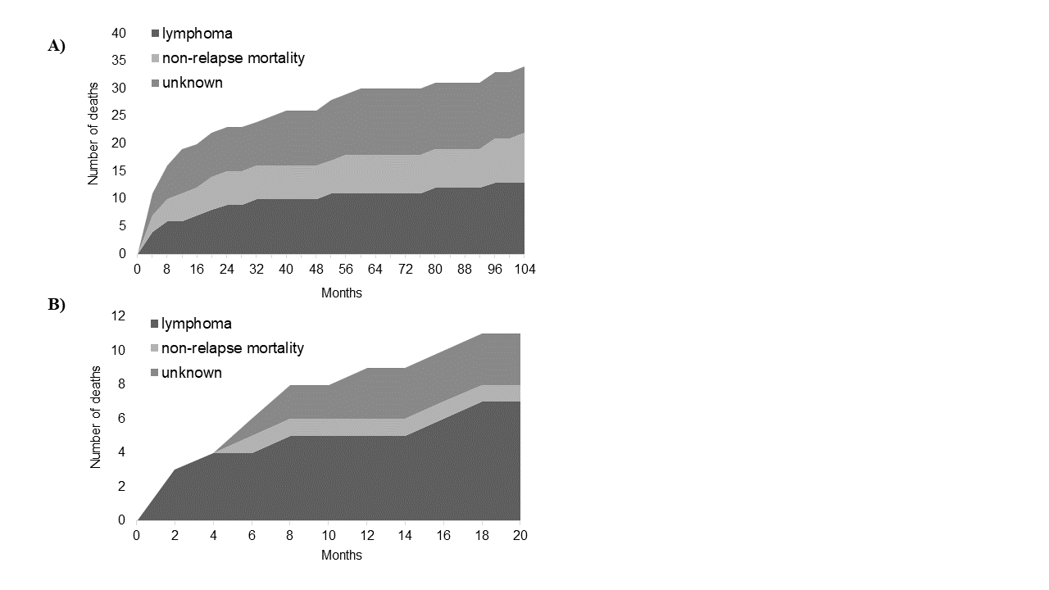

**Supplemental Figure 1: Cumulative incidence of death over time**

The cumulative incidence of death according to cause of death (lymphoma-associated, non-relapse mortality and unknown) is depicted separately for each cohort: A) R-CHOP-14, B) R-miniCHOP. Relatively higher non-relapse mortality is demonstrated for the R-CHOP-14 cohort but lower lymphoma-associated deaths compared to R-miniCHOP. The median follow-up for R-CHOP-14 was 49 months and for R-miniCHOP 32 months.